Name: Nguyen Thanh Nghia

Student Code: B1908341

Buoi2

1)

clear

echo "Hello $USER"

echo -e "Today is \c"; date

echo -e "Number of user login: \c"; who | wc -l

echo "Calendar"

cal

exit 0

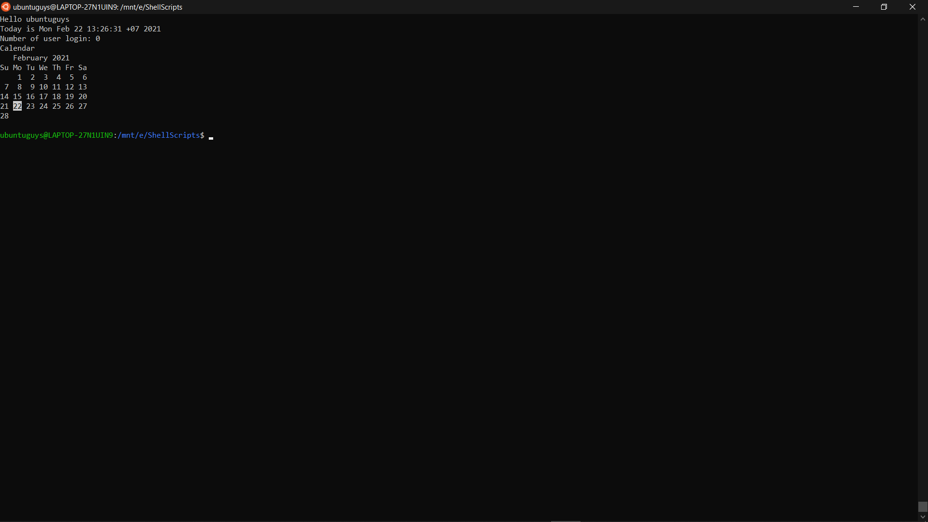

2)

myname=Vivek # correct

myos = TroubleOS # not correct (have space around =)

myno=5 # correct

echo "My name is $myname"

echo "My os is $myos"

echo "My number is: $myno"

3)

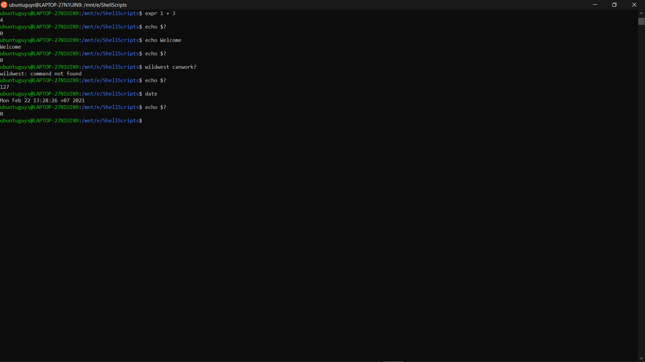

4)

echo -e "\\*\*\*\*\*\*\*\*\*\*\*\*\*\*\*\*\*\*\*\*\*\*\*\*\*\*\*\*\*\*\*\*\*\*\*\*\*\*\*\*\*\*\*"

echo "Today is: ";date

echo "Hello $USER"

echo "Your current working directory: `pwd`"

echo -n "Please press any key to finish: "

read

echo -e "\t\t\tThank you very much!"

echo -e "\\*\*\*\*\*\*\*\*\*\*\*\*\*\*\*\*\*\*\*\*\*\*\*\*\*\*\*\*\*\*\*\*\*\*\*\*\*\*\*\*\*\*\*"

5)

echo "Tham so ban da truyen vao la 2 so: $1 va $2"

echo "Tong: x + y = `expr $1 + $2`"

echo "Hieu: x - y = `expr $1 - $2`"

echo "Tich: x \* y = `expr $1 \\* $2`"

echo "Thuong: x / y = `expr $1 / $2`"

echo "So du: x % y = `expr $1 % $2`"

6)

if ! mkdir -p $1 2>/dev/null; then

echo "Khong the tao duoc thu muc!!!"

exit 1

Fi

7)

#!/bin/bash

$1 $2