Nguyen Thanh Nghia

B1908341

Exercise 1)

for i in {1..10}

do

for (( j = 1 ; j <= i ; j++ ))

do

echo -n "*"

done

echo -en "\n"

done

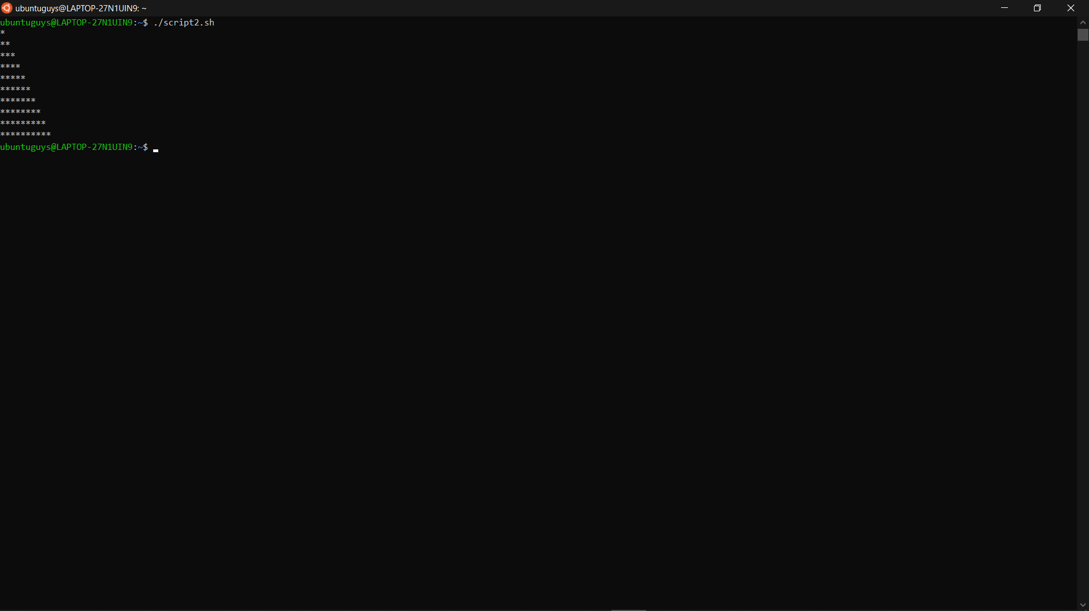

for i in {1..5}

do

for j in {1..5}

do

echo -ne "$j\t"

done

echo ""

done

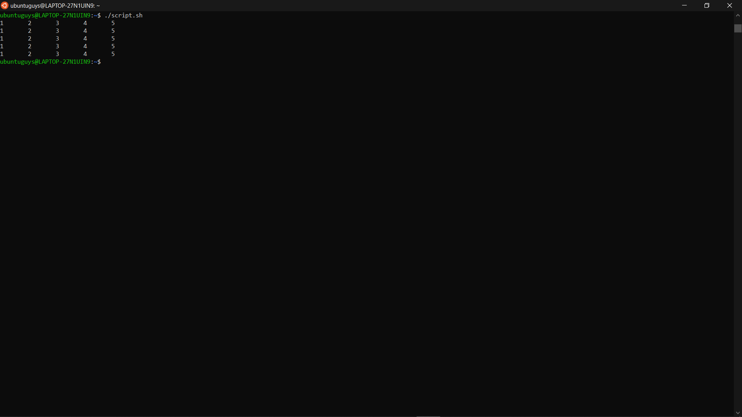

Exercise 2)

if [ $1 -eq 0 ]

then

if [ $2 -eq 0 ]

then

echo "Equation has infinity root"

else

echo "Equation has no root"

fi

exit 0

fi

echo -en "x = "

echo "print(-$2 / $1)" | python3

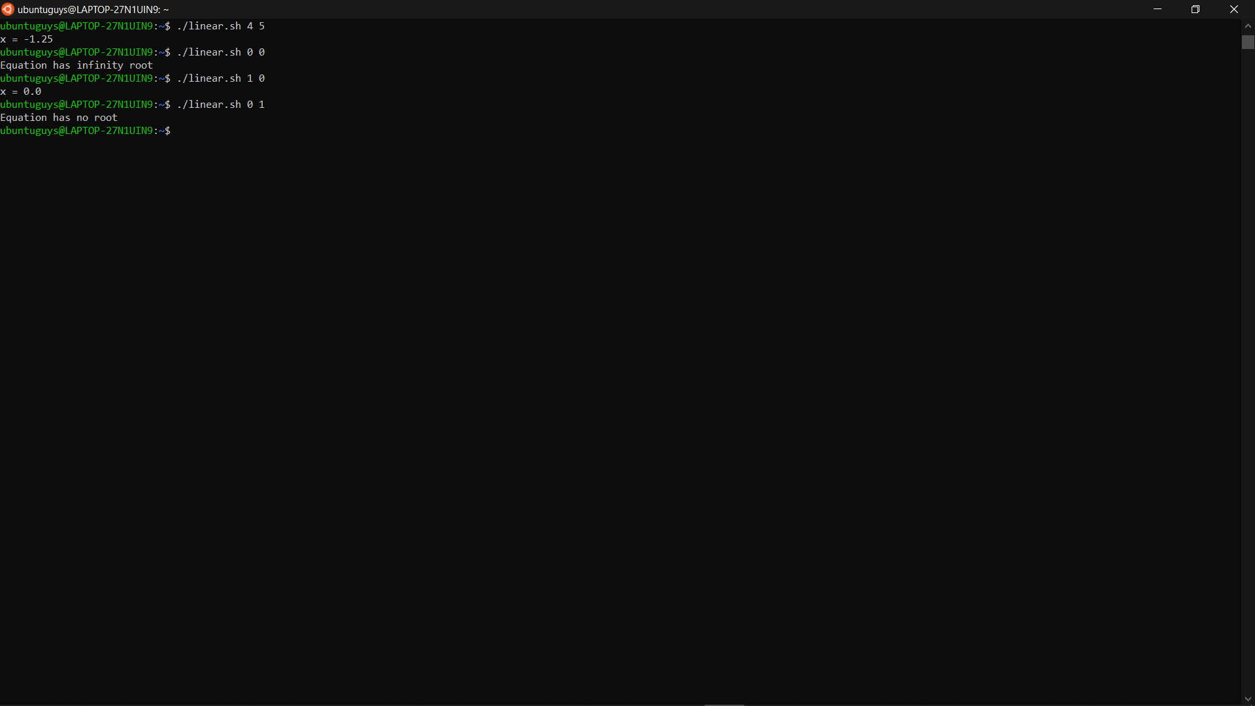

Exercise 3)

sum=0

for (( i = 0; i <= $1; i++))

do

sum=$((sum+$i))

done

echo "$sum"

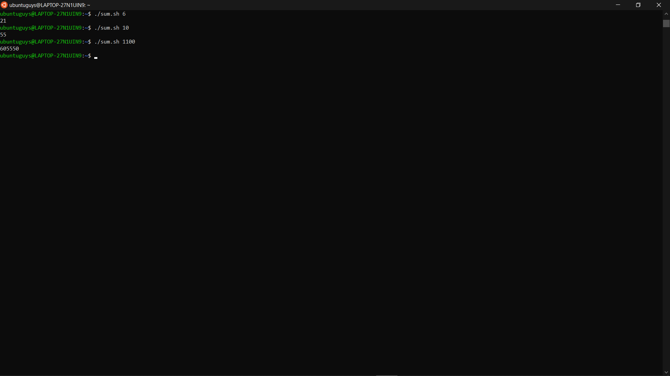

Exercise 4)

while

echo -n "Input n: "

read n

for i in {1..10}

do

echo "$i x $n = `expr $i \* $n`"

done

echo "Continue or not (y/n)?"

read c

[[ "$c" = "y" ]]

do true; done

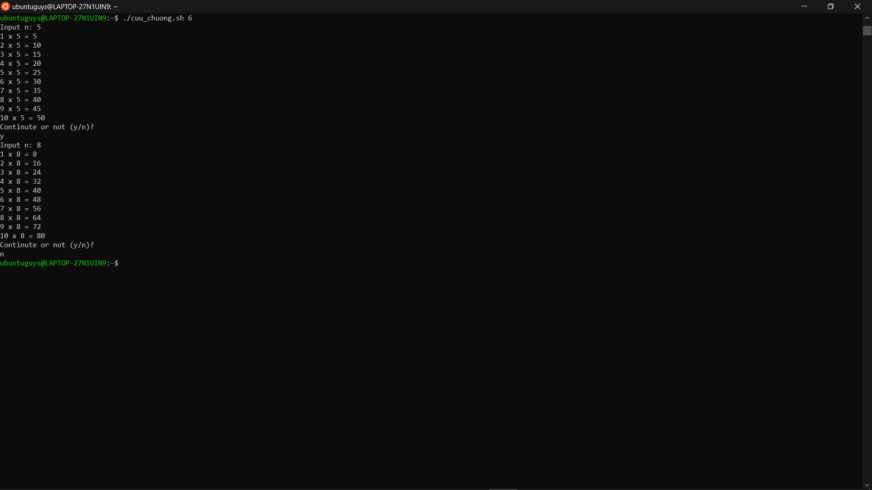

Exercise 5)

echo -n "Input n for number of directories: "

read n

for i in $(seq 1 $n)

do

mkdir ${USER}_${i}

done

