Flowchart Login & Profile

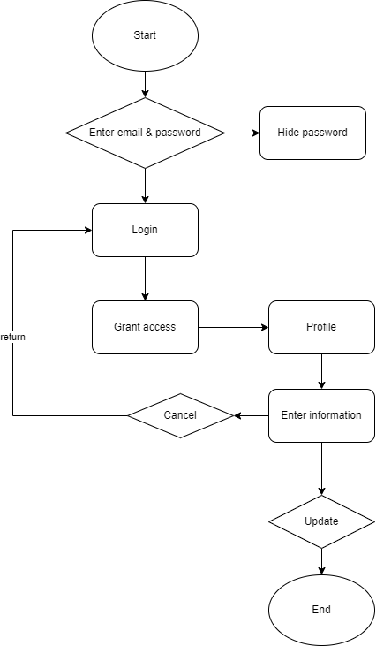

When starting, it will display on the login screen interface, you must enter your email and password to log in.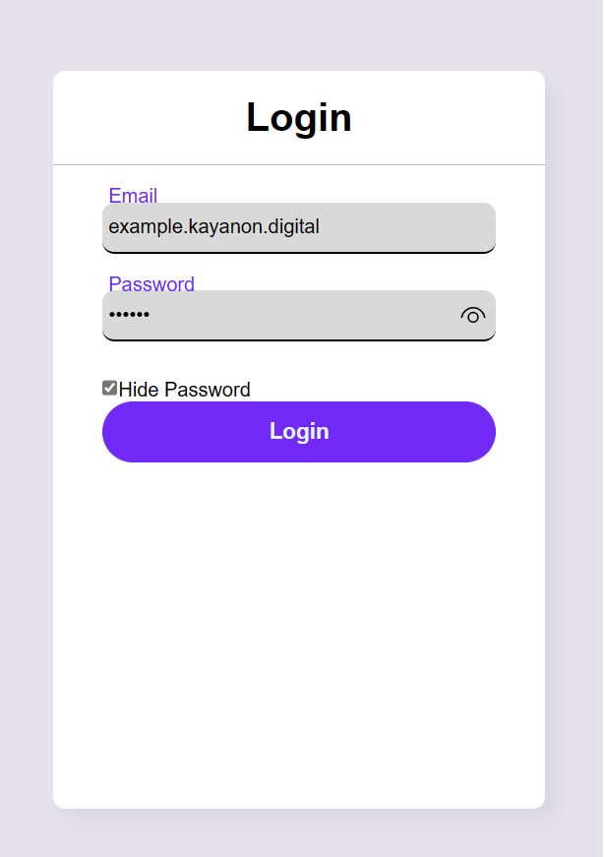

Then click login to log in. After logging in, it will display on the profile page

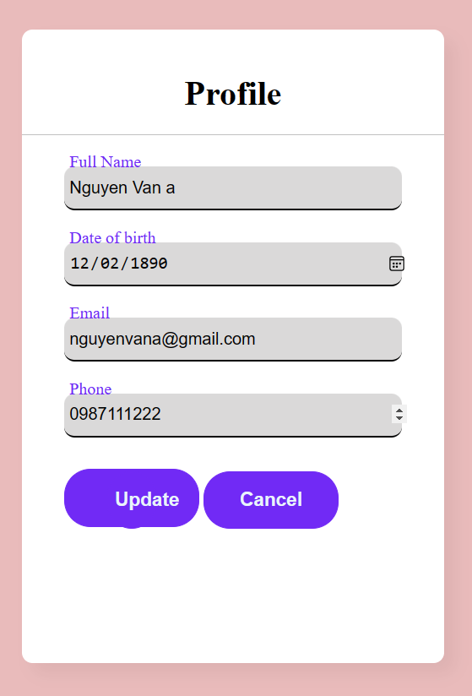

Click Update to update information. on the contrary, if you do not fill in the information but press the aupdate button, it will display "Update fall" .

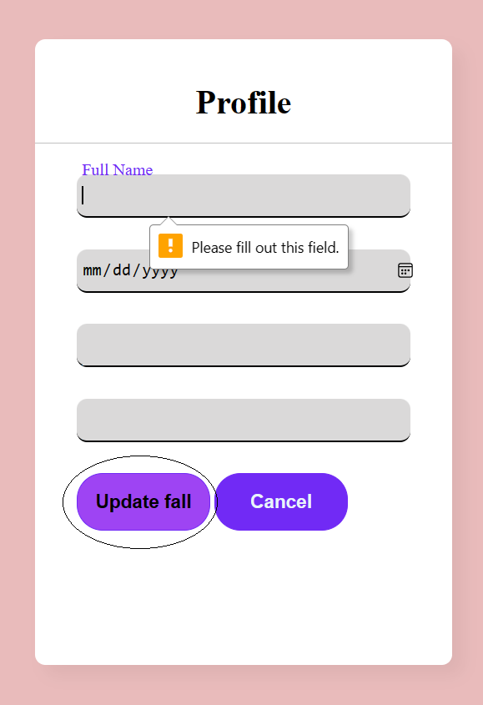

If you don't want to update your information yet, click cancel to return to the login page