**ECS deployment on EC2 Guide**

*** Prerequisite:

* Docker image

1/ Create ECR AWS and push image:

* Create this repo: test/thanh12345

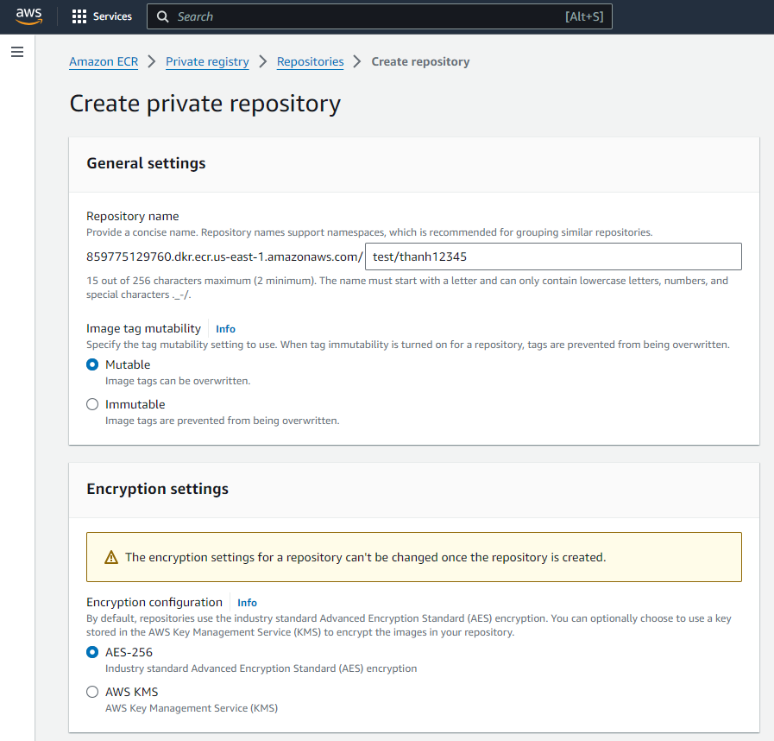

* Click on the newly created repo > view push command:

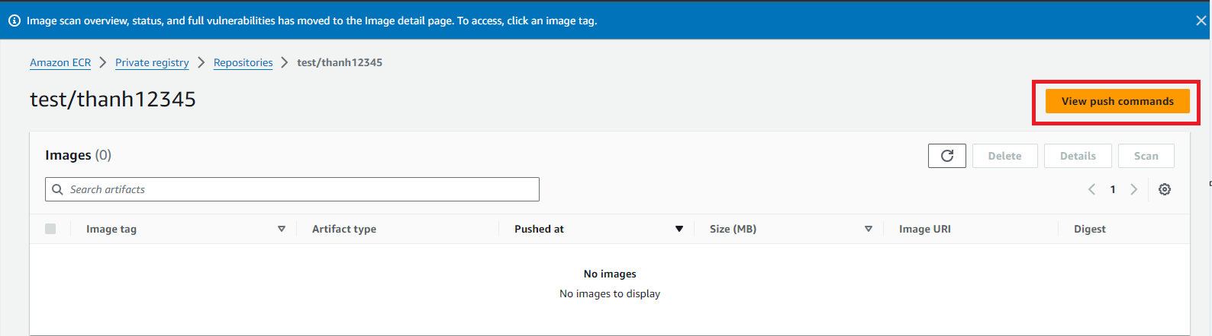

* Build and push like these commands:

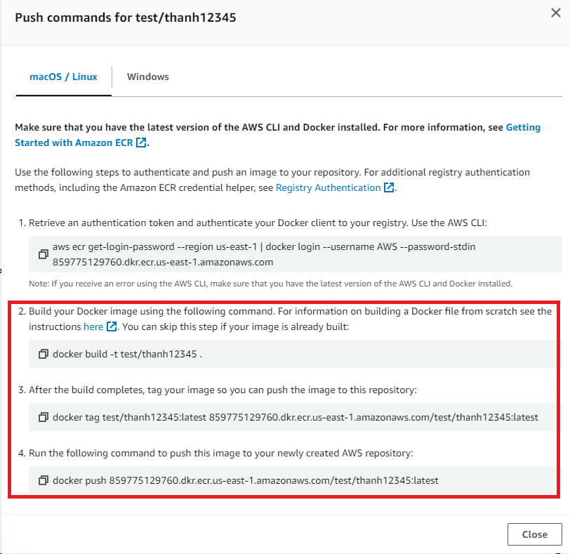

* Login to aws ECR with docker: (only change what are in the red color)

**aws ecr get-login-password --region region | docker login --username AWS --password-stdin aws_account_id.dkr.ecr.region.amazonaws.com**

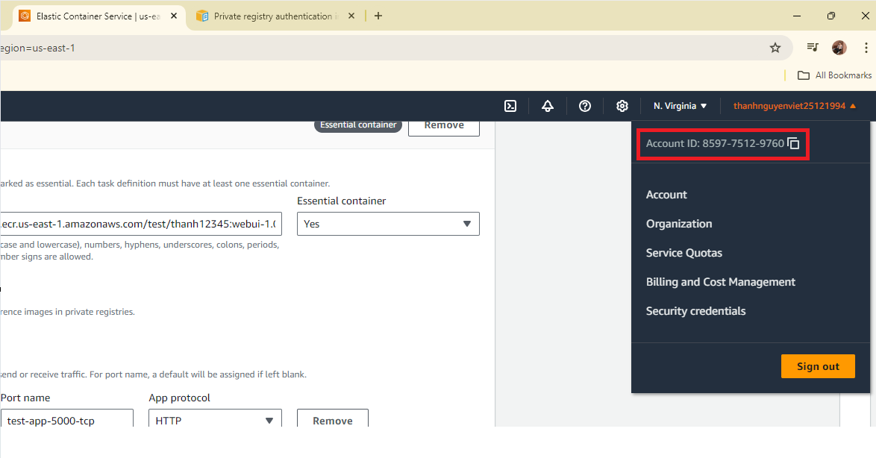

example:

aws ecr get-login-password --region us-east-1| docker login --username AWS --password-stdin 859775129760.dkr.ecr.us-east-1.amazonaws.com



* Push image:

docker push 859775129760.dkr.ecr.us-east-1.amazonaws.com/test/thanh12345:webui-1.0

2/ Create ECS cluster:

* Go to AWS > ECS > create cluster
* Do as the following:

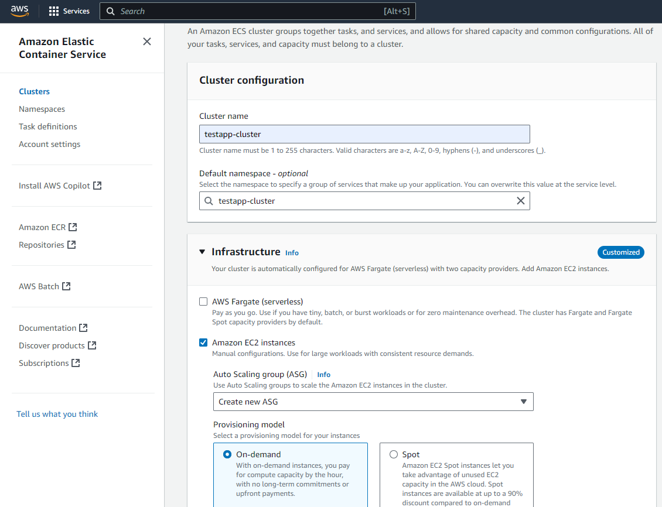

* For the role of EC2: need create a role with permission:
* 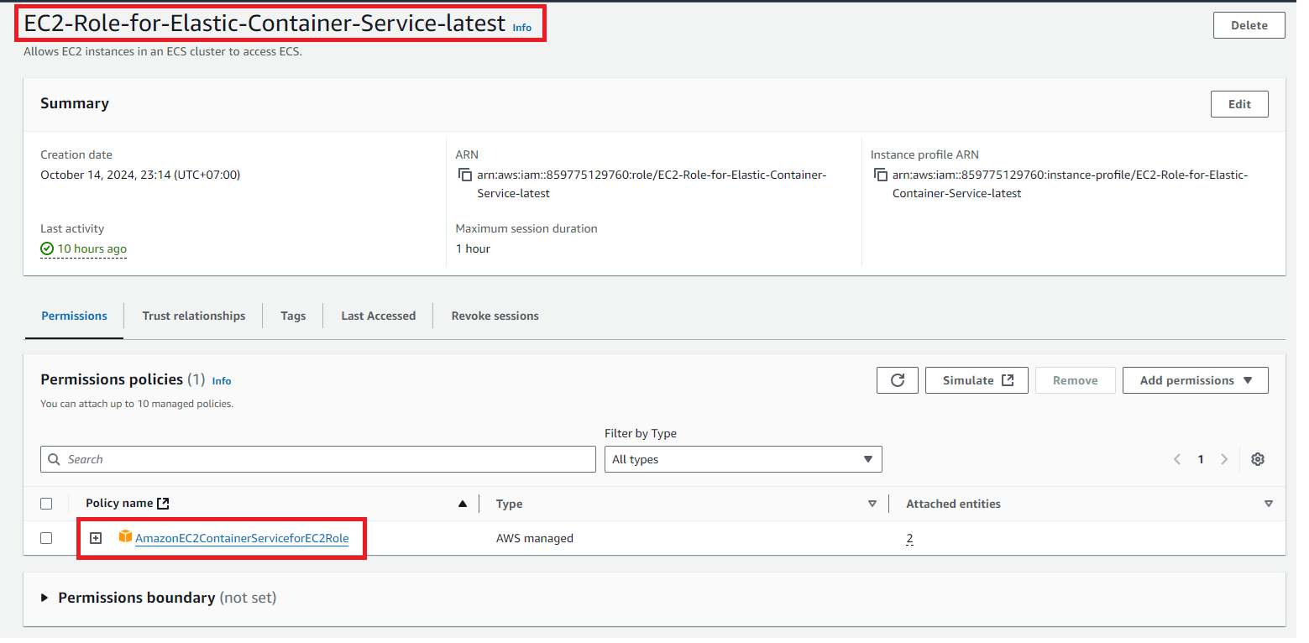

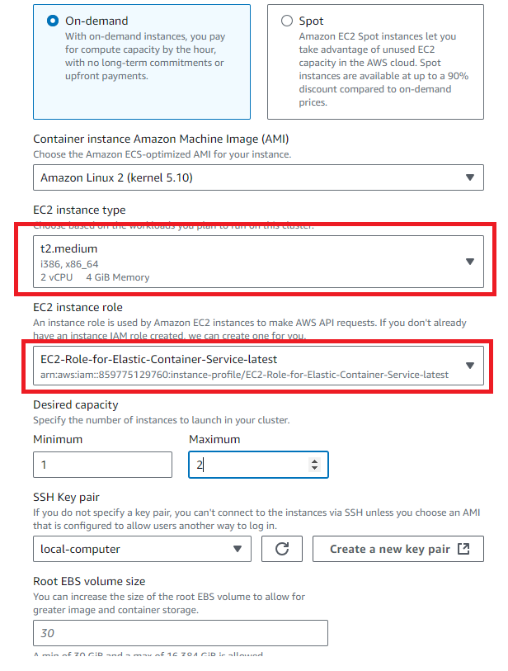

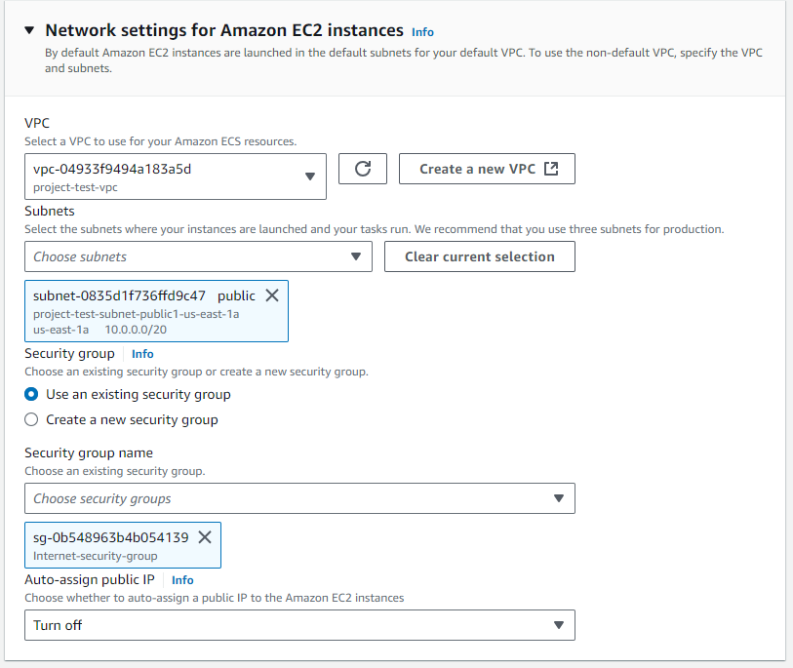

3/ Create task definition:

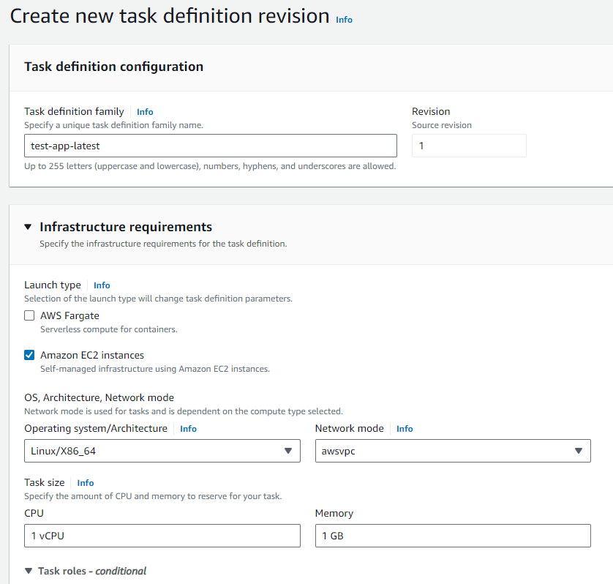

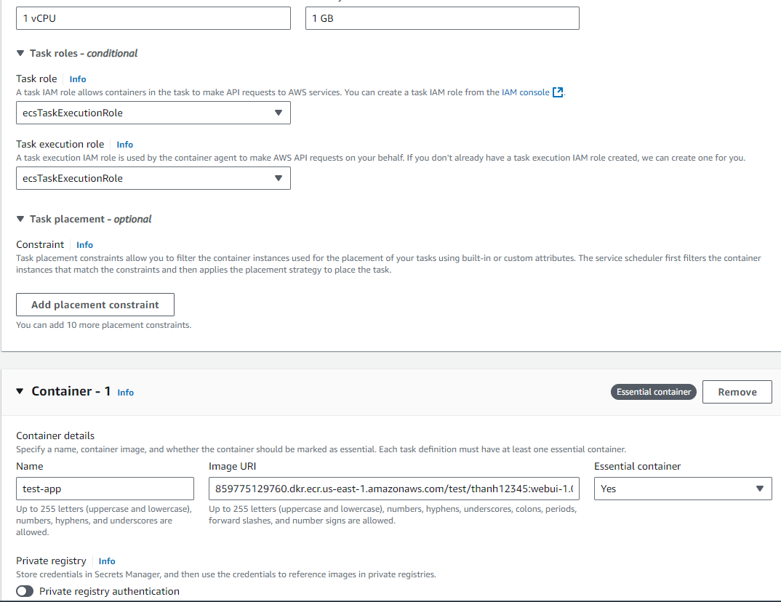

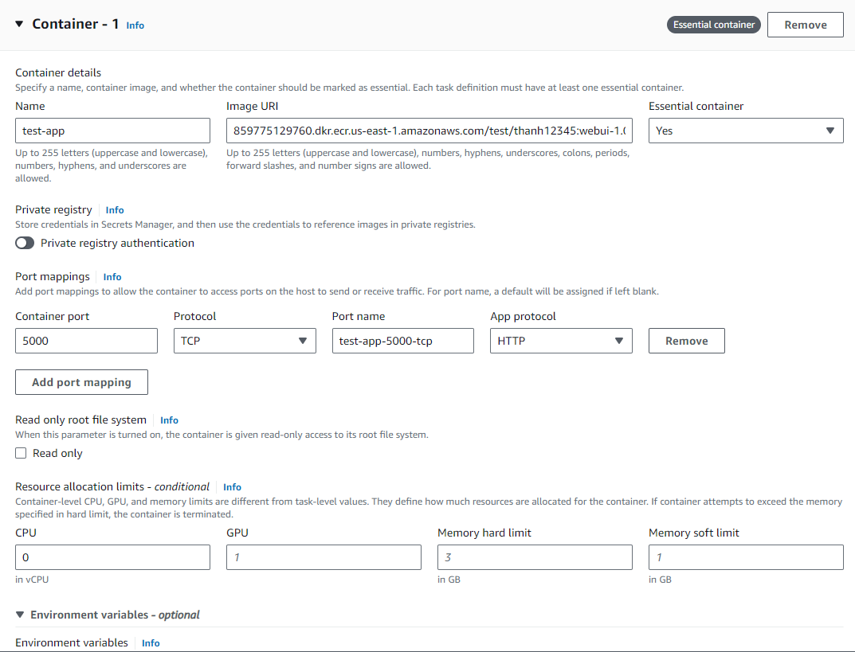

4/ Run task:

* Go to the newly created cluster > task > run task

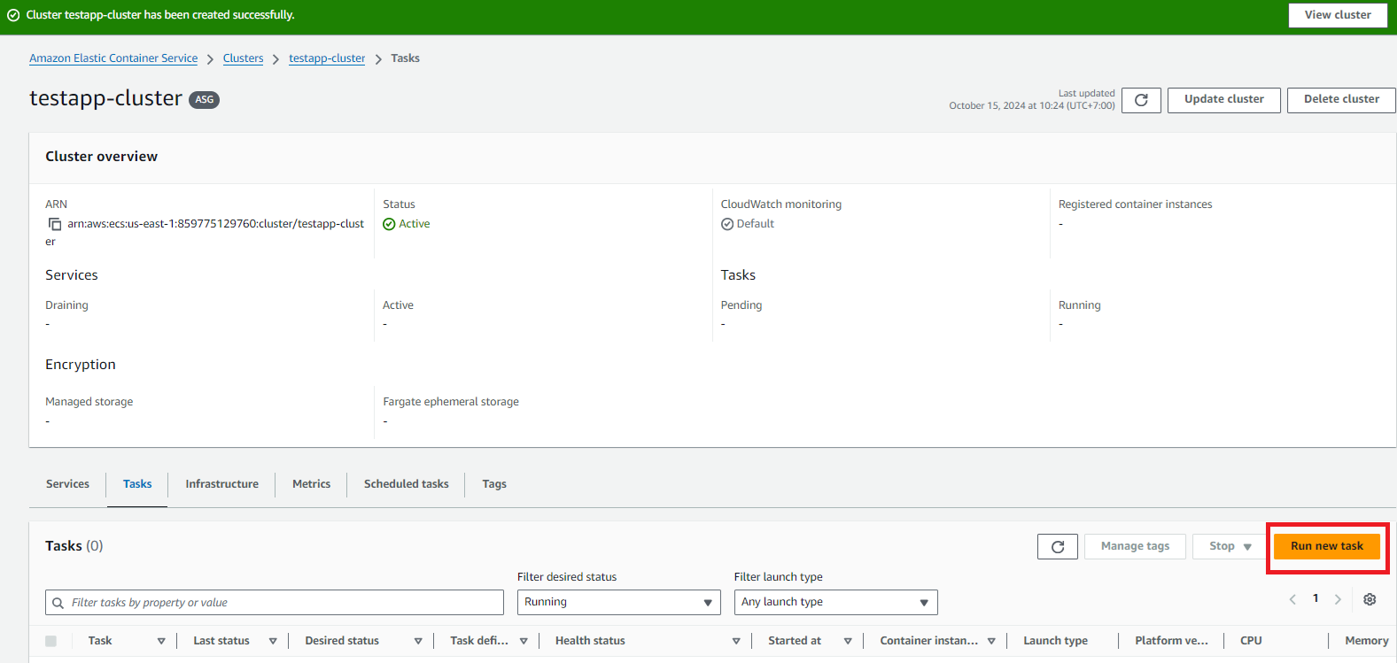

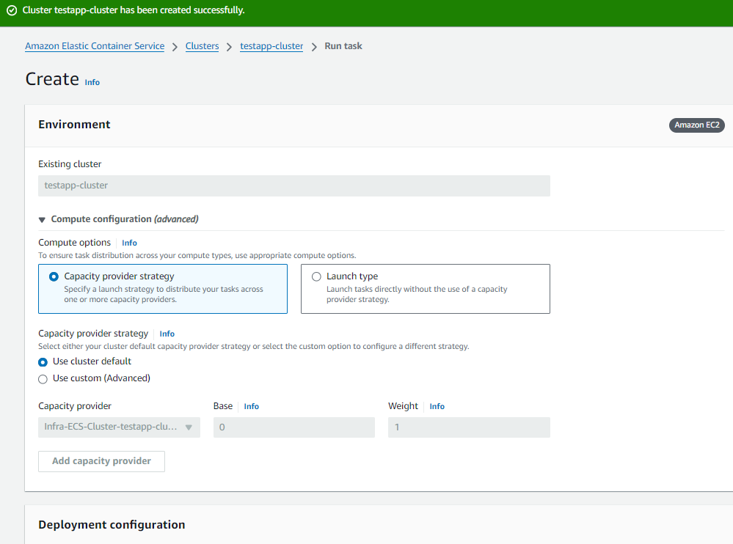

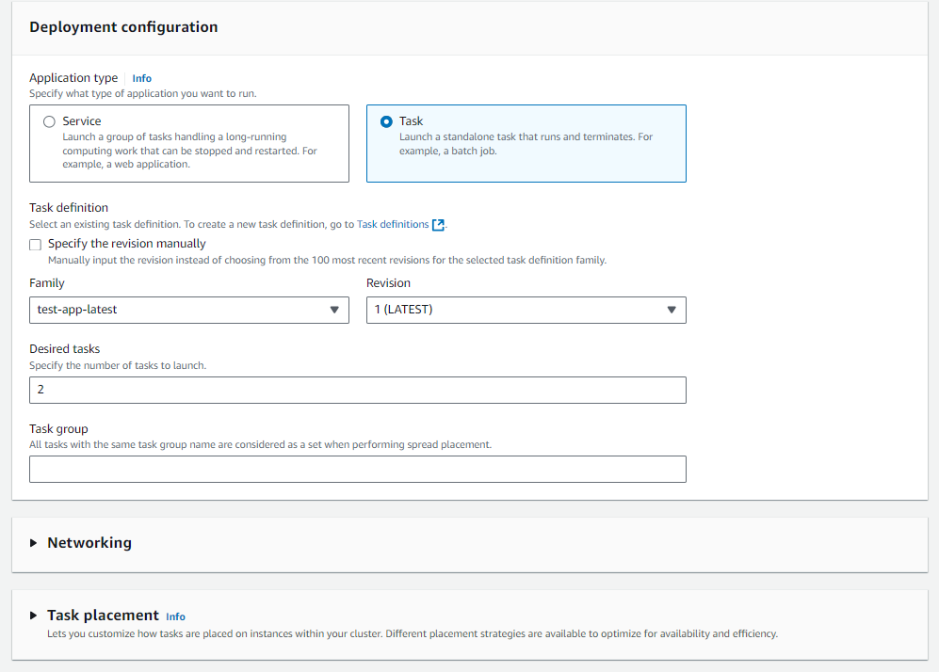

**Then click create to finish**

***note:  
- After finish create cluster, there should have a container instance EC2 registered in the infra tab:  
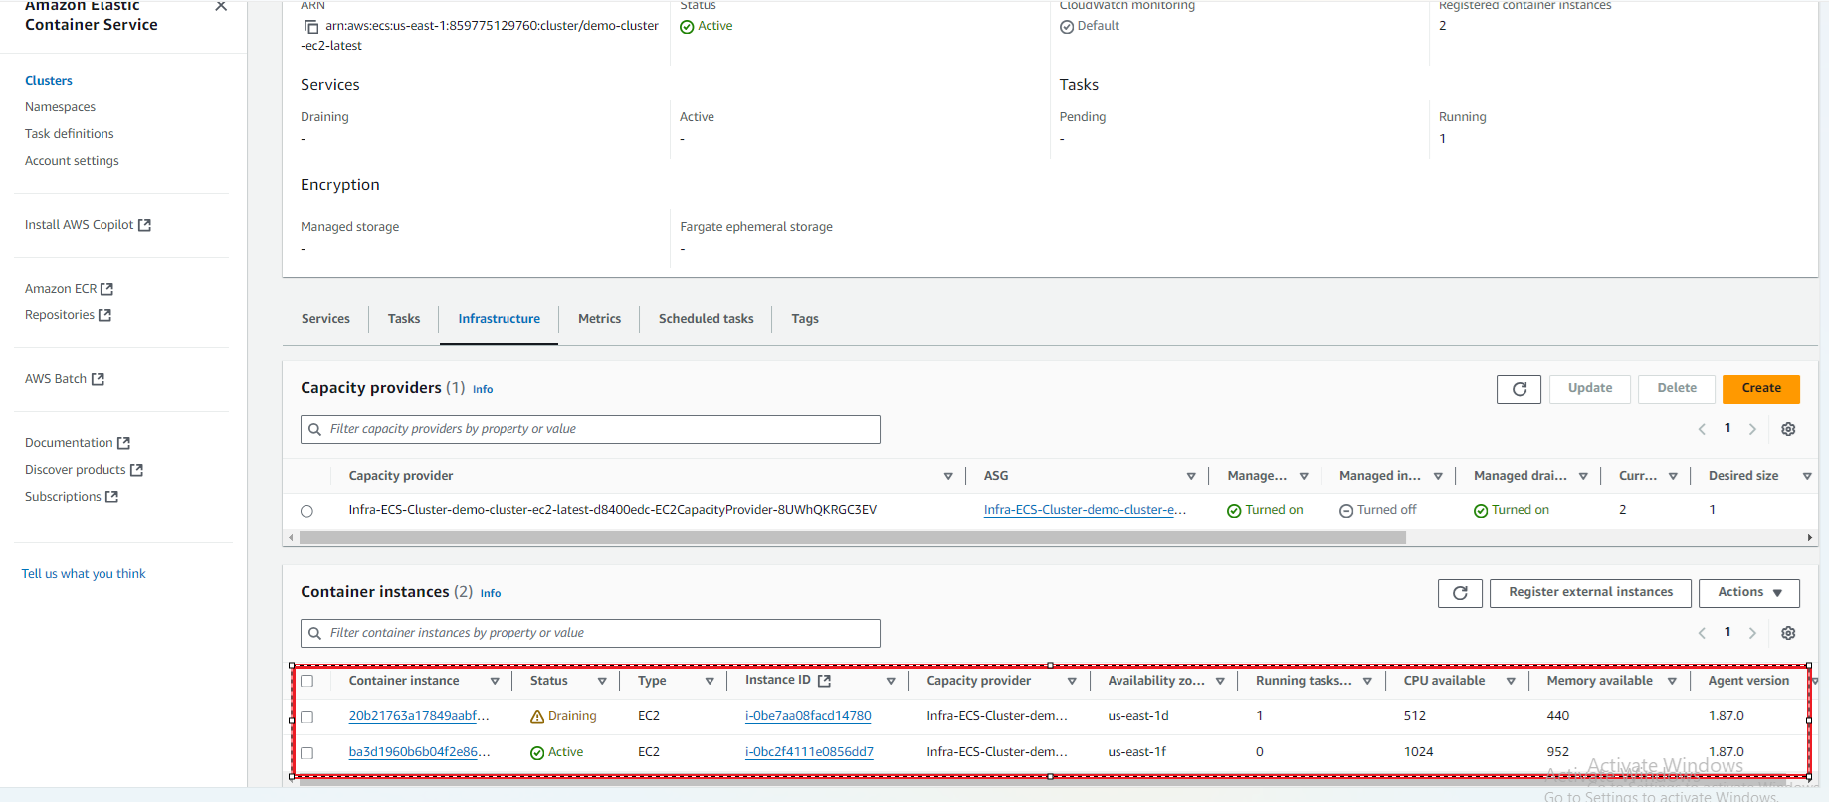

* If task is stuck in provisioning:

+ make sure the task RAM and CPU requirements in task definition meet EC2 instance scopes

+ make sure EC2 is installed in default VPC. Sometimes, Ec2 in non-default VPC cannot make call to ECS ( agent calls back to server)