Basic CRUD: (create, read, update, delete):

* Create:

|  |
| --- |
| CREATE TABLE parents (  parent_id INT PRIMARY KEY,  name VARCHAR(100)  ); |

Create table <name> and declare all the collums

* Read:

|  |
| --- |
| select first_name,last_name from Employees where first_name="John"; |

Select <collum_name_1>, <collum_name_2>, from <table> where <collum_name_x>=”…”;

(the where can refer to another column in the table)

* Update:

Insert:

|  |
| --- |
| INSERT INTO table_name (column1, column2, ...)  VALUES (value1, value2, ...); |

Update:

|  |
| --- |
| UPDATE table_name  SET column1 = value1, column2 = value2  WHERE condition; |

Alter:

|  |
| --- |
| ALTER TABLE table_name ADD column_name datatype;  ALTER TABLE table_name MODIFY column_name new_datatype; |

Update is used to change values while Alter is used to change column

* Delete:

|  |
| --- |
| DELETE FROM table_name WHERE condition; #delete data  DROP TABLE table_name; # delete a table |

Join: (inner, left, right, outer)

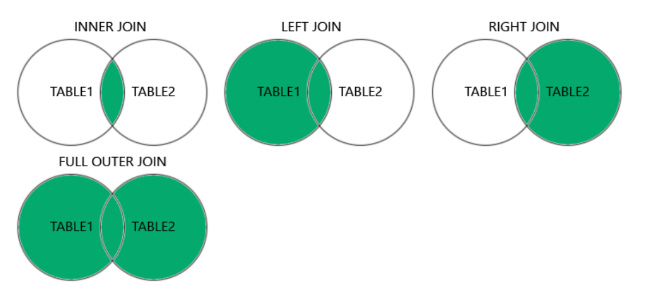

* Inner join: return only matches from both
* Left join: return matches from both and all not matches from left table only
* Right join: return matches from both and all not matches from right table only
* Outer (full) join: return all matches from both and all not matches from both

Check out: <https://joins.spathon.com/>

Examples:

|  |
| --- |
| SELECT Orders.OrderID, Customers.CustomerName, Orders.OrderDate  FROM Orders  INNER JOIN Customers ON Orders.CustomerID=Customers.CustomerID; |

SELECT collumns (from either table)

FROM left_table

<join_type> JOIN right_table ON left_foreign_key=right_foreign_key