1/ create docker network:
docker network create jenkins
2/ install jenkin with docker:
docker run \
--name jenkins-pipeline \
--restart=on-failure \
--detach \
--network jenkins \
--env DOCKER_HOST=tcp://docker:2376 \
--env DOCKER_CERT_PATH=/certs/client \
--env DOCKER_TLS_VERIFY=1 \
--publish 8080:8080 \
--publish 50000:50000 \
--volume jenkins-data:/var/jenkins_home \
--volume jenkins-docker-certs:/certs/client:ro \
jenkins/jenkins:lts-jdk17

3/ setup jenkin agent:
- Generate ssh key login on the master: ssh-keygen and ssh-copy-id
- Install java on the slave: apt install default-jre
- Create a root directory for jenkin: mkdir /home/sf/jenkin (assign owner of the dir so it matches ssh user)
- Go to jenkin UI > create node:
+ root directory for jenkin: /home/sf/jenkin
+ set credential: ssh username with private key (copy the private key)
+ under launch method > advanced > javapath: which java and then copy the path to the box

4/ Build pipeline

5/ setup access control:
- Create new user: devops
- Install plugin: Role-based Authorization Strategy
- Manage jenkin > security > Authorization > Role-based strategy
- Manage Jenkin > Manage and assign role > Manage role:
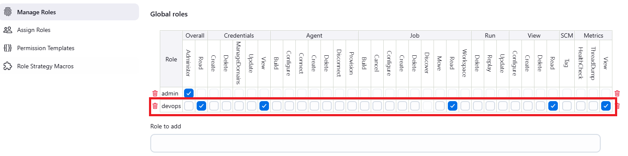
- Item roles: ( Pattern: Test.* - this means the role only have permissions to every pipeline whose name start with Test)
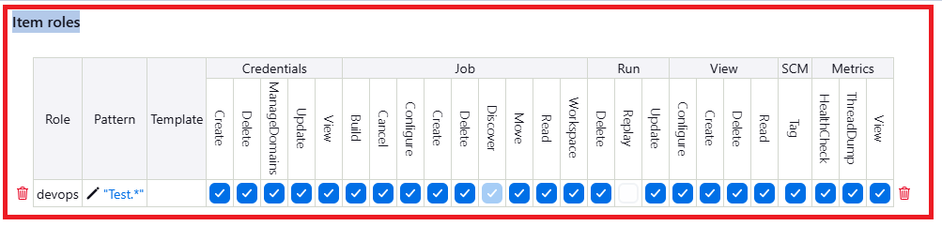
- Assign role:
