**BongdaNews**

**Development’s Guide**

**Faculty: Pham Cong Thanh**

**Batch No:**

**Group No: 1**

**Student:**

|  |  |  |
| --- | --- | --- |
| **No** | **Full Name** | **Roll No** |
| **1** | **Lê Thanh Nam** | **SE62352** |
| 2 | Nguyễn Trọng Minh Thành | SE62430 |
| 3 | Phạm Ngọc Minh Thư | SE62369 |

**Table of contents**

Table of contents 2

**Review 1** 3

* 1. Introduction 4
  2. Existing Scenario 4
  3. Customer Requirement Specification 4
  4. Functional Requirement Specification 5
  5. System Requirements 7
  6. Development Software 8
  7. Technology 8

**Review 2** 10

* 1. Use Case and Sequence Diagram 11
  2. Entity Relationship Diagram (ERD) 57

**Review 3** 60

* 1. Database Relationship Diagram 61
  2. Table Definition 62
  3. Other Constraint 66
  4. Site map 67
  5. GUI Design 69
  6. Report 87

**Task sheet** 87

Task sheet 88

**Monitoring Report** 91

Unit Test 92

**REVIEW 1**

# Introduction

The newspaper with more than 20 years of experience in the field of media, with the mission to bring readers news about the King's sports news to the reader as quickly and accurately as possible.

From the first day of establishment, we consider that the newspaper will give readers an objective perspective on football in Vietnam and the world. Therefore, "Football News" was born. Football News and writers experienced in the field of sport is committed to bringing readers the correct judgment.

# Existing Scenario

In order to catch up with the trend of the times and reach more readers, we established this website as a playground for the heart that share passion with round ball.

With a team of experienced and loyal readers which owns the newspaper, which is the biggest motivation for us to create this website. Only with a smartphone in hand, you can regularly update the information on the football, transfer market, match result and many information on the sidelines everywhere.

# Customer Requirement Specification

Collaborators will be able to post to the server, all submitted will be reviewed before being published. Collaborators have to tag, add topic for each post.

Moderator will review, edit tags, topic, browse, schedule the post is published.

Administrators have the ability to set roles, ban members.

bongdanews.com page is a news site.

The manage.bongdanews.com is the website manage data of bongdanews.com, where collaborators, moderators, admins manage resources (photos, videos) and posts.

# Functional Requirement Specification

## Create account (manage page)

### Description

Administrator will create a new account. The new account is not set role. To create an account, subscribers have to provide full information such as:

* + Name
  + Birthday
  + Identity card
  + Phone
  + Address
  + Mail
  + Sex

The newly created accounts will be provided a username similar to the registered email address. Default password of the account will be the phone number registered.

### Functional Requirements

1. People register have to provide full information (Name, Birthday, Identity card, Phone, Mail, Sex).
2. Email does not exist in the system.

## GUI Requirements

### Description

Bongdanews.com site must be simple, not distracting

The manage.bongdanews.com site is easy to manage site information

### Functional Requirements

1. Bright colors
2. Minimalist design, makes the readers focus on content

## Admin can manage staff’s account

### Description

System provides one page to manage account. Staff is moderator and collaborator.

### Functional requirements

1. Field data have to be validated before being inserted into the database.
2. Only admins can use all the functions mentioned.
3. Admin can:
   * + create account
     + view staff’s account information
     + edit staff’s account information
     + ban staff’s account (account banned after login will be unable to take any action beyond viewing their profile)
     + set role for staff’s account

## Staff can manage their account

### Description

System provides a page for staff to manage account.

### Functional Requirements

1. Update their password, phone.
2. Moderator and collaborator can use this function.

## Staff can view each other’s information

### Description

Each staff has a personal page. Staffs can view each other’s personal page.

### Functional Requirements

1. Some information can be viewed such as:

* Name
* Phone
* Email
* Description

## Admin, Moderator can manage post (publish, unpublish, rejected) base on topics or tags

### Description

The system provides a page for managing postings. The post will appear under status (published, unpublished, rejected), topic, tags in order of posting time (the first post will be the newest post was posted to the server).

### **Functional Requirements**

1. Each post needs to be tagged, topic related posts (at least 1 topic).
2. Posting time needs to be saved.
3. Only administrators or moderators can use this functionality.
4. Admin/mod can:
   * View the post
   * Approve the post has status is unpublished. After reviewing the status of the post, it will change to publish.
   * Reject the post has status is published, unpublished. After reject, the status of the post will change to rejected.
   * Edit, add topic or tag of 1 post.

## Collaborator can post new posts

### Description

The system must provide a page/interface to allow collaborator post new posts. The system must record the time the collaborator posted the post.

### Functional Requirements

1. The post must be sent to server to storage.
2. The Collaborator can insert/update/delete his own post.

## Collaborator can upload media source to system

### Description

The system must provide a page to allow collaborator add post’s media source.

### Functional Requirements

1. Those source will store at server.
2. The collaborator can insert/update/delete his own source.

## Reader can view posts base on topics, tags

### Description

Every posts are order by topics and mark by some tags. It will present by a link. When reader (user) click on the link below. The system must provide a page to show all post that relate to this topic/tag.

### Functional Requirements

1. Database must be organized in multi-layers. So that system can easy to get database by topic.

# System Requirements

## Hardware

### Web Server

|  |  |
| --- | --- |
| Processor | Pentium IV or higher. |
| Memory | 512MB RAM or greater. |
| Modem/ADSL | Connecting to internet 24/24 |

### Client

|  |  |
| --- | --- |
| Processor | Pentium III or higher. |
| Memory | 64MB RAM or greater. |
| Monitor | Super VGA (800x600) or higher resolution with 256 colors. |
| Pointing Device | Microsoft Mouse, Microsoft IntelliMouse®, or compatible pointing device. |
| Modem/ADSL | Connecting to internet |

## Software

### Web Server

|  |  |
| --- | --- |
| Operation System | Windows 2000/XP/2003 |
| Browser | Google Chrome version 61.0.3163.91 (Official Version) (64 bit) |
| Database | Microsoft SQL Server 2014 Express |
| Software | Java SDK 1.8 |
|  | Apache Tomcat 8.0.27.0 |
|  | Struts 2 framework version 2.3.15 |

### Client

|  |  |
| --- | --- |
| Operation System | Windows XP or later. |
| Browser | Internet Explorer 6.0 or higher. |

# Development Software

* Microsoft Windows 10 Professional
* Microsoft SQL Server 2014 Express
* Google Chrome version 61.0.3163.91 (Official Version) (64 bit)
* Netbeans IDE 8.1
* Java SDK 1.8
* Apache Tomcat 8.0.27.0
* Struts 2 Framework version 2.3.15
* Boostrap library

# Techonology

* Java Web Service
* JSP, Servlet
* HTML
* Struts 2 Framework

**REVIEW 2**

# Use Case and Sequence Diagram

## Admin

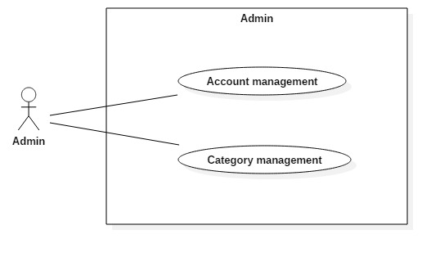

* + The administrator’s home page has:
* Search area, which has:
  + ‘Search’ text box
  + ‘Search’ button
* Menu bar which has:
  + ‘Account’ button
  + ‘Category’ button
* User area, which has:
  + ‘Name’
  + ‘Personal page’ button

### Account Management

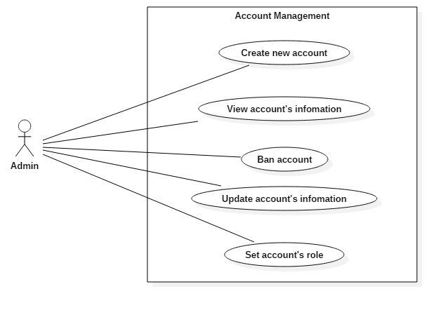

#### Create new account

|  |  |  |
| --- | --- | --- |
| **Author** | Lê Thanh Nam | |
| **Use Case Name** | Create new account | |
| **Actors** | Administrator | |
| **Description** | Administrator will create a new account. The new account is not set role. To create an account, subscribers have to provide full information such as:   * + Name   + Birthday   + Identity card   + Address   + Phone   + Mail   + Sex   The newly created accounts will be provided a username similar to the registered email address. Default password of the account will be the phone number registered. | |
| **Requirements** |  | |
| **Pre-conditions** | -Register must provide enough information.  -Admin logged in and had role as administrator.  -Admin is in homepage. | |
| **Post-conditions** | -Success: Go to ‘Confirm success page’ and go back to ‘Home’ page.  -Fail: Refill information. | |
| **Basic flow** | Actor Actions:  1. Actor clicks ‘Register’ link in Home page .  3. Actor inputs register’s information, select ‘Sex’ attributes and click ‘Register’ button. [Alternative 1] | System Responses:  2. System redirects to Register page and displays Registration form with the following control :  - ‘Name’ text field  - ‘Birthday’ datebox  - ‘Identity card’ checkbox group  - ‘Address’ text field  - ‘Phone’ text field  - ‘Email’ text field  - ‘Sex’ combobox with 3 value:’Male’, ‘Female’ and ‘Other’  -‘Role’ combobox with 2 value: ‘Moderator’ and ‘Collaborator’  - ‘Register’ button  - ‘Back to Home’ button  4. System checks the information.  [Exception 1]  5. System inserts the account into database, show message: ‘Your account has been created! The new account has username: <email address> and password:<phone number>’ and then redirects to Login page. |
| **Alternative flow** | Actor Actions:  [Alternative 1]  1. Actor click ‘Back to Home’ button. | System Responses:  2. System returns to Home page. |
| **Exception** | Actor Actions:  [Exception 1]   1. Actor lefts ‘Name’ text field blank. 2. Actor lefts ‘Birthday’ datebox blank. 3. Actor lefts ‘Identity card’ text field blank. 4. Actor input identity card number out of 9 or 12 digit. 5. Actor lefts ‘Phone’ text field blank. 6. Input ‘Phone’ not in numeric or phone length not in range 8 – 14 character. 7. Actor lefts ‘Address’ text field blank. 8. Actor lefts ‘Email’ text field blank or input an invalid email address. 9. The email address has been used before . | System Responses:  System displays message to Actor:  - ‘Name cannot be blank’.  -‘Birthday cannot be blank’.  -‘Identity card cannot be blank’.  -‘Identity card must be 9 or 12 digit’.  -‘Phone cannot be blank’.  - ‘The phone number should be numeric only and must be between 8 and 14 digits’.  -‘Address cannot be blank’.  -‘This email address is invalid’.  -‘This email has been used before’. |

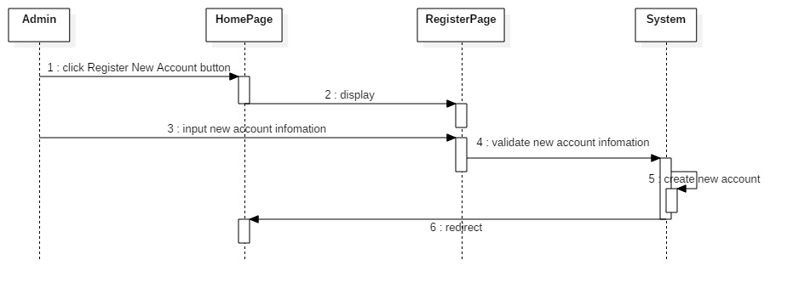

#### View account’s information

|  |  |  |
| --- | --- | --- |
| **Author** | Lê Thanh Nam | |
| **Use Case Name** | View account’s information | |
| **Actors** | Administrator | |
| **Description** | Administrator can view all information of an account, except password. | |
| **Requirements** |  | |
| **Pre-conditions** | - Admin logged in and had role as administrator.  - Admin is in home page. | |
| **Post-conditions** |  | |
| **Basic flow** | Actor Actions:  1. Actor input a keyword to search box. Admin click ‘Search’ button.  3. Actor click to a name of an user. | System Responses:  2. System return a result page with a list of user match with inserted keyword.  4. System return a page(Account’s information page) with information of that user. Information that will be shown are:  -Name  -Sex  -Email address  -Phone  -Address  -Birthday  -Identity card  -Role  -‘Back to previous page’ button  -‘Reset password’ button  -‘Update’ button  -‘Ban this account’ button  -‘Set role’ button |
| **Alternative flow** |  |  |
| **Exception** |  |  |

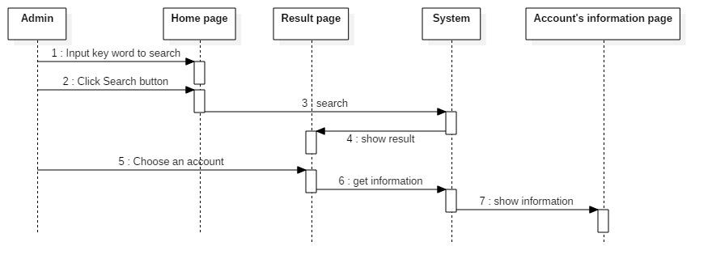

#### Update account’s information

##### **Reset password**

|  |  |  |
| --- | --- | --- |
| **Author** | Lê Thanh Nam | |
| **Use Case Name** | Reset password | |
| **Actors** | Adminstrator | |
| **Description** | Adminstrator can reset account’s password. The new password is account’s current phone number. | |
| **Requirements** |  | |
| **Pre-conditions** | - Admin logged in and had role as administrator.  -Admin is in a account’s information page. | |
| **Post-conditions** |  | |
| **Basic flow** | Actor Actions:  1.Actor click ‘Reset password’ button.  3. Actor click ’Yes’.  [Alternative flow 1] | System Responses:  2.System show a popup with message ‘Are you sure?’ with 2 button ‘Yes’ and ‘No’.  4.System set current phone number as new password. Then system redirect to account’s information page. |
| **Alternative flow** | Actor Actions:  [Alternative flow 1]  1. Actor click ‘No’ button. | System Responses:  2. Popup disappears. |
| **Exception** |  |  |

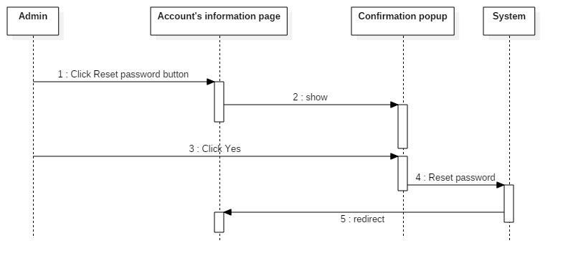

##### **Update basic information**

|  |  |  |
| --- | --- | --- |
| **Author** | Lê Thanh Nam | |
| **Use Case Name** | Update basic information | |
| **Actors** | Administrator | |
| **Description** | System provide a page to admin to update account’s information. | |
| **Requirements** |  | |
| **Pre-conditions** | - Admin logged in and had role as administrator.  - Admin is in account’s information page | |
| **Post-conditions** | -Success: update account’s information successfully.  -Failed: Refill information. | |
| **Basic flow** | Actor Actions:  1.Admin click ‘Update’ button.  3.Admin edit fields and click ‘Update’ button. [Alternative flow 1] | System Responses:  2.System return a page with Update form with following control:  -‘Name’ text field which is filled by current name  -‘Sex’ combobox which current account’s sex is chosen. This combobox has with 2 value: ‘Male’, ‘Female’ and ‘Other’  -‘Role’ combobox which current role is chosen. This combobox has with 2 value: ‘Moderator’ and ‘Collaborator’  -‘Phone’ text field which is filled by current phone  -‘Address’ text field which is filled by current address  -‘Birthday’ datebox which current account’s birthday is chosen  -‘Update’ button  -‘Back’ button  4.System check new information. [Exception 1]  5.System update information of the account. Then system will redirect to account’s information page. |
| **Alternative flow** | Actor Actions:  [Alternative flow 1]  1.Admin click ‘Back’. | System Responses:  2.System redirect to account’s information page. |
| **Exception** | Actor Actions:  [Exception 1]   1. Actor lefts ‘Name’ text field blank. 2. Actor lefts ‘Birthday’ datebox blank. 3. Actor lefts ‘Phone’ text field blank. 4. Input ‘Phone’ not in numeric or phone length not in range 8 – 14 character. 5. Actor lefts ‘Address’ text field blank. | System Responses:  System displays message to Actor:  - ‘Name cannot be blank’.  -‘Birthday cannot be blank’.  -‘Phone cannot be blank’.  - ‘The phone number should be numeric only and must be between 8 and 14 digits’.  -‘Address cannot be blank’. |

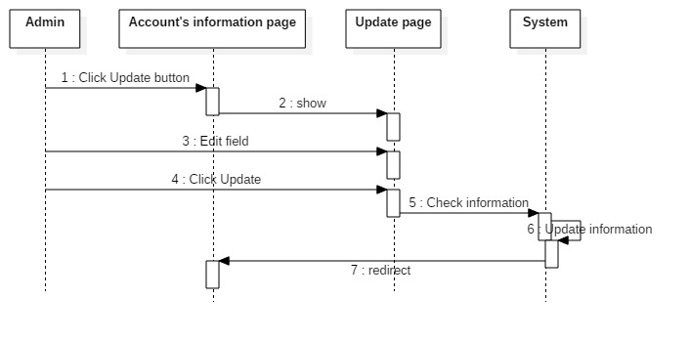

#### Ban account

|  |  |  |
| --- | --- | --- |
| **Author** | Phạm Ngọc Minh Thư | |
| **Use Case Name** | Ban account | |
| **Actors** | Administrator | |
| **Description** | Administrator is able to ban staff’s account. Banned account can only access his/her personal page and can’t use functionalities. | |
| **Requirements** |  | |
| **Pre-conditions** | - Admin logged in and had role as administrator. | |
| **Post-conditions** |  | |
| **Basic flow** | Actor Actions:  1. Admin access to account’s information page. Admin click ‘Ban this account’ button.  3. Admin click ‘Yes’.  [Alternative flow 1] | System Responses:  2. System show a popup with message ‘Are you sure?’ with 2 button ‘Yes’ and ‘No’.  4. System change password by current account’s phone number. And then refresh account’s information page. |
| **Alternative flow** | Actor Actions:  [Alternative flow 1]  1. Admin click ‘No’ | System Responses:  2. Popup disappears. |
| **Exception** |  |  |

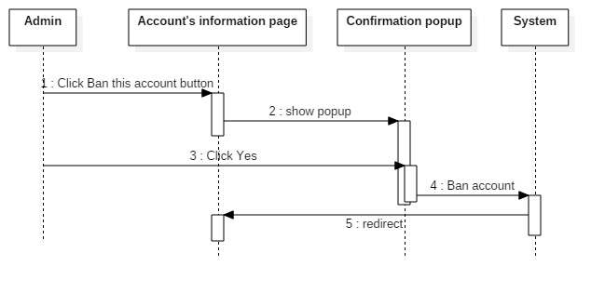

#### Set account’s role

|  |  |  |
| --- | --- | --- |
| **Author** | Phạm Ngọc Minh Thư | |
| **Use Case Name** | Set account’s role | |
| **Actors** | Administrator | |
| **Description** | System provide a page for admin to set account’s role(collaborator or moderator). | |
| **Requirements** |  | |
| **Pre-conditions** | - Admin logged in and had role as administrator. | |
| **Post-conditions** |  | |
| **Basic flow** | Actor Actions:  1. Admin access to account’s information page. Admin click ‘Set role’ button.  3. Admin choose role and click ‘Set role’.  [Alternative flow 1] | System Responses:  2. System show a popup with a combobox with 2 value ‘Moderator’ and ‘Collaborator’, a ‘Set role’ button.  4. System changes account’s role. And then refresh account’s information page. |
| **Alternative flow** |  |  |
| **Exception** |  |  |

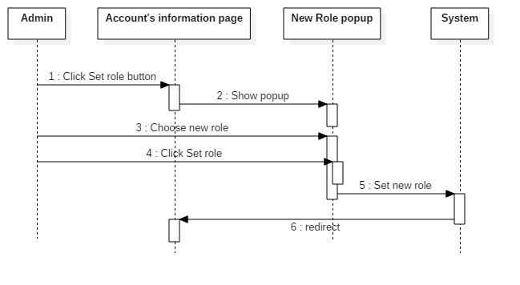

### Category management

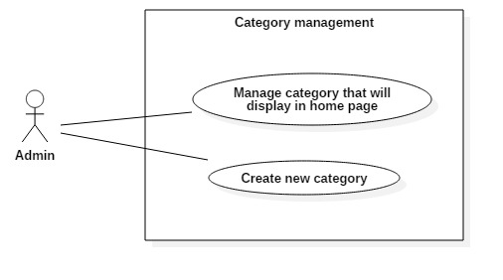

#### Manage category that will display in home page

|  |  |  |
| --- | --- | --- |
| **Author** | Lê Thanh Nam | |
| **Use Case Name** | Create new tag | |
| **Actors** | Administrator | |
| **Description** | -System provide an interface for actor to create new category. | |
| **Requirements** |  | |
| **Pre-conditions** | - Admin logged in and had role as administrator.  - Admin is in home page | |
| **Post-conditions** |  | |
| **Basic flow** | Actor Actions:   1. In administrator’s home page, actor click ‘Category’ button. 2. Actor click ‘Change’ button.   5. Actor choose category will be displayed in home page.  6. Click ‘Change’ button | System Responses:  2. System return a page which has following control:  - ‘Category’ area:   * List of current category * ‘Add category’ button   - ‘Home page category’ area:   * Current category in home page * ‘Change’ button   4. System open a ‘Change home category’ popup:  -List of available category.  -List of home page category, which is blank.  -‘Change’ button.  7. System change Home page’s categories. Then it close the popup. |
| **Alternative flow** |  |  |
| **Exception** |  |  |

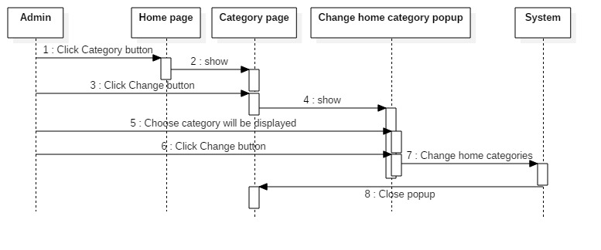

#### Create new category

|  |  |  |
| --- | --- | --- |
| **Author** | Lê Thanh Nam | |
| **Use Case Name** | Create new tag | |
| **Actors** | Administrator | |
| **Description** | - System provide an interface for actor to create new category. | |
| **Requirements** |  | |
| **Pre-conditions** | - Admin logged in and had role as administrator.  - Admin is in home page | |
| **Post-conditions** |  | |
| **Basic flow** | Actor Actions:  1. In administrator’s home page, actor click ‘Category’ button.  3. Actor click ‘Add category’  5. Actor input new category  7. Actor click ‘Add’ button | System Responses:  2. System return a page which has following control:  - ‘Category’ area:   * List of current category * ‘Add category’ button   - ‘Home page category’ area:   * Current category in home page * ‘Change’ button   4. ’Add new category’ popup appears, which has following control:   * ‘New category’ textbox * ‘Add’ button   6. System check new category.  [Exception 1]  8. System add new category to database. Then it close the popup. |
| **Alternative flow** |  |  |
| **Exception** | [Exception 1]  1.Actor let ‘New category’ textbox blank.  2.Inputed category has been existed. | System responds:  -‘New category can’t be blank’  -‘This category is already exited’ |

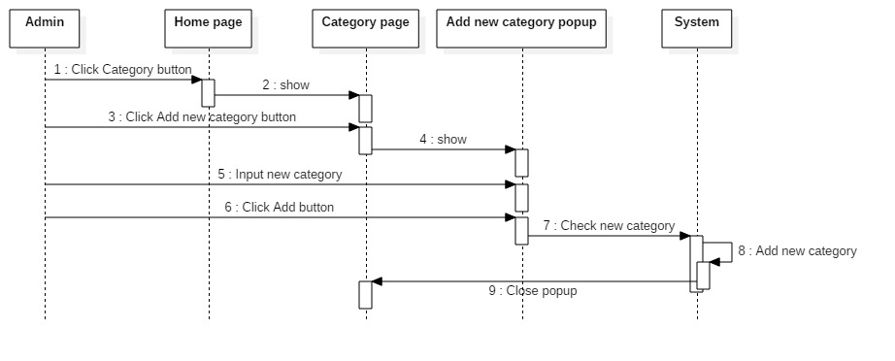

## Moderator and Collaborator

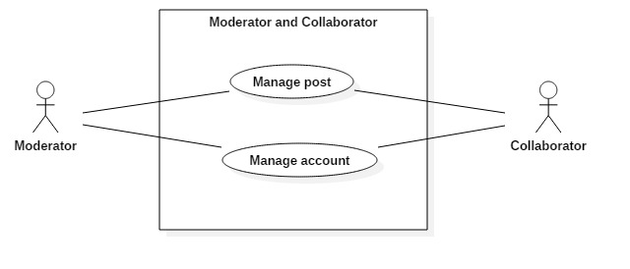

### Manage post

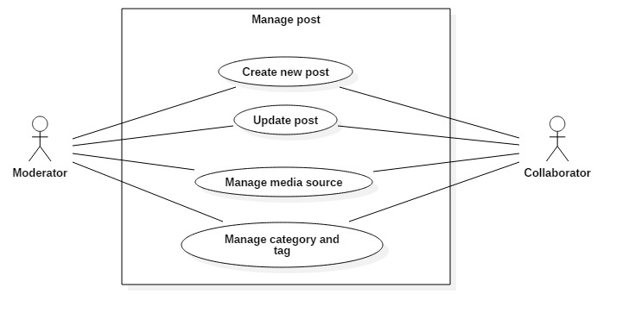

#### Create new post

|  |  |  |
| --- | --- | --- |
| **Author** | Lê Thanh Nam | |
| **Use Case Name** | Create new post | |
| **Actors** | Moderator and Collaborator | |
| **Description** | System provides an interface for moderator and collaborator to create new post. | |
| **Requirements** |  | |
| **Pre-conditions** | -User logged in and had role as moderator or collaborator.  -User is in home page. | |
| **Post-conditions** |  | |
| **Basic flow** | Actor Actions:  1. In home page, actor click ‘Create new post’ button.  4. Actor input content, and then click ‘Save Draft’ button. | System Responses:  2. System create a new post in database.  3. System redirect actor to that post’s control page has following control:  - ‘Title’ textbox  - ‘Content’ editor  - ‘Detail information’ area which has:   * Status of post * Created day * Published day (if the post has been published)   - ‘Category’ area which has:   * A current category list * ‘Add new category’ button   - ‘Tag’ area which has:   * A current tag list * ‘Add new tag’ button   - ‘Add media’ button  - ‘Save draft’ button  - ‘Publish’ button(Only moderator can see and use this button)  5. System will validate new information.[Exception 1]  6. System save post to database. Then it redirect actor to home page |
| **Alternative flow** |  |  |
| **Exception** | Actor Actions:  [Exception 1]  1.Actor left ’Title’ textbox blank. | System Responses:  -‘Title can not be blank’ |

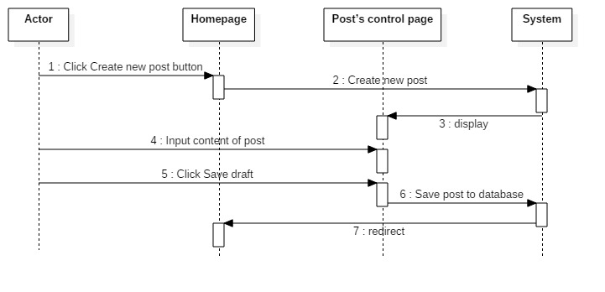

#### Update post

|  |  |  |
| --- | --- | --- |
| **Author** | Lê Thanh Nam | |
| **Use Case Name** | Update post | |
| **Actors** | Moderator and Collaborator | |
| **Description** | System provide an interface for actor to edit post. | |
| **Requirements** | Moderator can edit post of everyone, while collaborator can only edit his/her post. | |
| **Pre-conditions** | User logged in and had role as moderator or collaborator. | |
| **Post-conditions** |  | |
| **Basic flow** | Actor Actions:  1. Actor click to a link to edit post  3. Actor update content, and then click ‘Save Draft’ button. | System Responses:  2. System redirects actor to that post’s control page has following control:  - ‘Title’ textbox  - ‘Content’ editor  - ‘Detail information’ area which has:   * Status of post * Created day * Published day (if the post has been published)   - ‘Category’ area which has:   * A current category list * ‘Update category’ button   - ‘Tag’ area which has:   * A current tag list * ‘Add new tag’ button * ‘Update tag’ button   - ‘Add media’ button  - ‘Save draft’ button  - ‘Publish’ button(Only moderator can see and use this button)  4. System will validate new information.[Exception 1]  5. System save post to database. Then it redirect actor to previous page |
| **Alternative flow** |  |  |
| **Exception** | Actor Actions:  [Exception 1]  1. Actor left ‘Title’ textbox blank. | System Responses:  - ‘Title cannot be blank’ |

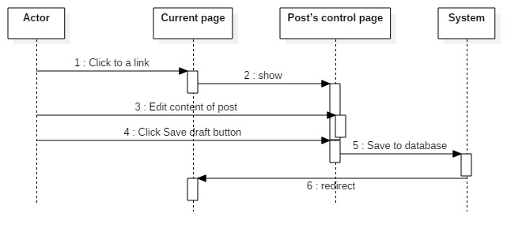

#### Manage media source

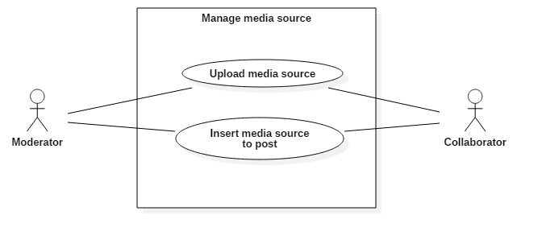

##### **Upload media and source**

|  |  |  |
| --- | --- | --- |
| **Author** | Lê Thanh Nam | |
| **Use Case Name** | Upload media source to server | |
| **Actors** | Moderator and Collaborator | |
| **Description** | System provide an interface for actor to upload media source to server. | |
| **Requirements** |  | |
| **Pre-conditions** | - User logged in and had role as moderator or collaborator. | |
| **Post-conditions** | - The media source uploaded will be owned by a post. | |
| **Basic flow** | Actor Actions:  1. In Post’s control page, actor click ‘Add media’ button  3. Actor click ‘Select file’ button. [Alternative 1]  4. Choose file to upload.Click ‘Open’ button. | System Responses:  2. A popup appears. Popup has following control:  - ‘Upload file’ tab is chosen. This tab has following control:   * ‘Select file’ button   - ‘Media library’ tab  - ‘Insert into post button’  5. System will check that file. [Exception 1]  6. System download that file and save it to server. Then it show the medias that have just uploaded. |
| **Alternative flow** | Actor Actions:  [Alternative 1]  1.Actor close popup. | System Responses:  2. Popup close. |
| **Exception** | Actor Actions:  [Exception 1]  1. Actor upload a file has size bigger than 20MB, or a file different from follow kind:   * Image: .jpg, .png, .bmg,… | System Responses:  - ‘File to upload must be smaller than 20MB and must be a image(.jpg, .png, .bmg)’. |

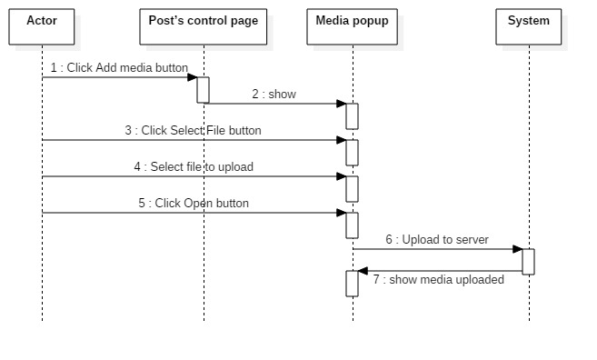

##### **Insert media to post**

|  |  |  |
| --- | --- | --- |
| **Author** | Lê Thanh Nam | |
| **Use Case Name** | Insert media to post | |
| **Actors** | Moderator and Collaborator | |
| **Description** | System provide an interface for actor to insert media source to server. | |
| **Requirements** |  | |
| **Pre-conditions** | - User logged in and had role as moderator or collaborator. | |
| **Post-conditions** |  | |
| **Basic flow** | Actor Actions:  1. In Post’s control page, actor click ‘Add media’ button  3. Actor click to ‘Media library’ tab  5. Actor choose media source.  6. Actor click ‘Insert into post’ button | System Responses:  2. A popup appears. Popup has following control:  - ‘Upload file’ tab is chosen. This tab has following control:   * ‘Select file’ button   - ‘Media library’ tab  - ‘Insert into post button’  4. A new tab show with following control:  - An area contain media source in system  7. The media source is insert into post |
| **Alternative flow** |  |  |
| **Exception** |  |  |

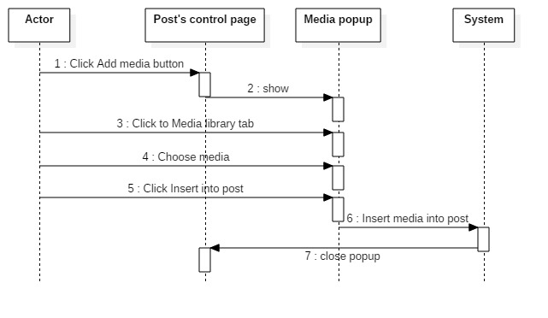

#### Manage category and tag

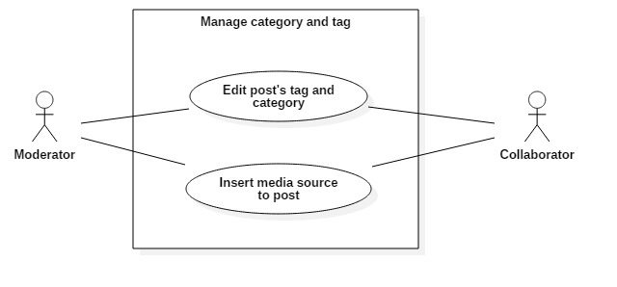

##### **Edit post’s tag and category**

|  |  |  |
| --- | --- | --- |
| **Author** | Nguyen Trong Minh Thanh | |
| **Use Case Name** | Manage tag and category | |
| **Actors** | Moderator or Collaborator | |
| **Description** | Moderator or Collaborator wants to Insert/Update tags/category of the posts. | |
| **Requirements** |  | |
| **Pre-conditions** | - User logged in and had role as moderator or collaborator.  - User is in a post control page. | |
| **Post-conditions** | Success: The name of tags or category must be insert or update successful  Failed: Type tags and category’s name again. | |
| **Basic flow** | Actor Actions:  1. Actor clicks ‘Update tags’ or ‘Update category’ button in the Post control page.  3. Actor choose the category or tag want to insert/update.  4. Actor click ‘Update’ button.  [Alternative 1] | System Responses:  2. System shows a popup that list available category or tag and current category or tag.  5. System save info into database and close the popup. |
| **Alternative flow** | Actor actions:  [Alternative 1]   1. Actor close the popup. | 1. Popup close. |
| **Exception** | Actor actions: | System Responses: |

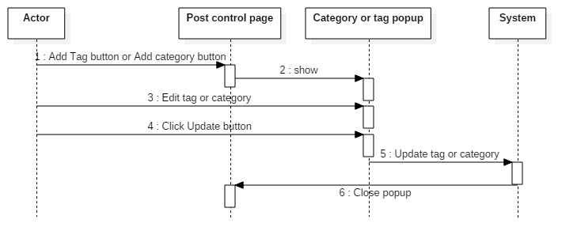

##### **Create new tag**

|  |  |  |
| --- | --- | --- |
| **Author** | Nguyen Trong Minh Thanh | |
| **Use Case Name** | Create new tag | |
| **Actors** | Moderator and Collaborator | |
| **Description** | -System provide an interface for actor to create new tag. | |
| **Requirements** |  | |
| **Pre-conditions** | -User logged in and had role as moderator or collaborator.  -User is in post control page | |
| **Post-conditions** |  | |
| **Basic flow** | Actor Actions:  1. In Post’s control page, actor click ‘Add new tag’ button  3. Actor input new tag  4. Actor click ‘Add’ button | System Responses:  2. A popup appears. Popup has following control:  - ‘New tag’ textbox  - ‘Add’ button  5. System check new tag.  [Exception 1]  6. System add new tag to database. Then it close the popup. |
| **Alternative flow** |  |  |
| **Exception** | [Exception 1]  1. Actor let ‘New tag’ textbox blank.  2. Inputted tag has been existed. | System respond:  - ‘New tag can’t be blank’  - ‘This tag is already exited’ |

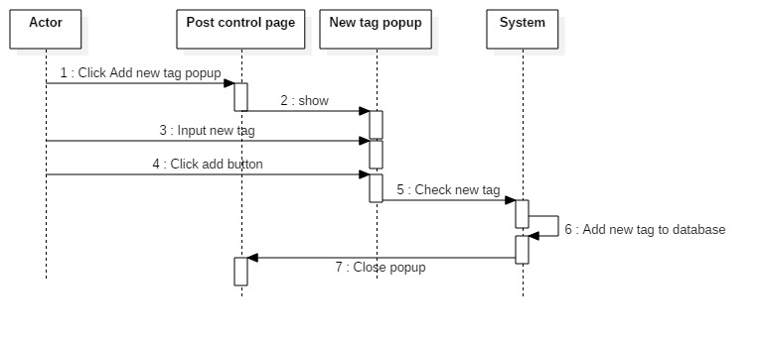

### Manage account

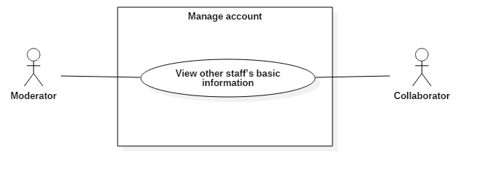

#### View other staff’s basic information

|  |  |  |
| --- | --- | --- |
| **Author** | Lê Thanh Nam | |
| **Use Case Name** | Create new tag | |
| **Actors** | Moderator and Collaborator | |
| **Description** | - System provide an interface for staff to see other’s basic information. | |
| **Requirements** |  | |
| **Pre-conditions** | - User logged in and had role as moderator or collaborator. | |
| **Post-conditions** |  | |
| **Basic flow** | Actor Actions:  1. In current page, click to a link to see other staff’s profile. | System Responses:  2. System return to an account’s information page, which has following information:  -Name  -Phone  -Email  -Description |
| **Alternative flow** |  |  |
| **Exception** |  |  |

## Moderator

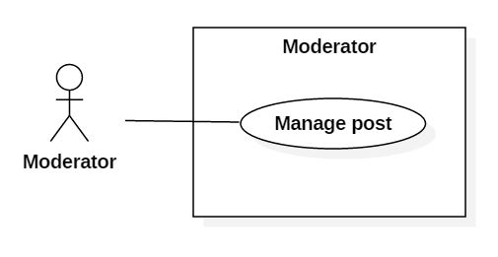

### Manage post

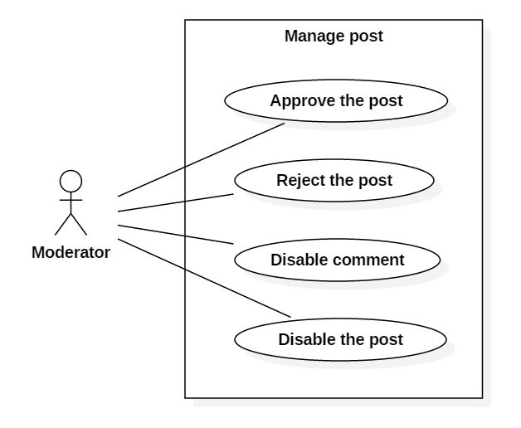

#### Approve the post

|  |  |  |
| --- | --- | --- |
| **Author** | Pham Ngoc Minh Thu | |
| **Use Case Name** | Approve the post | |
| **Actors** | Moderator | |
| **Description** | Moderator approve the post of collaborator. | |
| **Requirements** | Moderator have to login acccount. | |
| **Pre-conditions** | Only Moderator can use this function.  Moderator is in Post Control Page. | |
| **Post-conditions** |  | |
| **Basic flow** | Actor Actions:  1. Actor clicks All Posts menu.  3. Actor clicks on title of the post.  5. Actor approves the post. | System Responses:  2. System opens Post control Page and shows all posts of collaborator.  4. System shows content of the post. |
| **Alternative flow** |  |  |
| **Exception** |  |  |

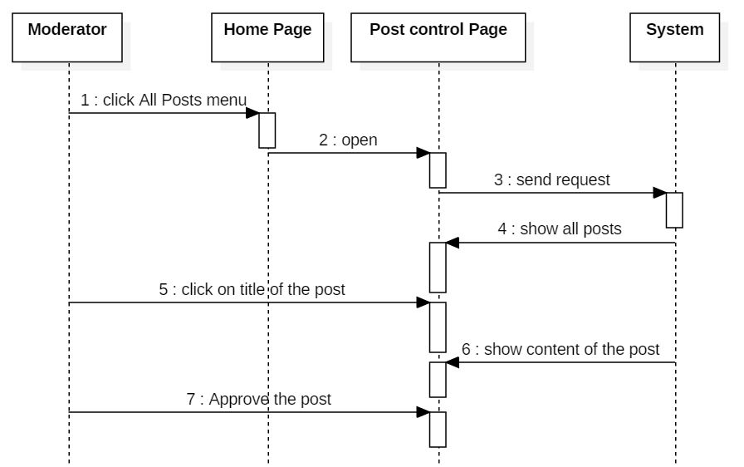

#### Reject the post

|  |  |  |
| --- | --- | --- |
| **Author** | Pham Ngoc Minh Thu | |
| **Use Case Name** | Reject the post | |
| **Actors** | Moderator | |
| **Description** | Moderator want to reject the post of collaborator | |
| **Requirements** | Moderator have to note the reason why they reject this post | |
| **Pre-conditions** |  | |
| **Post-conditions** | Success: The post will be rejected.  Fail: The post will be not rejected. | |
| **Basic flow** | Actor Actions:  1. Actor approve the post  2. Actor clicks ‘Reject’ button on the post.  4. Actor write the reason why actor reject this post on note.  5. Actor click ‘OK’ button. | System Responses:  3. System shows note reject.   1. System sends notify to collaborator. |
| **Alternative flow** |  |  |
| **Exception** |  |  |

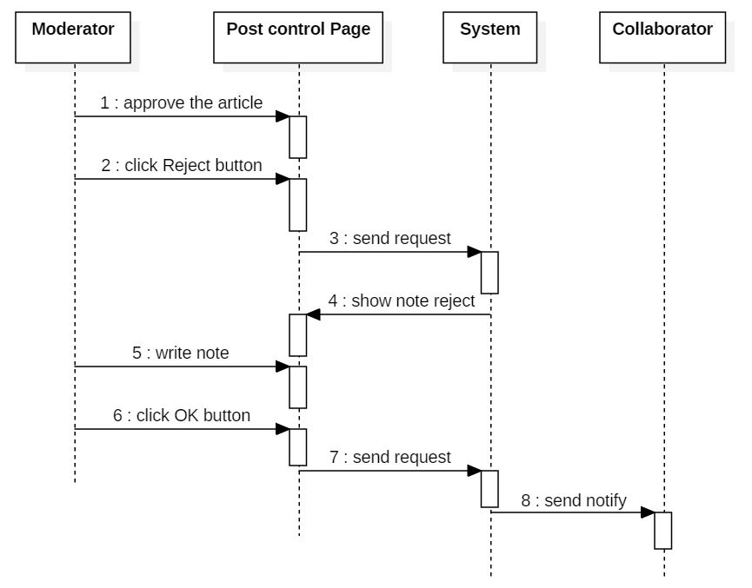

#### Disable comment

|  |  |  |
| --- | --- | --- |
| **Author** | Pham Ngoc Minh Thu | |
| **Use Case Name** | Delete comment | |
| **Actors** | Moderator | |
| **Description** | Moderator want to delete comment of reader. | |
| **Requirements** |  | |
| **Pre-conditions** |  | |
| **Post-conditions** |  | |
| **Basic flow** | Actor Actions:  1. Actor click ‘Comment’ button   1. Actor click ‘x’ to disable comment. | System Responses:  2. System opens popup on Post control Page and show all comments of reader. |
| **Alternative flow** |  |  |
| **Exception** |  |  |

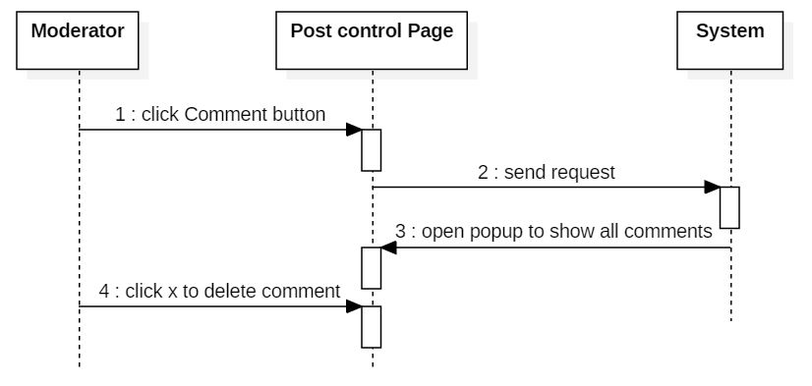

#### Disable the post

|  |  |  |
| --- | --- | --- |
| **Author** | Pham Ngoc Minh Thu | |
| **Use Case Name** | Reject the post | |
| **Actors** | Moderator | |
| **Description** | Moderator want to disable the post of collaborator | |
| **Requirements** | Moderator have to note the reason why they disable this post | |
| **Pre-conditions** |  | |
| **Post-conditions** | Success: The post will be disabled.  Fail: The post will be not disabled. | |
| **Basic flow** | Actor Actions:  1. Actor approve the post  2. Actor clicks ‘Disable’ button on the post.  4. Actor write the reason why actor disable this post on note.  5. Actor click ‘OK’ button. | System Responses:  3. System shows note reject.   1. System sends notify to collaborator. |
| **Alternative flow** |  |  |
| **Exception** |  |  |

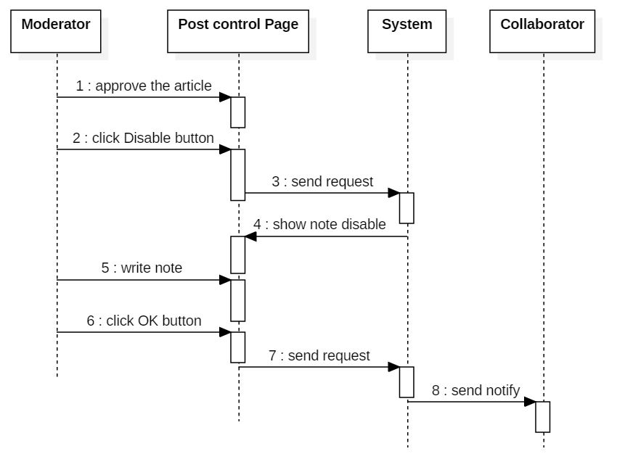

## Moderator and Admin

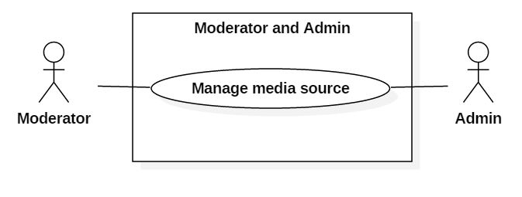

### Manage media source

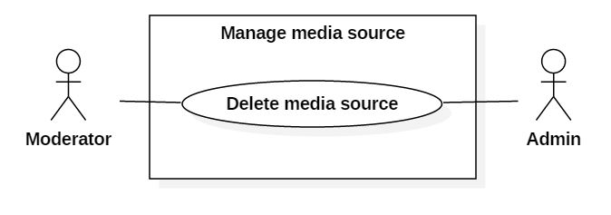

#### Delete media source

|  |  |  |
| --- | --- | --- |
| **Author** | Pham Ngoc Minh Thu | |
| **Use Case Name** | Delete media source | |
| **Actors** | Moderator and Admin | |
| **Description** | Admin and Moderator want to delete media source. | |
| **Requirements** |  | |
| **Pre-conditions** |  | |
| **Post-conditions** |  | |
| **Basic flow** | Actor Actions:  1. Actor click ‘Media’ button on Home Page.  3. Actor click ‘x’ to delete media source. | System Responses:  2. System shows Media Page and media source. |
| **Alternative flow** |  |  |
| **Exception** |  |  |

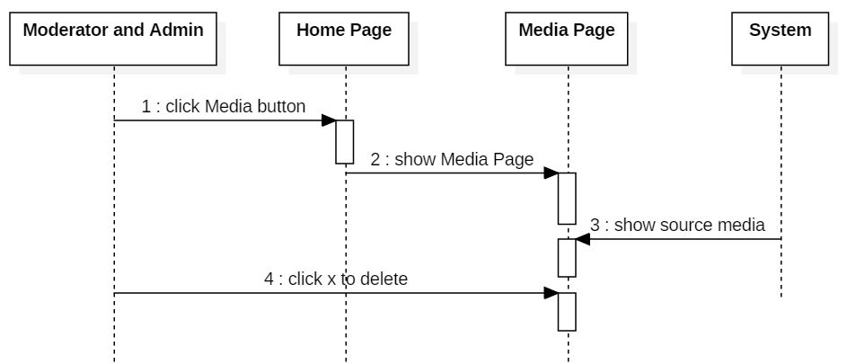

## Reader

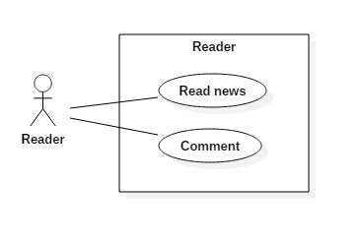

### Read news

|  |  |  |
| --- | --- | --- |
| **Author** | Nguyen Trong Minh Thanh | |
| **Use Case Name** | Read news | |
| **Actors** | Reader | |
| **Description** | Reader access the website to read news | |
| **Requirements** |  | |
| **Pre-conditions** |  | |
| **Post-conditions** |  | |
| **Basic flow** | Actor Actions:   1. Reader input url into browser 2. Reader choose an post to read.   6. Reader read an post. | System Responses:   1. System redirects to Home Page. Home page with the following menu:  * Menubar   + Home button  + New button  + 5 more button (value of those button will change by time, get by category from database)   * Content   + Hot news  + Newest post  + Older post  + Football result   1. System redirect to Post page. The Post page with the following menu:  * Content of the post * Comment text area * Send button * Menubar like Home Page |
| **Alternative flow** |  |  |
| **Exception** |  |  |

### Comment

|  |  |  |
| --- | --- | --- |
| **Author** | Nguyen Trong Minh Thanh | |
| **Use Case Name** | Comment | |
| **Actors** | Reader | |
| **Description** | Reader access the website to comment into posts | |
| **Requirements** |  | |
| **Pre-conditions** |  | |
| **Post-conditions** |  | |
| **Basic flow** | Actor Actions:   1. Reader input url into browser 2. Reader choose an post to read.   5. Write a comment and click ‘Send’ button | System Responses:   1. System redirects to Home Page 2. System redirect to Post page. The Post page with the following menu:  * Content of the post * Comment text area * Send button * Menubar like Home Page   6. System save the comment into database  7. System save the comment to database |
| **Alternative flow** |  |  |
| **Exception** |  |  |

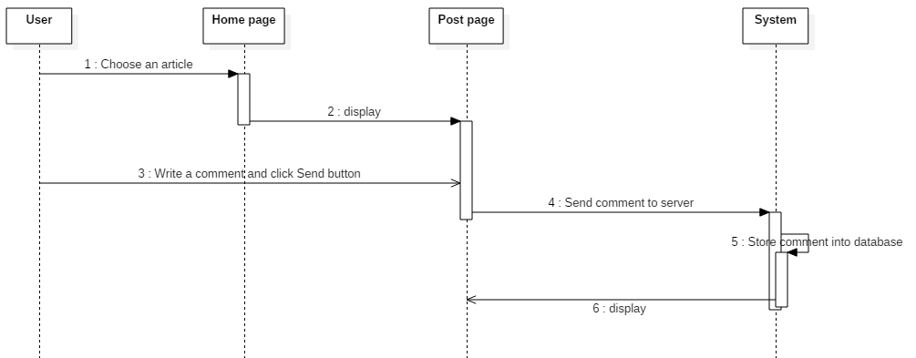

## Admin, Moderator, Collaborator

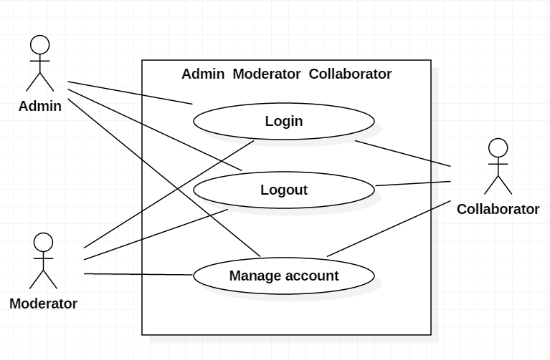

### Login

|  |  |  |
| --- | --- | --- |
| **Author** | Nguyen Trong Minh Thanh | |
| **Use Case Name** | Login | |
| **Actors** | Admin or Moderator or Collaborator | |
| **Description** | Admin or Moderator or Collaborator wants to login to website as a Admin or Moderator or collaborator member. | |
| **Requirements** | Actor provides username and password | |
| **Pre-conditions** |  | |
| **Post-conditions** | Success: User logged in to website.  Fail: Refill information | |
| **Basic flow** | Actor Actions:  1. Actor go to Login page of website.  3. Actor inputs Mail and Password, then click the Login button. | System Responses:  2. System redirects to Login page and displays Login form on the center with the following control:  - ‘Mail’ text field  - ‘Password’ text field  - ‘Login’ button  4. System checks the information  [Exception 1]  5. System redirects to Manage page. |
| **Alternative flow** | Actor Actions:  [Alternative 1]  1. Actor click ‘OK’ button, inputs Mail and Password, then click the Login button. | System Responses:  2. System checks the information  [Exception 1]  3. System redirects to Manage page. |
| **Exception** | Actor Actions:  [Exception 1]  1. Actor input invalid mail and password. | System Responses:  - System redirect to Login page with the following controls:  - ‘Mail text field  - ‘Password’ text field  - ‘Login’ button.  System show a message box: “Invalid Mail and password”.[Alternative 1] |

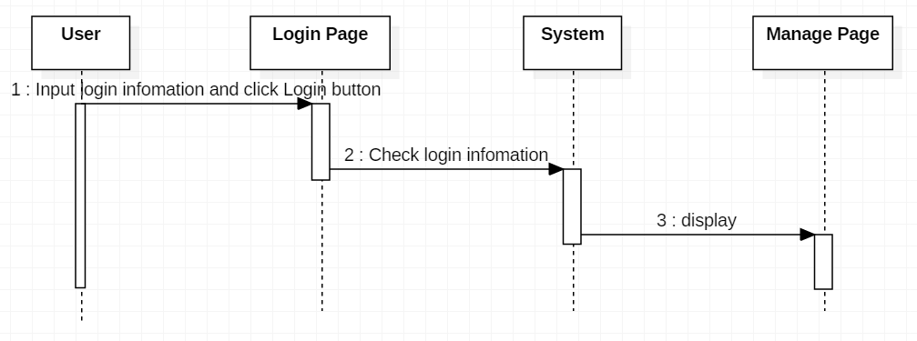

### Logout

|  |  |  |
| --- | --- | --- |
| **Author** | Nguyen Trong Minh Thanh | |
| **Use Case Name** | Logout | |
| **Actors** | Admin or Moderator or Collaborator | |
| **Description** | Admin or Moderator or Collaborator wants to log out of the System. | |
| **Requirements** |  | |
| **Pre-conditions** | Actor has logged in. | |
| **Post-conditions** | Success: Actor Logged out. | |
| **Basic flow** | Actor Actions:  1. Actor clicks ‘Log out’ button on the Manage page. | System Responses:  2. System redirect to Logout page, remove session, and then redirect to Login page. |
| **Alternative flow** |  |  |
| **Exception** |  |  |

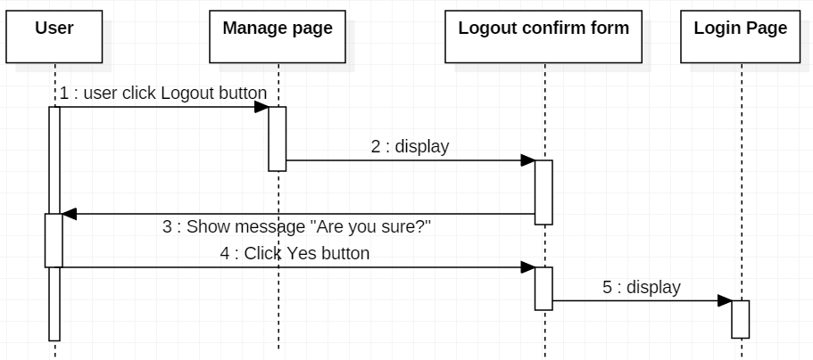

### Manage account

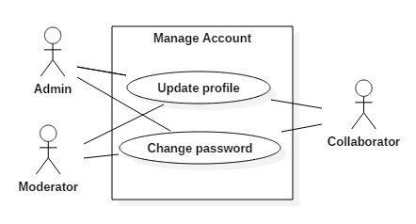

#### Update profile

|  |  |  |
| --- | --- | --- |
| **Author** | Nguyen Trong Minh Thanh | |
| **Use Case Name** | Update Profile | |
| **Actors** | Admin or Moderator or Collaborator | |
| **Description** | Admin or Moderator or Collaborator wants to View/Update his/her profile’s information. | |
| **Requirements** | Actor provides profile information | |
| **Pre-conditions** | Actor has logged in. | |
| **Post-conditions** | Success: Profile’s information of this user has been showed/updated.  Fail: Refill information | |
| **Basic flow** | Actor Actions:  1. Actor clicks ‘Thông tin cá nhân’ button in Manage page menu.  3. Actor updates information and click ‘Save’ button. [Alternative 1] | System Responses:  2. System redirects to Update Profile page and displays Update Profile form with the following control :  - ‘Mail text field (read only)  - ‘Name’ text field  - ‘Birthday’ text field  - ‘Gender’ checkbox group  - ‘Address’ text field  - ‘Phone’ text field  -‘Status’ text field  - ‘Save’ button  -‘Reset’ button  - ‘Back to Manage page button  4. System checks the information  [Exception 1]  5. System update the account into database and then redirects to Manage page. |
| **Alternative flow** | Actor Actions:  [Alternative 1]  1. Actor click ‘Back to Manage page’ button. | System Responses:  2. System returns to Manage page. |
| **Exception** | Actor Actions:  [Exception 1]  1. Actor lefts ‘Name’ text field blank.  2. Actor lefts ‘Birthday’ datebox blank.  3. Input age to ‘Birthday’ datebox less than 16.  4. Actor lefts ‘Address’ text field blank.  5. Actor lefts ‘Phone’ text field blank.  6. Input phone not in numeric or phone length not in range 8 – 14 character.  7. Actor lefts ‘Status text field . | System Responses:  System displays message to Actor :  - ‘Name cannot be blank’.  - ‘Birthday is invalid’.  - ‘Age must over 16’.  - ‘Address cannot be blank’.  - ‘Phone is invalid’.  - ‘The phone number should be numeric only and must be between 8 and 14 digits’.  - ‘Status cannot be blank’. |

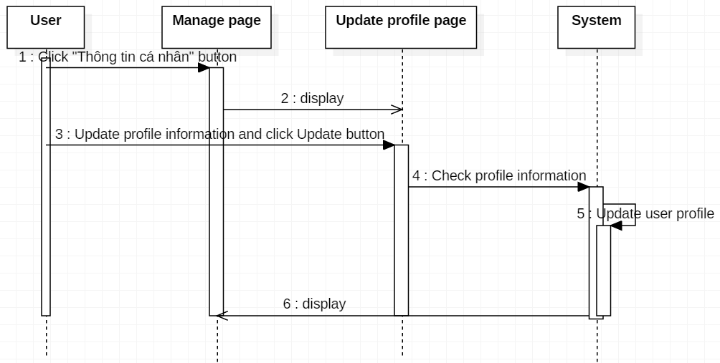

#### Change password

|  |  |  |
| --- | --- | --- |
| **Author** | Nguyen Trong Minh Thanh | |
| **Use Case Name** | Update Profile | |
| **Actors** | Admin or Moderator or Collaborator | |
| **Description** | Admin or Moderator or Collaborator wants to change his/her password. | |
| **Requirements** | Actor provides password | |
| **Pre-conditions** | Actor has logged in. | |
| **Post-conditions** | Success: Password of this user has been updated.  Fail: Refill information | |
| **Basic flow** | Actor Actions:  1. Actor clicks ‘Change password’ button in Manage page menu.  3. Actor fill information and click ‘Save’ button. [Alternative 1] | System Responses:  2. System redirects to Change password page and displays Change password form with the following control :  - ‘Old password’ password field  - ‘New password’ password field  - ‘Confirm new password’ password field  - ‘Save’ button  - ‘Reset’ button  - ‘Back to Manage page button  4. System checks the information  [Exception 1]  5. System update the password into database and then redirects to Manage page. |
| **Alternative flow** | Actor Actions:  [Alternative 1]  1. Actor click ‘Back to Manage page’ button. | System Responses:  2. System returns to Manage page. |
| **Exception** | Actor Actions:  [Exception 1]   1. Actor lefts ‘Old password’ text field blank. 2. Actor lefts ‘New password’ text field blank 3. Actor lefts ‘New confirm password’ text field blank 4. ‘New password’ and ‘New confirm passwod’ don’t match | System Responses:  System displays message to Actor :   * Old password can not be blank. * New password can not be blank. * New confirm password can not be blank. * New password and confirm password don’t match. |

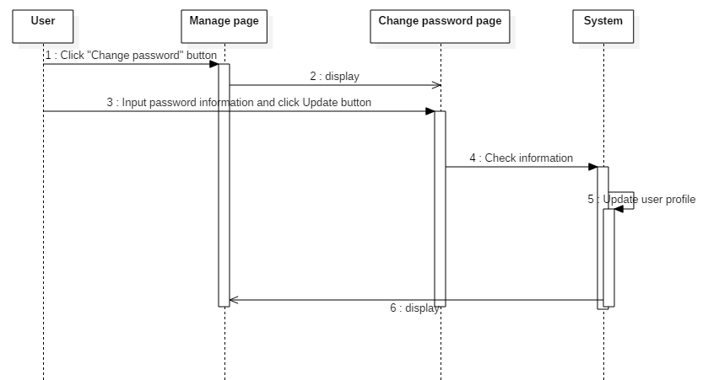

# Entity Relationship Diagram (ERD)

## ERD

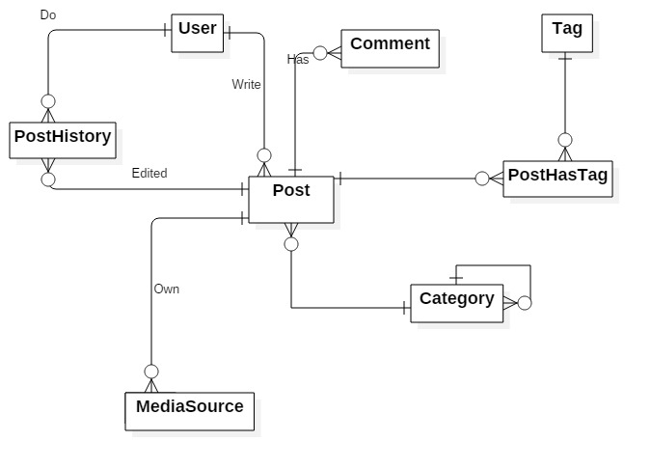

## Table

### Post

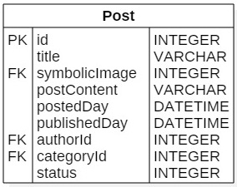

### User

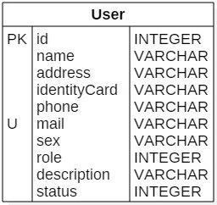

### PostHistory

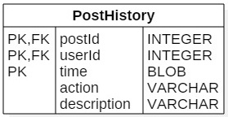

### Category

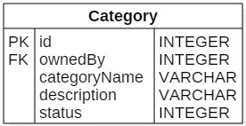

### Tag

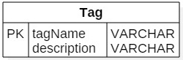

### PostHasTag

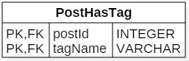

### MediaSource

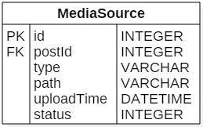

### Comment

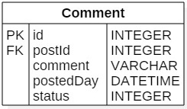

REVIEW 3

# 

# Database Relationship Diagram

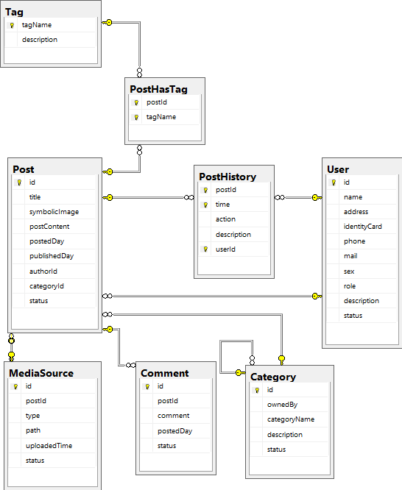

# Table Definition

## User

|  |  |  |  |  |  |  |  |
| --- | --- | --- | --- | --- | --- | --- | --- |
| **Key** | **Field Name** | **Data Type** | **Length** | **Allow Null** | **Default value** | **Table-Field-Ref** | **Description** |
| PK, FK | **id** | int | 1…4^32 | No |  |  | User’s Id |
|  | name | nvarchar | 50 | No |  |  | User’s Name |
|  | address | nvarchar | 50 | No |  |  | User’s Address |
|  | identityCard | nchar | 15 | No |  |  | User’s Identity Card |
|  | phone | nchar | 15 | No |  |  | User’s phone |
|  | mail | nchar | 50 | No |  |  | User’s mail must be unique |
|  | sex | nchar | 10 | No |  |  | User’s sex:  - male  - female  - other |
|  | role | int |  | No |  |  | User’s role:  0: admin  1: moderator  2: collaborator |
|  | description | nvarchar | 200 | Yes |  |  | User’s description |
|  | status | int |  | No |  |  | Status:  0: banned  1: actived |

**Contrainst:**

|  |  |  |  |
| --- | --- | --- | --- |
| **Name** | **Add** | **Delete** | **Update** |
| User | + | - | + |

## Post

|  |  |  |  |  |  |  |  |
| --- | --- | --- | --- | --- | --- | --- | --- |
| **Key** | **Field Name** | **Data Type** | **Length** | **Allow Null** | **Default value** | **Table-Field-Ref** | **Description** |
| PK, FK | **id** | int | 1…4^32 | No |  |  | Post’s Id |
|  | title | nvarchar | 100 | No |  |  | Post’s title |
|  | symbolicImage | int |  | Yes |  |  | Symbolic Image on home page |
|  | postContent | nvarchar | 2000 | Yes |  |  | Post’s content |
|  | postedDay | datetime |  | No |  |  | Posted day |
|  | publishedDay | datetime |  | Yes |  |  | Published day |
|  | authorId | int | 1…4^32 | No |  | User.id | Author’s Id |
|  | categoryId | int |  | Yes |  | Category.id | Category’s Id |
|  | status | int |  | No |  |  | Status:  0: disabled  1: rejected  2: draft  3: unpublished  4: published |

**Contrainst:**

|  |  |  |  |
| --- | --- | --- | --- |
| **Name** | **Add** | **Delete** | **Update** |
| Post | + | - | + |

## PostHistory

|  |  |  |  |  |  |  |  |
| --- | --- | --- | --- | --- | --- | --- | --- |
| **Key** | **Field Name** | **Data Type** | **Length** | **Allow Null** | **Default value** | **Table-Field-Ref** | **Description** |
| PK,FK | **postId** | int | 1…4^32 | No |  | Post.id | Post’s Id |
| PK | **time** | datetime |  | No |  |  | Time to take action |
|  | action | nchar | 50 | No |  |  | Post’s action:  - EDIT TAG  - EDIT CATEGORY  - EDIT CONTENT  - REJECT  - PUBLISH  - UNPUBLISH  - DISABLE POST  - DISABLE COMMENT |
|  | description | nvarchar | 50 | Yes |  |  | - REJECT: rejection reason  - EDIT CONTENT: reason for update |
| PK, FK | **userId** | int | 1…4^32 | No |  | User.id | User’s Id |

**Contrainst:**

|  |  |  |  |
| --- | --- | --- | --- |
| **Name** | **Add** | **Delete** | **Update** |
| PostHistory | + | - | - |

## Category

|  |  |  |  |  |  |  |  |
| --- | --- | --- | --- | --- | --- | --- | --- |
| **Key** | **Field Name** | **Data Type** | **Length** | **Allow Null** | **Default value** | **Table-Field-Ref** | **Description** |
| PK | **id** | int | 1…4^32 | No |  |  | Category’s Id |
| FK | ownedBy | int |  | No |  | Category.id | Show that this category is owned By other category |
|  | categoryName | nvarchar | 50 | No |  |  | Category’s Name |
|  | description | nvarchar | 50 | Yes |  |  | Category’s Description |
|  | status | int |  | No |  |  | Status:  -1: disabled  0: not show on home page  1, 2, 3,…n: displayed in nth order as sub category (if ownedBy field is not null) |

**Contrainst:**

|  |  |  |  |
| --- | --- | --- | --- |
| **Name** | **Add** | **Delete** | **Update** |
| Category | + | - | + |

## MediaSource

|  |  |  |  |  |  |  |  |
| --- | --- | --- | --- | --- | --- | --- | --- |
| **Key** | **Field Name** | **Data Type** | **Length** | **Allow Null** | **Default value** | **Table-Field-Ref** | **Description** |
| PK | **id** | int | 1…4^32 | No |  |  | Media Source’s Id |
| FK | postId | int | 1…4^32 | Yes |  | Post.id | Post’s Id |
|  | type | nchar | 30 | No |  |  | Media Source’s Type |
|  | path | nchar | 200 | No |  |  | Media Source’s Path |
|  | uploadedTime | datetime |  | No |  |  | Time to upload media source |
|  | status | int |  | No |  |  | Status:  0: disabled  1: actived |

**Contrainst:**

|  |  |  |  |
| --- | --- | --- | --- |
| **Name** | **Add** | **Delete** | **Update** |
| MediaSource | + | - | + |

## PostHasTag

|  |  |  |  |  |  |  |  |
| --- | --- | --- | --- | --- | --- | --- | --- |
| **Key** | **Field Name** | **Data Type** | **Length** | **Allow Null** | **Default value** | **Table-Field-Ref** | **Description** |
| PK,FK | **postId** | int | 1…4^32 | No |  | Post.id | Post’s Id |
| PK,FK | **tagName** | nchar | 30 | No |  | Tag.tagName | Tag’s Name |

**Contrainst:**

|  |  |  |  |
| --- | --- | --- | --- |
| **Name** | **Add** | **Delete** | **Update** |
| PostHasTag | + | + | - |

## Tag

|  |  |  |  |  |  |  |  |
| --- | --- | --- | --- | --- | --- | --- | --- |
| **Key** | **Field Name** | **Data Type** | **Length** | **Allow Null** | **Default value** | **Table-Field-Ref** | **Description** |
| PK | **tagName** | nchar | 30 | No |  |  | Tag’s Name |
|  | description | nvarchar | 50 | No |  |  | Tag’s description |

**Contrainst:**

|  |  |  |  |
| --- | --- | --- | --- |
| **Name** | **Add** | **Delete** | **Update** |
| Tag | + | - | - |

## Comment

|  |  |  |  |  |  |  |  |
| --- | --- | --- | --- | --- | --- | --- | --- |
| **Key** | **Field Name** | **Data Type** | **Length** | **Allow Null** | **Default value** | **Table-Field-Ref** | **Description** |
| PK | **id** | int | 1…4^32 | No |  |  | Comment’s Id |
| FK | postId | int | 1…4^32 | No |  | Post.id | Post’s Id |
|  | comment | nvarchar | 500 | No |  |  | Content of comment |
|  | postedDay | datetime |  | No |  |  | Posted day |
|  | status | int |  | No |  |  | Status:  0: disabled  1: actived |

### Contrainst:

|  |  |  |  |
| --- | --- | --- | --- |
| **Name** | **Add** | **Delete** | **Update** |
| Comment | + | - | + |

# Other constrains:

## Post and User

|  |  |  |  |
| --- | --- | --- | --- |
| **Name** | **Add** | **Delete** | **Update** |
| Post | +  (User.id must exist) | - | + |
| User | + | - | +  (User.id cannot be changed) |

## Post and Category

|  |  |  |  |
| --- | --- | --- | --- |
| **Name** | **Add** | **Delete** | **Update** |
| Post | +  (Category.id must exist) | - | + |
| Category | + | - | +  (Category.id cannot be changed) |

## Category

|  |  |  |  |
| --- | --- | --- | --- |
| **Name** | **Add** | **Delete** | **Update** |
| Category | + | - | +  (If you update ownedBy attribute, the Category.id which is referenced must existed first) |

## Post and MediaSource

|  |  |  |  |
| --- | --- | --- | --- |
| **Name** | **Add** | **Delete** | **Update** |
| Post | +  (MediaSource.id must exist) | - | +  (Post.id cannot be changed) |
| MediaSource | +  (Post.id must exist) | - | +  (MediaSource.id cannot be changed) |

## PostHistory and User

|  |  |  |  |
| --- | --- | --- | --- |
| **Name** | **Add** | **Delete** | **Update** |
| PostHistory | +  (User.id must exist) | - | - |
| User | + | - | +  (User.id cannot be changed) |

## PostHistory and Post

|  |  |  |  |
| --- | --- | --- | --- |
| **Name** | **Add** | **Delete** | **Update** |
| PostHistory | +  (Post.id must exist) | - | - |
| Post | + | - | +  (Post.id cannot be changed) |

## PostHasTag and Post

|  |  |  |  |
| --- | --- | --- | --- |
| **Name** | **Add** | **Delete** | **Update** |
| PostHasTag | +  (Post.id must exist) | + | - |
| Post | + | - | +  (Post.id cannot be changed) |

## PostHasTag and Tag

|  |  |  |  |
| --- | --- | --- | --- |
| **Name** | **Add** | **Delete** | **Update** |
| PostHasTag | +  (Tag.tagName must exist) | + | - |
| Tag | + | - | +  (Tag.tagName cannot be changed) |

## Comment and Post

|  |  |  |  |
| --- | --- | --- | --- |
| **Name** | **Add** | **Delete** | **Update** |
| Comment | +  (Post.id must exist) | - | + |
| Post | + | - | +  (Post.id cannot be changed) |

# Site map

## *Home Side*

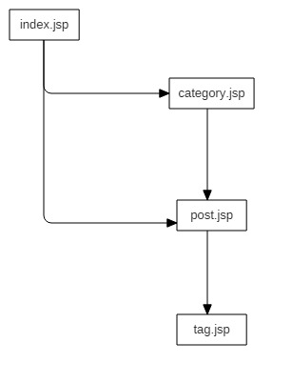

## *13.2. Admin site*

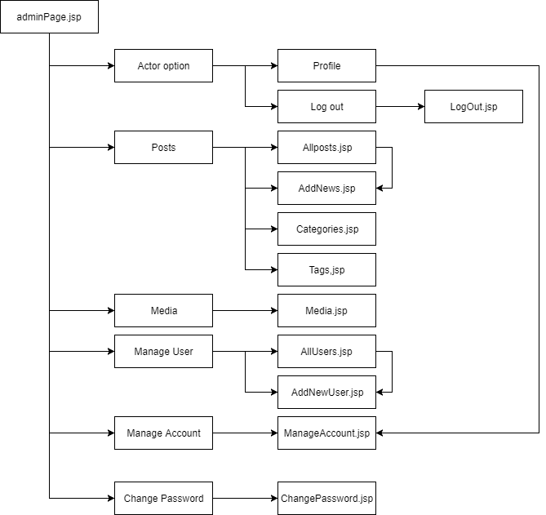

# 14. GUI Design

## 14.1 Home site

### 14.1.1 Home page:

This is Home page of the website, the readers will go to this page first.

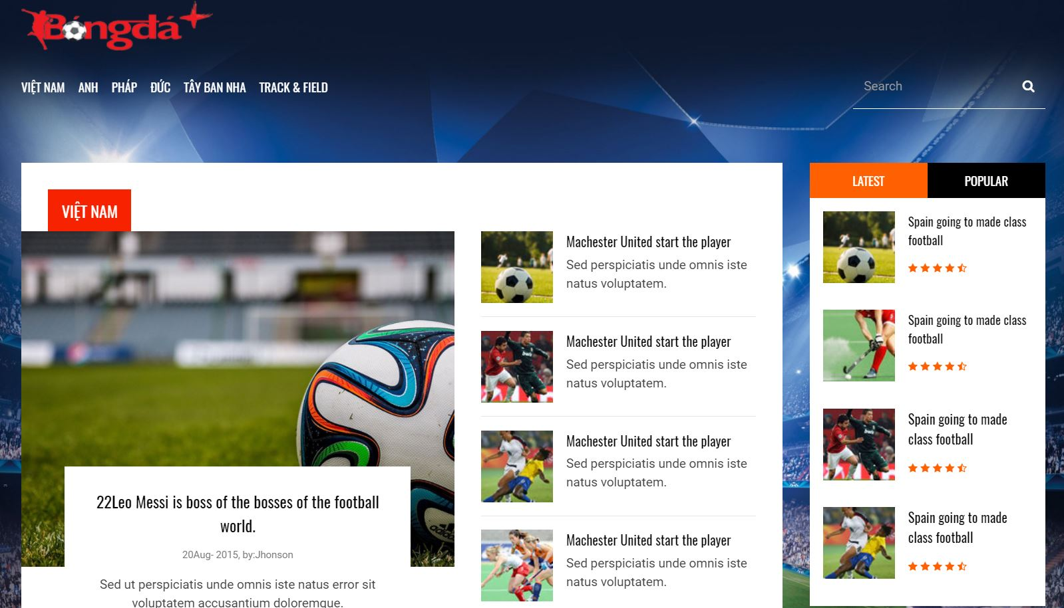

**12**

**11**

**10**

**9**

**8**

**7**

**6**

**5**

**4**

**3**

**2**

**1**

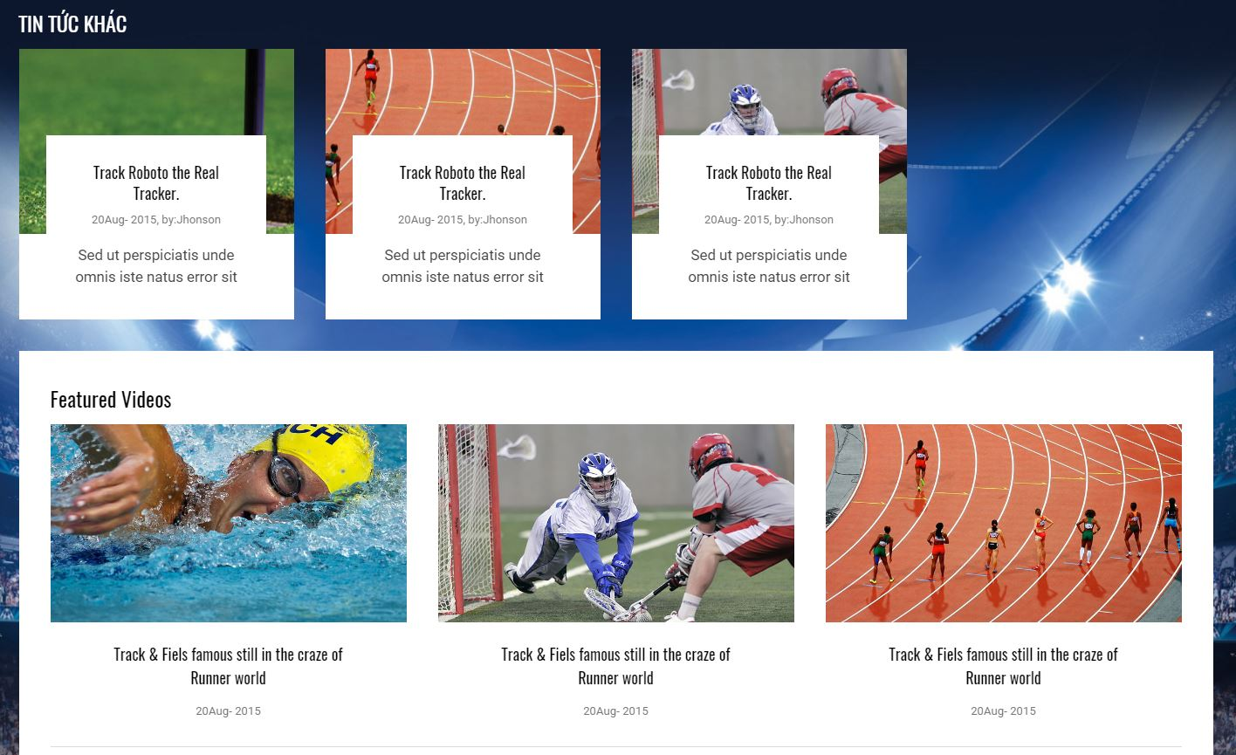

**14**

**13**

|  |  |  |  |  |  |  |
| --- | --- | --- | --- | --- | --- | --- |
| **No.** | **Name** | **Type** | **Validation** | **Event** | **Description** | **Status** |
| 1 | imgBongda | Image |  | Click | Redirect to Home page |  |
| 2 | btnVietNam | Button |  | Click | Redirect to VietNam page |  |
| 3 | btnAnh | Button |  | Click | Redirect to Anh page |  |
| 4 | btnPhap | Button |  | Click | Redirect to Phap page |  |
| 5 | btnDuc | Button |  | Click | Redirect to Duc page |  |
| 6 | btnTaybannha | Button |  | Click | Redirect to Tay Ban Nha page |  |
| 7 | btnTrack&Field | Button |  | Click | Redirect to Track&Field page |  |
| 8 | btnLatest | Button |  | Click | Show the lasted news in this field |  |
| 9 | btnPopular | Button |  | Click | Show the popular news in this field |  |
| 10 | btnSearch | Button |  | Click | Redirect to Search page |  |
| 11 | btnVietNam | Button |  | Click | Redirect to VietNam page |  |
| 12 | lb22LeoMessi | Label |  | Click | Redirect to news details page which related to label |  |
| 13 | lbTinTucKhac | Label |  |  | Tin tức khác |  |
| 14 | lbFeaturedVideos | Label |  |  | Featured Videos |  |

### 14.1.2 Category page:

This is the category (Baseball, Football, Hockey, Basketball, Boxing, Golf, Tennis, Horse Racing, Track & Field) page. This page will show all posts which related to the category. Readers click on the title to show details of the post.

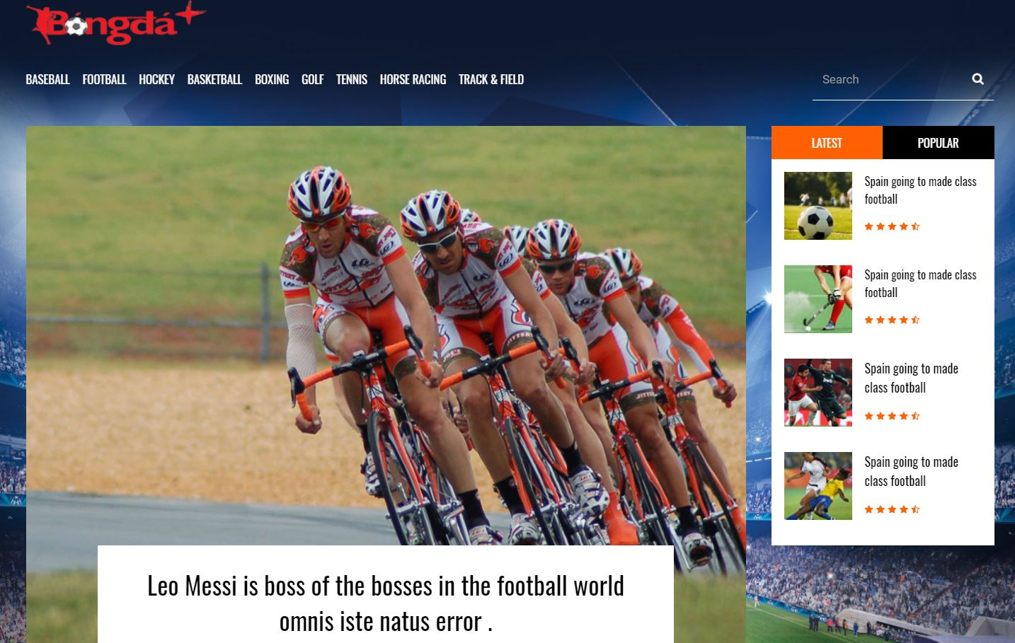

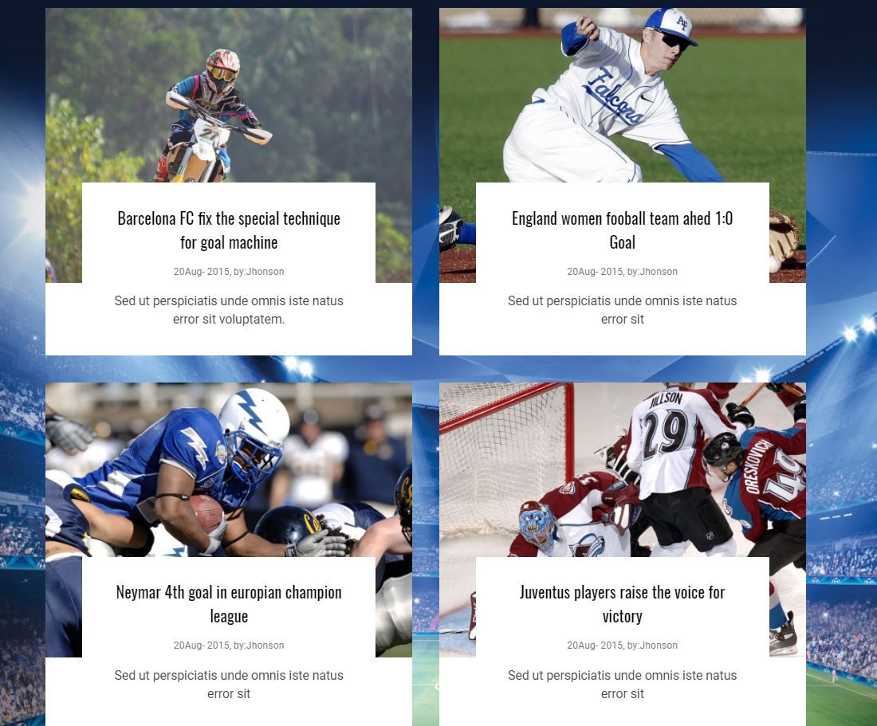

### 14.1.3 Post details page:

This is the post details page.



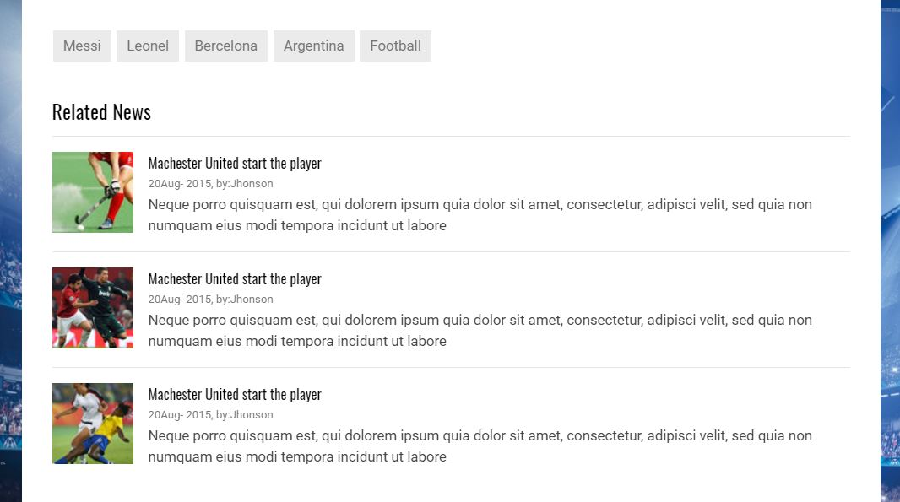

**4**

**5**

**3**

**2**

**1**

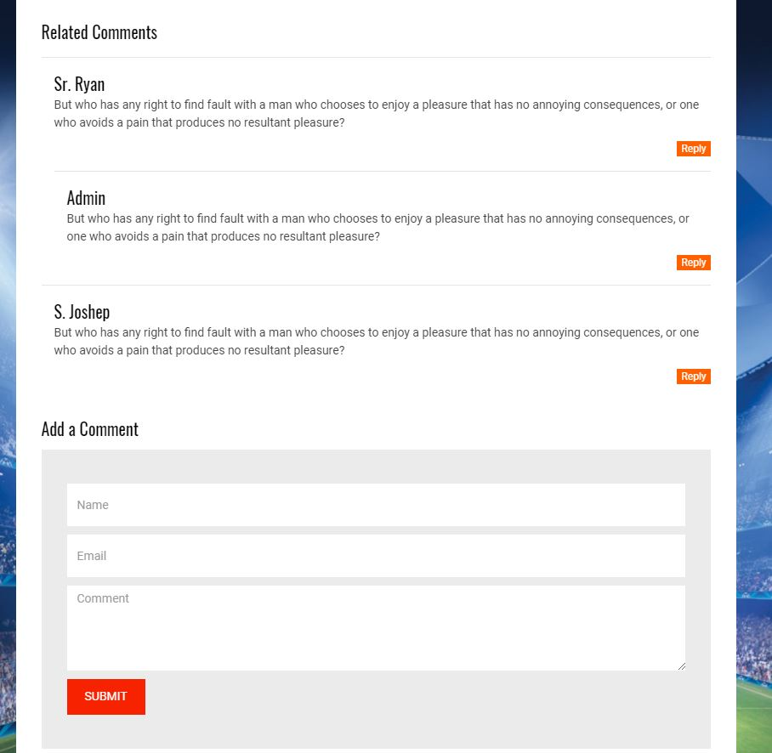

**10**

**9**

**8**

**7**

**6**

|  |  |  |  |  |  |  |
| --- | --- | --- | --- | --- | --- | --- |
| **No.** | **Name** | **Type** | **Validation** | **Event** | **Description** | **Status** |
| 1 | btnMessi | Button |  | Click | Redirect to Messi’s tag page |  |
| 2 | btnLeonel | Button |  | Click | Redirect to Leonel’s tag page |  |
| 3 | btnBercelona | Button |  | Click | Redirect to Bercelona’s tag page |  |
| 4 | btnArgentina | Button |  | Click | Redirect to Argentina’s tag page |  |
| 5 | btnFootball | Button |  | Click | Redirect to Football’s tag page |  |
| 6 | btnReply | Button |  | Click | Reply comment on this page, submit to the system and redirect to Post details page |  |
| 7 | txtName | Textfield | Not null |  | Name |  |
| 8 | txtEmail | Textfield | Not null |  | Email |  |
| 9 | txtComment | Textfield | Not null |  | Comment |  |
| 10 | btnSubmit | Button |  | Click | Submit to the system and redirect to Post details page |  |

### 14.1.3 Tag page:

This is the tag page. This page shows all news which related to one’s tag.

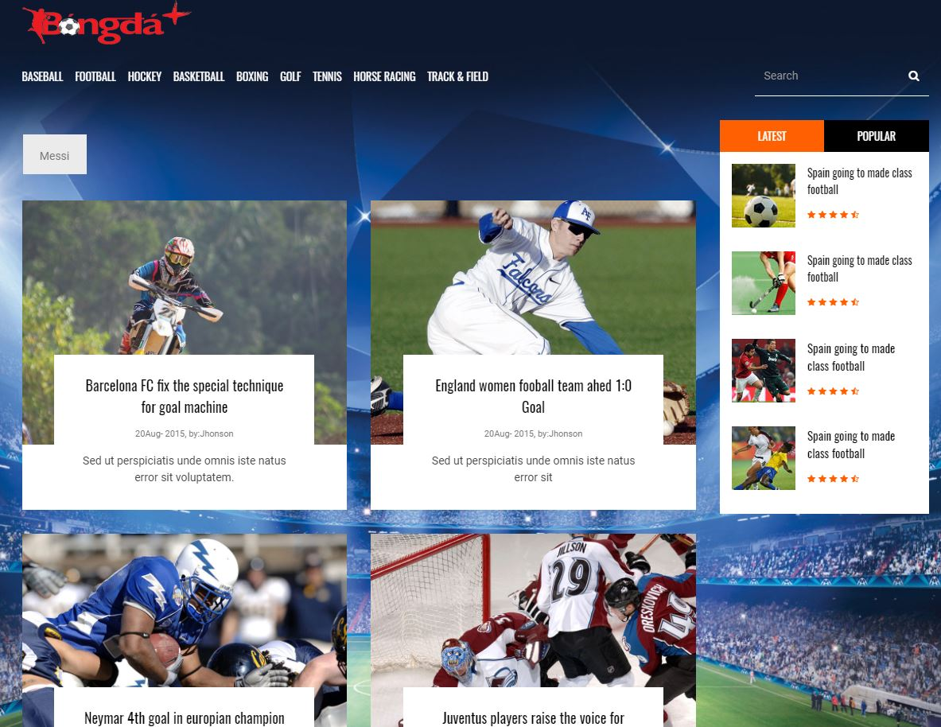

## 14.2. Admin side

Administrators and staff can use this page to manage the website.

### 14.2.1. Login page

Administrators and staff can login into the system in this page.

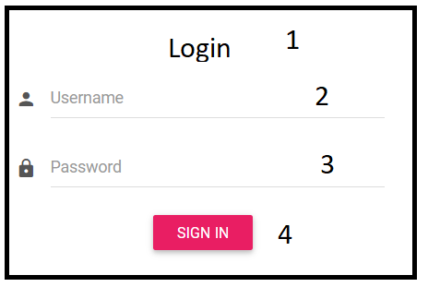

|  |  |  |  |  |  |  |
| --- | --- | --- | --- | --- | --- | --- |
| **No.** | **Name** | **Type** | **Validation** | **Event** | **Description** | **Status** |
| 1 | gridLogin | Grid |  |  | Grid contains controls: 2,3,4 |  |
| 2 | txtUsername | Text Field | Not null |  | Username |  |
| 3 | txtPassword | Text Field | Not null |  | Password |  |
| 4 | btnLogin | Button |  |  | Check Username and password and if they are correct, redirect to Admin Home page |  |

### 14.2.2. Admin Home Page

When the Administrators has logged in, the system will redirect All Post page.

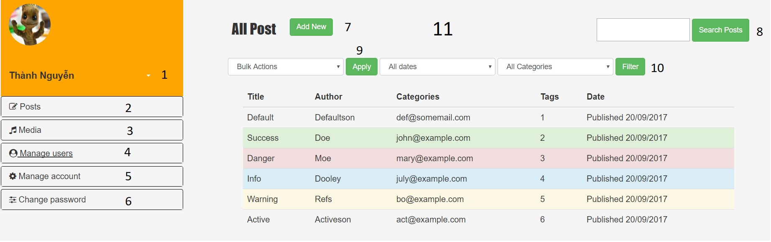

|  |  |  |  |  |  |  |
| --- | --- | --- | --- | --- | --- | --- |
| **No.** | **Name** | **Type** | **Validation** | **Event** | **Description** | **Status** |
| 1 | btnAccountOption | Grid |  |  | Grid List of Menu, include List of Menu controls |  |
| 2 | btnPosts | Hyperlink |  | Click | Show the list sub menu of posts |  |
| 3 | btnMedia | Hyperlink |  | Click | Redirect to Media page |  |
| 4 | btnManageUser | Hyperlink |  | Click | Show the list sub menu of Manage User |  |
| 5 | btnManageAccount | Hyperlink |  | Click | Redirect Manage Account page |  |
| 6 | btnChangePassword | Hyperlink |  | Click | Redirect to Change Password page |  |
| 7 | btnAddNew | Hyperlink |  | Click | Redirect to Add New Post page |  |
| 8 | btnSearchPost | Hyperlink |  | Click | Search post by name, the list of post will show in the table behind |  |
| 9 | btnApply | Hyperlink |  | Click | Apply actor’s action |  |
| 10 | btnFilter | Hyperlink |  | Click | Apply filter with the following chosen in select box. |  |
| 11 | frameInfo | IFrame |  |  | Show the page chosen in the left menu. |  |

### 14.2.3. Manage Account

The actor click the link “Manage account”. FrameInfo at the right side will load the page “ManageAccount.html”.

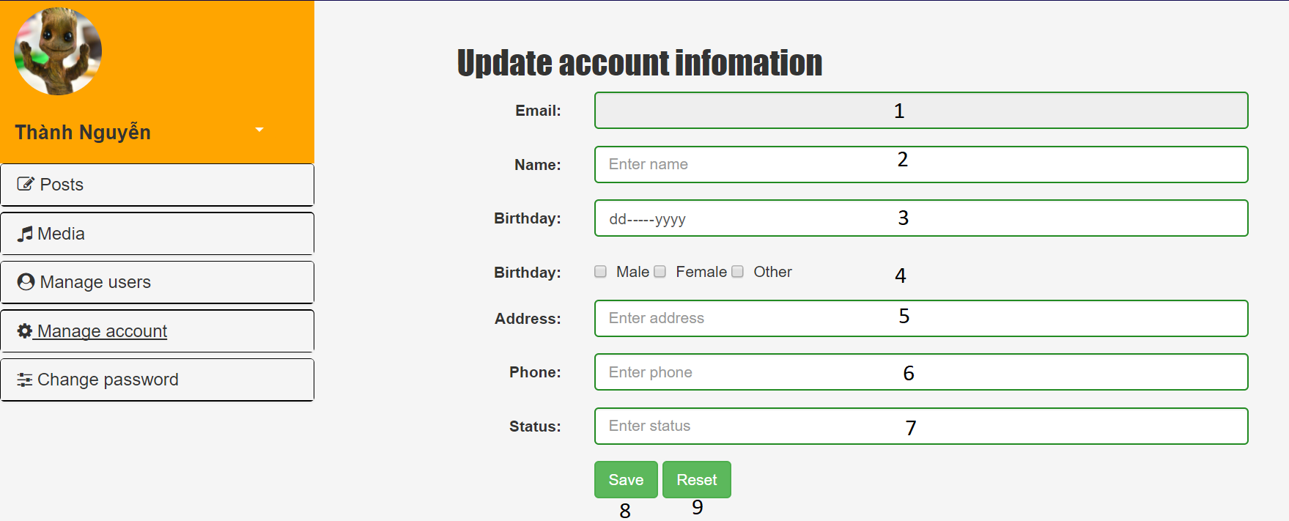

|  |  |  |  |  |  |  |
| --- | --- | --- | --- | --- | --- | --- |
| **No.** | **Name** | **Type** | **Validation** | **Event** | **Description** | **Status** |
| 1 | txtEmail | Textfield | Read only |  | Show email of actor |  |
| 2 | txtName | Hyperlink | Not null |  | Actor name |  |
| 3 | txtBirthday | Hyperlink | Not null |  | Actor birthday |  |
| 4 | cbSex | Hyperlink | Choose only 1 |  | Actor sex |  |
| 5 | txtAddress | Hyperlink | Not null |  | Actor address |  |
| 6 | txtPhone | Hyperlink | Not null |  | Actor phone |  |
| 7 | txtStatus | Hyperlink | Not null |  | Actor status |  |
| 8 | btnSave | Hyperlink |  | Click | Check validation of all textfield, submit info to server and update database. |  |
| 9 | btnReset | Hyperlink |  | Click | Clear all text in textfield |  |

### 14.2.4. Manage users

#### 14.2.4.1. All users

Show all the user that exist in system.

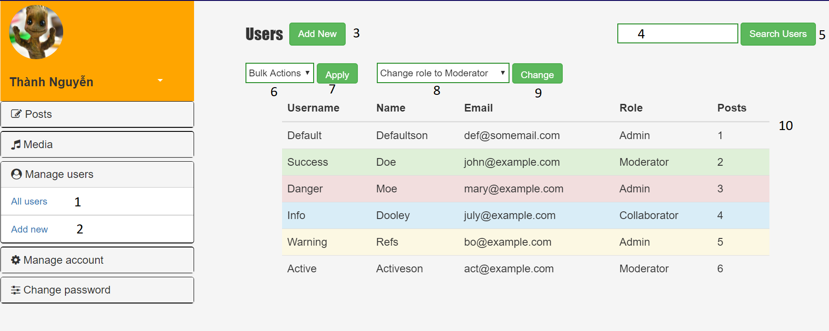

|  |  |  |  |  |  |  |
| --- | --- | --- | --- | --- | --- | --- |
| **No.** | **Name** | **Type** | **Validation** | **Event** | **Description** | **Status** |
| 1 | btnAllUser | Hyperlink |  | Click | Redirect to “All user” page |  |
| 2 | btnAddNew | Hyperlink |  | Click | Redirect to “Add new” page |  |
| 3 | btnAddNew2 | Button |  | Click | Redirect to “Add new” page |  |
| 4 | txtSearch | Textfield |  |  | Input text to search |  |
| 5 | btnSearch | Button |  | Click | Search value inputed in Search textfield |  |
| 6 | selectAction | Select |  | Click | Admin choose action |  |
| 7 | btnApply | Button |  | Click | Apply action selected |  |
| 8 | selectRole | Select |  | Click | Admin choose role |  |
| 9 | btnChange | Button |  | Click | Change the role of the user |  |

#### 14.2.4.2. Add new

The actor click the link “Add New”. FrameInfo at the right side will load the page “AddNew.html”.

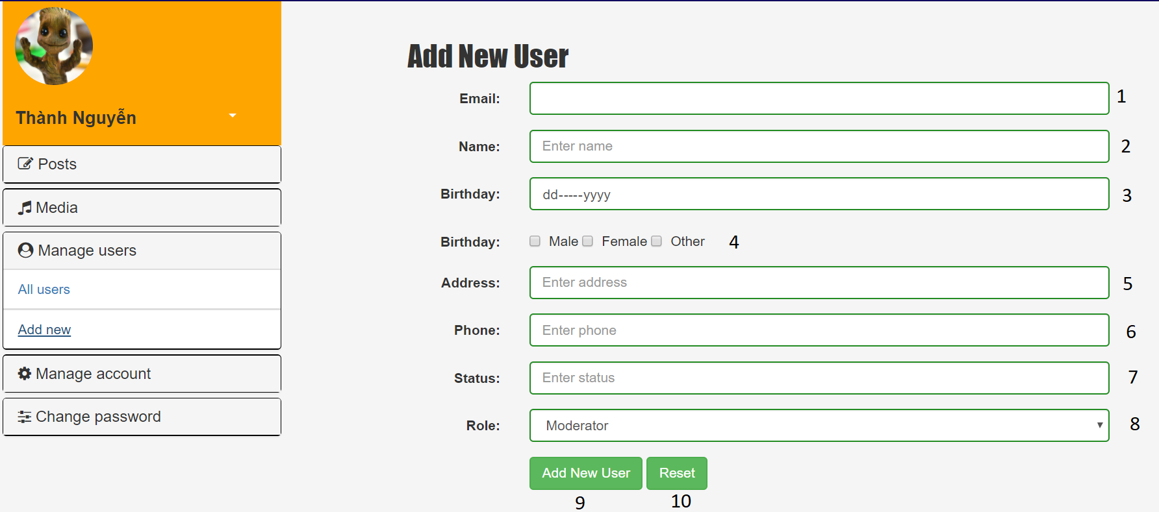

|  |  |  |  |  |  |  |
| --- | --- | --- | --- | --- | --- | --- |
| **No.** | **Name** | **Type** | **Validation** | **Event** | **Description** | **Status** |
| 1 | txtEmail | Textfield | Not null |  | Actor email |  |
| 2 | txtName | Textfield | Not null |  | Actor name |  |
| 3 | txtBirthday | Textfield | Not null |  | Actor birthday |  |
| 4 | cbSex | Textfield | Choose only 1 |  | Actor sex |  |
| 5 | txtAddress | Textfield | Not null |  | Actor address |  |
| 6 | txtPhone | Textfield | Not null |  | Actor phone |  |
| 7 | txtStatus | Textfield | Not null |  | Actor status |  |
| 8 | TxtRole | Textfield | Not null |  | Actor role |  |
| 9 | btnAddNewUser | Hyperlink |  | Click | Check validation of all textfield, submit info to server and add new user into database. |  |
| 10 | btnReset | Hyperlink |  | Click | Clear all text in textfield |  |

### 14.2.5. Change Password

The actor click the link “Change Password”. FrameInfo at the right side will load the page “ChangePassword.html”.

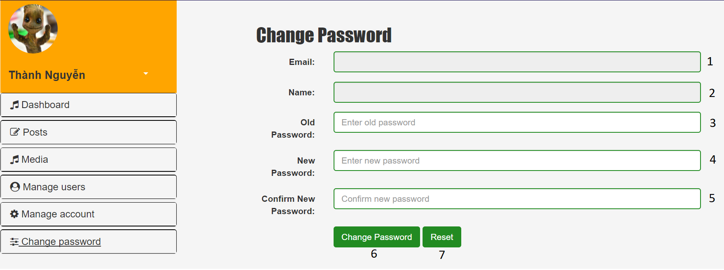

|  |  |  |  |  |  |  |
| --- | --- | --- | --- | --- | --- | --- |
| **No.** | **Name** | **Type** | **Validation** | **Event** | **Description** | **Status** |
| 1 | txtEmail | Textfield | Read only |  | Actor email (Read only) |  |
| 2 | txtName | Textfield | Read only |  | Actor name (Read only) |  |
| 3 | txtOldPassword | Textfield | Not null |  | Actor old password |  |
| 4 | txtNewPassword | Textfield | Not null |  | Actor new password |  |
| 5 | txtConfirmPassword | Textfield | Not null |  | Actor confirm password |  |
| 6 | btnChangePassword | Button |  |  | Check validation, send information into server and update to database. |  |
| 7 | btnReset | Button |  |  | Clear text in textfield |  |

### . Manage Post pages

#### List all post page

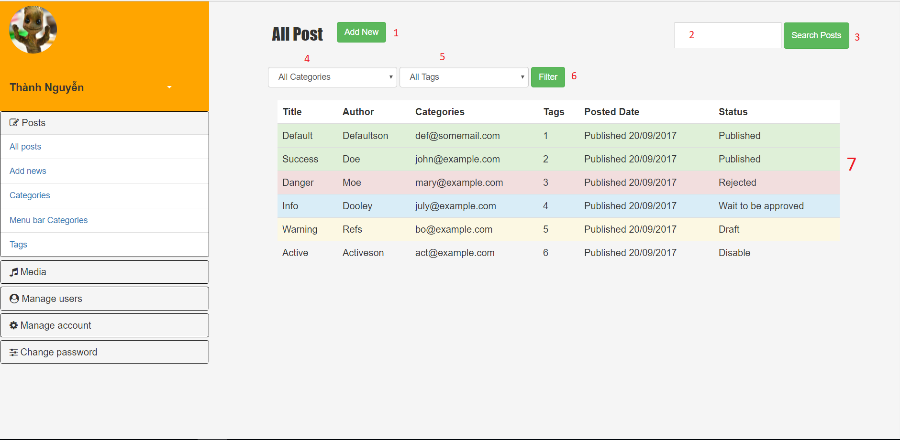

|  |  |  |  |  |  |  |
| --- | --- | --- | --- | --- | --- | --- |
| **No.** | **Name** | **Type** | **Validation** | **Event** | **Description** | **Status** |
| 1 | NewPostLink | Hyperlink |  |  | Link to Add new post page. |  |
| 2 | txtSearch | Text field | Not null |  | Name used to search by name. |  |
| 3 | btnSearch | Button |  | Click | Filter post base on name. |  |
| 4 | listCategory | Combobox |  |  | Show available categories. |  |
| 5 | listTag | Combobox |  |  | Show available tag. |  |
| 6 | btnFilter | Button |  | Click | Filter post base on category and tag. |  |
| 7 | tablePost | Table |  |  | Show all posts in database. |  |

#### Add new post page

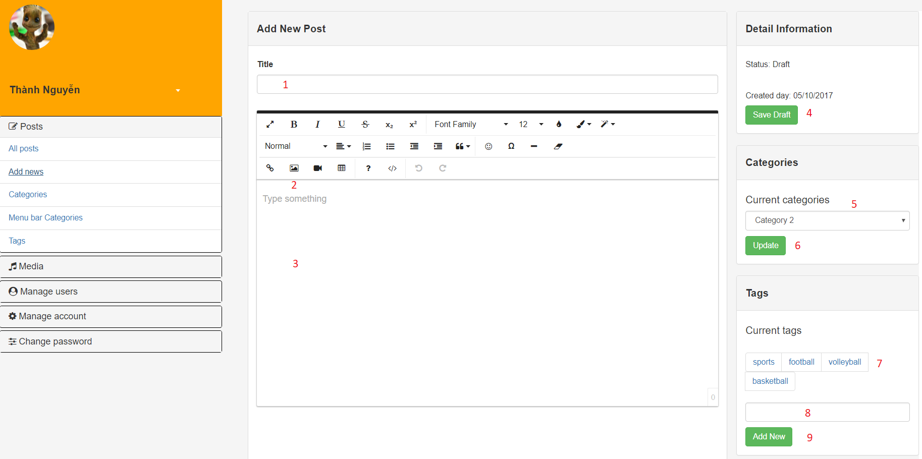

|  |  |  |  |  |  |  |
| --- | --- | --- | --- | --- | --- | --- |
| **No.** | **Name** | **Type** | **Validation** | **Event** | **Description** | **Status** |
| 1 | title | Text field | Not null |  | Title of Post |  |
| 2 | btnAddMedia | Button |  | Click | Insert picture to the post. |  |
| 3 | content | Text area |  |  | Content of the post. |  |
| 4 | btnSave | Button |  | Click | Save content to database. |  |
| 5 | categoryList | Combobox |  |  | Show available categories. |  |
| 6 | btnUpdate | Button |  | Click | Update category of this post. |  |
| 7 | tag | Hyperlink |  |  | Link to tags of this post. |  |
| 8 | txtNewTag | Text field |  |  | New tag name. |  |
| 9 | btnAddNewTag | Button |  | Click | Add new tag name to database and link it to this post. |  |

#### List all Categories page

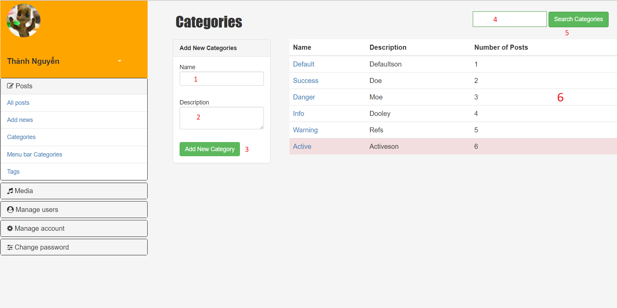

|  |  |  |  |  |  |  |
| --- | --- | --- | --- | --- | --- | --- |
| **No.** | **Name** | **Type** | **Validation** | **Event** | **Description** | **Status** |
| 1 | txtName | Text field | Not null |  | New Category's name. |  |
| 2 | txtDescreption | Text field |  |  | New Category's name. |  |
| 3 | btnAddNew | Button |  | Click | Add new category to database |  |
| 4 | txtSearch | Text field | Not null |  | Category name to search by name. |  |
| 5 | btnSearch | Button |  | Click | Search category by name. |  |
| 6 | tableCategory | Table |  |  | Show all category in database. |  |

#### Manage category in menu bar page

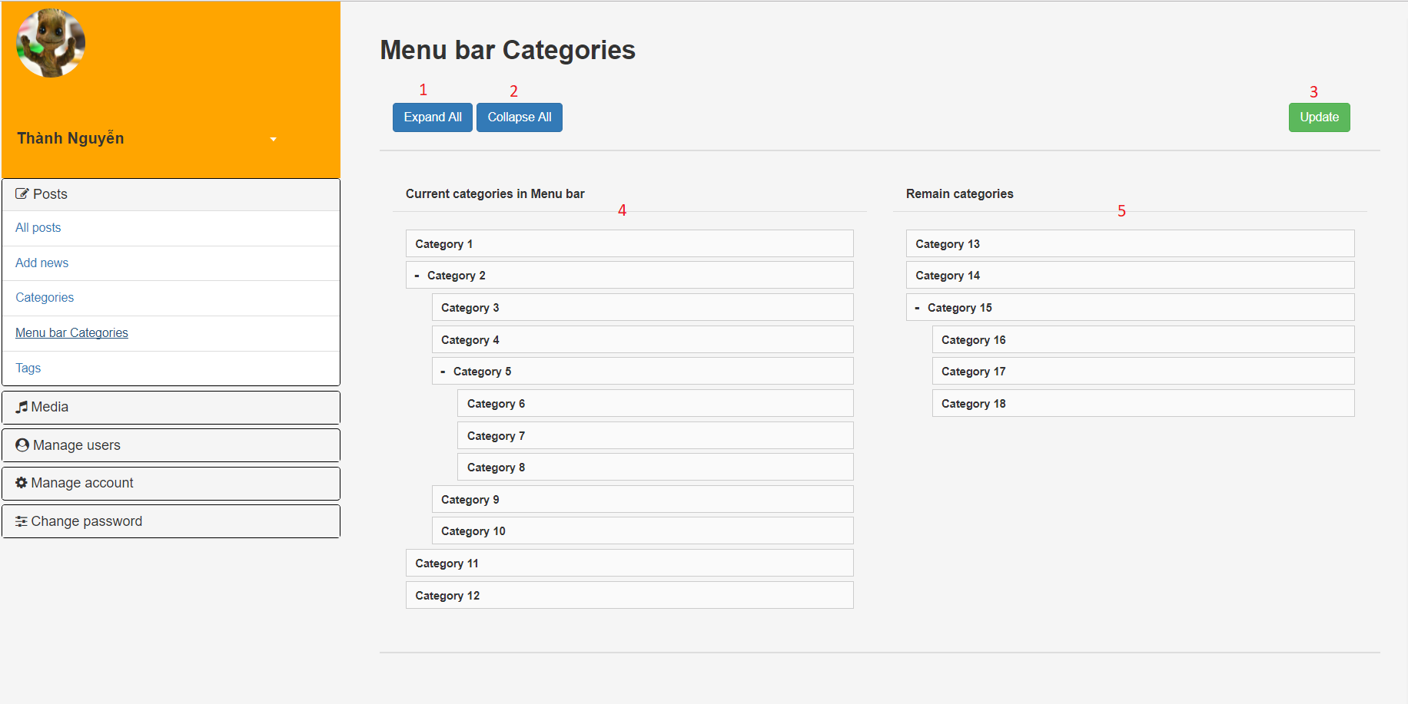

|  |  |  |  |  |  |  |
| --- | --- | --- | --- | --- | --- | --- |
| **No.** | **Name** | **Type** | **Validation** | **Event** | **Description** | **Status** |
| 1 | btnExpandAll | Button |  | Click | Expand all mother categories. |  |
| 2 | btnCollapseAll | Button |  | Click | Collapse all mother categories. |  |
| 3 | btnUpdate | Button |  | Click | Update categories in menu bar to database. |  |
| 4 | panelHomeCategory | Panel |  |  | Show all categories in menu bar. |  |
| 5 | panelRemainCategory | Panel |  |  | Show all remain categories. |  |

#### List all Tags page

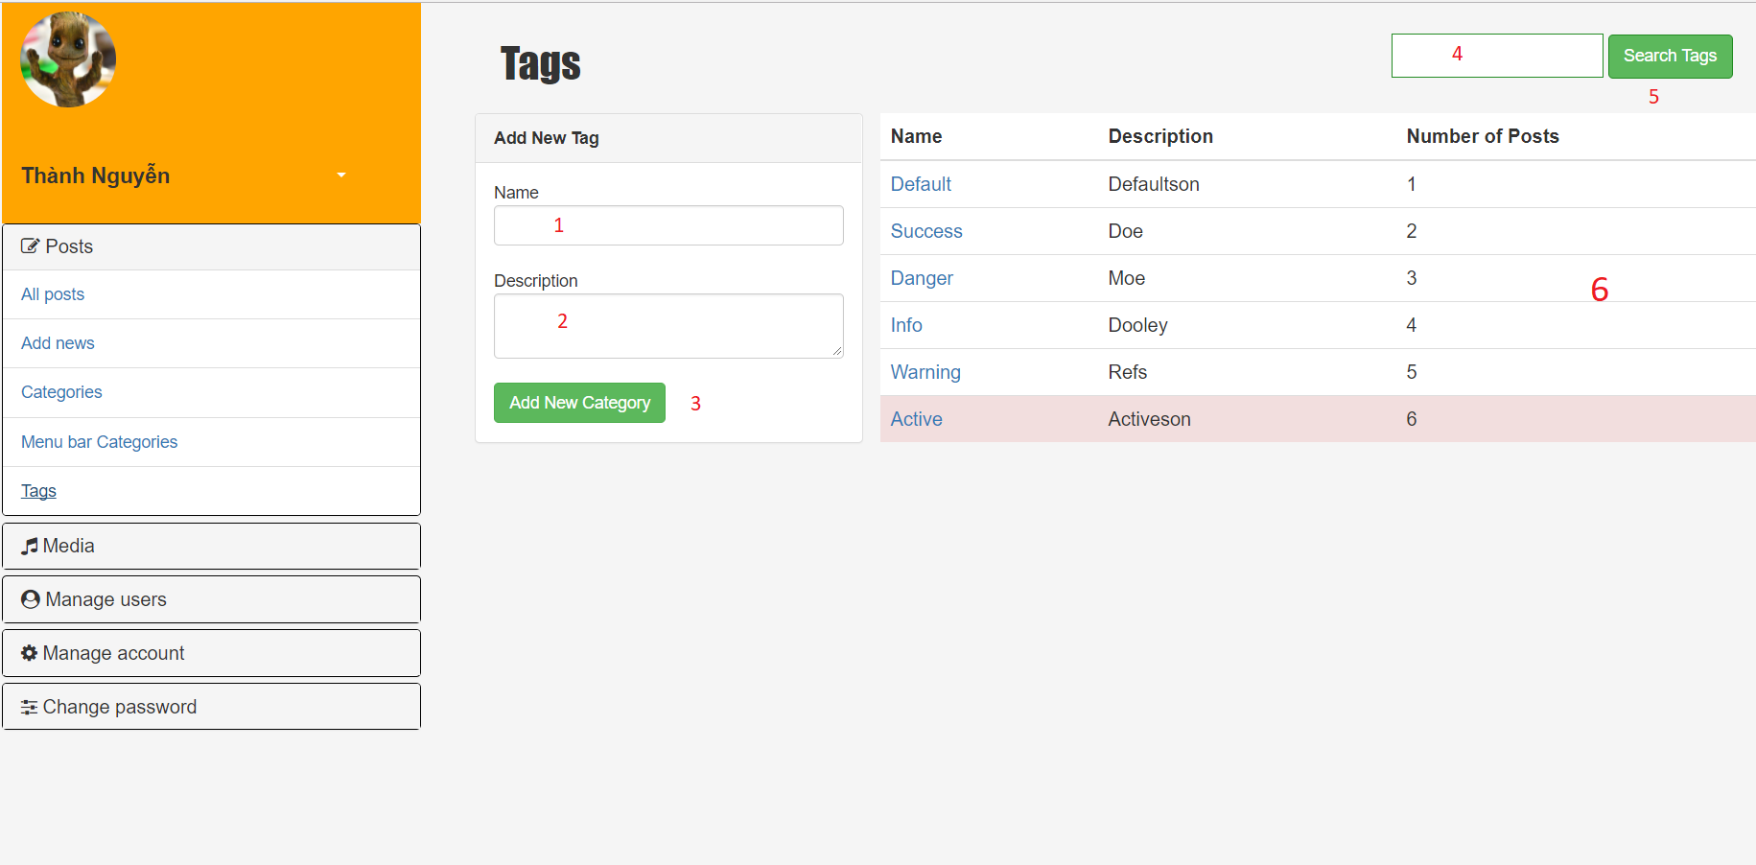

|  |  |  |  |  |  |  |
| --- | --- | --- | --- | --- | --- | --- |
| **No.** | **Name** | **Type** | **Validation** | **Event** | **Description** | **Status** |
| 1 | txtName | Text field | Not null |  | New Tag's name. |  |
| 2 | txtDescreption | Text field |  |  | New Tag's name. |  |
| 3 | btnAddNew | Button |  | Click | Add new tag to database. |  |
| 4 | txtSearch | Text field | Not null |  | Tag name to search by name. |  |
| 5 | btnSearch | Button |  | Click | Search tag by name. |  |
| 6 | tableTag | Table |  |  | Show all tag in database. |  |

### List all media source page

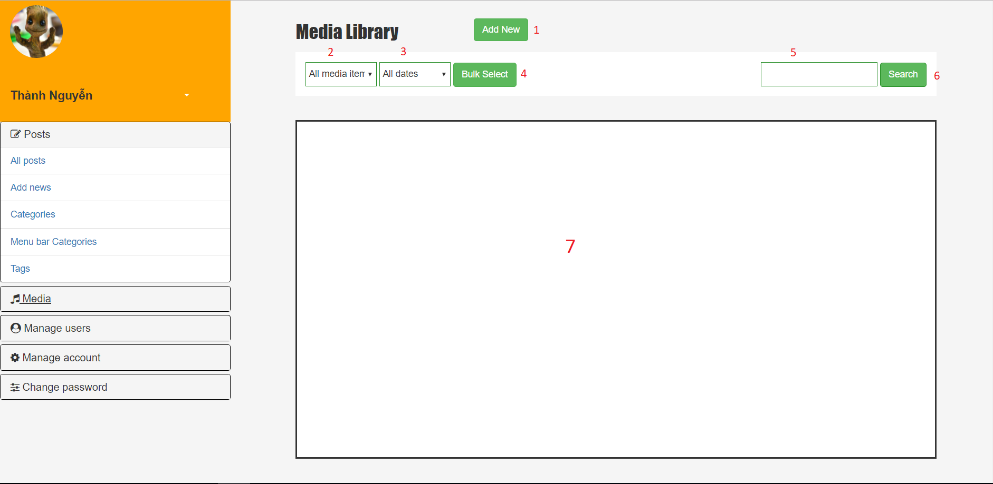

|  |  |  |  |  |  |  |
| --- | --- | --- | --- | --- | --- | --- |
| **No.** | **Name** | **Type** | **Validation** | **Event** | **Description** | **Status** |
| 1 | listType | Combobox |  |  | List of available media type. |  |
| 2 | btnFilter | Button |  | Click | Filter content base on type. |  |
| 3 | panelContent | Panel |  |  | Show all media content. |  |

TASK SHEET

TASK SHEET

|  |  |  |  |  |  |  |  |  |
| --- | --- | --- | --- | --- | --- | --- | --- | --- |
| **Project Ref. No 1** | | **Project Title** | **Activity Plan Prepared By** | **Date of Preparation of Activity Plan** | | | | |
| **Sr. No** | **Task** | **Start Date** | **End Date** | **Actual Days** | **Member’s name** | **Status** |
| **CRS document** | | | | | | | | |
| 1 | Introduction | BongdaNews | Le Thanh Nam | 09/16/2017 | 09/22/2017 | 3 | All of Team | FINISH |
| 2 | Existing Scenario | BongdaNews | Le Thanh Nam | 09/16/2017 | 09/22/2017 | 3 | All of Team | FINISH |
| 3 | Customer Requirement Specification | BongdaNews | Le Thanh Nam | 09/16/2017 | 09/22/2017 | 3 | All of Team | FINISH |
| 4 | Functional Requirement Specification | BongdaNews | Le Thanh Nam | 09/16/2017 | 09/22/2017 | 3 | All of Team | FINISH |
| 5 | System Requirements | BongdaNews | Le Thanh Nam | 09/16/2017 | 09/22/2017 | 3 | All of Team | FINISH |
| 6 | Development Software | BongdaNews | Le Thanh Nam | 09/16/2017 | 09/22/2017 | 3 | All of Team | FINISH |
| **Use Case and Sequence Diagrams** | | | | | | | | |
| 7 | Create new account | BongdaNews | Le Thanh Nam | 09/16/2017 | 09/22/2017 | 4 | Le Thanh Nam | FINISH |
| 8 | View account’s information | BongdaNews | Le Thanh Nam | 09/16/2017 | 09/22/2017 | 4 | Le Thanh Nam | FINISH |
| 9 | Reset password | BongdaNews | Le Thanh Nam | 09/16/2017 | 09/22/2017 | 4 | Le Thanh Nam | FINISH |
| 10 | Update basic information | BongdaNews | Le Thanh Nam | 09/16/2017 | 09/22/2017 | 4 | Le Thanh Nam | FINISH |
| 11 | Ban account | BongdaNews | Le Thanh Nam | 09/16/2017 | 09/22/2017 | 4 | Pham Ngoc Minh Thu | FINISH |
| 12 | Set account’s role | BongdaNews | Le Thanh Nam | 09/16/2017 | 09/22/2017 | 4 | Pham Ngoc Minh Thu | FINISH |
| 13 | Manage category that will display in home page | BongdaNews | Le Thanh Nam | 09/16/2017 | 09/22/2017 | 4 | Le Thanh Nam | FINISH |
| 14 | Create new category | BongdaNews | Le Thanh Nam | 09/16/2017 | 09/22/2017 | 4 | Le Thanh Nam | FINISH |
| 15 | Create new post | BongdaNews | Le Thanh Nam | 09/16/2017 | 09/22/2017 | 4 | Le Thanh Nam | FINISH |
| 16 | Update post | BongdaNews | Le Thanh Nam | 09/16/2017 | 09/22/2017 | 4 | Le Thanh Nam | FINISH |
| 17 | Upload media and source | BongdaNews | Le Thanh Nam | 09/16/2017 | 09/22/2017 | 4 | Le Thanh Nam | FINISH |
| 18 | Insert media to post | BongdaNews | Le Thanh Nam | 09/16/2017 | 09/22/2017 | 4 | Le Thanh Nam | FINISH |
| 19 | Edit post’s tag and category | BongdaNews | Le Thanh Nam | 09/16/2017 | 09/22/2017 | 4 | Nguyen Trong Minh Thanh | FINISH |
| 20 | Create new tag | BongdaNews | Le Thanh Nam | 09/16/2017 | 09/22/2017 | 4 | Nguyen Trong Minh Thanh | FINISH |
| 21 | View other staff’s basic information | BongdaNews | Le Thanh Nam | 09/16/2017 | 09/22/2017 | 4 | Pham Ngoc Minh Thu | FINISH |
| 22 | Approve the post | BongdaNews | Le Thanh Nam | 09/16/2017 | 09/22/2017 | 4 | Pham Ngoc Minh Thu | FINISH |
| 22 | Reject the post | BongdaNews | Le Thanh Nam | 09/16/2017 | 09/22/2017 | 4 | Pham Ngoc Minh Thu | FINISH |
| 23 | Disable comment | BongdaNews | Le Thanh Nam | 09/16/2017 | 09/22/2017 | 4 | Pham Ngoc Minh Thu | FINISH |
| 24 | Disable the post | BongdaNews | Le Thanh Nam | 09/16/2017 | 09/22/2017 | 4 | Pham Ngoc Minh Thu | FINISH |
| 25 | Delete media source | BongdaNews | Le Thanh Nam | 09/16/2017 | 09/22/2017 | 4 | Pham Ngoc Minh Thu | FINISH |
| 26 | Read news | BongdaNews | Le Thanh Nam | 09/16/2017 | 09/22/2017 | 4 | Nguyen Trong Minh Thanh | FINISH |
| 27 | Comment | BongdaNews | Le Thanh Nam | 09/16/2017 | 09/22/2017 | 4 | Nguyen Trong Minh Thanh | FINISH |
| 28 | Login | BongdaNews | Le Thanh Nam | 09/16/2017 | 09/22/2017 | 4 | Nguyen Trong Minh Thanh | FINISH |
| 29 | Logout | BongdaNews | Le Thanh Nam | 09/16/2017 | 09/22/2017 | 4 | Nguyen Trong Minh Thanh | FINISH |
| 30 | Update profile | BongdaNews | Le Thanh Nam | 09/16/2017 | 09/22/2017 | 4 | Nguyen Trong Minh Thanh | FINISH |
| 31 | Change password | BongdaNews | Le Thanh Nam | 09/16/2017 | 09/22/2017 | 4 | Nguyen Trong Minh Thanh | FINISH |
| **ERD** | | | | | | | | |
| 32 | ERD | BongdaNews | Le Thanh Nam | 09/23/2017 | 09/29/2017 | 4 | Le Thanh Nam | FINISH |
| 33 | Table | BongdaNews | Le Thanh Nam | 09/23/2017 | 09/29/2017 | 4 | Le Thanh Nam | FINISH |
| 34 | Database Relationship | BongdaNews | Le Thanh Nam | 09/23/2017 | 09/29/2017 | 4 | Le Thanh Nam | FINISH |
| 35 | Table Definition | BongdaNews | Le Thanh Nam | 09/23/2017 | 09/29/2017 | 4 | Pham Ngoc Minh Thu | FINISH |
| **GUI** | | | | | | | | |
| 62 | Home page | BongdaNews | Le Thanh Nam | 09/30/2017 | 10/07/2017 | 4 | Pham Ngoc Minh Thu | FINISH |
| 63 | Category page | BongdaNews | Le Thanh Nam | 09/30/2017 | 10/07/2017 | 4 | Pham Ngoc Minh Thu | FINISH |
| 64 | Post details page | BongdaNews | Le Thanh Nam | 09/30/2017 | 10/07/2017 | 4 | Pham Ngoc Minh Thu | FINISH |
| 65 | Tag page | BongdaNews | Le Thanh Nam | 09/30/2017 | 10/07/2017 | 4 | Pham Ngoc Minh Thu | FINISH |
| 66 | Login page | BongdaNews | Le Thanh Nam | 09/30/2017 | 10/07/2017 | 4 | Nguyen Trong Minh Thanh | FINISH |
| 67 | Admin Home page | BongdaNews | Le Thanh Nam | 09/30/2017 | 10/07/2017 | 4 | Nguyen Trong Minh Thanh | FINISH |
| 68 | Manage Account | BongdaNews | Le Thanh Nam | 09/30/2017 | 10/07/2017 | 4 | Nguyen Trong Minh Thanh | FINISH |
| 69 | All users | BongdaNews | Le Thanh Nam | 09/30/2017 | 10/07/2017 | 4 | Nguyen Trong Minh Thanh | FINISH |
| 70 | Add new | BongdaNews | Le Thanh Nam | 09/30/2017 | 10/07/2017 | 4 | Nguyen Trong Minh Thanh | FINISH |
| 71 | Change password | BongdaNews | Le Thanh Nam | 09/30/2017 | 10/07/2017 | 4 | Nguyen Trong Minh Thanh | FINISH |
| 72 | List all post page | BongdaNews | Le Thanh Nam | 09/30/2017 | 10/07/2017 | 4 | Le Thanh Nam | FINISH |
| 73 | Add new post page | BongdaNews | Le Thanh Nam | 09/30/2017 | 10/07/2017 | 4 | Le Thanh Nam | FINISH |
| 74 | List all Categories page | BongdaNews | Le Thanh Nam | 09/30/2017 | 10/07/2017 | 4 | Le Thanh Nam | FINISH |
| 75 | Manage category in menu bar page | BongdaNews | Le Thanh Nam | 09/30/2017 | 10/07/2017 | 4 | Le Thanh Nam | FINISH |
| 76 | List all tags page | BongdaNews | Le Thanh Nam | 09/30/2017 | 10/07/2017 | 4 | Le Thanh Nam | FINISH |
| 77 | List all media source page | BongdaNews | Le Thanh Nam | 09/30/2017 | 10/07/2017 | 4 | Le Thanh Nam | FINISH |
| **Permission Security** | | | | | | | | |
| 110 | Home page | BongdaNews | Le Thanh Nam | 09/30/2017 | 10/07/2017 | 4 | Nguyen Trong Minh Thanh | FINISH |
| 111 | Admin page | BongdaNews | Le Thanh Nam | 09/30/2017 | 10/07/2017 | 4 | Le Thanh Nam & Pham Ngoc Minh Thu | FINISH |
| **Task sheet** | | | | | | | | |
| 112 | Task sheet | BongdaNews | Le Thanh Nam | 10/08/2017 | 10/13/2017 | 1 | Pham Ngoc Minh Thu | FINISH |

MONITORING REPORT

Unit Test

# Create new post

|  |  |  |  |  |  |  |
| --- | --- | --- | --- | --- | --- | --- |
| **Author** | Lê Thanh Nam | | | | | |
| **Test case name** | Create new post | | | | | |
| **Actor** | Customer | | | | | |
| **Pre-requisite** | * User logged in * User has role as moderator or collaborator * User clicked to 'Add new post' button and is in 'Post control page' page | | | | | |
| **Process** | **Step No.** | **Action/Description** | **Input Data** | **Expected Result** | **Actual Result** | **Pass/Fail** |
| Create new post | 1 | Left all text field blank and click 'Create' button. |  | Popup with message "Please input title" |  |  |
| 2 | Input post's title and lick 'Create' button. | Sample title | Popup with message "Create post successfully" then redirect to user home page |  |  |

# Update post

|  |  |  |  |  |  |  |
| --- | --- | --- | --- | --- | --- | --- |
| **Author** | Lê Thanh Nam | | | | | |
| **Test case name** | Update post | | | | | |
| **Actor** | Customer | | | | | |
| **Pre-requisite** | * User had logged in  * User has role as moderator or collaborator  * User is in 'Post control page' page | | | | | |
| **Process** | **Step No.** | **Action/Description** | **Input Data** | **Expected Result** | **Actual Result** | **Pass/Fail** |
| Update post | 1 | Left all text field blank and click 'Create' button. |  | Popup with message "Please input title". |  |  |
| 2 | Input post's title and lick 'Create' button. | Sample title | Popup with message "Update post successfully" then redirect to user home page. |  |  |

# Upload media source

|  |  |  |  |  |  |  |
| --- | --- | --- | --- | --- | --- | --- |
| **Author** | Lê Thanh Nam | | | | | |
| **Test case name** | Upload media source | | | | | |
| **Actor** | Customer | | | | | |
| **Pre-requisite** | * User had logged in  * User has role as moderator or collaborator  * User is in 'Post control page' page | | | | | |
| **Process** | **Step No.** | **Action/Description** | **Input Data** | **Expected Result** | **Actual Result** | **Pass/Fail** |
| Upload media source | 1 | Click 'Add image' button |  | Popup appear to show file in system of user |  |  |
| 2 | Choose an .jpg file and click 'Open' |  | Image uploaded to database. |  |  |
| 3 | Choose an .jpg file and click 'Open' with size > 5MB |  | Popup appear with message:"Something went wrong, please try again." |  |  |

# Insert media to post

|  |  |  |  |  |  |  |
| --- | --- | --- | --- | --- | --- | --- |
| **Author** | Lê Thanh Nam | | | | | |
| **Test case name** | Insert media to post | | | | | |
| **Actor** | Customer | | | | | |
| **Pre-requisite** | * User had logged in  * User has role as moderator or collaborator  * User is in 'Post control page' page | | | | | |
| **Process** | **Step No.** | **Action/Description** | **Input Data** | **Expected Result** | **Actual Result** | **Pass/Fail** |
| Insert media to post | 1 | Click 'Add image' button |  | Popup appear to show file in system of user |  |  |
| 2 | Choose an .jpg file and click 'Open' with size < 5MB |  | Image uploaded to database, then it is inserted to text area. |  |  |
| 3 | Choose an .jpg file and click 'Open' with size > 5MB |  | Popup appear with message:"Something went wrong, please try again." |  |  |

# Edit post tag and category

|  |  |  |  |  |  |  |
| --- | --- | --- | --- | --- | --- | --- |
| **Author** | Lê Thanh Nam | | | | | |
| **Test case name** | Edit post tag and category | | | | | |
| **Actor** | Customer | | | | | |
| **Pre-requisite** | * User had logged in  * User has role as moderator or collaborator  * User is in 'Post control page' page | | | | | |
| **Process** | **Step No.** | **Action/Description** | **Input Data** | **Expected Result** | **Actual Result** | **Pass/Fail** |
| Edit post tag and category | 1 | In category area, choose a category, then click 'Update' button |  | Popup appear with message:"Update category successfully". |  |  |
| 2 | In tag area, left 'Tag name' text field blank, then click 'Add new' button |  | Popup appear with message:"Tag name can't be blank". |  |  |
| 3 | In tag area, input an existed tag to 'Tag name' text field, then click 'Add new' button | iphone-x | Popup appear with message:"Tag is added to post". Then the new tag is added to tag list above. |  |  |

# Create new tag

|  |  |  |  |  |  |  |
| --- | --- | --- | --- | --- | --- | --- |
| **Author** | Lê Thanh Nam | | | | | |
| **Test case name** | Create new tag | | | | | |
| **Actor** | Customer | | | | | |
| **Pre-requisite** | * User logged in * User has role as moderator or collaborator * User is in 'Post control page' page | | | | | |
| **Process** | **Step No.** | **Action/Description** | **Input Data** | **Expected Result** | **Actual Result** | **Pass/Fail** |
| Create new tag | 1 | In tag area, left 'Tag name' text field blank, then click 'Add new' button |  | Popup appear with message:"Tag name can't be blank". |  |  |
| 2 | In tag area, input to 'Tag name' text field, then click 'Add new' button | iphone-x | Popup appear with message:"New tag is added". Then the new tag is added to tag list above. |  |  |

# Create new category

|  |  |  |  |  |  |  |
| --- | --- | --- | --- | --- | --- | --- |
| **Author** | Lê Thanh Nam | | | | | |
| **Test case name** | Create new category | | | | | |
| **Actor** | Customer | | | | | |
| **Pre-requisite** | * User had logged in  * User has role as administrator  * User is in post Category page | | | | | |
| **Process** | **Step No.** | **Action/Description** | **Input Data** | **Expected Result** | **Actual Result** | **Pass/Fail** |
| Create new category | 1 | Left all text field blank and click 'Add new category' button. |  | Popup appear with message:"Name text field can't be blank." |  |  |
| 2 | Input 'Name' text field and click 'Add new category button'. |  | Popup appear with message:"Add new category successfully". |  |  |

# Comment

|  |  |  |  |  |  |  |
| --- | --- | --- | --- | --- | --- | --- |
| **Author** | Phạm Ngọc Minh Thư | | | | | |
| **Test case name** | Comment | | | | | |
| **Actor** | Reader | | | | | |
| **Pre-requisite** |  | | | | | |
| **Process** | **Step No.** | **Action/Description** | **Input Data** | **Expected Result** | **Actual Result** | **Pass/Fail** |
| Comment | 1 | From Post detail page, all textfield blank and then click on to the ‘Submit’ button. |  | All textfields will change red color and show red text ‘Required’ next to textfield |  |  |
| 2 | Enter Name in ‘Name’ textfield, ‘Email’ and ‘Comment’ textfield are blank, then click ‘Submit’ button. | Name: abc | ‘Email’ and ‘Comment’ textfield change red color and show red text ‘Required’ next to textfield |  |  |
| 3 | Enter Email in ‘Email’ textfield, ‘Name’ and ‘Comment’ textfield are blank, then click ‘Submit’ button. | Email: abc | - ‘Name’ and ‘Comment’ textfield change red color and show red text ‘Required’ next to textfield.  - ‘Email’ textfield change red color and show red text ‘Email must be abc@gmail.com’ |  |  |
| 4 | Enter Comment in ‘Comment’ textfield, ‘Name’ and ‘Email’ textfield are blank, then click ‘Submit’ button. | Comment: abc | ‘Name’ and ‘Email’ textfield change red color and show red text ‘Required’ next to textfield. |  |  |
| 5 | Enter Name in ‘Name’ textfield, enter Email in ‘Email’ textfield, enter Comment in ‘Comment’ textfield and then click ‘Submit’ button. | Name: abc  Email: [abc@gmail.com](mailto:abc@gmail.com)  Comment: abc | Show abc’s comment on page. |  |  |
| 6 | Click ‘Reply’ button. |  | Show ‘Comment’ textfield |  |  |

# Reset Password

|  |  |  |  |  |  |  |
| --- | --- | --- | --- | --- | --- | --- |
| **Author** | Phạm Ngọc Minh Thư | | | | | |
| **Test case name** | Reset Password | | | | | |
| **Actor** | Admin | | | | | |
| **Pre-requisite** | - Admin logged in and had role as administrator.  - Admin is in a account’s information page. | | | | | |
| **Process** | **Step No.** | **Action/Description** | **Input Data** | **Expected Result** | **Actual Result** | **Pass/Fail** |
| Reset password | 1 | Click ‘Reset password’ button. |  | A popup will show with message ‘Are you sure?’ with 2 button ‘Yes’ and ‘No’. |  |  |
| 2 | Click ’Yes’ |  | Current phone number is set as new password, then redirect to account’s information page. |  |  |
| 3 | Click ‘No’ button |  | Popup disappears. |  |  |

# Update basic information

|  |  |  |  |  |  |  |
| --- | --- | --- | --- | --- | --- | --- |
| **Author** | Phạm Ngọc Minh Thư | | | | | |
| **Test case name** | Update basic information | | | | | |
| **Actor** | Admin | | | | | |
| **Pre-requisite** | - Admin logged in and had role as administrator.  - Admin is in a account’s information page. | | | | | |
| **Process** | **Step No.** | **Action/Description** | **Input Data** | **Expected Result** | **Actual Result** | **Pass/Fail** |
| Update basic information | 1 | Click ‘Update’ button. |  | Update form will be shown on a page with following control:  - ‘Name’ text field which is filled by current name  - ‘Sex’ combobox which current account’s sex is chosen. This combobox has with 2 value: ‘Male’, ‘Female’ and ‘Other’  - ‘Role’ combobox which current role is chosen. This combobox has with 2 value: ‘Moderator’ and ‘Collaborator’  - ‘Phone’ text field which is filled by current phone  - ‘Address’ text field which is filled by current address  - ‘Birthday’ datebox which current account’s birthday is chosen.  - ‘Update’ button  - ‘Back’ button |  |  |
| 2 | All textfields blank and click ‘Update’ button. |  | Displays red message:  - ‘Name cannot be blank’.  - ‘Birthday cannot be blank’.  - ‘Phone cannot be blank’.  - ‘The phone number should be numeric only and must be between 8 and 14 digits’.  - ‘Address cannot be blank’. |  |  |
| 3 | Input ‘Phone’ not in numeric or phone length not in range 8 – 14 character. Other fields are filled and correct, then click Update. | - Name: abc  - Sex: Male  - Role:  Moderator  - Phone:  abc  - Address: abc  - Birthday: 12/10/1988 | Displays red message: ‘The phone number should be numeric only and must be between 8 and 14 digits’. |  |  |
| 4 | ‘Name’ text field blank. Other fields are filled and correct, then click Update. | - Sex: Male  - Role:  Moderator  - Phone:  01234567  - Address: abc  - Birthday: 12/10/1988 | Displays red message:  - ‘Name cannot be blank’. |  |  |
| 5 | All textfields are filled and correct, then click ‘Update’ button. | - Name: abc  - Sex: Male  - Role:  Moderator  - Phone:  01234567  - Address: abc  - Birthday: 12/10/1988 | Information of the account is updated. System will redirect to account’s information page. |  |  |
| 6 | Click ‘Back’ button. |  | System redirect to account’s information page. |  |  |

# Login

|  |  |  |  |  |  |  |
| --- | --- | --- | --- | --- | --- | --- |
| **Author** | Nguyễn Trọng Minh Thành | | | | | |
| **Test case name** | Login | | | | | |
| **Actor** | Admin, Collaborator and Moderator | | | | | |
| **Pre-requisite** |  | | | | | |
| **Process** | **Step No.** | **Action/Description** | **Input Data** | **Expected Result** | **Actual Result** | **Pass/Fail** |
| Login | 1 | From ‘Log in’ page, left all textfield blank and then click on to the ‘Login’ button. |  | A message box appears with content: “UserName and Password is invalid” |  |  |
| 2 | Enter UserName in ‘UserName’ textfield and then click ‘Login’ button. | Abcdef | A message box appears with content: “UserName and Password is invalid” |  |  |
| 3 | Enter Password in ‘Password’ textfield and then click ‘Login’ button. | Abcdef | A message box appears with content: “The Address cannot be blank. Please input the Address.” |  |  |
| 4 | Enter UserName in ‘UserName’ textfield, enter Password in ‘Password’ textfield (with UserName and Password of an admin account) and then click ‘Login’ button. | UserName: thanhntm  Password: thanhntm | Redirect to ‘Manage’ page. |  |  |

# Log out

|  |  |  |  |  |  |  |
| --- | --- | --- | --- | --- | --- | --- |
| **Author** | Nguyễn Trọng Minh Thành | | | | | |
| **Test case name** | Log out | | | | | |
| **Actor** | Admin, Collaborator and Moderator | | | | | |
| **Pre-requisite** | Admin, Collaborator and Moderator log in already | | | | | |
| **Process** | **Step No.** | **Action/Description** | **Input Data** | **Expected Result** | **Actual Result** | **Pass/Fail** |
| Log out | 1 | From ‘Log out’ pop-up, click “Cancel” button |  | Log out pop-up disappear |  |  |
| 2 | From ‘Log out’ pop-up, click “Ok” button |  | Redirect to “Log in” page. |  |  |

# Profile

|  |  |  |  |  |  |  |
| --- | --- | --- | --- | --- | --- | --- |
| **Author** | Nguyễn Trọng Minh Thành | | | | | |
| **Test case name** | Profile | | | | | |
| **Actor** | Admin, Collaborator and Moderator | | | | | |
| **Pre-requisite** | Admin, Collaborator and Moderator log in already | | | | | |
| **Process** | **Step No.** | **Action/Description** | **Input Data** | **Expected Result** | **Actual Result** | **Pass/Fail** |
| View personal information | 1 | From “Manage” page, click “Option” menu, choose “Profile” button. Personal information form of actor will show out. |  | Information of actor must be load and filled information in text field. Form appear with the following information:  ‘Email’ text field (read-only)  ‘Name’ text field  ‘Birthday’ text field  ‘Gender’ checkbox  “Address’ text field  ‘Phone’ text field  “Status’ text field  ‘Save’ button  ‘Reset’ button |  |  |
|  | 2 | Click ‘Reset’ button |  | All text in text field must be clear. |  |  |
| Update personal information | 1 | Click ‘Reset’ button and then click ‘Save’ button. |  | A red text will be appear: “Please fill all of information before click ‘Save’ button“. |  |  |
| 2 | Left one text field blank at each time click ‘Save’ button |  | A red text will be appear: “Please fill all of information before click ‘Save’ button“. |  |  |
| 3 | Enter a string in a ‘Phone’ text field. Other text field is entered with correct format. Then, click ‘Save’ button. | abcdef | A red text will be appear: “The ‘Phone’ can’t be a string”. |  |  |

# View people information

|  |  |  |  |  |  |  |
| --- | --- | --- | --- | --- | --- | --- |
| **Author** | Nguyễn Trọng Minh Thành | | | | | |
| **Test case name** | View people information | | | | | |
| **Actor** | Admin, Collaborator and Moderator | | | | | |
| **Pre-requisite** | Admin, Collaborator and Moderator log in already | | | | | |
| **Process** | **Step No.** | **Action/Description** | **Input Data** | **Expected Result** | **Actual Result** | **Pass/Fail** |
| View people information | 1 | From “Manage” page, click “All users” menu and then click on the name off user want to see info. Information pop-up of that user will show out. |  | Information of user must be load and filled information in text field and all text field must be in read-only. An pop-up appear with the following information:  ‘Email’ text field ‘Name’ text field  ‘Birthday’ text field  ‘Gender’ checkbox  “Address’ text field  ‘Phone’ text field  “Status’ text field  ‘Okay’ button |  |  |
| Close pop-up | 2 | Click ‘Okay’ button |  | Pop-up disappear. |  |  |

# Add new account

|  |  |  |  |  |  |  |
| --- | --- | --- | --- | --- | --- | --- |
| **Author** | Nguyễn Trọng Minh Thành | | | | | |
| **Test case name** | Add new account | | | | | |
| **Actor** | Admin | | | | | |
| **Pre-requisite** | Admin log in already | | | | | |
| **Process** | **Step No.** | **Action/Description** | **Input Data** | **Expected Result** | **Actual Result** | **Pass/Fail** |
| Add new | 1 | From “Manage” page, click “Add new” menu. A form with a list of text field will appear. |  | A form appear with the following information:  ‘Email’ text field  ‘Name’ text field  ‘Birthday’ text field  ‘Gender’ checkbox  ‘Address’ text field  ‘Phone’ text field  ‘Status’ text field  ‘Role’ select box  ‘Add new user’ button  ‘Reset’ button |  |  |
| 2 | Left everything blank and click “Add new user” button. |  | A red text appear “Please fill all the text field before submit”. |  |  |
| 3 | Left one text field blank at each time click ‘Add new user’ button. |  | A red text appear “Please fill all the text field before submit”. |  |  |
| 4 | Enter a wrong email format and then click ‘Add new user’ button. | Amcnc@ | A red text appear “Email inputed is wrong format”. |  |  |
| 5 | Enter a string into ‘Phone’ text field. Then, click ‘Add new user’ button. | Asdcvas | A red text appear “Phone can’t be a string”. |  |  |
| 6 | Enter a wrong phoner number. Then click ‘Add new user’ button. | 123456789 | A red text appear “Phone number must contain 10-11 digits”. |  |  |
| 7 | Enter everything at right format. Then click ‘Add new user’ button. | [thanhntm@gmail.com](mailto:thanhntm@gmail.com)  Thành Nguyễn  01/01/1997  Male ‘checked’  33 Tô Ký, Gò Vấp, HCM  0909123456  Good guys  Collaborator ‘selected’ | An pop-up will appear “Add new user” successful. |  |  |
| 8 | Enter everything into text field. Then click ‘Reset’ button. | Abc  Abc  Abc  Abc  Abc  Abc | All text in text field will clear. |  |  |

# Ban account

|  |  |  |  |  |  |  |
| --- | --- | --- | --- | --- | --- | --- |
| **Author** | Nguyễn Trọng Minh Thành | | | | | |
| **Test case name** | Ban account | | | | | |
| **Actor** | Admin | | | | | |
| **Pre-requisite** | Admin log in already | | | | | |
| **Process** | **Step No.** | **Action/Description** | **Input Data** | **Expected Result** | **Actual Result** | **Pass/Fail** |
| Ban account | 1 | From “Manage” page, click “All users” menu and then click on the name off user want to ban. Account information will appear. |  | Information of user must be load and filled information in text field. An pop-up appear with the following information:  Name  -Sex  -Email address  -Phone  -Address  -Birthday  -Identity card  -Role  -‘Back to previous page’ button  -‘Reset password’ button  -‘Update’ button  -‘Ban this account’ button  -‘Set role’ button |  |  |
| 2 | Click ‘Ban this account’ button. Then, confirm yes. |  | The pop-up appear with the message “Baned successful”. |  |  |
| 3 | Click ‘Ban this account’ button. Then, confirm no. |  | Don’t show anything |  |  |

# Set role

|  |  |  |  |  |  |  |
| --- | --- | --- | --- | --- | --- | --- |
| **Author** | Nguyễn Trọng Minh Thành | | | | | |
| **Test case name** | Set role | | | | | |
| **Actor** | Admin | | | | | |
| **Pre-requisite** | Admin log in already | | | | | |
| **Process** | **Step No.** | **Action/Description** | **Input Data** | **Expected Result** | **Actual Result** | **Pass/Fail** |
| Ban account | 1 | From “Manage” page, click “All users” menu and then click on the name off user want to ban. Account information will appear. |  | Information of user must be load and filled information in text field. An pop-up appear with the following information:  Name  -Sex  -Email address  -Phone  -Address  -Birthday  -Identity card  -Role  -‘Back to previous page’ button  -‘Reset password’ button  -‘Update’ button  -‘Ban this account’ button  -‘Set role’ button |  |  |
| 2 | Click ‘Set role’ button. Then, choose role and confirm yes. |  | The pop-up appear with the message “Set role successful”. |  |  |
| 3 | Click ‘Set role’ button. Then, choose role and confirm no. |  | Don’t show anything |  |  |