TECHNICAL CHANGE SPECIFICATION

IVI Scan Out Tool
Cleber.MES Named Pipe Change Specification
Vietnam Development Package | V1.4 | 2026-08-31
Purpose Define the IVI Scan Out Tool changes and Named Pipe contract required to replace the legacy HMES transfer/Web path, support mode-specific Cleber.MES processing, and allow IVI Scan Out Tool to request Tray completion.

1. Scope
Target application: IVI Scan Out Tool (.NET 8 WPF)
Integration target: Cleber.MES Client - IVI Scan Out screen
Transport: Named Pipe JSON on the same PC and Windows user account
Provided DLL: HSSMES.Cleber.MES.Client.IVIPipe.dll
JSON dependency: Retain the existing Newtonsoft.Json 13.0.3 PackageReference
Application method: Add IVIPipe.dll as an Assembly Reference

2. Process Change
Keep the existing running-mode selection and the GMES flow required by SCAN_OUT_RESCAN. Send Named Pipe SCAN requests in all three modes and send TRAY_COMPLETE when IVI Scan Out Tool requests the current Tray to close. Cleber.MES performs the mode-specific PID LOT, Tray, and label processing defined below.
Current flow
Serial Scanner → Scan Queue → Virtual COM → GMES ShopFloor → UIAutoLib result → HMES Oracle/Web → Chrome result → Final display
New flow
Serial Scanner → Scan Queue → Running-mode branch → Named Pipe SCAN → A: create/validate PID LOT + Tray/label → B: verify an existing Scan Out Only PID + Tray/label → C: create/validate PID LOT only → Final display
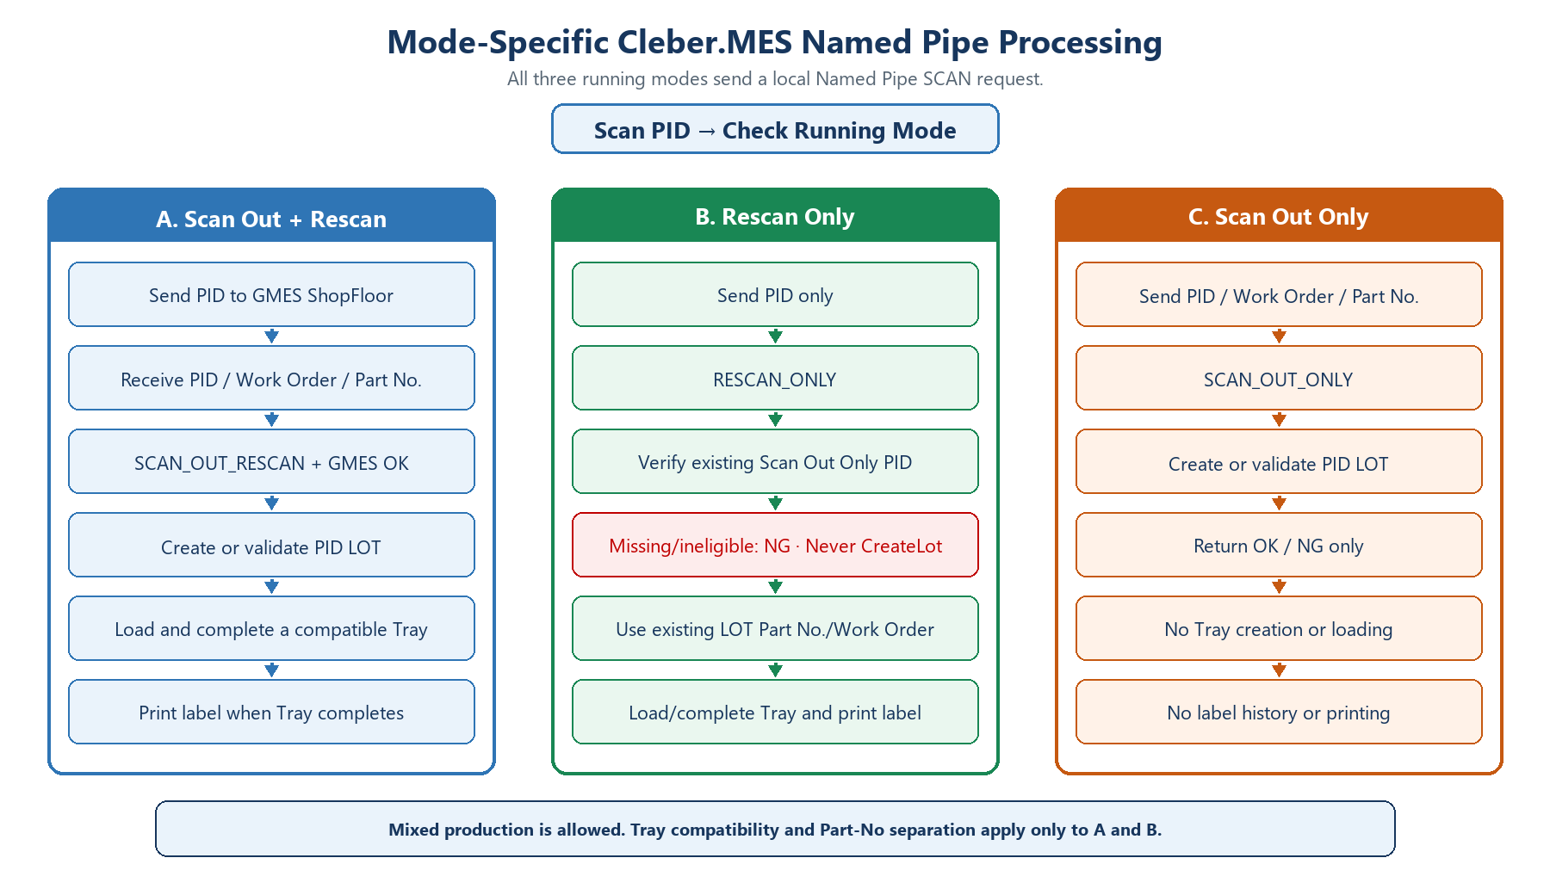
Figure 1. Revised scan process by running mode

2.1 Cleber.MES Client Screen Behavior
- The IVI Scan Out screen must remain open, but neither application needs keyboard focus during Named Pipe processing. A request may be temporarily rejected while the screen is closing, a blocking popup is open, or another Pipe request is being processed.
- Line, Operation, and Lane remain selectable on the IVI Scan Out screen. Cleber.MES uses the dropdown values selected when the request is received. Closing and reopening the screen initializes them from the Client Option defaults.
- Screen layout Set Window Layout to Maximized and Max Size Form to True. The MDI parent then starts maximized and the IVI Scan Out child fills the Client work area.
- Product is not required before STATUS. For SCAN_OUT_RESCAN and SCAN_OUT_ONLY, Cleber.MES uses request.partNo. For RESCAN_ONLY, IVI Scan Out Tool sends PID only; after confirming that the PID has an eligible existing Scan Out Only result, Cleber.MES reads Part No. and Work Order from the existing LOT. A different Part No. is accepted. Tray selection and display are changed only for SCAN_OUT_RESCAN and RESCAN_ONLY; SCAN_OUT_ONLY does not select or load a Tray.
- Mixed-production rule The multi-Tray screen allows consecutive Part No. changes and separates or reuses compatible Trays. The single-Tray screen allows only one OPEN Tray for the selected Line, Operation, and Lane. If SCAN_OUT_RESCAN receives another Part No. while that Tray is OPEN, Cleber.MES creates and commits the PID LOT using SCAN_OUT_ONLY semantics, but does not create or load another Tray. The existing OPEN Tray remains unchanged, and the response is success=false, partChanged=true, resultCode=PART_NO_CHANGED.
- The incoming PID is displayed in LOT SCAN. For SCAN_OUT_RESCAN and RESCAN_ONLY, refresh the current Tray, Tray quantity, PID Scan Count, and selected Tray LOT list after processing. For SCAN_OUT_ONLY, display only the OK/NG processing result and do not change the current Tray or Tray lists. Open and completed Tray history is limited to the current day, and the scanned-LOT list is limited to 500 rows.
- TRAY +1/-1 adjusts the Tray loading capacity. TRAY Scan is a separate manual input for selecting or scanning a Tray ID.
- Tray completion and IVI_MATERIAL_TAG_LABEL printing apply only to SCAN_OUT_RESCAN and RESCAN_ONLY. When a Tray reaches capacity or the operator uses TRAY Complete, Cleber.MES completes the Tray and prints the label. SCAN_OUT_ONLY never loads or completes a Tray and never prints a label. An unfinished Tray may be resumed from Open TRAY List or TRAY Scan.
- Label-history rule For Tray-producing modes only, history is saved once after the physical label prints successfully. If history saving fails, Cleber.MES logs and skips that failure without retries or a local recovery file; it does not roll back the completed production result or the physical print. A later Re Print may produce another physical label.
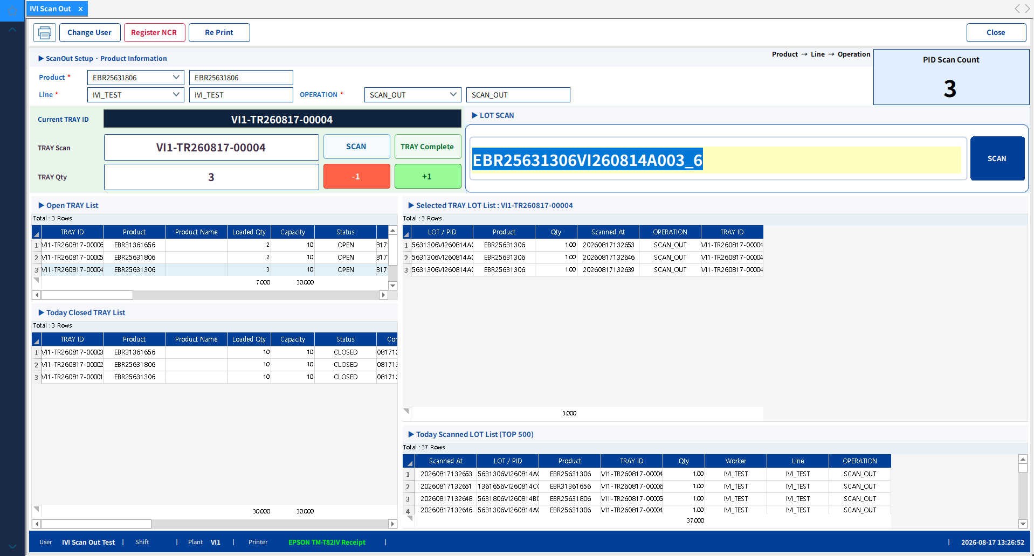
Figure 2. IVI Scan Out screen ready for a Named Pipe request
Expected STATUS result (VI1 development test environment)
success : True
ready : True
resultCode : READY
plantCode : VI1
lineCode : IVI_TEST
operationCode : SCAN_OUT
laneCode : 1
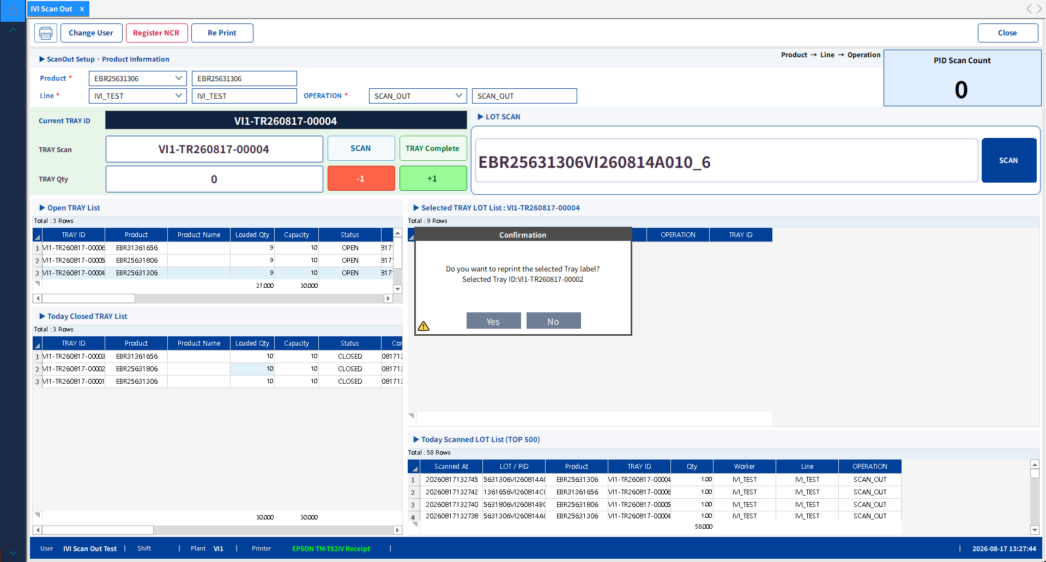
Figure 3. Label reprint confirmation popup shown after clicking Re Print
Label reissue (SCAN_OUT_RESCAN and RESCAN_ONLY only) If paper runs out or not all labels are printed, restore the printer condition, select the completed Tray in current-day history, and click Re Print. A reissue can create a physical duplicate, so verify the Tray ID. SCAN_OUT_ONLY has no completed Tray or label.

2.2 Startup and Scan Flow
- Check that GMES ShopFloor is ready only when SCAN_OUT_RESCAN is selected. RESCAN_ONLY and SCAN_OUT_ONLY do not require a GMES result.
- Send STATUS to Cleber.MES Client and confirm ready=true.
- Read the selected running mode and map it to SCAN_OUT_RESCAN, RESCAN_ONLY, or SCAN_OUT_ONLY.
- For SCAN_OUT_RESCAN, send PID to GMES and read PID, Work Order, and Part No. Send SCAN only after GMES returns OK. In multi-Tray mode, Cleber.MES creates or validates the PID LOT and loads it into a compatible Tray. In single-Tray mode, a Part No. different from the current OPEN Tray is created as a PID LOT but is not loaded into a Tray; PART_NO_CHANGED is returned as a business NG.
- For RESCAN_ONLY, send PID only without a GMES result, Work Order, or Part No. Cleber.MES must confirm that the PID already exists as an eligible Scan Out Only result. If it does not exist or is not eligible, return NG. Never call CreateLot in RESCAN_ONLY.
- For SCAN_OUT_ONLY, send PID, Work Order, and Part No. through the Named Pipe. Cleber.MES creates or validates the PID LOT and returns OK or NG. It does not select, load, or complete a Tray and does not save or print a label.
- For RESCAN_ONLY, Cleber.MES obtains Part No. and Work Order only from the existing PID LOT. Do not derive Part No. from PID characters and do not use request values to create a LOT.
- PID is required in every mode. Work Order and Part No. are required for SCAN_OUT_RESCAN and SCAN_OUT_ONLY and must match the applicable Line/flow. RESCAN_ONLY accepts PID only and uses the existing LOT's Work Order and Part No.
- Update the final UI and log from success, completed, partChanged, resultCode, and message. PART_NO_CHANGED is a business NG after successful PID LOT creation; SCAN_FAILED is reserved for an actual MES service failure.
Integration boundary SCAN_OUT_RESCAN keeps the existing Virtual COM and GMES/UIAutoLib flow and calls Named Pipe after GMES OK. RESCAN_ONLY calls Named Pipe with PID only and can process only an eligible existing Scan Out Only PID; it never creates a LOT. SCAN_OUT_ONLY calls Named Pipe with PID, Work Order, and Part No. and creates or validates the LOT only. Tray completion and label processing apply only to SCAN_OUT_RESCAN and RESCAN_ONLY. In the single-Tray service, a SCAN_OUT_RESCAN Part No. change creates the PID LOT but skips Tray creation/loading and returns PART_NO_CHANGED.

3. Required IVI Scan Out Tool Changes
Action | Component | Scope | Developer task
Keep | Serial Scanner / Scan Queue | PID input, duplicate prevention, sequential processing | Keep current behavior
Keep | Virtual Serial / SerialPortProxy | Send PID to GMES ShopFloor | Keep current behavior for SCAN_OUT_RESCAN
Keep | UIAutoLib / IShopFloorService | A: read GMES result, PID, WO, and Part No.; B: PID only; C: obtain PID, WO, and Part No. | Use mode-specific source data
Keep | RF Block validation | Block before sending to GMES | Keep current policy
Keep | Running Mode | Scan Out + Rescan / Rescan Only / Scan Out Only | Map each mode to the runMode contract
Remove | HMES Oracle processing | IScanDataService and DataExecuter DB transfer | Remove calls, registration, and references
Remove | HMES Web / Chrome | WebElement transfer, Chrome result check, refresh timer | Remove related UI and services
Remove | HMES Magazine controls | Manual Magazine, HMES Save Label, and HMES Print | Remove related UI, commands, and states
Remove | HMES Block branch | HmesBlockAction, CheckHmesBlock, Skip Web | Remove after-GMES HMES branches
Change | Session Part No. validation | Multi-Tray: allow consecutive Part No. changes / Single-Tray: create the LOT, then return PART_NO_CHANGED when the current OPEN Tray has another Part No. | Branch by response fields; do not classify it as SCAN_FAILED
Add | IVIPipe DLL | STATUS/SCAN/TRAY_COMPLETE JSON communication | Reference IVIPipe and retain Newtonsoft.Json 13.0.3
Add | Response handling | A/B: Tray quantity/completion; C: OK/NG; Single-Tray Part No. change: LOT created without Tray loading | Interpret success/completed/partChanged/resultCode/message
Add | Retry control | One retry with the same messageId on communication failure | Do not generate a new ID

3.1 Recommended File-Level Changes
- ScanOutTool.csproj: add an Assembly Reference to HSSMES.Cleber.MES.Client.IVIPipe.dll and retain the existing Newtonsoft.Json 13.0.3 PackageReference.
- DashboardViewModel.cs: preserve the running-mode branch and replace the applicable HMES calls with Named Pipe SCAN calls.
- DashboardPage.xaml: keep the running-mode selection, but remove HMES Magazine, Web, and related state sections.
- ScanOutTool.csproj: remove the old DataExecuter ProjectReference only after no code uses it.
Safe removal order Implement and test the Named Pipe flow first. After a successful build and integration test, remove HMES classes, controls, and settings only when reference search returns zero results.

4. Named Pipe Contract
Item | Value | Implementation rule
Pipe name | Cleber.MES.IVIScanOut | Use this name in C#
Windows path | \\.\pipe\Cleber.MES.IVIScanOut | For diagnostics and documentation
Execution | Same PC / same Windows user | Run the Tool and Client under the same account
Access control | Current user and local administrators allowed / Network denied | Remote network access is blocked
Encoding | UTF-8 without BOM | Same for request and response
Framing | One-line JSON + newline | Use WriteLine / ReadLine
Connection | One request per connection | Close after reading one response
Timeout | Connect 3 sec / SCAN or TRAY_COMPLETE total 60 sec | Allow for UI and label processing
Focus | Not required | Background processing is supported while the screen is open

Cleber readiness The Cleber.MES Client IVI Scan Out screen must be open, and Line, Operation, and Lane must be configured. Product is not a STATUS readiness condition. Do not send Line, Operation, Lane, or Equipment in SCAN or TRAY_COMPLETE requests.

4.1 STATUS
Send STATUS at startup and after reconnection. Start PID processing only when ready=true. If ready=false, stop scanning and display the returned message.
{"version":"1.0","type":"STATUS","messageId":"f91df9c3d72c4fa0a80f47ce7e164a20"}
{"version":"1.0","type":"STATUS_RESULT",
"messageId":"f91df9c3d72c4fa0a80f47ce7e164a20",
"success":true,"ready":true,"completed":false,
"resultCode":"READY",
"message":"MES Client is ready to receive IVI ScanOut requests.",
"plantCode":"VI1","lineCode":"IVI_TEST",
"operationCode":"SCAN_OUT","laneCode":"1"}

5. SCAN Request Data and TRAY_COMPLETE Contract
Field | Required | Format / example | Transmission rule
version | Y | 1.0 | Fixed value
type | Y | SCAN | Fixed value
runMode | Y | SCAN_OUT_RESCAN / RESCAN_ONLY / SCAN_OUT_ONLY | Set from the Tool running mode
messageId | Y | GUID N format | Generate once for each PID
pid | Y | Scanner PID | PID to be processed
workOrder | Conditional | Work Order | Required for SCAN_OUT_RESCAN and SCAN_OUT_ONLY; omit for RESCAN_ONLY
partNo | Conditional | Part No. | Required for SCAN_OUT_RESCAN and SCAN_OUT_ONLY; omit for RESCAN_ONLY
gmesResult | Conditional | OK | Required only for SCAN_OUT_RESCAN; omit for the other modes
gmesMessage | N | GMES message | Optional for SCAN_OUT_RESCAN only
scanTime | N | yyyy/MM/dd HH:mm:ss | Time of scan processing

Do not send Do not include Line, Operation, Lane, or Equipment in the SCAN request. Cleber.MES Client uses the current values selected on its screen and returns lineCode, operationCode, and laneCode only in the response.
Running-mode rules SCAN_OUT_RESCAN requires PID, Work Order, Part No., and GMES OK; it creates or validates the LOT and normally performs Tray/label processing. In the single-Tray service, if the current OPEN Tray has another Part No., the LOT is created but Tray creation/loading is skipped and PART_NO_CHANGED is returned. RESCAN_ONLY sends PID only; it requires an eligible existing Scan Out Only PID, never calls CreateLot, and uses the existing LOT's Part No. and Work Order for Tray/label processing. SCAN_OUT_ONLY requires PID, Work Order, and Part No.; it creates or validates the LOT but never performs Tray or label processing.

5.1 SCAN Request Example
{"version":"1.0","type":"SCAN",
"runMode":"SCAN_OUT_RESCAN",
"messageId":"7402235f7a3645898e8d68f25902a8ab",
"pid":"IVITEST0001VI2608210001",
"workOrder":"IVI-WO-260821-A01",
"partNo":"IVITEST0001",
"gmesResult":"OK",
"gmesMessage":"GMES ScanOut OK",
"scanTime":"2026/08/21 16:38:33"}

5.2 RESCAN_ONLY Request Example
{"version":"1.0","type":"SCAN",
"runMode":"RESCAN_ONLY",
"messageId":"f21ba84b97fc4c94a9ac83d569e87fb1",
"pid":"IVITEST0002VI2608210002",
"scanTime":"2026/08/21 16:40:10"}

5.3 SCAN_OUT_ONLY Request Example
{"version":"1.0","type":"SCAN",
"runMode":"SCAN_OUT_ONLY",
"messageId":"c31ba84b97fc4c94a9ac83d569e87fc2",
"pid":"IVITEST0002VI2608210002",
"workOrder":"IVI-WO-260821-C01",
"partNo":"IVITEST0002",
"scanTime":"2026/08/21 16:41:10"}

5.4 Tray Response Example (A/B)
{"version":"1.0","type":"SCAN_RESULT",
"messageId":"7402235f7a3645898e8d68f25902a8ab",
"pid":"IVITEST0001VI2608210001",
"success":true,"ready":true,"completed":false,
"resultCode":"OK","message":"PID processing completed successfully.",
"trayId":"VI1-TR260821-00001",
"currentQty":1,"maxQty":48,
"plantCode":"VI1","lineCode":"IVI_TEST",
"operationCode":"SCAN_OUT","laneCode":"1"}

5.5 SCAN_OUT_ONLY Response Example
{"version":"1.0","type":"SCAN_RESULT",
"messageId":"c31ba84b97fc4c94a9ac83d569e87fc2",
"pid":"IVITEST0002VI2608210002",
"success":true,"ready":true,"completed":false,
"resultCode":"OK","message":"PID processing completed successfully.",
"trayId":"","currentQty":0,"maxQty":0,
"plantCode":"VI1","lineCode":"IVI_TEST",
"operationCode":"SCAN_OUT","laneCode":"1"}

5.6 Single-Tray Part No. Change Response Example
{"version":"1.0","type":"SCAN_RESULT",
"messageId":"d41ba84b97fc4c94a9ac83d569e87fd3",
"pid":"IVITEST0002VI2608270003",
"workOrder":"IVI-WO-260827-B01",
"partNo":"IVITEST0002",
"success":false,"ready":true,"completed":false,
"partChanged":true,"resultCode":"PART_NO_CHANGED",
"message":"The MES PID was created, but no Tray was created because the Part No. differs from the current Tray.",
"trayId":"VI1-TR260827-00001",
"currentQty":7,"maxQty":48,
"plantCode":"VI1","lineCode":"IVI_TEST",
"operationCode":"SCAN_OUT","laneCode":"1"}

5.7 TRAY_COMPLETE Request
Send this request when IVI Scan Out Tool asks Cleber.MES to close the current OPEN Tray. type, runMode, and messageId are required. trayId is optional: an empty value means the current OPEN Tray; a non-empty value must match the current OPEN Tray. Use a new messageId for each logical completion and reuse the same ID only for one retry.
{"version":"1.0","type":"TRAY_COMPLETE",
"runMode":"SCAN_OUT_RESCAN",
"messageId":"80124eee934a43e2920fcbc86d0a93f3",
"trayId":""}

5.8 TRAY_COMPLETE Response
{"version":"1.0","type":"TRAY_COMPLETE_RESULT",
"messageId":"80124eee934a43e2920fcbc86d0a93f3",
"success":true,"ready":true,"completed":true,
"resultCode":"COMPLETED","message":"Tray completion succeeded.",
"trayId":"VI1-TR260831-00005","currentQty":2,"maxQty":8,
"partNo":"EBR27425801","plantCode":"VI1",
"lineCode":"MAN-02","operationCode":"SCAN_OUT","laneCode":"2"}
Result rules COMPLETED means Tray close and label output succeeded. COMPLETED_LABEL_FAILED means the Tray was closed but label output failed; do not resend completion as a new operation and use Re Print. RUN_MODE_REQUIRED, UNSUPPORTED_RUN_MODE, MESSAGE_ID_REQUIRED, MESSAGE_ID_CONFLICT, NOT_READY, NO_OPEN_TRAY, TRAY_MISMATCH, TRAY_COMPLETE_FAILED, and TRAY_COMPLETE_ERROR are failures with success=false. Branch on success, completed, and resultCode; do not parse message text.

6. Response and Message Handling
Condition | Meaning | IVI Scan Out Tool action
success=false / PART_NO_CHANGED / partChanged=true | MES PID LOT creation succeeded; no new Tray was created or loaded because the current OPEN Tray has another Part No. | Show the mixing/NG alarm; keep the current OPEN Tray and retry the PID after that Tray is completed
success=false / SCAN_FAILED | MES service processing failed, including CreateLot | Show NG; log resultCode/message and identify the cause
success=true / completed=false | A/B: Tray remains OPEN; C: LOT create/validation succeeded without a Tray | A/B update trayId/quantity; C show OK only
success=true / completed=true | Tray completed in SCAN_OUT_RESCAN or RESCAN_ONLY | Show completion; record trayId; display the returned message
ready=false | Cleber screen cannot process | Stop scanning and recheck with STATUS
GMES_NOT_OK | SCAN_OUT_RESCAN did not receive GMES OK | Show NG; do not retry as RESCAN_ONLY
RESCAN_ONLY existing PID check failed | No eligible existing Scan Out Only result | Show NG; do not call CreateLot
SCAN_OUT_ONLY success | LOT created or validated; no Tray/label | Show OK/NG only and ignore Tray fields
MESSAGE_ID_CONFLICT | Same ID used with another PID | Correct the request and start a new PID transaction
success=true / TRAY_COMPLETE_RESULT | Current OPEN Tray completed | Record trayId/quantity; if COMPLETED_LABEL_FAILED, use Re Print
RUN_MODE_REQUIRED / NO_OPEN_TRAY / TRAY_MISMATCH | Invalid Tray-completion request | Display NG and correct request or screen state before retrying
TRAY_COMPLETE_FAILED / TRAY_COMPLETE_ERROR | Tray close service or exception failure | Display NG; log resultCode/message; do not assume completion

6.1 Decision and Retry Rules
- Create messageId once immediately before processing one PID.
- On timeout or a broken pipe, retry once with the same request object and messageId.
- Never generate a new messageId during retry because a successful request could be inserted twice.
- If the same messageId is sent with a different PID, handle MESSAGE_ID_CONFLICT as a failure.
- Branch only by success, ready, completed, partChanged, and resultCode. Never parse or compare message text. Handle PART_NO_CHANGED before the generic failure branch; it means the PID LOT was created successfully but Tray creation/loading was skipped.

6.2 Responsibility Boundary
- IVI Scan Out Tool: A sends PID, Work Order, Part No., and GMES OK; B sends PID only; C sends PID, Work Order, and Part No. without a GMES result. All modes call the supplied Named Pipe API.
- Cleber.MES Client: A creates or validates the LOT and performs Tray/label processing. In the single-Tray service, if A receives a different Part No. while one Tray is OPEN, it commits the PID LOT, keeps the existing Tray, skips Tray creation/loading, and returns PART_NO_CHANGED. B verifies an eligible existing Scan Out Only PID, never creates a LOT, reads Part No./Work Order from the existing LOT, and performs Tray/label processing. C creates or validates the LOT only and never performs Tray/label processing.
- RESCAN_ONLY must not derive Part No. from PID text, must not accept request Part No./Work Order as creation data, and must never call CreateLot. Tray compatibility and mixed-production separation apply only to A and B.

7. Library Reference Method
Delivered item | Purpose | IVI Scan Out Tool usage
HSSMES.Cleber.MES.Client.IVIPipe.dll | Runtime Class Library | Add as an Assembly Reference
Newtonsoft.Json 13.0.3 | Existing JSON serialization package | Keep the current PackageReference
Change specification | Call point, contract, and test criteria | Use as implementation and review baseline

Reference rule Put IVIPipe.dll in the Tool's Lib folder, add it as an Assembly Reference, and enable Copy Local. Keep the existing Newtonsoft.Json 13.0.3 PackageReference; do not copy Newtonsoft.Json.dll 9.0.1 into the same output folder.

7.1 ScanOutTool.csproj Reference Example
<ItemGroup>
<Reference Include="HSSMES.Cleber.MES.Client.IVIPipe">
<HintPath>Lib\HSSMES.Cleber.MES.Client.IVIPipe.dll</HintPath>
<Private>true</Private>
</Reference>
</ItemGroup>
<ItemGroup>
<PackageReference Include="Newtonsoft.Json" Version="13.0.3" />
</ItemGroup>

7.2 Public API and Dependency Scope
- ICleberMesPipeClient: communication interface used by IVI Scan Out Tool.
- CleberMesPipeClient: STATUS/SCAN/TRAY_COMPLETE, JSON conversion, timeout, and retry.
- IVIScanOutPipeRequest/Response: request and response DTOs. The request DTO includes TrayId for TRAY_COMPLETE.
- IVIScanOutPipeConstants exposes the three RunMode constants plus RequestTypeTrayComplete and ResponseTypeTrayCompleteResult. The Tool must send runMode for every SCAN and TRAY_COMPLETE request.
- IVIScanOutPipeServer: internal to Cleber.MES Client; do not create or call it from the Tool.
- IVIPipe.dll was built against Newtonsoft.Json 9.0.1 and has been verified with the IVI Scan Out Tool's existing Newtonsoft.Json 13.0.3 PackageReference.
- Keep Newtonsoft.Json 13.0.3 as the single runtime version. Do not copy or reference Newtonsoft.Json.dll 9.0.1 in the Tool project at the same time.
- No additional Named Pipe package is required.

8. Example - Calling the Supplied DLL
The supplied DLL handles Named Pipe connection, JSON serialization, timeout, and one retry with the same messageId for SCAN and TRAY_COMPLETE. IVI Scan Out Tool calls only the public API shown below.
using HSSMES.Cleber.MES.Client.IVIPipe;
using System;
using System.Threading.Tasks;
public sealed class CleberMesService
{
private readonly ICleberMesPipeClient _client;
public CleberMesService(ICleberMesPipeClient client)
{
_client = client;
}
public Task<IVIScanOutPipeResponse> GetStatusAsync()
{
return _client.GetStatusAsync();
}
public Task<IVIScanOutPipeResponse> SendScanAsync(
string runMode, string pid, string workOrder, string partNo,
string gmesResult, string gmesMessage)
{
IVIScanOutPipeRequest request = new IVIScanOutPipeRequest
{
Version = "1.0",
Type = "SCAN",
RunMode = runMode,
MessageId = Guid.NewGuid().ToString("N"),
PID = pid,
WorkOrder = workOrder,
PartNo = partNo,
GmesResult = gmesResult,
GmesMessage = gmesMessage,
ScanTime = DateTime.Now.ToString(
"yyyy/MM/dd HH:mm:ss")
};
return _client.SendScanAsync(request);
}
}

8.1 TRAY_COMPLETE Call Example
public Task<IVIScanOutPipeResponse> CompleteTrayAsync(
string runMode, string trayId)
{
IVIScanOutPipeRequest request = new IVIScanOutPipeRequest
{
Version = IVIScanOutPipeConstants.ProtocolVersion,
Type = IVIScanOutPipeConstants.RequestTypeTrayComplete,
RunMode = runMode,
MessageId = Guid.NewGuid().ToString("N"),
TrayId = trayId ?? string.Empty
};
return _client.SendTrayCompleteAsync(request);
}

9. Example - DashboardViewModel Integration
Preserve the running-mode branch and call the supplied DLL in all three SCAN modes. Use SendTrayCompleteAsync when IVI Scan Out Tool requests the current OPEN Tray to close; this request is independent from the PID SCAN request and must include the selected runMode.
private readonly ICleberMesPipeClient _cleberMesPipeClient;
private async Task SendToCleberMesAsync()
{
IVIScanOutPipeRequest request = new IVIScanOutPipeRequest
{
Version = "1.0",
Type = "SCAN",
MessageId = Guid.NewGuid().ToString("N"),
PID = PID,
ScanTime = DateTime.Now.ToString("yyyy/MM/dd HH:mm:ss")
};
if (SelectedRunningMode == RunningMode.ScanOutAndRescan)
{
request.RunMode = IVIScanOutPipeConstants.RunModeScanOutRescan;
request.WorkOrder = WorkOrder;
request.PartNo = PartNo;
request.GmesResult = Result;
request.GmesMessage = ResultMessage;
}
else if (SelectedRunningMode == RunningMode.RescanOnly)
{
request.RunMode = IVIScanOutPipeConstants.RunModeRescanOnly;
request.WorkOrder = string.Empty;
request.PartNo = string.Empty;
request.GmesResult = string.Empty;
request.GmesMessage = string.Empty;
}
else
{
request.RunMode = IVIScanOutPipeConstants.RunModeScanOutOnly;
request.WorkOrder = WorkOrder;
request.PartNo = PartNo;
request.GmesResult = string.Empty;
request.GmesMessage = string.Empty;
}
IVIScanOutPipeResponse response =
await _cleberMesPipeClient.SendScanAsync(request);
if (!response.Success)
{
if (response.PartChanged &&
response.ResultCode == "PART_NO_CHANGED")
{
ShowMixingAlarm(response.Message);
return;
}
// SCAN_FAILED and other actual MES failures
ShowWarningMessage($"{response.ResultCode}: {response.Message}");
return;
}
if (SelectedRunningMode == RunningMode.ScanOutOnly)
{
InformationMessage = response.Message;
return;
}
InformationMessage = response.Completed
? $"TRAY completed: {response.TrayId} - {response.Message}"
: $"{response.TrayId} ({response.CurrentQty}/{response.MaxQty}) - {response.Message}";
}
Do not reimplement Do not implement NamedPipeClientStream, JSON DTOs, or retry logic again in IVI Scan Out Tool. Use only the public API in the supplied DLL.

10. Acceptance Criteria
No. | Test | Pass criteria
1 | STATUS ready | ready=true and resultCode=READY
2 | Scan Out + Rescan / GMES NG | GMES_NOT_OK; no LOT, Tray, or label processing
3 | Scan Out + Rescan / GMES OK | PID, Work Order, Part No., and GMES OK are sent; LOT is created or validated; Tray quantity is updated; completion prints the label
4 | Rescan Only / existing PID | PID only is sent; an eligible existing Scan Out Only result supplies Work Order and Part No.; CreateLot is never called; Tray/label processing succeeds
5 | Rescan Only / missing PID | A missing or ineligible existing Scan Out Only PID returns NG; no LOT, Tray, or label is created
6 | Scan Out Only | PID, Work Order, and Part No. create or validate the LOT and return OK/NG; trayId is empty, quantities are zero, and no label is printed
7 | TRAY completion (A/B only) | completed=true with completed TRAY ID and message; completion label is printed
8 | Not-ready state | Screen/Line/Operation/Lane issue returns ready=false
9 | Communication retry | One retry with the same messageId causes no duplicate processing
10 | Background processing | Request succeeds while Client has no focus and the screen remains open
11 | HMES cleanup | No Oracle/Web/Chrome/Magazine references remain
12 | Label paper-out recovery (A/B only) | Completed production remains and Re Print works from current-day completed-Tray history
13 | Mixed-production Part No. change (A/B Tray modes) | A(SCAN_OUT_RESCAN) → B(RESCAN_ONLY) → A(SCAN_OUT_RESCAN) succeeds with compatible Tray separation/reuse; the preparatory C request creates no Tray
14 | Mode-specific request fields | A requires PID/WO/Part No./GMES OK; B sends PID only; C requires PID/WO/Part No. without a GMES result
15 | Single-Tray / SCAN_OUT_RESCAN Part No. change | The PID LOT is created and committed, but no new Tray is created or loaded; the existing OPEN Tray remains; success=false, completed=false, partChanged=true, resultCode=PART_NO_CHANGED
16 | MES service processing failure | Only an actual service failure such as CreateLot returns success=false and resultCode=SCAN_FAILED; it is distinct from PART_NO_CHANGED
17 | TRAY_COMPLETE without trayId | Completes the current OPEN Tray; type=TRAY_COMPLETE_RESULT; success=true; completed=true
18 | TRAY_COMPLETE with matching trayId | Completes only the matching current OPEN Tray and returns its final quantity/capacity
19 | TRAY_COMPLETE validation | Missing runMode, no OPEN Tray, or mismatched trayId returns the documented failure resultCode
20 | TRAY_COMPLETE retry | Same request/messageId returns the cached completion response; a conflicting request returns MESSAGE_ID_CONFLICT
21 | Label failure after completion | completed=true and resultCode=COMPLETED_LABEL_FAILED; operator can use Re Print

