PARTNER SETUP GUIDE
Cleber.MES Client
Setup & Named Pipe Test Guide
IVI Scan Out Tool Integration | DEV / VI1 Development Test Environment | V1.2 | 2026-08-21
Item | Value
Target machine | IVI Scan Out machine
Cleber screen | IVI Scan Out
Named Pipe | \\.\pipe\Cleber.MES.IVIScanOut
Test account | VI1 / IVI_TEST / Password: 1
Document date | 2026-08-21

Deployment answer Cleber.MES Client must be installed on the same scan-out machine as IVI Scan Out Tool. The IVI Scan Out screen must remain open, but the Cleber.MES Client window does not need keyboard focus.

1. Package Contents
Folder | Purpose
01_SetupKit | Cleber.MES.Client.SetupKit.exe
02_Documentation | Change specification and this setup/test guide
03_IVIPipe_Library | .NET Framework 4.6.1 IVIPipe DLL and Newtonsoft.Json dependency

2. Prerequisites
Requirement | Required value
Operating system | Windows 10 or Windows 11
Runtime | .NET Framework 4.6.1 or later
Machine | Same PC as IVI Scan Out Tool
Windows session | Both applications run under the same logged-in Windows user
MES server access | Cleber.MES message server at 10.7.20.122 is reachable
Screen authorization | VI1 / IVI_TEST_GROUP / IVI Scan Out

Named Pipe scope The Pipe is local to the Windows PC. It is not a TCP service and is not accessed by another computer.

3. Install Cleber.MES Client
- Copy the delivered folder to the IVI Scan Out machine.
- Close Cleber.MES Client if it is already running.
- Open 01_SetupKit and run Cleber.MES.Client.SetupKit.exe.
- Confirm that the application is installed under %APPDATA%\Lisner\Cleber.MES.Client.
- Start Cleber.MES Client from the installed shortcut or MES.Client.exe.
Install path The per-user default is C:\Users\<WindowsUser>\AppData\Roaming\Lisner\Cleber.MES.Client. Install and run both applications under the same Windows login.
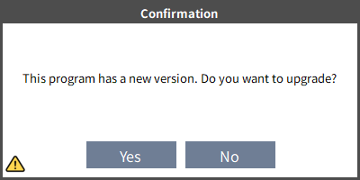
Figure 1. Version confirmation shown at startup
Required upgrade When the new-version prompt appears, select Yes and complete the upgrade. Do not continue with login, option setup, or Named Pipe testing until the upgrade finishes successfully.

4. Login and Test Security
Security item | Configured value
Plant | VI1
User ID | IVI_TEST
Password | 1
Security group | IVI_TEST_GROUP
Allowed screen | IVI Scan Out
Permission type | Normal, minimum screen permission

Test authorization relationship In the VI1 development test environment, IVI_TEST must belong to IVI_TEST_GROUP, and that group must be authorized to open the IVI Scan Out screen. No database query or authorization script is included in the delivery folder.
Test use only IVI_TEST is a dedicated integration-test account. Do not reuse it as an operator or administrator account.
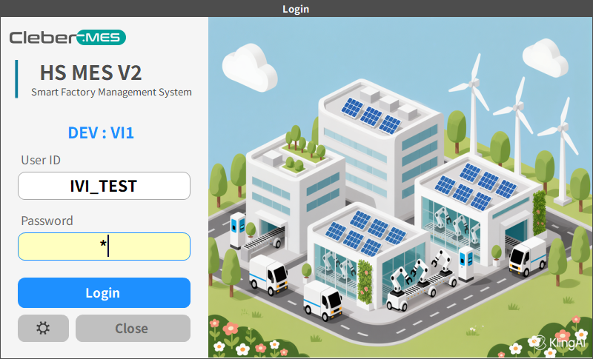
Figure 2. Login with the IVI_TEST account

5. Verify Client Connection Options
Open Option from the login screen or the Client menu and configure the values below. Verify the selected detail values rather than the Server Connection List at the top. Apply the settings and restart the Client. A restart is also required after changing Language.
Option | Value | Rule
Site ID | DEV | VI1 development connection profile
Server Address | 10.7.20.122 | Cleber.MES message server
Plant Code | VI1 | Development test Plant
Language | English | English document capture; restart after changing
Window Layout | Maximized | Maximize the parent window
Max Size Form | True | Fill the Client area with the MDI child
Shop Code | IVI_TEST | VI1 test Shop
Line Code | IVI_TEST | Required for Pipe READY
Operation Code | SCAN_OUT | Required for Pipe READY
Lane Code | 1 | Required for Pipe READY
Equipment Code | No required value | Do not delete or overwrite an existing equipment setting
Terminal Name | Current computer name | Use the local scan-out computer

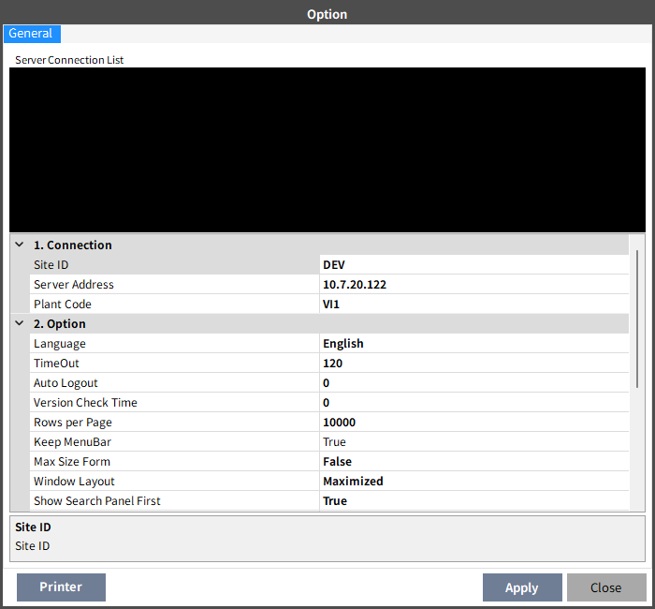
Figure 3. Connection profile and general options
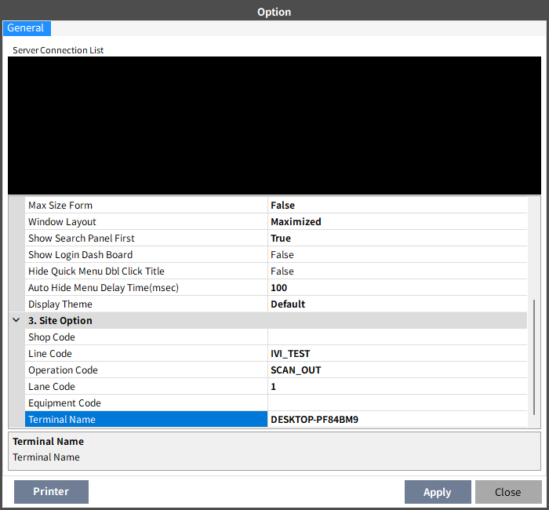
Figure 4. Site options for IVI Scan Out

6. Open and Keep the IVI Scan Out Screen Ready
- Log in with Plant VI1, User ID IVI_TEST, and Password 1.
- Open the screen named IVI Scan Out from the menu.
- Keep the IVI Scan Out screen open during the Named Pipe test.
- Confirm Line IVI_TEST, Operation SCAN_OUT, and Lane 1. Product is not required before STATUS. SCAN_OUT_RESCAN and SCAN_OUT_ONLY use the request Part No.; RESCAN_ONLY uses the Part No. and Work Order stored on the eligible existing Scan Out Only PID LOT. Consecutive Part No. changes are allowed.
- Confirm Window Layout=Maximized and Max Size Form=True so that the MDI child fills the entire Cleber.MES Client work area.
- Do not open a blocking popup while sending a Pipe request.
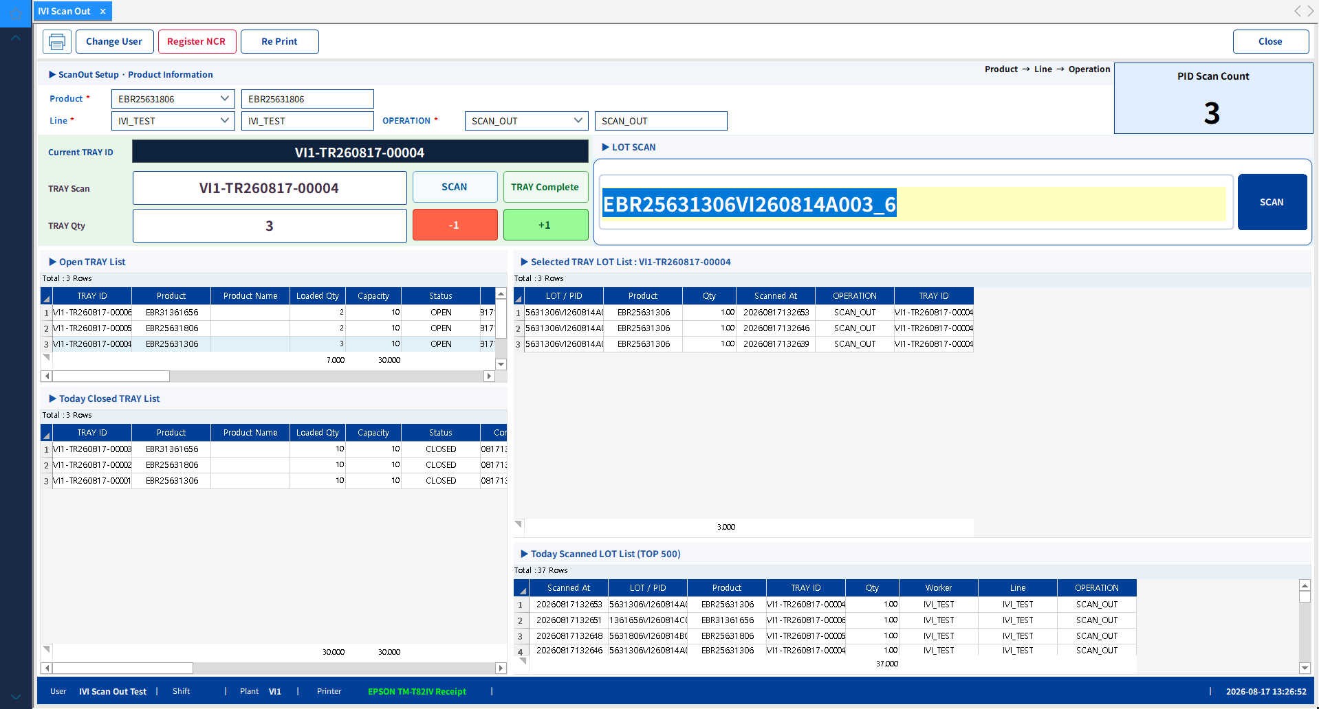
Figure 5. Maximized IVI Scan Out screen ready for Named Pipe requests
Background processing Named Pipe processing continues even when Cleber.MES Client does not have focus. The screen must remain open in the same Windows session.

7. Test the Named Pipe Connection
- Keep the IVI Scan Out screen open in Cleber.MES Client.
- Start IVI Scan Out Tool under the same Windows user.
- Call GetStatusAsync() through the supplied IVIPipe DLL before enabling PID processing.
- Confirm success=true, ready=true, resultCode=READY, plantCode=VI1, lineCode=IVI_TEST, operationCode=SCAN_OUT, and laneCode=1.
- Test all three modes with approved data. For SCAN_OUT_RESCAN, send PID, Work Order, Part No., and GMES OK. For RESCAN_ONLY, send only a PID that already has an eligible Scan Out Only result. For SCAN_OUT_ONLY, send an unused PID, Work Order, and Part No.
Expected STATUS response fields
type : STATUS_RESULT
success : True
ready : True
resultCode : READY
plantCode : VI1
lineCode : IVI_TEST
operationCode : SCAN_OUT
laneCode : 1
Expected result When the IVI Scan Out screen is ready, the Client returns success=true, ready=true, and resultCode=READY for VI1 / IVI_TEST / SCAN_OUT / Lane 1.

8. Running Mode Rules
Mode boundary A and C may create or validate a PID LOT. B must use an eligible existing C result and must never create a LOT. Only A and B perform Tray and label processing.
IVI Tool mode | Named Pipe action | Required source data
Scan Out + Rescan | Send runMode=SCAN_OUT_RESCAN after GMES OK; create/validate LOT, load/complete Tray, print label | PID, Work Order, Part No., GMES OK
Rescan Only | Send runMode=RESCAN_ONLY with PID only; verify existing Scan Out Only result; never CreateLot; then load/complete Tray and print label | Eligible existing PID only
Scan Out Only | Send runMode=SCAN_OUT_ONLY; create/validate LOT only; no Tray or label | PID, Work Order, Part No.

Rescan Only prerequisite Send PID only. The PID must already exist as an eligible Scan Out Only result. Cleber.MES reads Part No. and Work Order from the existing LOT, never derives Part No. from PID text, and never calls CreateLot. A missing or ineligible PID must return NG.
Mixed-production test First create the B PID with SCAN_OUT_ONLY. Then send A1(SCAN_OUT_RESCAN) → B1(RESCAN_ONLY) → A2(SCAN_OUT_RESCAN). Confirm separate compatible A/B Trays and A2 reuse while the first A Tray is OPEN and not full. SCAN_OUT_ONLY must not create or change a Tray.

9. Troubleshooting
Symptom | Check | Action
Pipe not found / connection timeout | Screen closed or Client under another Windows user | Open IVI Scan Out under the same Windows login and retry STATUS
ready=false / NOT_READY | Line, Operation, Lane, popup, or busy state | Set required values, close the popup, and retry STATUS
Login fails | Site ID, server address, Plant, test account | Verify DEV / 10.7.20.122 / VI1 / IVI_TEST / 1
IVI Scan Out is not visible | VI1 IVI_TEST_GROUP screen authorization | Ask the customer PM or MES administrator to verify authorization
MDI child opens as a window | Window Layout / Max Size Form | Apply Maximized / True and restart the Client
GMES_NOT_OK | SCAN_OUT_RESCAN sent without GMES OK | Stop as NG; do not route it as RESCAN_ONLY
PART_NO_REQUIRED / WORK_ORDER_REQUIRED | SCAN_OUT_RESCAN or SCAN_OUT_ONLY missing Part No./Work Order | Correct the mandatory request data
Work Order validation fails | SCAN_OUT_RESCAN or SCAN_OUT_ONLY Work Order does not match Part No./Line | Send the correct Work Order; do not route it as RESCAN_ONLY
RESCAN_ONLY PID rejected | No eligible existing Scan Out Only result | Show NG; do not retry with creation data and do not call CreateLot
SCAN_OUT_ONLY created a Tray or label | Incorrect mode routing | Stop the test and report a defect; this mode must return OK/NG without Tray/label
Label paper out or incomplete print (A/B only) | Printer, paper, and IVI_MATERIAL_TAG_LABEL | Restore the printer, select the completed Tray, and use Re Print

10. Completion Checklist
- Cleber.MES Client is installed on the IVI Scan Out machine.
- Cleber.MES Client upgrade has been completed before the test.
- DEV / 10.7.20.122 / VI1 development connection is configured.
- IVI_TEST can log in to VI1 and open IVI Scan Out.
- Shop IVI_TEST, Line IVI_TEST, Operation SCAN_OUT, and Lane 1 are configured.
- Window Layout=Maximized and Max Size Form=True are applied, and both the parent and MDI child are maximized.
- STATUS returns success=true and ready=true.
- IVI Scan Out Tool and Cleber.MES Client run under the same Windows user.
- All new IVI Scan Out Tool user-facing messages and logs are implemented in English.
- The A(SCAN_OUT_RESCAN) → B(RESCAN_ONLY) → A(SCAN_OUT_RESCAN) mixed-production sequence succeeds with Part-No-specific Tray separation or reuse. The preparatory SCAN_OUT_ONLY request creates no Tray.
- Mode-specific fields and results are verified. A/C require PID, Work Order, and Part No. B uses only an eligible existing C PID; a missing or ineligible PID returns NG without creating a LOT. C returns OK/NG without a Tray ID, quantity change, label history, or physical label.

11. Label Reissue
Automatic Tray completion, IVI_MATERIAL_TAG_LABEL printing, and Re Print apply only to SCAN_OUT_RESCAN and RESCAN_ONLY. SCAN_OUT_ONLY never creates, loads, or completes a Tray and never prints a label. If an A/B completion label is not fully printed, restore the printer, select the completed Tray in current-day history, and click Re Print.
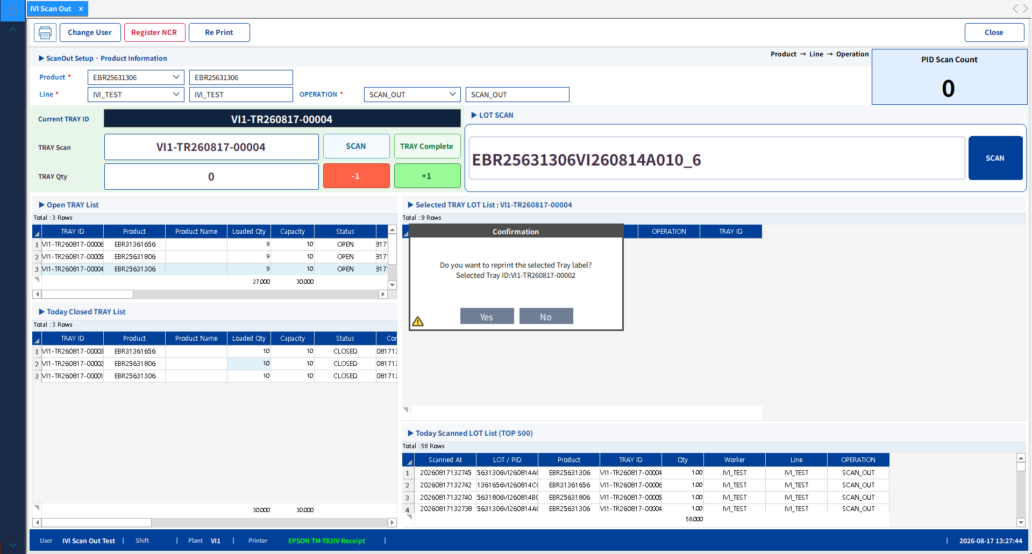
Figure 6. Label reprint confirmation popup shown after clicking Re Print

