 |  | 
CAN THO UNIVERSITY SOFTWARE CENTER
MEKONG DELTA - APTECH

SUNDAY System

Instructor: | Class: CP2496G06
Mrs. | Students:  1. A23048 - Trần Đức Tâm  2. A23000 - Nguyễn Thành Phát  3. A23000 – Nguyễn Tấn Lộc  4. A23056 – Nguyễn Trần Minh Nhựt

PROBLEM DEFINITION OF PROJECT

DT Company a business operating in the field of retailing consumer goods and necessities. The company has no branches and only one address at 01 Ly Tu Trong, Ninh Kieu Ward, Can Tho City and operates according to the online retail supermarket model. Currently, the system is managing the quantity of products sold and products in stock using an excel file.
During traditional operations, supermarkets face many difficulties such as manual inventory management that is prone to errors, slow updating of goods quantity, complex order processing, unclear delivery tracking and heavy dependence on paper exchanges or verbal communication. The lack of connection between the management, warehouse and delivery departments leads to slow processing, loss of goods and reduced customer experience. In addition, customers have to go directly to the supermarket to shop, causing inconvenience in busy situations or when traveling is limited. Therefore, a centralized solution is needed to overcome the above limitations, automate the process and ensure accuracy in management.
The Sunday Supermarket Online Supermarket System was developed to solve the above problems by providing a modern shopping platform where customers can view products, search, add to cart and order online. The system supports administrators in managing products, categories, brands, inventory, orders and assigning delivery people. At the same time, shippers can view delivered orders and update status in real time. With the ability to store data centrally, track orders clearly and operate automatically, Sunday Supermarket provides a more efficient and transparent supermarket management method and significantly enhances the customer shopping experience.
The Sunday Supermarket system serves four main user groups with their own roles and functions:
- Administrator (Admin) manages products, category, brands, inventory, orders, stock transactions, users and assigns shipper.
- Customers can view and search for products, add to cart, place orders, track orders, view purchase history, update personal information and submit product reviews.
- Shipper Delivery personnel are responsible for delivery, view order details and update delivery status.
- Guest can only view products and reviews but cannot place orders or interact deeply with the system.

CUSTOMER REQUIREMENTS SPECIFICATION (CRS)
Name of Project: SUNDAY SYSTEM
- Modeling requirements of customer (Use case Diagram)
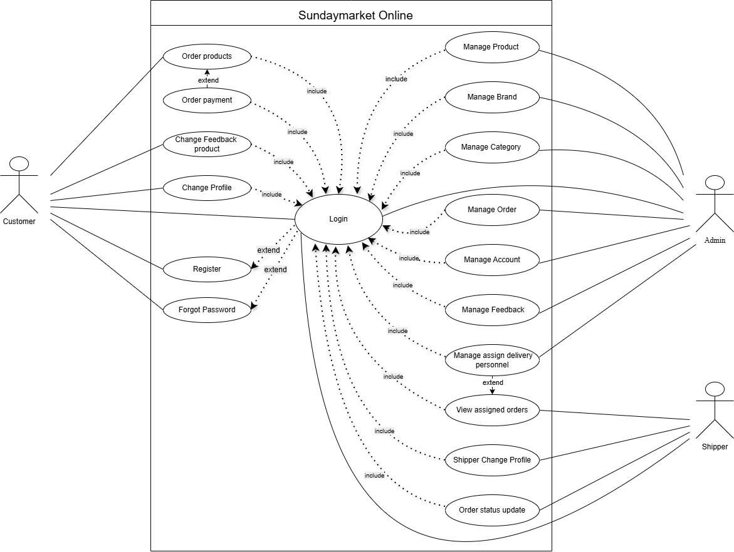

- Actor Description
No. | Actor | Use Case | Description
 | Admin | Login | Administrator logs into the system to access management functions.
 | Admin | Product Management | Administrator manages product information: add, edit, delete, and update products.
 | Admin | Category Management | Administrator manages product categories: create, edit, and delete categories.
 | Admin | Brand Management | Administrator manages product brands: add, edit, and delete brands.
 | Admin | Inventory Management | Administrator manages inventory: tracks the quantity of products in stock.
 | Admin | Create Purchase Order | Administrator creates purchase orders to add more products to inventory.
 | Admin | Stock Transaction Management | Administrator manages stock transactions: stock in, stock out, and inventory adjustments.
 | Admin | User Management | Administrator manages users: view, add, edit, delete, and assign permissions to users.
 | Admin | Assign Shipper | Administrator assigns shippers (delivery personnel) to orders.
 | Admin | Order Management | Administrator manages orders: view, update status, and process orders.
 | Admin | Feedback Management | Administrator manages customer feedback: view, delete, and respond to reviews.
 | Customer | Login | Customer logs into the system to access member-only features.
 | Customer | Browse Products | Customer browses through the list of available products in the system.
 | Customer | Search Products | Customer searches for products by keywords, categories, or other criteria.
 | Customer | View Product Details | Customer views detailed product information including price, description, images, and reviews.
 | Customer | Add to Cart | Customer adds products to the shopping cart for later purchase.
 | Customer | View Cart | Customer views the list of products added to the shopping cart.
 | Customer | Update Cart | Customer updates the quantity or information of products in the shopping cart.
 | Customer | Remove Cart Item | Customer removes products from the shopping cart.
 | Customer | Checkout / Place Order | Customer proceeds with payment and places an order for products in the shopping cart.
 | Customer | View Order History | Customer views the history of previously placed orders.
 | Customer | View Order Details | Customer views detailed information of a specific order.
 | Customer | Give Product Feedback | Customer provides ratings and reviews for purchased products.
 | Customer | Change Profile | Customer updates personal information such as name, address, phone number, and email.
 | Shipper | Login | Shipper logs into the system to access delivery functions.
 | Shipper | View Assigned Deliveries | Shipper views the list of orders assigned for delivery.
 | Shipper | View Delivery Details | Shipper views detailed information of an order to be delivered: address, products, and customer information.
 | Shipper | Update Delivery Status | Shipper updates delivery status: in transit, delivered, delivery failed, etc.
 | Shipper | Shipper Forgot Password | Shipper recovers password if they forgot their login password.
 | Shipper | Shipper Change Profile | Shipper updates personal information such as name, phone number, and address.
 |  | Browse Products | Unregistered users can browse through the list of available products in the system.
 |  | Search Products | Unregistered users can search for products by keywords, categories, or other criteria.
4. | Guest | View Product Details | Unregistered users can view detailed product information.
 |  | Register | Unregistered users can create a new account in the system to become a customer.
 |  | Login | Unregistered users can log into the system if they already have an account.
 |  | Forgot Password | Unregistered users can recover their password if they forgot their login password.

- Use case Description
  - Users Management
Mô-đun này cho phép Quản trị viên quản lý các tài khoản bao gồm: thêm, chỉnh sửa, xóa, xem và tìm kiếm.
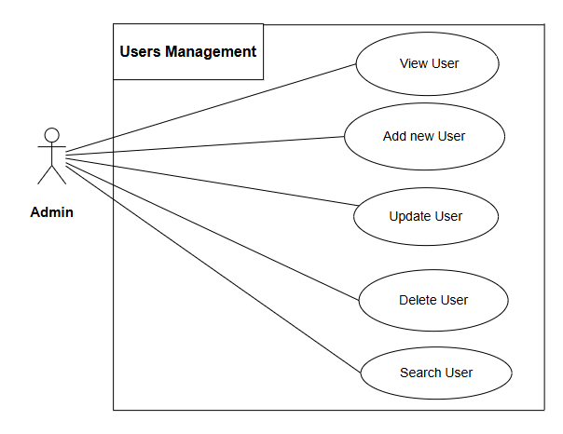
    - View User
      - Mục đích: Chức năng này cho phép Người quản lý xem thông tin người dùng.
      - Đầu vào: không có.
      - Đầu ra : Thông tin người dùng sẽ được hiển thị trên màn hình.

    - Add new Users
      - Mục đích: chức năng này cho phép Người quản lý thêm người dùng mới vào cơ sở dữ liệu
      - Đầu vào:
- Tên đăng nhập
- Mật khẩu
- Phone
- Email
- Ảnh đại diện
- Vai trò
- Trạng thái
      - Đầu ra : Người dùng mới sẽ được thêm vào hệ thống.
    - Update User
      - Mục đích: Chức năng này cho phép Quản lý cập nhật thông tin của người dùng
      - Đầu vào:
- Tên đăng nhập mới
- Mật khẩu mới
- Phone mới
- Email mới
- Ảnh đại diện mới
- Vai trò mới
- Trạng thái mới
      - Đầu ra : thông tin mới sẽ được cập nhật trong bảng User.
    - Delete User
      - Mục đích: chức năng này cho phép Người quản lý xóa tài khoản trong bảng User.
- Đầu vào:
  - ID tài khoản
      - Đầu ra : người dùng sẽ bị xóa trong bảng User.
    - Search User
      - Mục đích: chức năng này cho phép Người quản lý tìm kiếm người dùng trong bảng User.
- Đầu vào:
  - Search input value
      - Đầu ra: Hiển thị danh sách người dùng tương ứng.
  - Register
Mô-đun này cho phép Người dùng đăng ký tài khoản để đăng nhập vào ứng dụng.
- Mục đích: chức năng này cho phép Người dùng đăng ký tài khoản và lưu vào bảng User.
- Đầu vào :
- Tên đăng nhập
- Họ và tên
- Phone
- Email
- Username
- Password
- Đầu ra: thông báo đăng ký tài khoản thành công. Nếu không, hệ thống sẽ báo lỗi và yêu cầu người dùng nhập lại.
  - Change Profile
Mô-đun này cho phép người dùng thay đổi thông tin tài khoản của mình.
- Mục đích: Chức năng này cho phép người dùng thay đổi thông tin để thực hiện đúng.
- Inputs:
- Tên đăng nhập
- Họ và tên
- Phone
- Email
- Username
- Password
- Ảnh đại diện
- Đầu ra: thông tin khách hàng đã được thay đổi
  - Forgot Password
Mô-đun này cho phép người dùng khôi phục mật khẩu đã quên.
- Mục đích : Mô-đun này cho phép người dùng khôi phục mật khẩu đã quên và cập nhật mật khẩu mới
- Đầu vào:
- User name
- Account_ID
- Phone
- New Password
- Đầu ra : Thông báo thay đổi mật khẩu thành công. Nếu sai, bạn sẽ phải thực hiện lại..

- Hardware and Software required for implementing the project
 | Server | Client
Hardware | - Processor: Intel Core i5 or higher  - RAM: Minimum 8GB (16GB recommended)  - Storage: SSD 256GB or higher  - Network: Ethernet 100Mbps+ | - Processor: Intel Core i3 or equivalent  - RAM: Minimum 4GB  - Storage: 128GB or higher
Software | - JDK: Java Development Kit 11+  - Application Server: GlassFish 7.0 (Jakarta EE 10)  - Database: Microsoft SQL Server  - IDE: Apache NetBeans 24+ | - Web Browser:  + Google Chrome 90+  + Mozilla Firefox 88+  + Microsoft Edge 90+
Additional Technology | - Jakarta EE 10 Platform:  + Jakarta Faces (JSF) 4.0  + Jakarta EJB 4.0  + Jakarta Persistence API 3.0  - JDBC Driver: MS JDBC for SQL Server | - CSS3  - JavaScript (ES6+)  - XHTML/Facelets Templates  - JSF AJAX (f:ajax)

CUSTOMER ACCEPTANCE CRITERIA
No. | Customer's Acceptance Criteria
1 | User can register a new account with valid information (username, password, email, full name)
2 | User can login with correct username and password
3 | System correctly assigns access rights based on user role (Admin, Customer, Shipper)
4 | Admin can add, edit, and delete products with complete information (name, description, price, image)
5 | Customer can search products by name and view search results with pagination
6 | Customer can add products to shopping cart and update quantity
7 | Shopping cart calculates total amount correctly including promotions/discounts
8 | Customer can place order from shopping cart successfully
9 | Customer can view order history and track order status
10 | Admin can manage and update order status (Pending, Processing, Shipped, Delivered)
11 | Shipper can view assigned deliveries and update delivery status
12 | System logs all delivery activities with timestamp (DeliveryLog)
13 | Customer can rate products (1-5 stars) and write reviews after purchase
14 | Product pages display average rating and total number of reviews
15 | Admin can create and manage promotions (product discounts, time-based offers)
16 | System automatically applies eligible promotions to orders
17 | Admin can manage inventory and track stock transactions
18 | User can view and update personal profile information and upload avatar

PROJECT PLAN
Project Details
Name of the Client: SUNDAY System.
Date of the Project Plan: 18/11/2025
Project Vision/Objectives:
The Online Supermarket System aims to provide a modern, efficient, and convenient platform for customers to shop for groceries online. The system supports product browsing, ordering, delivery tracking, inventory management, and supplier coordination. It helps streamline supermarket operations by automating stock updates, order processing, delivery assignment, and user account management.
The objective is to create a unified platform that improves shopping experience, reduces manual effort, ensures accurate inventory levels, and supports smooth communication between administrators, customers, and shippers.

Scope :
The scope of the project includes one administrator, multiple customers, and multiple shippers.
The administrator manages products, categories, brands, inventory, purchase orders, stock transactions, users, feedback, and delivery assignments.
Customers can browse products, manage shopping carts, place orders, track deliveries, and submit product feedback.
Shippers can view assigned deliveries and update delivery status.
The system supports essential supermarket functions including product management, order processing, delivery tracking, and feedback handling.
Our understanding of the client organization:
Target Audience:
- Users who want to buy groceries online quickly and conveniently.
- Customers who want home delivery and easy order tracking.
- Administrators who need to manage stock, products, orders, and suppliers efficiently.
- Shippers responsible for delivering orders to customers.
Technology Requirements:
- The system must support user registration and authentication.
- Product browsing, searching, categorization, shopping cart, and checkout features.
- Inventory management with automatic stock updates.
- Delivery management with shipper assignment.
- Feedback system for product reviews.
- Optional integration with online payment services.
Business Model:
- Customers can create accounts and shop freely.
- Revenue is generated through product sales.
- Inventory is managed through supplier purchase orders.
- Delivery costs may be included or charged depending on business rules.
- System helps reduce operational costs by automating processes.
Security:
- User authentication with encrypted passwords.
- Role-based access control (Admin, Customer, Shipper).
- Secure handling of order data and customer personal information.
- Protection against unauthorized access or data manipulation.

Project Organization with Responsibilities and Authorities: (Give the name of Project team members their roles and responsibilities)

No | Member | Roles | Responsibilities
1 | Tran Duc Tam | Leader | Complete Form 1, 6, 9  Complete the login form and register for an account. Complete the function account (User, Role, Notification, Feedback)
2 | Nguyen Tran Minh Nhut | Member | Complete Form 5, 8, 11  Complete the functions (Import Trasaction, Shopping cart,Category, Brand)
3 | Nguyen Thanh Phat | Member | Complete Form 2, 7, 12  Complete functions (Product, Promotions, Supplier)
5 | Nguyen Tan Loc | Member | Complete Form 3, 4, 10  Complete the functions (Order, Order Detail, Shopping cart)

Project Initiation/Requirement Documents
- The application will have two major login types: Customer/Shipper login and Admin login.
Users must register an account before they can log in and use the system.
- Customers will have access to supermarket features such as: product browsing, searching, adding items to cart, placing orders, tracking deliveries, and submitting product feedback.
- Registered users (Customers and Shippers) will be able to log in using their valid username and password.
- Each main entity in the system—Users, Products, Orders, Order Details, Inventory, Purchase Orders, Feedback, etc.—must have a unique ID to ensure correct identification.
- The admin will be able to add, update, and delete information related to:
  - Users
  - Products
  - Categories
  - Brands
  - Import transactions
  - Shipper assignments
  - Feedback management
- Product information such as name, category, brand, price, description, stock levels, and image must be clearly maintained and editable by the administrator.
- Proper authentication must be applied to all login operations:
  - If the username or password is incorrect, login must be denied.
  - Only authorized users may perform sensitive operations (e.g., Admin can manage products, shippers can update delivery status, customers can place orders).
  - Users cannot update or delete any resource unless their role permissions allow it.
- The system must maintain accurate order information including:
  - Items purchased
  - Quantity
  - Unit price
  - Delivery address
  - Delivery status
  - Assigned shipper
- The system must securely store passwords, enforce role-based access control (RBAC), and protect user data.
Deliverables
- Design Document
- Document Form
- Installation Manual
- User Manual
Project Dependencies
- Each member clearly understands his or her mission in the project.
- Interaction between members when there is a problem to find a way to fix it.
Lost data
https://github.com/thanhphat369/Supermarket
Major Project Milestones
(Generating CRS, Building a Prototype, Gartt - describe the main milestones of the project)
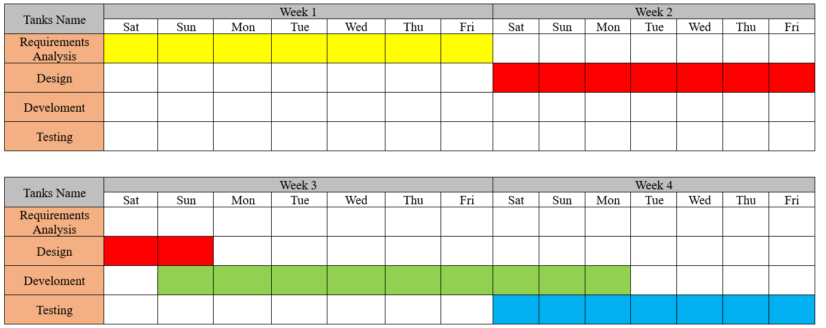
Quality Plan
Review Activities
- First time:
- Meeting day: 18/11/2025
- Activity: assign work, exchange collected documents related to the topic.
- Target: complete the work assignment, understand the duties of each member.
- Second time:
- Meeting day: 25/11/2025
- Activity: exchange documents, check the completion progress of each member, modify and add content.
- Target: complete the content and reach agreement on the content among the members.
- Third time:
- Meeting day: 02/12/2025
- Activity: exchange documents, check the completion progress of each member, modify and add content.
- Target: complete the content and reach agreement on the content among the members.
- Fourth time:
- Meeting day: 09/12/2025
- Activity: exchange documents, check the completion progress of each member, modify and add content.
- Target: complete the content and reach agreement on the content among the members.
- Five time:
- Meeting day: 21/12/2025
- Activity: exchange documents, check the completion progress of each member, modify and add content; exchange documents, check the completion progress of each member, edit and add content, orient the interface of the application, list each specific function.
- Target: complete the content and reach agreement on the content among the members.
Testing Activities (Final Test)
- Unit Test
Backup and Recovery Strategies (In case of disk crash, network failures, and so on)
- Hard Disk Drive
- Google Drive

ARCHITECTURE & GUI STANDARD OF APPLICATION
- Architecture of Application
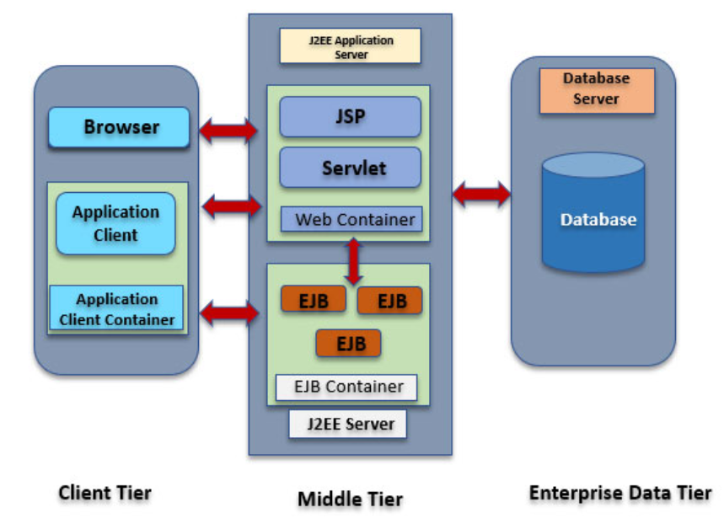
- GUI Standard Application

Property | Value
Document Theme and Color Scheme
Form - Background Color
Title - Font Size
Title - Font Color
Title - Font Style
Title - Alignment
Background color of Controls on the form
Foreground color of Controls on the form
Control Caption - Font Size
Control Caption - Font Color
Control Caption - Font Style
Control caption and controls - Alignment
Command button - Alienment

INTERFACE DESIGN DOCUMENT

List of forms to be created
- Document Name: System management

VI. DATABASE DESIGN DOCUMENT

6.1. ER/Class Diagram

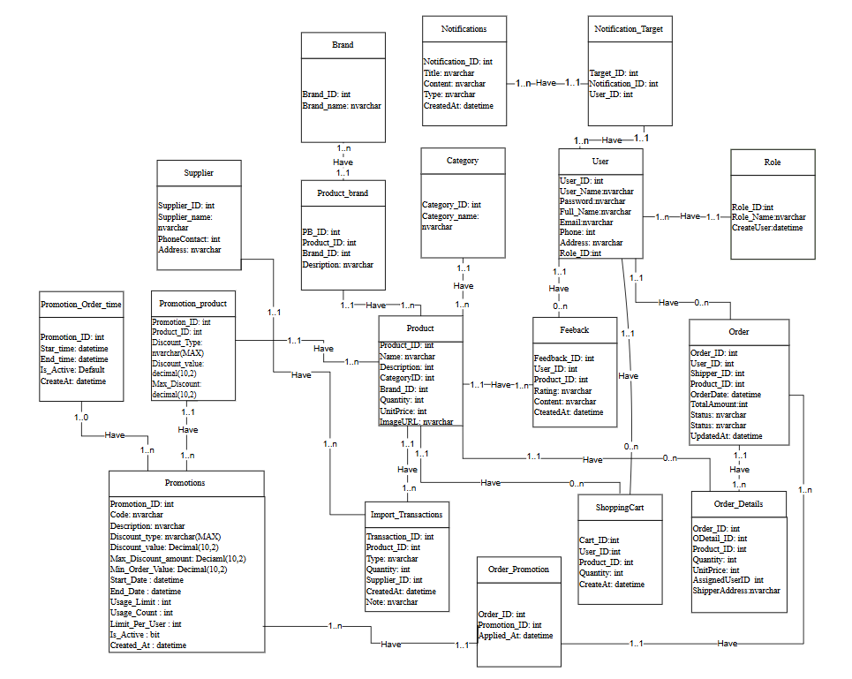

6.2. Table Description
User

Field Name | Data Type | Constraint  (Primary Key, Foreign Key, Identity, Not Null,...) | Description
User_ID | int | PK, NOT NULL, AUTO_INCREMENT | User ID
User_Name | varchar(255) | NOT NULL, UNIQUE | Login username
Password | VARCHAR(100) | NOT NULL | Hashed password
Full_Name | varchar(255) | Null | Full name
Email | varchar(255) | Null | Email address
Phone | varchar(255) | Null | Phone number
Address | VARCHAR(255) | Null | Address
Role_ID | INT | Null | References role

Supplier
Field Name | Data Type | Constraint  (Primary Key, Foreign Key, Identity, Not Null,...) | Description
Supplier_ID | int | PK, NOT NULL, AUTO_INCREMENT | Unique supplier identifier
Supplier_Name | VARCHAR(200) | Not Null | Supplier’s name
Phone Contact | INT | Not null | Supplier phone number
Address | Nvarchar | NOT NULL | Supplier address

Promotions
Field Name | Data Type | Constraint  (Primary Key, Foreign Key, Identity, Not Null,...) | Description
Promotion_ID | Int
  Pk, identity(1,1), not null
  Unique ID for each promotion
Code | Nvarchar(50) | Not null | Promotion code
Description | Nvarchar(50) | Null
  Description of the promotion
Discount_Type | Nvarchar(50) | Not null
  Type of discount: fixed amount or percent
Discount_Value | Decimal(10,2) | Not null
  Discount value (money or %)
Max_Discount_Amount | Decimal(10,2) | Null
  Maximum discount allowed (only for percent type)
Min_Order_Value | Decimal(10,2) | Default
  Minimum order total to apply this code
Start_Date | Datetime | Not null
  Start validity date
End_Date | Datetime | Not null
  End validity date
Usage_Limit | Int | Default
  Maximum usage for the entire system (0 = unlimited)
Usage_Count | Int | Default
  Number of times code has been used
Limit_Per_User | Int | Default
  Maximum times a user can use this code
Is_Active | Bit | Default
  1 = active, 0 = disabled
Created_At | Datetime | Default | Creation timestamp

User Promotion Usage
Field Name | Data Type | Constraint  (Primary Key, Foreign Key, Identity, Not Null,...) | Description
Usage_ID | INT | PK, Identity(1,1), NOT NULL
  Unique usage log identifier
User_ID | INT | NOT NULL, FK → User(User_ID)
  User who used the promotion
 | INT | NOT NULL, FK → Promotions(Promotion_ID)
  Promotion_ID
  Which promotion code was used
Order_ID | Int | Not null, Fk → Order(Order_ID)
  The order associated with the discount
Used_At | DATETIME | Default | Timestamp when the promotion was used

Brand
Field Name | Data Type | Constraint  (Primary Key, Foreign Key, Identity, Not Null,...) | Description
Brand_ID | INT | PK, NOT NULL, AUTO_INCREMENT | Brand ID
Brand_Name | Nvarchar | NOT NULL | Brand name
Supplier_ID | INT | FK → Supplier | Supplier ID
Description | NVARCHAR(MAX) | NULL | Desciption Brand

Category
Field Name | Data Type | Constraint  (Primary Key, Foreign Key, Identity, Not Null,...) | Description
Category_ID | INT | PK, NOT NULL, AUTO_INCREMENT | Brand ID
Category_Name | Nvarchar | NOT NULL | Brand name
ParentCategoryID | INT | FK → Category | CategoryParent

Product
Field Name | Data Type | Constraint  (Primary Key, Foreign Key, Identity, Not Null,...) | Description
Product_ID | INT | PK, NOT NULL, AUTO_INCREMENT
  Product ID
Product_name | INT | Null
  Product name
Description | DATETIME | NOT NULL, DEFAULT CURRENT_DATE
  Product description
Category_ID | INT | FK → Class(Class_ID), NOT NULL
  Product category
Brand_ID | INT | FK → Courses(Course_ID), NOT NULL
  Product brand
UnitPrice | INT | FK → User(User_ID), NOT NULL
  Selling price
ImageURL | Nvarchar | NOT NULL | Product image path

Feedback
Field Name | Data Type | Constraint  (Primary Key, Foreign Key, Identity, Not Null,...) | Description
Feedback_ID | Int | PK, NOT NULL, AUTO_INCREMENT
  Feedback ID
User_ID | int | FK → User(User_ID)
  Customer who submitted
Product_ID | int
  FK → Product(Product_ID)
  Reviewed product
Rating | Int | NOT NULL
  Rating (1–5)
Content | Nvarchar | FK → User(User_ID), NOT NULL
  Review content
CreatedAt | Datetime |  | Submission date
  Default GETDATE()

Inventory
Field Name | Data Type | Constraint  (Primary Key, Foreign Key, Identity, Not Null,...) | Description
Product_ID | Int | PK, FK → Product(Product_ID)
  Product ID
 | int | NOT NULL
  Stock
  Current stock
MinStock | int | NOT NULL
  Minimum acceptable stock
LastUpdate | Datetim |  | Last updated date
  Default GETDATE()

Stock Transaction
Field Name | Data Type | Constraint  (Primary Key, Foreign Key, Identity, Not Null,...) | Description
Transaction_ID | Int | PK, NOT NULL, AUTO_INCREMENT
  Transaction ID
Product_ID | DATE |  | Product
  FK → Product(Product_ID)
Type | Nvarchar | Not null
  IN / OUT
Quantity | int | Not Null
  Quantity change
Supplier_ID | Int
  FK → Supplier(Supplier_ID), Null allowed
  Only for IN transactions
CreateAt | Datetime |  | Timestamp
  Default GETDATE()
Note | Nvarchar |  | Comment
  Null allowed

Role
Field Name | Data Type | Constraint  (Primary Key, Foreign Key, Identity, Not Null,...) | Description
Role_ID | int | PK, Auto Increment | Role ID
Role_Name | Nvarchar | Not null, Unique | Role name
CreateUser | Datetime | Default GETDATE() | Creation date

ShoppingCart
Field Name | Data Type | Constraint  (Primary Key, Foreign Key, Identity, Not Null,...) | Description
Cart_ID | INT | PK, Auto Increment | Cart ID
User_ID | INT | FK → User(User_ID) | Owner of the cart
Product_ID | INT | FK → Product(Product_ID) | Product added
Quantity | INT | NOT NULL | Quantity
CreateAt | DATETIME | Default GETDATE() | Time added

Order
Field Name | Data Type | Constraint  (Primary Key, Foreign Key, Identity, Not Null,...) | Description
Order_ID | INT | PK, NOT NULL, AUTO_INCREMENT | Order ID
User_ID | INT | FK → User(User_ID) | Customer
AssignedUserID | INT | FK → User(User_ID), Null allowed | Shipper
OrderDate | DATETIME | Default GETDATE() | Date created
TotalAmount | INT | NOT NULL | Total order cost
Status | NVARCHAR | NOT NULL | Status Order

Order_Details
Field Name | Data Type | Constraint  (Primary Key, Foreign Key, Identity, Not Null,...) | Description
ODetail_ID | INT | PK, NOT NULL, AUTO_INCREMENT | Detail ID
Order_ID | INT | FK → Order(Order_ID) | Order
Product_ID | INT | FK → Product(Product_ID) | Product
Quantity | INT | NOT NULL | Quantity purchased
UnitPrice | INT | NOT NULL | Price at purchase time
ShippingAddress | NVARCHAR | NOT NULL | Delivery address

Delivery
Field Name | Data Type | Constraint  (Primary Key, Foreign Key, Identity, Not Null,...) | Description
Delivery_ID | INT | PK, Auto Increment | Delivery ID
Order_ID | INT | FK → Order(Order_ID) | Order ID
User_ID | INT | FK → User(User_ID) | Assigned shipper
Status | NVARCHAR | Not Null | Delivery status
UpdatedAt | DATETIME | Default GETDATE() | Last update time
Picked_Up_At | DATETIME | Null | Time taken
Delivered_At | DATETIME | Null | Deliver time

Promotions
Field Name | Data Type | Constraint  (Primary Key, Foreign Key, Identity, Not Null,...) | Description
Promotion_ID | INT | PK, Auto Increment | Promotion ID
Code | NVARCHAR(50) | Not Null, Unique | Promotion code
Description | NVARCHAR(255) | Null | Promotion description
Discount_Type | NVARCHAR(20) | Not Null | Discount type (PERCENT/FIXED)
Discount_Value | DECIMAL | Not Null | Discount value
Max_Discount_Amount | DECIMAL | Null | Maximum discount amount
Min_Order_Value | DECIMAL | Null | Minimum order value to apply
Start_Date | DATETIME | Not Null | Promotion start date
End_Date | DATETIME | Not Null | Promotion end date
Usage_Limit | INT | Null | Total usage limit
Usage_Count | INT | Null | Current usage count
Limit_Per_User | INT | Null | Usage limit per user
Is_Active | BIT | Null | Active status
Created_At | DATETIME | Default GETDATE() | Creation time

Promotions_Product
Field Name | Data Type | Constraint  (Primary Key, Foreign Key, Identity, Not Null,...) | Description
Promotion_ID | INT | PK, FK → Promotions(Promotion_ID) | Promotion ID
Product_ID | INT | PK, FK → Product(Product_ID) | Product ID
Discount_Type | NVARCHAR(20) | Not Null | Discount type (PERCENT/FIXED)
Discount_Value | DECIMAL | Not Null | Discount value
Max_Discount | DECIMAL | Null | Maximum discount amount

Order_Promotions
Field Name | Data Type | Constraint  (Primary Key, Foreign Key, Identity, Not Null,...) | Description
Order_ID | INT | PK, FK → Order(Order_ID) | Order ID
Promotion_ID | INT | FK → Promotions(Promotion_ID), Not Null | Applied promotion ID
Applied_At | DATETIME | Default GETDATE() | Time promotion was applied

Notifications
Field Name | Data Type | Constraint  (Primary Key, Foreign Key, Identity, Not Null,...) | Description
Notification_ID | INT | PK, Auto Increment | Notification ID
Title | NVARCHAR(200) | Not Null | Notification title
Content | NVARCHAR(MAX) | Not Null | Notification content
Type | NVARCHAR(20) | Not Null | Notification type
CreatedBy | INT | FK → User(User_ID), Not Null | Creator user ID
CreatedAt | DATETIME | Default GETDATE() | Creation time

Notifications_Target
Field Name | Data Type | Constraint  (Primary Key, Foreign Key, Identity, Not Null,...) | Description
Target_ID | INT | PK, Auto Increment | Target ID
Notification_ID | INT | FK → Notifications(Notification_ID), Not Null | Notification ID
User_ID | INT | FK → User(User_ID), Not Null | Target user ID

Delivery_log
Field Name | Data Type | Constraint  (Primary Key, Foreign Key, Identity, Not Null,...) | Description
Log_ID | INT | PK, Auto Increment | Log ID
Delivery_ID | INT | FK → Delivery(Delivery_ID), Not Null | Delivery ID
Event_Type | NVARCHAR(50) | Not Null | Event type (received/picked_up/arrived/  delivered/failed/note)
Description | NVARCHAR(MAX) | Null | Event description
Image_Path | NVARCHAR(255) | Null | Image path for proof
Location | NVARCHAR(255) | Null | Event location
Created_At | DATETIME | Default GETDATE() | Event creation time

Note:
      - (PK): Primary Key
      - (FK): Foreign Key (with ON DELETE RESTRICT or CASCADE depending on business rules)
      - (1): One, (N): Many to indicate relationship cardinality
      - All VARCHAR/NVARCHAR fields should use UTF-8 encoding to support multilingual product names and user information
      - DATETIME fields (e.g., CreatedAt, UpdatedAt, OrderDate, LastUpdate) ensure accurate timestamp tracking
- CHECK constraints should be applied where appropriate, such as:
- Valid delivery statuses
- Positive product prices and quantities
- Valid rating range (e.g., 1–5)
- Transaction type values (“IN”, “OUT”)
- UNIQUE constraints recommended for fields such as:
- Username
- Email
- Category names
- Brand names
- Foreign Keys between tables must maintain referential integrity
(e.g., Order → User, Delivery → Shipper, Product → Category/Brand)
- Inventory.Product_ID acts as both PK and FK, ensuring each product has exactly one inventory record
- ShoppingCart may contain multiple rows per user, one row per product
- Order and Delivery support multiple updates, where Delivery tracks shipping status history
- Auto-incrementing integer fields used for all primary keys except composite/linked keys
- All monetary values (UnitPrice, TotalAmount, UnitCost) should be validated as non-negative integers

PROCESS DESIGN DOCUMENT

CODING STANDARDS DOCUMENT

8.1 Programming Standards

Standard set name

- Standard code format

- Standard exception handling

- Standard used memory

- Standard handle string

- Standard use of static methods

- Standard set variable name

- Standard use of footnotes

8.2 Standards for code writing style

- Name variables, methods, classes, packages, according to CamelCase rules, where the first word is lowercase and the next words are capitalized. Example: firstName, getFirstName()

- Use spaces properly to make code easier to read, e.g. after keywords (if, else, for, while, switch), before and after commas, between operators (e.g. +, -, *, /), and between method parameters.

- Indent properly to show the structure of the program, making the source code easier to read. Usually use 4 spaces for indentation.

- Use the getter and setter methods to access and change the properties of the object, and name these methods according to the get/set +NameProperty rules, e.g. getFirstName(), setLastName().

- Using try-catch to handle exceptions in the program, and placing try-catch blocks in a correct structure makes the program easy to read and understand.

- Use the correct data type corresponding to the value and purpose of the variable.

8.3 Standards for declaring Variables

- Declare multiple variables of the same data type in the same line by separating them with commas. For example: int x, y, z.

- Name variables according to CamelCase rules, where the first word is lowercase and the next words capitalize the first letter. For example: firstName, lastName, numberOfStudents.

- Use a data type that matches the value and intended use of the variable. Avoid using data types that are too large or too small for your needs.

- Declare the variable in the form "NameDataTypeVariable name". For example: int age, String name, double salary

  - Standards for Function Declarations
- Use variables for the right purposes
- Use parameters to pass data to the function and return the result using the "return" keyword. For example: public double calculateSalary(double baseSalary, double bonus), public String getFullName(String firstName, String lastName), public void setAge(int age).
- Use the return data type that matches the function's return result. If no result is returned, use data type "void".
- Place parentheses or braces in a new line, to make the source code easier to read.

  - Other Standards
- Use abstract classes and interfaces to separate parts of your program and define common methods.
- Use static methods to define common methods and minimize the creation of multiple objects.
- Using unit tests to check the functionality of the program and ensure the stability of the program

TASK SHEET

- Project Title: SUNDAY System.
No. | Task | Actual Start Date | Actual Days | Teammate Name | Status
 | Document 1 | 19/11/2025 | 7 Days | Tran Duc Tam | Completed
 | Document 2 | 20/11/2025 | 7 Days | Nguyen Thanh Phat
 | Document 3 |  | 7 Days | Nguyen Tan Loc
 | Document 4 |  | 3 Days | Nguyen Tan Loc
 | Document 5 |  | 7 Days | Nguyen Tran Minh Nhat
 | Document 6 |  | 5 Days | Tran Duc Tam
 | Document 7 |  | 7 Days | Nguyen Thanh Phat
 | Document 8 |  | 3 Days | Nguyen Tran Minh Nhut
 | Document 9 |  | 3 Days | Tran Duc Tam
 | Document 10 |  | 1 Days | Nguyen Tan Loc
 | Document 11 |  | 3 Days | Nguyen Tran Minh Nhut
 | Document 12 |  | 5 Days | Nguyen Thanh Phat
 | Demo:( User, Role, Brand, Supplier, Feedback) |  | 10 Days | Tran Duc Tam
 | Demo:( Product, Category, Promotions, User Promotion Usage) |  | 10 Days | Nguyen Thanh Phat
 | Demo:( Delivery, Stock Transaction, Inventory) |  | 10 Days | Nguyen Tran Minh Nhut
 | Demo:(Order, Order Detail, Shopping cart) |  | 10 Days | Nguyen Tan Loc

Note: You can use list or Gartt

TESTING DOCUMEN

ID | Test Case Name | Task | Result | Expected | Actual Result | Pass/Fail-Comments

XI. PROJECT REVIEW

Date | Project Plan Activity/Milestone | Work Specification | Status of the Activity | Remarks | Responsibility

XII. Final Check List

No. | Aspect tested | Suggestion/Remarks
1 | Tất cả các mô-đun đã được tích hợp thuộc tính và chúng có hoạt động hoàn toàn bình thường không? | Yes
2 | Tất cả các xác thực có diễn ra theo đúng quy định trong Thiết kế Quy trình không? | Yes
3 | Tất cả các tiêu chuẩn Thiết kế và Mã hóa đã được tuân thủ và triển khai chưa? | Yes
4 | Tất cả các mô-đun đã được tích hợp thuộc tính và chúng có hoạt động hoàn toàn bình thường không? | Yes
5 | Tất cả các xác thực có diễn ra theo đúng quy định trong Thiết kế Quy trình không? | Yes
6 | Tất cả các tiêu chuẩn Thiết kế và Mã hóa đã được tuân thủ và triển khai chưa? | Yes
7 | Tất cả các mô-đun đã được tích hợp thuộc tính và chúng có hoạt động hoàn toàn bình thường không? | Yes
8 | Tất cả các xác thực có diễn ra theo đúng quy định trong Thiết kế Quy trình không? | Yes

