Github: https://github.com/thanhphuongne/QE180130_PRN232_PE
Vercel: https://qe-180130-prn-232-pe.vercel.app/
Question 1:
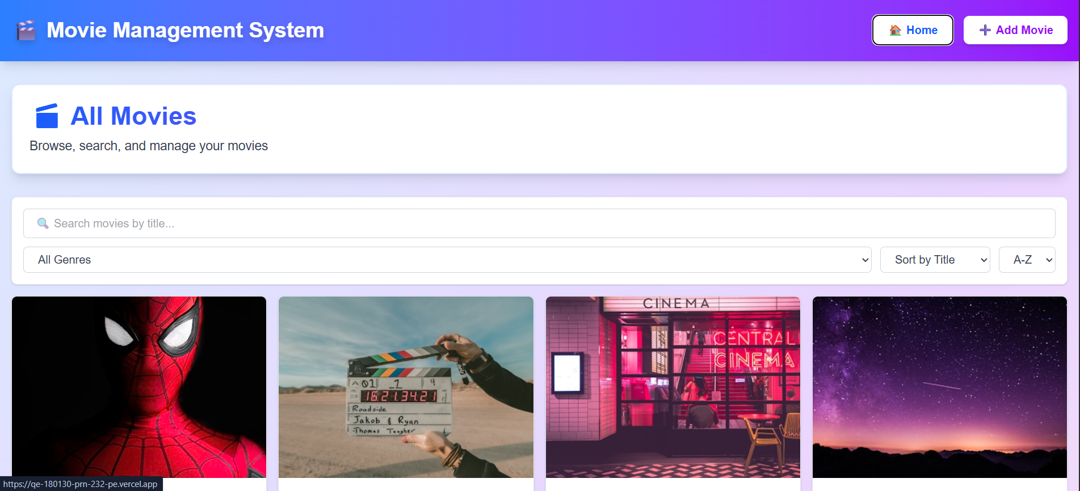
Question 2:
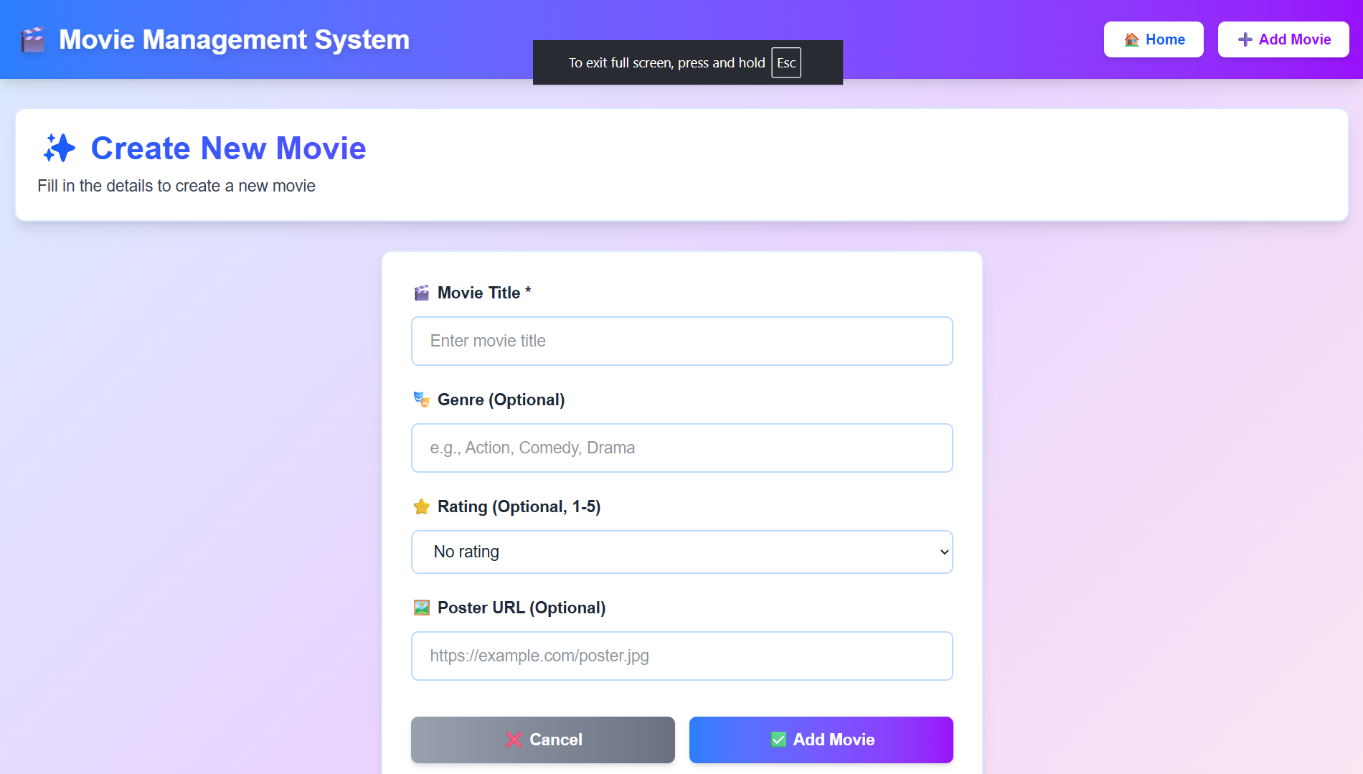
Question 3:
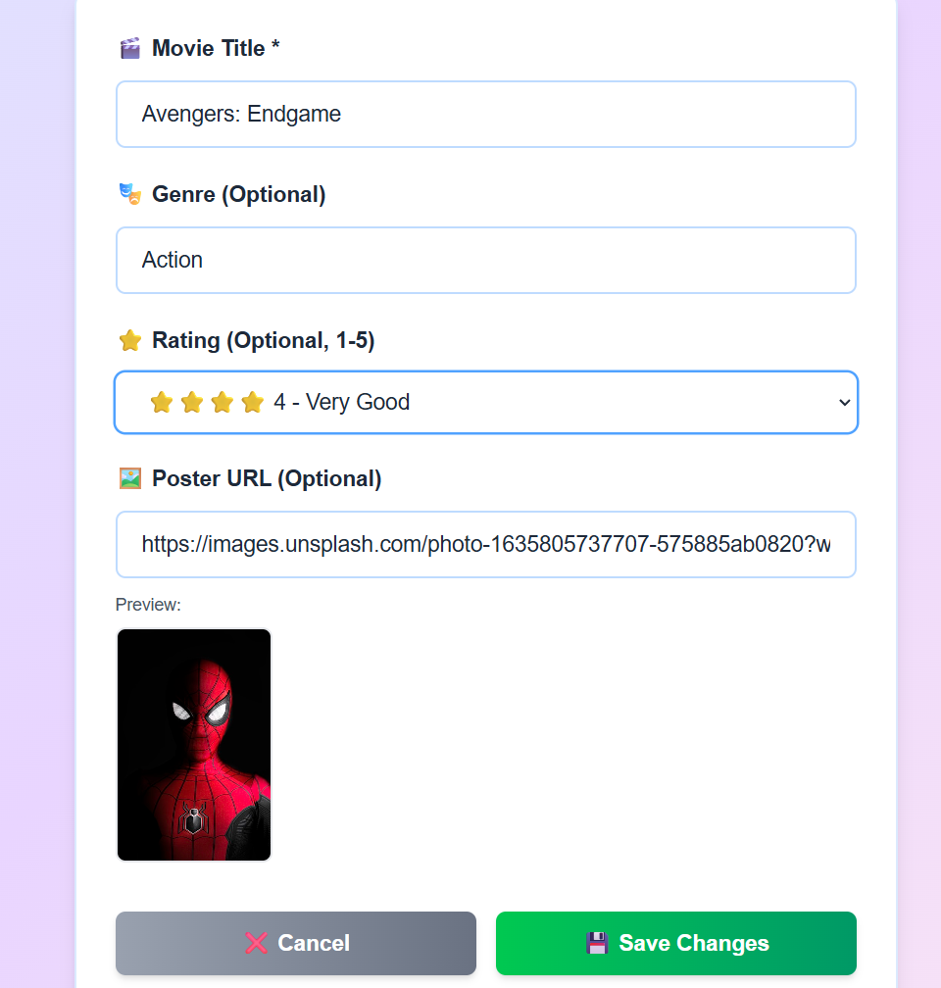
Question 4 :
