15/3

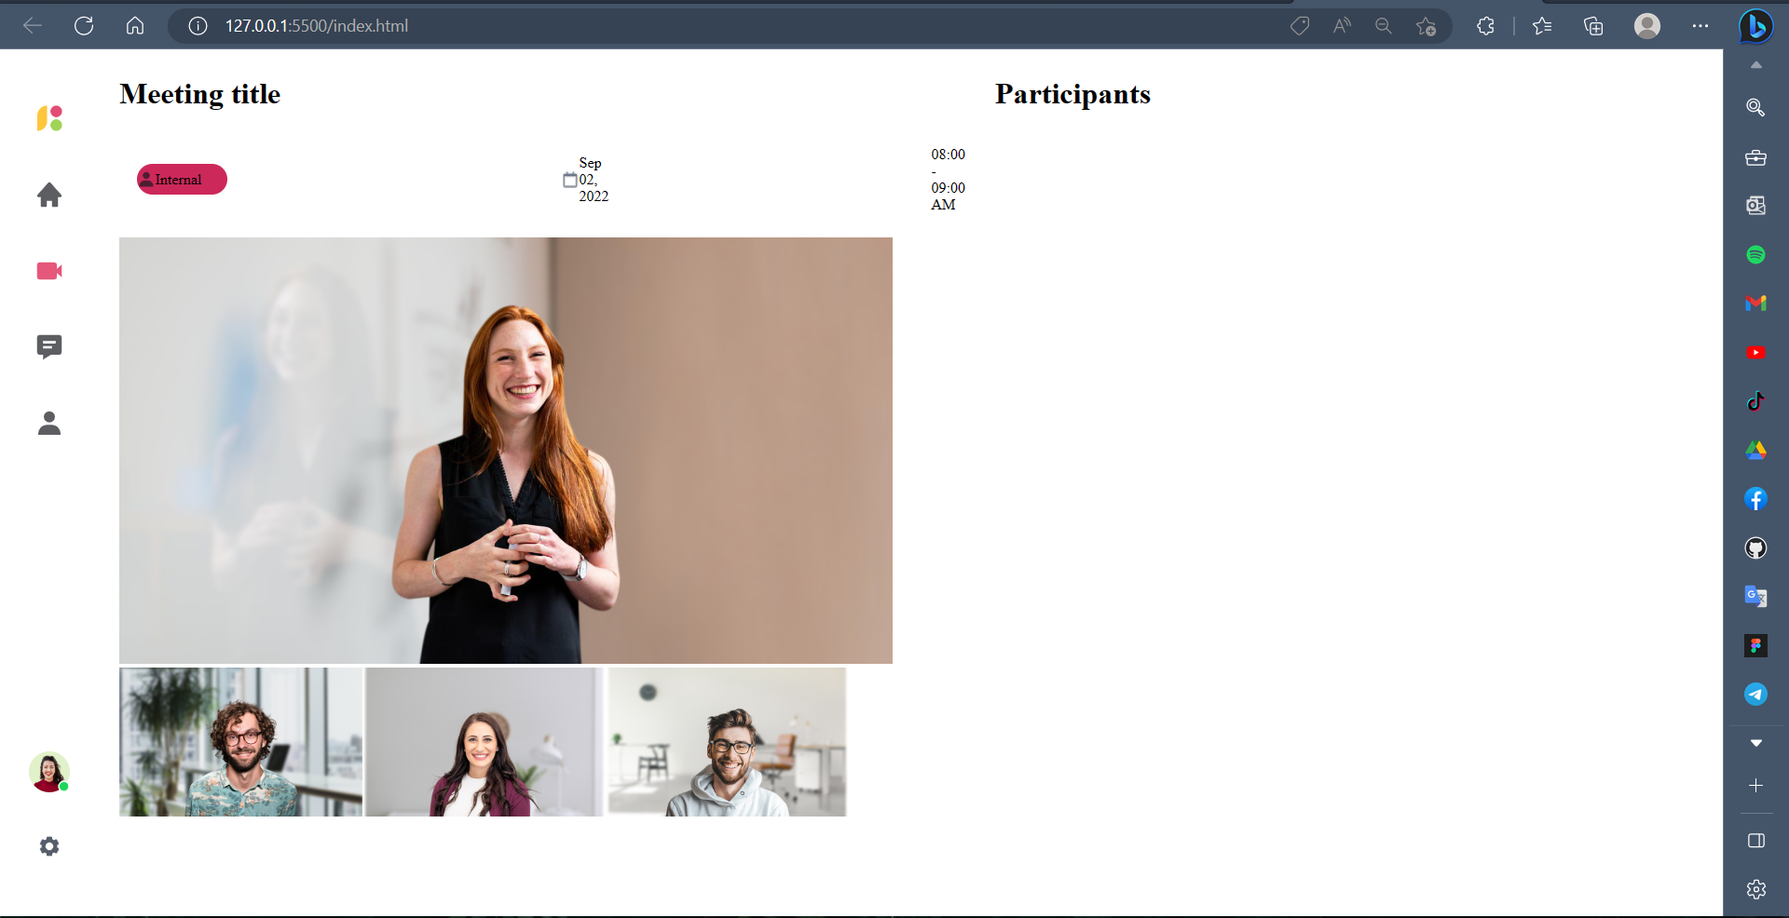

19/3 hoàn thành meeting title

