

FPT University

University of Greenwich

Employability and Professional Development



Employability and professional development

by

Nguyễn Đình Tùng

(GC00952)

**Table of Contents**

**Introductions** 5

**Task 1:** **Be able to take responsibility for own personal and professional development** 6

1.1 Reflect on own current skills and competencies against professional standards and organizational objectives 6

1.2 Evaluate own development needs and the activities required to meet them 9

1.3 Devise a personal and professional development plan based on identified needs 9

1.4 Reflect on own development against original aims and objectives set in the personal and professional development plan 10

**Task 2:** **Be able to demonstrate acquired interpersonal and transferable skills**  11

Slide 11

**Task 3:** **Understand the dynamics of working with others** 17

1.1 Analyze team dynamics, discussing the roles people play in a team and how they can work together to achieve shared goals 17

1.2 Discuss alternative ways to complete tasks and achieve team goals 20

**Task 4:** **Be able to develop strategies for problem solving** 23

1.1 Review tools and methods for developing solutions to problems 23

1.2 Develop an appropriate strategy for resolving a particular problem 27

1.3 Evaluate the potential impact on the business of implementing the strategy 28

**References** 29

**Table of Figures**

Figure 1. communication and time management 8

Figure 2.Slide 1 11

Figure 3.Slide 2 11

Figure 4. Slide 3 12

Figure 5.Slide 4 12

Figure 6.Slide 5 13

Figure 7.Slide 6 13

Figure 8.Slide 7 14

Figure 9.Slide 8 14

Figure 10.Slide 9 15

Figure 11.Slide 10 15

Figure 12.Slide 11 16

Figure 13.Slide 12 16

Figure 14.model 6-steps problems solving 23

Figure 15.model 5Whys problems solving 24

Figure 16.model 4 frames problems solving 25

Figure 17.model 8 principles problem solving of Ford 26

Figure 18.model Cynefin framework 27

**Table of tables**

Table 1. Overview current skills 6

Table 2.Evaluate skills 7

# Introductions

This book will cover the following main ideas

- How to identify the skills that will help you in your current and future career, what skills are good, and which skills are weak. They need to be improved and developed to fit the target. the standard of the organization (ACM or BCS).

- Helping you better understand communication skills and time management, how important they are to work and life, and how to do them.

- You will have more knowledge about teamwork, the role of teamwork in a project, how the team can work effectively and achieve the goals of the team, members need. Take responsibility for how the team develops.

- The problems in life are inevitable. I will help you learn more about the tools and methods to solve the problem quickly and efficiently depending on the problem you encounter.

# Task 1: Be able to take responsibility for own personal and professional development

## Reflect on own current skills and competencies against professional standards and organizational objectives

|  |  |
| --- | --- |
| Strengths | Weakness |
| - I can speak English and communication with other people  - I have knowledge about java, C#, HTML and CSS, SQL Management…  - My teamwork skill is good  - Creativity and problem solving.  - Have responsibility for work and complete on time | - E-book reading and analysis is not good  - ability time management is not good  - I can’t control my stress  - Not confident ahead of the crowd  - Easy forget everything in short time |

Table 1. Overview current skills

|  |  |  |
| --- | --- | --- |
| Skills | Point  (5) | Evaluate |
| communication | 3 | I think my communication ability is pretty simple and it’s only achieve point 3. |
| decision making | 3 | Sometime I change my mind when I faced different problems and I think it is not good. |
| showing commitment | 4 | I am quite confident in myself so give a fairly normal commitment to me |
| flexibility | 2 | I am a very honest and honest person so my flexibility is very poor |
| time management | 4 | I am very busy so time management skill is very important with me but I am not yet control my time by away perfect |
| Leadership | 3 | I think my ability leadership is pretty simple and nothing special |
| Creativity and problem solving | 4 | I am very confident with my ability research and logical thinking and apply it to solve problems |
| Teamwork | 4 | I am very confident with my teamwork skill because I was trained when I was in school |
| Accepting responsibility | 3 | The ability to accept responsibility is very important in my work, I always learn and develop it but now my ability is still in the average |
| Ability to work under pressure | 3 | I always try to can work under pressure from people around. Current this my ability is incomplete, I still angry when faced with a lot of problem come me together. |

Table 2.Evaluate skills

**Follow standards of the Association for Computing Machinery (ACM). I have to evaluate yourself the following:**

**1. Try hard to achieve the highest quality, effective more, maintain competence and create products perfect more of professional work.**

- A programming expert must always strive for perfection and be able to keep up with the latest trends and be aware of the consequences of creating poor quality programs. It is great if you know how to improve your abilities and it is important to evaluate your competencies.

- Maintain competence: it is dependents on individuals who take responsibility for acquiring and maintaining professional competence. A professional must participate in setting standards for appropriate levels of competences and strive to achieve those standards. Upgrading technical knowledge and competence can be achieved in several ways doing independent study; attending seminars, visit companies about program software, conferences, or courses; and being involved in professional organizations.

**2. Let honest and trustworthy.**

- Being a member of your organization, it is your responsibility to be always honest with the organization to help that organization grow stronger and to create an organizational foundation for you.

- A developer needs to be honest about his or her ability to avoid conflicting situations of interest and improve product quality.

**3. Communication and time management.**

- Organizers always appreciate the ability to communicate and manage time with each individual.

- The ability to communicate is extremely important when you go to work, it helps you to integrate with people in different working environments quickly, create good relationships in the organization, create opportunities for you to grow and it also helps you in teamwork.



Figure 1. communication and time management

- You should have specific plans to manage your time in the most scientific way, avoiding wasted time in vain, as a programmer it is extremely important.

**4. Respect the privacy of others.**

- Nowadays, social networking sites are very powerful. It is the ability to collect and exchange personal information very easily, so the possibility of violating privacy rights also increases. It is the responsibility of the professionals to ensure the confidentiality of the user's personal information, protect it from unauthorized access.

## Evaluate own development needs and the activities required to meet them

* As per organizations requirements, employees should have time management skill, leadership skill, IT skill etc. Among the skills I've weakness in leadership skill and IT skill. To heal up my weaknesses in those area I'm participating in various development training sessions.
* Personal activities or strategies: To improve my skills or performance I've to take some strategies. I read more newspaper such as The Guardian, The Financial Times, The Telegraph etc. to enlarge my knowledge area which also helps to develop communication skill important for the organization. By doing the analysis of external environment like politically, economically, socially and technologically (PEST) personal development can be made

## Devise a personal and professional development plan based on identified needs

* To become successful in personal and professional life everyone need to do a proper planning regarding his/her defined needs or goal. For future development a person need to do an effective planning and put it in the right place. Everyone required to expand their knowledge and abilities with the passage of time because change is essential in every aspect of life. Stages for the professional development plan are given below.
* SWOT Analysis: Self-monitoring can be done by SWOT Analysis. By this analysis I can identify my strengths, weaknesses, opportunities and threats regarding professional development. This will give me a chance to do self-learning process so that I can work out my weakness and can avoid threats.
* Time Frame analysis is also important for my professional development from the beginning of my professional career. Along with self-learning I need to learn effectively from various seminars and other programs and that will help me to develop my personality as well as professional efficiency

## Reflect on own development against original aims and objectives set in the personal and professional development plan

* Initial meeting preparation: Preparation is very important in every level whatever it's academic, personal and professional levels. The reason behind that is to balance the expectation among the team members.
* Past knowledge and experiences: Previous knowledge and experience regarding the developed plan makes the thing easy and raise the level of confidence.
* Motivation and anticipation: To know the level of anticipation is very important regarding personal and professional development plan. It helps to find out the required type of skills; helps to know the other personal and professional objectives for the upcoming years and helps to define long term and short-term goals. All these anticipations derive the perfect motivation criteria for the employees.
* **Conclusions:**

This task I write about my skills, my knowledges, current I have which skills, which skills of me is poor and which skills of me is good, I need development which skills to support for my work in the future, I describe about method to evaluate yourself, help you determined you have which skills at present, organizations requirement about you need which skills…

# Task 2: Be able to demonstrate acquired interpersonal and transferable skills

## Slide

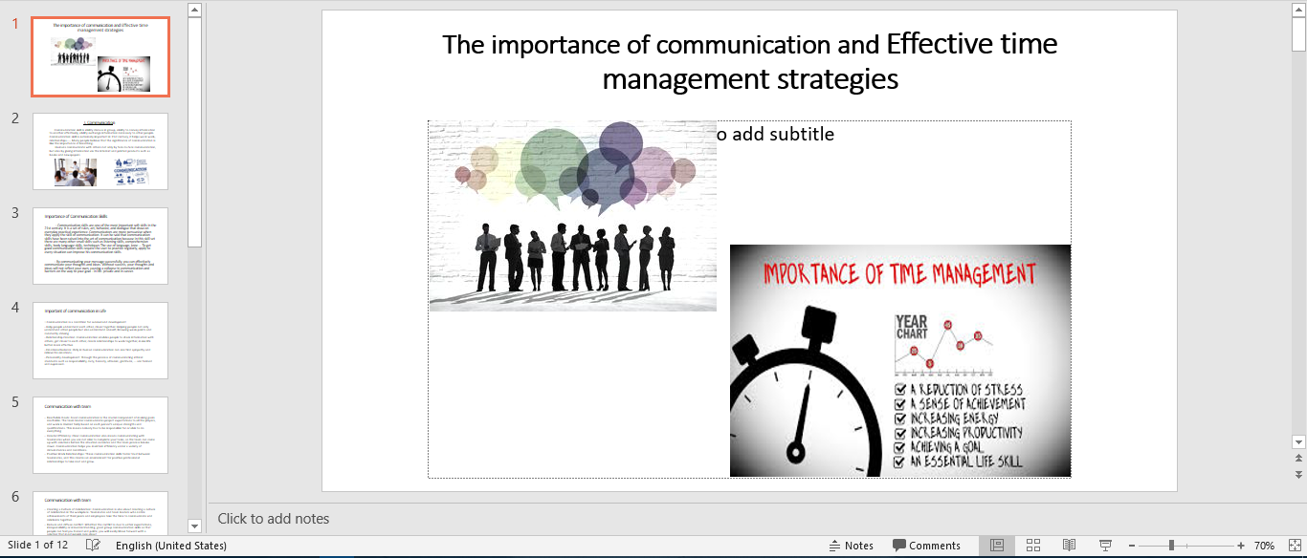

Figure 2.Slide 1

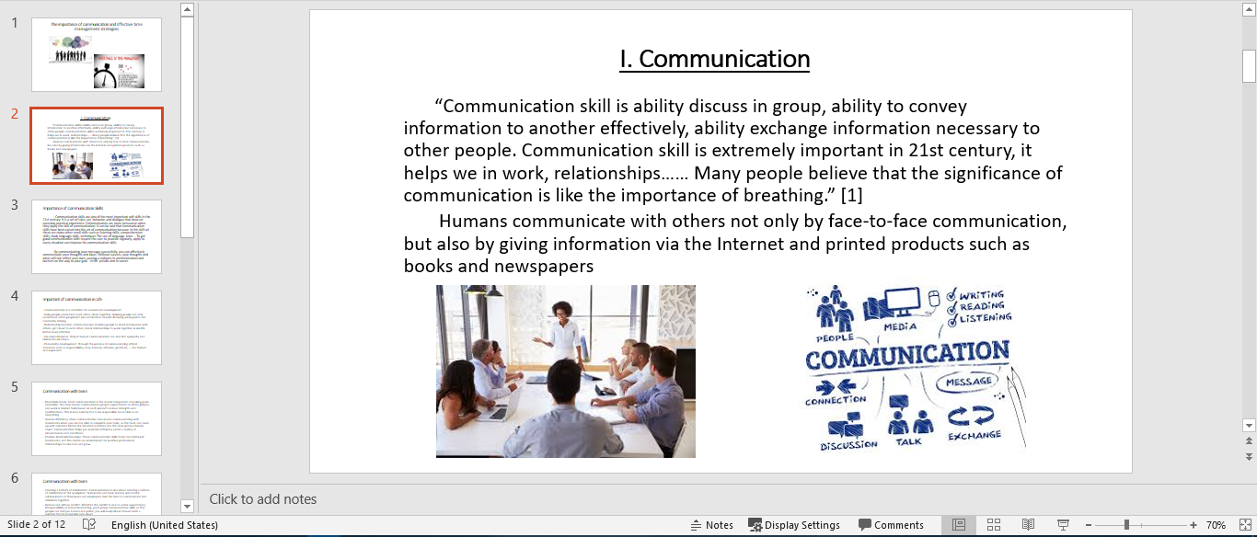

Figure 3.Slide 2

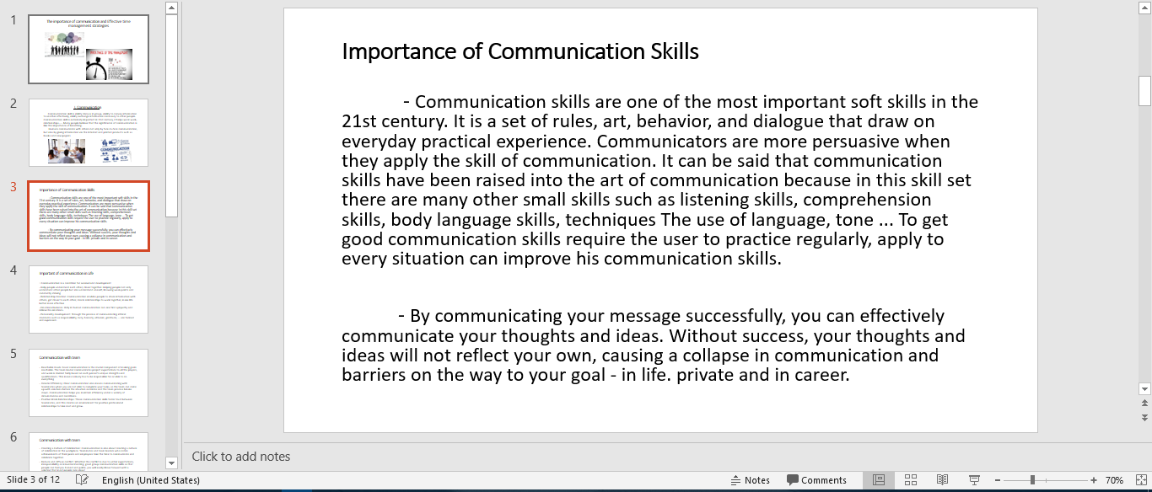

Figure 4. Slide 3

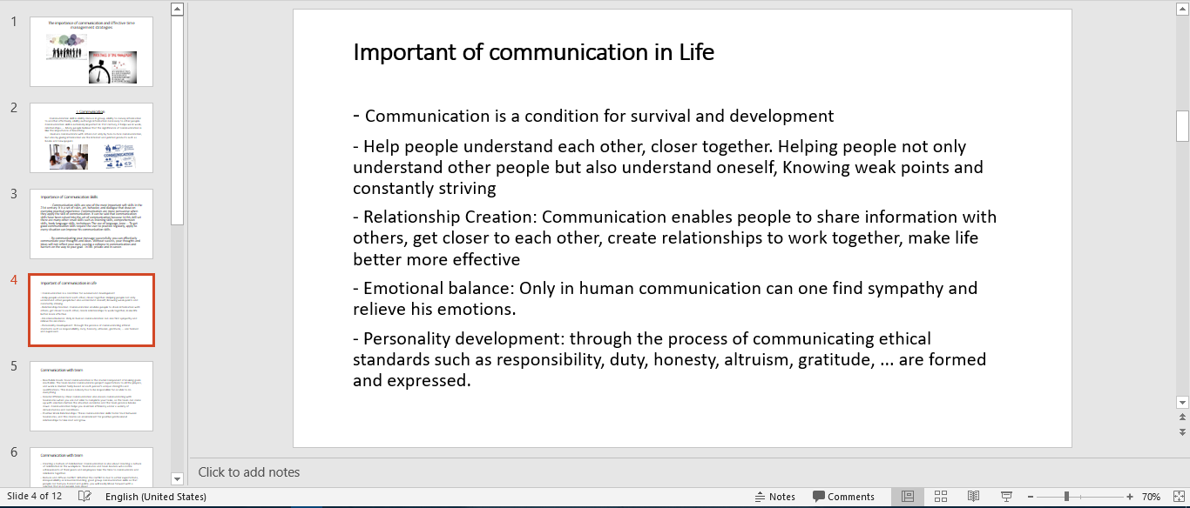

Figure 5.Slide 4

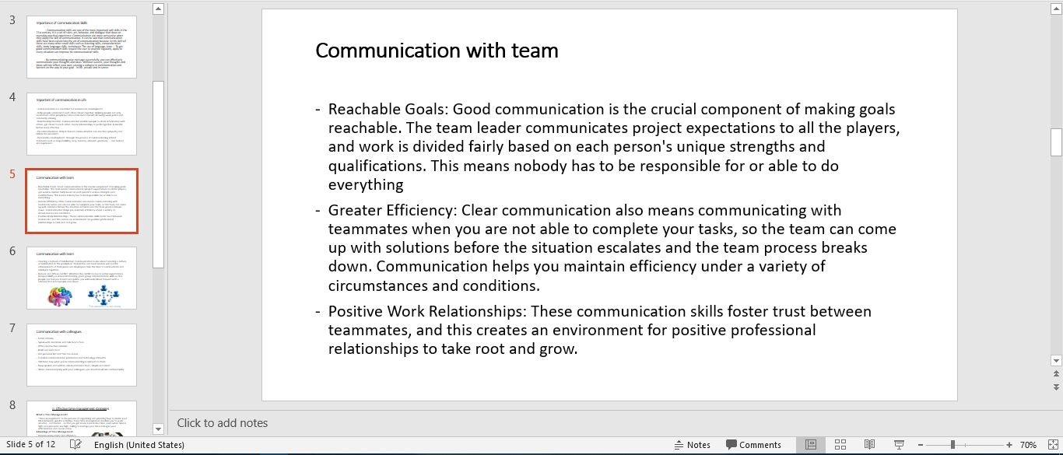

Figure 6.Slide 5

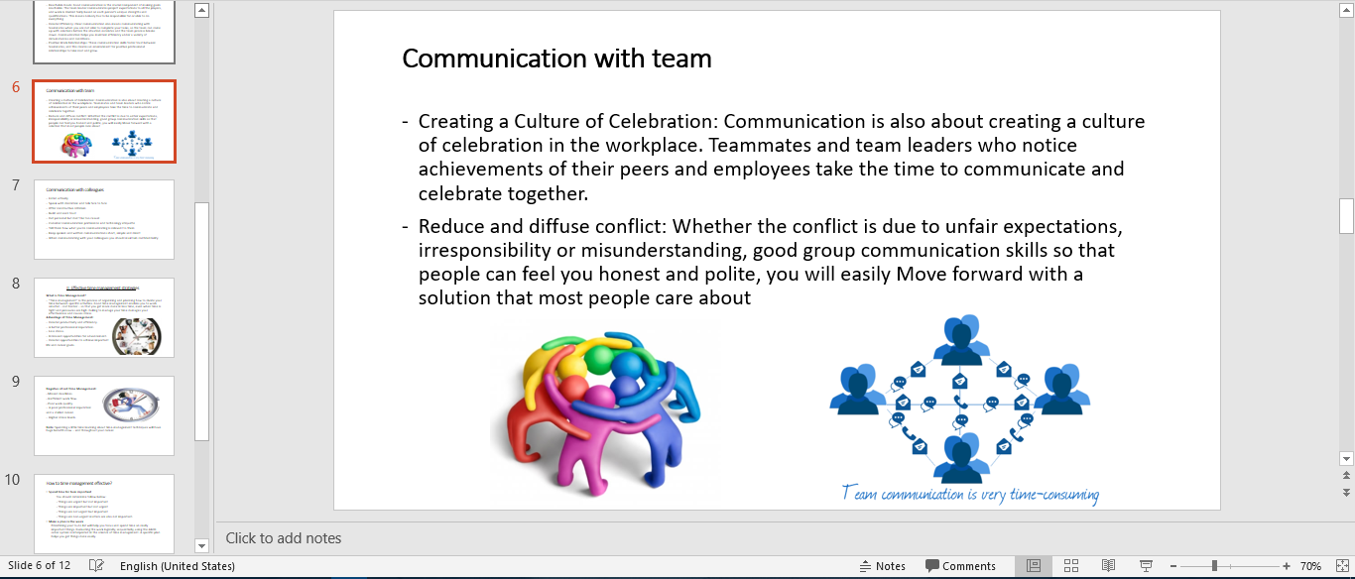

Figure 7.Slide 6

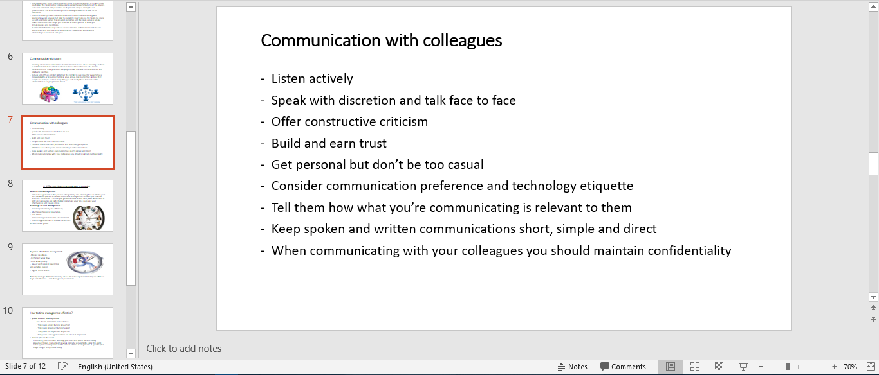

Figure 8.Slide 7

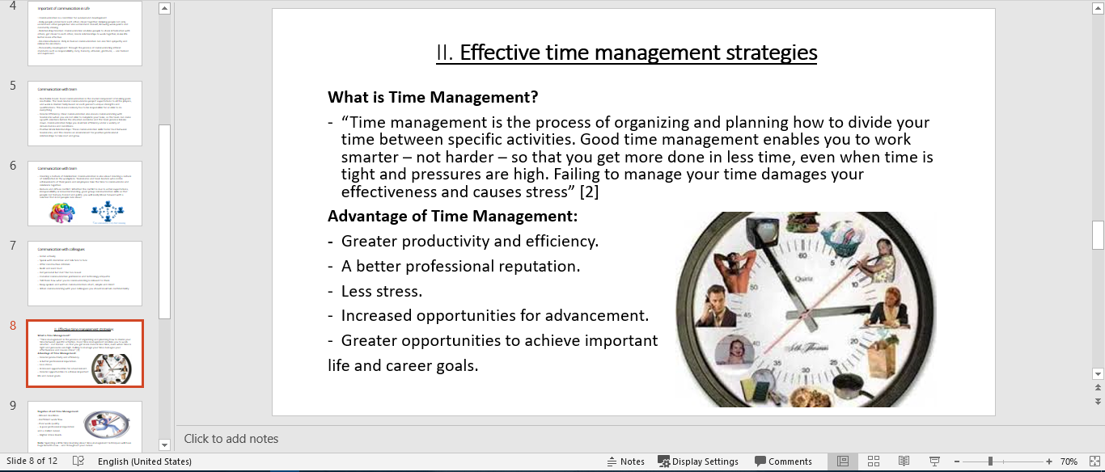

Figure 9.Slide 8

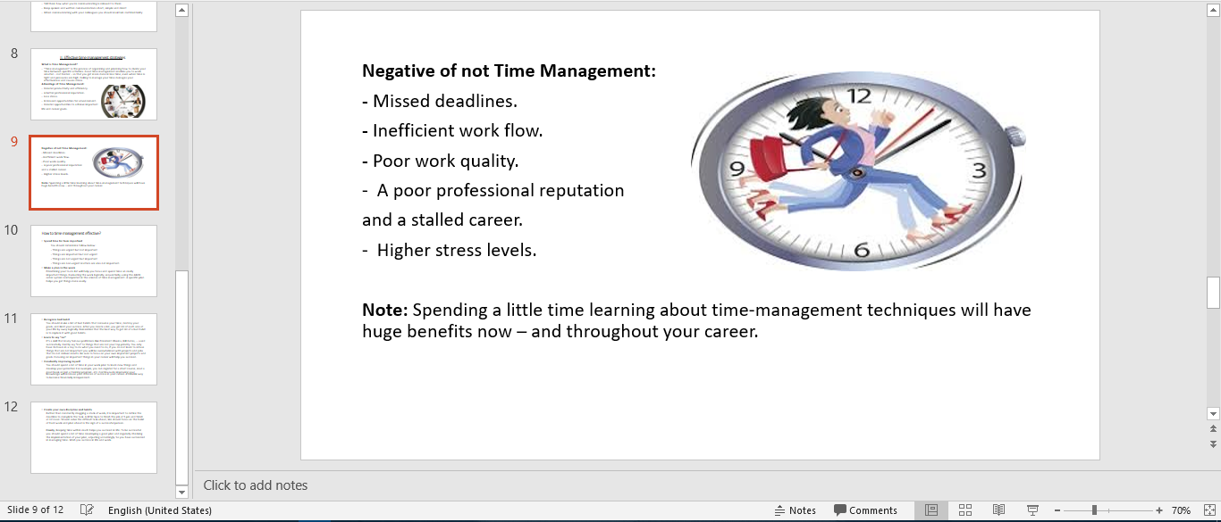

Figure 10.Slide 9

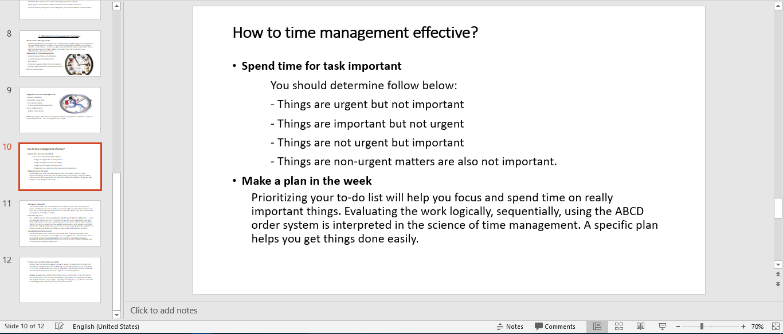

Figure 11.Slide 10

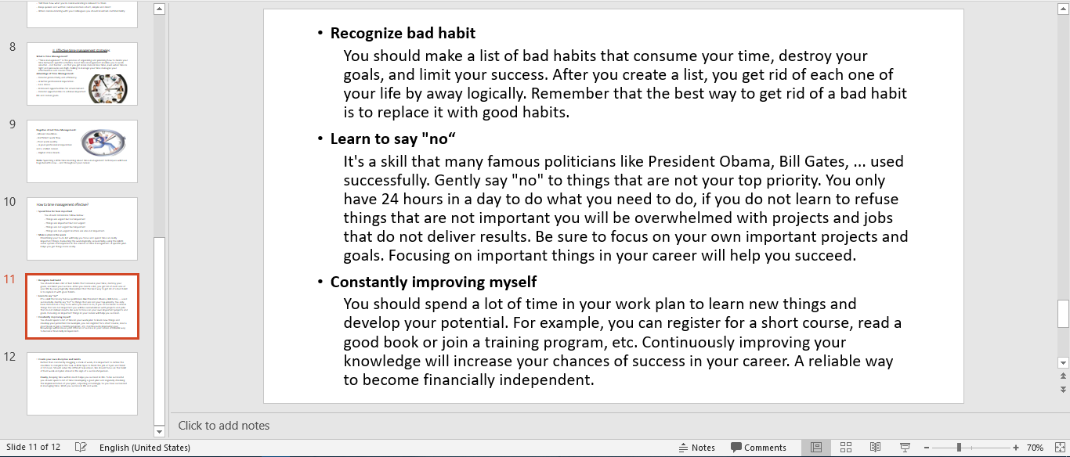

Figure 12.Slide 11

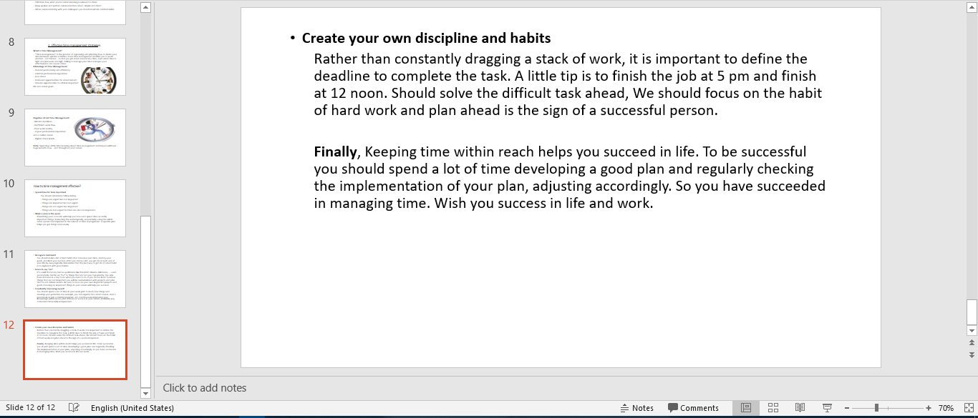

Figure 13.Slide 12

* **Conclusions:**

Through this task you will understand more about communication skills, benefits of communication skills bring what for you, important of communications skills in work and life, require of communication skills in when do teamwork, colleagues. Help you understand about time management, benefits of time, negative when you can’t management your time, how to make a plan to management time a way the most effective.

# Task 3: Understand the dynamics of working with others

## Analyze team dynamics, discussing the roles people play in a team and how they can work together to achieve shared goals

1. **What is teamwork skills?**

“The process of working collaboratively with a group of people in order to achieve a goal.

Team work is often a crucial part of a business, as it is often necessary for colleagues to work well together, trying their best in any circumstance. Teamwork means that people will try to cooperate, using their individual skills and providing constructive feedback, despite any person conflict between individuals.” [3]

1. **Benefits of teamwork and role of members to build productivity group**

In the current work environment, teamwork is a must, and it is extremely important because it offers many benefits:

* Every member of the organization will be more conscientious towards the goal and strive for collective success as they work together to identify and define the way to achieve them.
* Being a member of a group, they have a better sense of control over their lives and do not have to endure the arbitrariness of any leader.
* Group work offers the opportunity for members to meet the needs of the self, to be receptive and to show their potential.
* Group management breaks down the dividing wall, creating openness and friendliness among members and leaders.
* Group work promotes the ability to combine creative minds to make the right decisions.

So to become productivity group we should adhere to role of members in group below:

**The executor**

* Team role - Put your plans and ideas into actionable work, Executors are the real organizers.
* Working style - Serious, disciplined, orderly, oriented work
* Identification - Using a template approach, hard-working, systematic thinkers, professionals with a pragmatic perspective focus on the question: is it effective?
* Limitations - They are not flexible and not open to innovation

**Accessor**

* Role in the team - Develop and hold a wealth of communication within and outside the team and bring opportunities and ideas to the team.
* Working style - love to improve, communicate with people, they like diversity, always curious with new possibilities
* Identity - Enthusiastic, high adventure, outgoing, happy, open minded
* Limitations - They can become careless when they are no longer new, sometimes unrealistic and over-enthusiastic, making them easily distracted and unable to finish their jobs.

**Sow Ideas**

* Group role - This is the person who has the most creative thinking in the group. They love intellectual challenges and often offer solutions to difficult problems.
* Working style - Creative, quiet, they need their own space and be recognized
* Identification - They are introverted, need space to imagine new and surprising solutions for complex problems.
* Limitations - They like to think rather than actually work, so sometimes they become too dreamy.

**Moderator**

* Role in the team - As an analyst of the group, they love to analyze the situation until they fully understand. Therefore, they often have accurate judgments as well as obtain strategic and important insights.
* Working style - They like to analyze, argue, learn.
* Identify - Ask more questions to find out, comprehend and discover the rational causes.
* Constraints - They are very rational and take a long time to analyze, often signify the problem, lack of sympathy and distance.

**Shape Maker**

* Team role - Defender ensures that deadlines are met and goals are met, in one way or another. They push the group forward, overcome obstacles and handle conflicts easily.
* Working style - Want to see the results, they always have a strong urge for the whole team to work together, look for challenges and do everything works.
* Outcomes - Led by enthusiasm and enthusiasm, they love emulation, pressure and triumph.
* Limitations - Usually do not be patient and react anger or disappointment to those who are less ambitious or lack of effort.

**Partner**

* Team role - They monitor the processes, help members clarify their intentions and summarize what people need. They are good at recognizing talent as well as team management.
* Working style - They like the procedures, processes, decisions, goals and work together.
* Identify - Be calm, patient, active and open, they clarify goals and conduct discussions.
* Constraints - Co-workers tend to manipulate people and give easy assignments, so sometimes they let things go to other people.

**Completed Person**

* Role in the team - they are the ones who control the quality and safety best. They play the role of risk analysis as well as looking at potential problems.
* Working style - Very detailed and detailed, they tend to be perfectionist
* Identify - Stress or nervousness, love the accuracy
* Limitations - Difficult to give work to others.

**Team Person**

* Group role - The most sensitive member in the group, very helpful in creating a comfortable atmosphere, united and that is what they focus on.
* Working style - love balance and harmony, close to others
* Identity - Harmony, human oriented, open, sensitive, happy
* Limitations - They avoid conflicts, disagreements and hesitations

**Expert**

* Team role - A mentor with a great deal of knowledge and skills in a particular field
* Working style - they like to work independently and have the opportunity to present their insights. They are also dedicated and focused professionals
* Identification - Little talk, not a good soloist, often give advice, advice on deep issues.
* Constraints - Often there is a tendency to separate and lack of social interaction.

As you can see, an effective team does not include the same people. In contrast, effective teamwork is made up of diverse contributions of the individual in different ways but complementary. Team role is the perfect tool for managing members and performance. Of courses there are factors such as leadership, team building culture, clear goals ... but understanding the difference and ability of each member is the first step to building an effective team.

## Discuss alternative ways to complete tasks and achieve team goals

Group work skills are great, but to do so is very difficult, below I have some tips to make team work more effective and help the team achieve goals easier.

1. **The same goals**

Team members clearly have different opinions, leading to conflict situations. Achieving a common goal requires a clear focus. Therefore, it is important to be aware of the goals of the whole organization instead of focusing on individual views and working together to achieve common goals.

The group needs to understand the goals and commit to that goal. Having a clear vision and orientation of mission and purpose is very important for effective teamwork. If the whole team has a clear expectation of work, goals, responsibilities and outcomes, teamwork will be smoother.

1. **Communication effective and listen**

Team members should communicate freely with each other directly and towards the goal of achieving success for the project. The communication between the members and the leader should be a two-way process. This will help them understand each other and solve problems quickly.

Communicate openly, honestly and respectfully. Members are free to express their thoughts, ideas and potential solutions to problems. People feel listened to and understood. Members should ask questions to clarify their opinions and not try to rebut their colleagues.

Listen skill is very important because team members must listen to each other's opinions. This skill reflects respect among the team members. Listening is not just the reception of information from the speaker, but also analytical, positive perception and feedback with respect to the opinions of the speaker, whether it is the opposite of my point of view.

1. **Good management**

The speed of the leader is the speed of the group. An effective team leader is someone who can set a good example for the team. A good team leader can place the importance of team goals on a personal level and can provide direction, ensuring that team members remain focused on achieving that goal.

Leader engage in leadership in meetings, assign tasks, record decisions and commitments, assess progress, ensure the responsibilities of team members, and provide direction for the whole. the group.

1. **Assignment of effective responsibilities**

Assigning responsibilities is as important as ensuring that everything is done. Therefore, it is necessary to assign work based on the capacity of the team members.

Clearly assigning responsibilities to each individual in the group makes the teamwork process fair and convenient. Try to avoid overlapping jurisdiction

1. **Management conflict**

One of the things of the teamwork skill required is to resolve the conflict within the group. Even in critical situations, knowing how to handle a professional will be less harmful to others. Disagreements should not affect the results of group work.

The team needs to agree on the process of reviewing, analyzing, evaluating and resolving issues within the group as well as conflicts. Should not support personal conflict or segregation when conflict occurs. Instead, team members need to work towards a common solution.

1. **Belief**

In any relationship or in a team environment, trust is a very important factor. Do not disclose personal secrets, new project details or any new innovative ideas unless it is for the benefit of the organization.

An effective team environment is where people are comfortable accepting the right risks in communication, advocating views and implementing action. Team members trust each other and listen to each other's opinions.

1. **Respect**

Each team member must respect the opinions of others expressed by encouraging, supporting each other, making efforts to make them a reality. When team members show respect for each other, they are contributing to the success of organizing group activities.

1. **Avoid negative**

Avoid negative emotions, jealousy or malicious thoughts. Do not engage in ineffective or unhealthy discussions.

Encourage creativity, innovation and different perspectives. Do not use words that are critical, blame others.

1. **Regularly check work progress**

Frequent Checking is an important part of ensuring team progress. The group needs to discuss publicly about the group's metrics and the issues that hinder the pace of development or discuss the impact on the team's efforts, capabilities and strategies.

1. **Together**

Each member must contribute intellectual energy together to implement the plan. That is, the whole group needs to understand what the purpose of the group is to achieve and have the same desire to accomplish it. "Imagine, we are in the same boat, all must row together to get the boat to the finish!".

* **Conclusions:**

At this task I write about teamwork skill, what is teamwork, benefits of teamwork for project, rules to build a good team and how to make the team work best, members of group need do what to help their group work effective.

# Task 4: Be able to develop strategies for problem solving

## Review tools and methods for developing solutions to problems

At work as well as in life there are times when we will all face difficult problems, how to solve those problems quickly and thoroughly below I will briefly introduce some Tools and methods help you do that.

1. **6-step model solves the problem**

The 6-steps problem solving process is a simple and reliable way. This process keeps the problems solving team in the right direction while they conduct the investigation and seek a solution

Complex issues with teams and departments ... are often resolved faster, more efficiently by using scientific, systematic methods to address them. Below is model of it:

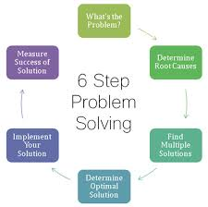

Figure 14.model 6-steps problems solving

These six steps are a continuous improvement process. The goal is not only to solve a problem but also to develop and continually adjust the solution as new challenges emerge, by repeating the 6 Step Process.

1. **Deep digging technique**

When running a complex and rugged business, the problem lies in grasping the schedule. With that in mind, you need to have a plan for solving complex problems in a way that will allow you to find the right solution as soon as possible. An approach known as Deep Drilling (drill)

Depth-of-the-field techniques are often used in the business. Specifically, the 5Whys method is consistent with this line of thinking in many ways. Both methods focus on finding the root problem rather than just identifying the problem, and both methods require you to think about your business as a whole instead of just the Factors directly related to the problem in front of you. Below is model 5Whys

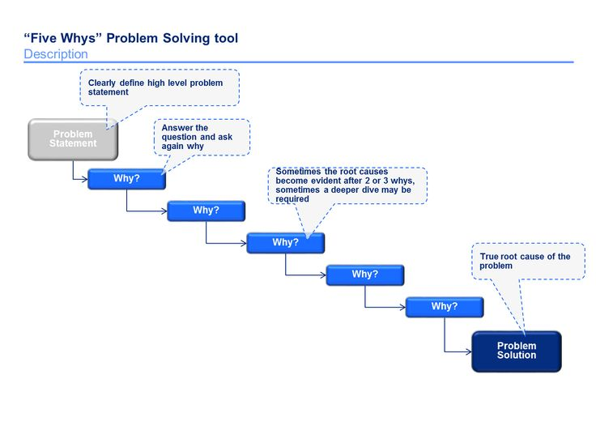

Figure 15.model 5Whys problems solving

1. **Model 4 frames**

Model 4 Framework is a concept that divides any organization into 4 frames

- For the purpose of better understanding of the organization, as they are divisible in this way. Organizations are extremely complex entities, with a large number of personality, motivation, ability, constraints and more.

- If you want to make the most of your organization, you need to understand it as deeply as possible. While there are many tools to help you with this purpose, the 4-frame model is one of the most in-depth tools and one of the most successful tools.

Below is model of 4 frames.

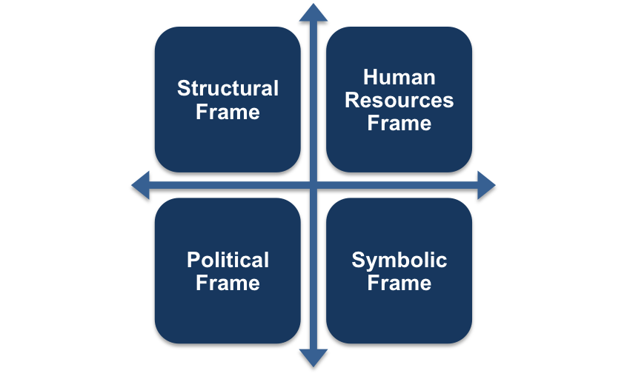

Figure 16.model 4 frames problems solving

1. **8 principles of problem solving**

These 8 principles are developed and used by ford as one of the world's leading automobile manufacturers, points main of method this is:

* The 8-step problem solving process focuses on product and process improvement, its purpose is to identify, correct and eliminate repeat problems.
* It aims to establish a permanent corrective action based on identifying the source of the problem by identifying the root cause.
* This is a highly disciplined and scientific approach to solving chronic and recurring problems.

Below is model of method:

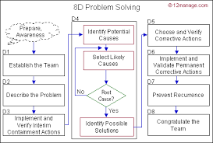

Figure 17.model 8 principles problem solving of Ford

1. **Cynefin framework**

* The Cynefin framework helps you find out how you should think about a problem instead of providing a method for solving it. The core of this framework is to break the problem into one of five contexts.
* The idea is to put the problem you are facing into one of these specific contexts, which will help you decide how to approach the problem.
* Once you've identified your position, you can start solving them in different ways.

Below is model of this method:

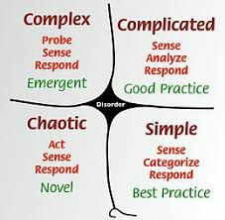

Figure 18.model Cynefin framework

## Develop an appropriate strategy for resolving a particular problem

To solve the problem in the most effective and fastest way you should have a specific preparation, I will suggest you some of the following steps.

1. **Understand the source of the problems**

Any matter large or small, but to find a solution to the problem of science, before the news you have to understand the source of that, then you will have a good solution to handle that problem but does not affect the results of the work.

1. **Analysis problems**

Once you understand the problem, the next step is to analyze the problem. Problem analysis helps you better understand the nature of the problem, whether the problem is wrong, whether it is serious, whether it is serious or not, and gives the most reasonable options for dealing with the problem. best way.

1. **Choose tools or methods to solve problems**

After recognizing, evaluating, and proposing solutions, the next important step that will determine the outcome of the problem is the solution. If you choose the wrong solution that will solve your problem will fall into a deadlock. So, consider carefully the solution. Take a look at the source, evaluate the problem carefully to make surethe solution youchoose is the most appropriate.

Some solutions you can choose these is: 6-step model solves the problem, Deep digging technique combined 5Whys, Model 4 frames…

1. **Perform**

Everything is ready to be completed, now your task is to get started or rather start working on the problem. This is a very important stage, the problems that may arise more will appear at this stage. So instead of following through with the plans already laid out, always take the initiative to deal with the problems that arise, to make sure that your problem is resolved in the best way and to bring about the best results. As expected.

1. **Reassess the result of the problem**

After you solved problems you need review all steps you performed, which steps were performed good, which steps were performed not good, you should learn from omissions and evaluate about all process perform.

## Evaluate the potential impact on the business of implementing the strategy

Business strategies play a very important role in the survival and development of each business. Proper business strategy will create a good direction for the business, business strategy can be considered as a guide to guide the business in the right direction.

Business strategy brings many benefits to the business, its importance is reflected in the following aspects:

* orienting for its future activities through the analysis and forecasting of the business environment. Business is an activity that is always influenced by external and internal factors.
* Both flexible and active to adapt to the market changes, while also ensuring the business operation and development in the right direction.
* Catch the opportunities as well as the full threat to the development of resources of the business. It helps businesses exploit and rational use of resources, promote the strength of the business.
* **Conclusions:**

This task helps you how to problems solving, there are five most popular methods today, depending on the situation of the problem you have to decide which method to solve the problem in the fastest and most effective way and evaluate about potential impact on the business of implementing the strategy.

# Reference

[1] <http://www.businessdictionary.com/definition/communication-skills.html>

[2] <https://www.mindtools.com/pages/article/newHTE_00.htm>

[3] <http://www.businessdictionary.com/definition/teamwork.html>