**BTEC LEVEL 5 HND COMPUTING AND SYSTEM DEVELOPMENT**

**QULITY SYSTEMS IN IT**



A Project Quality Systems in IT Presented

by

Nguyễn Đình Tùng(GC00952)



Submitted to the Graduate School of the

University of Greenwich Vietnam in partial fulfillment

Friday, 23th March 2018

**Table of Contents**

Abstractions 5

Introductions 5

Task 1 **Understand the need for quality assurance in IT systems** 6

1.1 Discuss appropriate standards for the development of an IT system 6

1.2 Assess the risks associated with the development of an IT system 9

1.3 Discuss quality assurance practices at all stages of the systems development lifecycle 10

Task 2 **Be able to employ standard quality control documentation**  13

1.1 Produce quality control documentation for each stage of the systems development lifecycle 13

Task 3 **Be able to use project management tools** 24

1.1 Apply project planning and management tools to plan specific resources and requirements for an IT system development 24

1.2 Evaluate the suitability of tools used to manage the development of an IT system. 25

References 29

**Table of figures**

Figure 1.software development life cycle 11

Figure 2.Work Breakdown Structure 26

Figure 3.Gantt chart 27

Figure 4.Critical Path 28

**Table of tables**

Table 1.Risks of System IT with database centre 10

Table 2.Manpower requirements 14

Table 3.Test objective 15

Table 4.Test case 1: Change status of account Customer from Manager 17

Table 5.Test case 2: Create account of Customer from Customer 17

Table 6.Test case 3: Edit info account of Customer from Customer 18

Table 7.Test case 4: Sign in with account Manager 19

Table 8.Test case 5: Sign in with account Customer 19

Table 9.Test case 6: Search product 20

Table 10.Test case 7: Add product from Manager 20

Table 11.Test case 8: Update product from Manager 21

Table 12.Test case 9: Add product to Cart from Customer 21

Table 13.Test case 10: Payment a Product of Customer 22

Table 14.Test result from test description 23

Table 15.Summary tables for total number of pass and fail 23

Table 16.Activity 27

# Abstractions

Amazon Inc. is an American international e- commerce company. It was started by Jeffrey P. Bezos in the year 1994. Today, it is the world largest online retailer.

Amazon makes use of the latest information technologies to maintain, and develop, its competitiveness including “big data” and cloud-based e-commerce applications which are web-browser accessible and database-centred. It develops these in-house using its extensive business analysis and computing expertise in these areas.

This report will support you understand about Amazon website

# Introductions

This report, I will analysis for you know about:

* What is Quality assurance?, what is Quality control? , SQA standards with develop of IT system, risks involve to development of an IT system with big data and cloud-based, discuss about SDLC and explain it
* I will analysis about How to test plan a software?, how to test description a software, how to test report a software?. I will make example on website Amazon.com
* I will explain the importance of project management to the production of high quality IT systems and I will make a example with software Project Management of Microsoft

Through this report I wish you will understand more Quality System in IT and you will have many knowledges to support for you in work

# Task 1 **Understand the need for quality assurance in IT systems**

## 1.1 Discuss appropriate standards for the development of an IT system

1. **Explains why a systematic approach to quality assurance, and quality control is needed**
2. **What is Quality Assurance (QA) and Quality Control (QC)?**

* “Quality assurance (QA) is the process of verifying whether a product meets required specifications and customer expectations. QA is a process-driven approach that facilitates and defines goals regarding product design, development and production. QA's primary goal is tracking and resolving deficiencies prior to product release.” [1]
* “Quality control is the set of measures and procedures to follow in order to ensure that the quality of a product is maintained and improved against a set of benchmarks and that any errors encountered are either eliminated or reduced. The focus of quality control is to ensure that the product and product manufacturing are not only consistent but also in line with customer requirements.” [2]

1. **Why quality control is needed?**

* The competitive market, demanding to survive and develop, must provide good quality products and services to meet market demand.
* General principles: Good quality management will create good quality products and services. Therefore, to create products and services of good quality, high efficiency, we must manage quality.
* We need to test our products before shipping them to our partners or customers to avoid any errors or omissions, including mandatory standards and customer requirements. This is an important activity in quality management.
* We need to plan and organize all activities to ensure that our products are consistent and consistent with what we have outlined. Therefore, we need to monitor and control these actions as part of quality management.
* We have to use a document system such as workflows, records, record forms. It helps we avoid case the personnel situation changed a lot, the old cadres vacated, replaced by new recruits. But this new person can’t do the job as the old one right away, easily creating defective products, not suitable, causing loss of time and money. This is the focus of quality management.
* Employees may not understand or adhere to the company's internal regulations for safety, operation, maintenance, or troubleshooting. Remedies can lead to bankruptcy. Avoid this by managing quality.

1. **Discusses various SQA standards.**
2. **What is Software Quality Assurance(SQA)?**

* “Software quality assurance (SQA) is a process that ensures that developed software meets and complies with defined or standardized quality specifications. SQA is an ongoing process within the software development life cycle (SDLC) that routinely checks the developed software to ensure it meets desired quality measures.” [3]
* At present there are many quality assurance systems such as ISO 9000 system, TQM system, Q.Base system, HACCP (Hazard Analysis Critical Control Points), GMP (Good Manufacturing Practice), ISO14000… But the most reliable is ISO 9000, If you want to research more about ISO 9000 let go to <https://en.wikipedia.org/wiki/ISO_9000>

1. **Benefits of SQA?**

* Better customer service: Always ensure the quality of the software for the customer, ensure that the application works as expected and bring satisfaction to customers.
* Lesser cost for development:
  + When using SQA in an application, the application will be monitored frequently and overall inspection before release in many aspects of the application, so there will be fewer bugs and developers will not need to go back to fix interruptions. Help for developers not to waste time, labor and cost after release
  + Developers do not need to stick to a single project in most of the time and move on to other things. If developers have contracts, the application is made on time or even earlier.
* Maintenance cost reduces: An application that does not use SQA will cost a lot to maintain, because without SQA, it will be difficult to detect errors before launching applications or selling applications, and after a lifetime of use, customers will find error during use and feedback so developers have to upgrade and maintain will be longer and more costly

1. **Purpose of SQA?**

* Risk Management: Software bugs cause costly damage on time, resources and possibly death. The reasons for the change from poorly designed user interfaces are due to direct programming errors.
* Cost Management: A well-tested, software-quality application system that minimizes development, maintenance, and change costs to meet business need.

1. **Standards to evaluate software quality**

* **Correctness:** extent to which a project fulfills its specifications.
* **Efficiency:**
  + It is the ability to respond appropriately to resource efficiency, application performance, and scalability. The source code ensures high performance when software runs on the system such as algorithms, transactions, scalability, etc. This analysis provides potential risks, Harms caused by software delays over time.
  + Evaluate the effectiveness of the software under the following conditions:
    - Application structure
    - Appropriate interactivity with resources
    - Performance, access time and data management
    - Manage memory, network and disk space
    - Process encryption, programming
* **Flexibility:** ease of making changes required by changes in the operating environment.
* **Integrity:** protection of the project from unauthorized access.
* **Interoperability:** effort required to integrate the system to another system.
* **Maintainability:**
  + Maintenance capabilities include the ability to test, upgrade, change and develop software to suit new requirements, functions, and environments.
  + Maintainability includes adaptability, portability and portability. Need to update information technology or changes in the market, enterprises always provide information, software quality to users.
  + Evaluate maintenance through the following attributes:
    - Software architecture and object-oriented programming
    - Analytical capabilities
    - Complexity of transactions, programming, algorithms
    - Control the level of encryption
    - Stability of hardware, operating system, intermediate components, standalone database
    - Ability to test
* **Portability:** effort required to transfer a project from one environment to another.
* **Reliability:**
  + The cause of poor reliability is due to software architecture that does not incorporate encryption. Assessing the reliability of a software provides estimates of the amount of business risk and the potential for errors in the application when testing. The purpose of testing and monitoring reliability is to minimize software defects such as outages or errors that directly affect the user.
    - Finalization of the application structure
    - Encryption process
    - The complexity of programming algorithms
    - Ability to handle and fault tolerance
    - Resilience, resource management
    - Software to manage the integrity and consistency of data
* **Reusability:** ease of re-using software in a different context.
* **Testability:** ease of testing the project to ensure that it is error-free and meets its specification.
* **Usability:** ease of use of the software.

## Assess the risks associated with the development of an IT system

* Risks are subjective events that interfere with the development of a software project.
* Risk can’t be ruled out that one needs to manage to minimize its damage
* In fact, software manufacturing companies need mechanisms and procedures to adjust the risks.
* Risk management needs planning and moving towards automation
* In the process of developing an application or software inevitably occurs the risk. The occurrence of risks causes the project to fail or waste time and workforce, reducing profitability and trusting the customer. Amazon's IT software development is no exception. Amazon uses a central database to store data. So, here's a list of possible risks that might arise when using a central database.

|  |  |  |
| --- | --- | --- |
| No | Risk | Risk mitigation action |
| 1 | Hardware version, software change during project implementation | Buyers should request the latest version or package solution |
| 2 | Interfaces to internal systems and external systems may not be completed on time. | 1. Start early, standard connection  2. Update the old system to new standards.  3. Work immediately with external systems to unify standards. |
| 3 | Implementing the test may not be sufficient for defining performance assurance when deploying a wide area. | 1. Prepare, test and follow detailed testing plans, identify critical components and essential operations that are required to be tested.  2. Adoption of the pilot implementation will not be complete and indicate what needs to be corrected before deployment as well as what needs to be adjusted later. |
| 4 | Business processes can be changed while deploying IT projects | 1. High-level management must be involved in the policy making process in order to understand the impact of any significant change.  2. Make the necessary changes to the system through the approved change management process. |
| 5 | The system may not meet the needs or expectations of the user | 1. Ensure that staff at all levels are involved in the redesign of business processes and systems.  2. Mobilize users to check and,  3. Experiment with many major functions |
| 6 | Malware infections causing incidents such as unauthorized access, leakage or disclosure of personal or proprietary data, deletion of or damage to the data or programs, interruption or denial of authorized access to the database, attacks on other systems and the unanticipated failure of database services unauthorized or unintended activity or misuse by authorized database users, database administrators, or network / systems | 1. Kill virus regularly for software, perform routine application check and documentation  2. Regular maintenance, restart the software when needed |
| 7 | Disaster prevention measures may not be as expected | Specify explicit and specific requirements, requiring a disaster prevention screening system. |

Table 1.Risks of System IT with database centre

## 1.3 Discuss quality assurance practices at all stages of the systems development lifecycle

1. **What is the Software Development Life Cycle(SDLC)?**

* SDLC is a systematic and orderly approach to solving problems related to software systems or in other words, it is a structure for the development of a software product. Depending on the different types of software development models, the following stages can be organized and organized.
* Diagram of SDLC below:

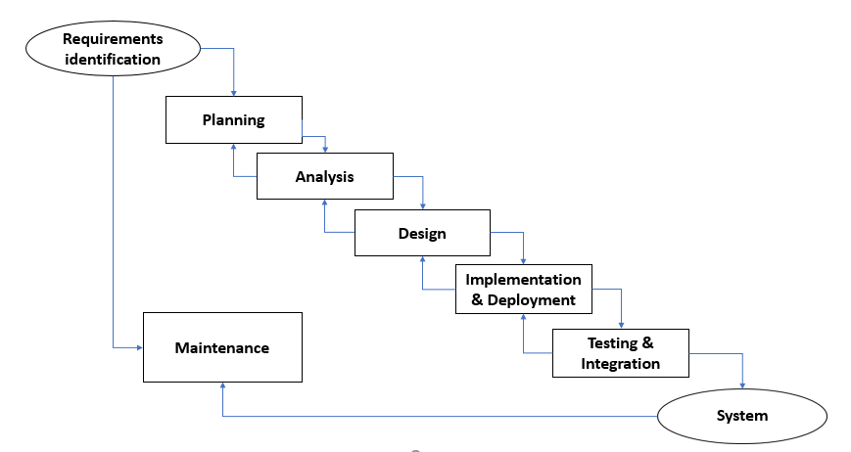

Figure 1.software development life cycle

1. **Explain**

* **Domain Analysis:** This phase is very important. The goal of this stage is to exploit and collect requirements. Analysts will come up and collect requests from experts and stakeholders. The more you understand the requirements, the easier and easier your job will be.
* **Requirement Analysis:** The most important task in creating a software product is to isolate the requirements. Customers often know what they want, but that's not what software should do if these requirements are incomplete, unclear or contradictory. These requirements need to be recognized / validated by software engineers who are skilled and experienced.
* **Scope Analysis:** Once the requirements are collected from the client, analysis of the scope of the development should be defined and specified. This is often referred to as a scope document.
* **Specification:** It is the task of accurately describing the software to be written. In fact, the most successful specification written to understand and refine applications has been perfected, though in theory these specifications should be carefully defined before application development. The most important specification for partners outside the organization (stakeholder, client, partner) and stable (less varied). A good way to determine if the specifications are accurate enough is to have a third party review the documentation and ensure that the requirements are reasonable.
* **Software Architecture / Design:** The architecture involves ensuring that the software system meets the requirements of the product, as well as ensuring that future requirements can be addressed. It also involves communication between software systems and other software products, as well as underlying hardware or host operating systems.
* **Coding:** Design must be translated into a readable form. The code phase will perform this task. If the design is done in detail, coding can be done without much hassle. Programming tools such as compilers, interpreters, debuggers, etc. are used to generate encodings. Various high-level programming languages such as C, C ++, Pascal, Java are used to write code. Depending on the type of application, the appropriate programming language will be selected.
* **Testing:** Once the code is created, the software test begins. Different testing methods can be used to elucidate errors that have been committed in previous phases. Automated testing tools can also be used to increase the effectiveness of software testing. Some companies build their own testing tools to support their development activities.
* **Implementation / deployment:** Once the code is properly tested and approved, it will be put into practice.
* **Documentation:** An important task is to write and store internal design documentation of the software for the purpose of maintaining and enhancing in the future.
* **Maintenance:** Maintaining / maintaining and upgrading software to deal with newly discovered problems or new requirements can take longer than with the initial development of software.
* **Software Training and Support:** As part of the deployment phase, training classes for software users are very important. The user will have a lot of questions and software issues leading to the next stage of the software.
* **Conclusions:**
* Through what I analyzed above you will understand more about what is quality assurance, what is quality control, why we need use quality assurance and quality control in development software, purpose of Software Quality Assurance(SQA), benefit of SQA with develop software, what is Software development life cycle(SDLC) and explain how each phase of the life-cycle is quality assured.

# Task 2 **Be able to employ standard quality control documentation**

## Produce quality control documentation for each stage of the systems development lifecycle

* + 1. **A software test plan (STP)**

1. **Scope of the tests**
2. **The software package to be tested (name, version and revision)**

The web-site develops by Amazon

1. **The documents that provide the basis for the planned tests**

The documents: Coding Document, Design Document, Database Document

1. **Testing environment**
2. **Sites**

The web-site: Amazon.com

1. **Required hardware and firmware configuration**

* The computer for the required testing needs to be a new machine, and the devices of the computer must work well to prevent the computer from shutting down naturally during the testing process which will affect the time and next test process. The computer must be connected to a local area network at least 25MB / s.
* During testing, the test team will need at least 10 machines running Windows 8 or later. The minimum RAM is 16GB and the processor speed is 4.5 GHz. On each machine must install some necessary software such as XAMPP to be able to connect to the database server and web server.

1. **Participating organizations**

Participating organizations are: Amazon

1. **Manpower requirements**

|  |  |  |
| --- | --- | --- |
| No. | Manpower | Task |
| 1 | Developer team about website | - When testing team are complete test, developers will edit and update software  - Support testing team in process test |
| 2 | Testing team | - Identify the requirements to produce effective test methods.  - Technical description of test tools.  - Evaluation and reporting of Test Approach.  - Conduct tests, record the results of test and report bugs. |
| 3 | Project management | Make plan and schedule for testing, support and observe process test |
| 4 | SQA team | They have to responsible for quality assurance. Process testing that meets the requirements is outlined? |

Table 2.Manpower requirements

1. **Preparation and training required of the test team**

Requirements of test team are they must have experience in develop software about web-site from 3 years to 5 years, have good communication skills, energetic at work, sociable with people, have responsibility in work.

1. **Tests details (for each test)**
2. **Test identification**

Before testing objective, we need to test port components that will be used to know which processes in the system are running properly.

Portal component testing is used to ensure each of the individual components of the system operates correctly.

• Positive User Testing: The portal, when used correctly in the manner prescribed in the user manual, must generate the correct final results for the selected application

• Negative User Testing: The portal should be tested for invalid user inputs and actions.

• System Testing: The portal should be tested for cases when partial system failures occur; mean one of the hosts or Web services is temporarily unavailable.

1. **Test objective**

|  |  |  |
| --- | --- | --- |
| Module Name | Application Roles | Description |
| Account | Manager  Customer | **Manager:** Is a manager, they can view all accounts of customer, change accounts of customer but in limit, can management info for web-site for example edit info…  **Customer:** Is a customer, they can create accounts with under the jurisdiction of the customer, each number phone or email only create one account, view information for own account, edit account for themselves |
| Sign In | Manager  Customer | **Manager:** Is a manager, they can sign in with own account only spend for management  **Customer:** They can login as a customer when they create account we make default is customer |
| Search | Manager  Customer | **Manager:** Manager can search everything on website  **Customer:** Customer just can search products on website |
| Product | Manager  Customer | **Manager:** They can add, edit, delete, view products  **Customer:** They can view products, cancel products when these products on cart, add products to cart themselves |
| Payment | Customer | **Customer:** They can buy on website and payment by cart… Buy products in their cart and charge all at once |
| Bills and revenue statistics | Manager  Customer | **Manager:** They cansee the entire bill they bought the product and monthly statistics  **Customer:** They can see the entire bill they bought the product |

Table 3.Test objective

1. **Test schedule**

**Preparation: 4 weeks**

+ Human resources preparation: 1 week

+ Prepare Computer: 1 week

+ Make plan test: 2 weeks

**Testing: 2 weeks**

+ Testing: 1 week

+ Write report: 1 week

**Error correction: 3 weeks**

+ Make plan fix error: 1 week

+ fix error: 1 week

+ Write report: 1 week

**Regression tests: 1 week**

* + 1. **A software test description (STD)**

1. **Introduction**

The following is the documentation of the software testing process of the Amazon web development project. This document records the module tests in Amazon's testing plan. It is focus on two parts this is:

- Software integration tests: The process of testing modular groups is combined from single modules. It is done after the unit test and before the confirmation test. The integration tests will take the modules that were passed from the unit test then combine them with the larger groups, applying the tests defined in the integrated test plan into the that group and output the integrated system output ready for system testing.

- Software Verification tests: Is a software test to ensure the software will fully meet all the requirements expected.

1. **Test Preparation**

* The computer for the required testing needs to be a new machine, and the devices of the computer must work well to prevent the computer from shutting down naturally during the testing process which will affect the time and next test process. The computer must be connected to a local area network at least 25MB/s.
* During testing, the test team will need at least 10 machines running Windows 8 or later. The minimum RAM is 16GB and the processor speed is 4.5 GHz. On each machine must install some necessary software such as XAMPP to be able to connect to the database server and web server.

1. **Test Description**
2. **Test Module Account**

**a.1. Test case 1: Change status of account Customer from Manager**

|  |  |
| --- | --- |
| Test ID | AMAZON-WEB-TC001 |
| Test description | Change status of account Customer from Manager |
| Initial conditions | The status will be selected by the manager, for example, the account status is locked or the account is not locked |
| Tests inputs | Testers must select a status to change |
| Request to complete | Change status complete and save to database |

Table 4.Test case 1: Change status of account Customer from Manager

**Test procedure:**

Step 1: with interface of manager, they can view detail info of customer, in this interface they can select status to change

Step 2: after select status they will click to button “Save” to save selected status to database. If success system will load to interface and will display selected status. If no success system will display a dialog info about this error.

**a.2. Test case 2: Create account of Customer from Customer**

|  |  |
| --- | --- |
| Test ID | AMAZON-WEB-TC002 |
| Test description | Sign up an account |
| Initial conditions | The data will be entered by the tester |
| Tests inputs | Tester will enter full data to form on interface such as Name, Email, Password and re-enter password must same together |
| Request to complete | If success data will be save to database and tester can sign in with this account |

Table 5.Test case 2: Create account of Customer from Customer

**Test procedure:**

Step 1: On interface of Customer, tester let to click button “Account & list”, after on new interface tester click to button “Create your Amazon account” it will lead you to interface sing up

Step 2: tester let enter full data to form on interface, email is real, password not least 6 characters, re-enter password must same together password

Step 3: after enter full data, tester click to button “Create your Amazon account”, if success it will go back home interface and tester can sign in with this account, if no success when email is not real or password less more 6 characters or re-enter password is not same with password.

**a.3. Test case 3: Edit info account of Customer from Customer**

|  |  |
| --- | --- |
| Test ID | AMAZON-WEB-TC003 |
| Test description | Edit info account of Customer from Customer |
| Initial conditions | Data will be entered by tester |
| Tests inputs | Tester can change avatar, change email, add location… |
| Request to complete | All data will be update to database and on interface profile will display info changed |

Table 6.Test case 3: Edit info account of Customer from Customer

**Test procedure:**

Step 1: After tester sign in with account was created, on interface tester move mouse to button “Account & list” after click to “Your account”, after on new interface tester let to click on symbol of account and to new interface on this interface tester let to click on button “Edit your Profile” it will lead you to site profile.

Step 2: on interface profile tester can enter data into the item that the tester wants to change, email can’t change and email is correctly to database, after that tester let click to button “Save” on interface to change info

Step 3: If success system will load and display items the tester has been changed, if no success system will display a dialog and info about errors.

1. **Test Module Sign In**

**b.1. Test case 4: Sign in with account Manager**

|  |  |
| --- | --- |
| Test ID | AMAZON-WEB-TC004 |
| Test description | Sign in with account Manager |
| Initial conditions | Data will be entered by tester |
| Tests inputs | Data from tester enter must same with data in database |
| Request to complete | If success system will auto move to interface only for manager |

Table 7.Test case 4: Sign in with account Manager

**Test Procedure:**

Step 1: on general interface tester click to button “Account & list” after tester enter email same with email in database and click on button “Continue”, if fail it display info error at top, if success system will move to form other, at this form tester let enter password for account, password must same with password in database, after click button “Sign in”.

Step 2: If success it will move to home interface of manager. If no success it will display error at top.

**b.2. Test case 5: Sign in with account Customer**

|  |  |
| --- | --- |
| Test ID | AMAZON-WEB-TC005 |
| Test description | Sign in with account Customer |
| Initial conditions | Data will be entered by tester |
| Tests inputs | Data from tester enter must same with data in database |
| Request to complete | If success system will auto move to interface only for customer |

Table 8.Test case 5: Sign in with account Customer

**Test Procedure:**

Step 1: on general interface tester click to button “Account & list” after tester enter email same with email in database and click on button “Continue”, if fail it display info error at top, if success system will move to form other, at this form tester let enter password for account, password must same with password in database, after click button “Sign in”.

Step 2: If success it will move to home interface of customer. If no success it will display error at top.

1. **Test Module Search**

**c.1. Test case 6: Search product**

|  |  |
| --- | --- |
| Test ID | AMAZON-WEB-TC006 |
| Test description | Search product |
| Initial conditions | Tester will enter or select information |
| Tests inputs | Data enter will prepare with name of product in database |
| Request to complete | System will show all product related to keywords |

Table 9.Test case 6: Search product

**Test procedure:**

Step 1: On interface of customer tester will enter or select information to search, after click button “Search”

Step 2: If success system will show all products related to keywords, If no success system does not show anything.

1. **Test Module Product**

**d.1. Test case 7: Add product from Manager**

|  |  |
| --- | --- |
| Test ID | AMAZON-WEB-TC007 |
| Test description | Add product from Manager |
| Initial conditions | Tester will enter all data |
| Tests inputs | Tester must enter full data |
| Request to complete | Data will be saved to database and products will display if tester search it |

Table 10.Test case 7: Add product from Manager

**Test procedure**

Step 1: When tester sign in with account manager, tester can see button “Add new product” through management menu bar

Step 2: After click button “Add new product” tester let enter full data to form displayed on screen after click button “Add product”

Step 3: If success all data will be saved to database and tester must search this product and it will display on screen, if no success this product will not display.

**d.2. Test case 8: Update product from Manager**

|  |  |
| --- | --- |
| Test ID | AMAZON-WEB-TC008 |
| Test description | Update product from Manager |
| Initial conditions | Tester will enter all data |
| Tests inputs | Tester must enter full data |
| Request to complete | Data will be updated to database and information of product will change when tester search it |

Table 11.Test case 8: Update product from Manager

**Test procedure:**

Step 1: On interface of manager when view product will add an edit button tester will click this button

Step 2: tester let enter information want edit, after that click button “Edit product”

Step 3: if success tester will see information changed after system load interface, if no success information of product will no change

**d.3. Test case 9: Add product to Cart from Customer**

|  |  |
| --- | --- |
| Test ID | AMAZON-WEB-TC009 |
| Test description | Add product to Cart from Customer |
| Initial conditions | Tester let choose a product |
| Tests inputs | Product must have in database |
| Request to complete | Tester will check this account’s cart if it displayed is success |

Table 12.Test case 9: Add product to Cart from Customer

**Test procedure:**

Step 1: Tester will choose a product and click this product, system will move to interface other, on this interface tester click button “Add to Cart”

Step 2: After that tester click button Cart on interface, if success product will display on interface cart, if no success product will no display.

1. **Test Module Payment**

**e.1. Test case 10: Payment a Product of Customer**

|  |  |
| --- | --- |
| Test ID | AMAZON-WEB-TC010 |
| Test description | Payment a Product of Customer |
| Initial conditions | Tester will enter code pin and code account of credit |
| Tests inputs | Code pin of tester’s credit must correctly, code account of credit must correctly |
| Request to complete | System will send to tester’s email info that payment success and detail about method receive product |

Table 13.Test case 10: Payment a Product of Customer

**Test procedure:**

Step 1: On interface cart, after tester add product to cart, tester will see a method payment, tester will click button “Apply now”

Step 2: After that system will move to interface payment and tester will enter code pin credit and code account credit, after that click button “Payment”

Step 3: Tester will check this email and open email from Amazon, If success content email will show detail payment and method receive product, if no success email will show info error for tester.

* + 1. **A software test report (STR)**

1. **Test result from test description**

|  |  |  |  |  |
| --- | --- | --- | --- | --- |
| Test ID | Test case | Test result | Tester identification | Note |
| AMAZON-WEB – TC001 | Change status of account Customer from Manager | Pass | Member of testing team |  |
| AMAZON-WEB – TC002 | Sign up an account | Pass | Member of testing team |  |
| AMAZON-WEB – TC003 | Edit info account of Customer from Customer | Fail | Member of testing team | System display information for error this is email is not correctly |
| AMAZON-WEB – TC004 | Sign in with account Manager | Pass | Member of testing team |  |
| AMAZON-WEB – TC005 | Sign in with account Customer | Pass | Member of testing team |  |
| AMAZON-WEB – TC006 | Search product | Pass | Member of testing team |  |
| AMAZON-WEB – TC007 | Add product from Manager | Pass | Member of testing team |  |
| AMAZON-WEB – TC008 | Update product from Manager | Fail | Member of testing team | System info error this is Can’t save to database |
| AMAZON-WEB – TC009 | Add product to Cart from Customer | Pass | Member of testing team |  |
| AMAZON-WEB – TC010 | Payment a Product of Customer | Fail | Member of testing team | System info error because code pin incorrectly |

Table 14.Test result from test description

1. **Summary tables for total number of pass and fail**

|  |  |  |  |
| --- | --- | --- | --- |
| Test cases planned | Test cases executed | Test cases pass | Test cases fail |
| 17 | 10 | 7 | 3 |

Table 15.Summary tables for total number of pass and fail

* **Conclusions:**
* Through what I write in test software a website of Amazon’s system IT you will know how to write a report for software, what is test plan, why need test plan, how to test plan, what is test description and test report and how to test them.

# Task 3 **Be able to use project management tools**

## Apply project planning and management tools to plan specific resources and requirements for an IT system development

1. **What is project management?**

Project Management is the application of knowledge, skills, tools, and techniques to project activities to meet the project requirements.

The challenge, as well as the most headache of project management, is how to achieve the project objectives in terms of constraining the seven key elements (the first of which is triple constraints):

* Scope
* Cost (cost)
* Time (time)
* Quality
* Resources
* Risk (risk)
* Customer Satisfaction

1. **Why project management is important to the production high quality IT systems?**

* Project Manager - PM (Project Manager) is the key person in the process of project implementation. PM decides the success or failure of the project, holding up to 50% of the fate of a project. If project organization is like a human body, PM is the brain's activity. The good brain can coordinate with other parts of the body rhythmic, resulting in significant results. In contrast, when the brain has problems, no matter how well each part of the body works, their efforts not good or no result. A moderate PM is the manager of the overall problem, as well as the person involved in all the work in the project.
* The most important aspects of the project are the responsibilities of PM: Budget estimation, project team building, project planning, project division, progress and quality management, work with customers, resource management, ...
* A Project Manager needs to maintain a perspective on a "big picture" that directs the project to success, handles tasks in daily work, and responds to any crisis. can happen in the project. They need a lot of skills as well as expertise to be able to manage the project well. Here is what the project management needs.
  + Understand the business strategy: The project manager needs to understand the business strategy of the business so that he can accurately predict the changes and is ready to take the appropriate approach to deal with the change.
  + Risk assessment and management: As a project manager you need to have the skills to analyze the risks, evaluate them and manage the threats to the success of the project. You also need to consider the opportunities from the risks (not the risk that causes negative results) to achieve good results in time, cost allows.
  + Conflict management: When conflict occurs, the project manager needs to find out the source of the disagreement, set up meetings to listen and discuss different perspectives with the insiders to find consensus and Have specific solutions to allow the project progress to continue.
  + Time management: You must be able to analyze what you are doing, spend time on what work and what works are really important to determine the success of the project. Your main task is to plan, guide the implementation team, monitor the overall project, create and lead innovation in how the problem arises.
  + Communication skills: Communication skills are one of the key skills a project manager should have. You may have good management, technical skills ... so you can take on the job of a big project manager, but it will be difficult for you to succeed if you are not able to communicate effectively. with stakeholders and project team in their language. So you need to have good skills to be a good project manager
  + Problem solving and technical skills: An effective project manager needs to have an in-depth understanding of what he is doing, the technology trends, the limitations of each technology applied in the project, etc. These allow you to understand the work. Specific members, and stakeholders to get the right support, make the right decision and more importantly, over time you gain respect from the team.

## Evaluate the suitability of tools used to manage the development of an IT system.

1. **A Work Breakdown Structure:**

A work breakdown structure (WBS) a step-by-step diagram of completing a project that helps the project manager identify the correct steps, helping them explain the steps to implement the project with the easier implementation of the project, from WBS the manager can create a specific time schedule for the project, helping the manager to divide work and assign work to the operator easily, helping the manager estimate The start time and end of the project, estimated investment costs for the project. Here is the Work Breakdown Structure of the Amazon website project:

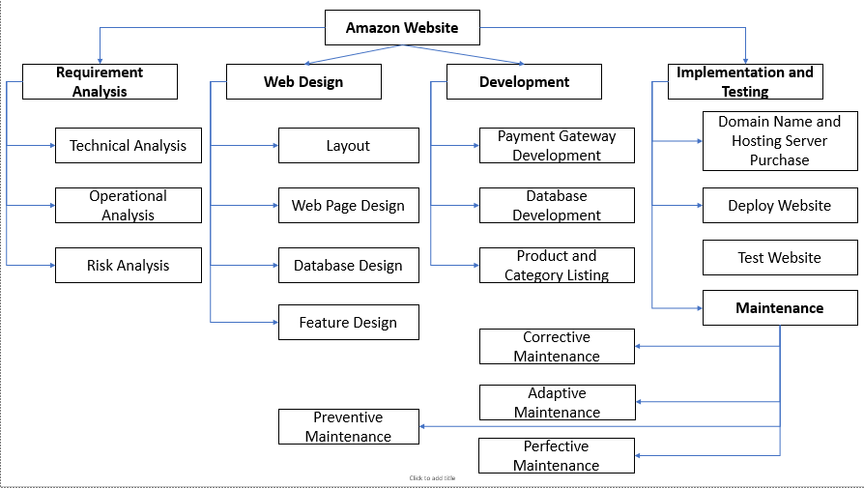

Figure 2.Work Breakdown Structure

1. **A Gantt Chart**

Gantt chart, Gantt chart is very easy to understand and so it is popular, Gantt charts showing the progress of the project. The left side of the chart shows the steps taken by the project and the progress of the project, to the right of the Gantt graph showing the time periods to complete. into the steps taken. The following criteria can be easily seen:

* + The activities of the project
  + Start and end time for each activity
  + The expected time for each activity
  + Time activities must be done together
  + Start time and end time of the project

Here is the Gantt chart of the amazon website project:

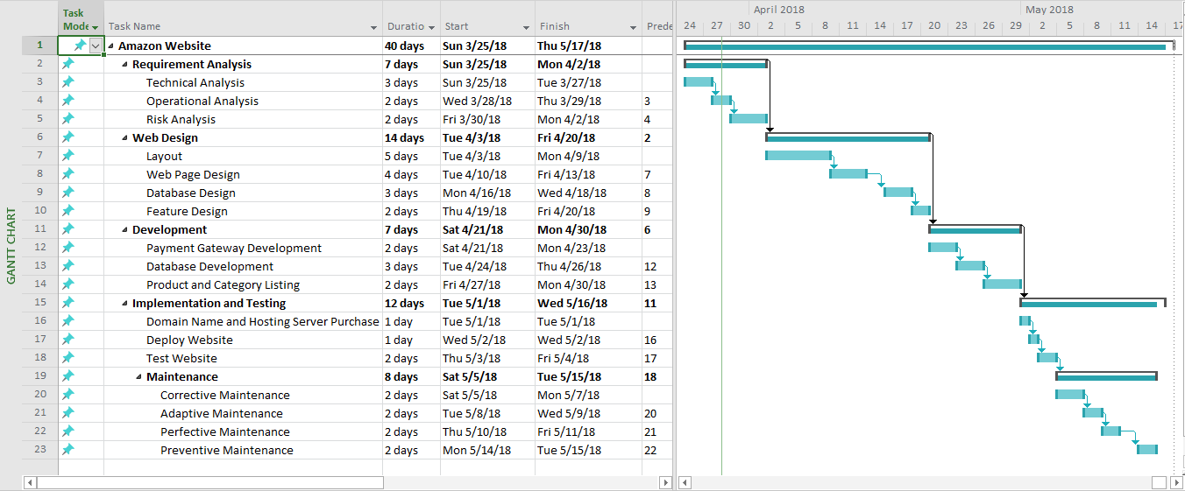

Figure 3.Gantt chart

1. **A Critical Path Method:**

The critical path is the longest path to complete the project. It is often perceived that the other way is red. In the process of implementing a critical path, if one step is delayed or stopped, the whole project will be stopped, especially if the next task is required to complete the task.

|  |  |  |  |
| --- | --- | --- | --- |
| Activities | Activity ID | Immediate Predecessor | Time (Days) |
| Requirement Analysis | **A** |  | 7 |
| Web Design | **B** | 2 | 14 |
| Development | **C** | 6 | 7 |
| Implementation and Testing | **D** | 11 | 12 |

Table 16.Activity

**Below Diagram Critical Path****:**

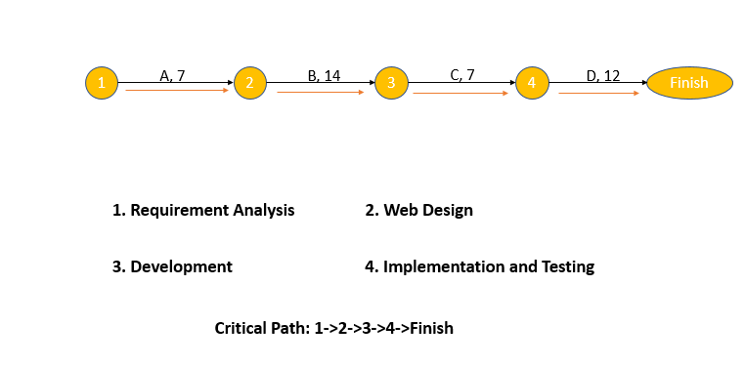

Figure 4.Critical Path

* **Conclusions:**
* At this task I explained for reader about why we should use project management in software development and I have an example to you can understand more about how to project management a project.

# References

[1] <https://www.techopedia.com/definition/9038/quality-assurance-qa>

[2] <https://www.techopedia.com/definition/12191/quality-control-qc>

[3] <https://www.techopedia.com/definition/4363/software-quality-assurance-sqa>