**BTEC Level 5 HND Computing and Systems Development**



A Project Web Design Presented

by

Nguyễn Đình Tùng(GC00952)



Submitted to the Graduate School of the

University of Greenwich Vietnam in partial fulfillment

Friday, 20th April 2018

Lecturer: Lại Mạnh Dũng

**Table of Contents**

**Introduce** 5

Task 1: **A document, correctly formatted, indexed and fully referenced of not more than 800 words illustrated with screenshots of good and bad examples of websites.** 6

1.1 Research and analyze the factors that are considered essential for a modern web design 6

1.2 Make sure you consider functionality, usability, accessibility and business requirements 13

1.3 Produce your list of essential design elements, referencing your sources 14

1.4 Choose three good and three bad web designs and evaluate them against your list, discussing their strengths and weakness 14

1.5 Discuss and justify how you would improve the bad examples 19

**References** 21

**Table of figures**

Figure 1. Visibility 6

Figure 2. Consistency 7

Figure 3. Familiarity 8

Figure 4. Affordance 9

Figure 5.Navigation 10

Figure 6. Feedback 11

Figure 7. Recovery 12

Figure 8. Flexibility 13

Figure 9. Good web design for cuisine 14

Figure 10. Good web design about news of London 15

Figure 11. Good web design for Academy 16

Figure 12. Bad web design about technology 17

Figure 13. Bad web design for high school sport 18

Figure 14. Bad web design for website game 19

**Table of tables**

Table 1. solution for bad web design 19

# **Introduce**

This report I will write about 12 principles to evaluate a website in web design of developer web, I have examples for each principle and explain it. I will help you understand more about web design with consider functionality, usability, accessibility and business requirements. I will get examples about good website and bad website to analysis strengths and weakness of them and get solutions for bad website to improve them.

# Task 1: **A document, correctly formatted, indexed and fully referenced of not more than 800 words illustrated with screenshots of good and bad examples of websites.**

## Research and analyze the factors that are considered essential for a modern web design

* Below I will write about principles to design websites

1. **Principle 1: Visibility**

* Visibility in design websites is set the hidden attribute for the body of the content.
* You should be able to see what functions are available and what the system is doing.
* For an example in my website this is display alert when check info register, you should return a specific error for each info help user easy understand.

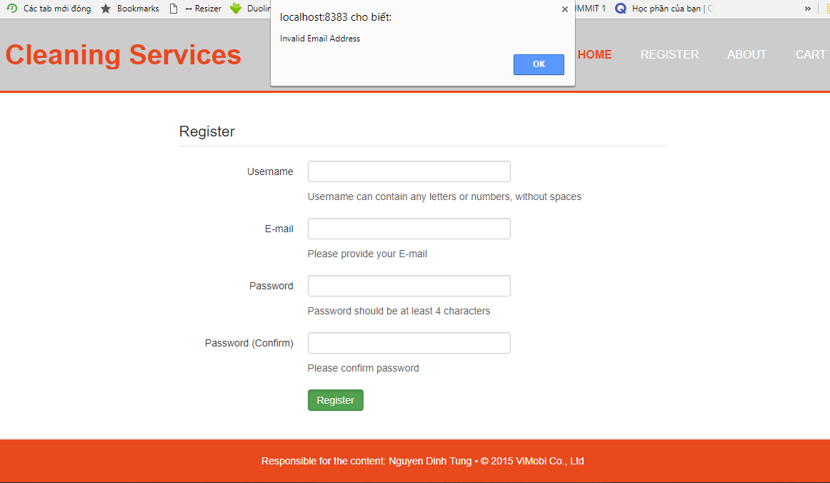

Figure 1. Visibility

* Alert info invalid email address will help user easy recognize it is error about email not format

1. **Principle 2: Consistency**

* The unified interface design makes the user feel comfortable because they only need one-time experience to easily use all the features on the website. This gives a sense of familiarity and is not short of customers. To ensure consistency, you need to be sure that reminders, notifications, menus, etc. must be used consistently across all pages.
* For an example below:

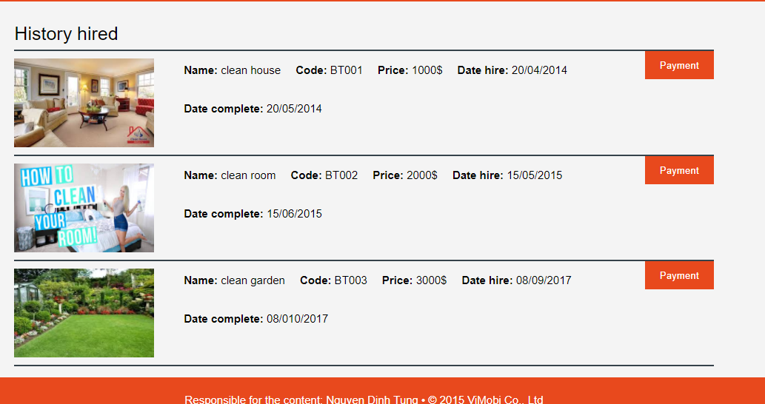

Figure 2. Consistency

* This example for I see website display straight blocks, rational fonts, equal structures, consistent colors all make up the site consistency.

1. **Principle 3: Familiarity**

* The extent to which users recognize UI components and their interaction views are natural; The similarities of the interface to specific objects that users have interacted with in the past. The user interface can be familiar by mimicking the visual appearance of real-world objects, by relying on standardized commands or by following other common metaphors.
* For an example about familiarity below:

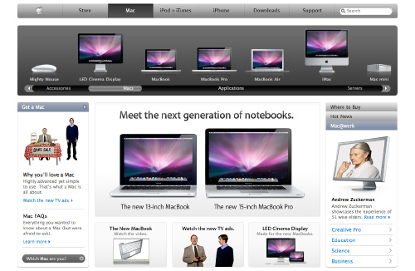

Figure 3. Familiarity

* Images, fonts are very familiar to everyone, users can easily understand what the site displays.

1. **Principle 4: Affordance**

* Even if the individual realizes that the possibility of action is irrelevant - the affordability is still present.
* Perceptual abilities are particularly relevant in interface design
* Symbols play a role in interacting with the user. In many ways, the characteristics of an object suggest to individuals what actions may be taken.
* For an example about affordance below: a button must look like a button to user easy realize

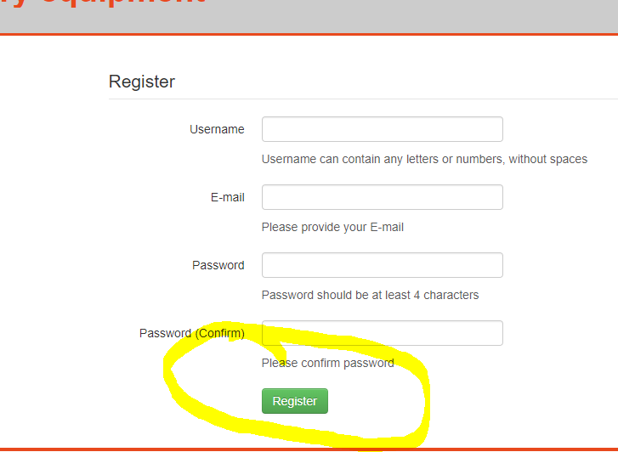

Figure 4. Affordance

1. **Principle 5: Navigation**

* Navigation design is the leading component of online presence to help your website succeed. It is the gateway to different parts of the content of a website. Site navigation is essential to a good customer experience for your online presence. It is similar to the road map for all the parts and different information that is attached to the site. Proper use of a consistent navigation scheme from page to page can be very helpful for your audience to find out the navigation system of your site.
* Below is an example I take a photo my assignment

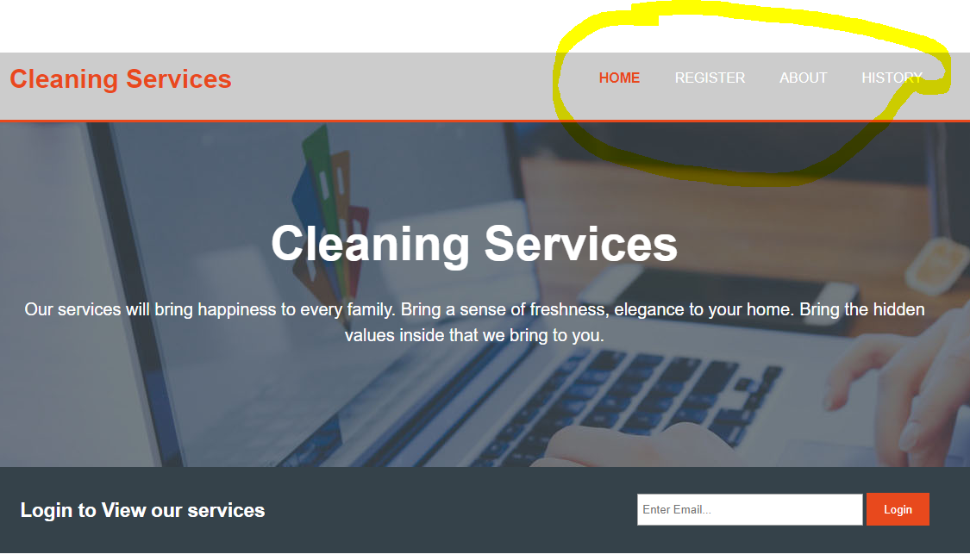

Figure 5.Navigation

* Texts home, register, about, history help user easy recognize this is a link can click mouse to it to move to other pages.

1. **Principle 6: Control**

* Make it clear who or what is in control and allow people to take control.
* Control is enhanced if there is a clear, logical mapping between controls and the effect that they have.
* For an example: when a human login to your website, you use session to management, control actions of them and help audiences recognize they are doing on your website. Other example you use button to implement an action or use element <a></a> to move other page.

1. **Principle 7: Feedback**

* Your site's system needs feedback on the results of the action when the user performs an action
* For an example info register successful in my website below

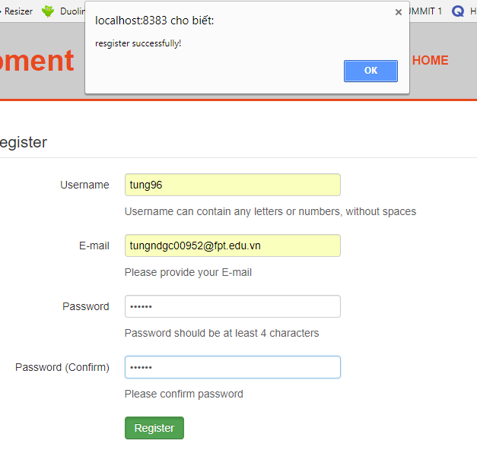

Figure 6. Feedback

* Or you have a separate page for user feedback to your site.
* Info register successful indicates that the site system has been registered for the user account and responds to the user successfully.

1. **Principle 8: Recovery**

* Allows the user to return when performing the wrong operation or to return to the wrong navigation
* For example: button reset data when user enter wrong info or button back when user navigation fail.

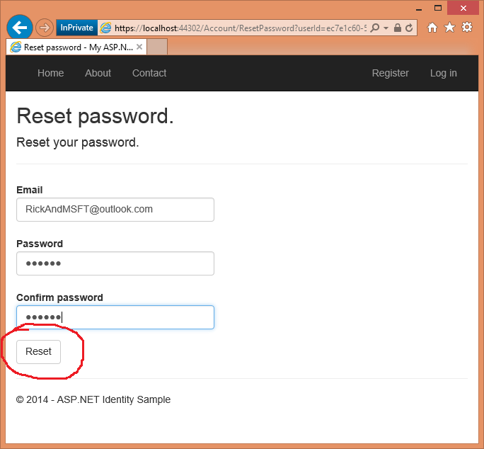

Figure 7. Recovery

* Button reset help user can restores all entered information to empty status

1. **Principle 9: Constraints**

* “provide constraints so that people do not try to do things that are inappropriate.
* should be prevented from making serious errors
* allowable actions and seeking confirmation of dangerous operations.” [1]

1. **Principle 10: Flexibility**

* When audiences use your website they need have experience the hidden interface or they can change interface follow their style.
* For example hidden interface in my website below

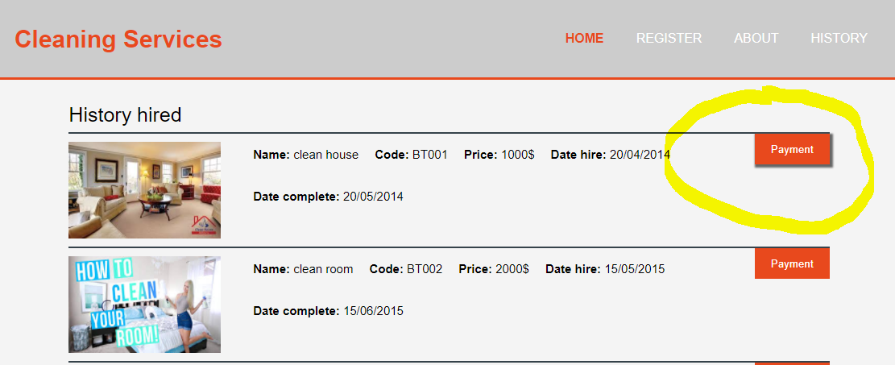

Figure 8. Flexibility

* When move mouse to button payment user can see button changed and more prominent than other buttons.

1. **Principle 11: Style**

* You should design follow separate style, creativity, simple and usability

1. **Principle 12: Conviviality**

* “Interactive systems should be polite, friendly, and generally pleasant.
* Nothing ruins the experience of using an interactive system more than an aggressive message or an abrupt interruption.
* Conviviality also suggests joining in and using interactive technologies to connect and support people.” [2].

## Make sure you consider functionality, usability, accessibility and business requirements

* 1. **Usability**
* The ability to use the site is all the desired action of the user on your site with ease.
* List of essential design elements base 12 principles this is: Navigation, Control, Feedback, Recovery, Constraints.
  1. **Accessibility**
* Can accommodate a wide range of devices, whether handheld or desktop:
* Portable and mobile technologies are more text-based and include Personal Digital Assistants (PDA), smart and cell phones, Blackberries, etc.
* Some visitors to Web sites turn off images to speed downloading pages, so text alternatives for images are necessary
* Visually-impaired visitors rely on text-alternativeswhen accessing Web sites, and rely on clear, succinct text
* Voice reading devices for the visually-impaired also read these text alternatives, as do text-based library terminals.
* List of essential design elements base 12 principles this is: Flexibility, Style, Conviviality.
  1. **Business requirements**
* Site requests are a list of functions, capabilities or characteristics needed in relation to your site and site creation plans. There are several types of requirements that can be identified during the gathering process to focus and prioritize the project plan.
* List of essential design elements base 12 principles this is: Visibility, Consistency, Familiarity, Affordance.

## Produce your list of essential design elements, referencing your sources

* Some elements frequent appearances in my website this is
  + element <a href=””></a> I used to navigation
  + element <div></div> I used to divide the sections in the site
  + element <img></img> to display photo….

## Choose three good and three bad web designs and evaluate them against your list, discussing their strengths and weakness

1. **Three good web designs**

* Good web design for website about cuisine, below is image of it

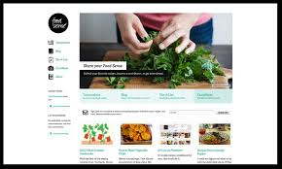

Figure 9. Good web design for cuisine

* **Strengths:**
  + This website have full feature level learnable this is: visibility, consistency, familiarity and affordance. With info and images very required, content enough to user can understand, it isn’t over also not less.
  + I think principle navigation, control, feedback, recovery of it also very good because it is display info when user implement actions…
  + It had style design unique, I like this.
  + Principle flexibility good.
* **Weakness:**
  + I think website’s color not reasonable, it is too bright
  + Split part on website not reasonable because on both sides still empty.
  + I can see this website haven’t header for website, it is very terrible.
  + It is not safe and secure.
  + logo is not clear, not appropriate with website.
* Good web design for website about news of London, below is image of it

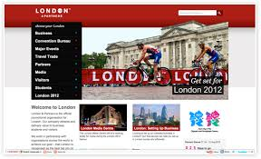

Figure 10. Good web design about news of London

* **Strengths:**
  + This website have full feature level learnable this is: visibility, consistency, familiarity and affordance. With info and images very required, content enough to user can understand, it isn’t over also not less, split part on website very reasonable, beautiful images
  + I think principle navigation, control, feedback, recovery of it also very good because it is display info when user implement actions…
  + Style design very beautiful.
  + All parts are clear, usability, colors are reasonable, appropriate with current websites.
* **Weakness:**
  + I think part header very simple, should add some text for example: “News will bring your home only with internet”.
  + Website should have part breaking news to review info for new day.
  + Website should add part menu bar with many other info to easy navigation to other pages.
* Good web design for website of CortLand Academy, below is image of it

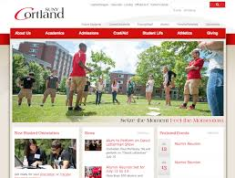

Figure 11. Good web design for Academy

* **Strengths:**
  + This website have full feature level learnable this is: visibility, consistency, familiarity and affordance, full level effective, full level accommodating. With info and images very required, content enough to user can understand, it isn’t over also not less, split part on website very reasonable, beautiful images
  + I think principle navigation, control, feedback, recovery of it also very good because it is display info when user implement actions…
  + Style design very beautiful.
  + All parts are clear, usability, colors are reasonable, appropriate with current websites.
* **Weakness:**
  + I think it hadn’t weakness.

1. **Three bad web designs**

* Bad web design for website sell products online about technology, below is image of it

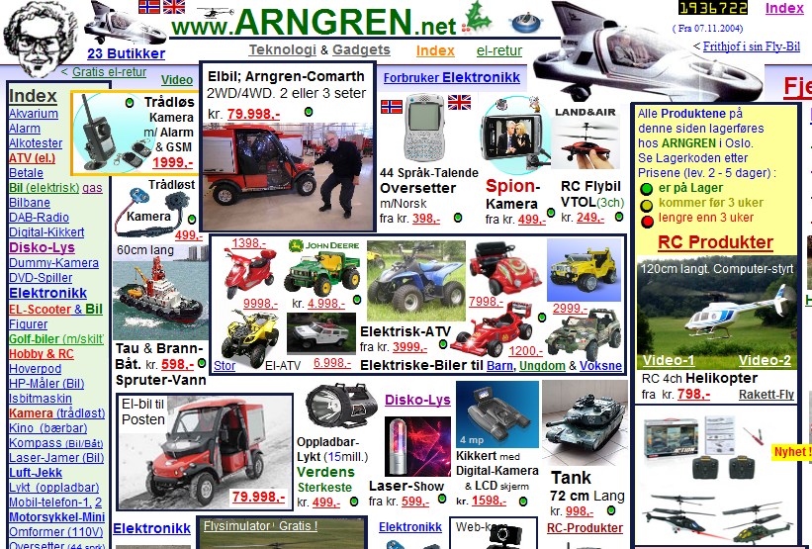

Figure 12. Bad web design about technology

* **Strengths:**
  + I think this website hadn’t strengths.
* **Weakness:**
  + Bad design layout, this website not achieved any level of website design review based on 12 principles. Display products overlap, info of product is very simple, font text difficult to recognize, parts of website not clear, everything on website asynchronous…

- Bad web design for website high school sport, below is image of it

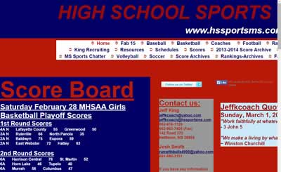

Figure 13. Bad web design for high school sport

* **Strengths:**
  + Not strengths
* **Weakness:**
  + Bad design layout, this website not achieved any level of website design review based on 12 principles. Info is very simple not image illustration, font text difficult to recognize, parts of website not clear, everything on website asynchronous, color very terrible with students...

- Bad web design for website game, below is image of it

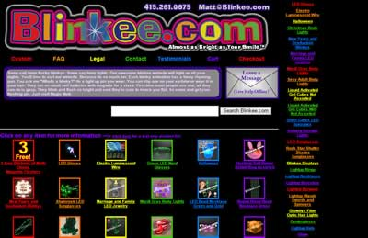

Figure 14. Bad web design for website game

* **Strengths:**
  + Not strengths
* **Weakness:**
  + Bad design layout, this website not achieved any level of website design review based on 12 principles. Display game very simple not lively, It does not make sense for users to try it out, font text difficult to recognize, parts of website not clear, everything on website asynchronous, color very terrible with one website about game...

## 1.5 Discuss and justify how you would improve the bad examples

I will discuss about that through table below

|  |  |  |  |
| --- | --- | --- | --- |
| No | Name | Weakness | Solutions |
| 1 | Bad web design for website about sell products technology online | Bad design layout, this website not achieved any level of website design review based on 12 principles. Display products overlap, info of product is very simple, font text difficult to recognize, parts of website not clear, everything on website asynchronous… | I will design again all, design again layout, color for each layout need appropriate with website, reposition the product view clear more, user friendly, easy use, use control |
| 2 | Bad web design for website high school | Bad design layout, this website not achieved any level of website design review based on 12 principles. Info is very simple, not image illustration, font text difficult to recognize, parts of website not clear, everything on website asynchronous, color very terrible with students... | I will design again all, design again layout, color for each layout need appropriate with website, design view, with each info will have describe with image, ensure to meet the requirements of 12 principles. |
| 3 | Bad web design for website about game | Bad design layout, this website not achieved any level of website design review based on 12 principles. Display game very simple not lively, It does not make sense for users to try it out, font text difficult to recognize, parts of website not clear, everything on website asynchronous, color very terrible with one website about game... | I will design again header for website, change color for website friendly with user, appropriate with website game, image will display big more help user easy recognize… |

Table 1. solution for bad web design

* **Conclusions:** This report I written about 12 principles to evaluate a good web design or bad web design, for example for each principle to all guys understand more and can implement it apply your web design. For example good web design and bad web design and analysis strengths and weakness for each example and make solutions for them.

# **References**

[1] page17 – slide0-ArtOfInteractionDesign

[2] page22 – slide0-ArtOfInteractionDesign