**BTEC Level 5 HND Computing and Systems Development**



A Project Programming in .NET Presented

by

Nguyễn Đình Tùng(GC00952)

Assignment 3



Submitted to the Graduate School of the

University of Greenwich Vietnam in partial fulfillment

Wednesday, 18th July 2018

Lecturer: Đỗ Quốc Bình

**Table of Contents**

**Introduction** 5

**1.** **Critically review and test a .NET programming solution.** 6

**2.** **Analyze actual test results against expected results to identify discrepancies.** 11

**3.** **Evaluate independent feedback on a developed .NET program solution and make recommendations for improvements.** 15

**4.** **Create user documentation for the developed .NET program solution.** 19

**5.** **Create technical documentation for the support and maintenance of a .NET program solution.** 26

**Table of figures**

Figure 1. Function register 6

Figure 2. Function login 7

Figure 3. Function search products follow price 7

Figure 4. Function order (add to cart) 7

Figure 5. Function view cart 8

Figure 6. Function management categories 8

Figure 7. Function management manufacturers 9

Figure 8. Function management products 9

Figure 9. Function management customers 10

Figure 10. Function view report 10

Figure 11. First questionnaire 16

Figure 12. Second questionnaire 16

Figure 13. Third questionnaire 17

Figure 14. Fourth questionnaire 17

Figure 15. Use case diagram 28

Figure 16. ERD diagram 29

Figure 17. Class diagram 31

Figure 18. Data validation 33

Figure 19. Validation account fail 34

Figure 20. Validation account not yet accept 34

**Table of tables**

Table 1. Table test case for system. 15

Table 3. Result and solution for questionnaire 18

# **Introduction**

This report we will discuss about overview my program and give solution for program in the future, next is make a test plan for my program with actual result and expected result, next is make a feedback from teacher and members in my class to evaluate and give solution for problems in my program, next is make a use manual to help users can easy use my program, final is make a document to help maintain and develop this program.

# **Critically review and test a .NET programming solution.**

ABC is a company selling laptops and computer accessories. The company is going to build a solution which helps the company to manage the business operations. So, we developed this program follow web-based application and use .NET Framework language to write code for the program, the program write code follow model MVC, because it bring good performances and easy more in management, fix errors for the program

The program split two main roles this is role intended for managers and role intended for customers, with each role have different functions. Below is some functions in my program

The functions intended for role Customers, first is function register for customer

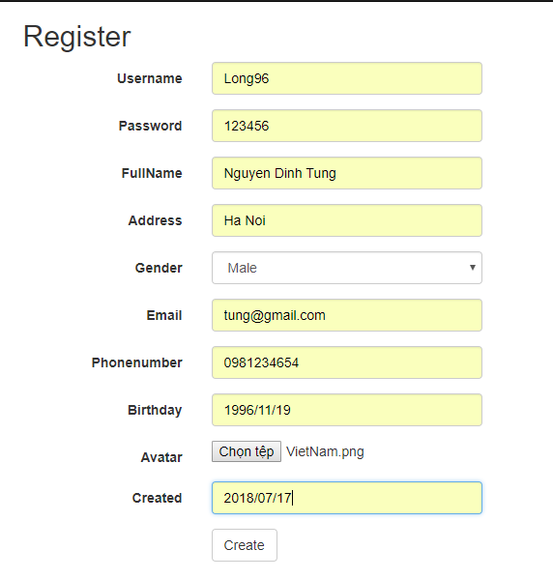

Figure 1. Function register

Continue is function login for customers

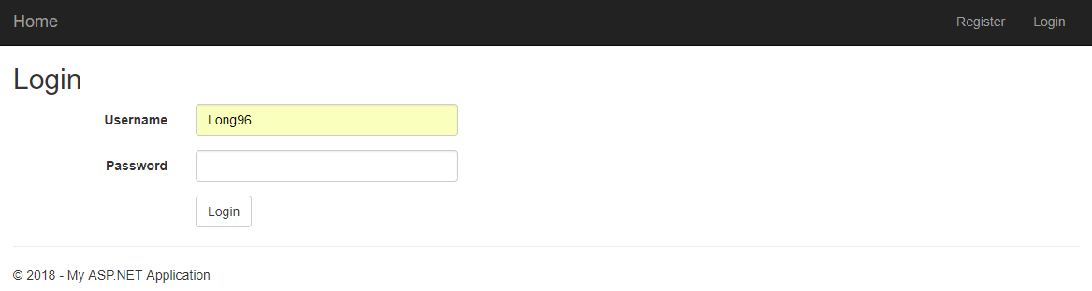

Figure 2. Function login

Continue is function search products in store follow price intended for role customers

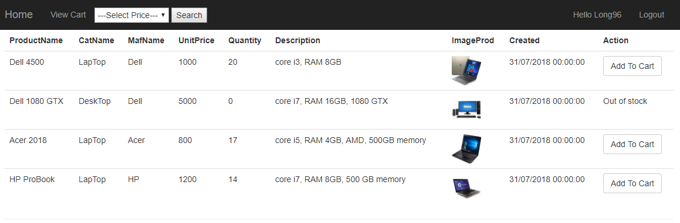

Figure 3. Function search products follow price

Continue is function order products intended for customers (add products to cart)

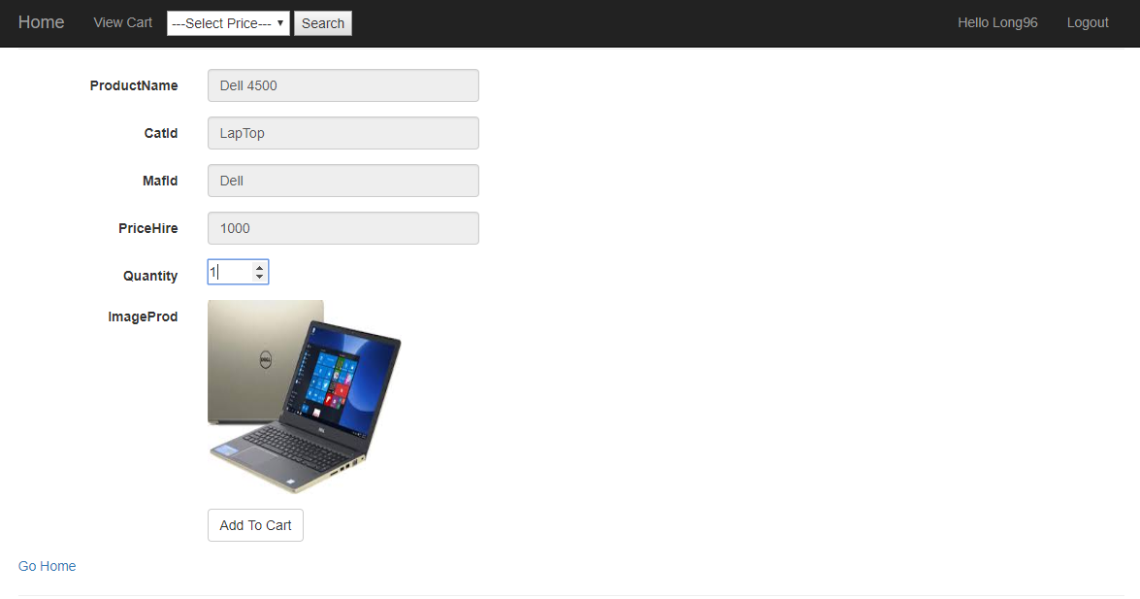

Figure 4. Function order (add to cart)

Continue is view cart of this customer and payment or cancel products added to cart

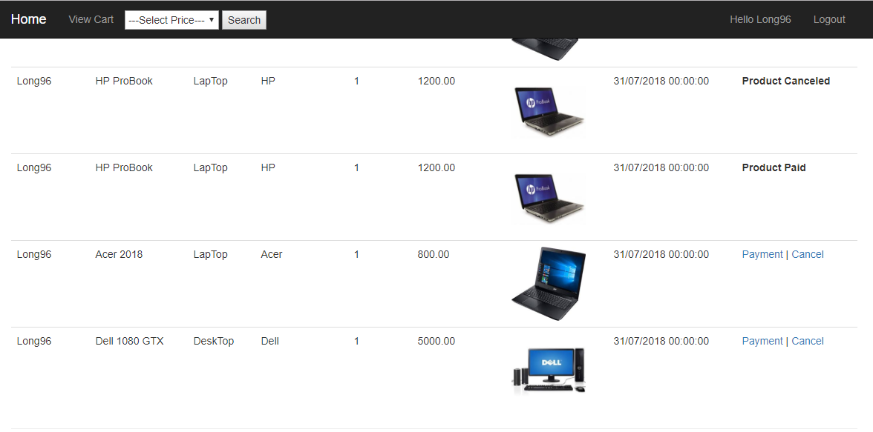

Figure 5. Function view cart

The functions intended for role Managers, first is function management categories with features are create new category, update and delete category

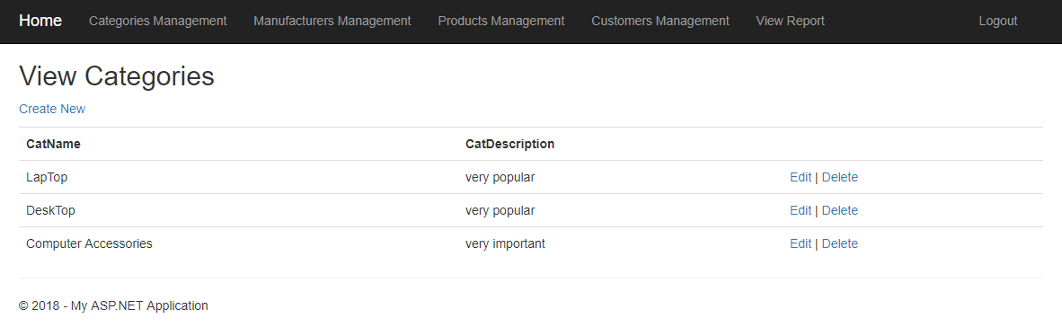

Figure 6. Function management categories

Continue is function management manufacturers, with features are create new manufacturer, update and delete manufacturers

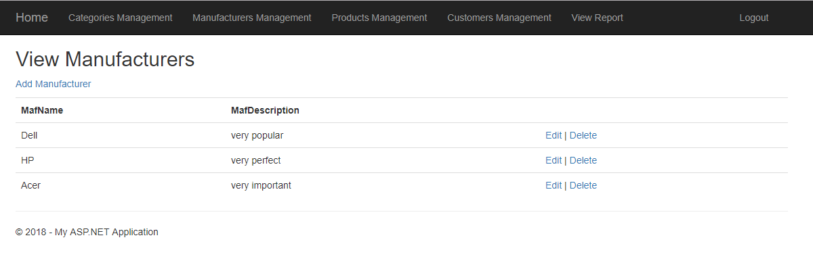

Figure 7. Function management manufacturers

Continue is function management products (computers and computer accessories), with features create new product, update and delete product

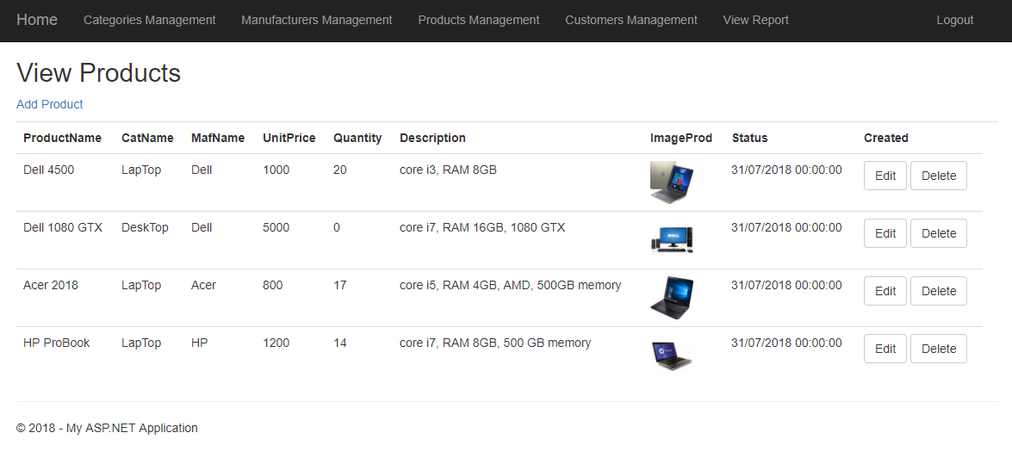

Figure 8. Function management products

Continue is function management customer’s accounts, with features are accept new accounts, lock accounts and unlock accounts

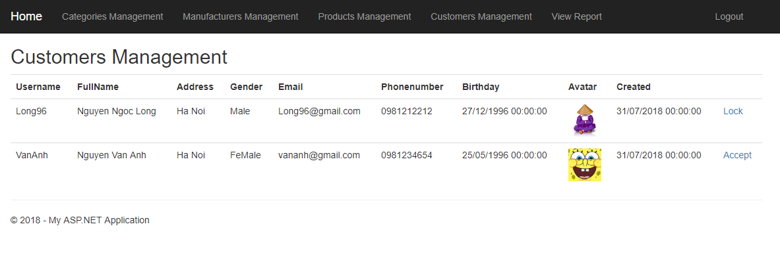

Figure 9. Function management customers

Final is function view report for managers, they can revenue statistics of store follow duration they want example follow month or follow quarters of the year.

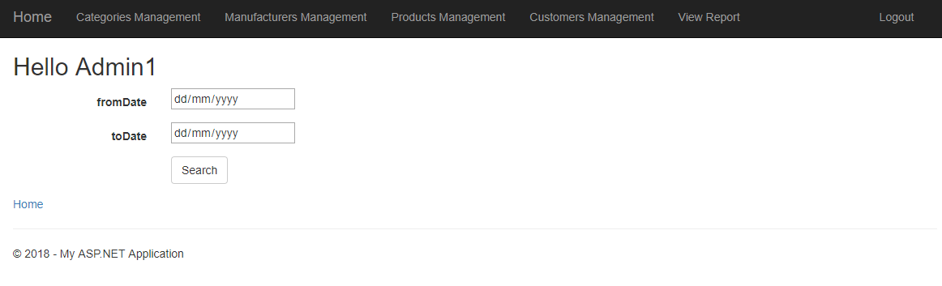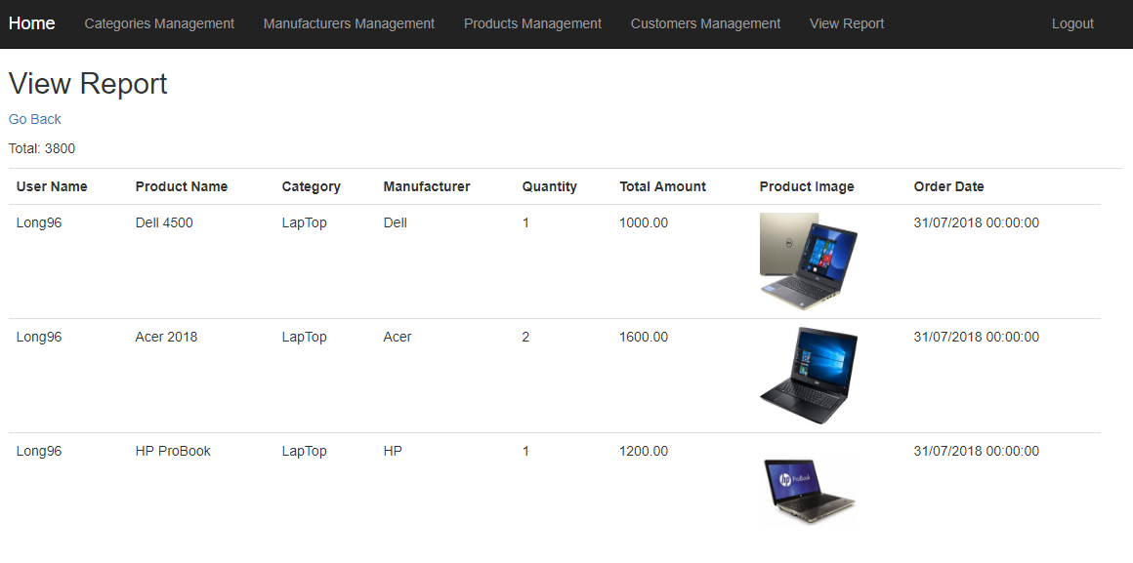

Figure 10. Function view report

* **Conclusions:** As you see all main functions in my program, the program is pretty good about design business logic and interfaces pretty good, but still need improve about method payment, it is not yet method payment clear, not yet method payment by account bank or payment by card… Beside need improve about management store this is add role intended for admin, they can management staffs in store…

# **Analyze actual test results against expected results to identify discrepancies.**

Below is table test plan for my system, before starting the test plan, you need to prepare a programmable computer, which includes test manager and tester components.

|  |  |  |  |  |  |  |
| --- | --- | --- | --- | --- | --- | --- |
| No | Scope | Type | Input | Actual output | Expected output | Status |
| 1 | Register | Normal scenarios | Username: Long96  Password: 123456  Name: Nguyen Ngoc Long  Address: Ha Noi  Gender: Male  Email: long96@gmail.com  Telephone: 0987243425  Birthday: 1996/11/19  Avatar: VietNam.png  Created: 2018/07/17  Level: 0  Status: 0 | Insert table Customers successful (register successfully) | Insert table Customers successful (register successfully) | Pass |
| 2 | Register | Data validation | Username: Long96  Password: 123456  Name: Nguyen Ngoc Long  Address: Ha Noi  Gender: Male  Email: null  Telephone: null  Birthday: 1996/11/19  Avatar: VietNam.png  Created: 2018/07/17  Level: 0  Status: 0 | Insert tables Customers is not successful (register not successfully because all attributes are not null) | Insert tables Customers is not successful (register not successfully because all attributes are not null) | Pass |
| 3 | Login | Normal scenarios | Username: Long96  Password: 123456 | Login to system successfully | Login to system successfully | Pass |
| 4 | Login | Data validation | Username: dsdasd  Password: 123456 | Login to system is not successful (because username and password is not exist already) | Login to system is not successful (because username and password is not exist already) | Pass |
| 5 | Add Category | Normal scenarios | CatName: Laptop  CatDescription: very popular | Insert table Categories successful | Insert table Categories successful | Pass |
| 6 | Add Category | Data validation | CatName: null  CatDescription: very popular | Insert table Categories is not successful (because all attributes are not null) | Insert table Categories is not successful (because all attributes are not null) | Pass |
| 7 | Add Manufacturer | Normal scenarios | MafName: Dell  MafDescription: very perfect | insert table Manufacturers is successful | insert table Manufacturers is successful | Pass |
| 8 | Add Manufacturer | Data validation | MafName: null  MafDescription: very perfect | insert table Manufacturers is not successful (because all attributes are not null) | insert table Manufacturers is not successful (because all attributes are not null) | Pass |
| 9 | Add Product | Normal scenarios | ProductName: Dell 4500  CatId: 1  MafId: 1  PriceHire: 1500  Quantity: 20  Description: core i7, ram 8gb  ImageProd: dell1.png  Level: 5  Status: 0  Created: 2018/07/18  Creator: Admin1 | insert table Products is successful | insert table Products is successful | Pass |
| 10 | Add Product | Data validation | ProductName: HP Pro  CatId: asa  MafId: 1  PriceHire: 1500  Quantity: 20  Description: core i7, ram 8gb  ImageProd: dell1.png  Level: 5  Status: 0  Created: 2018/07/18  Creator: Admin1 | insert table Products is not successful (because field CatId is not exist already) | insert table Products is not successful (because field CatId is not exist already) | Pass |
| 11 | Update Product | Normal scenarios | ProductId: 1  ProductName: Dell 4500  CatId: 1  MafId: 1  PriceHire: 2000  Quantity: 10  Description: core i7, ram 8gb  ImageProd: dell1.png  Level: 5  Status: 0  Created: 2018/07/18  Creator: Admin1 | Update table Product Dell 4500 is successfully | Update table Product Dell 4500 is successfully | Pass |
| 12 | Update Product | Data validation | ProductId: qw  ProductName: Dell 4500  CatId: 1  MafId: 1  PriceHire: 2000  Quantity: 10  Description: core i7, ram 8gb  ImageProd: dell1.png  Level: 5  Status: 0  Created: 2018/07/18  Creator: Admin1 | Update table Product Dell 4500 is not successfully (because ProductId is not exist already) | Update table Product Dell 4500 is not successfully  (because ProductId is not exist already) | Pass |
| 13 | Orders | Normal scenarios | UsernameC: Long96  UsernameS: Admin1  TotalAmount: 1000  OrderDate: 2018/07/19  Status: 0 | Insert table Orders is successfully | Insert table Orders is successfully | Pass |
| 14 | Orders | Data validation | UsernameC: dasd  UsernameS: Admin1  TotalAmount: 1000  OrderDate: 2018/07/19  Status: 0 | Insert table Orders is not successfully (because UsernameC is not exist already and OrderDate is not less more date now) | Insert table Orders is not successfully (because UsernameC is not exist already and OrderDate is not less more date now) | Pass |
| 15 | OrderDetail | Normal scenarios | OrderId: 1  ProductId: 1  UnitPrice: 2000  Quantity: 2 | Insert table OrderDetail is successfully | Insert table OrderDetail is successfully | Pass |
| 16 | OrderDetail | Data validation | OrderId: qw  ProductId: 1  UnitPrice: 2000  Quantity: 30 | Insert table OrderDetail is not successfully (because field OrderId is not exist already and field Quantity is over quantity in stock) | Insert table OrderDetail is not successfully (because field OrderId is not exist already and field Quantity is over quantity in stock) | Pass |
| 15 | View Report |  | FromDate: 2018/07/15  ToDate: 2018/08/15 | View total price and all orders in this duration successfully | View total price and all orders in this duration successfully | Pass |

Table 1. Table test case for system.

**Conclusions:** Through table result test case for my program above, I can conclude that there is 15 test cases and all test cases are pass and have not test cases are fails. That prove that my program is pretty ok, features are work very good, the features were pre-designed are complete as expect result. Test plan and test cases for each function is very important, because it is help program work better when it was put into use and reduce ability happen errors, errors are always fix before put into use. In the future my program need improve for function payment of store and some other function.

# **Evaluate independent feedback on a developed .NET program solution and make recommendations for improvements.**

To get a sense of the value of my program, I have prepared the following questions to consult with my classmates and teachers so that I can draw strengths and weaknesses. of the program. . Number of responses: 15 responses.

First question and the chart statistics the results of the question Are the program can meet the requirements of the user?

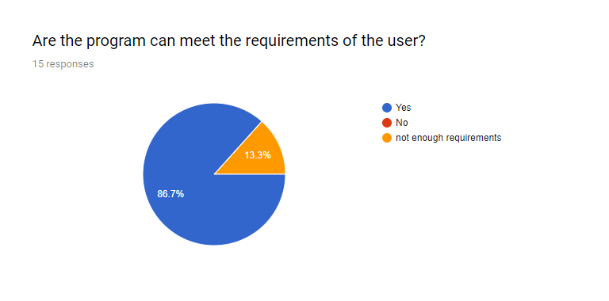

Figure 11. First questionnaire

Second question and the chart statistics the results of question Are the program is easy to use?

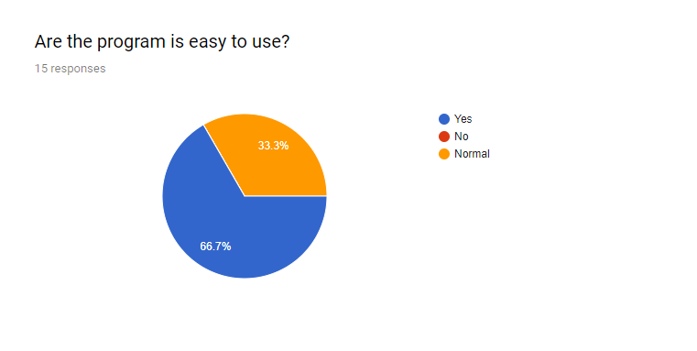

Figure 12. Second questionnaire

Third question and the chart statistics the results of question Are the program works well?

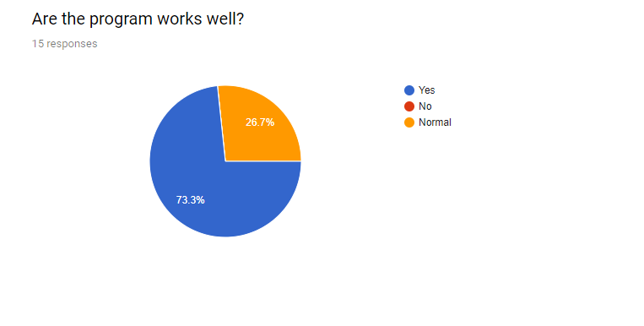

Figure 13. Third questionnaire

Fourth question and the chart statistics the results of question The issues of the chapter need improvement.

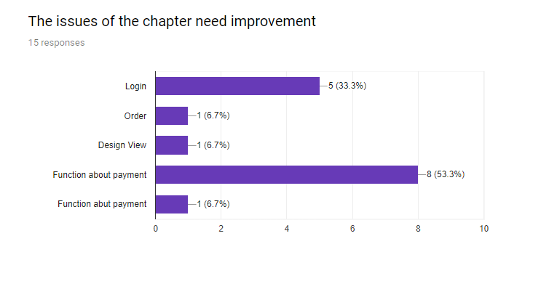

Figure 14. Fourth questionnaire

**Table result for feedbacks and solution**

|  |  |  |  |
| --- | --- | --- | --- |
| No | Questions | Result | Solution |
| 1 | Are the program can meet the requirements of the user? | Yes: 86.7%  No: 13.3%  Not enough requirements: 0% | Results show that the features of the program meet the requirements of the user, the features are necessary and useful to the user. So we should not change the features of the program |
| 2 | Are the program is easy to use? | Yes: 66.7%  No: 33.3%  Normal: 0% | The results show that the program is quite easy to use, but besides that the interface design is quite simple and difficult to see so need to improve in terms of user interface. Beside we need guide for new customers. |
| 3 | Are the program works well? | Yes: 73.3%  No: 26.7%  Normal: 0% | The program performs well without any problems, but there are still some flaws that need to be repaired as the performance of the user needs to be responded more quickly. I will improve performances of my program by away use latest technology to apply in my program. |
| 4 | The issues of the chapter need improvement | Login: 33.3%  Order: 6.7%  Design View: 6.7%  Functions about payment: 53.3% | Through result feedback, the program needs to be upgraded to function manage the staff. Empowering employees so that they can be easier to manage ... outside need more staff management Features for store bosses, need improve function payment for customers add other methods to can easy in problems payment. Function login need to upgrade to help customers more satisfied. Outside I will upgrade for interfaces display to users. |

Table 2. Result and solution for questionnaire

**Conclusions:** Overall my program works very well, its features are relatively good and fit well with the requirements of the client, the performance is also very good, less errors occur. But it also needs to change functions about methods payment of store, can create more methods to more easy payment for example payment by card... In the future if the customer needs to expand and add features I will ensure that it can quickly and without affecting the current system.

# **Create user documentation for the developed .NET program solution.**

Although my program is very easy to use, but with new users will faced some problems, so below I will write some guides important for my program.

Some guides intended for role Customers

1. **How to register a new account**

* **Step 1:** First you need to run program and system will display interface as image below

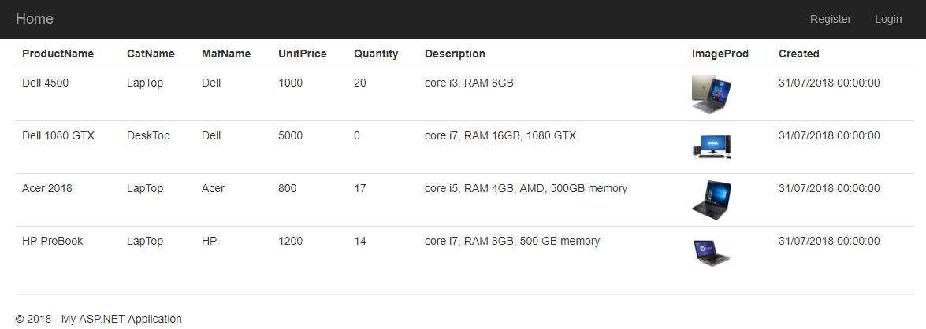

* **Step 2:** Continue you let click to button link “Register” to system move to screen register as image below

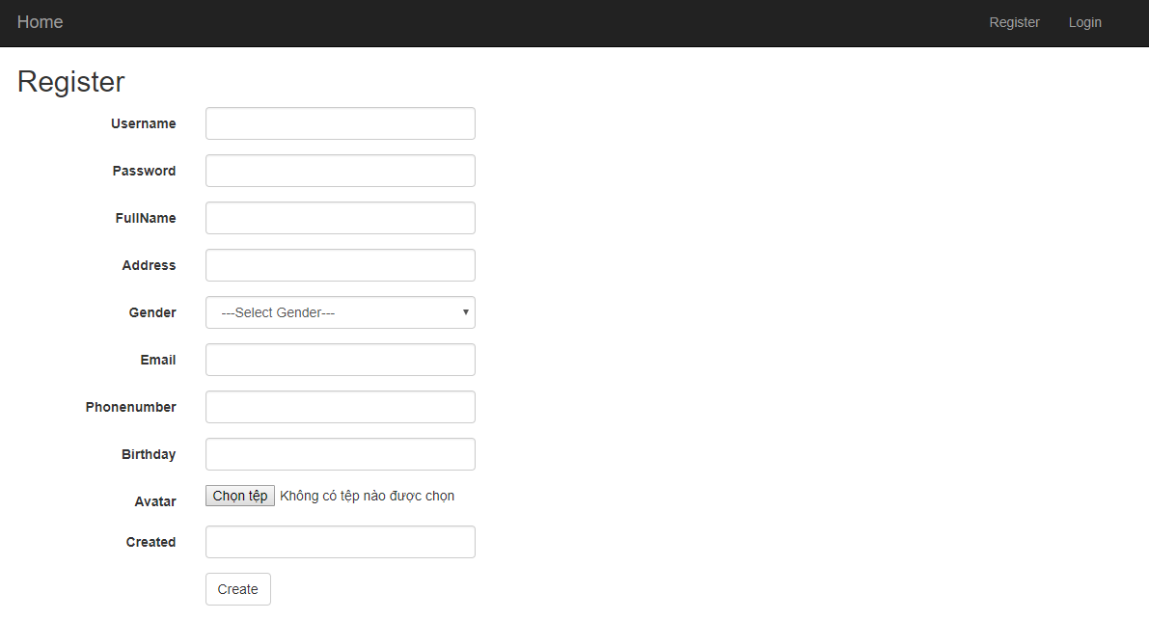

* **Step 3:** At this screen for function register you let enter all attributes on screen, after you let click to button “Create” to system save information and info success as image below



1. **How to login to system**

* **Step 1:** After you registered a new account success, system will move to screen login as image below

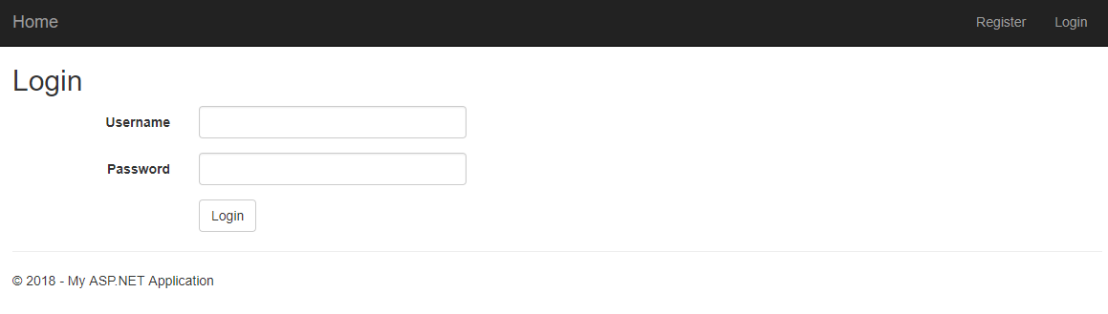

* **Step 2:** Continue at this screen login, you let enter username and password, after click to button “Login” to system check your username and password as image below.

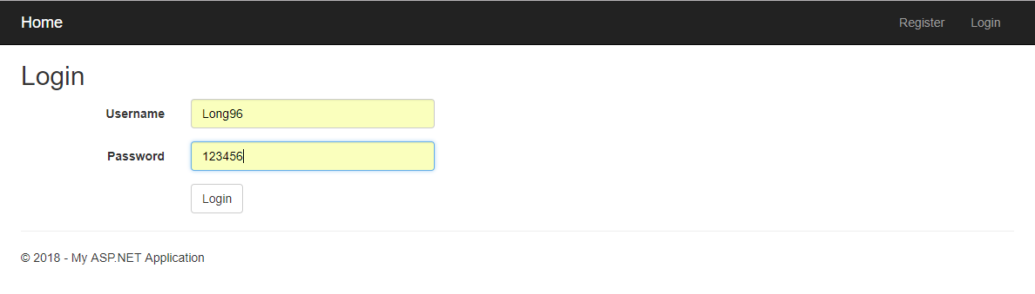

* **Step 3:** If your account is not exist already, system will info error and requirement enter again, if your account is account depends account intended for managers system will move to screen for managers, if your account depends account intended for customers system will move to screen for customers as image below

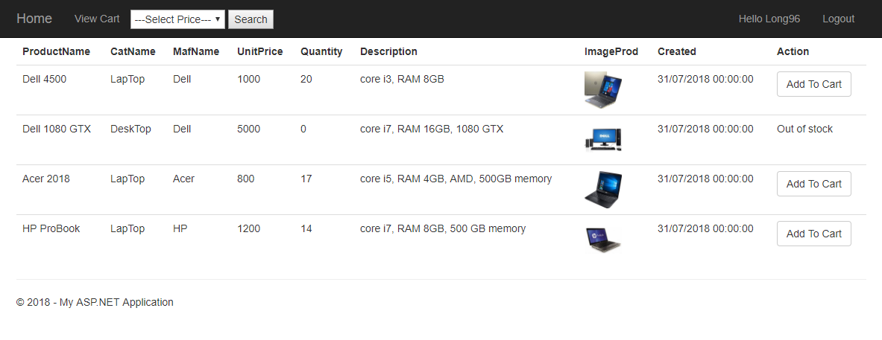

1. **How to search products**

* **Step 1:** At this screen home intended for customers, on header you let choose a price in combobox “Select Price” and click to button “Search” to system find products follow this price as image below

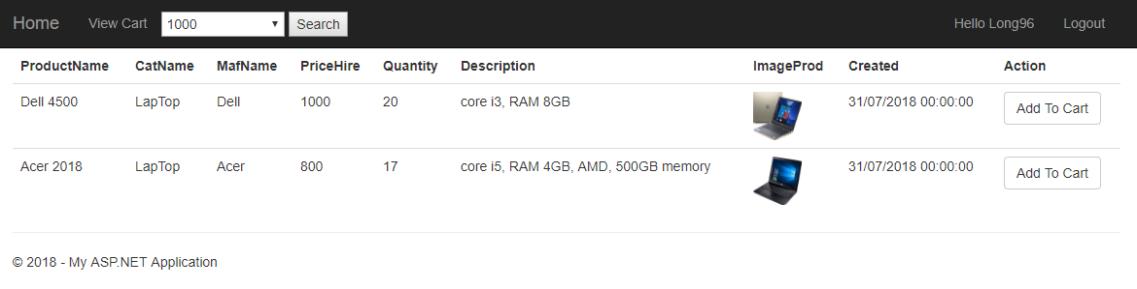

1. **How to add products to cart**

* **Step 1:** At this screen home intended for customers, you let click to button “Add To Cart” to system move to screen order intended for customers. At this screen order you let enter quantity that you want buy and click to button “Add To Cart” to system save product to cart as image below

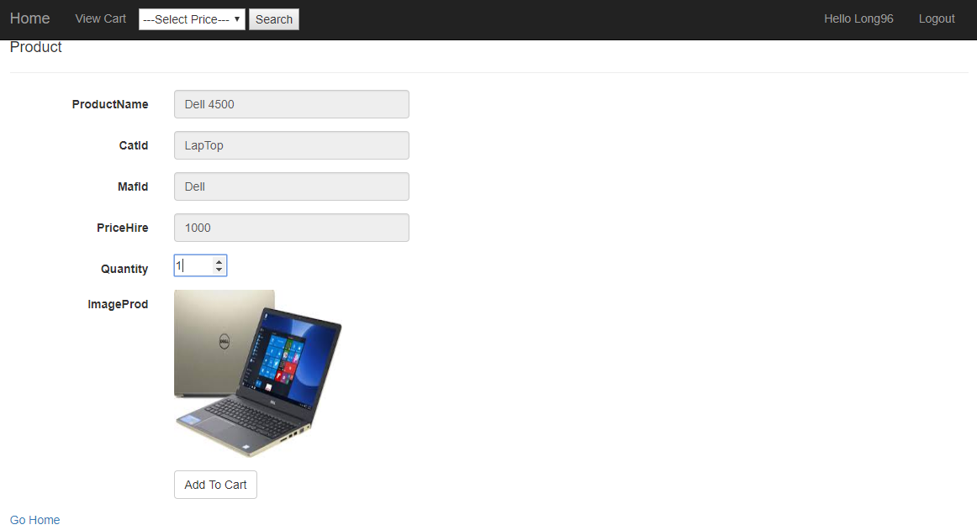

* **Step 2:** After you added product to cart success, you let click to button link “View Cart” to view all products you added to cart as image below



1. **How to payment or cancel product**

* **Step 1:** At screen view cart of customers. The products paid it will display status “Product Paid”, the products canceled it will display status “Product Canceled”, if you want payment product you let click button link “Payment” and system will implement require, if you want cancel product you let click button “Cancel” as image below



Some guides intended for role Managers

1. **How to management Categories**

* **Step 1:** After you were login to system follow role intended for managers system will display screen as image below

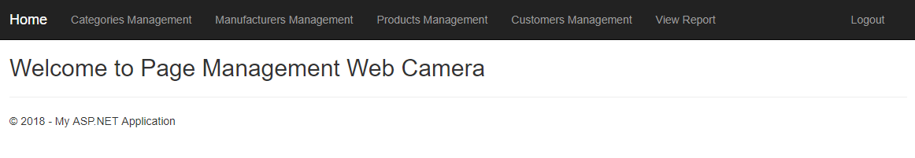

* **Step 2:** At this you let click to button link “Categories Management” to system move to interface management categories as image below

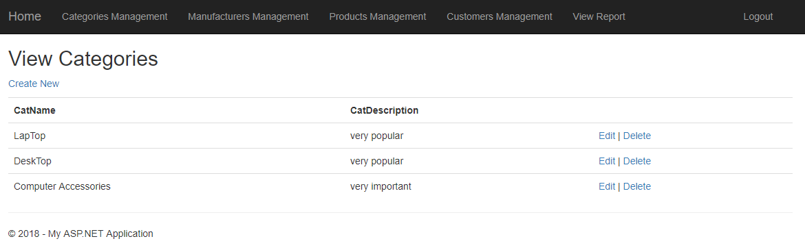

* **Step 3:** At this, if you want create new a category, you let create to button link “Create New” system will move interface create new category, if you want edit let click to button link “Edit” and if you want delete let click to button link “Delete”

1. **How to management Manufacturers**

* **Step 1:** Same with function management categories, this is function management manufacturers



1. **How to management Products**

* **Step 1:** Same with two functions management above, this is function management products



1. **How to management Customers**

* **Step 1:** Below is screen for management customers



* **Step 2:** If you want lock account of customer, let click to button link “Lock”, if you want accept account customer let click button link “Accept” and want unlock also same this

1. **How to View Report**

* **Step 1:** Below is screen for function view report

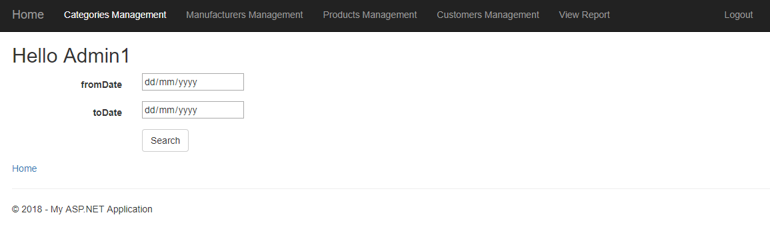

* **Step 2:** At this screen you let choose duration you want show report for example as image below

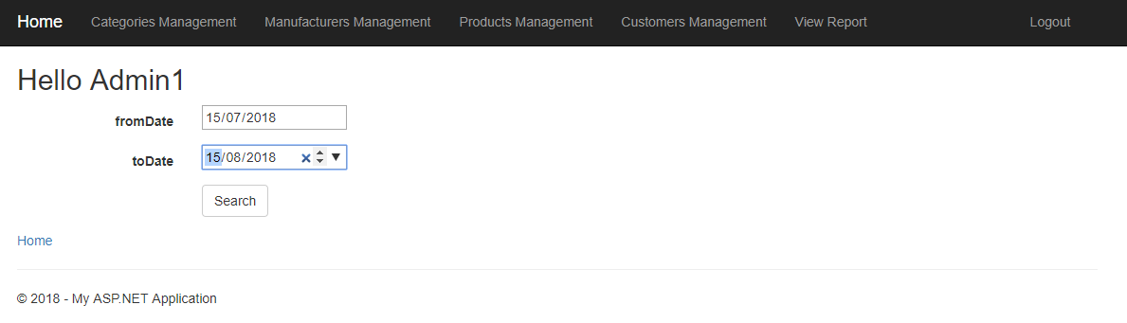

* **Step 3:** After you let click to button “Search” and system will move to screen report as image below



# **Create technical documentation for the support and maintenance of a .NET program solution.**

1. **Introduction**

This program with purpose create a store help customers can buy products about computers and computer accessories. This store is online help customers can buy products at their house only need they use smart phone or a laptop have connect to internet. Store will help customers are not time to go to shopping or customers lazy. The program is a website online allow users can register account and login to website to buy products about computers and computer accessories that they want.

1. **Program overview**

Same with part 1 of this report I wrote overview for this program, I showed interfaces for each functions in program, describe about functions, so at here I only describe briefly about the program as below

ABC is a company selling laptops and computer accessories. The company is going to build a solution which helps the company to manage the business operations. Your software produced need to have following features:

• Managing Categories for administrators

• Managing Products for administrators

• Managing Orders for administrators

• Managing Customer’s queries for administrators [each query has 3 statuses: working, cancelled, done]

• Search product for a range of price for customers

Outside this program also describe some features about customers as below

* Customers can register a new account and login to system
* Customers can buy products in store
* Customers can view history buy and cancel products of themselves.

1. **Use case diagram**

Same with reality a store allow customers can buy computers or computer accessories, so sure in my program must have role intended for customers. After then I had idea for customers role I was asked me, who will management store, management products, management categories, management manufacturers, write report for each month… I had an idea for managers roles to management store. So, sure in my program I was determined two main roles this is customers and managers. Below I will specific analysis for each role.

Role intended for Customers: with customers, they can register a new account when they want buy computers or computer accessories at store, after they were registered, they can login to system store online and search for themselves products that they like and they can buy this laptop or computer accessories depending on economic conditions. Why we must requirement customers register before buy products because from information customers were registered, we can deliver follow address that they were registered

Role intended for Managers: to management quantity of products in store as add new a product to system store online or update products about quantity, price, management categories, management manufacturers… role intended for managers is very important. Outside they can management status of account of customers. For example when customers want register new account must need have managers accept this accounts, because if to customers register free will lead to many problems for system and store. Or staffs can view report for result activities of store each month…

So, why we must divide roles for system of store . Because when we divide role to management will easier when not divide roles and increase effective for store, increase professionalism…

Below is use-case diagram I was designed for system store selling computers or computer accessories online

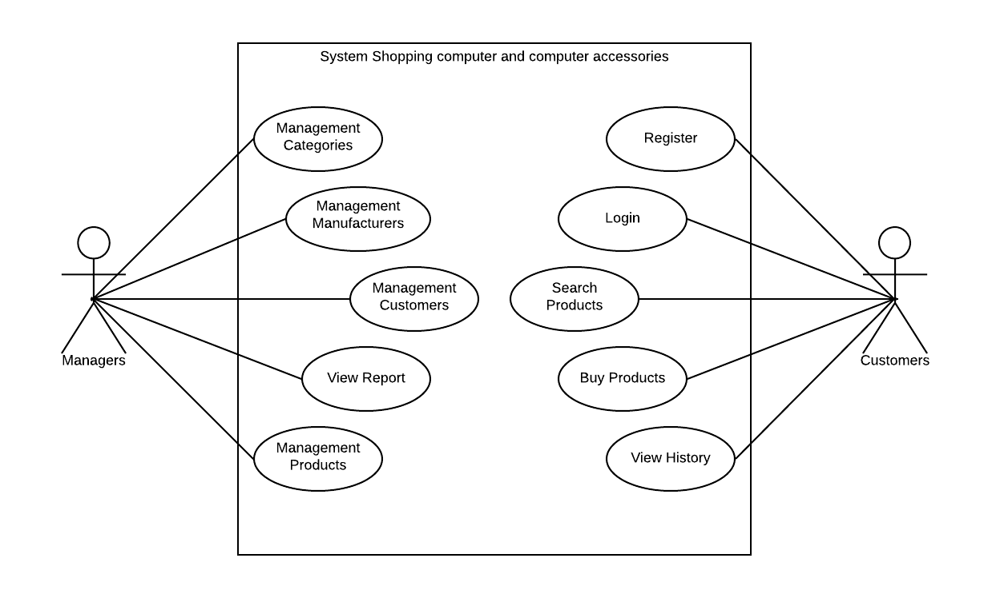

Figure 15. Use case diagram

1. **ERD diagram**

From use-case diagram above I was designed a ERD diagram intended for database with relationship between tables includes primary key, foreign key…

I was designed seven tables for database this is: table Staffs, table Customers, table Categories, table Manufacturers, table Products, table Orders and table OrderDetail

Table Staffs includes attributes as Username, Password, FullName, Address, Gender, Email, Phonenumber, Birthday, Avatar, Created, Salary, Status with primary key is field Username

Table Customers same with table Staffs, but also have difference this field Salary at table Staffs be instead by field Level at table Customers.

Table Categories and table Manufacturers same together with attributes CatId, CatName intended for table Categories and MafId, MafName intended for table Manufacturers, field Description is have in both table. Two fields CatId and MafId will is primary key for each table.

Table Products includes attributes as ProductId, ProductName, CatId, MafId, PriceHire, Quantity, Description, ImageProd, Level, Status, Created, Creator with primary key is ProductId and three foreign keys this is CatId will foreign key with table Categories, MafId will foreign key with table Manufacturers and Creator will foreign key with table Staffs.

Table Orders includes attributes as OrderId, UsernameC, UsernameS, TotalAmount, OrderDate, Status with primary key is OrderId, there are two foreign keys this is UsernameC foreign key with field Username at table Customers and UsernameS foreign key with field Username at table Staffs.

Table OrderDetail includes attributes as OrderDetailId, OrderId, ProductId, UnitPrice, Quantity with primary key is OrderDetailId, there are two foreign keys this is OrderId foreign key with field OrderId at table Orders and ProductId foreign key with field ProductId at table Products.

Below is image ERD diagram for system Selling Computers and computer accessories.

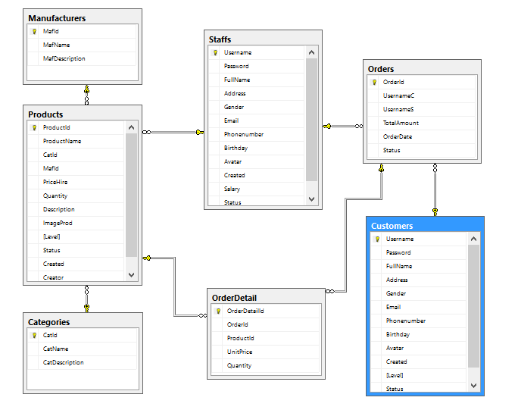

Figure 16. ERD diagram

1. **Class diagram**

With ERD diagram above, I was designed for program structures classes as follows: one class for customers and one class for staffs, one class for categories and one class manufacturers, one class to save information for products (computers and computer accessories) one class to save information order of customers with system store selling computers and computer accessories online.

Why need have classes?, because information that customers were registered or buy computers and computer accessories will must be saved to database and I need create a class intended customers or order to can mediate between view users and controller and database. Problem use classes is very important, it will help increase performances for system and clear design help programmer easier management system and can easier in debugs problems. Classes will is an important link in the MVC design model. It represents the data (value) of an object…

Why need have class intended customers?, because class will represents the data (value) of an object , represents information from customers to system and opposite, help system determined clearly activities of customers, status of customers… That will help we management a way thoroughly avoid will happened bugs from system…

The other classes also same with customers, they only change about attributes in each class and other activities…

After we determined clearly classes and why need them, we will must set up relation for classes. For example in my program about relationship, I will create relation for class customers, products and class orders because when staffs want management orders from customers will need must know account this customers and code products to can easier in management report as management order of store. I has created relationship as follows class Staffs association with classes Categories, Customers, Products, it can management all of them, Categories association with class Products, Manufacturers association with class Products, because class Categories and Manufacturers will provides CatId and MafId for class Products and class Order will association with classes Customers and Orders, because an Order always be created by a Customer and CarIds.

Below is class diagram I was designed for my program selling computers and computer accessories

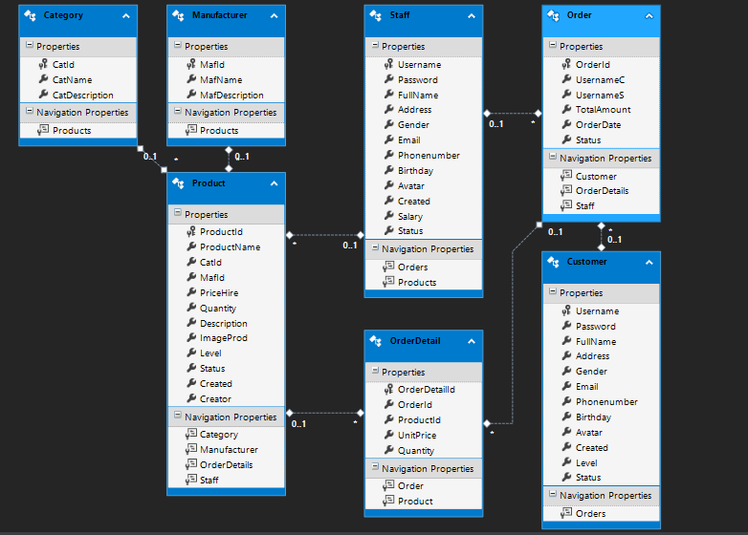

Figure 17. Class diagram

1. **Error handling and Data validation**

To can design a program that is not faced with errors is very difficult, so to can discovered the errors in my program I used query **try{}catch** to match errors for program as code snippet below to match error for query linq get data from database

public ActionResult Index()

{

try

{

var customer = Session["customer"].ToString();

var r = from b in db.OrderDetails

where (b.Order.UsernameC == customer)

select b;

return View(r.ToList());

}

catch (Exception ex)

{

Console.WriteLine(ex.ToString());

return null;

}

}

Outside I also use query **if{}else** to check validation for my program for example as code snippet below to check quantity of customers entered and quantity in stock, if quantity customers entered more than quantity in stock will info error to customers by dialog, if quantity of customers entered less more quantity in stock will implement add data to database and save database.

if(quantity > prod.Quantity)

{

TempData["SuccessMessage"] = "You can not order because quantity over quantity in stock";

return RedirectToAction("Index", "Home");

}

else

{

prod.Quantity = quantitychange;

order.OrderDate = now;

order.TotalAmount = totalamount;

order.Status = 0;

db.Orders.Add(order);

orderDetail.OrderId = order.OrderId;

orderDetail.ProductId = productid;

orderDetail.UnitPrice = Convert.ToDecimal(prod.PriceHire);

orderDetail.Quantity = quantity;

db.OrderDetails.Add(orderDetail);

db.SaveChanges();

TempData["SuccessMessage"] = "You ordered successfully";

return RedirectToAction("Index", "Home");

}

Below is image info error of program

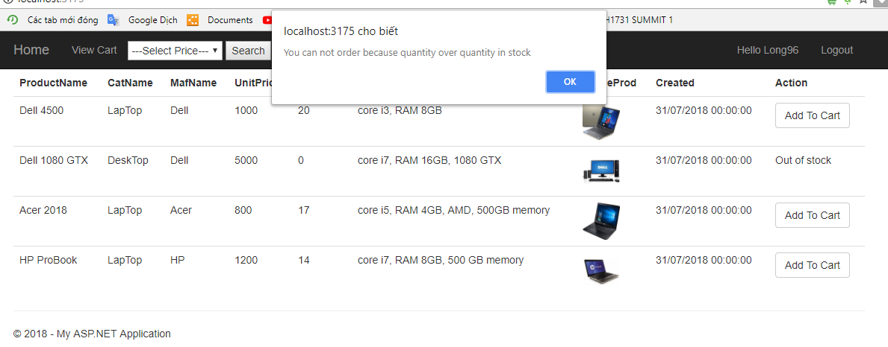

Figure 18. Data validation

This is code snippet to check validation for function login, if customers enter user name and password is not already system will info error and if account not yet accept from admin system will info error

if (cus != null && sta == null)

{

if(cus.Status == 0)

{

TempData["SuccessMessage"] = "Your account is waiting to accept";

return RedirectToAction("Login", "Customers");

}

else if(cus.Status == 2)

{

TempData["SuccessMessage"] = "Your account is locked";

return RedirectToAction("Login", "Customers");

}

else

{

TempData["SuccessMessage"] = "Login Successfully";

Session.Add("customer", cus.Username);

return RedirectToAction("Index", "Home", Session);

}

}

else if(cus == null && sta != null)

{

TempData["SuccessMessage"] = "Login Successfully";

Session.Add("staff", sta.Username);

return RedirectToAction("Index", "Home", Session);

}

else

{

TempData["SuccessMessage"] = "You entered fail username or password";

return RedirectToAction("Login");

}

Below is image info error for case customers enter fail username and password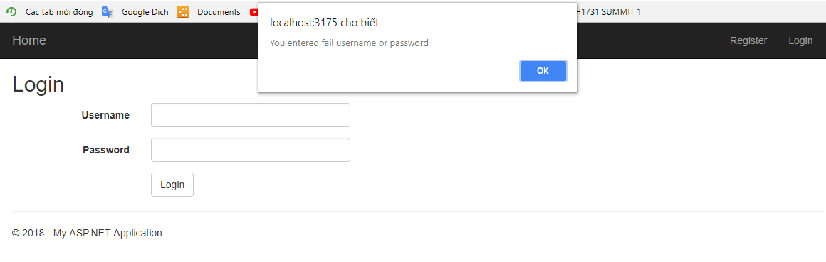

Figure 19. Validation account fail

Below is image info error for case customer’s account is not yet accept from managers

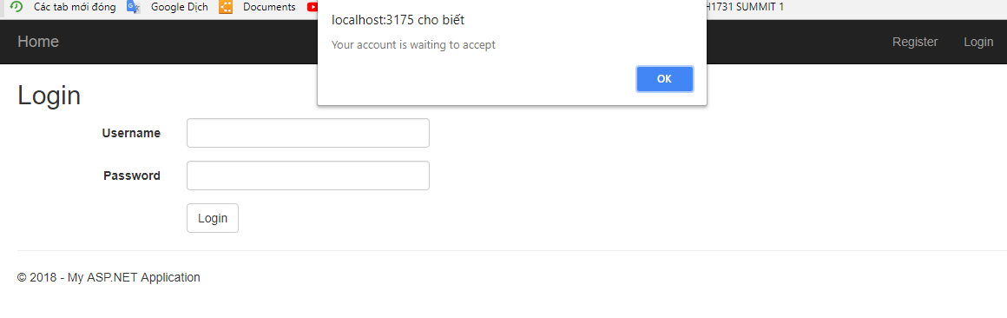

Figure 20. Validation account not yet accept

1. **Possible improvements**

Overall this program pretty good, ability program’s performances pretty ok, it is less more happen problems and errors, functions are effective, meet the requirements of customers, business logic is pretty good, functions logically together… Beside interfaces of program also pretty ok.

To put the program into practical use, this program need improve some problems as improve about function login of system, add feature login for admin to administrators can manage staffs in store and need to improve security by increase length and complexity of the password. We also should improve functions about payment of program for example add methods to payment online as payment by card or online banking… Moreover we need to always improve interfaces display with users to can attractive customers with beautiful interfaces…

1. **Testing plan used**

In the part 2 of this report I was implemented method test cases for each function in my program, here I will write about statistical about result of process test. Through table result test case for my program above, I can conclude that there is 15 test cases and all test cases are pass and have not test cases are fails. Process test cases includes members this is Project management, Testers and Customers to increase objectivity of process test