 

FPT University

University of Greenwich

Employability and Professional Development

Employability and professional development

by

Phạm Xuân Tiến

(GC00742)

Table of Contents

Task 1 3

1.1 CV 3

1.2 SWOT 4

1.3 Personal and professional developmental plan 5

1.4 Evaluate 6

TASK 2 8

Slide 8

Slide Note 25

The importance of communication skills: 25

There are two types of communication skill: 26

Importance of Communication Skill 26

Time management strategies 27

Task 3 29

3.1 Discuss and analyse different roles people play in a team and how they manage to work together to achieve shared goals. 29

Real Project: G4 Computer Service 33

3.2 Discuss alternative techniques to manage team work and achieve team goals. 36

Task 4 37

4.1 Provide a review of different methods and tools used for problem solving. 37

Problem in real project: G4 Computer Service 39

4.2 Solve Problem 39

4.3 Evaluate you can own problem sovling skill 40

Reference 42

# Task 1

## 1.1 CV

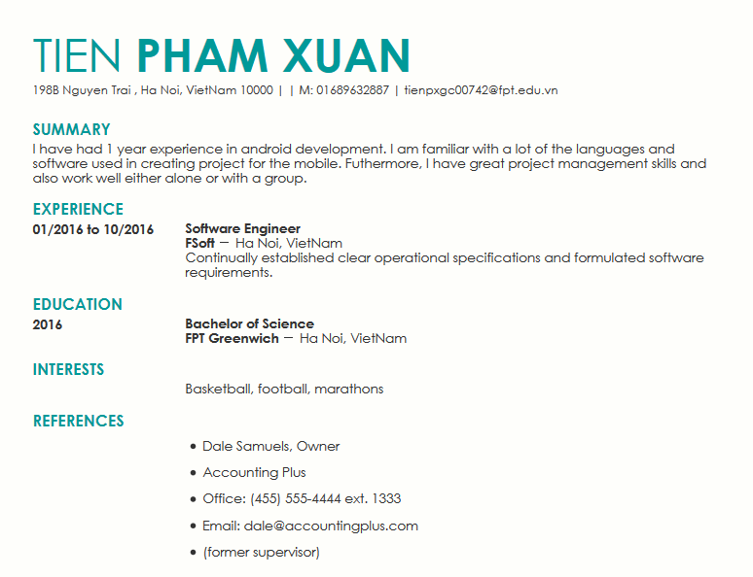

## 1.2 SWOT

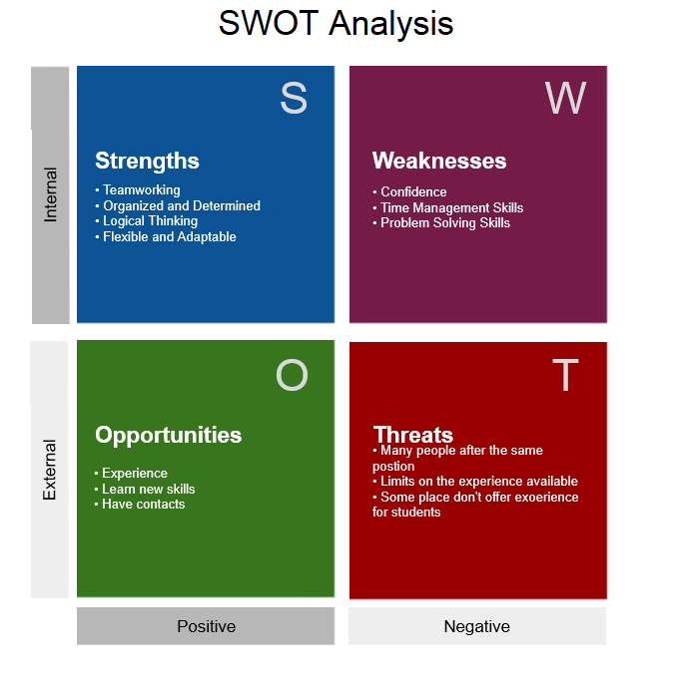

## 1.3 Personal and professional developmental plan

|  |  |  |  |  |  |
| --- | --- | --- | --- | --- | --- |
| **Development objective** | **Priority** | **Specific actions** | **Support required** | **How I will know when I have achieved the objective** | **Target date of achieving my objectives** |
| To gain confidence in talking to group about my work | High | Practice | Presenting the report allows us talk about our work | Posutuve responses from others after presenting | October 2016 |
| Time management skills | High | Using diary to managing my time to make sure tasks are completed at the best capability | A diary to keep all tasks and dates organised so you don’t forget also a calendar | By accomplishing a number of things within the same time scale as reaching to accomplish other tasks or goals | August 2016 |
| Problem solving skills | High | Define task clearly,understand what is required to complete that task and develop a action plan | Asking leader/employer to monitor my performance | Evaluate my performance see how well I achieved my goal | September 2016 |

## 1.4 Evaluate

Activity: Learn how to gain confidence in talking to group about my work.

|  |  |  |
| --- | --- | --- |
| 1 | Summarise the feedback | Mr.Tung told me that I had needed to prepare that know what you are going to say and why you want to say it. |
| 2 | How effective was the development method? | By the end of October I was able to build confidence in talking to people. |
| 3 | Review your activity | The activity went as planned but I didn’t know how to connect with my audience.I should look them in the eye as you speak to them, one person at a time. |
| 4 | What can you do better as a result of the development | I understand my lack of self-confidence  I know how to prepare a talk  I know how to breathe  I know how to act confident |

Activity: Learn how to develop time management skills.

|  |  |  |
| --- | --- | --- |
| 1 | Summarise the feedback | N/A |
| 2 | How effective was the development method? | By the end of August I was able to learn and maintain good time management skills. |
| 3 | Review your activity | The activity went as planned but I needed to stop multi-tasking because our minds work better when we are truly able to focus and concentrate on one thing.I should also reward myself when I accomplish the goal. |
| 4 | What can you do better as a result of the development | I know how to make a list  I know how to set deadlines  I understand why need to stop multi-tasking  I know how to use my downtime |

Activity: Learn how to develop problem solving skills.

|  |  |  |
| --- | --- | --- |
| 1 | Summarise the feedback | Mr.Diep told me that I had needed to stop looking for the right answer and start looking for the right question. |
| 2 | How effective was the development method? | By the end of September I was able to improve my problem solving skills. |
| 3 | Review your activity | The activity went as planned but I should define the problem more clearly. If I don’t properly understand the problem, my solutions may be ineffective or fail entirely. |
| 4 | What can you do better as a result of the development | I understand the importance of understanding the problem  I know how to gather information  I know how to devising a plan  I know how to evaluate the solutions |

# TASK 2

## Slide

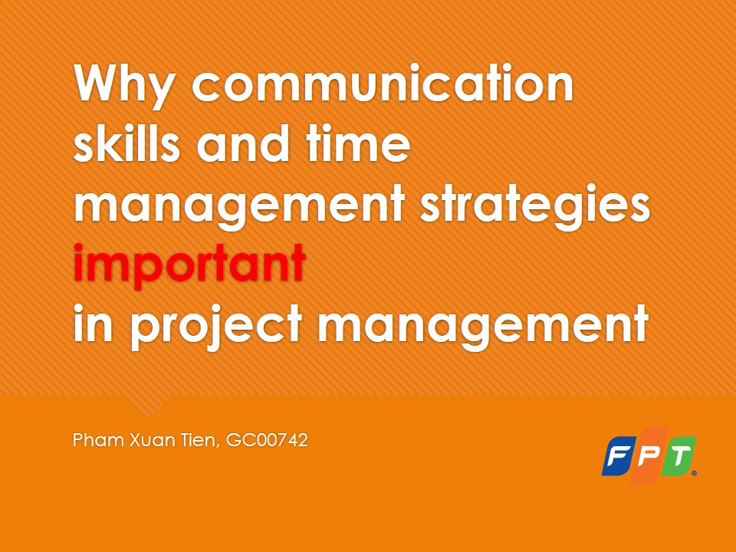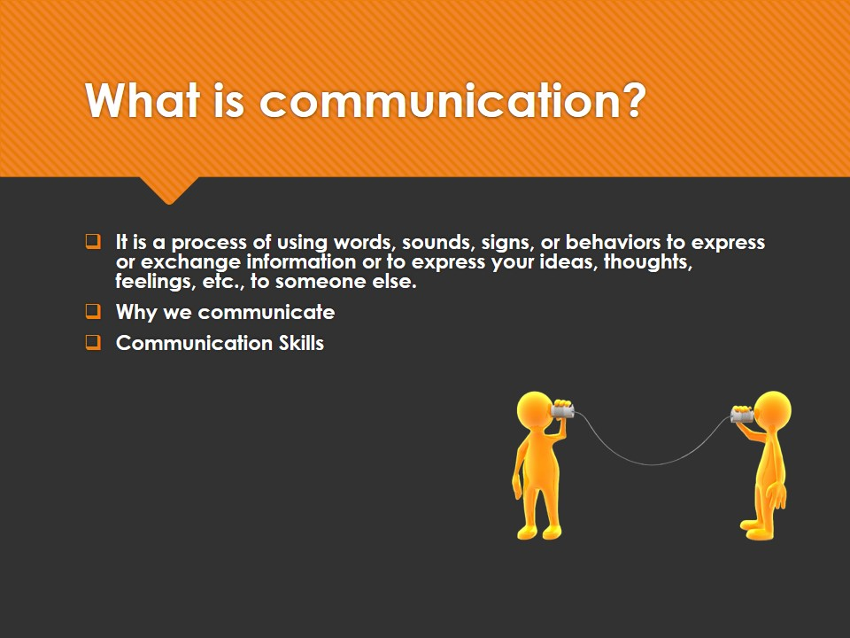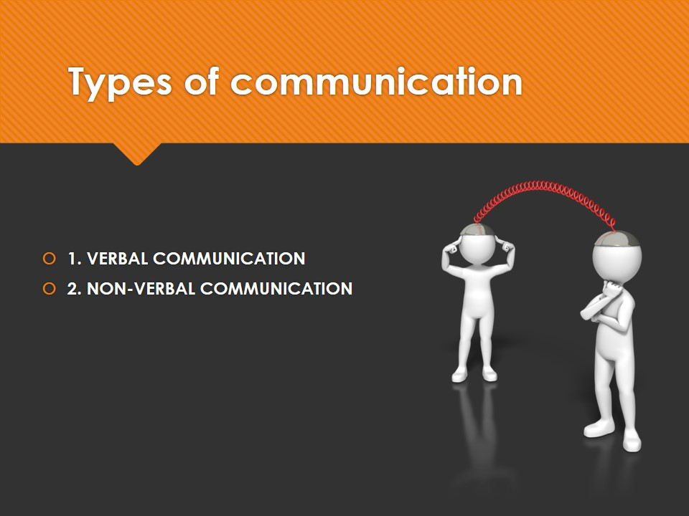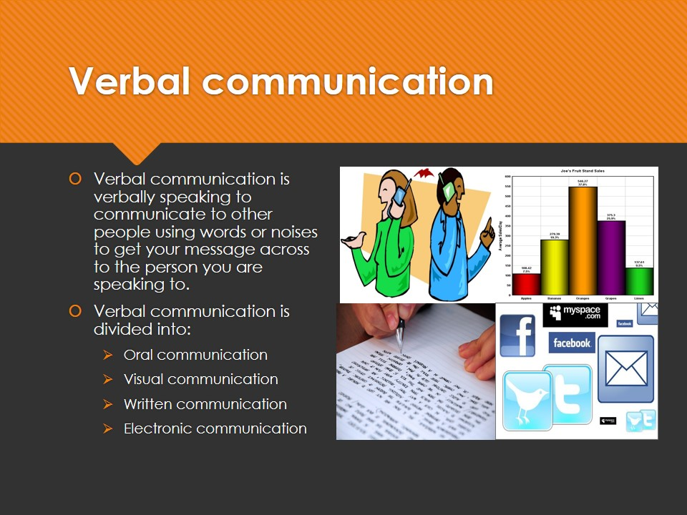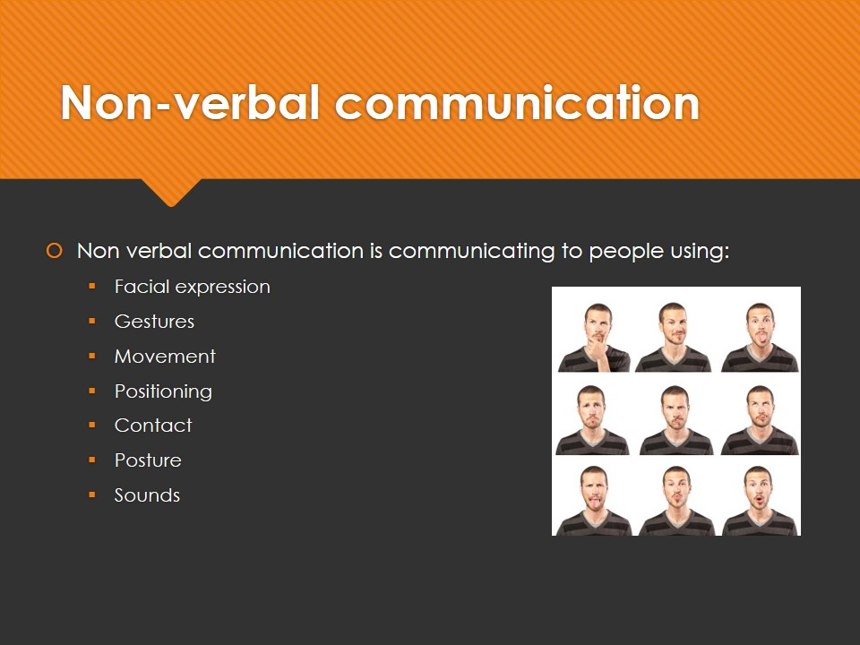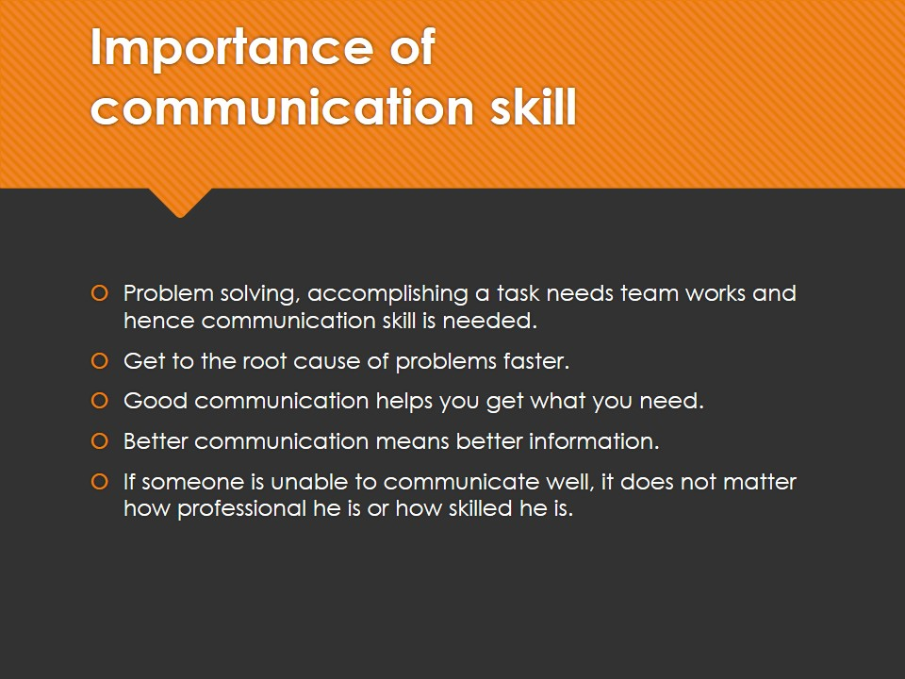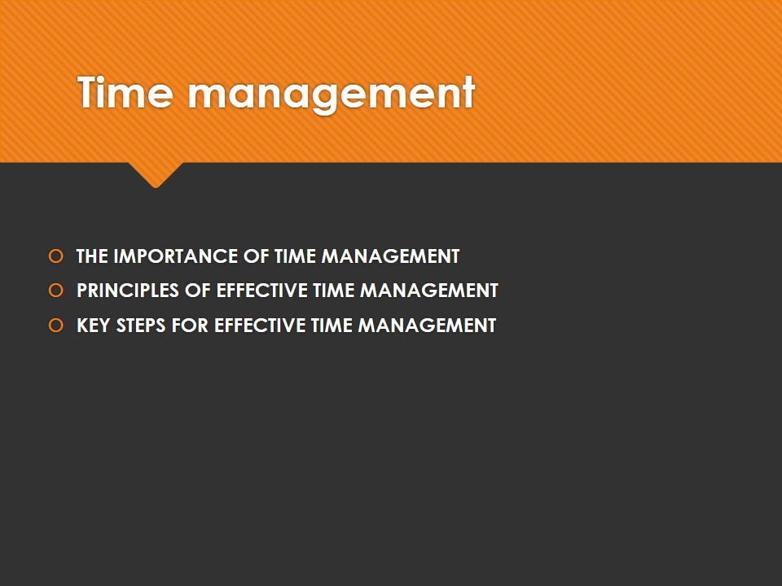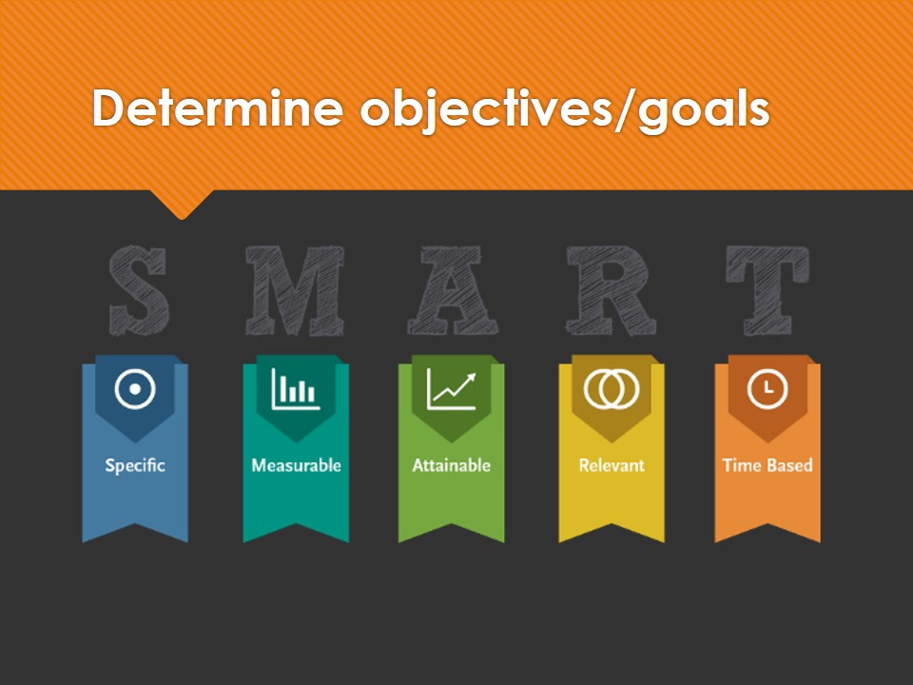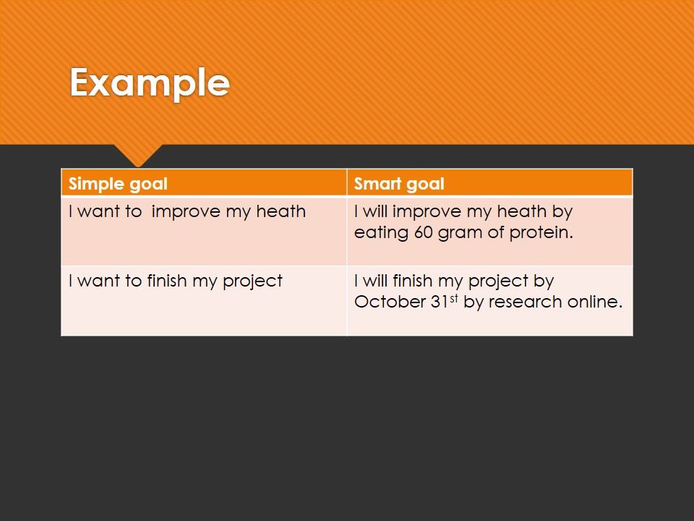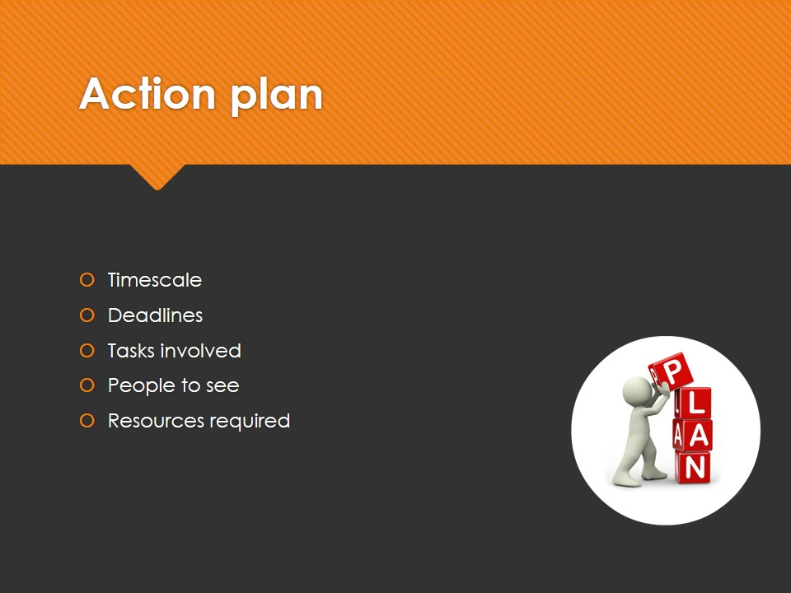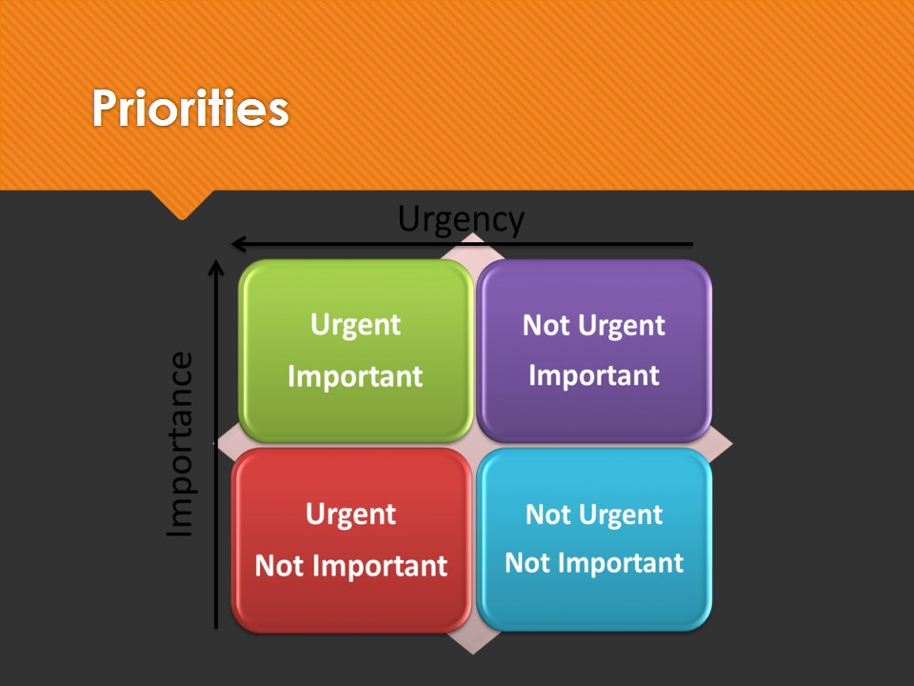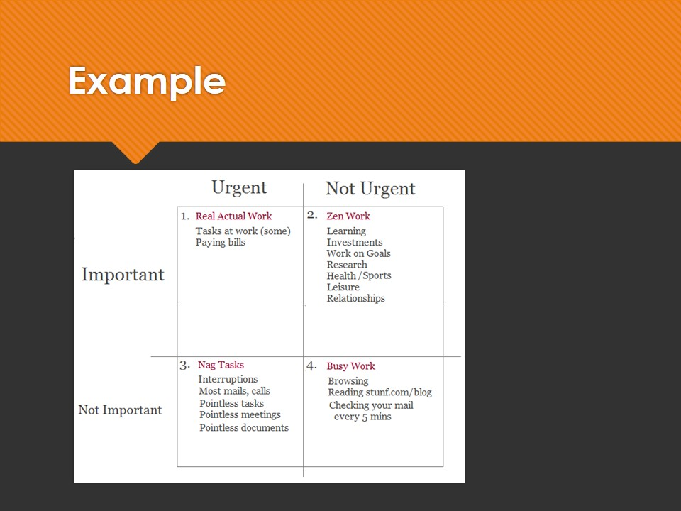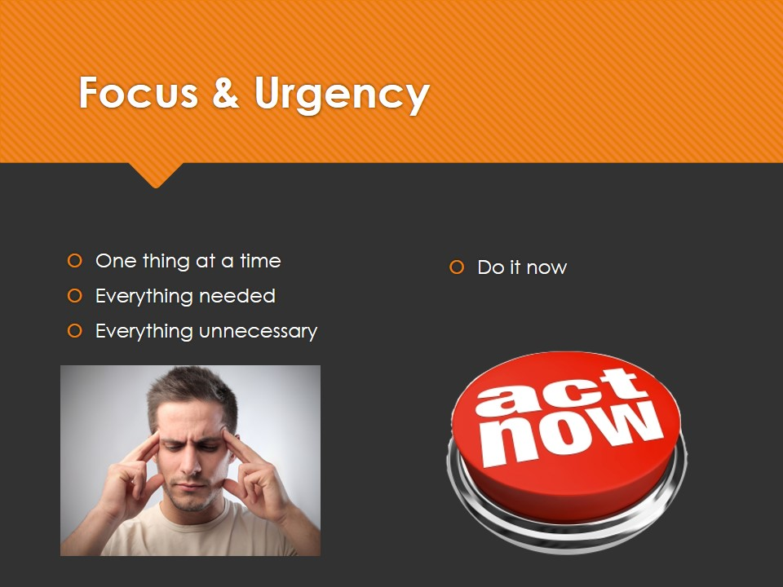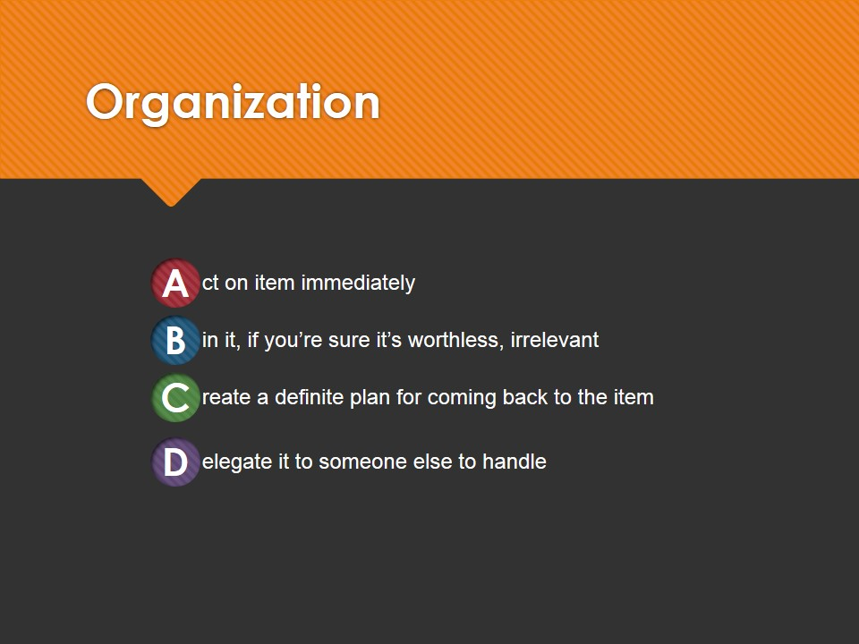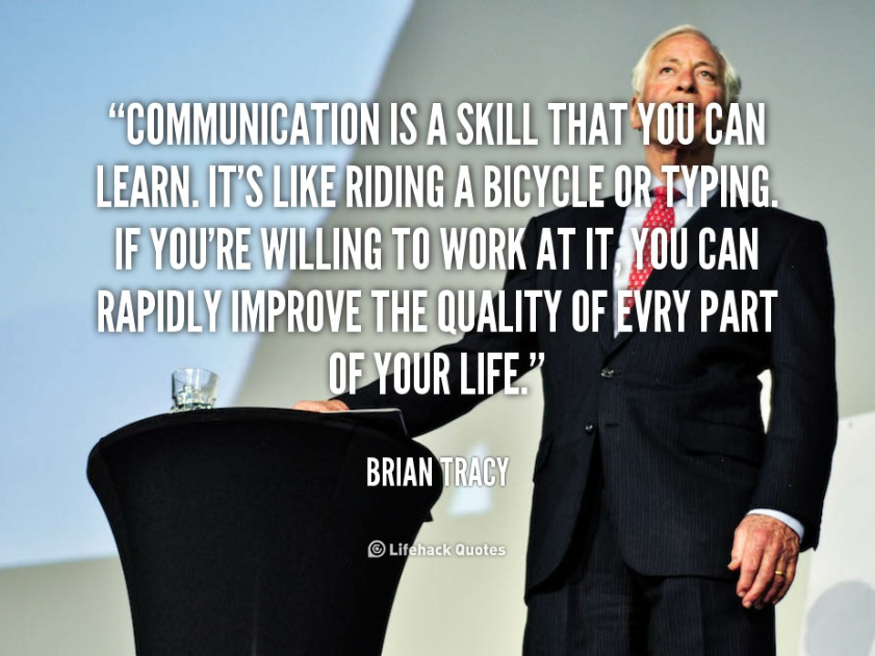

## Slide Note

### The importance of communication skills:

**Communication:**

the act or process of using words, sounds, signs, or behaviors to express or exchange information or to express your ideas, thoughts, feelings, etc., to someone else**.**

**Why we communicate:**

To inform: give people data that they require

To persuade: to get somebody to do st

To request:to ask for st

To confirm: to check information

To build the relationship:giving information to acknowledge and maintain relationship

**Communication skills:**

The ability to communicate clearly and effectively with patients, family members, physicians, nurses, pharmacists and other health care professionals.

### There are two types of communication skill:

**NON-VERBAL COMMUNICATION:**

Non verbal communication is communicating to people using sign language or simple hand movements and also body language such as facial gestures and eye contact.

* Facial expression
* Gestures
* Movement
* Positioning
* Contact
* Posture
* Sounds

**VERBAL COMMUNICATION:**

Verbal communication is verbally speaking to communicate to other people using words or noises to get your message across to the person you are speaking to.

* 1. Oral communication, such as dialogue, discussion, telephone calls.
  2. Visual communication, such as maps, graphics, traffic signals, advertisement.
  3. Written communication, such as letters, reports, papers.
  4. Electronic communication, facilitated by an interface with a computer, modem, fax, E-mail.

### Importance of Communication Skill

* Problem solving, accomplishing a task needs team works and hence communication skill is needed.
* Get to the root cause of problems faster.
* Good communication helps you get what you need.
* Better communication means better information.
* If someone is unable to communicate well, it does not matter how professional he is or how skilled he is.

### Time management strategies

#### The importance of time management:

Time management implies planning the best use of time.

Failure to manage your time can leave you so short of it that you have a last minute rush to get a really important job done.

#### Principles of effective time management:

Time management is a set of principles, practices, skills, tools, and systems working together to help you get more value out of your time with the aim of improving the quality of your life.

#### Key steps for effective time management:

**Determine objectives/goals**

Objective which to be useful need to be SMART:

**S**pecific

**M**easurable

**A**ttainable

**R**ealistic

**T**ime-bounded

**Action plan**

Making written action plans that set out how you intend to achieve your goals: timescale, deadlines, tasks involved, the people to see or write to, resources required.

Starting with notes, lists or flowcharts that will help you to capture and clarity your ideas and intentions.

**Priorities**

Deciding which tasks are the most important (first priority) – what is the most valuable use of your time at that very moment.

**Focus: one thing at a time**

Work on one thing at a time until it is finished

* Using follow-up system
* Make sure that everything that you need is available before you start work
* Before you start a task clear away everything from your desk that you do not need for that particular task

**Urgency: do it now**

Do not put off large, difficult or unpleasant tasks simply because they are large, difficult or unpleasant.

If you put it off today, it will be even more of an emergency tomorrow.

**Organization**

Apart form working to plans, checklists and schedules, your work organization might be improved by:

* An ABCD method of work management

**A**ct on item immediately

**B**in it, if you’re sure it’s worthless, irrelevant

**C**reate a definite plan for coming back to the item

**D**elegate it to someone else to handle

* Organize your work in batches of jobs requiring the same activities, files, equipment
* Take advantage of your natural work patterns

# Task 3

## 3.1 Discuss and analyse different roles people play in a team and how they manage to work together to achieve shared goals.

Teamwork is the action of group of people in which the individial interests of group members become secondary to achieving the goals of the group.

A Team Role is defined as "a tendency to behave, contribute and interrelate with others in a particular way.". For a team to be successful it needs to have access to each of the 9 Belbin Team Roles:

|  |  |  |  |  |
| --- | --- | --- | --- | --- |
|  | Role | Description | Teamrole contribution | Allowable weaknesses |
| 1 | Plant | Creative, imaginative, unorthodox | Solves difficult problems | Ignores detail too preoccupied to communicate effectively |
| 2 | Resource investigator | Extrovert, enthusiastic, communicative | Explores opportunities, develops contacts | Over-optimistic, loses interest once initial enthusiasm has passed |
| 3 | Coordinator | Mature, conndent a good chairperson | Clarifies goals, promotes decision-making, delegates well | Can be seen as manipulative,delegates personal work |
| 4 | Shaper | Challenging, dynamic, thrives on pressure | Has the drive and courage to overcome obstacles | Can provoke others, hurts people's feelings |
| 5 | Monitor evaluator | Sober, strategic and discerning | Sees all options, judges accurately | Lacks drive and ability to inspire others, overly critical |
| 6 | Team worker | Mild, cooperative, perceptive and diplomatic | Listens, builds, averts friction, calms the waters | Indecisive in crunch situations, can be easily influenced |
| 7 | Implementer | Reliable, disciplined, conservative and efficient | Turns ideas into practical | Somewhat inflexible, slow to respond to new possibilities |
| 8 | Completer | Anxious, painstaking, conscientious | Searches out errors and omissions, delivers on time | Inclined to worry unduly, reluctant to delegate, can be a nitpicker |
| 9 | Specialist | Single-minded, self-starting, dedicated | Provides knowledge and skills i in rare supply | Contributes only on a narrow front, dwells on technicalities, overlooks the “big picture” |

The stages involved in team building are to:

• Clarify the team goals

• Identify those issues which inhibit the team from reaching their goals

• Address those issues, remove the inhibitors and enable the goals to be achieved

Developing the characteristics outlined above is the first stage of building an effective and enjoyable team. Psychologist Bruce Tuckman first came up with the memorable phrase "forming, storming, norming, and performing" in his 1965 article, "[Developmental Sequence in Small Groups](http://psycnet.apa.org/journals/bul/63/6/384/)." He used it to describe the path that most teams follow on their way to high performance.

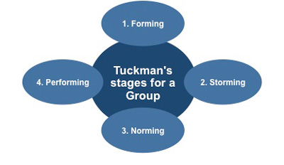

Forming: involves the introduction of team members

Storming: involves more or less open conflict between team members who will have different opinions as to how the team should operate.

Norming: a period of settling down

Performing: emphasis is now on reaching the team goals, rather than working on team process.The team sets to work to execute its task.

The action steps for moving through team development:

Forming to storming:

The action steps for moving through team development:

Forming to storming

• Build a shared purpose/mission and continuously clarify team outcomes

• Create a sense of urgency and rationale for the purpose/mission

• Select members based on resource and skill needs

• Invest time getting to know each member's skills, experience and personal goals

• Bring individuals together to work on common tasks

• Define recognition and rewards, both individual and team-based

• Work on personal commitment by linking personal goals to team roles

Storming to norming

• Build a common understanding by periodically communicating the team’s purpose/mission

• Acknowledge times when the team is struggling and take time to discuss ways to move toward “Norming”

• Set out to achieve a few performance goals and tasks

• Encourage members to express their differing opinions, ideas, and feelings by asking open-ended questions

• Make connections between divergent perspectives; acknowledge where there are differences

• Build a set of operating agreements (rules for team behaviour)

• Raise issues, confront deviations from commitments, and allow conflict to occur

Norming to performing

• Develop shared leadership based on expertise and development needs

• Translate common purpose and team expectations into performance goals that are specified and measurable

• Build consensus on overarching goals and approaches

• Formally give and receive feedback within the team

• Maintain focus on external relationships: commitments, requirements, feedback, and competitive realities

• Celebrate successes, share rewards, recognise team and individual achievements

• Continue to evaluate team against performance goals

Below are some important points to build a successful and effective team:

Size and composition - ideally a team should have seven to nine people and no delegates. You do not want people who have to take the team's ideas back to someone else to get authorisation. In the best teams, no one hesitates to act out of a fear that what they are about to do is not in their area of responsibility. Good team players take action.

Diversity - members must have adequate levels of complementary skills. A team should be made up of people who have different opinions about things, people who approach their work in different ways, intuitive thinkers as well as logical thinkers. Diversity (of skills and opinions) is one of the keys to a successful team.

Shared culture - to have a successful team, you must have a shared organisational culture. People from different parts of a company will, in all likelihood, have disparate styles, expectations, and reward systems. A shared organisational culture will mitigate the differences.

Well-defined goals - the team must have a specific goal or goals and have a well-defined purpose or vision of what the team will accomplish. The team's mission and mode of operation must be clearly defined and every team member has to understand it. That includes an understanding of the projects purpose, the strategy for getting the work accomplished, the ultimate goal, the benefits people will receive if the goal is met, the measurement system thafs going to be used, and how differences of opinion (conflicts) are going to be handled.

Positive attitude and cooperative spirit ~ in successful teams all team members are positive thinkers. A team cannot function with excuse-driven, •no-can-do' members on board. Team members need to be fiercely independent, and at the same time, intensely collaborative. They constantly ask questions and challenge ideas to achieve results as part of an open and positive feedback process.

### Real Project: G4 Computer Service

**Forming:**

We meet each other. In this first meeting, team members are introduced to each. We share information about our backgrounds, interests and experience and form first impressions of each other.

Do Vu Quoc Bao: He is a confident and friendly. He has good communication skills.

Pham Xuan Tien: He is a proactive, confident and friendly. He has good communication and customer service skills.

Nguyen Ba Hung: He is a friendly and have a positive attitude. He has a thorough knowledge of operating systems, hardware and commonly used software.

Nguyen Huu Diep: He is an extremely serious while working. He has 1 years experience in computer & laptop repair.

Effiong ekpenyong: He is hard-working person who always want to complete the job in the best way. He has excellent listening and questioning skills.

Hoang Manh Hiep: He is a friendly but lack focus. He has a good memory of how software and operating systems work.

Phan Thanh Tung: He is an open and approachable. He has good communication and customer service skills.

**Storming:**

We begins to work together. In the process, we encountered a number of difficulties as below:

Resistance: people refuse to work in the early stages because everyone is busy.

Solution: Skype group chat.

Lack of participation: During the meeting the group,  we are not involved enough members because of personal reasons.

Solution: Communication between the team members and team leaders.

**Norming:**

Effiong ekpenyong - Leader

He was good at dividing and guiding the work of the group, power transmission work for the members. In the process of work, he regularly participates in helping the problems of the group members.

Nguyen Huu Diep - Computer Repair Technician

He has a good understanding of computer hardware, computer disassembly, proper tools, and good troubleshooting skills.

Hoang Manh Hiep - Computer Repair Technician

He has excellent analytic skills and the ability to troubleshoot and resolve hardware and software problems.

Nguyen Ba Hung – Computer Repair Technician

He has the ability to perform tasks such as providing operating systems and application software installations and upgrades, virus protection and eradication.

Phan Thanh Tung – Customer Service

He has the ability to interact confidently with clients to establish what the problem is.

Pham Xuan Tien – Customer Service

He has good communication skills and a general understanding of the company and its services.

Do Vu Quoc Bao - Technical Support

He has a basic understanding of computers, computer's software, and hardware.

**Performing:**

**Team Goal:**

* Members understand about the process of development of the individual, the team.
* The members clearly understand each other's strengths and weaknesses.
* The ability to cope or resolve the problem of the team.
* Build trust between team members.

**Issues:**

Teamwork:In the course of work, the members are not willing to help or replace mutual roles as needed. The members have the skills should be prepared to change roles to ensure the team's performance

Skill:In technical team, requires a lot of skill to fix the computer but some team members lacked skills in the array. The other members can teach directly to ensure the performance of work for the group.

**Evaluate:**

|  |  |  |  |
| --- | --- | --- | --- |
| Name | Position | Effectiveness | Need improve |
| Effiong ekpenyong | Leader | Good | Providing feedback, **motivate others** |
| Nguyen Huu Diep | Computer Repair Technician | Good | Keep up to date with IT development |
| Hoang Manh Hiep | Computer Repair Technician | Poor | **Communication skills,**ability to meet deadlines |
| Nguyen Ba Hung | Computer Repair Technician | Very-Good | Ability to prioritise his workload |
| Phan Thanh Tung | Customer Service | Excelent |  |
| Pham Xuan Tien | Customer Service | Very-Good | Stress handling |
| Do Vu Quoc Bao | Technical Support | Very-Good | Questions handling |

## 3.2 Discuss alternative techniques to manage team work and achieve team goals.

**Clear Objectives:** The team's overall objective needs to be identified and defined in terms which allow each member to understand the same goal.

**Commitment to the team:** Team members experience real strength from their membership and the sharing of goals. They are willing to invest considerable energy in the interests of the team.

**Getting things done:** The successful team not only knows where it is going, it knows when it has arrived.

**Learning:** The team and its members learn from their experiences, including their mistakes. Mistakes made in good faith do not lead to heavy penalties, but are incorporated into expectations about the team and its members maturing over time.

**Working techniques:** The team needs to invest time and effort into developing working techniques, methods, procedures and ground rules to move the team toward its goal in the most efficient way consistent with preserving those other qualities associated with effective teams.

**Relationships with other teams:** An effective team also invests time and energy into developing ground rules for managing its relationships with other teams in a positive and productive way

# Task 4

## 4.1 Provide a review of different methods and tools used for problem solving.

There are two stages in the process: a free thinking stage and an organising stage - these should not be done together.

Stage 1: **Brainstorming**

Write your topic or area of study in the centre of a blank page. Use colours, pictures, words and symbols to record any other ideas, topics, authors, theories or anything else associated with the topic. You can put these anywhere on the page. Associate freely and do not filter out ideas; at this point anything and everything is OK.

Stage 2: **Mind mapping**

Map the relationships between the ideas or key points using lines, arrows, colours and words to link them. Identify the type of relationship between points: contrast/similarity/cause/effect. Write these along the linking lines.

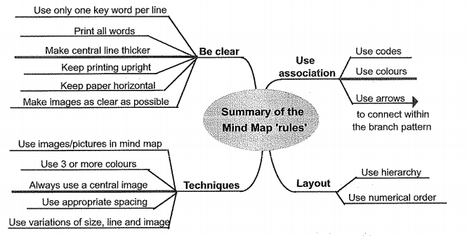

Finding possible solutions - closed problems generally have one or a limited number of possible solutions, while open-ended problems usually can be solved in a large number of ways. The most effective solution to an open-ended problem is found by selecting the best from a wide range of possibilities. Finding solutions involves analysing the problem to ensure that you fully understand it and then constructing courses of action which will achieve your objective. The more ideas you have to work with, the better your chances of finding an effective solution.

Choosing the best solution - the stage at which you evaluate the possible solutions and select that which will be most effective in solving the problem. It is a process of decision making based on a comparison of the potential outcome of alternative solutions. This involves:

* Identifying al! the features of an ideal solution, including the constraints it has to meet
* Eliminating solutions which do not meet the constraints
* Evaluating the remaining solutions against the outcome required
* Assessing the risks associated with the 'best solution
* Making the decision to implement this solution

Implementing the solution - involves three separate stages:

1. Planning and preparing to implement the solution
2. Taking the appropriate action and monitoring its effects
3. Reviewing the ultimate success of the action

Problem solving requires two distinct types of mental skill, analytical and creative.

Analytical or logical thinking includes skills such as ordering, comparing, contrasting, evaluating and selecting. It provides a logical framework for problem solving and helps to select the best alternative from those available by narrowing down the range of possibilities (a convergent process). Analytical thinking often predominates in solving closed problems, where the many possible causes have to be identified and analysed to find the real cause.

Creative thinking - is where problem solving is used as a creative tool to generate new ideas for doing things, starting with a blank sheet. This type of problem solving requires the most flexible approach.

### Problem in real project: G4 Computer Service

**Situation:** Customers find our service too little is not as we expected, management wants to find new ways. Leader is looking for new ways to attract new customers and to increase the frequency of existing customers.

**Problem:** How can we get more customers?

## 4.2 Solve Problem

**Brainstorming Steps:**

* Plan the session – fix the place and time.
* Leader and team members are invited to participate.
* The session is held in FPT University.
* The leader is a is a good communicator and uses a word to warm-up the group.
* The leader raises the question: How can we get more customers? She/he writes down the problem on a board.
* The leader set out the rules of the session: anyone can produce an idea, every member has to respect the ideas of his/her colleague and not criticise.
* The scribe, using a mind map, writes down the ideas generated.
* A discussion session to evaluate and choose the most suitable idea.

**Brainstorming Results:**

1. Create facebook page to promote company.
2. Advertising posters around school.
3. Provide new service to secure computer against virus infection.
4. Provide new service to recover data from accidental deletion, format, hard drive corruption, raw partitions.
5. Provide new service to speed up computer performance.
6. Reduce prices of activing windows and office.
7. 10% discount for customer using 2 service at the same time.

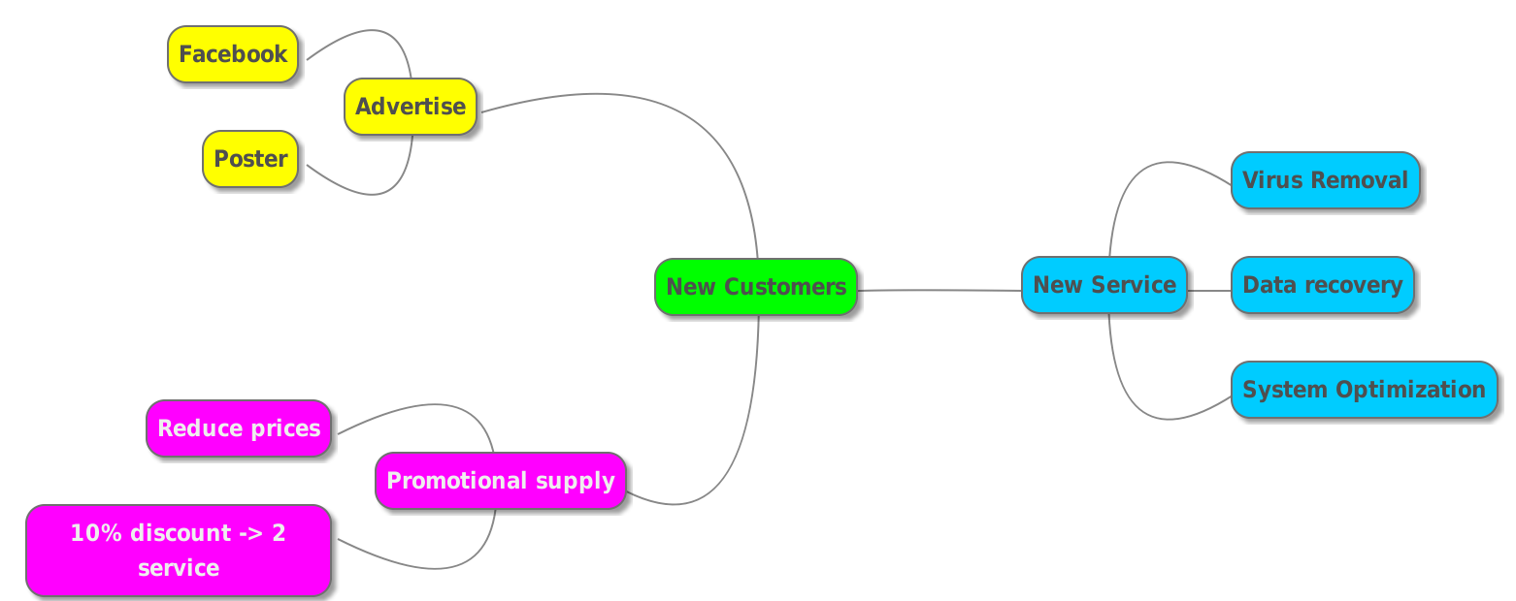

## 4.3 Evaluate you can own problem sovling skill

Using problem sovling skill in real project help my team such as:

**Imagination:**

The exchange of ideas can act as a stimulus to the imagination, encouraging individuals to explore ideas they would not otherwise consider.

**Better solutions:**

Team members can bring a broad range of ideas, knowledge and skills to bear on a problem. This creates a stimulating interaction of diverse ideas which results in a wider range and better quality of solutions.

**Greater output:**

Simply because of the number of people involved, each with differing experience, knowledge, points of view and values, a larger number and variety of ideas for solving a problem can be produced.

# Reference

BPP Learning Media, 2013. *Business Essentials Management: Leading People and Professional Development: Study Text*. Edition. BPP Learning Media.