 VNX.SI
MARKETING OVERVIEW / 01

VNX.SI Marketing Overview
Software you need. Built by people you can meet.
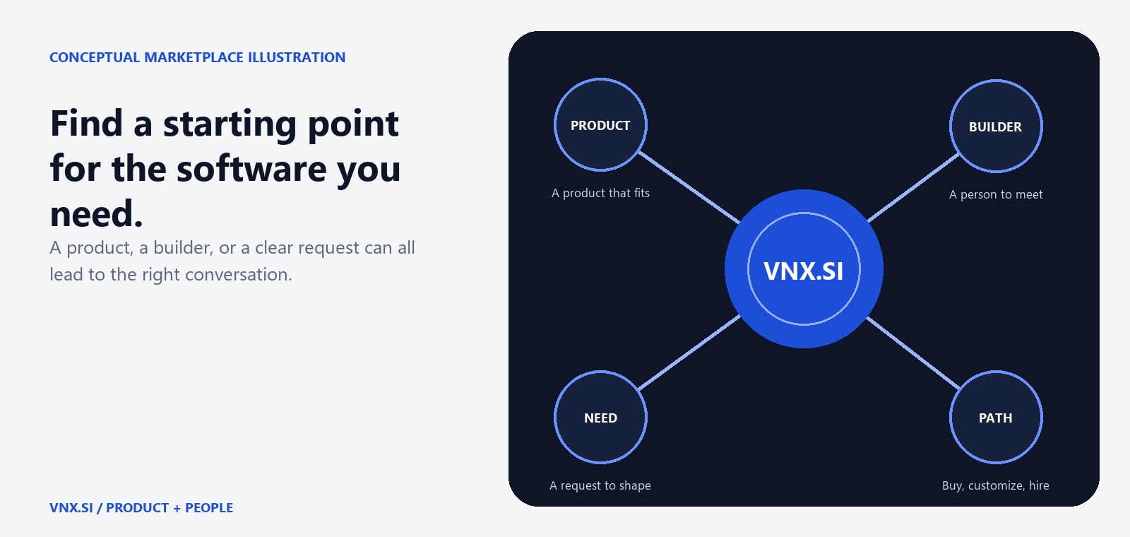
Conceptual marketplace illustration. VNX.SI brings products, builders, and needs into one clear starting point.
VNX.SI is a marketplace for AI-built products and the builders behind them. People who need software can start with a product that already fits, ask for a tailored version, work directly with a builder, or describe what they need when the catalogue does not have the answer.
Current scope - As of October 2026, VNX.SI focuses on builder profiles, product listings, catalogue discovery, Inquiry, and Post a request. The platform does not process payments; clients and builders agree final scope, price, licence, and delivery directly.

START WITH THE OUTCOME / 02

Choose the route that fits
You do not need to begin by choosing a framework or a development process. Begin with the work you want software to improve, then choose the route that matches the distance between your need and the available supply.
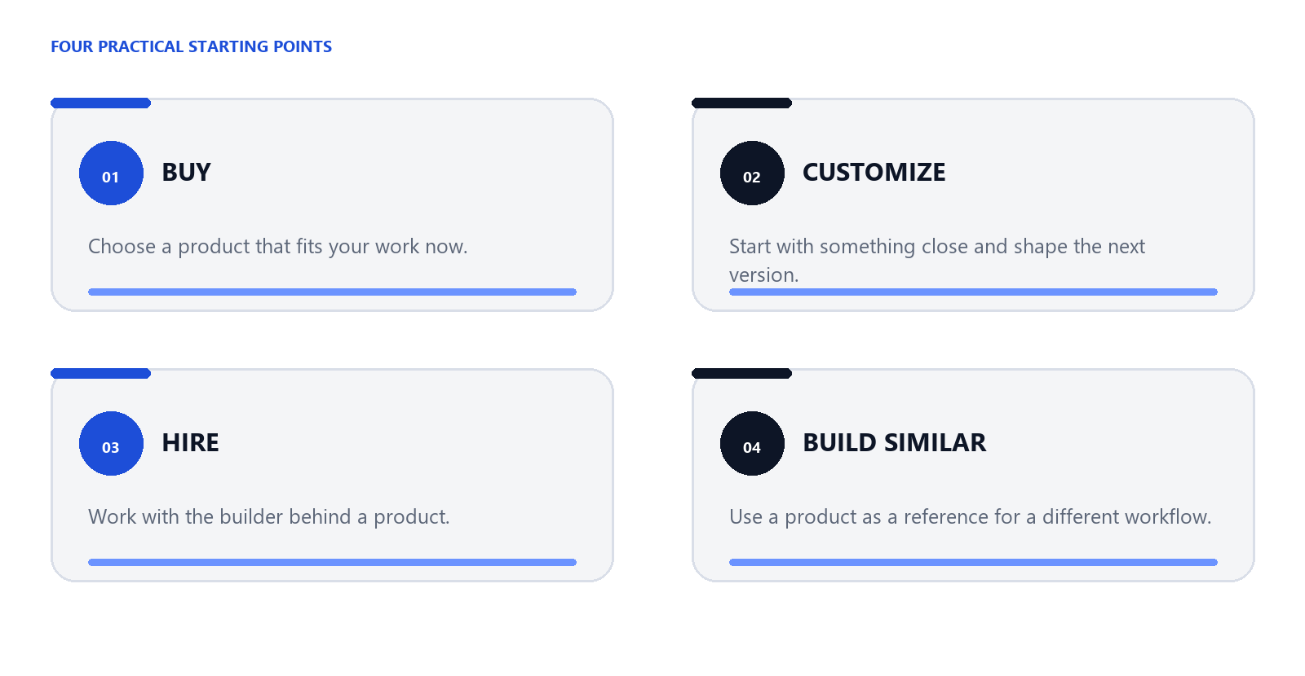
Conceptual route map. The four paths describe how a client can move from a need to a useful conversation.

Buy
Inspect the problem statement, features, demo, pricing tiers, licence, support policy, and builder. Send a Buy Inquiry when you want to ask a question or discuss next steps.

Customize
If a product is close but needs changes, choose Customize when the builder offers it. Share context, budget range, and deadline so the conversation starts with a concrete brief.

Hire the builder
Review the builder's profile, skills, portfolio, and availability, then send a Hire Inquiry for a separate project.

Build Similar
Use a product as a useful starting point for a different business or workflow. Explain what you want to keep and what needs to change.

A CLEARER ROUTE FROM IDEA TO CONVERSATION / 03

From need to conversation
VNX.SI keeps the first step concrete. A client can discover supply, understand what a product or builder offers, and choose a direct Inquiry or a private request without handing over an email address through the flow.
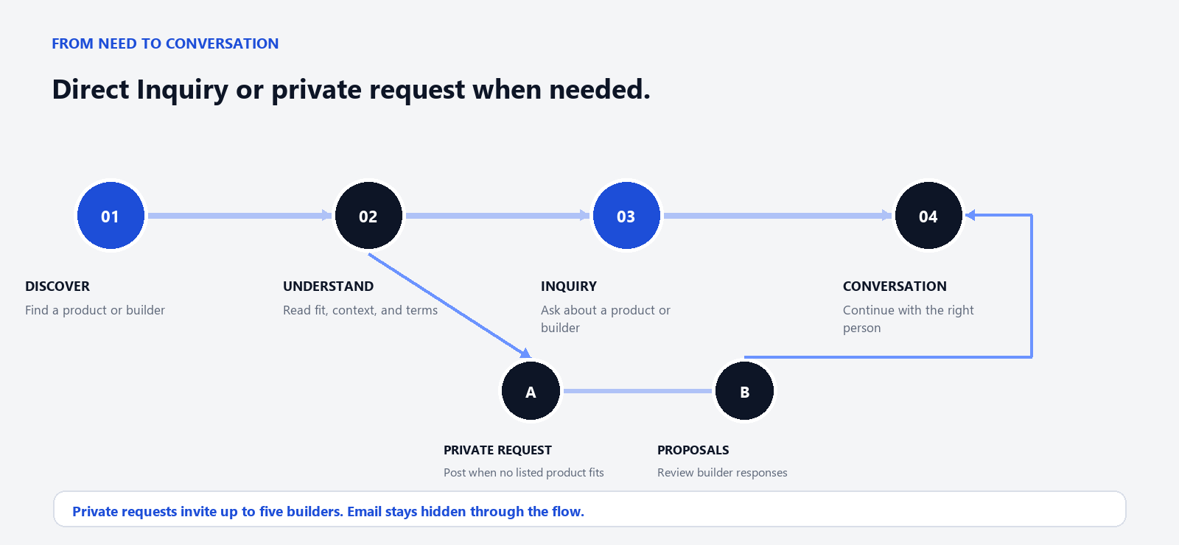
The paths meet at conversation: use a direct Inquiry for a product or builder, or a private request when the catalogue is not enough.
01 Discover. Search the catalogue by category, delivery model, starting price, language, or verification badge. Browse builders by skill, language, country, and availability.
02 Understand. Read the product page for its problem, intended users, features, technology context, pricing, licence, customization, support, and builder.
03 Choose a route. Send a direct Inquiry when a product or builder is close, or post a private request when the catalogue does not have the right fit.
04 Open an Inquiry. Share a message, budget range, and optional deadline. The conversation continues in the VNX.SI web inbox.
05 Review proposals when needed. For a private request, the VNX.SI team can invite up to five builders to respond with proposals; review them in your account.
06 Continue. Select a direction and keep the discussion focused on scope, price, licence, and delivery.
Privacy by default - Signed-out clients confirm their email before an Inquiry or request is opened for a builder to see. Builders do not receive a client's email through these flows.

FOR BUILDERS / 04

Turn useful work into a durable presence
AI can make building faster. VNX.SI gives what you build a place to be found, understood, and connected to the next conversation. A product can represent a SaaS, source-code offering, or service package.
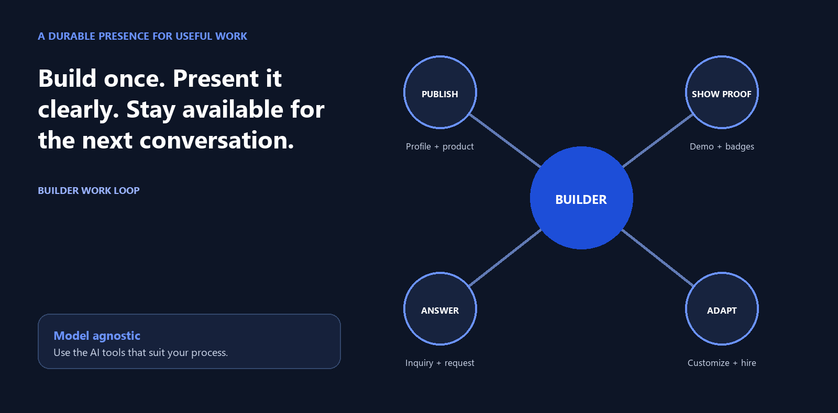
Conceptual builder work loop. A clear presence lets one useful piece of work support several kinds of conversation.
Publish the work | Continue the conversation
Create a profile with skills, working languages, availability, and portfolio. Publish a product with its problem, target users, features, demo, pricing, licence, customization options, and support policy. | Receive Inquiries from people who want to buy, customize, hire, or build something similar. Respond to private requests with an approach, price or price range, and expected timeline.

A channel for more than one project
The catalogue lets builders present products instead of explaining the same work from scratch. During the founding phase, listings are intended to be free while the initial supply is built.
Become a builder at vnx.si/for-builders

TRUST YOU CAN READ / 05

Trust you can read
VNX.SI uses evidence-based badges instead of star ratings it cannot substantiate. Each active badge appears with a verification date and names the check that supports it.
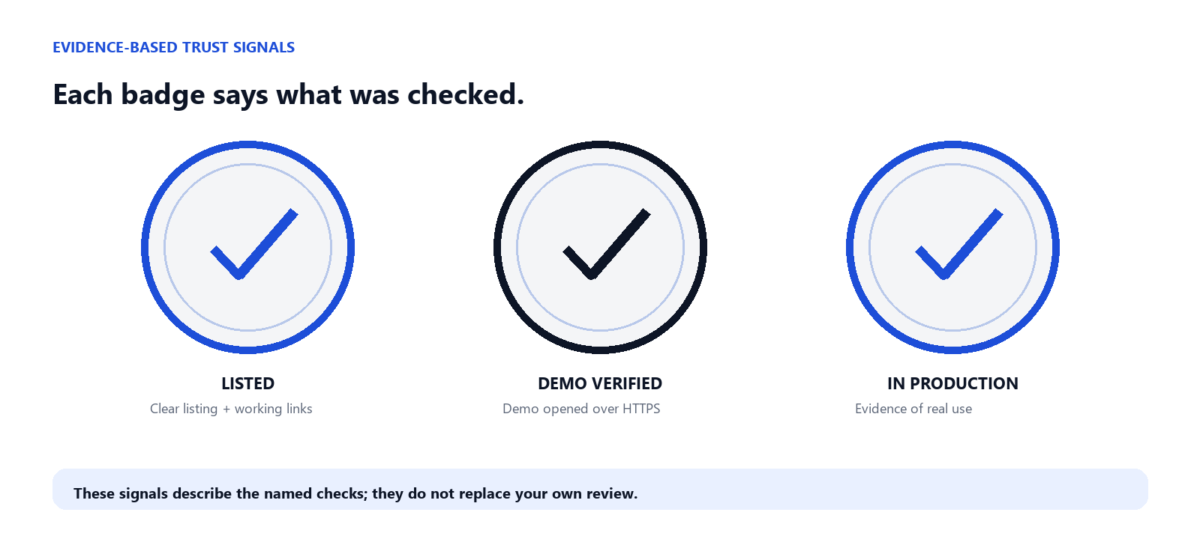
Evidence-based badges. Each signal describes the check it names.
Badge | What the check means
Listed | The VNX.SI team reviewed the listing for a clear description, pricing or a clear way to request pricing, and working links before publication.
Demo verified | The team opened the demo and saw it work over HTTPS at the time of review. A changed demo URL revokes the badge.
In production | The builder provided evidence of real customers using the product, and the team checked that evidence.
These signals do not replace your own review of a product's fit, security, performance, licence, or commercial terms. A badge is a readable starting point, not a guarantee.

Organic ranking has a clear line
Organic ranking is never for sale. Product and builder lists cannot be moved by payment, partner commission, or monetization data. If VNX.SI introduces sponsored placement in a later phase, it will be a separate, clearly labelled area and will not change organic order.
The same separation guides partner work. Future partner links may be disclosed and measured through controlled routes; a click or commission cannot become a quality signal. Partnership conversations can start at contact@vnx.si.

WHAT COMES NEXT / 06

Build in stages
The first phase is about making supply discoverable and conversations useful enough to support the next one. Later phases are planned directions, evaluated before they become product promises.
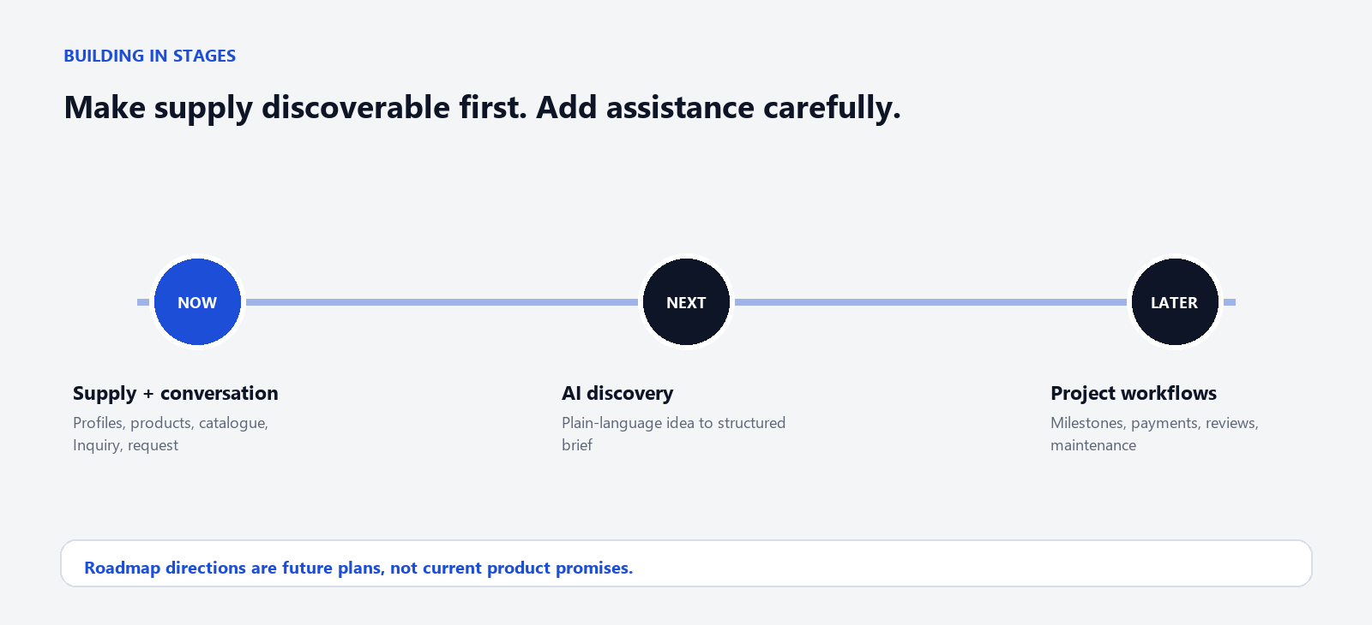
Roadmap direction. The future stages are clearly separated from the current product scope.
Available now | Planned directions
Builder profiles, product listings, catalogue discovery, Inquiry, and Post a request. The interface supports English, Vietnamese, Simplified Chinese, and Traditional Chinese. | AI Discovery, recommendations grounded in real products and builders, assisted matching and estimates, and project, milestone, payment, payout, review, and maintenance workflows.

Start with VNX.SI
Have a software idea but unsure whether to buy, customize, or build? Start with real products and builders, then turn the need into a clear conversation.
Explore products and builders at vnx.si
Press, partnerships, and general questions: contact@vnx.si

