**Write NO MORE THAN TWO WORDS for each answer.**

31 Where are the British Isles situated? In the ______

32 The Venn diagram is being used to help students see the difference between geographic and what other regions?

**Label the diagram below.**

**Write ONE WORD ONLY for each answer.**

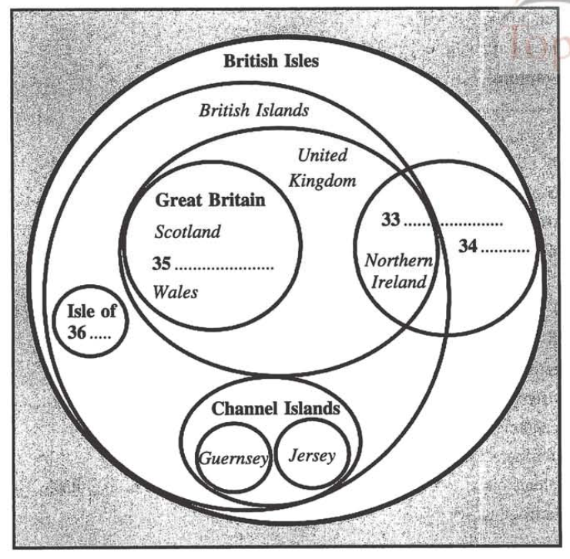

**Complete the sentences below.**

**Write ONE WORD ONLY for each answer.**

37 There is ______ with language also when it comes to describing the British Isles.

38 The northernmost point of Ireland belongs to the Republican ______ of Donegal.

39 A Welshman will be upset if you call him ______.

40 The former British Empire is now known as the Commonwealth of Nations to avoid recalling previous ______ relationships.