**Tacoma Narrows Bridge**

*- Disaster Strikes*

When the Tacoma Narrows Bridge opened for traffic on 1 July 1940, it was celebrated as a major engineering achievement. Even before construction was completed, however, flaws in the design were apparent; workers sucked on lemon slices to avoid motion sickness as the structure swayed in the relatively mild winds. Engineers tried three different revisions during construction to address the vibration problem. Initially, tie-down cables were anchored to fifty-tonne bulkheads on the river banks. These were ineffective, as the cables soon detached. Then a pair of inclined cable locks was introduced to connect the main cables to the bridge deck at mid-span. These stayed throughout the bridge's lifespan, but did nothing to reduce vibration.A further measure—the installation of hydraulic dampers between the towers and the floor system—was nullified because the dampers were compromised when the bridge was sand-blasted before painting.

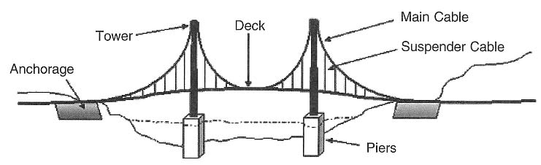

Shortly after opening, the bridge quickly acquired the fond nickname of 'Galloping Gertie' because of the way it would roll in either side-to-side or length-ways movements—known in physics terms as the longitudinal and transverse modes of vibration respectively. These movements did not compromise the core integrity of the structure, but did make the crossing a somewhat white-knuckle affair. Many drivers reported seeing cars ahead disappear from sight several times as they sank into troughs from transverse vibrations (imagine the ripple across a packed stadium during a Mexican wave). The experience of a longitudinal wave is closely analogous, but more accurately associated with the waves one would encounter in the ocean. On a suspension bridge though,these waves are a unique experience—some dare-devils were happy to pay the 75c toll just for the thrill!

Four months later, however, a never-before-seen type of vibration began afflicting the bridge in what were still fairly gentle winds (about 40 kmph). Rather than the simple 'wave' motion that characterises longitudinal and transverse vibration, the left side of the bridge would rise while the right side fell, but the centre line of the road would remain completely level. This was proved when two men walked along the centre of the bridge completely unaffected by the rocking motions around them. Visually the bridge's movements seemed to be more like a butterfly flapping its wings than a simple rolling motion. Engineers now understand this to be the torsional mode of vibration, and it is extremely hard to detect. In aeroplane design, for example, even minute shifts of the aircraft 's mass distribution and an alteration in one component can affect a component with which it has no logical connection. In its milder forms this can cause a light buzzing noise, similar to that which a wasp or a bumble bee makes, but when allowed to develop unchecked it can eventually cause the total destruction of an aeroplane.

The torsional mode of vibration is the consequence of a set of actions known as aerostatic flutter. This involves several different elements of a structure oscillating from the effect of wind, with each cycle of fluttering building more energy into the bridge's movements and neutralising any structural damping effects. Because the wind pumps in more energy than the structure can dissipate, and the oscillations feed off each other to become progressively stronger, the aerostatic fluttering and torsional vibrations were all but assured to destroy the Tacoma Bridge on the morning of 7 November. At 11.00 am the fluttering had increased to such amplitude that the suspender cables were placed under excessive strain. When these buckled, the weight of the deck transferred to the adjacent cables which in turn were unable to support the weight.These cables buckled, leaving nothing to stop the central deck breaking off into the Tacoma River.

It was at around 10.15 am on 7 November that torsional vibration began afflicting the bridge. This made driving treacherous, and newspaper editor Leonard Coatsworth's car was jammed against the curb in the centre of the bridge as he attempted to cross. Coatsworth tried to rescue his daughter's cocker spaniel from the back seat but was unsuccessful, and fearing for his life, crawled and staggered to safety on his own. At this point, an engineering professor named Bert Farquharson proceeded onto the bridge in an attempt to save the frightened animal. Farquharson had been video-recording from the banks of the river and had just returned from purchasing more rolls of film. As an avowed dog lover he felt obliged to attempt a rescue. Unfortunately, the professor too was bitten and retreated empty handed, walking off just moments before the cables snapped and the giant concrete mass of the central deck caved inwards and disappeared into the river.