The graph below shows the proportion of four different materials that were recycled from 1982 to 2010 in a particular country.

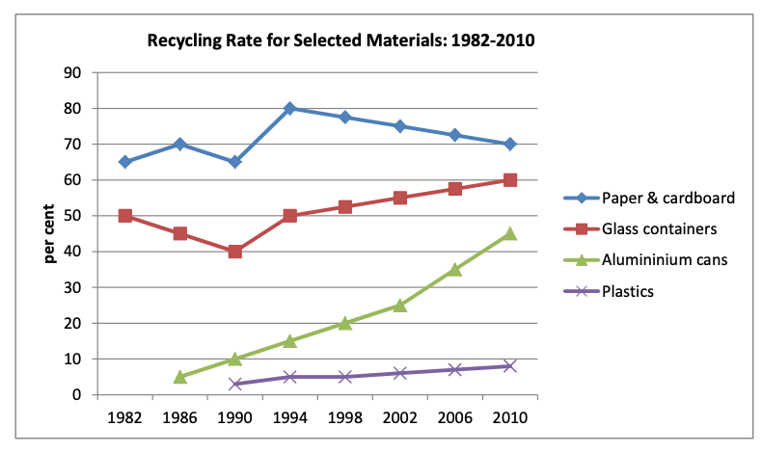Summarise the information by selecting and reporting the main features, and make comparisons where relevant.