The graph below gives information about the sales of the three most commonly purchased items in a particular bakery for the year 2014.

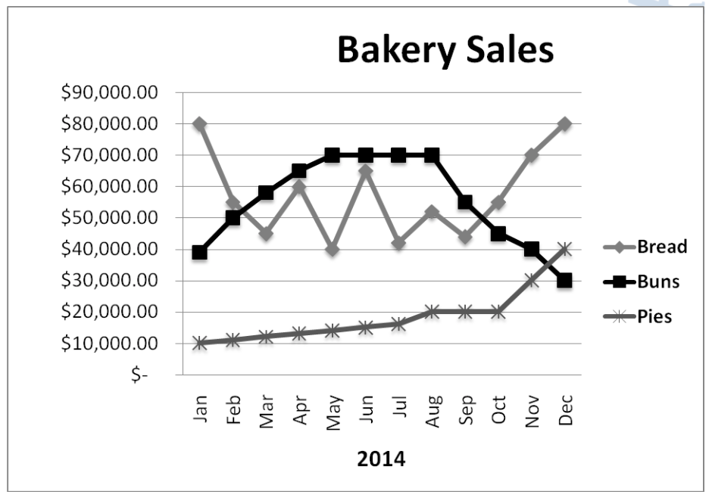Summarise the information by selecting and reporting the main features, and make comparisons where relevant.