Gateway modbus Serial

Feature:

* 4x Modbus Master
* Lwip stack with LAN7820A
* Socket, tcp, mqtt implementation
* Serial commad line configuration

Parameter:

* Gateway ID: setid id
  + setid 1
* Gateway local IP (ip, default gateway, netmask) //temporary not use, using dhcp intead.
  + setlocalip 192.168.1.2
* Mqtt Server ip: setmqttip mqtt_ip
  + setmqttip 192.168.1.2
* Save and restart (store data to flash restart to take a new param): save
  + Save

MQTT dowlink request:

* Topic: modbus/id/downlink. Ex: modbus/1/downlink
* Json message: {\"NodeID\":8,\"FunC\":6,\"RegAdrH\":03,\"RegAdrL\":08,\"RegDataH\":00,\"RegDataL\":3,\"PortID\":1}"

MQTT uplink reponse:

* Topic: modbus/id/downlink. Ex: modbus/1/downlink
* Json message: {\"NodeID\":8,\"FunC\":6,\"RegAdrH\":03,\"RegAdrL\":08,\"RegDataH\":00,\"RegDataL\":3,\"PortID\":1}"

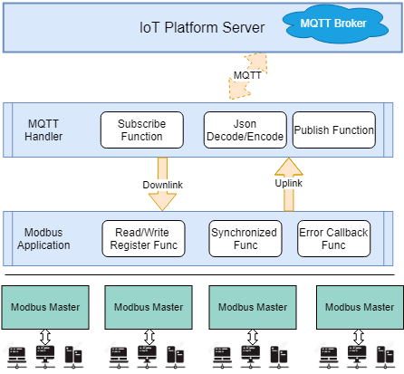

Todo:

* Implementing Read/Write coil function
* Change MQTT protocol to TCP (or Modbus TCP) (optional)
* Auto reconnect, Warning,…

Bug:

* Command line is reponse slow
* Lwip: not reconnect when re-plugin the Ethernet cable
* 