IoT Node

Feature:

* 3x digital, 2x adc, 1x onewire port
* Modbus on RS485 and LoRaWAN support
* EEPROM for param storing

App:

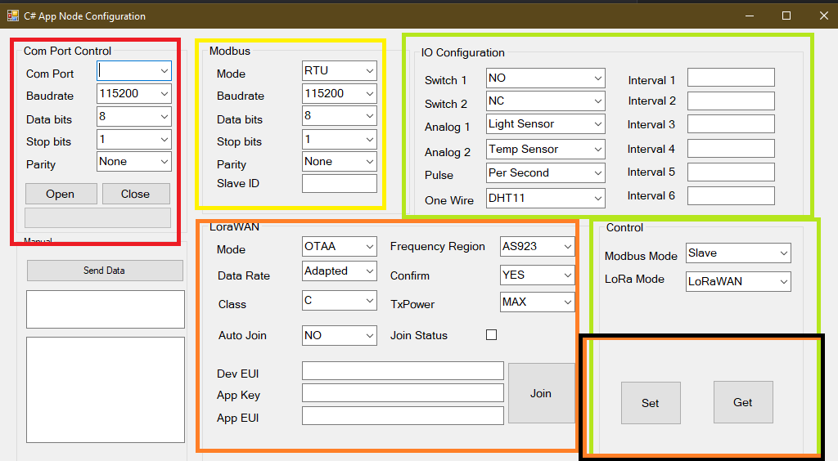

* Red: Serial to PC communcation
* Yellow: Modbus Param
* Orange: LoRaWAN param. // join button and join status not use
* Green: Node mode and port mode: not use//
* Flow:
  + Connect RS232 to node
  + Open port with 115200 8n1
  + Get button to get pre-configured param
  + Modify if u want
  + Save
* Bug: speed and waiting for rx cause time consuming

Todo:

* LoRaWAN:
  + Process uplink/downlink
  + Parse AT command reponse to detect error
* Modbus
  + Implementing Read/Write coil function
  + Reform the modbus memory
* Port Monitoring
  + Schedule
  + Process data collected base on profile

Bug:

* ……
* ……
* ….