# IOM PROGRAMMING MANUAL

# Programming connector:

## On-Board connector:

Remove all valves. There is an on-board programming connector as showed on the picture below. There are 4 signals used for programming: VCC, SWCLK, SWIO and GND

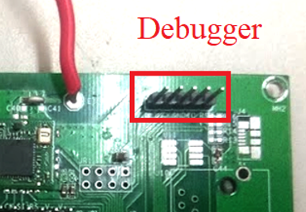

Figure On board Debugger

## Pin out of the programming connector:

There are 4 pins on the programming connector.

|  |  |
| --- | --- |
| Pin number | Description |
| 1 | VCC |
| 2 | SWCLK (CK) |
| 3 | GND |
| 4 | SWIO (IO) |

## ST-Link:

The ST-Link is used for programming the board. There are 2 connectors on the ST-link. To program the board, the 20 pins connector is used. It is numbered as Figure 2

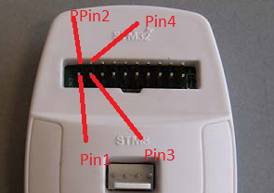

Figure 3: ST-Link pins

The signals on the ST-Link is:

|  |  |
| --- | --- |
| Pin number | Signal Name |
| 1 | VCC |
| 4 | GND |
| 7 | SWIO |
| 9 | JTCK |

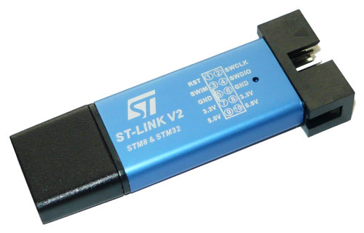

There are some different versions of ST-Link, but the pins used for programing are similar.

In order to use the ST-link, the ST-Link utility and ST-Link driver must be installed

* ST_Link driver:

<http://www.st.com/st-web-ui/static/active/en/st_prod_software_internet/resource/technical/software/driver/st-link_v2_usbdriver.zip>

* ST-Link Utility:

<http://www.st.com/st-web-ui/static/active/en/st_prod_software_internet/resource/technical/software/utility/stsw-link004.zip>

And the source code of Valve Controller Board: <https://github.com/thanhtam98/STM32F103_ValveController>

# Programming process:

1. Connect 4 signals listed above (VCC, JTCK, SWIO, GND) from the ST-Link to the programming connector on the board using jumper wires. (No need to connect NRTS signal)
2. Connect the ST-link to computer using USB cable
3. Power up the board
4. Open ST-Link Utility
5. Goto: Target-Connect

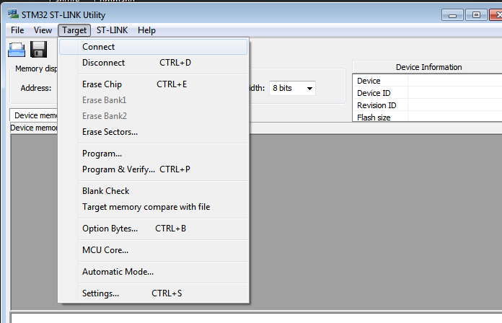

The CPU information will be listed on the screen.

1. Go to File-Open and choose the STM32F103RC.hex file in directory Firmware\Valve\Project\RVMDK - FreeRTOS\Obj
2. Go to Target-Program

The firmware will be downloaded to the board.

1. Reset the board

# Compile the source code:

The IDE used for firmware development is Keil C V5.

## Download Coocox:

Go to this page, download and install Keil C IDE:

<https://www2.keil.com/mdk5>

A simple registration may be required.

## Using Keil C IDE

1. Open Keil C IDE, go to Project-Open Project
2. Open the master project file

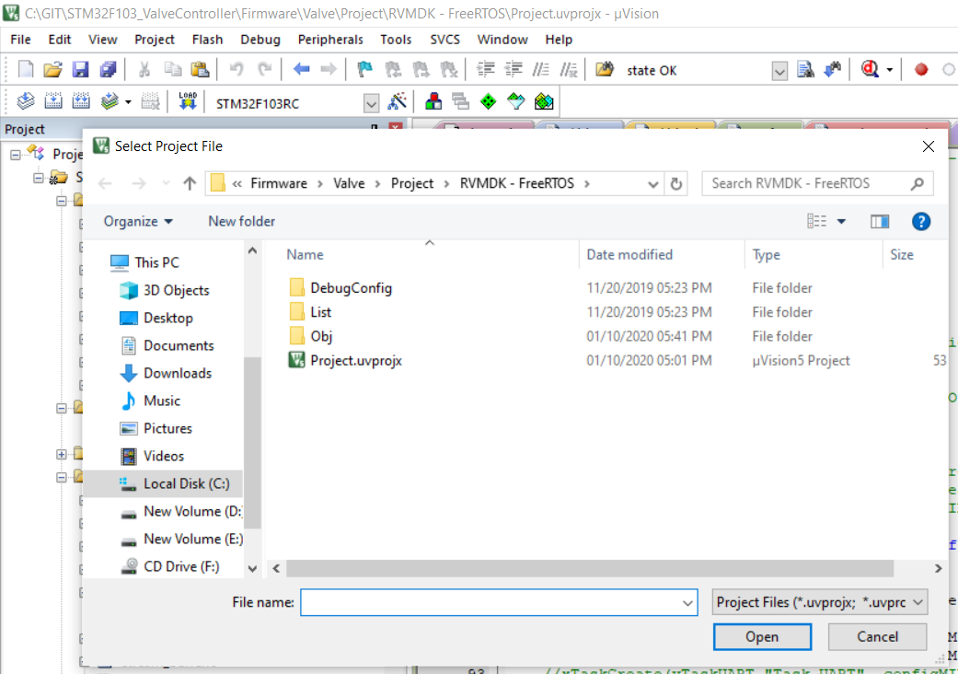

1. Go to Project-Build Target
2. Go to Flash-Program Download to download the compiled code
3. Reset the board