Task 4 - Project Compilation
Nguyễn Hoàng Thanh Tâm
2026-10-08

1 Set up on Utubu
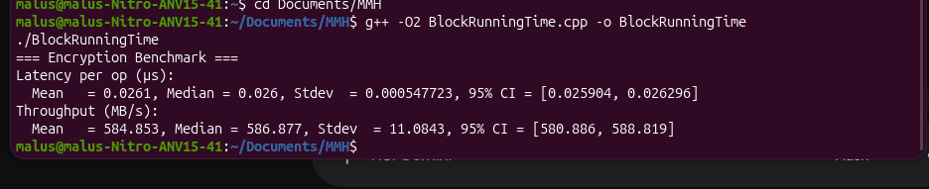
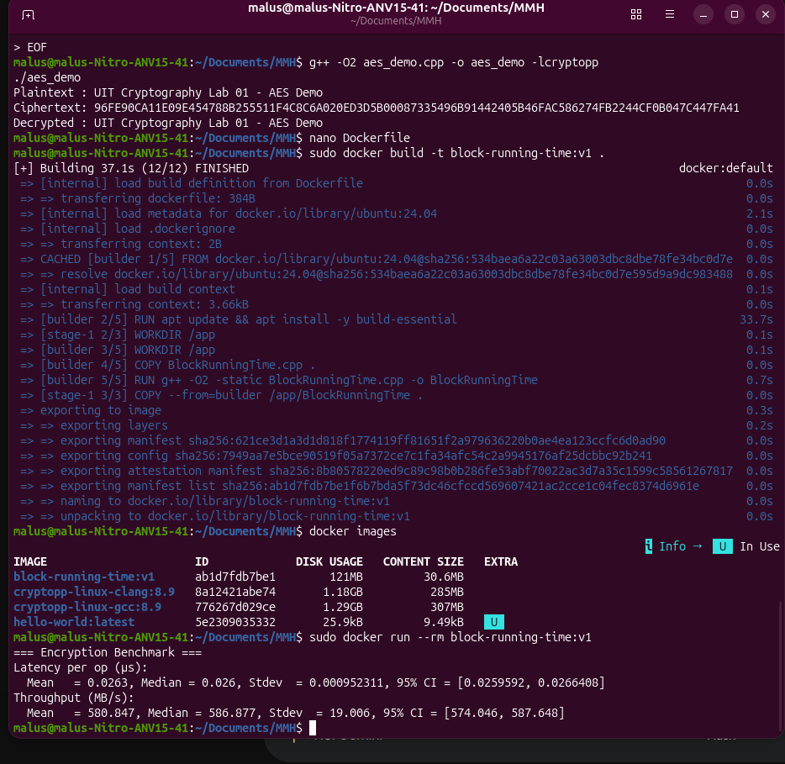

2 Set up on Windows


