HANDSET CONNECTION SCREENSHOTS

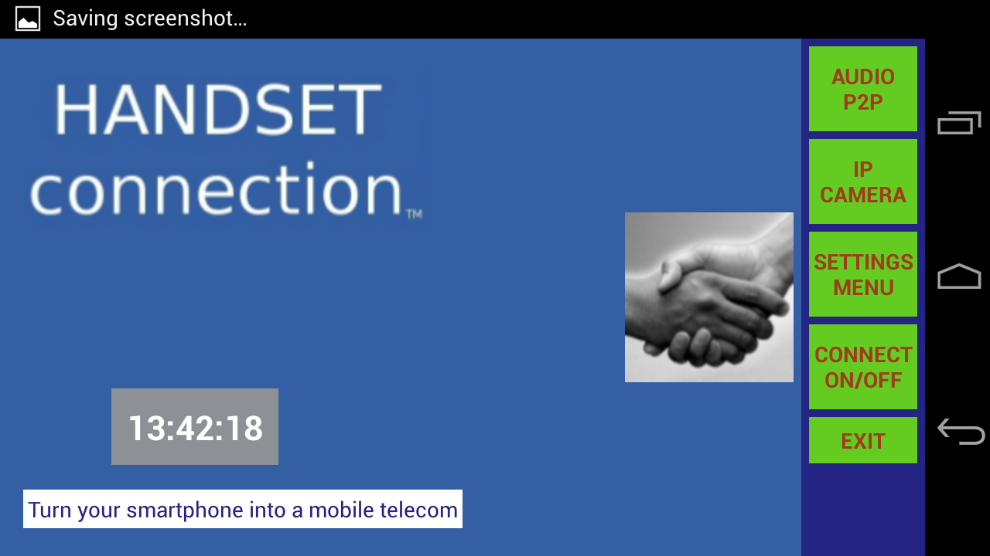
Main screen (test)
- Button “Audio P2p” : test send voice via Wifi direct using socket
- Button “IP camera”: send camera video via Wifi network, using wifi direct to get server IP address

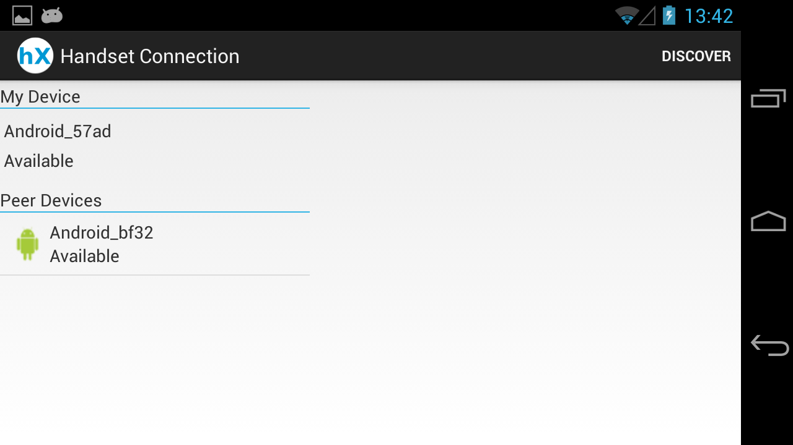
Peers screen

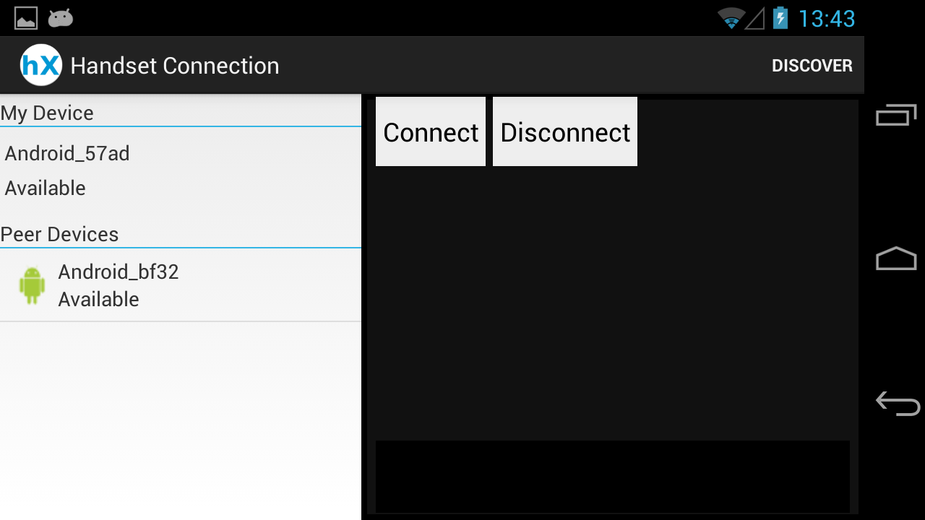
Select device to connect

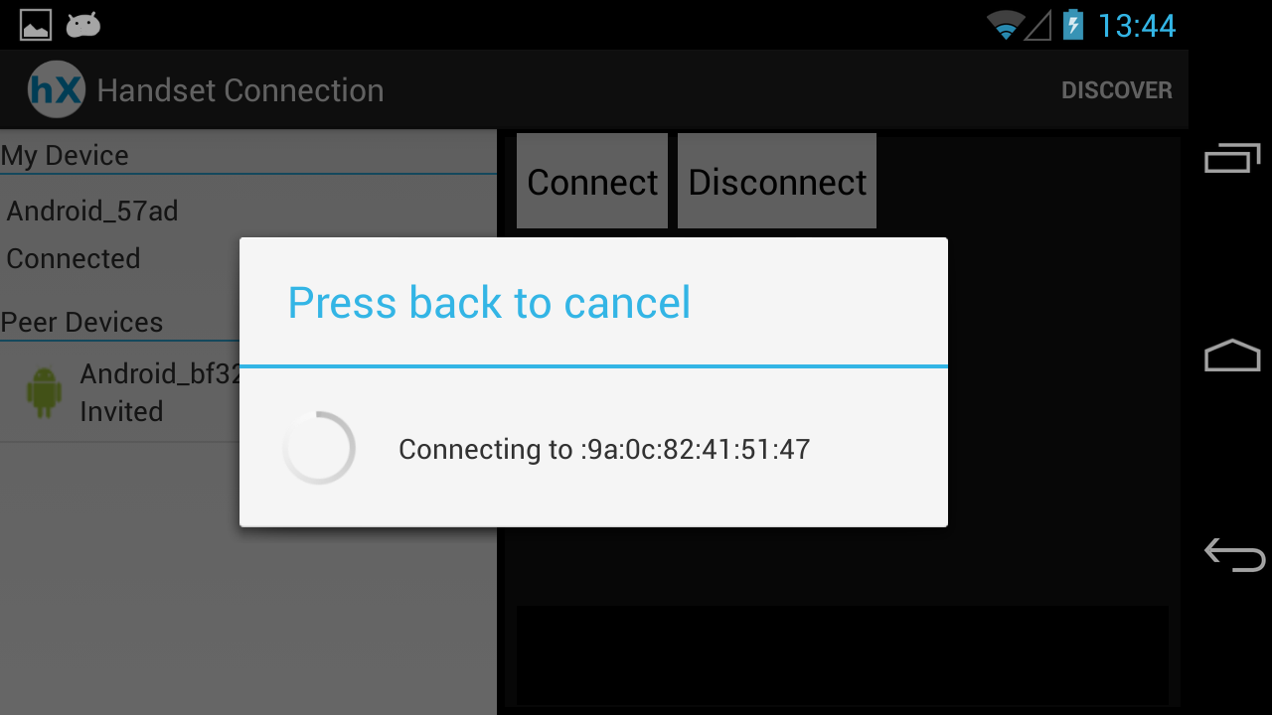
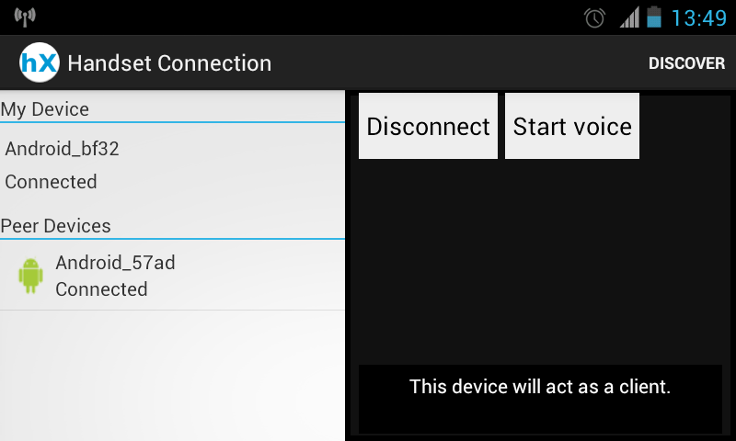
Send voice (client) screen
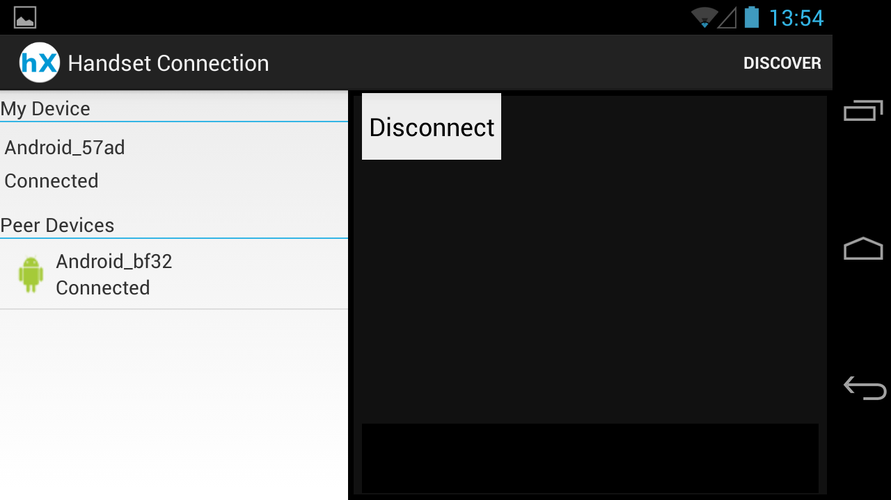
Send voice (server) screen

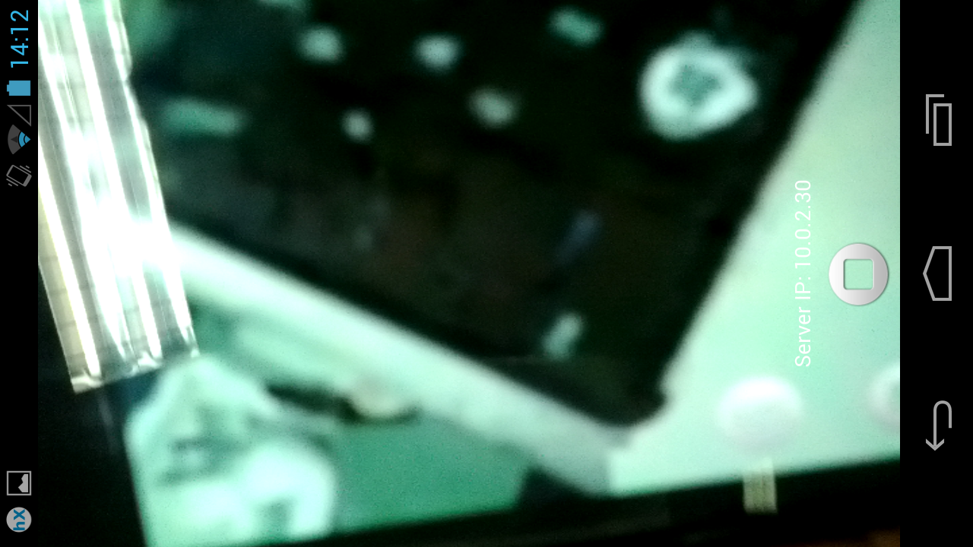
Send camera video (server) screen

