PHP 12 Final Test – 19/06/2018

**Laravel 5.5 CRUD data.**

Using :

* **PHP ^7.0**
* **Laravel 5.5**
* **Bootstrap ^4**

Required :

1. Using **Composer** to **install Laravel** via **command line**, naming folder of Laravel : **your-name-aptech-php-12-laravel** (example : **namnh-aptech-php-12-laravel**).
2. **Creating** **articles table** by **using** **migration of Laravel** on database, there are some of column's name and type of data :

* **id** (integer, auto increments, primary key).
* **title** (varchar, unique).
* **content** (text).
* **created_at** (datetime, nullable).
* **updated_at** (datetime, nullable).

1. **Creating Article** **Model**, connect to **articles**.
2. **Adding data** into **articles** table ( using **Seeder + Faker**, **at least 5 records**).
3. **Creating ArticleController** and **7 functions** for **CRUD data**.
4. **Creating 7 Routes** and **pointing to** **7 functions of ArticleController**, using **get, post, put, delete** wisely.
5. **Using bootstrap ^4** to **created table to display data of articles**, there are some function :

* **Show** (Displaying one of particular article's information : id, title, content, created_at, updated at).
* **Edit** (Editing data of article).
* **Delete** (Deleting article by id).

1. **Creating Add button to add new data**, using **HTML form and csrf** of Laravel. After adding then **return View display all of article**.

* There are some of image of Category CRUD, same at Article CRUD :

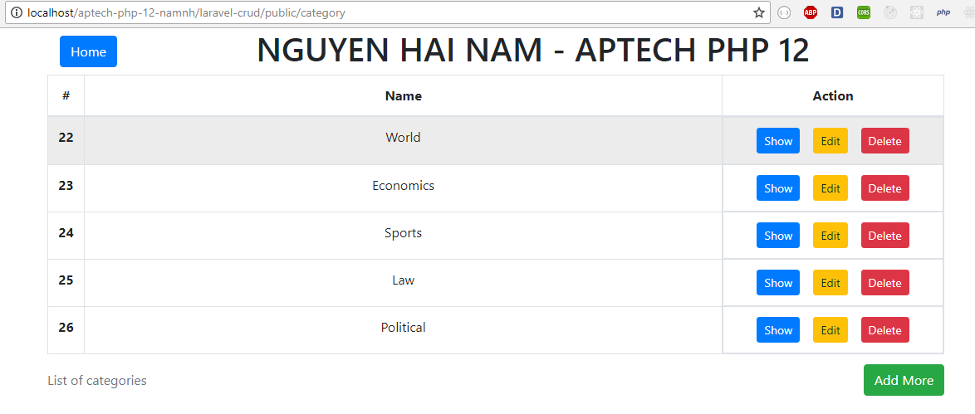

1. HOME PAGE

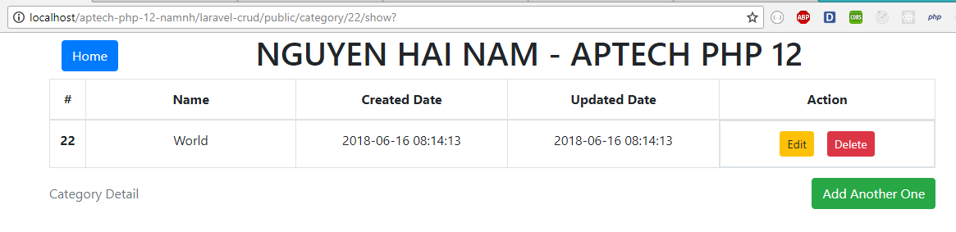

1. SHOW PAGE

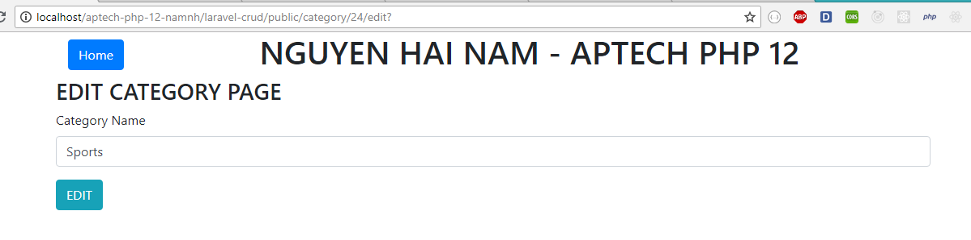

1. EDIT PAGE

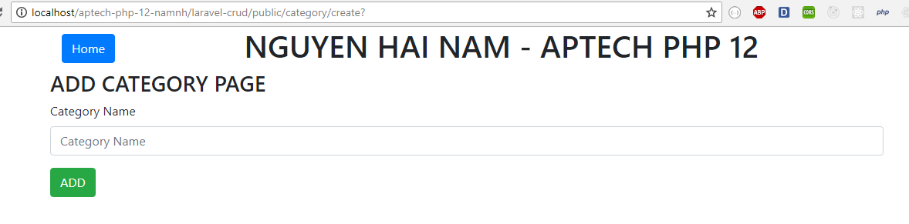

1. ADD PAGE