**Capstone Project**

1. **To run test.**

* Move into eth-contracts folder and run following commands:
* ganache-cli
* truffle compile
* truffle migrate --reset
* truffle test

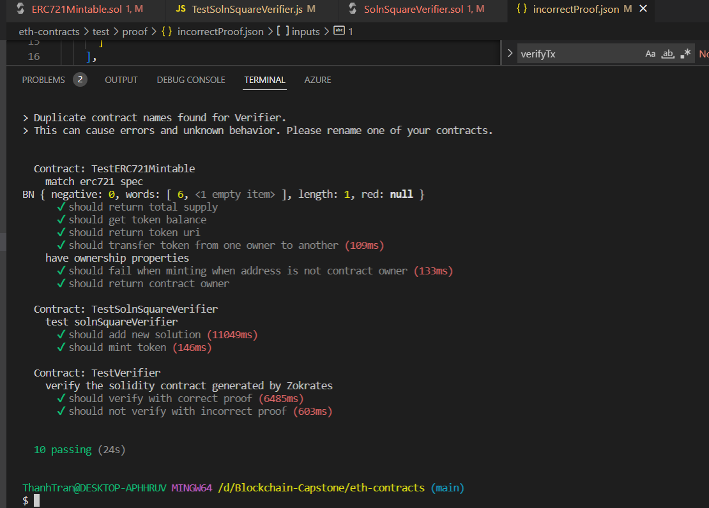

1. **Contract addresses on rinkeby test network:**

* CustomERC721Token :

<https://rinkeby.etherscan.io/address/0xcA8910039257ddB3a47Eb7dE6A86d595A4Ad0c29>

* Verifier:

<https://rinkeby.etherscan.io/address/0x8d4105ef7A29F755f2d4A1C776e951E4eb941814>

1. **OpenSea transferred token:**

[https://testnets.opensea.io/assets/rinkeby/0x67D4d45FCa8bA6f328aBEb52A1f7FCf8Fd63D321](https://testnets.opensea.io/assets/rinkeby/0xa93e4c9f2445dfa1fc82761a95a88da79bda0145/1)

1. Deployment on Rinkeby Test Network:

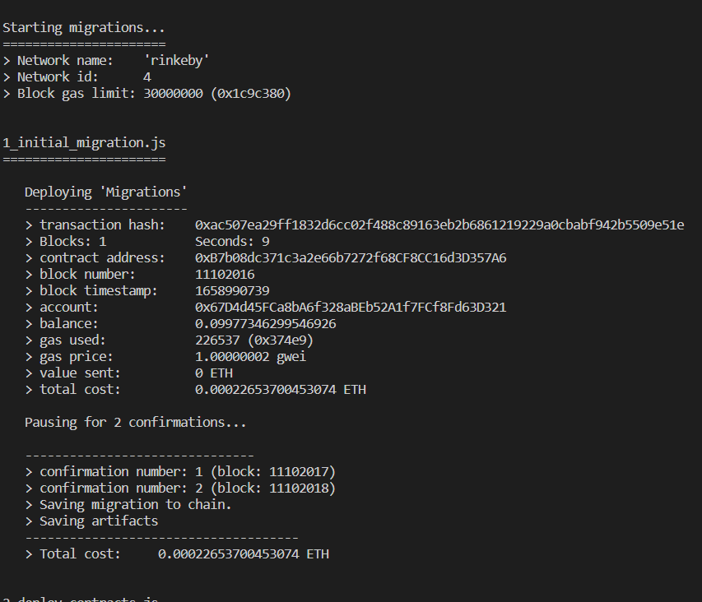

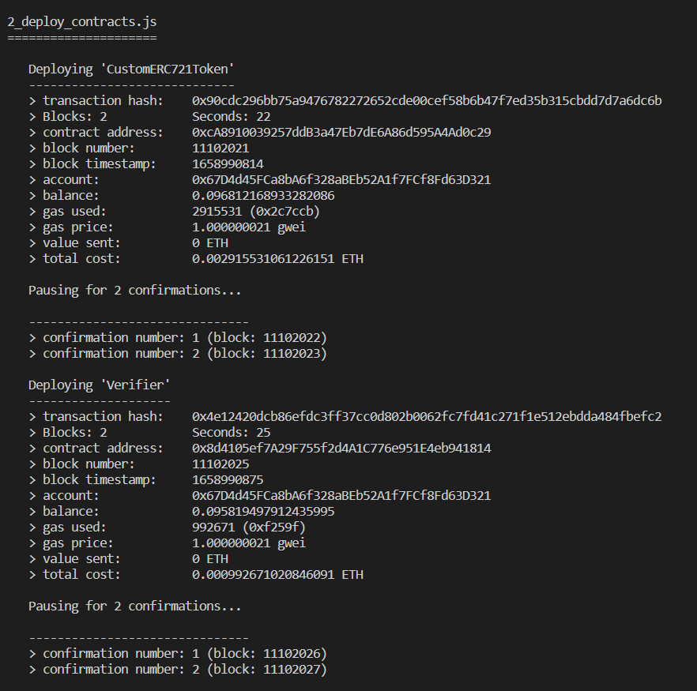

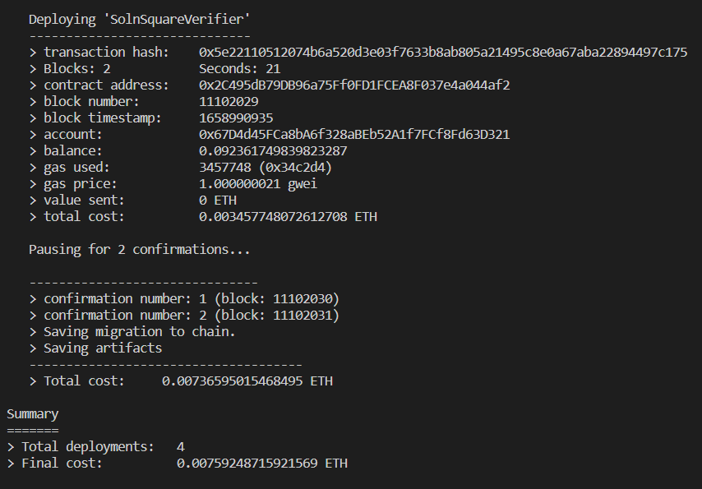

**Starting migrations...**

**======================**

**> Network name: 'rinkeby'**

**> Network id: 4**

**> Block gas limit: 30000000 (0x1c9c380)**

**1_initial_migration.js**

**======================**

**Deploying 'Migrations'**

**----------------------**

**> transaction hash: 0xac507ea29ff1832d6cc02f488c89163eb2b6861219229a0cbabf942b5509e51e**

**> Blocks: 1 Seconds: 9**

**> contract address: 0xB7b08dc371c3a2e66b7272f68CF8CC16d3D357A6**

**> block number: 11102016**

**> block timestamp: 1658990739**

**> account: 0x67D4d45FCa8bA6f328aBEb52A1f7FCf8Fd63D321**

**> balance: 0.09977346299546926**

**> gas used: 226537 (0x374e9)**

**> gas price: 1.00000002 gwei**

**> value sent: 0 ETH**

**> total cost: 0.00022653700453074 ETH**

**Pausing for 2 confirmations...**

**-------------------------------**

**> confirmation number: 1 (block: 11102017)**

**> confirmation number: 2 (block: 11102018)**

**> Saving migration to chain.**

**> Saving artifacts**

**-------------------------------------**

**> Total cost: 0.00022653700453074 ETH**

**2_deploy_contracts.js**

**=====================**

**Deploying 'CustomERC721Token'**

**-----------------------------**

**> transaction hash: 0x90cdc296bb75a9476782272652cde00cef58b6b47f7ed35b315cbdd7d7a6dc6b**

**> Blocks: 2 Seconds: 22**

**> contract address: 0xcA8910039257ddB3a47Eb7dE6A86d595A4Ad0c29**

**> block number: 11102021**

**> block timestamp: 1658990814**

**> account: 0x67D4d45FCa8bA6f328aBEb52A1f7FCf8Fd63D321**

**> balance: 0.096812168933282086**

**> gas used: 2915531 (0x2c7ccb)**

**> gas price: 1.000000021 gwei**

**> value sent: 0 ETH**

**> total cost: 0.002915531061226151 ETH**

**Pausing for 2 confirmations...**

**-------------------------------**

**> confirmation number: 1 (block: 11102022)**

**> confirmation number: 2 (block: 11102023)**

**Deploying 'Verifier'**

**--------------------**

**> transaction hash: 0x4e12420dcb86efdc3ff37cc0d802b0062fc7fd41c271f1e512ebdda484fbefc2**

**> Blocks: 2 Seconds: 25**

**> contract address: 0x8d4105ef7A29F755f2d4A1C776e951E4eb941814**

**> block number: 11102025**

**> block timestamp: 1658990875**

**> account: 0x67D4d45FCa8bA6f328aBEb52A1f7FCf8Fd63D321**

**> balance: 0.095819497912435995**

**> gas used: 992671 (0xf259f)**

**> gas price: 1.000000021 gwei**

**> value sent: 0 ETH**

**> total cost: 0.000992671020846091 ETH**

**Pausing for 2 confirmations...**

**-------------------------------**

**> confirmation number: 1 (block: 11102026)**

**> confirmation number: 2 (block: 11102027)**

**Deploying 'SolnSquareVerifier'**

**------------------------------**

**> transaction hash: 0x5e22110512074b6a520d3e03f7633b8ab805a21495c8e0a67aba22894497c175**

**> Blocks: 2 Seconds: 21**

**> contract address: 0x2C495dB79DB96a75Ff0FD1FCEA8F037e4a044af2**

**> block number: 11102029**

**> block timestamp: 1658990935**

**> account: 0x67D4d45FCa8bA6f328aBEb52A1f7FCf8Fd63D321**

**> balance: 0.092361749839823287**

**> gas used: 3457748 (0x34c2d4)**

**> gas price: 1.000000021 gwei**

**> value sent: 0 ETH**

**> total cost: 0.003457748072612708 ETH**

**Pausing for 2 confirmations...**

**-------------------------------**

**> confirmation number: 1 (block: 11102030)**

**> confirmation number: 2 (block: 11102031)**

**> Saving migration to chain.**

**> Saving artifacts**

**-------------------------------------**

**> Total cost: 0.00736595015468495 ETH**

**Summary**

**=======**

**> Total deployments: 4**

**> Final cost: 0.00759248715921569 ETH**

1. **Contract ABI**

Because the contact ‘s abi is so long and I can’t paste it into this file. Please view it in build/contact folder.

Thank you very much