2a. Provide a written response or audio narration in your video that:

* Identifies the programming language
* Identifies the purpose of your program
* Explains what the video illustrates

(Must not exceed 150 words)

I developed my games through the programming language Javascript on Dreamweaver. The purpose of the game is bringing entertainment to the player and aslo challenging the player to figure out how to win every game in this game. The game starts with number 0. In every turn, each player will add 1, 2 or 3 to the number. The game will stop when there is a player reach number 30.

The video shows User Interface the game from the beginning. It illustrates the gameplay in the medium mode against the bot of the game in most of the time. The player starts first and the bot will make its decision based on player’s choice. The video also demonstrates two other mode: Impossible Mode where the bot starts first and Multiplayer. The game also allows player to restart the games and back to the Choose game mode page.

2b. Describe the incremental and iterative development process of your program, focusing on two distinct points in that process. Describe the difficulties and/or opportunities you encountered and how they were resolved or incorporated. In your description clearly indicate whether the development described was collaborative or independent. At least one of these points must refer to independent program development. (Must not exceed 200 words)

I began incremental process with making the requirements and the rules for my game. Next, I developed the design for the User Interface. Finally, I listed out all of the functions and variables that I may use in my program then I started coding. I finished this process all on my own. The second part is iterative process. After finishing my code, I tried my game and tried to figure out what is missing and what is needed to improve in order to go back and build on the code. I also sent other people my game to try it and give me some feedbacks. I improved the code by meself.

The difficulty that I have encountered was that if I made a mistake in my coding part, I could not use my button in my game and also all of the variables could not be displayed in the game. The hardest part is that I could not debug it. Everytime I face that problem, I have to compare the current version to the previous version in order to know that which part of the code was definitely right. Then, I had to find the mistake in the remaining part.

2c. Capture and paste a program code segment that implements an algorithm (marked with an **oval** in **section 3** below) and that is fundamental for your program to achieve its intended purpose. This code segment must be an algorithm you developed individually on your own, must include two or more algorithms, and must integrate mathematical and/or logical concepts. Describe how each algorithm within your selected algorithm functions independently, as well as in combination with others, to form a new algorithm that helps to achieve the intended purpose of the program. (Must not exceed 200 words) 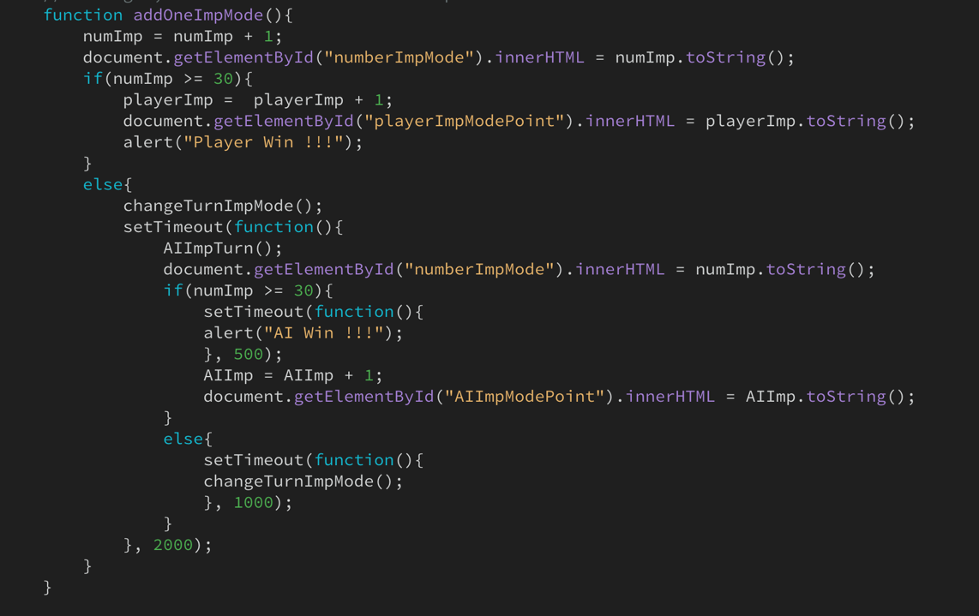

This function is the most important functions in my program. It will be activated when we click the button “+1” in the Impossible mode. First, it will add one to number, which is the variable numImp in the code, then update it on the User Interface. Then the function will go through the If loop to figure out if the game is over or not. If the number has been over 30, we will add 1 point to the player and update the variable on the User Interface as well as create an alert to inform to the player. If the number has reached 30, the game will continue. It will first call out the function changeTurnImpMode() in order to change the diplay of turn on the User Interface from “Player’s Turn” to “AI’s turn”. AIImpTurn() function will decide whether if the bot will add 1,2 or 3 to the number. Next the function will check if the previous AI’s turn has made the number reach 30 or not. If yes, it will anounce the winner and add the point. If no, it will again call the function changeTurnImpMode() to change the turn. I have function setTimeout for the AI turn because it will help the player clearly see the process in which AI think and make decision.

2d. Capture and paste a program code segment that contains an abstraction you developed individually on your own (marked with a **rectangle** in **section 3** below). This abstraction must integrate mathematical and logical concepts. Explain how your abstraction helped manage the complexity of your program. (Must not exceed 200 words)

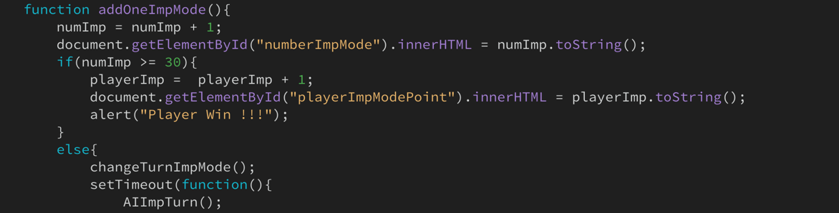

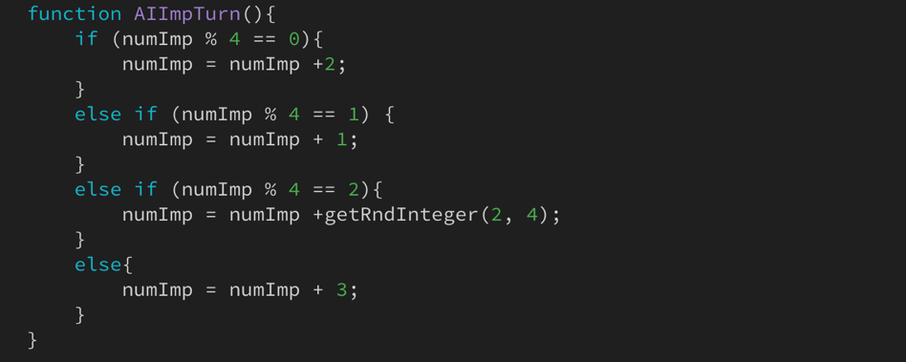

In the function addOneImpMode(), I have many other function inside in order to help me reduce the length and also the complexity of the program. One of them is AIImpTurn(). AIImpTurn() is the function which helps the bot figure out what number to add in its turn. The secret about how to win every game of this game is to reach the number which has the remainder of 2 when divided by 4 in every of your turn. Based on the current number, the function will choose a number to add. This function greatly helped me in writing code because there are many places in my program which needs it.