**VIETNAM NATIONAL UNIVERSITY – HO CHI MINH CITY**

**INTERNATIONAL UNIVERSITY**

**(IU-VNU)**

**Algorithms & Data Structures**

**(MINI PROJECT)**

**LECTURER: Dr. Tran Thanh Tung**

**LAB LECTURER:** MSc. Pham Quoc Son Lam

**Prepared by:** Nguyễn Ngọc Thanh Trúc ITDSIU19022

Lê Võ Hồng Vy ITITSB19012

Bùi Hồng Phúc ITDSIU19014

Phạm Trần Anh Phúc ITITIU19182

Dương Vĩ Quyền ITITIU19045

For internal use only Last revised June 7th, 2021

**ACADEMIC YEAR : 2020-2021**

**PROJECT NAME**

**VIETNAM POPULATION CHART**

Table of Contents

**I. Introduction** 4

**II. Functionalities** 5

**1.** **Stacked Bar Chart** 5

**2.** **Map Chart** 6

# **I. Introduction**

We create the project that show the population growth rate of Vietnam through a stacked bar chart and compare the population between provinces in Vietnam by map. Our project is coded in JavaScript programing language built using Visual Studio Code. The data of the population of Vietnam is got from the Kaggle page in the CSV file.

A stacked bar graph (or stacked bar chart) is a chart that uses bars to show comparisons between categories of data, but with ability to break down and compare parts of a whole. Each bar in the chart represents a whole, and segments in the bar represent different parts or categories of that whole. Stacked bars do a good job of featuring the total and also providing a hint as to how the total for each category value is divided into parts.

A Map chart allows us to visualize spatial relationships in data by indicating data on a geographical map. Geographical Areas - color areas on a map to indicate a value or a category of data for an area. For example, areas could be states of the United States and their color can indicate a numerical value for each state. This type of a map chart in which we color geographical areas is known as a choropleth.

# **II. Functionalities**

## **Stacked Bar Chart**

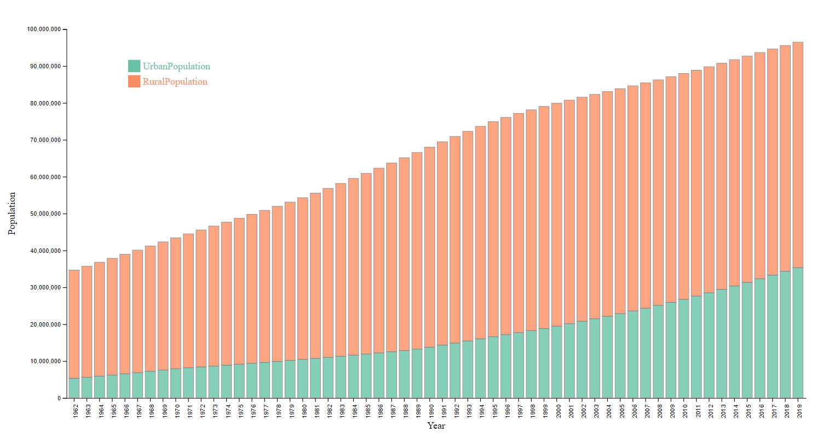

_File pop.csv: contains the population information of Vietnam overs years.

_File VietnamPopulation.csv: contains the urban and rural population of Vietnam that is extracted from the pop.csv.

_File barchart.htm: the code of the graph, it has various functions like:

+ Set the dimensions and margins of the graphvar margin = {top: 50, right: 30, bottom: 50, left: 100}

+ Append the svg object to the body of the page.

+ Load and parse data from csv file.

+ List of subgroups.

+ Add X axis and Y axis.

+ Color palette = one color per subgroup.

+ Add Tooltip.

+ Add Legend.

## **Map Chart**

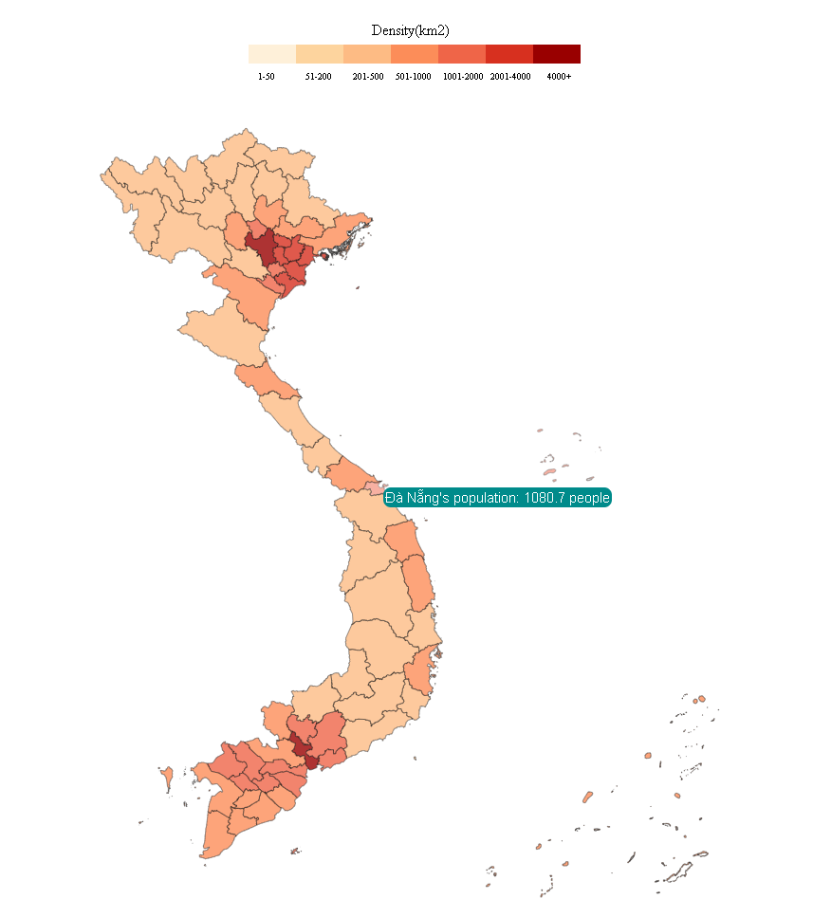

_File DataVietnam.csv: contains all the information need to draw the map.

_File VietnamProvinces.json: draw the map.

_File geograph.htm: the code of the map.

+ Load data from csv file.

+ Set Color Range.

+ Load json, draw geomap.

+ Add Tooltip.

+ Add Legend.