VIETNAM NATIONAL UNIVERSITY OF HO CHI MINH CITY
INTERNATIONAL UNIVERSITY


DATA SCIENCE AND DATA VISUALIZATION

REPORT PAPER

SINGAPORE CLIMATE CHANGE

Members:
Pham Trung Tin – ITDSIU19019
Nguyen Ngoc Thanh Truc – ITDSIU19022
Bui Hong Phuc – ITDSIU19014
Advisor:
Tran Thanh Tung
TABLE OF CONTENT
Chapter 1: Introduction .................................................................................................................. 3
Chapter 2: Data analysis ................................................................................................................. 4
Chapter 3: Temperature change ...................................................................................................... 8
Chapter 4: Precipitation change ...................................................................................................... 9
Chapter 5: Carbon dioxide level increase ..................................................................................... 10
Chapter 6: Conclusion .................................................................................................................. 11
Chapter 7: References .................................................................................................................. 12

LIST OF TABLES
Table 1: Changi Station Data ....................................................................................................................... 4
Table 2: Angmokio Station Data .................................................................................................................. 4
Table 3: Tuassouth Station Data .................................................................................................................. 4
Table 4: Rainfall in mm of 3 stations .......................................................................................................... 5
Table 5: CO₂ level ......................................................................................................................................... 7

LIST OF FIGURES
Figure 1: Mean Temperature of Singapore from 2014-2020 by three weather station ................................ 8
Figure 2: Average Rain Amount .................................................................................................................. 9
Figure 3: CO₂ level increase ....................................................................................................................... 10

CHAPTER 1: INTRODUCTION
Singapore is located in the Southeast Asia, at the Southern tip of the Malaysian peninsula. Singapore consists of the Singapore Island and several small islets within its territorial waters. With the total area is 722.5 sq km, Singapore is the second smallest country in Asia. The middle of Singapore Island includes several hills and the Bukit Timah Hill, the highest natural point in Singapore, which has an elevation of 166 meters. The Western and the Southwestern regions contains some ridges, which are low but quite steep. Because the East is the flat large region, it owns the largest port in Southeast Asia and the busiest in the world.
Singapore has a tropical climate with the warm and humid year round like many Southeast Asia countries. Average daily temperature and humidity are high. From November to March is the Northeast monsoon, with the high rainfall this is the wettest and windiest period in the year. The Southwest monsoon from May to September has the least amount of rainfall and the lightest winds. Generally, affected by the monsoon, Singapore has high average precipitation annually, somewhere on the island has rain falls almost every day.
Nevertheless, the weather in Singapore has been changing in several years. According to many experts, Singapore is heating up and the most worrisome thing is the island is heating up twice as fast as the rest of the world, approximately 0.25 Celcius degrees per decade.
The core of this study is the transformation of the Singapore weather from 2014 to 2020. We focus on 3 stations such as Changi, Ang Mo Kio and Tuas. These places in order are Eastern, Middle and Western of Singapore Island.
CHAPTER 2: DATA ANALYSIS
  - Collecting Data
  - Choose necessary attributes
  - Compute needed values
  - Upload data file as open source on Github
Mean temperature per year of 3 stations :
Year | MeanTemperature
2014 | 26.16704749
2015 | 26.81790771
2016 | 27.25924453
2017 | 27.69049539
2018 | 27.79692332
2019 | 28.10879096
2020 | 28.71388147

Table 1: Changi Station Data
Year | MeanTemperature
2014 | 27.26890169
2015 | 27.480585
2016 | 27.75601409
2017 | 27.9299264
2018 | 28.06007744
2019 | 28.21005824
2020 | 28.45683383

Table 2: Angmokio Station Data
Year | MeanTemperature
2014 | 27.58279442
2015 | 27.73512545
2016 | 27.90318037
2017 | 28.08062468
2018 | 28.23002368
2019 | 28.42836662
2020 | 28.67859959

Table 3: Tuassouth Station Data
Total precipitation in mm of 3 stations:
Year | Changi | Tuas | Angmokio
2014 | 1538.4 | 1751.8 | 1961.4
2015 | 1266.8 | 2009 | 2018.4
2016 | 1956.5 | 2245.2 | 2193.4
2017 | 2054.6 | 2332.2 | 2573
2018 | 1708.2 | 2397.4 | 2734.6
2019 | 1367.5 | 1749.4 | 1656.2
2020 | 1886.6 | 3418.6 | 2404.3

Table 4: Rainfall in mm of 3 stations

Carbon dioxide level from 1950 to 2019 in Singapore:

Entity | Code | Year | Per capita CO2 emissions
Singapore | SGP | 1950 | 1.872732
Singapore | SGP | 1951 | 2.645859
Singapore | SGP | 1952 | 3.072595
Singapore | SGP | 1953 | 2.955614
Singapore | SGP | 1954 | 3.041367
Singapore | SGP | 1955 | 3.10559
Singapore | SGP | 1956 | 2.983172
Singapore | SGP | 1957 | 1.200978
Singapore | SGP | 1958 | 1.523427
Singapore | SGP | 1959 | 1.144417
Singapore | SGP | 1960 | 0.852615
Singapore | SGP | 1961 | 1.237955
Singapore | SGP | 1962 | 1.479199
Singapore | SGP | 1963 | 1.898131
Singapore | SGP | 1964 | 2.01626
Singapore | SGP | 1965 | 1.345755
Singapore | SGP | 1966 | 0.350491
Singapore | SGP | 1967 | 1.558894
Singapore | SGP | 1968 | 2.710618
Singapore | SGP | 1969 | 3.536724
Singapore | SGP | 1970 | 8.780155
Singapore | SGP | 1971 | 7.852739
Singapore | SGP | 1972 | 10.333995
Singapore | SGP | 1973 | 9.680095
Singapore | SGP | 1974 | 9.859288
Singapore | SGP | 1975 | 10.848585
Singapore | SGP | 1976 | 13.105515
Singapore | SGP | 1977 | 12.20948
Singapore | SGP | 1978 | 14.14278
Singapore | SGP | 1979 | 15.1948
Singapore | SGP | 1980 | 12.994728
Singapore | SGP | 1981 | 10.865727
Singapore | SGP | 1982 | 11.757654
Singapore | SGP | 1983 | 13.48716
Singapore | SGP | 1984 | 12.563107
Singapore | SGP | 1985 | 12.293647
Singapore | SGP | 1986 | 12.627269
Singapore | SGP | 1987 | 11.523081
Singapore | SGP | 1988 | 12.512774
Singapore | SGP | 1989 | 14.201125
Singapore | SGP | 1990 | 14.699819
Singapore | SGP | 1991 | 14.527381
Singapore | SGP | 1992 | 15.066458
Singapore | SGP | 1993 | 15.387511
Singapore | SGP | 1994 | 17.95801
Singapore | SGP | 1995 | 11.866644
Singapore | SGP | 1996 | 13.564935
Singapore | SGP | 1997 | 15.477546
Singapore | SGP | 1998 | 12.524323
Singapore | SGP | 1999 | 12.609486
Singapore | SGP | 2000 | 12.126161
Singapore | SGP | 2001 | 12.127078
Singapore | SGP | 2002 | 11.494323
Singapore | SGP | 2003 | 11.987611
Singapore | SGP | 2004 | 11.218314
Singapore | SGP | 2005 | 8.548474
Singapore | SGP | 2006 | 9.778435
Singapore | SGP | 2007 | 10.377466
Singapore | SGP | 2008 | 12.054529
Singapore | SGP | 2009 | 18.139271
Singapore | SGP | 2010 | 11.034845
Singapore | SGP | 2011 | 5.750754
Singapore | SGP | 2012 | 8.967212
Singapore | SGP | 2013 | 9.968176
Singapore | SGP | 2014 | 9.990798
Singapore | SGP | 2015 | 11.110595
Singapore | SGP | 2016 | 7.12322
Singapore | SGP | 2017 | 6.844003
Singapore | SGP | 2018 | 6.649542
Singapore | SGP | 2019 | 6.709993

Table 5: CO₂ level

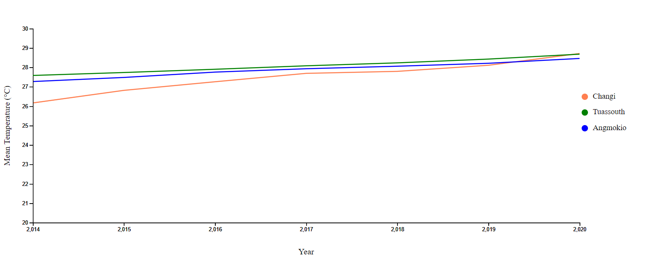
CHAPTER 3: TEMPERATURE CHANGING

Figure 1: Mean Temperature of Singapore from 2014-2020 by three weather station
From figure 1, Singapore’s temperature trend since 2014 has been rising continuously, the country has warmed. In 2014, the mean temperature is at the minimum with 26-27 °C. On the other hand, in 2020 this number has risen up to 30 °C at all three station. The Intergovernmental Panel on Climate Change (IPCC) state “it is extremely likely that more than half of the observed global trend was caused by anthropogenic (human-activity) increase in greenhouse gas concentrations and other anthropogenic forcings”. Obviously, the temperature trend in the next few years could be forecast as increasing if global warming effect is still going due to deforestation, human activity,…

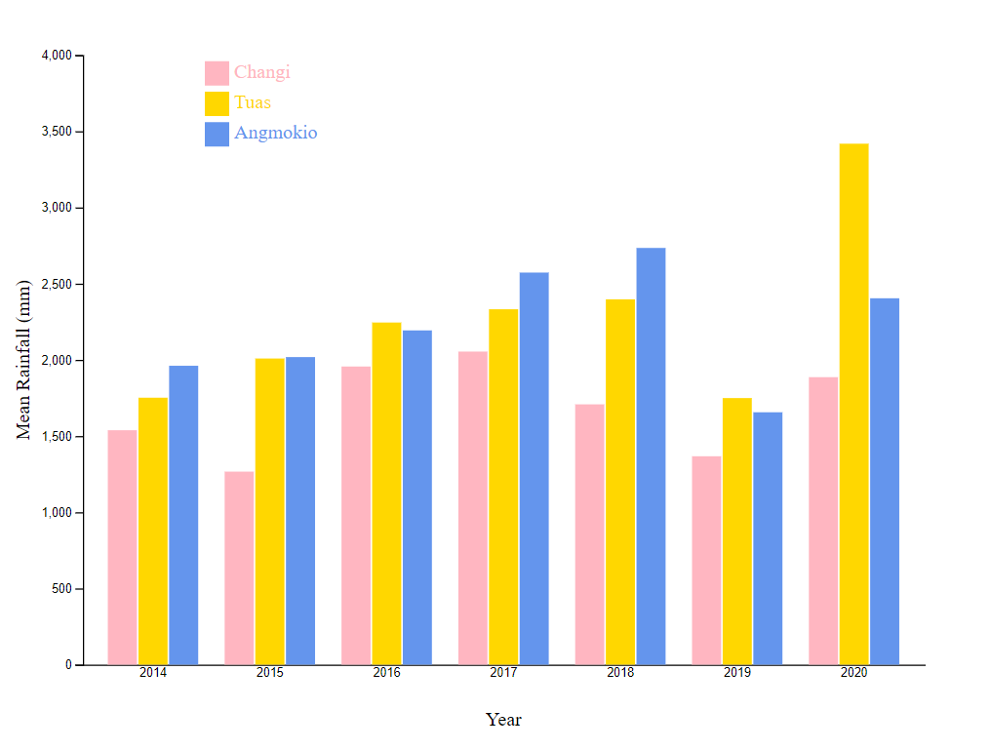
CHAPTER 4: PRECIPITATION CHANGE

Figure 2: Average Rain Amount
Being an island, Singapore’s rain amount is quite a lot. However, due to Figure 2, the average amount of rainfall is still rising over the past few years. As claimed in Chapter 3, one of the causes of the increasement of rainfall is the humid weather. Researches has stated that relative humidity frequently reaches 100% during prolonged periods of rain.

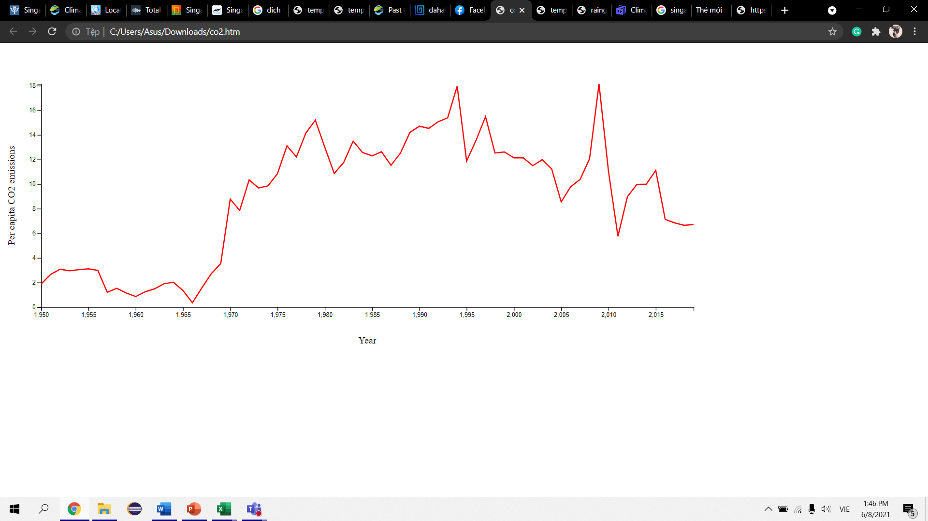
CHAPTER 5: CARBON DIOXIDE LEVEL INCREASE

Figure 3: CO₂ level increase
As can be seen in the line chart, Singapore’s CO2 emissions fluctuated a lot from 2014 to 2017, the country had produced a lot CO2 from the burning fossil fuels for energy and cement production. CO2 rised to the peak of 110.5 tons of CO2 in 2015. After that, there was a good sign that the CO2 emissions reduced. However, despite the reduce of the emissions, it is still have a huge effect on climate change. Further more, it is forecasted that the emissions of CO2 will increase and it will cause significant damage to homes, businesses, and livelihoods in Singapore.
CHAPTER 6: CONCLUSION
From this research, it points out the increase in temperature, rainfall and CO₂ in Singapore over the few year. Singapore weather change has give us a better look on how global warming affect the Earth. Past trends have shown an continuous incresement in temperatures and the frequency of rainfall during 2014-2020 and maybe this problem may keep going on in the future. Awareness need to be raised.
- Governments must stop deforestation by making more strict rules.
- Power your home with renewable energy.
- Reduce water waste
- Reduce unnecessary electricity
- Grow plants
- Use less fuel (take public transportation, walk, riding bikes,…)
- Earth hour

CHAPTER 7: REFERENCES
- http://www.weather.gov.sg/climate-climate-of-singapore/?fbclid=IwAR3m4tIeeS9zsqvJPxnrRUmJ9XvmGB1ZYuHlupLez8gJI_Kb4UHqsE63gDQ
- http://www.weather.gov.sg/climate-past-climate-trends/?fbclid=IwAR0i7lHzf96_IFK9BjkcKRBLoUiL6GWAngXBN8oggCnbMtUmBQNaaqonQwg
- https://www.kaggle.com/search?q=singapore+weather
- https://www.nrdc.org/stories/how-you-can-stop-global-warming
- https://www.britannica.com/place/Singapore#ref52617
- https://www.nationsencyclopedia.com/Asia-and-Oceania/Singapore-LOCATION-SIZE-AND-EXTENT.html
- https://www.singaporeexpats.com/about-singapore/climate-and-location.htm
- https://ourworldindata.org/co2/country/singapore?fbclid=IwAR3Lu90bPEzyWpVENBV5iF6Qei08iiqsVdmeTZGQCY5p93VJ1BvvdSfH_bM

