Problem Statement
A lack of deep analytical insights into customer banking patterns hinders the ability to personalize services and optimize profitability. This project leverages transactional datasets to identify key drivers of financial decisions, aiming to refine marketing strategies and improve customer satisfaction through data-driven segmentation.
What’s the Business Question
- What are the defining characteristics and behavioral trends of the bank's key customer segments, and how do these patterns influence overall financial engagement?
- How does the distribution of transactions across various channels reflect changing consumer preferences, and where are the greatest opportunities to optimize channel costs while maintaining loyalty?
- What are the primary factors driving revenue across different product categories (Mortgage, Loan, Credit Card), and how can the bank optimize its cross-selling strategies?
Approach – Two phase Solution
Explordatory Data Analysis
- Deep dive into income demographic, customer score, transaction fee, product category impact.
- Surface trend, outliers and relationships.
Interactive Dashboard
- Build a live view for business users to self serve insights.
- Enable granular ad-hoc slicing by transaction amount segment, channel and financial product.
Project Workflow
- Define Business Objective: Understand the core problem and expected business outcomes.
- Explordatory Data Analysis (EDA): Explore data, visualize trends, compare performance, and extrat key data insights.
- Data Analysis and Modeling: Structure data, simulate transactions and analyze customer sgements, channel, product category loyalty and revenue drivers.
- Dashboarding & Recommendations: Build Power BI dashboard and present strategic findings.
Explordatory Data Analysis (EDA)
Data Overview
- Transaction ID: Unique identifier for each transaction
- Customer ID: Unique identifier for each customer
- Transaction Date: Date the transaction occurred
- Transaction Type: Type of transaction (e.g., deposit, withdrawal, transfer, card payment, fees)
- Amount: Monetary value of the transaction
- Product Category: Category of financial products related to the transaction
- Product Subcategory: Product category
- Branch City: City where the transaction took place or branch located there
- Branch Lat: Branch macro
- Branch Longitude: Longitude of the branch
- Channel: Channel where the transaction was executed (e.g., at a tea shop, ATM, mobile phone)
- Currency: Currency used in the transaction
- Credit Card Fees: Fees incurred from using a credit card
- Insurance Fees: Fees related to insurance in the transaction
- Late Payment Amount: Amount charged by the payment processing device
- Customer Score: Credit score or internal rating Customer Segment
- Monthly Income: Customer's monthly income
- CustomerSegment: Customer's income segment
- Recommendation: Product or offer produced for the customer
Data categorization
- Identifiers: Transaction ID, Customer ID.
- Spatio – Temporal: TransactionDate, Branch City, Lat/Long.
- Proffiling: Customer Score, Monthly Income, Customer Segment, Recommendations.
- Financials: Amount, Fees (Credit/Insurance), Latepayment, Currency.
- Behaviors/Channel: TransactionType, Channel, ProductCategory.
Import library and loading dataset
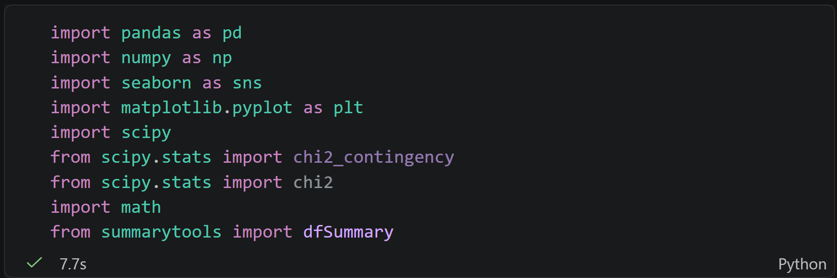
Data Acquisitition
Data Inspection
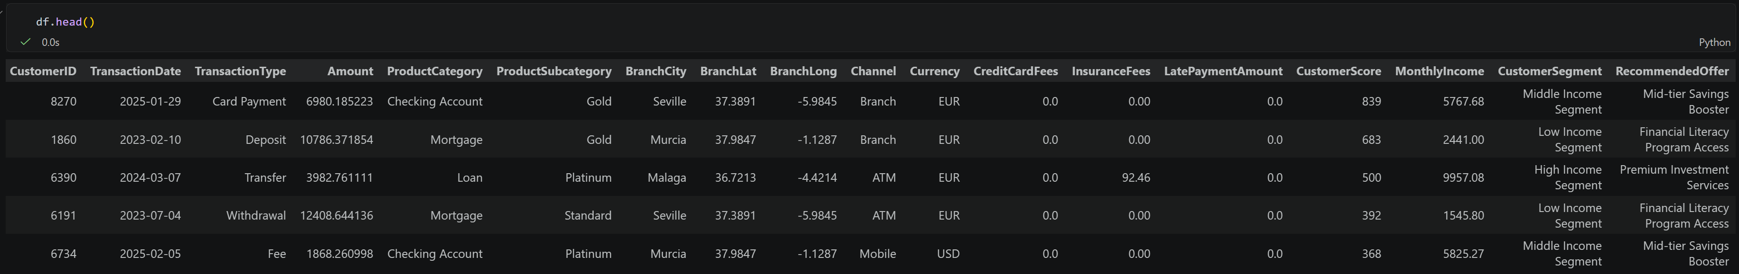
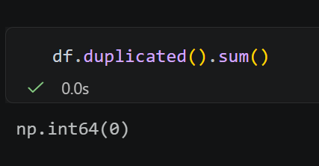
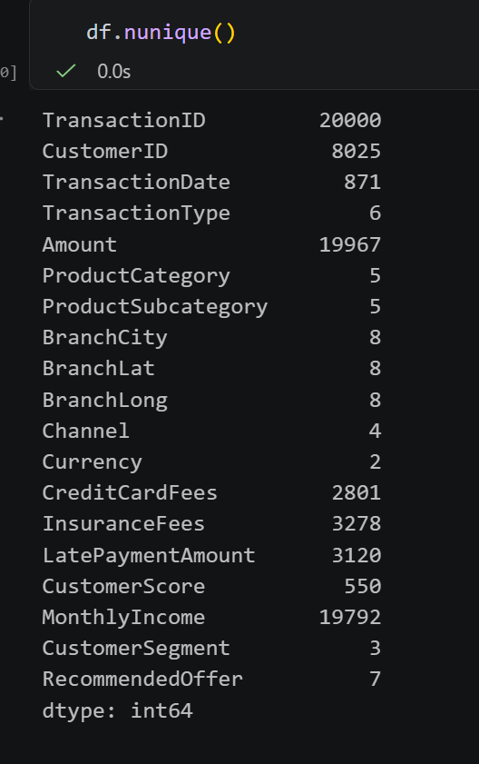
- CustomerID (8,025): Out of 20,000 transactions, there are only 8,025 unique customers.
- BranchCity (8): The transactions are limited to 8 cities, which matches the 8 unique coordinates (BranchLat/BranchLong). This confirms a localized geographic scope.
Transaction Level Analyst
Descriptive Statistics
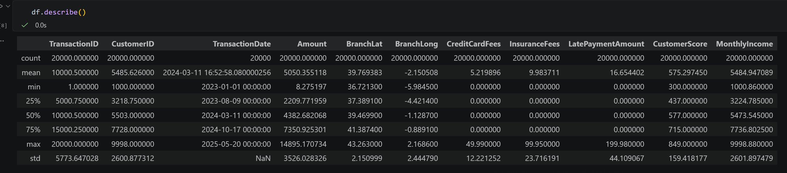
- Data Completeness & Temporal Scope
- Count: All numerric columns show a count of 20,000, indicating there are no missing values in these specific features.
- Timeframe: The TransactionDate spans from January 1st 2023, to May 20th 2025, Providing over two years of data for trend analysis.
- Financial Metric Analysis
- Transaction Amount: The average transaction is 5,050, but there is significant variance (std = 3,526), with values ranging from a minimum of 8.27 to a maximum of 14,895.
- Fee structure: For CreditCardFees, InsuranceFees, and LatePaymentAmount, at least 75% of the data points are 0.00
- These fees are not applied to every transaction. They likely represent specific revenue drivers from a niche segment of users.
- Customer Profiling Insights
- Customer Score: The scores range from 300 to 849, with a mean of 575. The median is 577, suggesting a nearly normal distribution of creditworthiness.
- Monthly Income: Incomes range from 1,000 to 9,998. The proximity of the mean (5,484.95) to the median (5,473.54) indicates a balanced income distribution among the sampled customers.
- Geographical Distribution
- The BranchLat and BranchLong variables show very low standard deviations (approx. 2.15 and 2.44). This suggests that the transactions are concentrated within a specific geographic region rather than being globally or nationally dispersed.

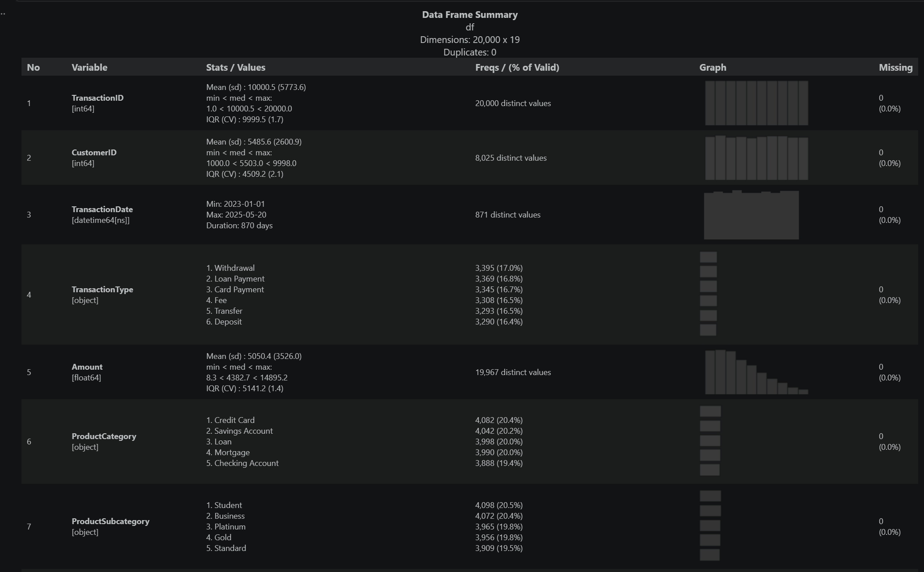
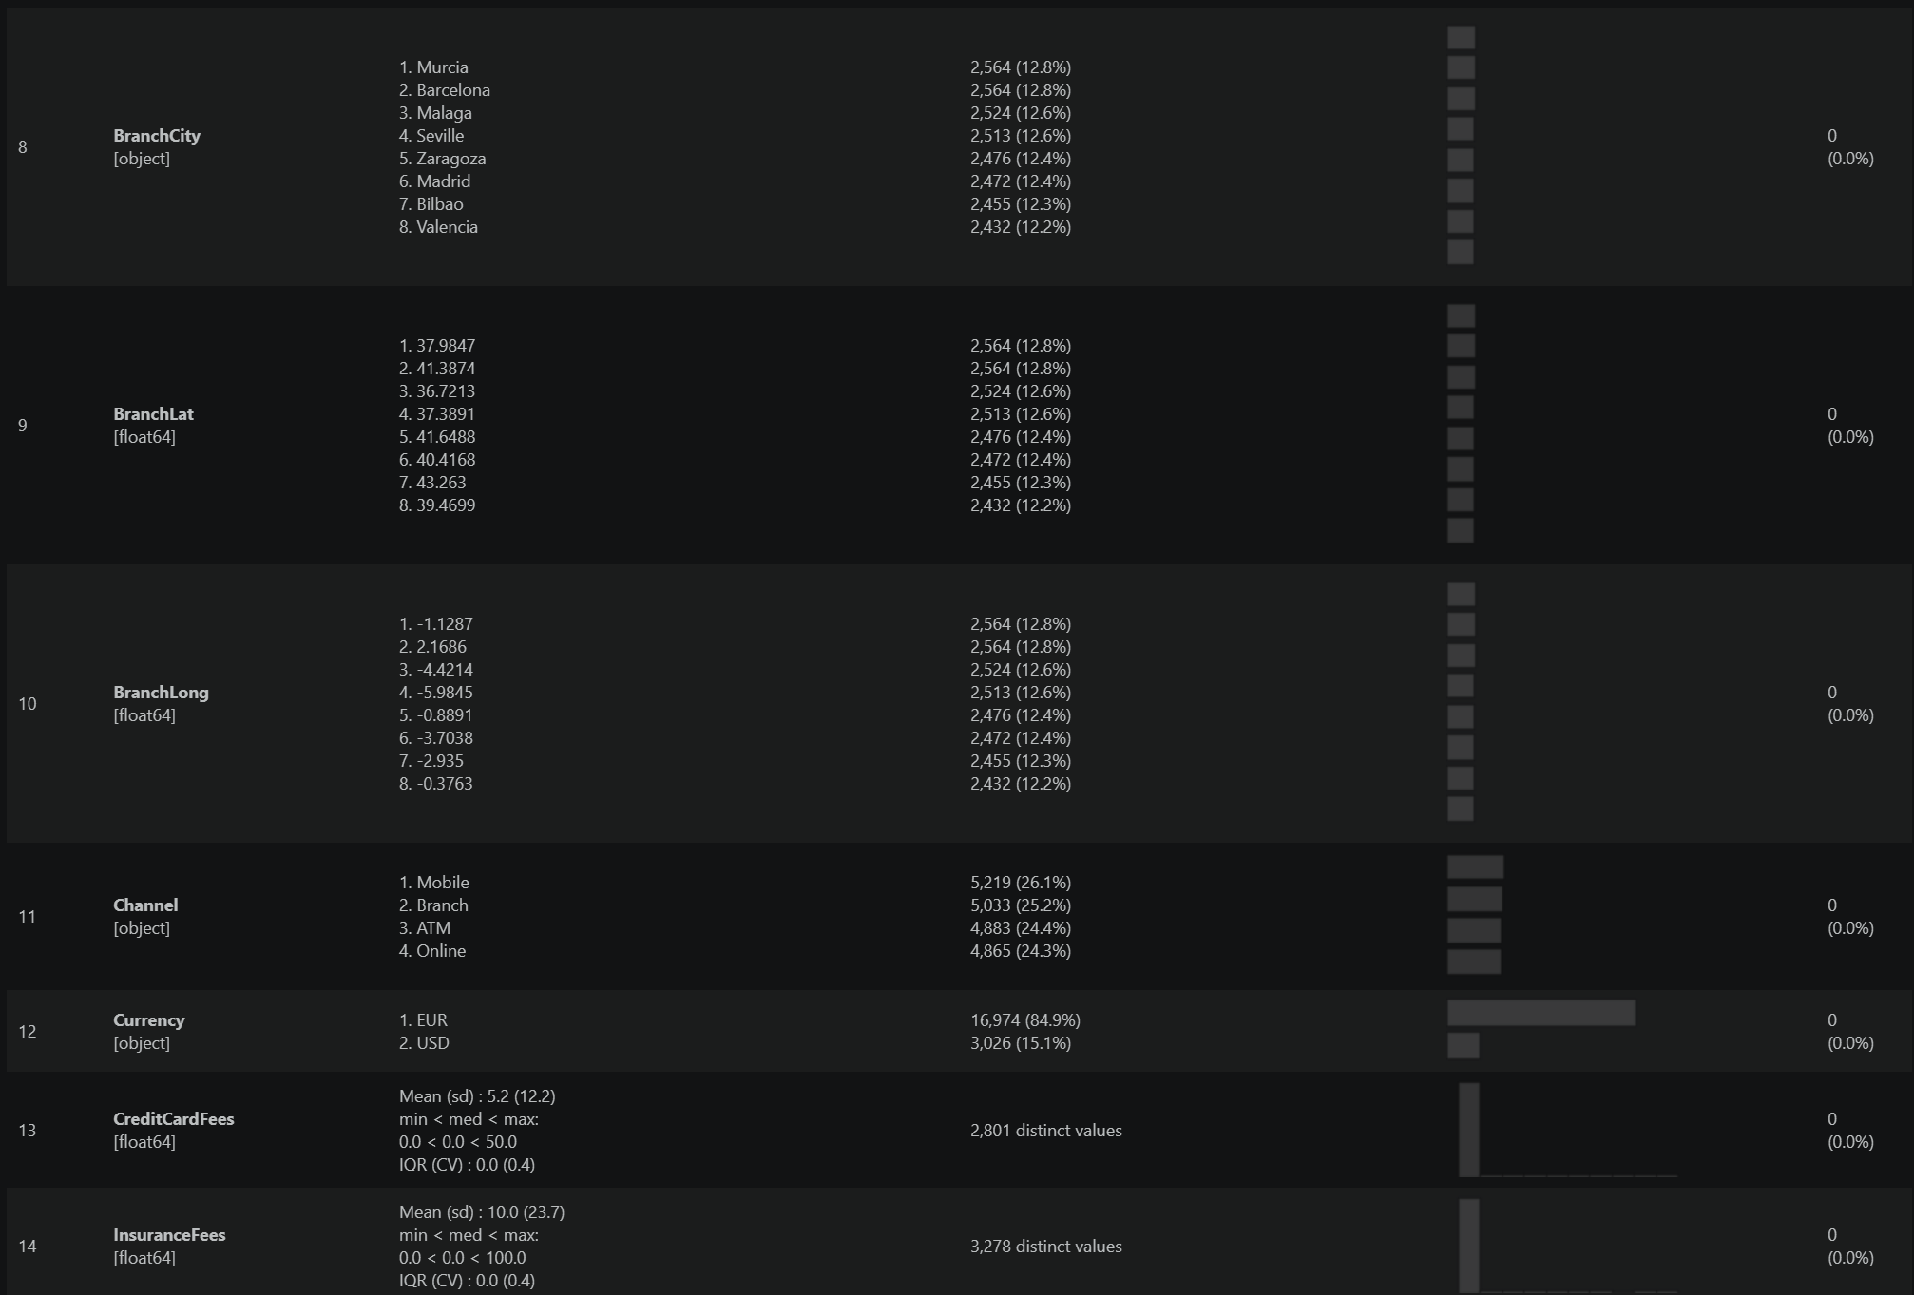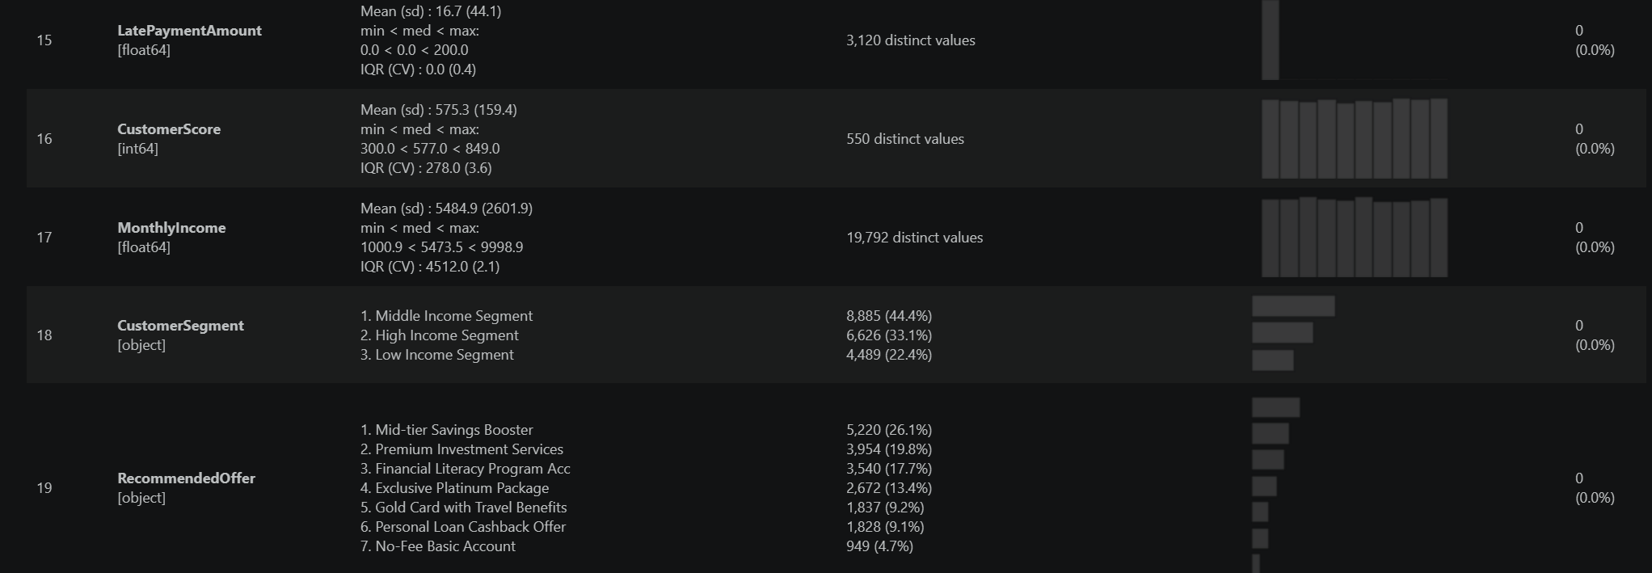
Identifier:
- On average, each customer made approximately 2.5 transactions throughout the data period. This indicates customer retention, which is a good basis for analyzing loyalty.
Spatio – Temporal:
- Timeframe: Data spans 870 days (from January 1, 2023 to May 20, 2025). The frequency graph shows a very even distribution of transactions across the days, with no data breaks.
- Geography: Operates in 8 major cities of Spain (Murcia, Barcelona, ​​Madrid, etc.).
Profilling:
- Income Segmentation: Middle Income customers account for the majority (44.4%), followed by High Income customers (33.1%). This is an ideal customer structure for sustainable retail banking services.
- Customer Score: The average score is 575.3 points. The score distribution is quite wide, ranging from 300 to 849, indicating that the bank is serving a diverse range of customers with varying risk levels.
- Recommended Offer: The "Mid-tier Savings Booster" package accounts for the highest percentage (26.1%), showing that the bank's current focus is on attracting savings deposits from the middle-income customer group.
Financials:
- Transaction Amount: The average is 5,050.4 EUR/USD. The data is right-skewed with a peak value of 14,895, indicating a small group of clients conducting high-value transactions.
- Revenue Drivers: * 75% of the data shows zero fees (Credit/Insurance/Late Payment). Revenue from fees is not widespread but concentrated on specific events. In particular, the late payment penalty (LatePaymentAmount) has a maximum value of 200, a key indicator for risk analysis.
- Currency: 84.9% of transactions were conducted in EUR. However, the 15.1% USD transactions need to be converted to a common value system before calculating total profitability.
Behaviors/Channel:
- Withdrawal (17.0%) and Loan Payment (16.8%). Since Withdrawal, Transfer, and Deposit are nearly equal. the bank sees a very healthy and active flow of cash. The high percentage of Loan Payments suggests a strong credit-related revenue stream.
- The high usage of Digital (Mobile + Online = ~50%) vs. Physical (Branch + ATM = ~50%) shows a perfectly balanced hybrid banking behavior.
Unvariate Analysis
Continuous Variance
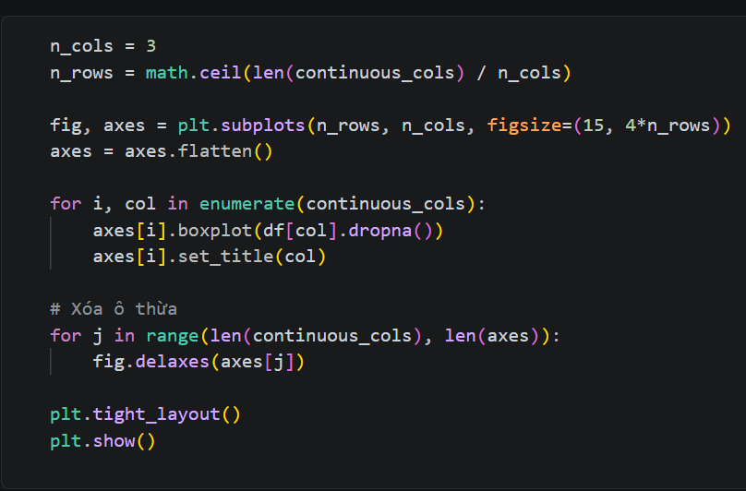
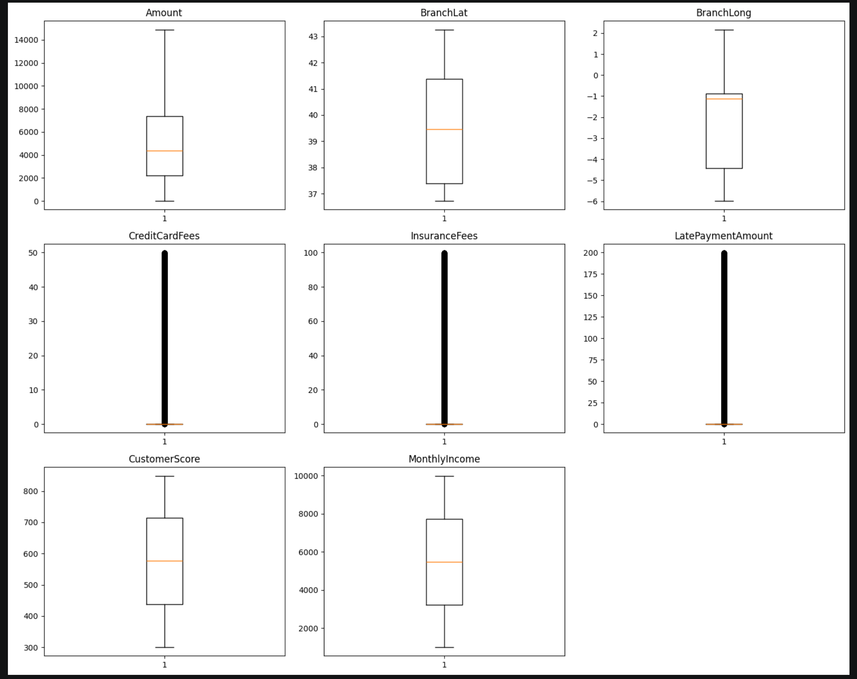
Identifier:
- Geographic Distribution (BranchLat & BranchLong): The boxplot shows that the branches are fairly widely distributed with no outliers. The bank has a stable presence across different geographic coordinates. However, the range of values ​​for BranchLong is wider than BranchLat, indicating that the branches tend to be spread more along an East-West axis.
Profiling:
- Customer Score (Credit Score): The boxplot shows a very well-balanced and balanced distribution of scores (close to a normal distribution). The median is around 577. No customers have unusually low or high scores (no outliers). This suggests the bank's customer base has a stable, medium-risk profile.
- Monthly Income: Income ranges from 1,000 to 10,000. The median is approximately 5,473. The gap between Q1 and Q3 (IQR) is quite wide, indicating a diverse range of customer financial capabilities, suitable for launching a wide range of products.
Financials:
- Amount (Transaction Value): The Amount boxplot has a long upper wick, indicating many high-value transactions. However, there are no scattered outliers, meaning large transactions remain manageable and occur frequently.
- Fees (CreditCardFees, InsuranceFees, LatePaymentAmount): All three charts have a flattened bottom with a dense black band of outliers at the top. The majority of customers do not pay these fees. However, those who do pay fees pay very high amounts (up to 50 for card fees, 100 for insurance, and 200 for penalty fees). This is the group of customers that generate high profit margins (Revenue Drivers) but also carry a high risk of bad debt.
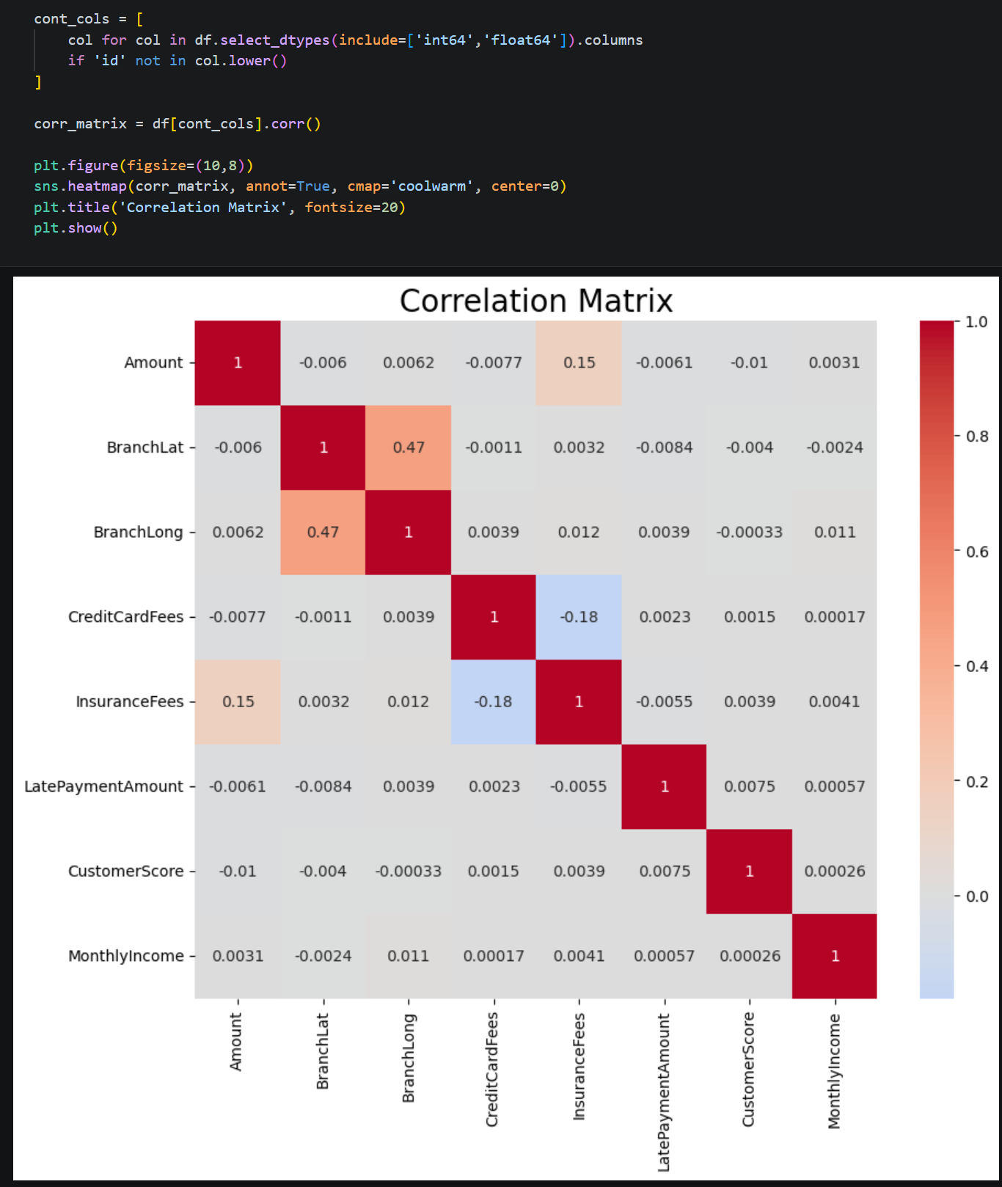
Profiling
- Credit & Income Independence: A critical finding is the near-zero correlation between MonthlyIncome and CustomerScore. Higher income does not guarantee better credit behavior in this dataset. This allows the bank to decouple risk management from product scale offering high-limit products to high-income users while maintaining strict risk controls for those with low scores.
- Late Payment Amount vs. Monthly Income ($0.00): Late payment penalties occur among both wealthy and low-income earners.
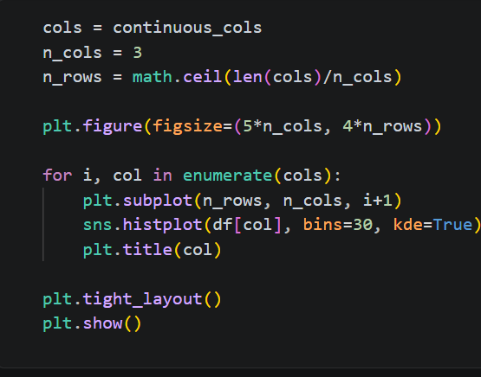
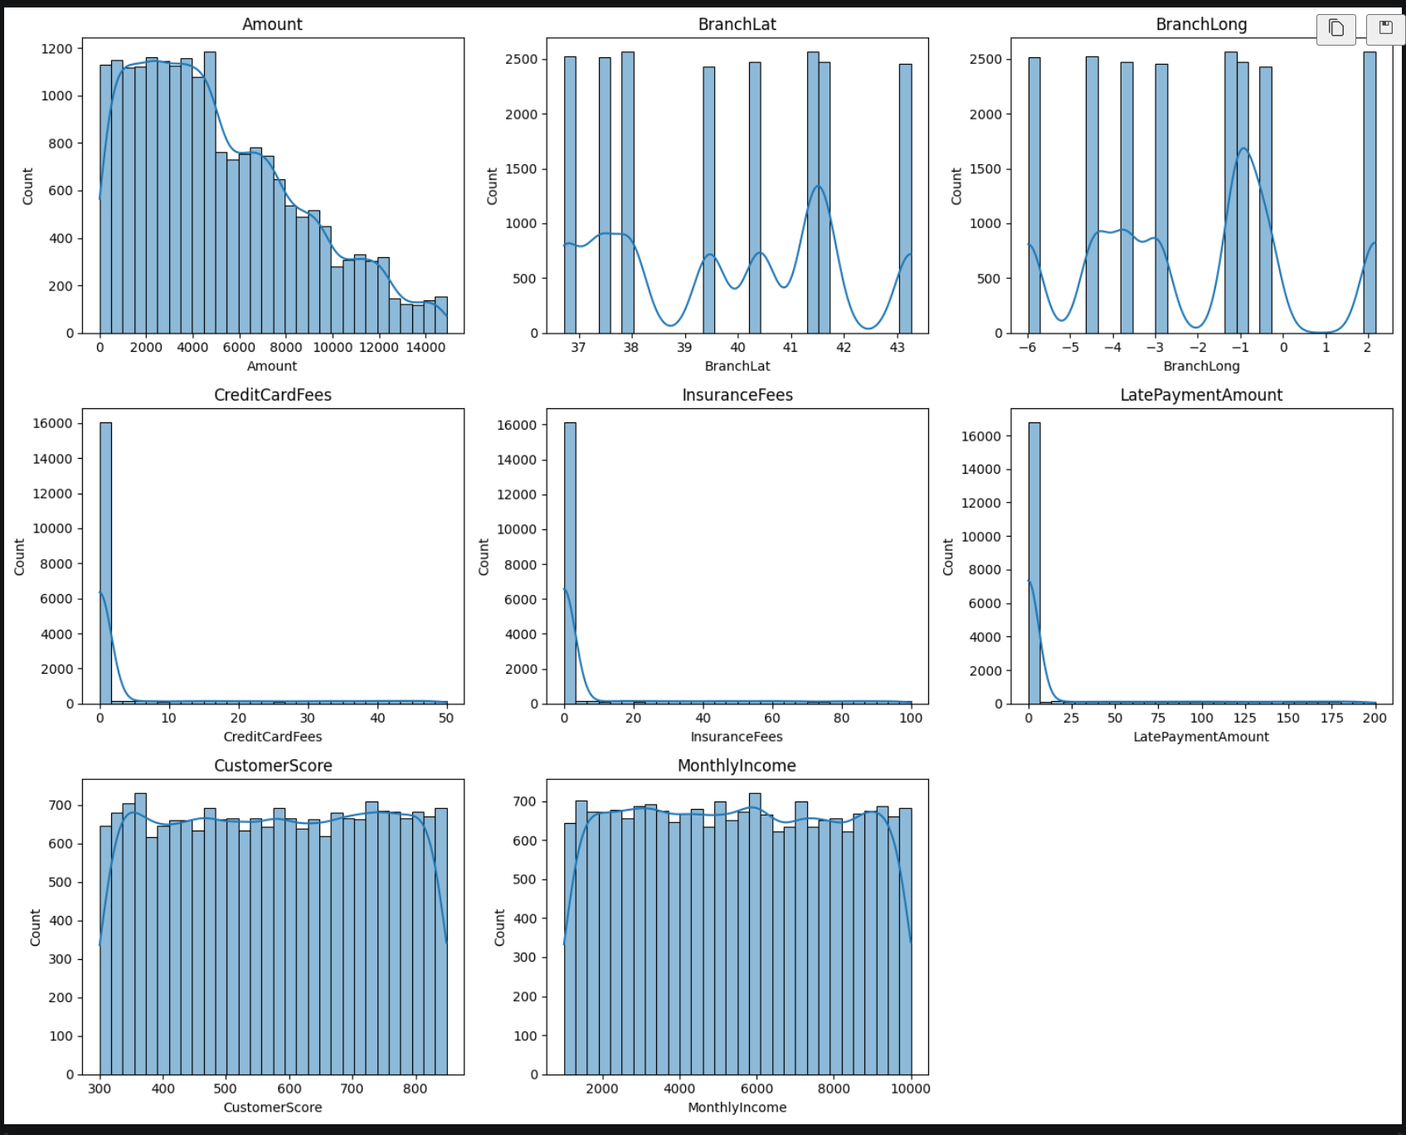
- Amount: Many transactions are small in value (a few hundred to a few thousand), and only a few are very large (over 10,000).
- CreditCardFees, InsuranceFees, LatePaymentAmount: The majority of customers do not incur fees (0). Only a small group customers bear these fees. This is a group of customers that brings high profit margins but whose behavior needs to be carefully monitored.
- Customer Score: The distribution is very balanced. The majority of customers have an average credit score (around 575). This indicates that the bank's risk is being managed at a stable level, not heavily skewed towards the bad debt group or the overly safe group.
- Monthly Income: The distribution is relatively even and flat at the top. This shows that your customer base has incomes ranging from low to high, not extremely concentrated in one particular income group.
Bivariate Analysis
Amount vs Categorical Variable
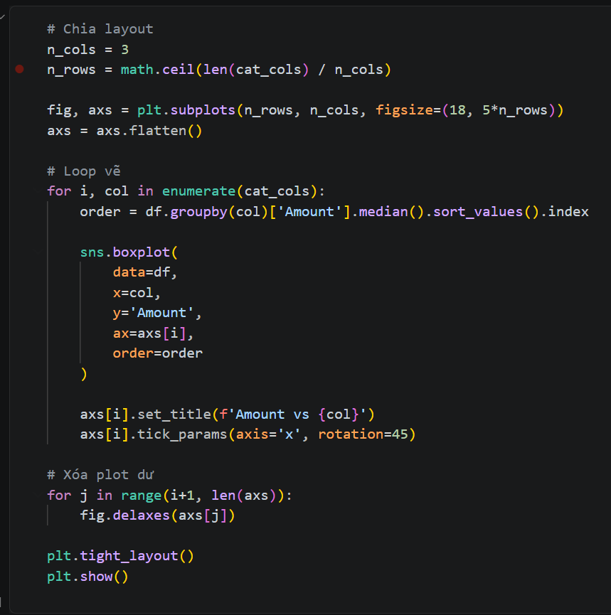
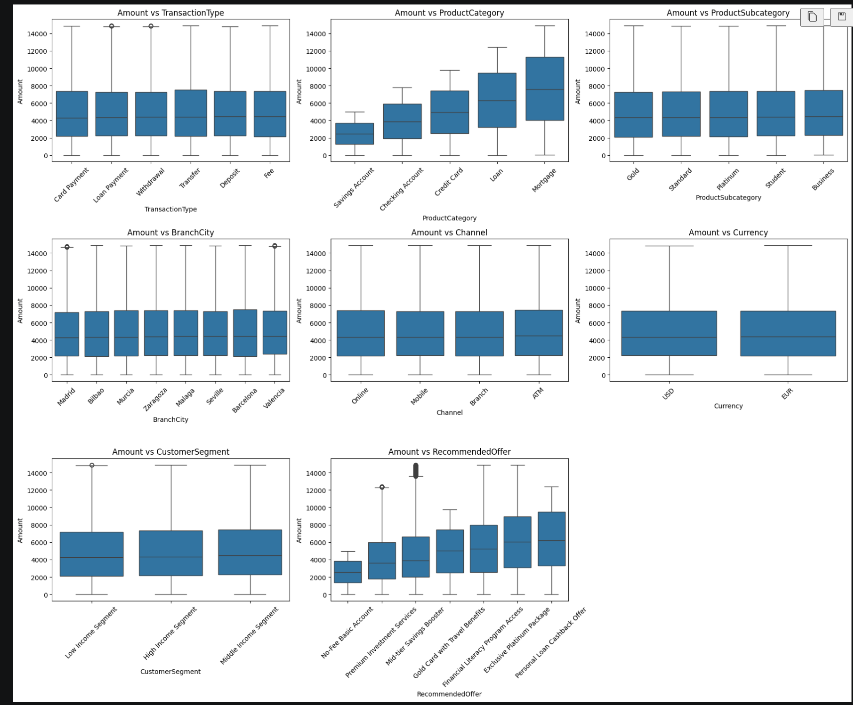
Amount vs Product Category
- Mortgage and Loan products exhibit the highest median transaction amounts and the widest interquartile ranges (IQR). Conversely, Savings Account transactions are significantly smaller and more clustered. Large capital movements are concentrated in debt-related products. To increase the bank's total transaction volume, marketing efforts should prioritize these high-value categories.
Amount vs Recommended Offer
- There is a clear upward progression in transaction amounts across the offers. The Exclusive Platinum Package is associated with the highest amounts, while the No-Fee Basic Account correlates with the lowest. The recommendation engine is functioning logically. It successfully identifies high-velocity users and targets them with premium, high-value service packages, while keeping low-volume users in basic tiers.
Amount vs. Customer Segment (The Distribution Paradox)
- The distribution of Amount is remarkably similar across Low, Middle, and High Income segments. This confirms that Income does not dictate transaction size. High-income individuals may perform many small transactions, while lower-income individuals may occasionally perform large ones. Profitability is a factor of transaction frequency across all segments, not just the wealthy ones.
Amount vs. Channel & Transaction Type (Omnichannel Maturity)
- Transaction amounts across Mobile, Online, Branch, and ATM are virtually identical. Similarly, there is no significant difference in volume between Withdrawals, Deposits, and Transfers. This indicates high Customer Trust in digital platforms. Customers are as comfortable moving large sums via Mobile or Online as they are at a Physical Branch. This supports a "Digital-First" strategy to reduce operational costs at branches without losing transaction volume.
Amount vs Branch City
- There is no significant variance in transaction amounts across the 8 Spanish cities or between EUR and USD transactions.
Customer Level Analyst
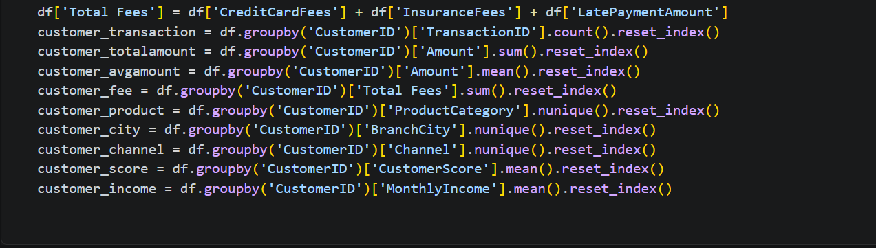
Financial Value
- Total Amount: This calculates the total cash flow each custoemr has moved through the bank. It helps us identify VIP or high – volume users.
- Average Amount: Distinguish between people who make many small purchases and those who make few but very large payments
- Total Fees: By combining credit card fees, insurance, and late penalties, we see the total service revenue each person provides. This is the most direct way to see which customers are the most profitable for the bank.
Engagement & Diversity
- Transaction Count: This measures frequency. It tells us how often a customer interacts with the bank. A high count usually means high loyalty and daily usage.
- Product Variety (Nunique): This counts how many different types of products (loans, savings, etc.) a person uses. Customers with many products are "stickier"—they are much less likely to leave for another bank.
Stability & Profile
- Average Score & Income: Since income and credit scores can fluctuate slightly over time, taking the average gives us a stable financial identity for the person.
Descriptive & Statistic
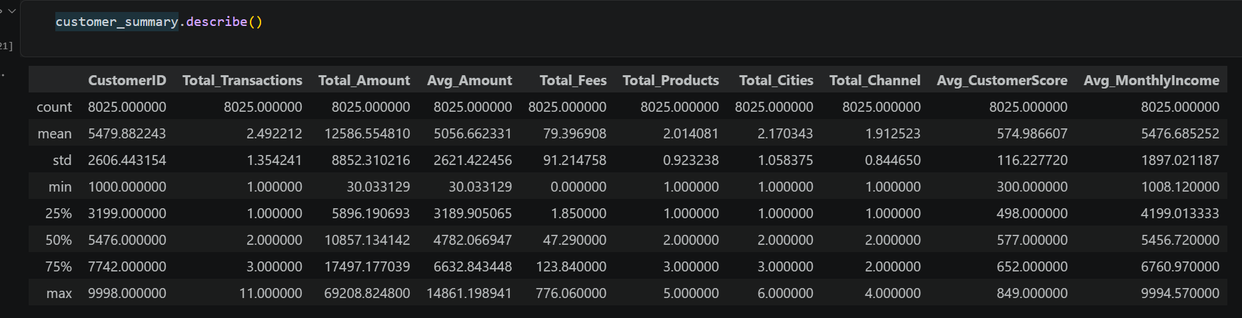
- Total Transactions: The average customer performs roughly 2.5 transactions over the observed period. However, the range is significant, with some customers performing only 1 transaction (likely new or inactive users) and others performing up to 11
- The bank has a core of high-frequency users who are significantly more engaged than the average
- Product & Channel Diversity: On average, customers use 2 different product categories and 1.9 channels. The maximum values (5 products and 4 channels) indicate a highly "sticky" segment of customers who utilize the bank's full ecosystem (Mobile, Online, ATM, and Branch).
- Total Amount: The average total spend per customer is 12,586. However, the standard deviation is very high (8,852), and the maximum value reaches 69,208.
- This confirms a "Long Tail" distribution where a small percentage of VIP customers contribute a disproportionately large amount of the total cash flow.
- Average Customer Score: The mean score is 574.9, with a healthy median of 577. This suggests the bank's portfolio is risk-stable.
- Average Monthly Income: The average income is 5,476, ranging from a minimum of 1,008 to a maximum of 9,994.
- The bank serves a broad economic spectrum, but the majority (50%) of customers earn between 4,199 and 6,760.
Unvariate Analyst
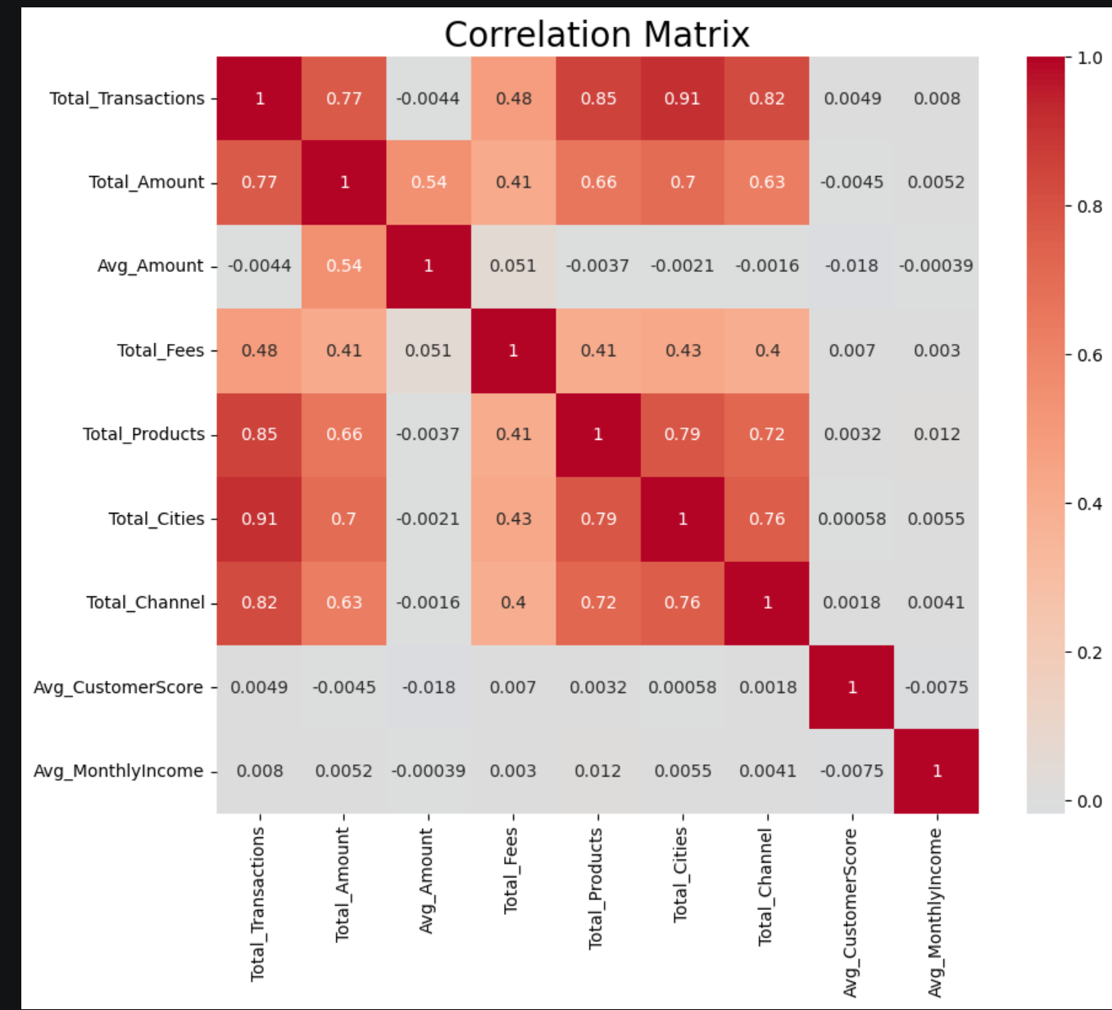
- Engagement customer: if the customer uses more channels, they use more products and transact in more cities.
- Total transactions vs total amount: Total spending volume is driven primarily by frequency, not necessarily by the size of individual transactions. The more often a customer uses the bank, the higher their total lifetime value.
- Total transactions vs total fees: This suggests that fee revenue is also dependent on specific behaviors (like late payments or insurance purchases) rather than just raw volume.
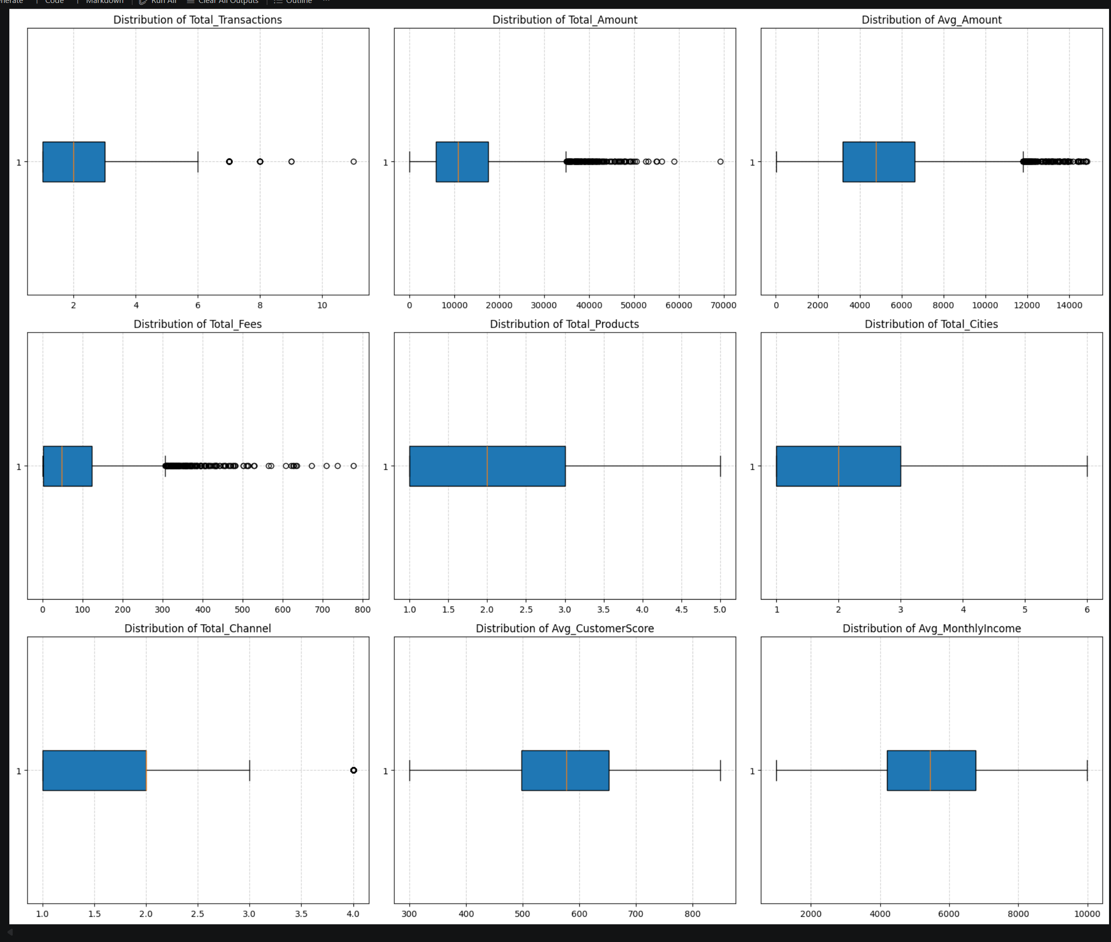
Engagement Patterns (Transactions, Products, Cities, Channels)
- Total Transactions: The median is 2 transactions, with most customers falling between 1 and 3. However, there are significant outliers reaching up to 11. These outliers represent your "Power Users."
- Product & City Reach: Most customers use 2 products and visit 2 cities. The spread for Total_Products is very tight, suggesting that the bank successfully moves customers past a single-product relationship quickly.
- Total Channels: The median is 2 channels, but there is a clear outlier at 4. This represents the small elite group of "True Omnichannel" customers who use every available touchpoint.
Financial & Profitability Spread (Total Amount & Total Fees)
- Total Amount: The data shows a massive concentration at the lower end (median ~$10k) but a very long tail of outliers extending beyond $60k.
- Total Fees: This chart is the most skewed. The median is low, but the outliers are numerous and reach up to $776
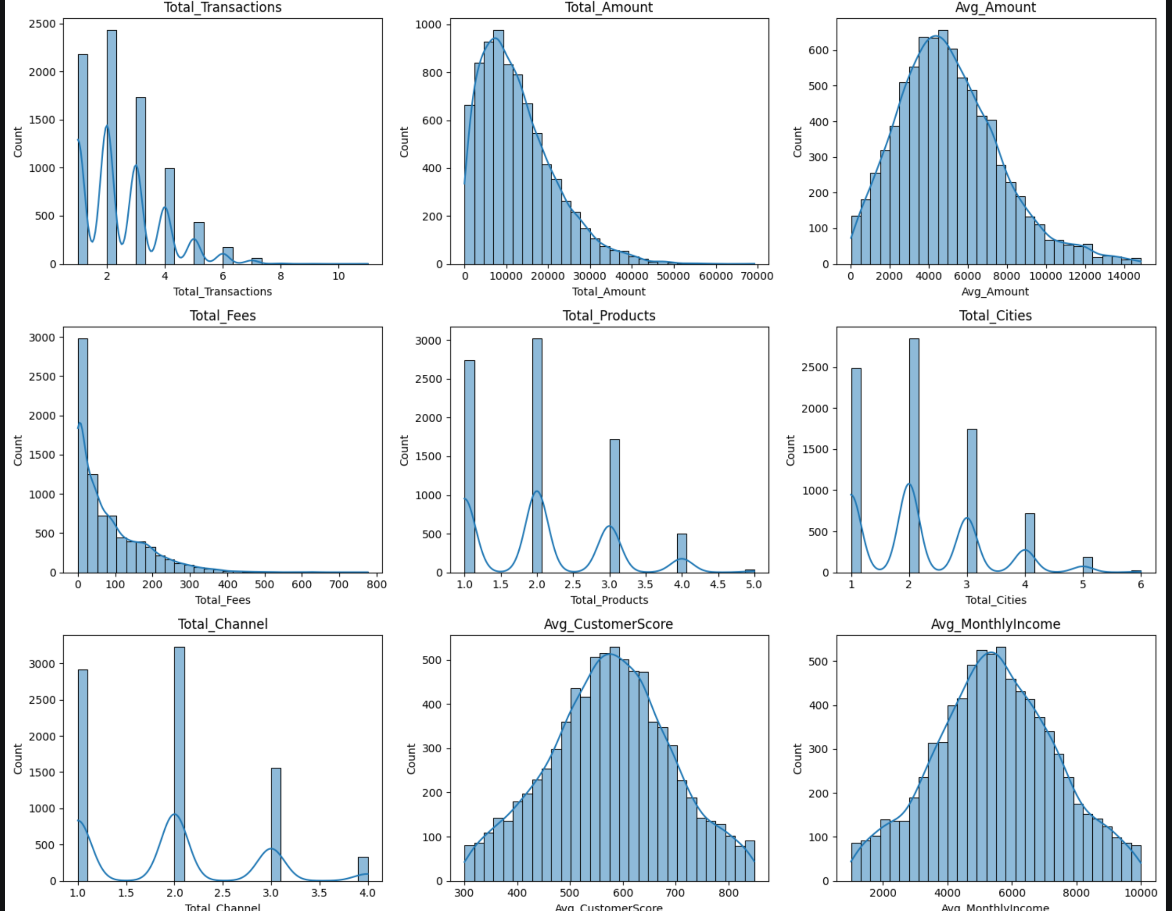Engagement & Stickiness
- Activity Peaks: Most customers cluster around 1-3 transactions. However, there are distinct "peaks" at 2 products and 2 channels.
- The "3-Product" Barrier: A secondary peak appears at the 3-unit mark across products and channels. Customers who cross this threshold transition into the "Power User" category, showing significantly higher integration into the bank's ecosystem.
- Geographic Spread: Most users are active in 2 different cities, indicating a mobile and active customer base.
Financial Value & Profitability
- Total Amount: While the majority of customers contribute approximately $10k in total volume, the bank’s total liquidity is heavily supported by a "long tail" of high-value reaching up to $70k.
- Total Fees: This is the most skewed variable. Most customers generate near-zero fee revenue. Profitability is highly concentrated in a small, specific niche of customers (the outliers) who drive the bank's service-based margins.
Customer Health & Stability
- Predictable Profiles: Both Customer Score and Monthly Income follow a Normal (Symmetric) Distribution.
- Stability: The customer base is fundamentally stable, consisting primarily of "Middle-Class" individuals with incomes around $5.5k and consistent credit scores around 575. There are no extreme outliers in terms of financial risk.
DASHBOARD
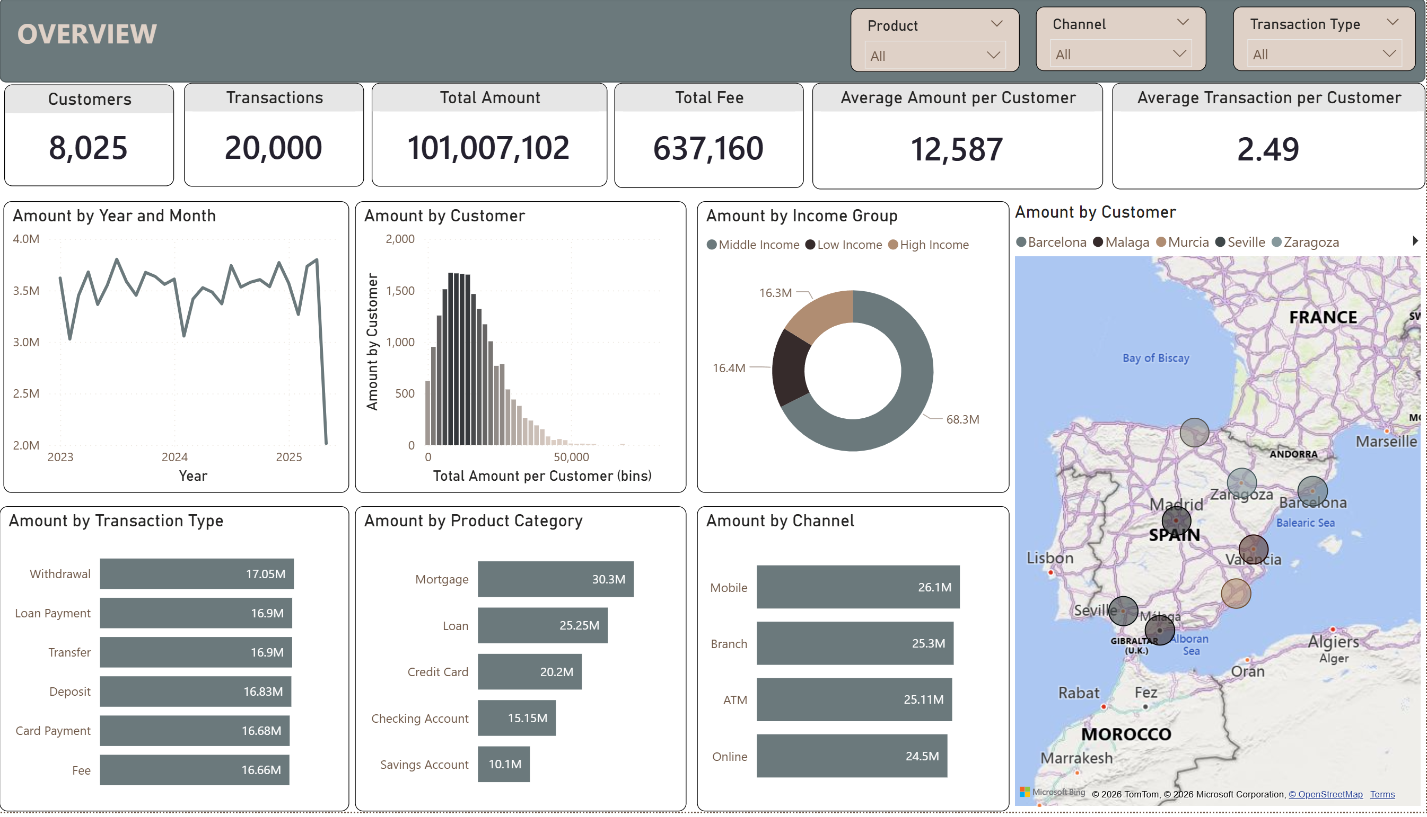
The dashboard presents a robust financial operation concentrated in Spain, with data spanning from early 2023 to mid-2025. The business demonstrates a stable transaction volume, with a heavy reliance on the middle-income demographic and lending products (Mortgages and Loans). Notably, customer interaction is highly balanced across all banking channels and transaction types.
Here is a concise, scannable version of the analysis:
- KPIs: 8,025 customers generated 101M in total transaction volume (across 20,000 transactions) and 637k in fees.
- Demographics & Geo: Operations are exclusively in Spain. The Middle-Income segment drives the vast majority of volume (68.3M), with most individual customers transacting under 20,000.
- Products: Lending drives the highest financial value, led by Mortgages (30.3M) and Loans (25.25M), significantly outpacing daily banking products.
- Channels & Behavior: The business has a perfectly balanced omnichannel adoption. Volume is evenly split across Mobile, Branch, ATM, and Online platforms (~24M–26M each), and across all transaction types (~16.6M–17M each).
- Trends: Monthly performance remained highly stable, hovering between 3M and 4M from early 2023 to early 2025.

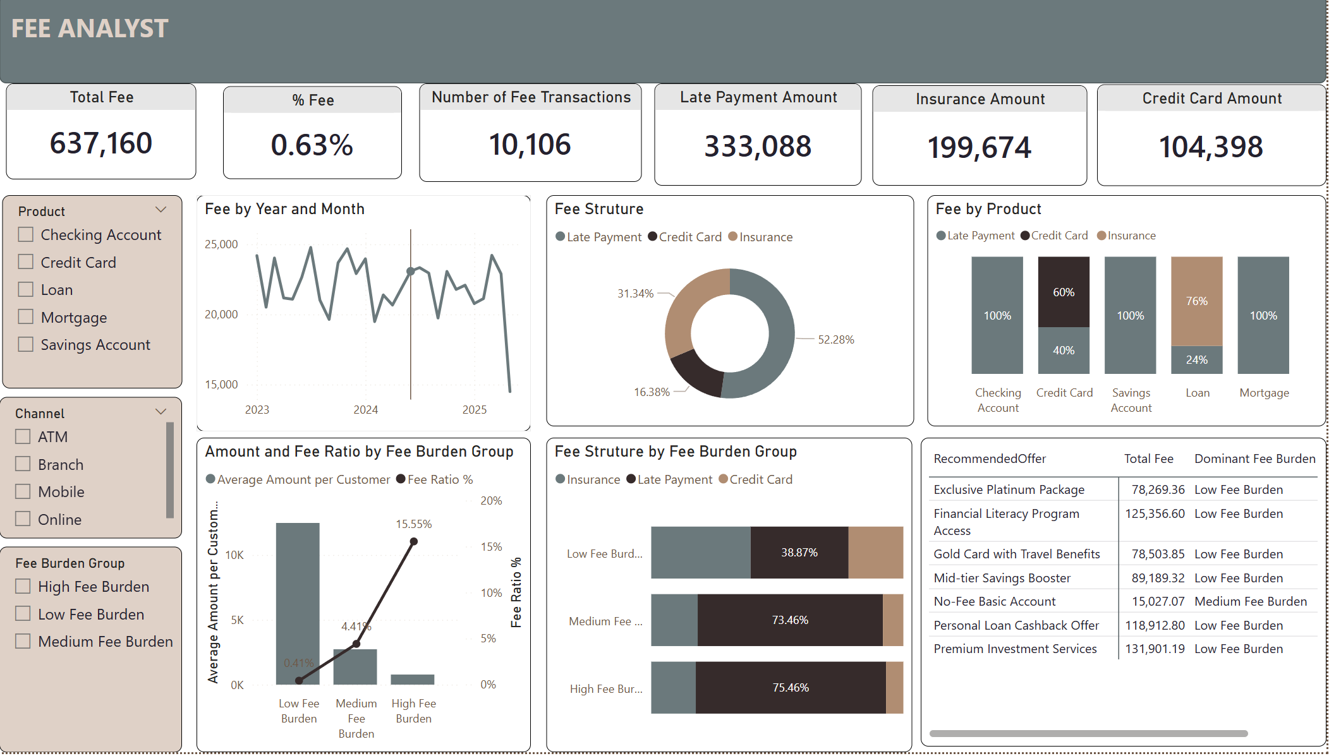

- Top KPIs: Total fees collected are 637,160 from 10,106 transactions (a very low average fee ratio of 0.63%).
- Fee by Year and Month (Line Chart): Monthly fee trends remain relatively stable (between 20,000 and 25,000) from 2023 to 2025. The sharp drop in the final month is likely due to incomplete data.
- Fee Structure (Donut Chart): Late Payments are the largest source of fee revenue, accounting for over half (52.28%), followed by Insurance (31.34%) and Credit Card fees (16.38%).
- Fee by Product (Stacked Column Chart): Late payments account for 100% of the fee structure for Checking Accounts, Savings Accounts, and Mortgages. For standard Loans, Insurance fees dominate (76%).
- Amount & Fee Ratio by Fee Burden Group (Combo Chart): Highlights a stark disparity. The customer group with the lowest average balance (High Fee Burden) bears the highest fee ratio at 15.55%. Conversely, the group with the highest balance faces a negligible fee ratio (0.41%).
- Fee Structure by Fee Burden Group (Horizontal Stacked Bar Chart): Explains the disparity above. For the Medium and High Fee Burden groups, their fee structure is heavily driven by Late Payments (73.46% and 75.46%, respectively).
- Recommended Offer (Table): The system recommends premium, wealth-oriented packages for the "Low Fee Burden" (wealthy) group, while suggesting a "No-Fee Basic Account" solution for the group struggling with high fees.

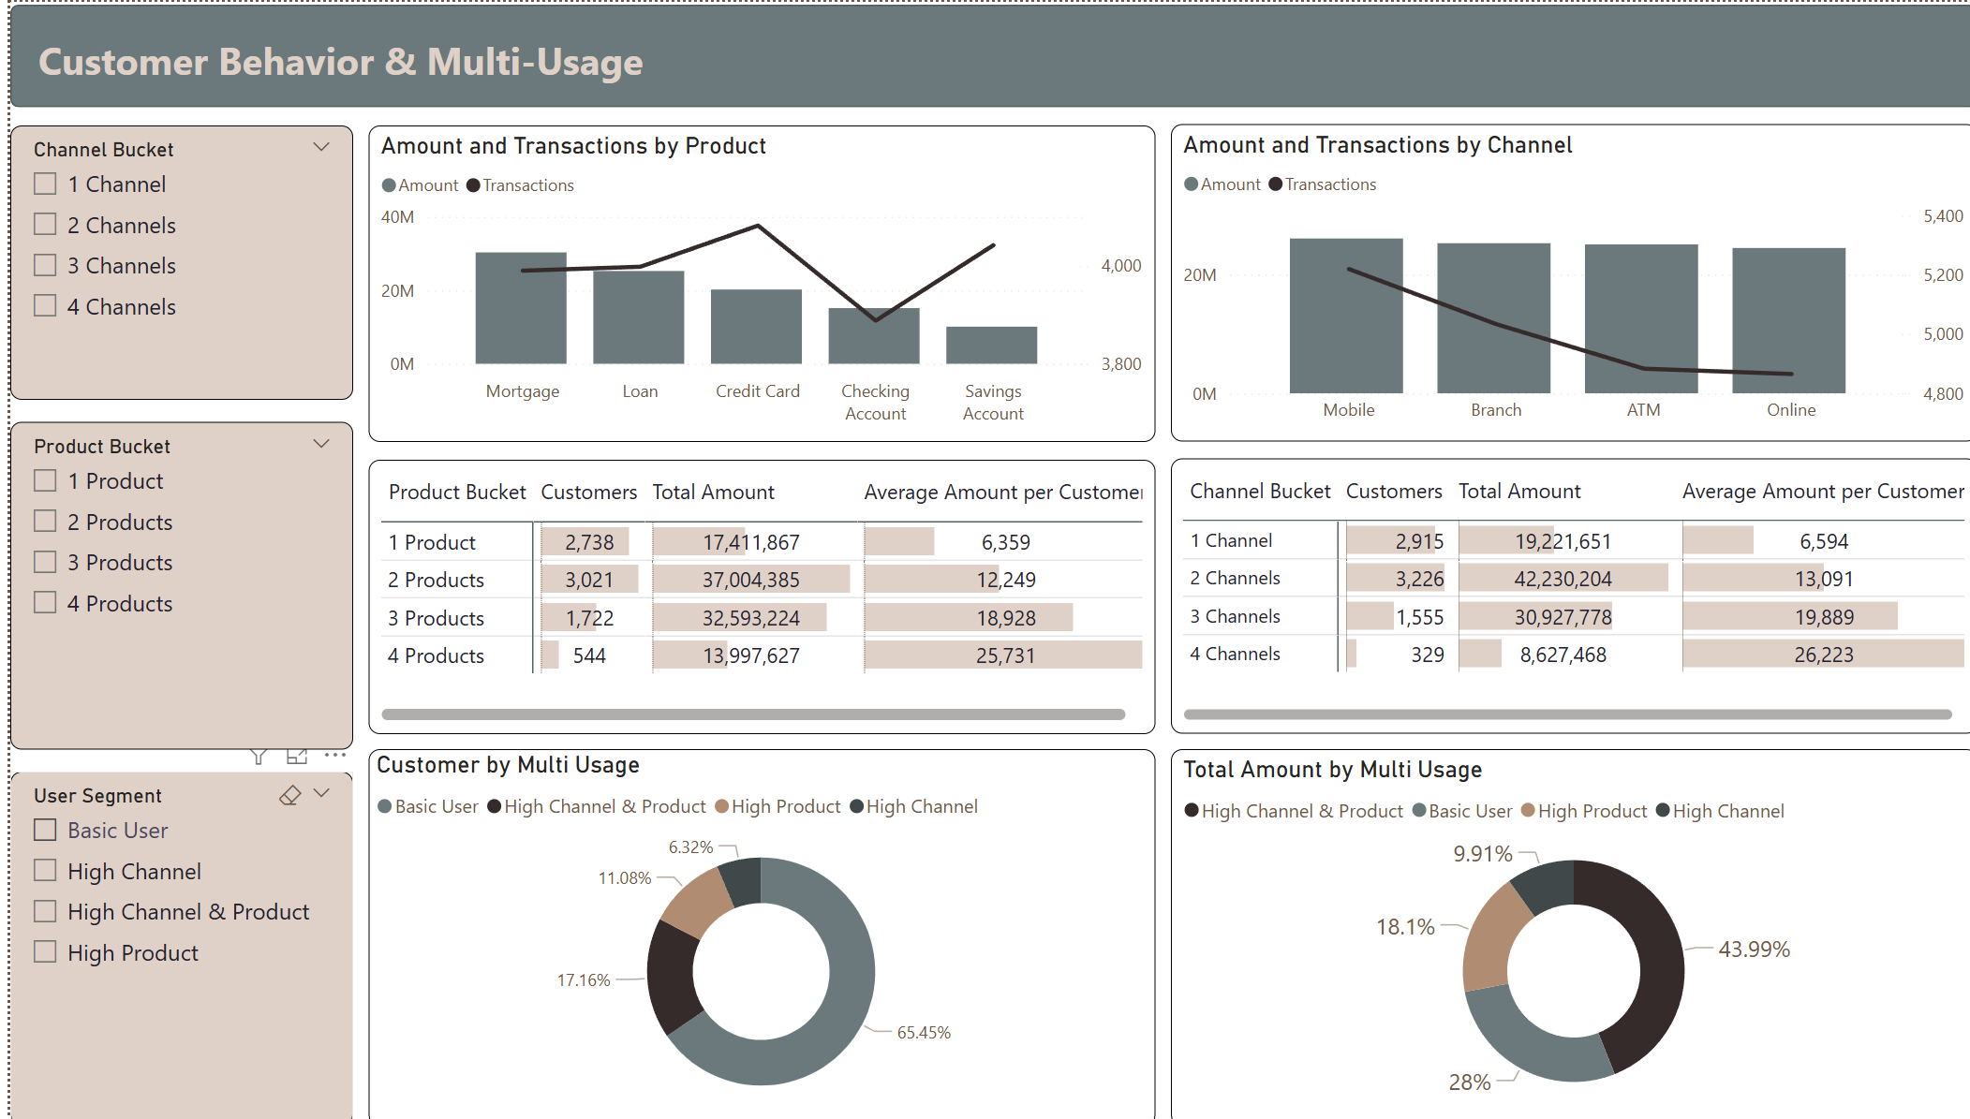
- Mortgage generates the highest transaction amount (30M), while credit card records the highest number of transactions.
- Savings and Checking Accounts contribute lower transaction amounts, reflecting their role as fundamental banking products rather than high value financial services.
- Credit cards demonstrate high customer activity despite generating a lower transaction value than Mortgage and Loan Products.
- Mobiles Banking generates the highest transaction amount and transaction volume, confirming it as the primary customer interaction channel.
- Branch, ATM and Online channels show relatively similar transaction values, suggesting customers actively use multiple banking channels rather than relying on a single platform.
- Customers using two products and two channels represent the largest customer groups and contribute the highest total transaction amounts. More importantly, the average transaction amount per customer increases consistently as customers adopt additional products and channels, reaching 25.7K for four-product users and 26.2K for four-channel users.
- Although Basic Users account for 65.45% of the customer base, they generate only 28% of the total transaction value, whereas High Channel & Product users represent just 17.16% of customers but contribute nearly 44% of the total transaction amount
- These findings indicate that highly engaged customers deliver disproportionately greater business value, highlighting significant opportunities to increase customer lifetime value through cross-selling, omnichannel adoption, and personalized engagement strategies.

KEY INSIGHTS
- Stable Business Performance: The bank serves 8,025 customers with 20,000 transactions, generating over 101M in transaction value, while customer engagement remains relatively low at 2.49 transactions per customer.
- Core Revenue Drivers: Mortgage is the highest-value product, Mobile Banking is the leading transaction channel, and Middle-Income customers contribute the largest share of total transaction value.
- Fee Structure: Late Payment Fees account for 52.28% of total fee income, indicating a strong reliance on penalty-based revenue rather than value-added services.
- Customer Engagement Matters: Customers using more products and channels consistently generate higher average transaction values, demonstrating a strong positive relationship between engagement and customer value.
- High-Value Customer Segment: Although High Channel & Product users represent only 17.16% of customers, they contribute 43.99% of the total transaction amount, making them the bank's most valuable customer segment.
- Growth Opportunity: The large Basic User segment (65.45% of customers) presents significant opportunities for cross-selling, omnichannel adoption, and personalized marketing to increase customer lifetime value and drive sustainable business growth.
RECOMMENDATIONS
- Increase customer engagement by encouraging Basic Users to adopt additional banking products and channels through personalized cross-selling and bundled financial packages.
- Strengthen digital banking adoption, particularly Mobile Banking, by enhancing user experience and introducing exclusive digital promotions to increase transaction frequency.
- Reduce reliance on Late Payment Fees by implementing payment reminders, auto-payment services, and financial education programs to improve customer satisfaction while maintaining sustainable revenue growth.
- Prioritize high-value customers by offering personalized rewards, premium services, and loyalty programs to retain customers with high product and channel usage.
- Expand value-added fee-based services, such as insurance, investment, and premium credit card offerings, to diversify fee income beyond penalty-related charges.
- Leverage customer segmentation to design targeted marketing campaigns, improving product adoption, customer lifetime value, and long-term profitability.

