HOTEL BOOKING ROOM SYSTEM

LEVEL 0 DFD - CONTEXT DIAGRAM
The Context Diagram defines the operational boundaries of the entire system Hotel Booking Room System acting as a central processing unit that interacts with
5 External Entities:
- Guest (Unregistered Customer):
+ Inflows: Register an account, search for available rooms, view introduction information and hotel amenities (Register, Search rooms, View information).
+ Outflows: Detailed hotel information and room search results (Room information, Search results).
- User (Logged-in Customer):
+ Inflows: Book rooms, make payments, submit cancellation requests, write reviews, and update personal profiles (Book room, Make payment, Cancel booking, Review, Update profile).
+ Outflows: Booking confirmation notices, booking history, and published reviews (Booking confirmation, History, Reviews).
- Administrator (Hotel Manager / Owner):
+ Inflows: Configure room details, set up pricing and promotions, handle check-in/check-out operations, request reports (Room configuration, Pricing & Promotions setup, Handle Check-in/out, View reports).
+ Outflows: Management data, floor-by-floor room layouts, and statistical reports (Management data, Room layout/map, Reports).
- Payment Gateway:
+ Exchanges: Sends Payment request / Refund request and receives Transaction result / Refund notification.
- Email Service:
+ Outflows: Sends Notification emails / Activation & Reset links to users.

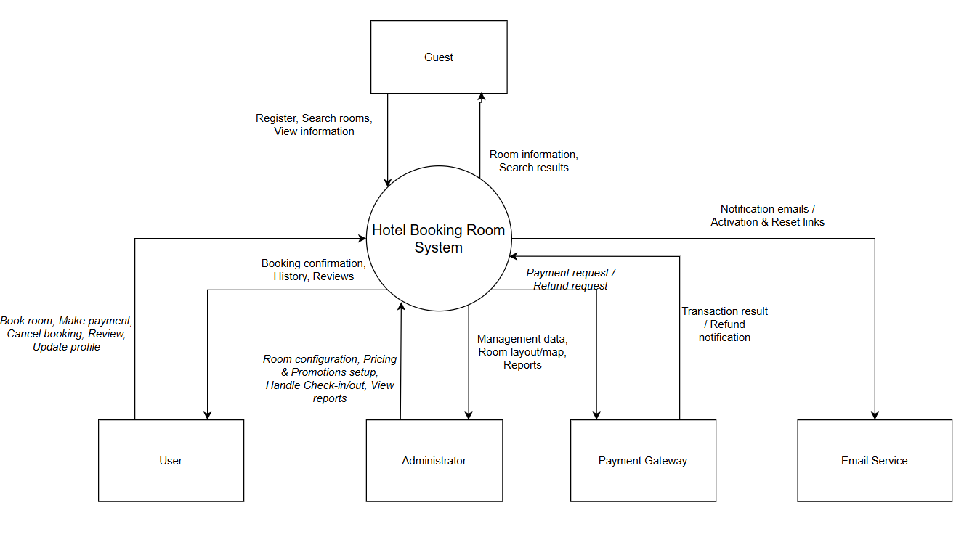

LEVEL 1 DFD - FUNCTIONAL DECOMPOSITION
At Level 1, the system is decomposed into 7 Main Functional Processes interacting closely with 6 Data Stores:
Data Stores:
- D1: Accounts: Stores user account credentials.
- D2: Rooms & Hotel: Stores room layouts, amenities, room statuses, and hotel details.
- D3: Pricing & Vouchers: Stores pricing rules (weekends, peak seasons, holidays) and promotional codes.
- D4: Bookings: Stores all booking transaction records.
- D5: Reviews: Stores customer feedback and ratings.
- D6: Audit Logs & Reports: Stores operation logs and reporting data.
7 Main Processes:
- 1.0 Account Management: Handles registration, login, and password recovery; interacts with data store D1 and coordinates the Email Service.
- 2.0 Hotel & Room Info Management: Allows administrators to configure hotel info and room statuses; updates data store D2.
- 3.0 Room Search & Lookup: Processes search criteria from clients; queries available rooms from D2 and pricing rules from D3 to return matching room types.
- 4.0 Booking & Payment: Handles room bookings, deposit selections (20%, 50%, 100%); validates promo codes at D3; communicates with the Payment Gateway; creates booking records at D4; holds rooms temporarily for 15 minutes at D2 and sends confirmation emails.
- 5.0 Operation & Booking Management: Assists admins with check-ins (Citizen ID inputs), check-outs, and invoicing; processes cancellations; updates booking statuses at D4, room statuses at D2 (Occupied, Needs cleaning), and records audit trails at D6.
- 6.0 Pricing & Promotion Management: Allows admins to configure pricing rules and promotional codes, saving them to data store D3.
- 7.0 Reports & Reviews: Collects 1-5 star customer ratings into data store D5; aggregates data from D4 and D6 to generate revenue and occupancy reports for admins in Dashboard or Excel/PDF formats.

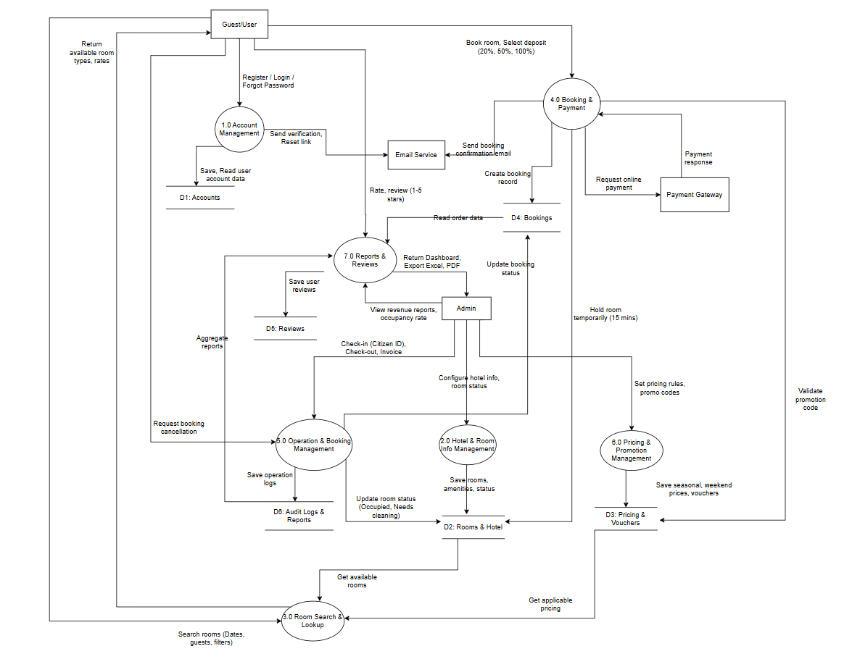

LEVEL 2 DFD - DETAILED SUB-PROCESS DECOMPOSITION
To describe internal operations in detail, the Level 1 processes are decomposed into sub-processes:

Process 3.0 Decomposition: Room Booking
- 3.1 Check Room Availability: Processes dates and guest counts from the User to read available room statuses from D2: Rooms & Hotel.
- 3.2 Calculate Estimated Price: Reads base pricing and seasonal rules from D3: Pricing & Vouchers to compute the estimated cost.
- 3.3 Fill Guest Details & Requests: Captures specific guest information (full name, phone number, nationality, special requests).
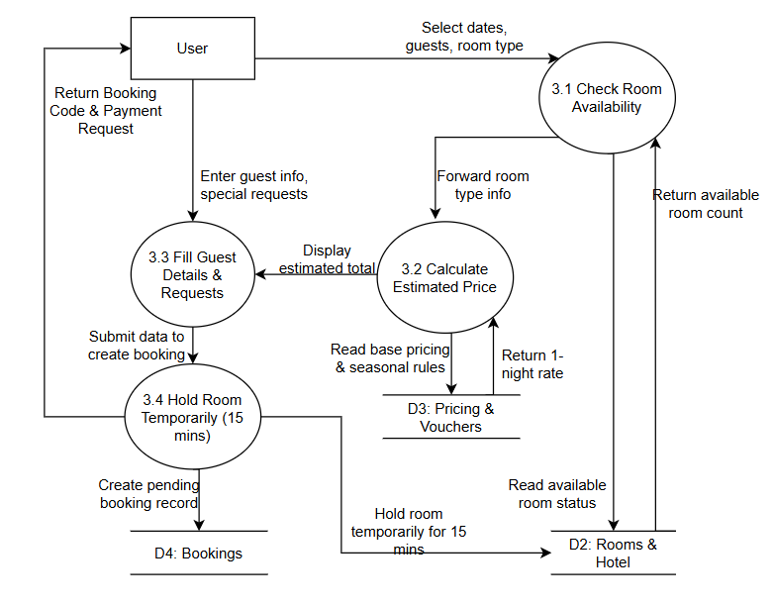
- 3.4 Hold Room Temporarily (15 mins): Temporarily holds room slots for 15 minutes in D2 and initializes a pending booking record in D4: Bookings.

Process 4.0 Decomposition: Payment & Confirmation
- 4.1 Apply Promotion Code: Validates the expiration date and conditions of the user's promo code against D3.
- 4.2 Select Deposit Level: Captures the customer's payment deposit option (20%, 50%, or 100% of the total amount).
- 4.3 Connect Payment Gateway: Sends the payment request to the Payment Gateway and receives successful transaction feedback.
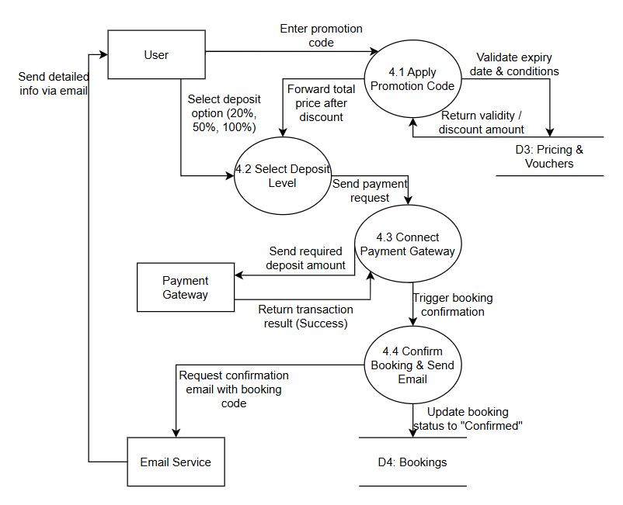
- 4.4 Confirm Booking & Send Email: Updates the booking status to "Confirmed" in D4 and requests the Email Service to send detailed confirmation info to the customer.

Process 5.0 Decomposition: Operation & Management
- 5.1 Handle Check-in: Admin inputs the booking code and Citizen ID; updates the booking status to "Checked-in" in D4, assigns a specific room number, and changes the room status to "Occupied" in D2.
- 5.2 Handle Check-out: Calculates extra fees, updates the booking status to "Checked-out" in D4, and switches the room status to "Needs cleaning" in D2.
- 5.3 Handle Cancellation & Refund: Processes cancellation requests, updates the booking status to "Cancelled" in D4, releases the room back to "Available" in D2, and forwards refund requests to the payment gateway.
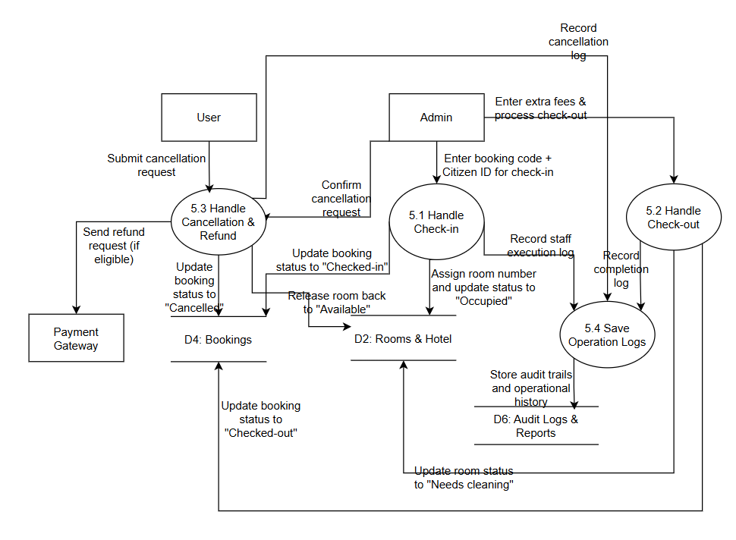
- 5.4 Save Operation Logs: Stores complete operational histories and staff execution logs into D6: Audit Logs & Reports.

Process 6.0 Decomposition: Reviews & Feedback
- 6.1 Submit Review: Captures star ratings, comments, and photos from the User; verifies the 30-day post-checkout eligibility window from D4 to save the review into D5: Reviews.
- 6.2 Moderate Reviews: Allows admins to view lists, reply, or hide spam and inappropriate posts on D5.
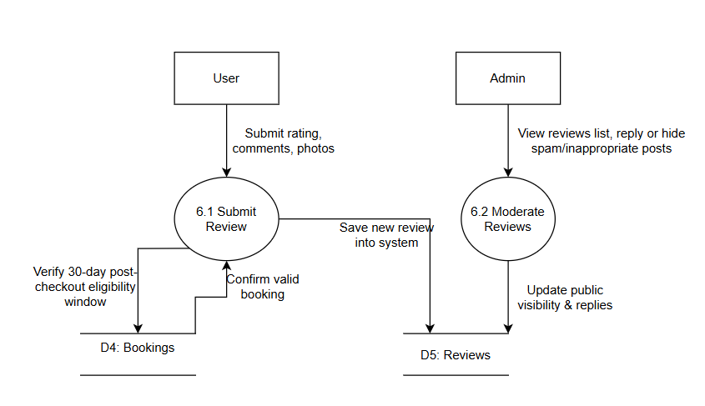

Process 7.0 Decomposition: Admin, Pricing & Reports
- 7.1 Manage Pricing & Vouchers: Allows admins to set up weekend/holiday rates and create new vouchers saved to D3.
- 7.2 Manage User Accounts: Assists admins in searching, locking, or unlocking violating user accounts in D1: Accounts.
- 7.3 Generate Reports & Dashboard: Queries data from booking records D4 and operational logs D6 to aggregate revenue and occupancy reports for display on the Dashboard or export to Excel/PDF.


