PURPOSE OF THE SYSTEM

This project is aimed to developing an online Health Insurance System. An Organization wants to start Health Insurance for its employees. The Medicare system will maintain all information related to the employee (Patient), maintenance of Claims pertaining to the Insurance companies, information about all sort of medical services providing by the hospital to the corporate employees, claim settlements & adjustments against their services authorizing by the Insurance Companies. Additionally this system can also maintain the health related all information of the employees.
The software should be fully integrated with CRM (Customer Relationship Management) as well as CMS (Content Management System) solution in a manner that is easily manageable, time saving and relieving one from manual works.

PROBLEMS IN THE EXISTING SYSTEM:

- It is limited to a single system.
- It is less user-friendly.
- It is having lots of manual work (Manual system does not mean that you are working with pen and paper, it also include working on spread sheets and other simple software's)
- It requires more no of employees need to work.
- It is time consuming process.
- The present system is very less secure.
- It is unable to Maintain Employee specific information and also their policy info.

Modules:

The modules involved are:
- Administration
- Employee
- Search
- Report
- Authentication

1. Administration:-

Admin has all privileges to add/modify employee and view Policy information etc..

- Add Resource
- Employee Support
- Search
- Requests

Add Resource:

This module only for Add Insurance Company Details and also add Their Corresponding Policy Details.

- Module maintenance is used to register a new Insurance company, modify the details of existing Insurance or remove the existing Insurance.
- Only the admin type user will have access to this part. Normal user won’t have access to this.

Employee Support:

This module is used to maintain all departments’ employee information in the organization. In This Module Admin can add new employee to his Company and also he gives username, password to employee while enter the employee details. He also assigns a policy based on employee requests. He can see all employees in his company.

2. Report:-
- This module is used to print various online reports. This module will be enabled only to the admin type of users.
- In this admin generate various types of reports about the employees working in the organization.
- In this admin generate various types of billing reports which are generated by employees working in the organization.
- In this admin generates the reports by date wise as input and gives details of bill made on that date along with total information. This report should be available for a given date or for a date range.

3. Employee Module

In this module again divided into 3 module

- Employee Details
- Search
- Order for insurance

Employee Details

- In This Employee can also change his password.

- And also change his own Details
Search

  - In this module an employer can able to search policies based on his requirements.
  - If a policy selected by the employee he can get company details of that particular policy.
  - An employee can able to find the details of claims on particular policy.
  - He can also claims for a policy after getting search results.

Order for Insurance

In this module he sends a request to admin for a required policy.

4. Authentication:-
This module contains all the information about the authenticated user. User without his username and password can’t enter into the login if he is only the authenticated user then he can enter to his login.

INPUTS & OUTPUTS

The main inputs, outputs and major functions of the system are as follows.
Inputs:

  - Any user should login into the system by passing login parameters. User can enter the site based on roles and enters his or her own page.
  - Admin Register the Employee and assign the login parameters.
  - Admin manage the department details.
  - Admin generate the reports.
  - Admin requests the search.
  - Request creators will create the request or bills.
  - Manager type users approve or reject the request.
  - Manager type gives the approved bills to corresponding Finance Manager.
  - Finance Manager credits the amount to the request creator.
  - Finance Manger close the request after payment.
Outputs:
- Admin receive the bill details.
- Request creators see their own details.
- Request creators can see the bill status which send by them.
- Managers receive the generated bills.
- Managers can see their own details.
- Finance managers receive the accepted bills by managers.
- Finance Managers can see their own details.

Tables:

  - AdminLogin

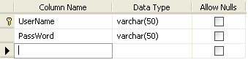

  - CompanyDetails

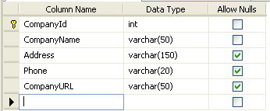
  - EmpRegister
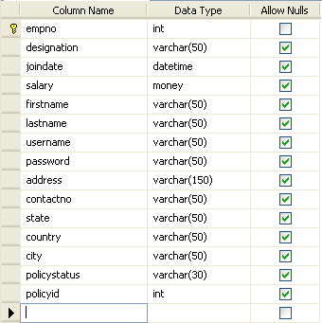

  - HospitalInfo

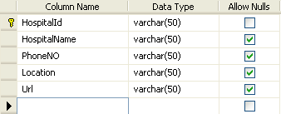
  - policies
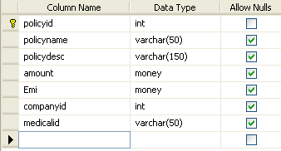
  - policiesonemployees

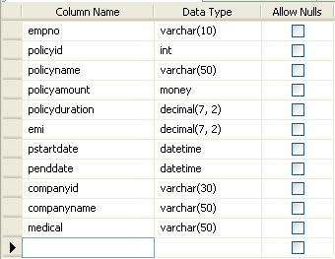

  - PolicyApprovalDetails

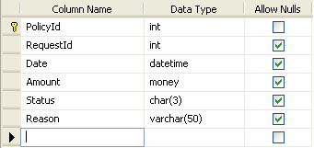

  - PolicyRequestDetails
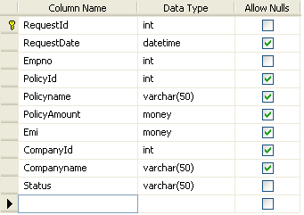

  - PolicyTotalDescription:
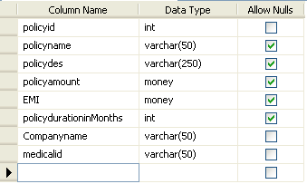

Sample Screens
Home
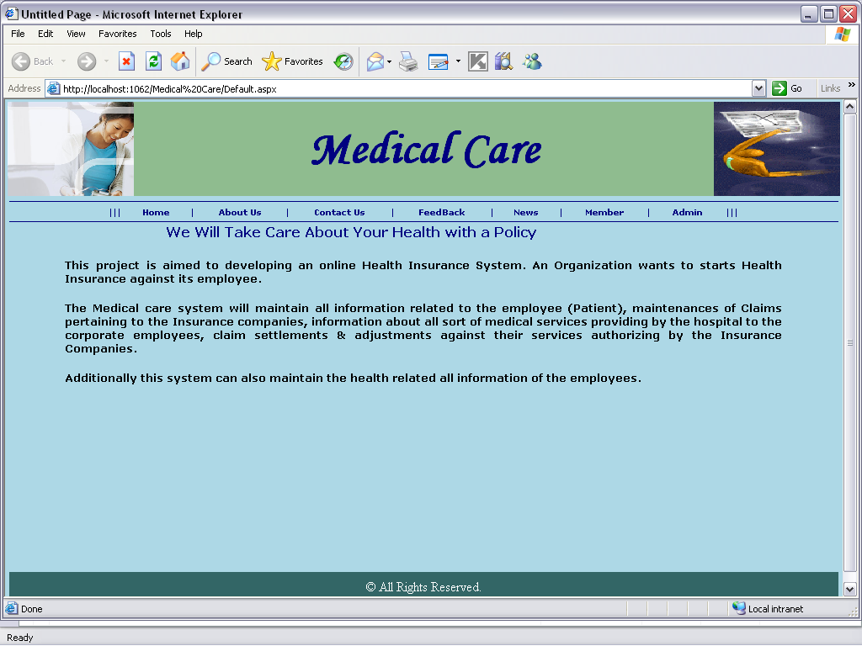

About us
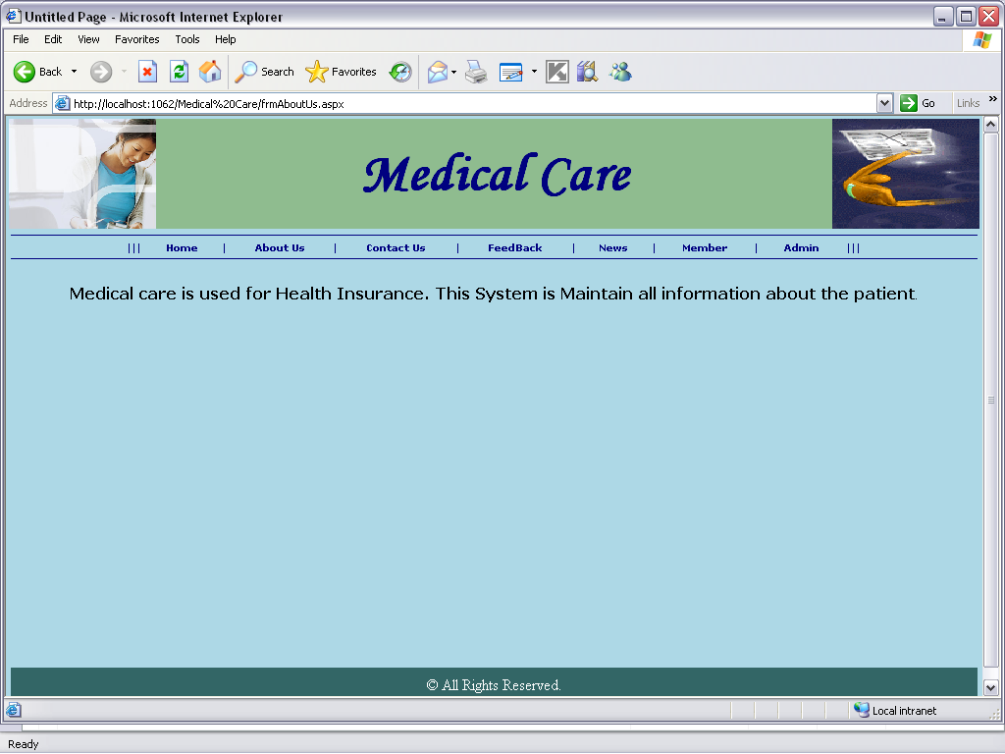

Contact Us
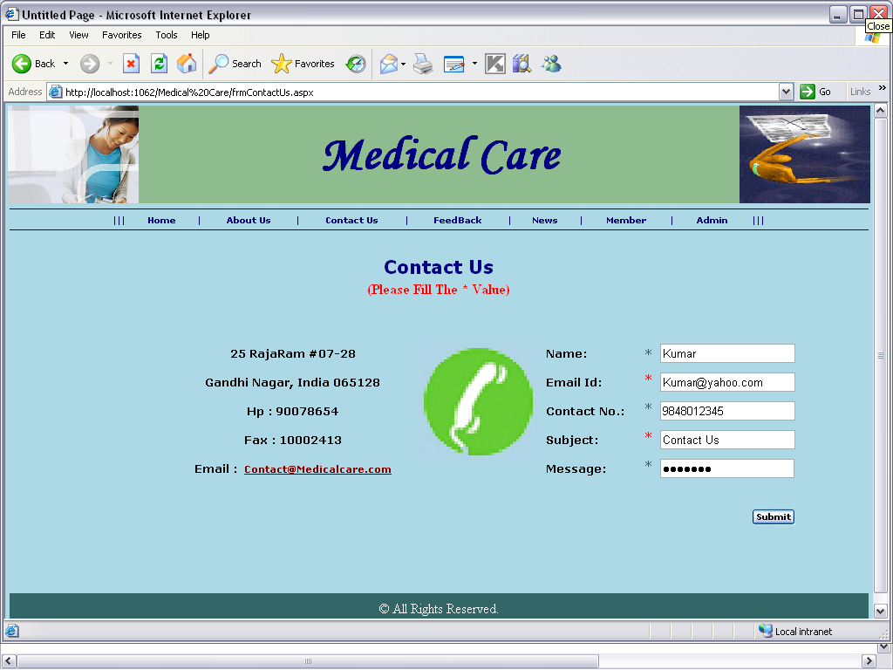

Feed Back

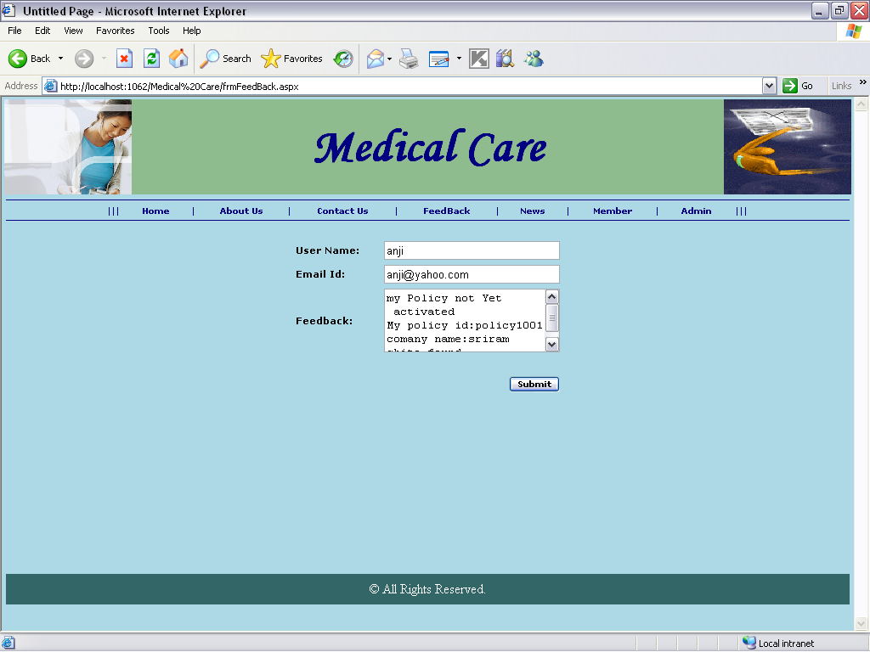

Member

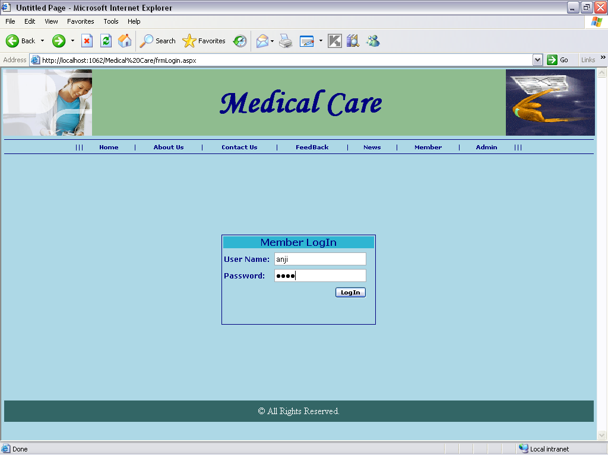

Emp
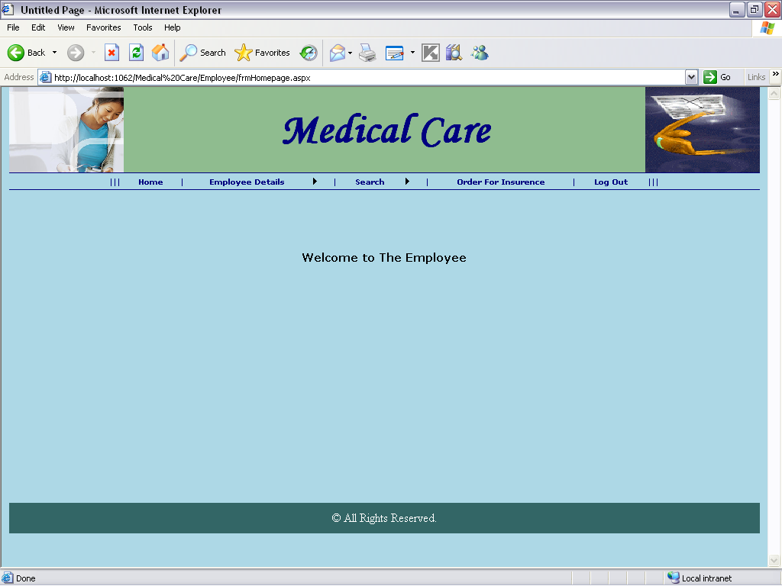
change password page

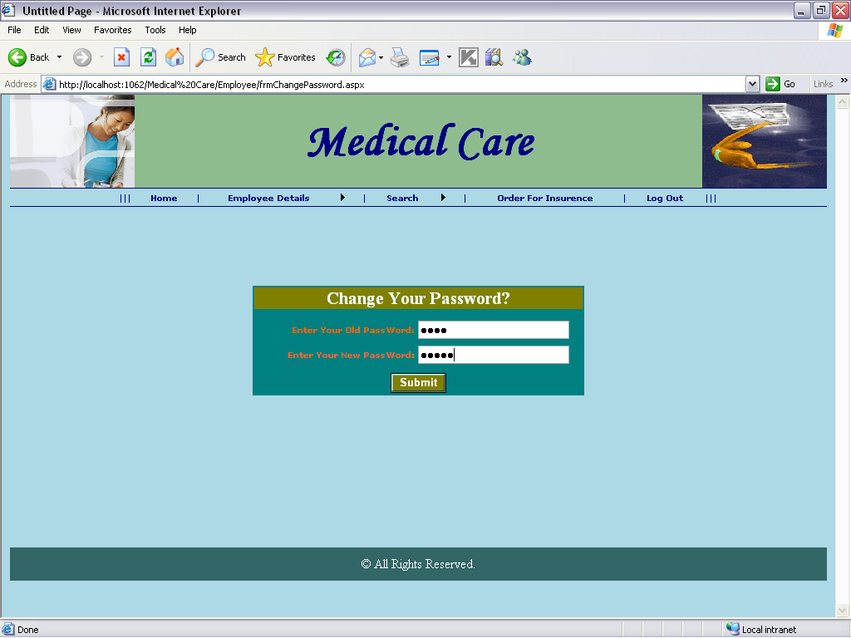

update emp details
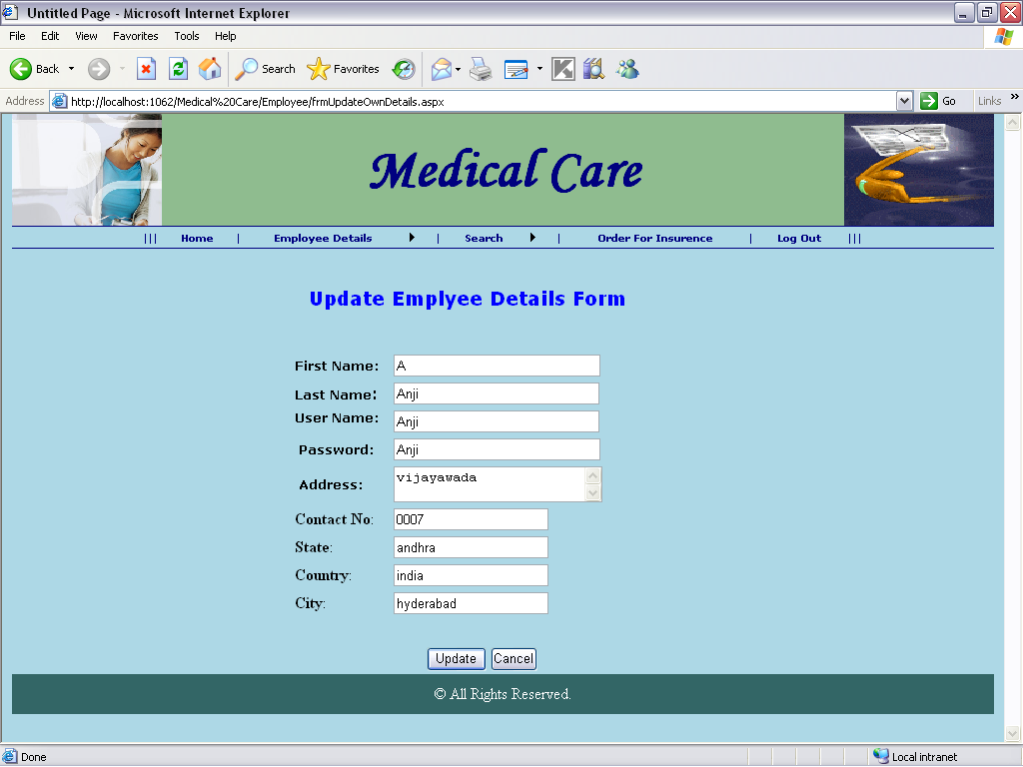

policy details
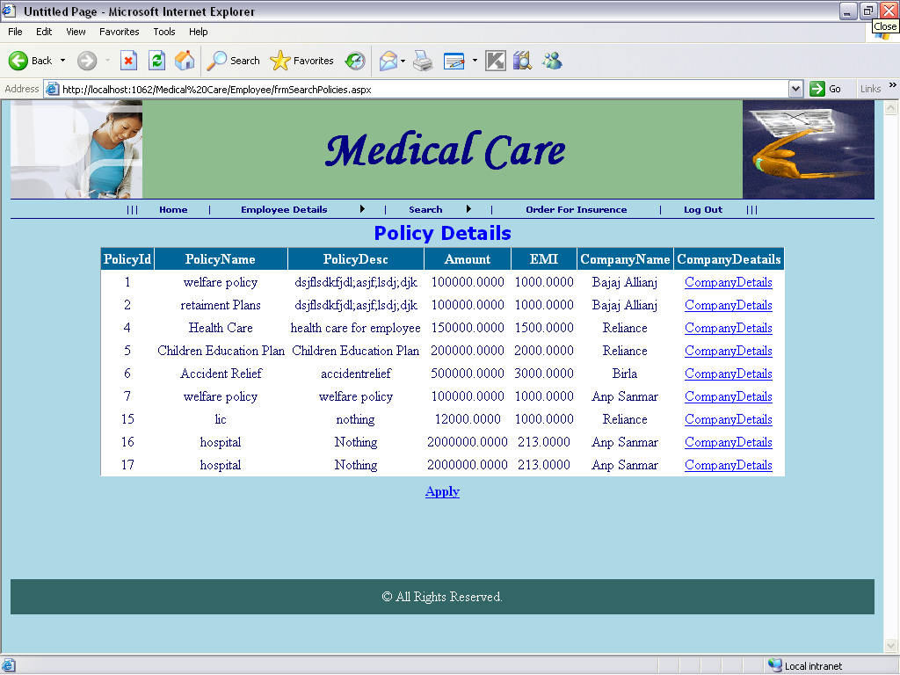

policy details
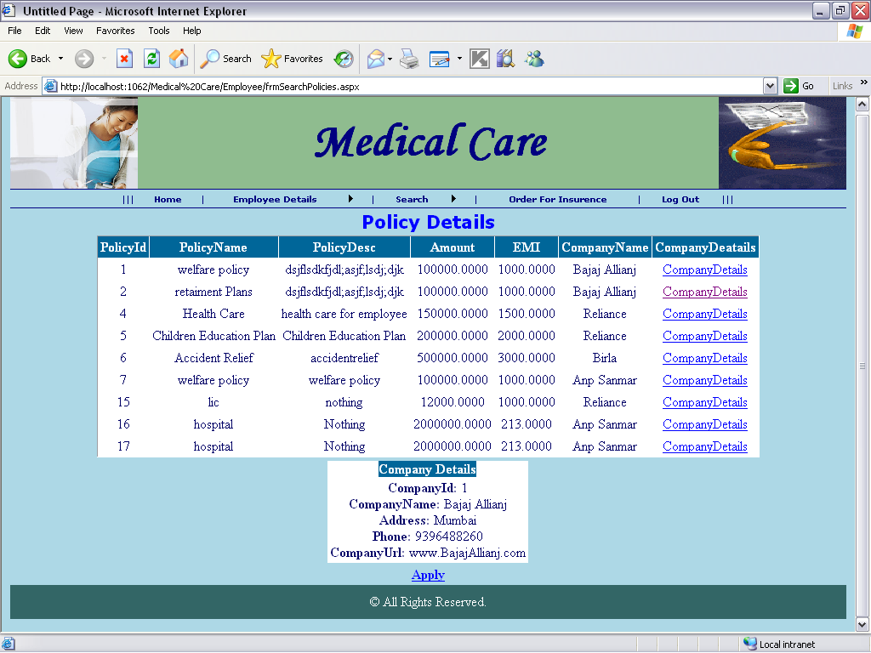
Order for insurance policy
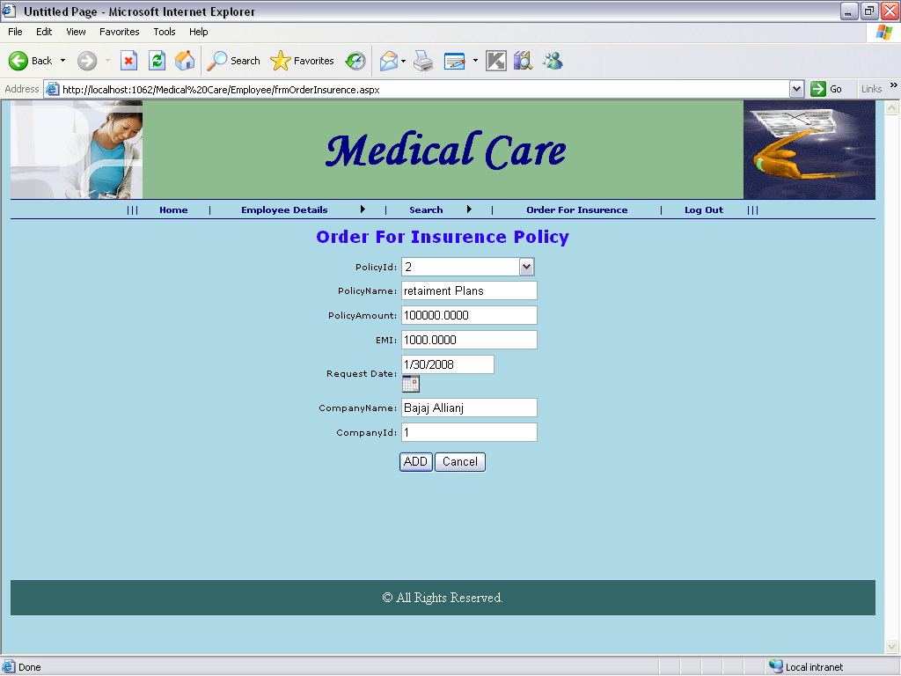

admin login
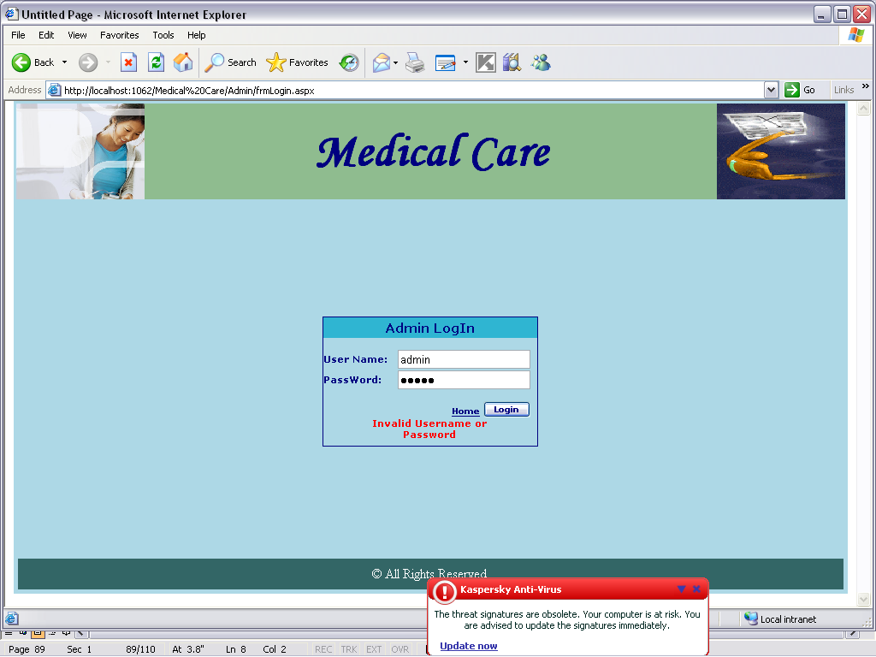

Add insurance company details form
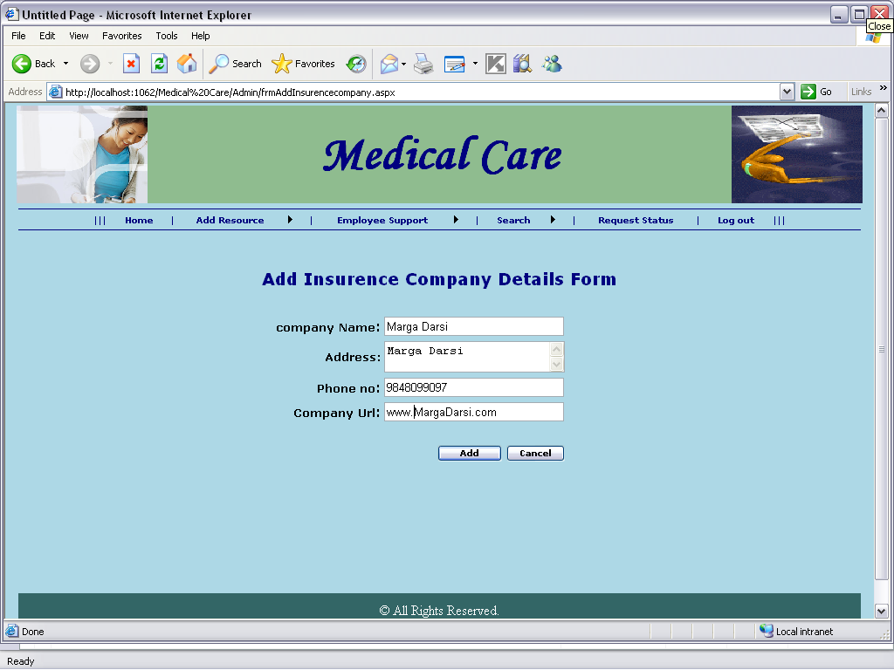
Add policy
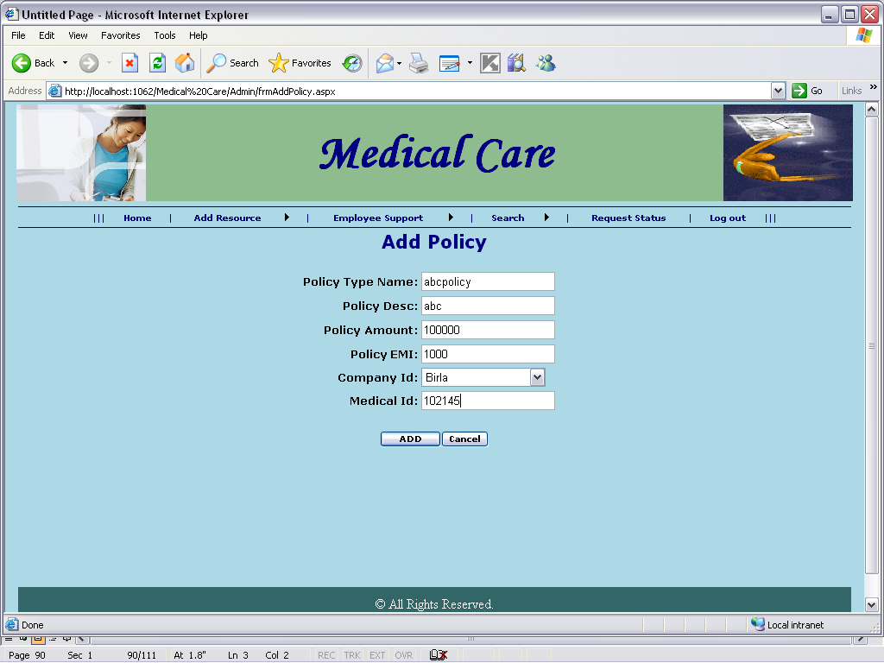

emp details
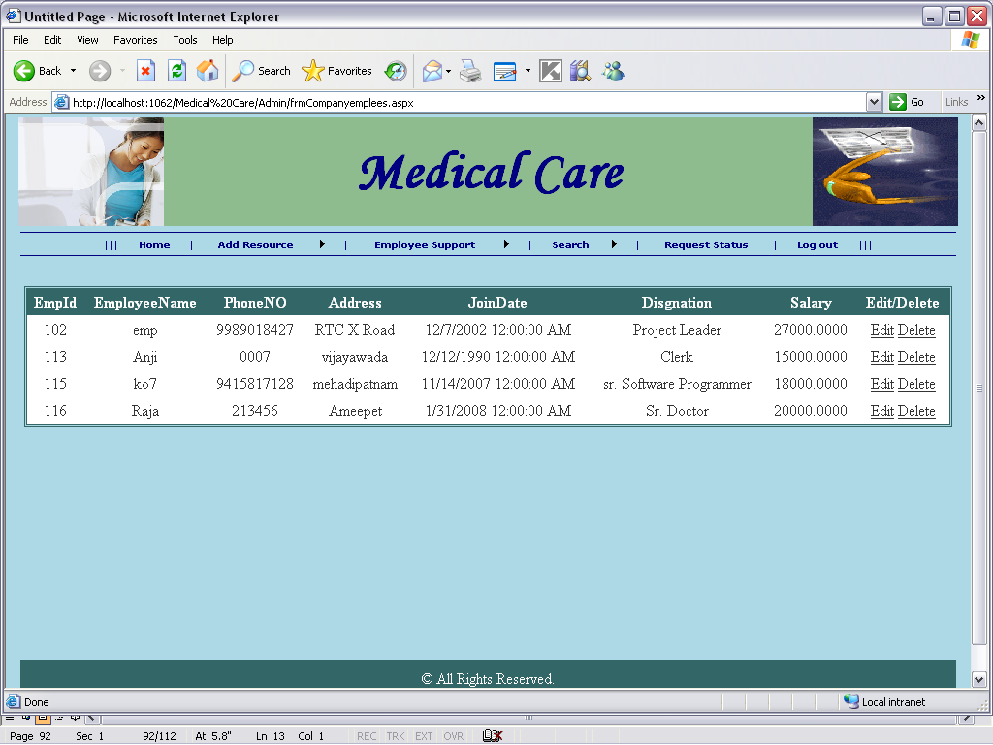
employee register
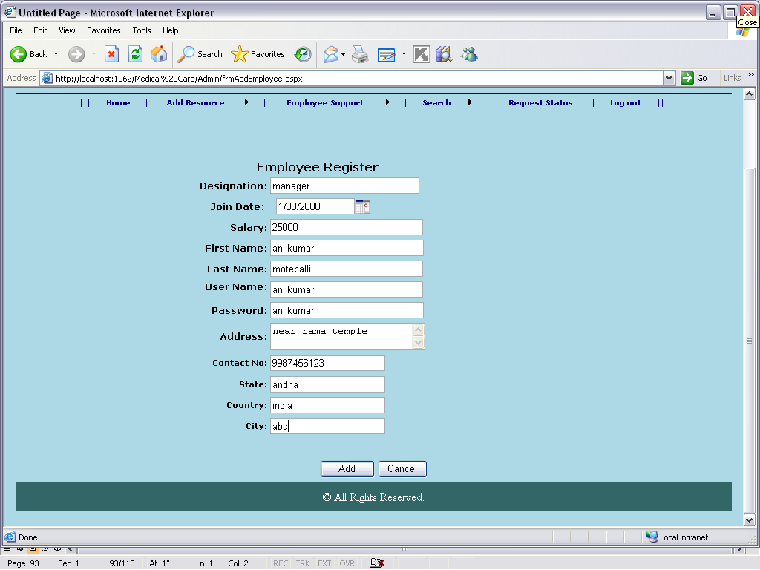

policy request details
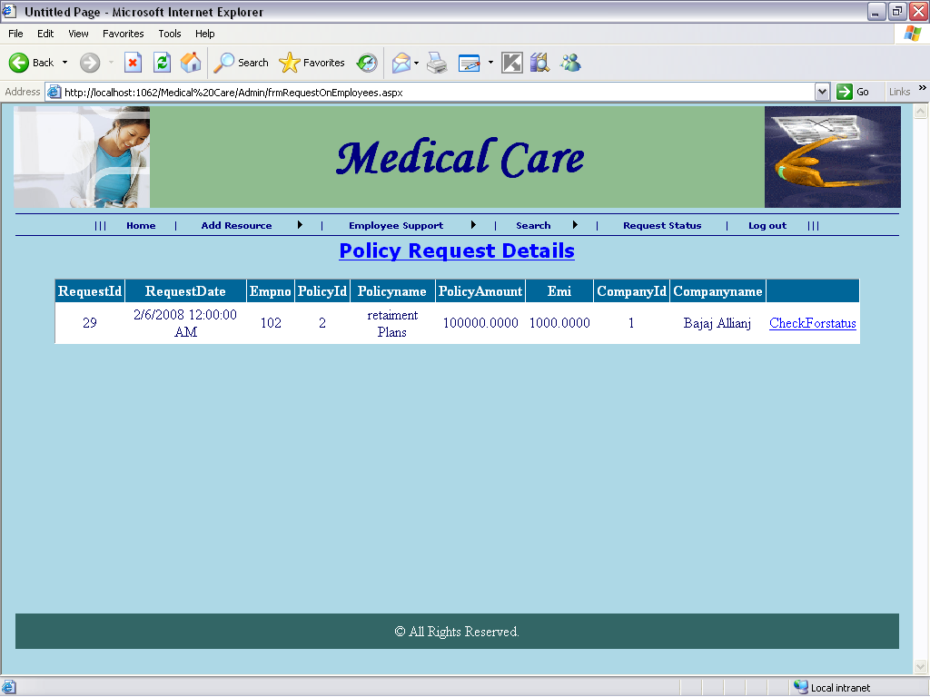
policy details
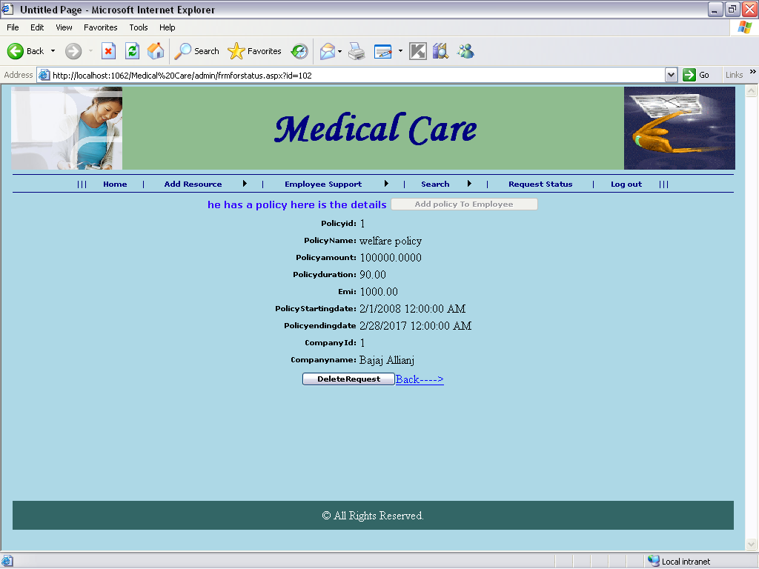

Add policy on emp

