REQUEST SURVEY

We conducted a survey to evaluate the quality of a hotel booking website based on the following criteria:

-Ease of use

-Beauty (Aesthetic appeal)

-Interactivity

-Website content

We surveyed 5 people, and each criterion was rated on a scale of 1 to 5. The results are as follows:

**Ease of use:**

-3 people rated it 5

-2 people rated it 4

The hotel booking website was evaluated as easy to use by most of the survey participants. Only 2 people rated it 4, possibly indicating that they needed some time to familiarize themselves with the website.

**Beauty** (Aesthetic appeal)**:**

-3 people rated it 5

-2 people rated it 4

The website was also highly rated in terms of aesthetics. Most of the survey participants found the website design to be attractive and appealing.

**Interactivity:**

-1 person rated it 5

-2 people rated it 4

-2 people rated it 3

The hotel booking website was evaluated as having good interactivity, although some survey participants suggested that there is room for improvement in this aspect.

**Website content:**

-2 people rated it 4

-3 people rated it 3

The website content was rated as average. While two participants rated it highly, the majority of the survey participants suggested that the website content could be improved.

*In summary, the hotel booking website was rated highly in terms of ease of use and aesthetic appeal, but there is still room for improvement in interactivity and website content.*

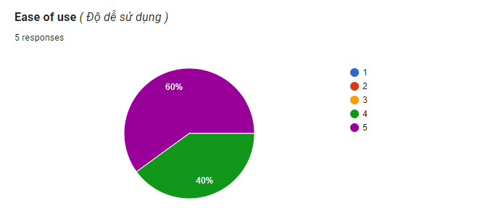

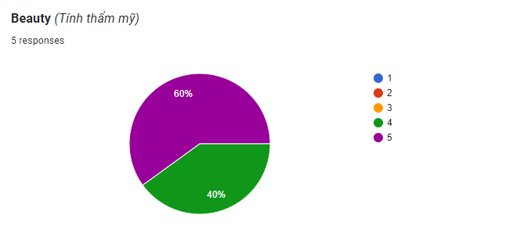

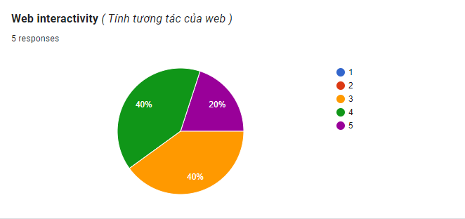

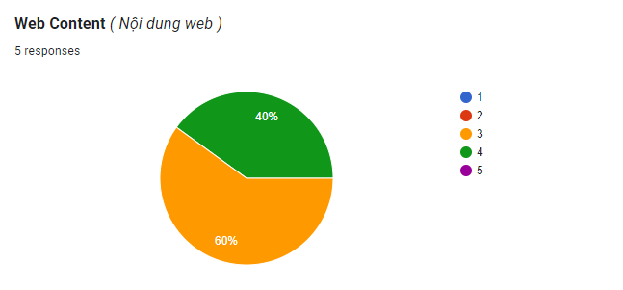

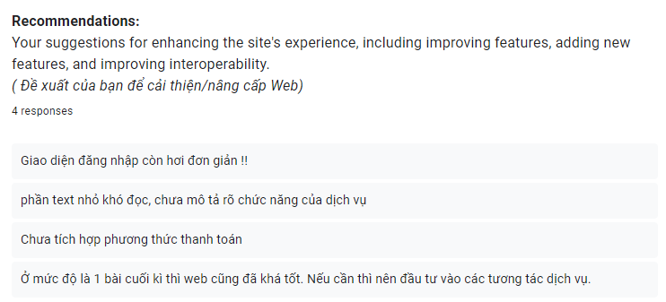

*The survey is presented for easier reference in*

*Link_Gg_sheet:*

*<https://docs.google.com/spreadsheets/d/1bqET-Q2BL8dt1VTnaJZPOLht9eFs9Lv8hBn-r8vE94Y/edit?usp=sharing>*