VIETNAM GENERAL CONFEDERATION OF LABOR

**TON DUC THANG UNIVERSITY**

**FACULTY OF INFORMATION TECHNOLOGY**

**FINAL PROJECT**

**WEB PROGRAMMING AND APPLICATIONS**

*Instructor:* **TS Phạm Thái Kỳ Trung**

*Student:* ***Nguyễn Thanh Tuấn_521H0327***

***Lê Nguyễn Tuyết Nhi_521H0364***

*Student ID:* **521H0327**

**521H0364**

*Class:* **21H50301**

**21H50202**

**HO CHI MINH CITY, 2023**

**VIETNAM GENERAL CONFEDERATION OF LABOR**

**TON DUC THANG UNIVERSITY**

**FACULTY OF INFORMATION TECHNOLOGY**

**FINAL PROJECT**

**WEB PROGRAMMING AND APPLICATIONS**

*Instructor:* **TS Phạm Thái Kỳ Trung**

*Student:* ***Nguyễn Thanh Tuấn_521H0327***

***Lê Nguyễn Tuyết Nhi_521H0364***

*Student ID:* **521H0327**

**521H0364**

*Class:* **21H50301**

**21H50202**

**HO CHI MINH CITY, 2023**

**Acknowledgement**

We would like to thank the teachers of Ton Duc Thang University in Ho Chi Minh City, as well as the teachers of the Department of APPLIED PROBABILITY AND STATISTICS FOR IT for their enthusiastic guidance during my time studying at the school; Special thanks to Mr.Trung who directly guided me to complete my graduation thesis. Besides, I would also like to thank all the friends of the 21H50301 and 21H0202 class, friends, and brothers and sisters who have accompanied and encouraged me during the past time.

Above all, We would like to thank my parents for their dedication to nurturing and teaching; always support, care for me, give me peace of mind to study.

We sincerely thank!

Table of content

I. Introduction 1

1. Reason 1

2. Project mission 1

2.1 Target 1

2.2 Range: 2

II. Theoretical basis 2

1. Concept 2

2. Issues related to website development booking 3

III.Analysis and design requirements 3

1. Requirements Analysis 4

2. Analysis and design of system architecture 4

2.1 Database 4

2.2 Interface 4

IV. Result 6

1. Overall results 6

1.1 Database [ code] 6

1.2 Ux/Ui [framework] 6

2. Impact of project 6

2.1 User experience 6

2.2 Survey and rating chart 6

V. Reference 7

1. Citation of documents. 7

2. Cite the image source. 7

CHAPTER I: INTRODUCTION

1. **Reason**

In today's digital age, online services are becoming more popular than ever. Among them, online hotel booking is widely used and is one of the services that is growing rapidly.

For a long time, hotel bookings were usually made by contacting the hotel directly or through travel agencies. However, with the development of technology, online hotel booking websites have emerged and are increasingly being widely used.

To learn and apply the knowledge learned into practice, I have decided to choose a topic to build a hotel booking website. This is an interesting and highly applicable topic, helping me to develop and improve my web programming skills as well as to have a better understanding of the process of developing online services.

To be able to carry out this topic, I will need to research about website building techniques, database design, understand hotel booking systems, and related issues regarding customer information security.

I believe that researching and building a hotel booking website will help me improve my knowledge and skills in web programming and help me better understand the process of developing online services, from which I can apply and implement them effectively in practice.

1. **Project mission**
   1. Target

The objective of this project is to build a hotel booking website with all necessary functions for users to easily, quickly, and conveniently book rooms.

Specifically, the website will have the following features:

- Display detailed information about the hotel such as address, phone number, and descriptions of amenities and services.

- Allow users to search for hotels based on criteria such as location, price, amenities, and services.

- Allow users to make online reservations through the website.

- Allow users to view their booking history and cancel reservations.

Integrate security features for customer information and safe online payments.

* 1. Range

-To research website development techniques such as HTML, CSS, JavaScript, and PHP.

-To design a database to store information about hotels, rooms, and customer booking information.

-To study the hotel booking systems that are currently being used and develop similar functions.

-To research methods for securing customer information and integrate security features into the website.

-To test and evaluate the effectiveness of the hotel booking website.

CHAPTER II. THEORETICAL BASIS

**1. Concept**

Hotel booking: The process of reserving hotel rooms over the internet through hotel booking websites.

Hotel booking website: A website that provides online hotel booking services to users, allowing them to search, compare, and book hotels conveniently.

Database: A system for storing information about hotels, rooms, prices, bookings, payments, etc.

Search and filter: A feature that allows users to search for hotels based on criteria such as location, price, room type, amenities, etc.

Online booking and payment: A feature that enables users to book and pay for hotels online quickly and securely through the hotel booking website.

Information security: A system that protects customer information from cybersecurity threats, ensuring the confidentiality and security of customer information.

**2. Issues related to website development booking**

Design an intuitive, user-friendly interface that helps users easily search and book hotels.

Integrate an effective hotel search and filtering system that helps users search and compare prices, room types, amenities, location, etc.

Build an accurate and comprehensive database of hotel information, including rooms, prices, etc.

Integrate online booking and payment features to ensure safety and convenience for users.

Ensure customer information security, minimize cybersecurity threats, and protect the privacy of customer information.

Optimize the website to reduce page load times and provide a better user experience.

Ensure hotel service quality and provide customer support when necessary.

Promote and effectively reach customers to attract a large number of visits and increase sales.

CHAPTER III. ANALYSIS AND

DESIGN REQUIREMENTS

1. **Requirements Analysis**

Develop a hotel booking website including basic features that allow customers to book rooms and allow hotels to manage rooms.

Customers can choose the date and number of rooms to book, and the search results will display different room types with different features and prices.

In addition, customers can choose additional services such as breakfast or airport transfer. Customers do not need to log in to book a room and can also view their booking information. If customers log in, they can also edit their personal information to automatically fill in the form each time they book a room. To develop a hotel booking website as required by the customer, it is necessary to consider and handle issues such as room management, payment system, customer information management, and integration of other support services.

1. **Analysis and design of system architecture**
   1. Database

During the analysis and design process of a hotel booking website, building a database is an important step. The database will store information about customers, rooms, bookings, payments, and other related information.

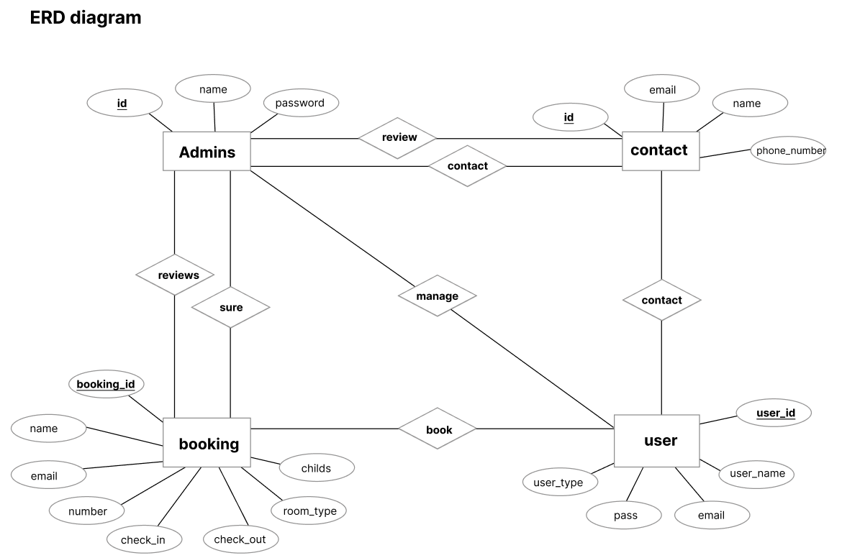

Detailed attributes

**1. admins**

- id (primary key): admins identifier attribute

- name: attribute name admins

- password: password attribute of admins

**2. contact**

- id (primary key): attribute distinguishing contacts

- email: the email attribute left by the user

- phone_number: customer's phone number to contact

1. **booking**

- booking_id (primary key) : attribute identifying the room that the guest booked

- name: attribute of room name

- email: the email attribute the customer fills in

- number: customer's contact phone number

- rooms: number of rooms

- check_in: check-in date

- check-out: check-out date

- children: number of children

- room_type: room type

1. **user**

- user_id (primary key) : customer identifier

- user_name: customer name

- email: the email of the customer using the login

- pass: customer's login password

- user_type: distinguish users and admins

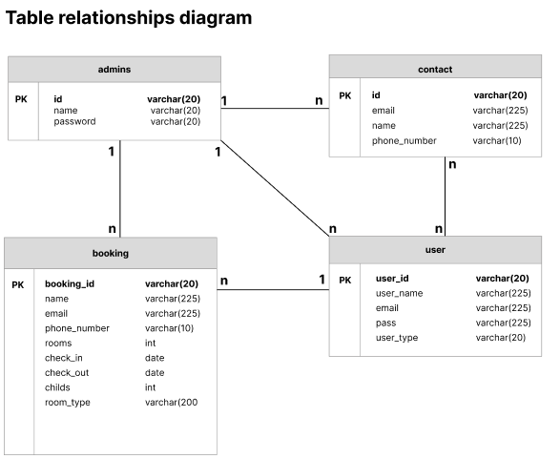

`

2.2 Interface

2.2.1 Design style

The modern and minimalistic design style is a popular design style used in many fields, including web design. This is a design style that focuses on minimalism and content, making the website creative and attractive.

Colors in modern and minimalistic design style often use monochromatic or light colors to minimize complexity and enhance the aesthetics of the website. Additionally, lines, images, and graphics are also used minimally, lightly, and simply.

Furthermore, high interactivity is also an important factor in modern and minimalistic design style. Website elements are arranged clearly, with links and easy searchability, helping users quickly access the information they need.

The modern and minimalistic design style also allows the use of interactive effects such as hover, scroll, click, etc. to enhance interactivity and create a better user experience.

2.2.2 Wireframe

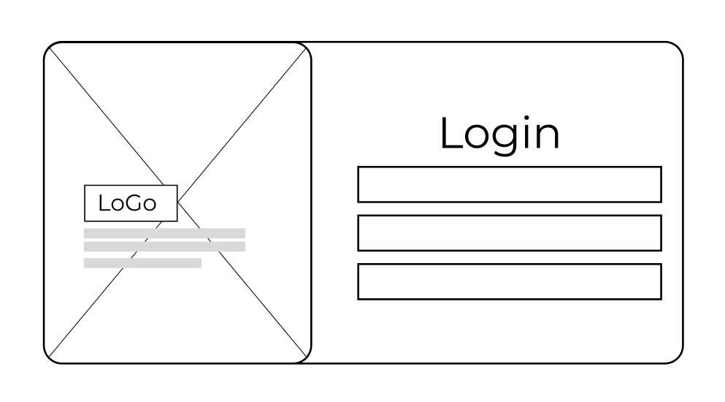

1. Login form

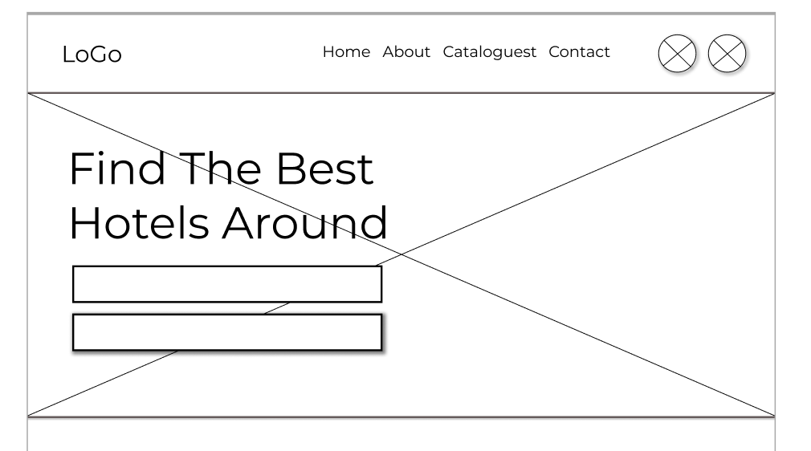

1. Header

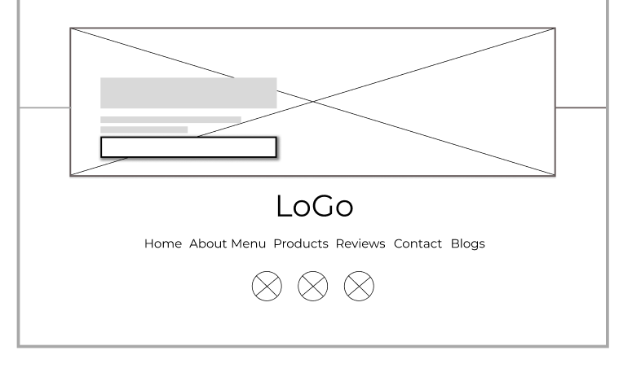

1. Footer

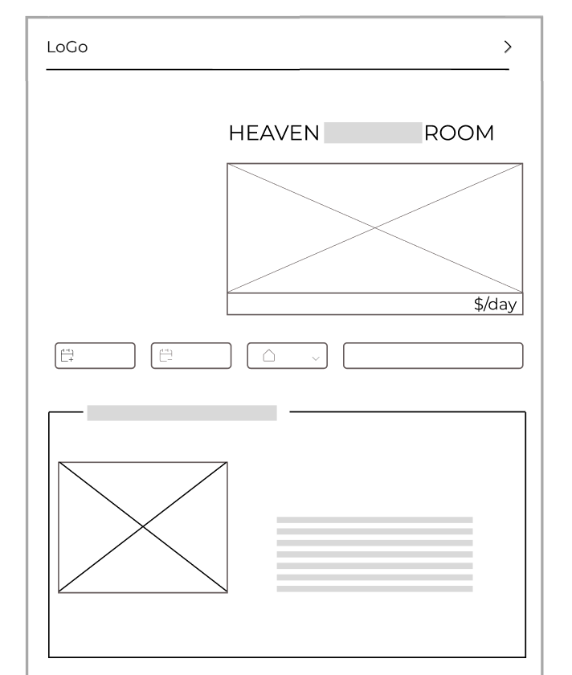

1. Room_booking

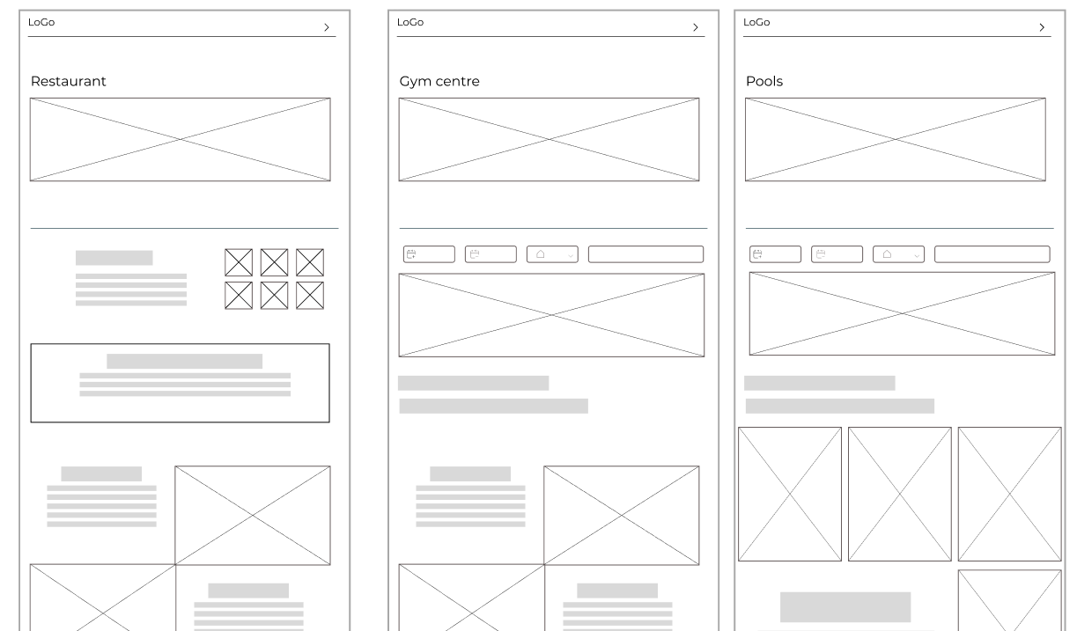

1. Facilities

Link_my_wireframe

<https://www.figma.com/file/IGYzDnucoA4ezrygWBMxMj/521H0327_NGuyenThanhTuan_WireFrame?type=design&node-id=0%3A1&t=M2fO93bLmOV6uaX9-1>

CHAPTER IV. RESULT

**1. Overall results**

1.1 Database

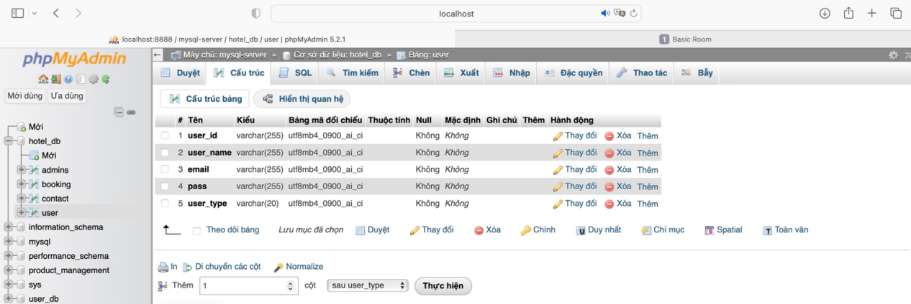

1. User

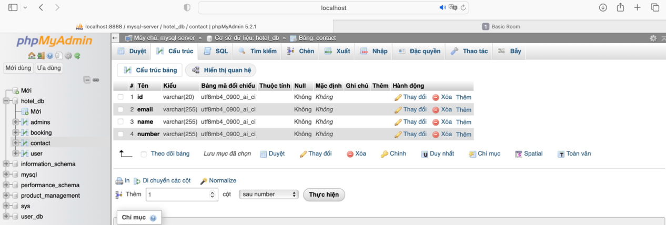

1. contact

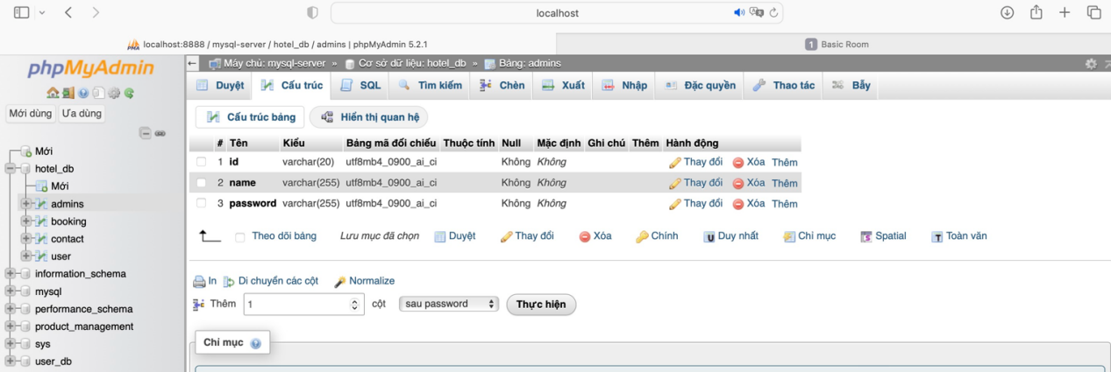

1. admins

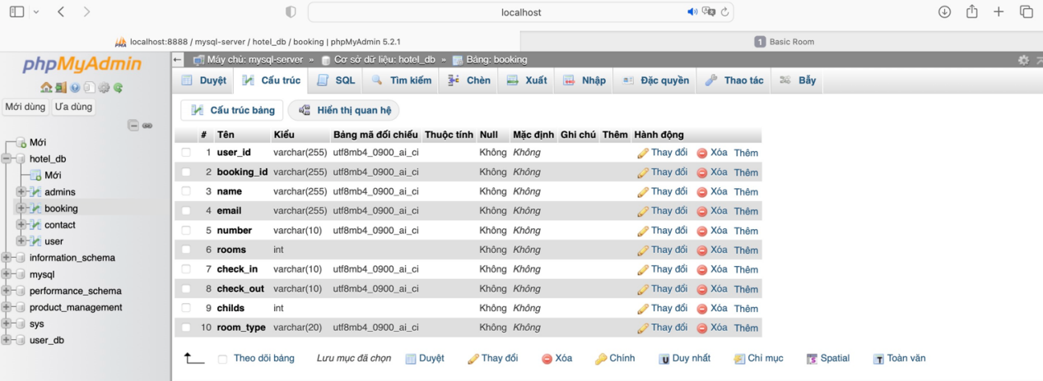

1. booking

1.2 Ux/Ui

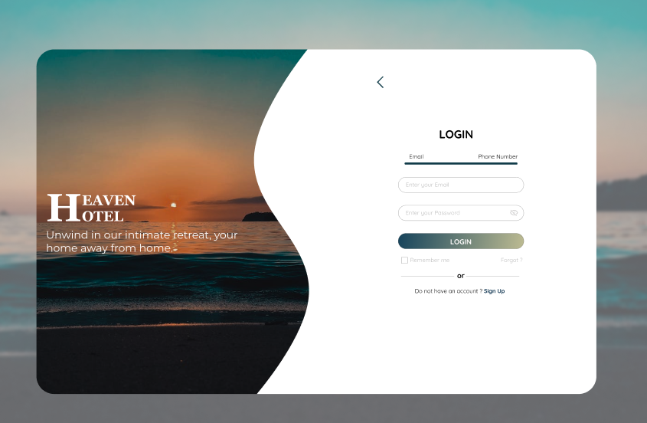

1. Login_form

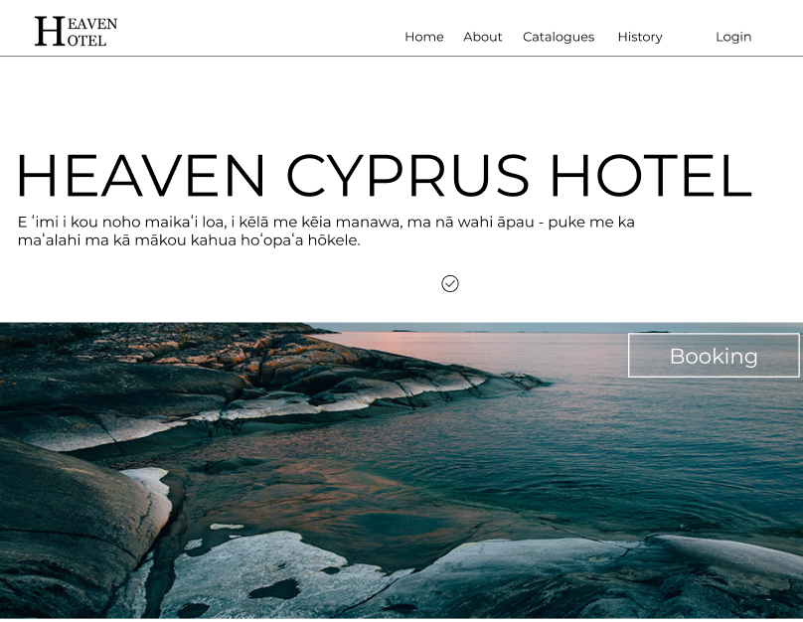

1. Header

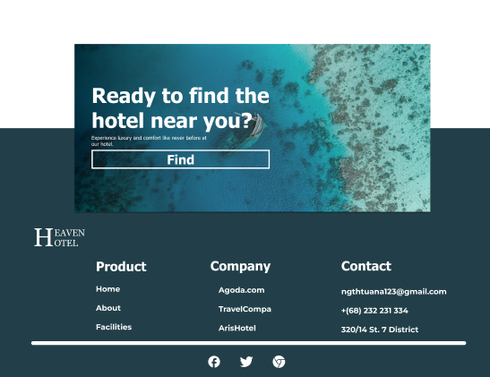

1. Footer

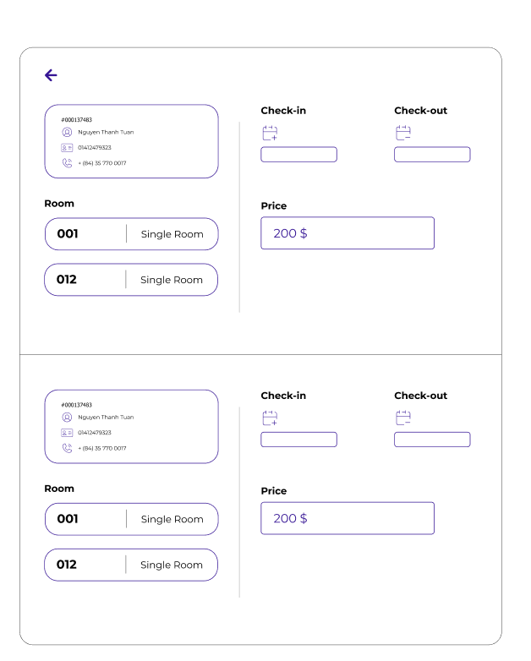

1. History_check

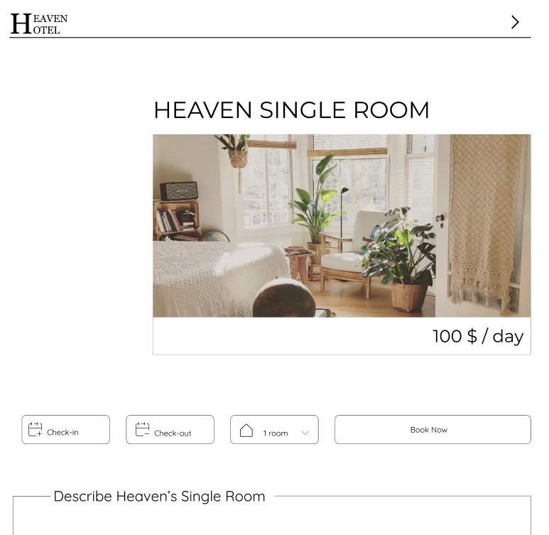

1. Room

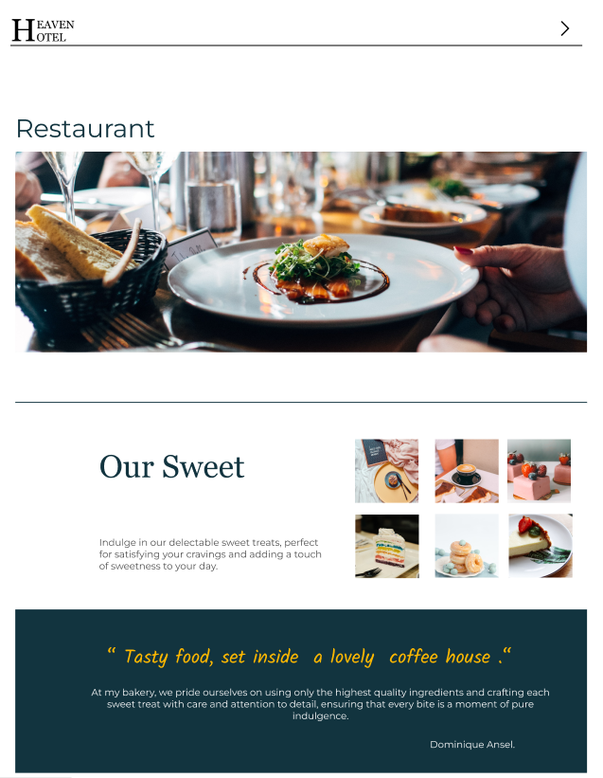

1. Restaurant

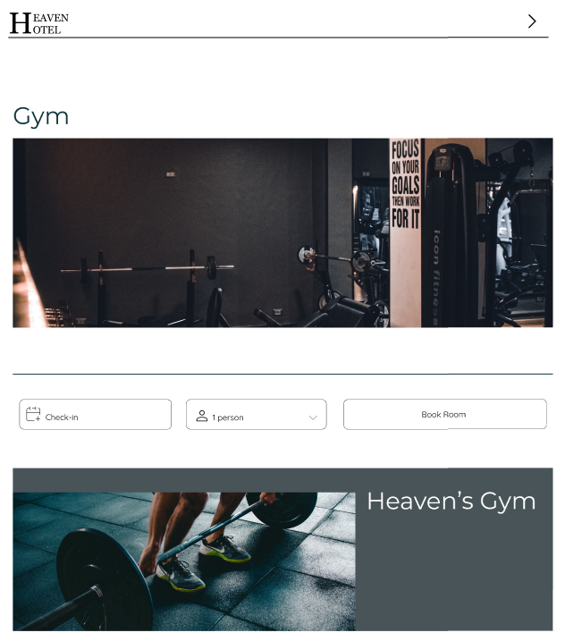

1. Gym

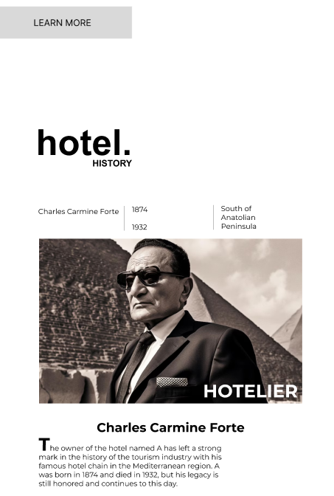

1. About_hotel

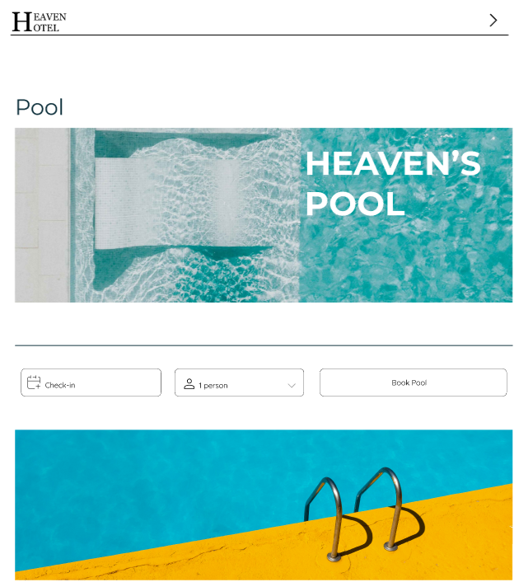

1. Pool

Link_Figma_frame

<https://www.figma.com/file/PRAeRxHQ7fM95sm9yeNkD2/Frame_dynamte?type=design&node-id=0%3A1&t=nTdBZAwrQFeFZn1U-1>

**2. Impact of project**

2.1 User experience

Link form feedback:

<https://forms.gle/9TZuq1XAcUVq6Jcf8>

2.2 Survey and rating chart

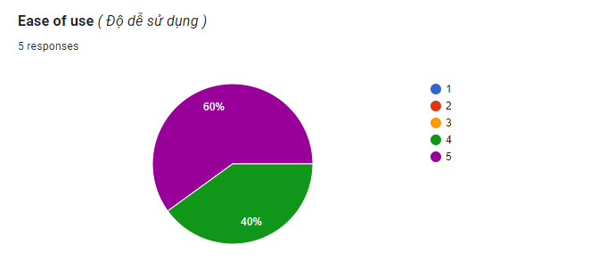

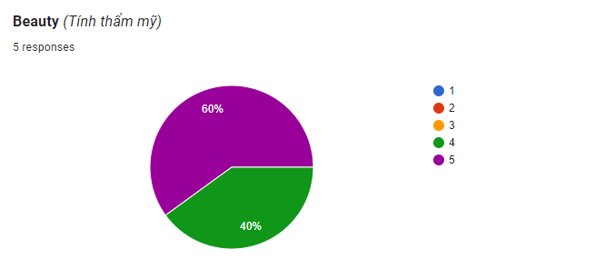

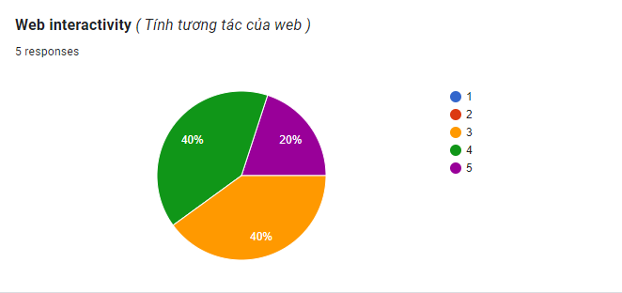

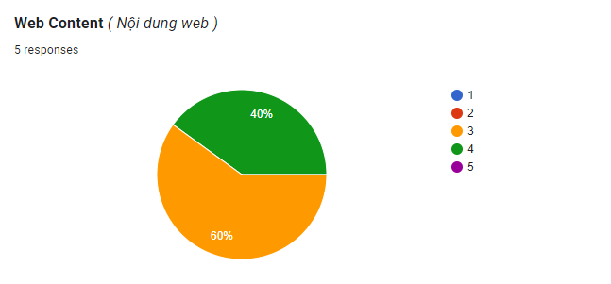

CHAPTER V. REFERENCE

1. **Citation of documents**

W3schools: <https://www.w3schools.com/>

Cdnjs library: <https://cdnjs.com/libraries>

F8.com: <https://fullstack.edu.vn/>

1. **Cite the image source**

Freepik.com: <https://www.freepik.com/>

Behance.net: <https://www.behance.net/>