Keycloak Configuration – Global Merchant API

##### 

**Log-in to Keycloak admin console: http://api-backoffice-aaa.truemoney.com/auth/** **2**

**Select backoffice realm** **3**

**Go to Clients and select acm-global-merchant-operation-api** **3**

**Input the following value in Role Name 3 times** **4**

**Select Authorization ,then Resource and Create** **4**

**Input the following values and save** **5**

**Go to Policies , click Create Policy and choose Role** **6**

**Input the following value for Role Policy and save and repeat for each set** **6**

**Select Permission then click Create Permission and choose Scope-based** **7**

**Input the following value to add scope permission and repeat for each set** **8**

**Choose client backofficeui , select Scope and choose acm-global-merchant-operation-api for Client Roles** **9**

**Select all 3 available roles for admin and click Add selected** **9**

**Go to Groups and double-click on global-merchant** **10**

**Select Role Mappings then choose acm-global-merchant-operation-api for Client Roles and add all 3 admin roles** **10**

##### 

##### Log-in to Keycloak admin console: <http://api-backoffice-aaa.truemoney.com/auth/> [1]

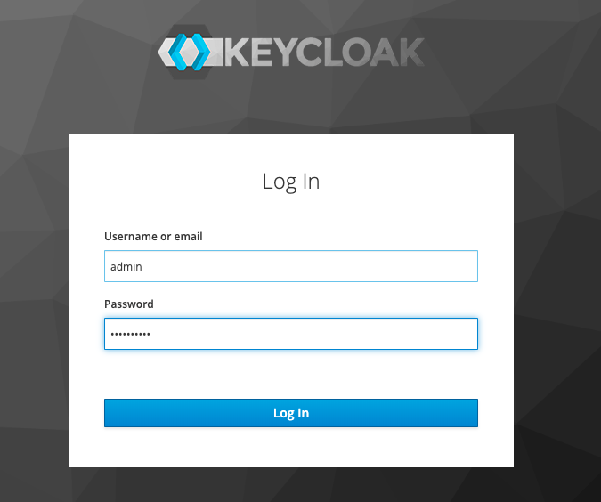

##### Select *backoffice* realm

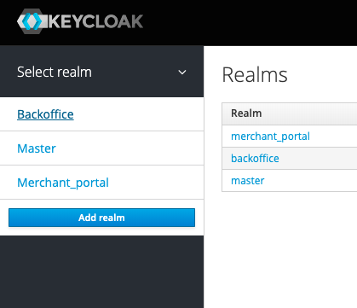

##### Go to *Clients* and create *acm-global-merchant-operation-api*

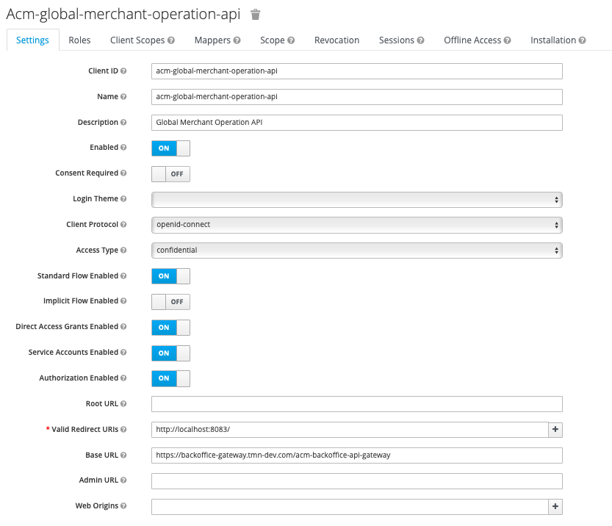

|  |  |
| --- | --- |
| Client ID | acm-global-merchant-operation-api |
| Name | acm-global-merchant-operation-api |
| Description | Global Merchant Operation API |
| Enabled | ON |
| Consent Required | OFF |
| Client Protocol | openid-connect |
| Access Type | confidential |
| Standard Flow Enabled | ON |
| Implicit Flow Enabled | OFF |
| Direct Access Enabled | ON |
| Service Account Enabled | ON |
| Authoriation Enabled | ON |
| Root URL |  |
| Valid Redirect URL | https://backoffice-ui.truemoney.com/* |
| Base URL | https://backoffice-gateway.truemoney.com/acm-backoffice-api-gateway |
| Admin URL |  |
| Web Origins |  |

We will have:

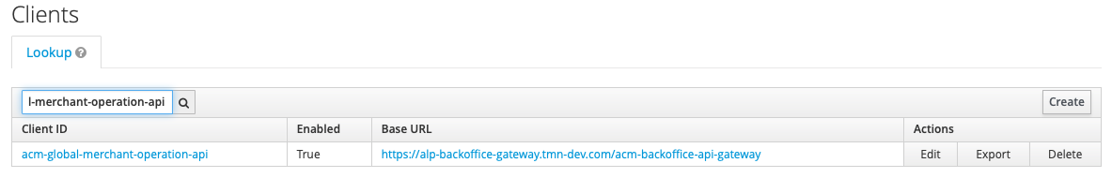

Select *Role* and *Add role*

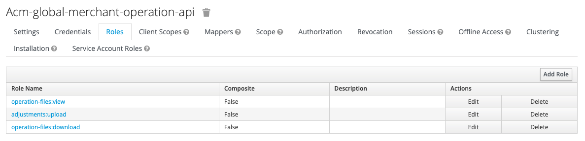

##### Input the following value in *Role Name* 3 times

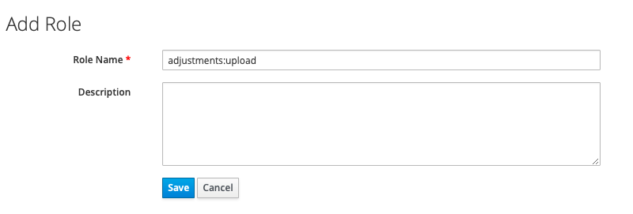

|  |  |
| --- | --- |
| No | 1 |
| Role Name | operation-files:view |
| No | 2 |
| Role Name | operation-files:download |
| No | 3 |
| Role Name | adjustments:upload |

##### Select *Authorization*, then *Authorization Scope* and *Create*

##### 

##### 

|  |  |  |
| --- | --- | --- |
| Name | urn:truemoney.com:scopes:view | urn:truemoney.com:scopes:create |

##### Select *Authorization*, then *Resource* and *Create*

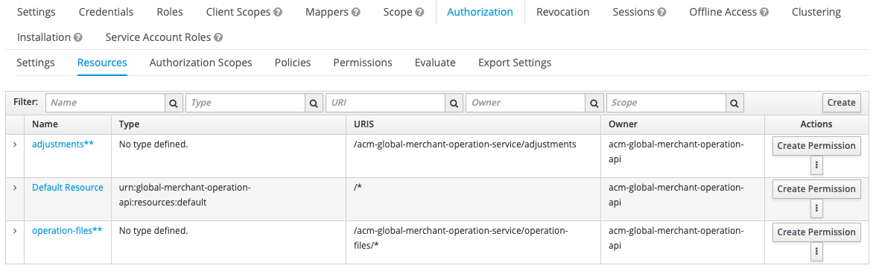

##### Input the following values and save



|  |  |  |
| --- | --- | --- |
| Name | operation-files** | adjustments** |
| Scopes | urn:truemoney.com:scopes:view | urn:truemoney.com:scopes:create |
| URI | /acm-global-merchant-operation-service/operation-files/* | /acm-global-merchant-operation-service/adjustments |

##### Go to *Policies* , click *Create Policy* and choose *Role­­*

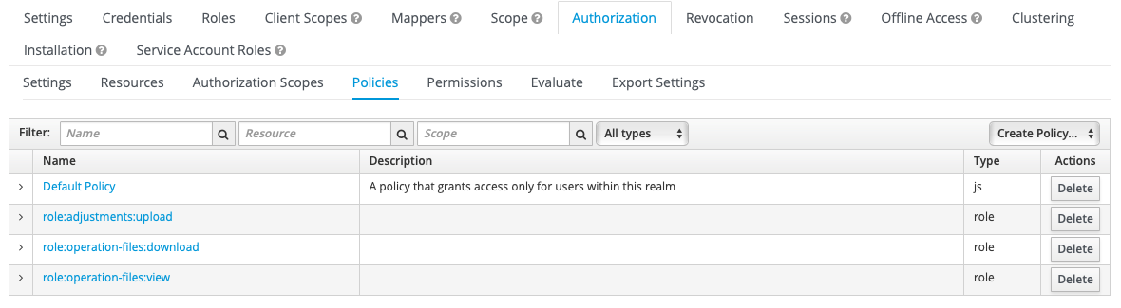

##### Input the following value for Role Policy and save and repeat for each s

|  |  |  |  |
| --- | --- | --- | --- |
| No. | 1 | 2 | 3 |
| Name | role:operation-files:view | role:operation-files:download | role:adjustments:upload |
| Clients | acm-global-merchant-operation-api | acm-global-merchant-operation-api | acm-global-merchant-operation-api |
| Client Roles | operation-files:view | operation-files:view | adjustments:upload |
| Required | Yes | Yes | Yes |

##### Select *Permission* then click *Create Permission* and choose *Scope-based*

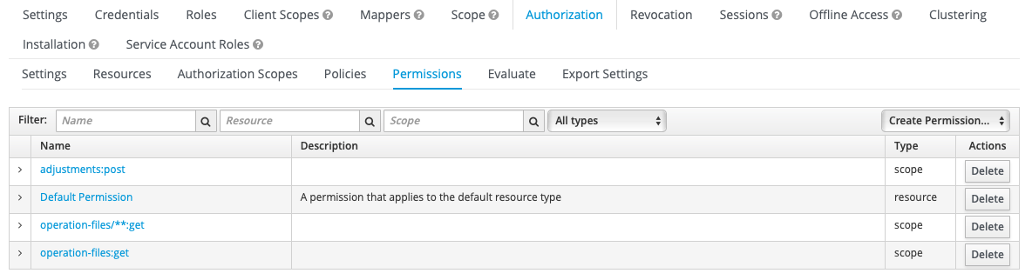

##### Input the following value to add scope permission and repeat for each set

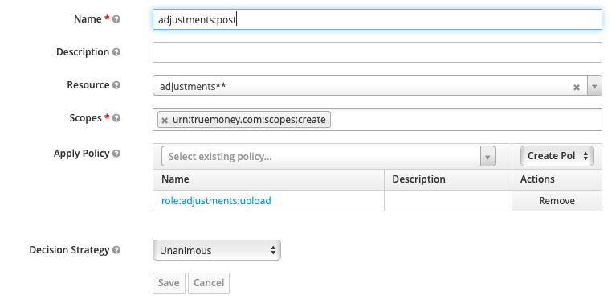

|  |  |  |  |
| --- | --- | --- | --- |
| No. | 1 | 2 | 3 |
| Name | operation-files:get | operation-files/**:get | adjustments:post |
| Resource | operation-files** | operation-files** | adjustments** |
| Scopes | urn:truemoney.com:scopes:view | urn:truemoney.com:scopes:view | urn:truemoney.com:scopes:create |
| Apply Policy | role:operation-files:view | role:operation-files:download | role:adjustments:upload |

##### Choose client *backofficeui* , select *Scope* and choose *acm-global-merchant-operation-api* for *Client Roles*

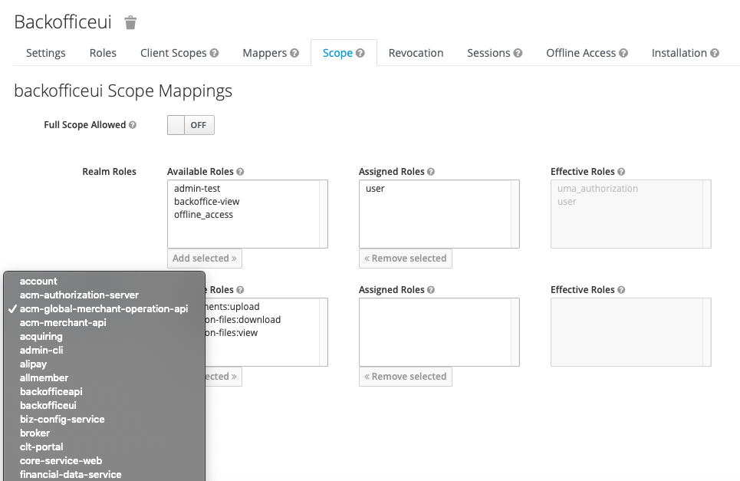

##### Select all 3 available roles for admin and click *Add selected*

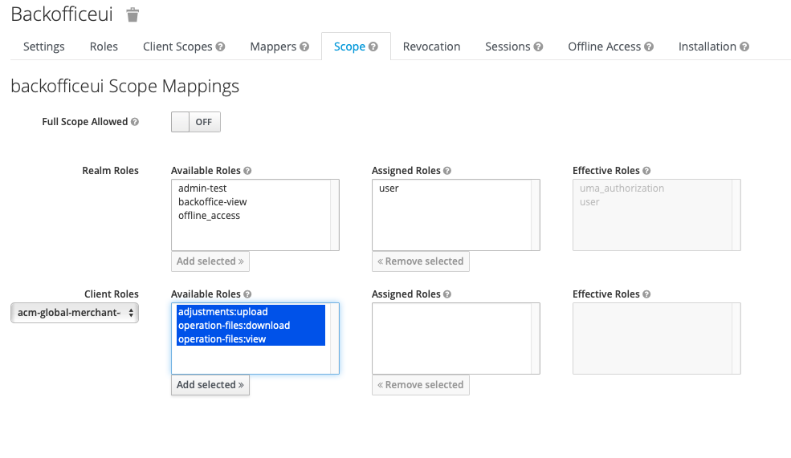

##### Go to *Groups* and create parent group *global-merchant* & child group *global-merchant-admin*

##### 

##### Go to *Groups* and double-click on *global-merchant-admin*

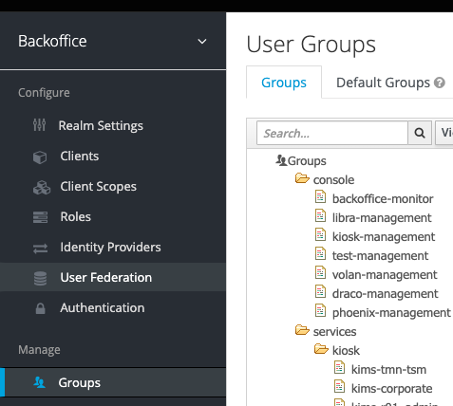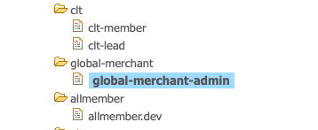

##### Select *Role Mappings* then choose *acm-global-merchant-operation-api* for *Client Roles* and add all 3 admin roles

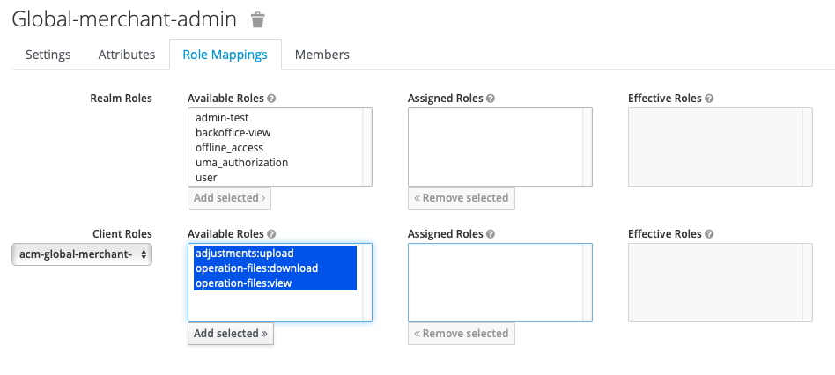

1. Required a connection to AIA build WiFi or TDPK WiFi