Group Project Documentation   
Basic Cross-Platform Application Programming with .NET

***OJT Managerment System***

**Prepared by Group 1**

***Thái Quốc Toàn – SE151272***

***Lưu Thanh Huy – SE151262***

***Nguyễn Hữu Thanh – SE151252***

***Mai Thanh Tỷ - SE151170***

**Ho Chi Minh City, 2022**

**Table of Contents**

**Table of Contents ii**

**Revision History ii**

**1.** **Project Introduction 1**

1.1 Product Perspective 1

1.2 User Classes and Characteristics 1

**2.** **Database Design 4**

**3.** **System Architecture 5**

**4.** **Implementation 5**

4.1. Deployment Considerations 5

4.2. Screenshots and explanations 6

**Revision History**

|  |  |  |  |
| --- | --- | --- | --- |
| **Name** | **Date** | **Reason For Changes** | **Version** |
| *Group 1* | *01 June 2022* | *Initial draft* | *1.0 draft 1* |
|  |  |  |  |
|  |  |  |  |
|  |  |  |  |

# Project Introduction

## Product Perspective

The OJT management system allows students, a university, and companies to access and use all functions of each specific role. Before the system was built, the legacy still was done by hand through the excel file.

* The business relations department allows students to register via google form and then aggregate the list using excel
* The problem is that it takes time to summarize and when there is a change such as a student reservation, student change enterprise. In addition, the process of recording the completion and evaluation of the OJT period also takes a lot of times for the corporate relations department.
* The system was born to solve the must-have problems, to support the business relations department in the management of OJT and businesses with students participating in OJT.

## User Classes and Characteristics

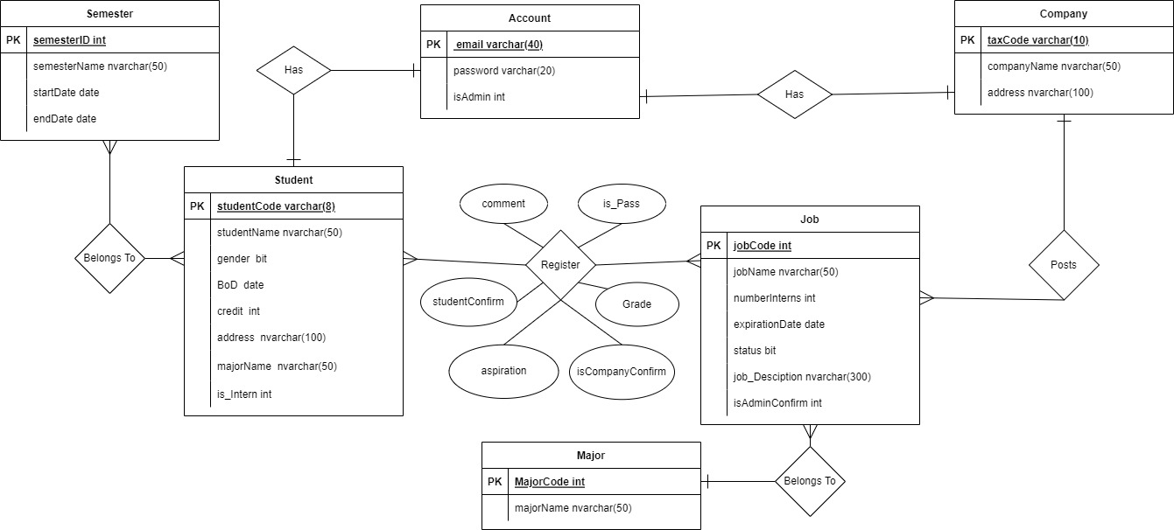

* *Student:*

***+*** Login with Student’s role.

+ Update student’s profile includes: name of student (length 6-50 characteristics), gender(Male/Female), birth of date, address(length 10-50 characteristics).

+ Change password. (condition: length 6-20 characteristics).

+ Find, and View the company following name, address, and job.

+ Register into jobs of companies that the student wants to join the internship. The condition when students wish to register for the internship that each student allows registering a maximum of 2 companies. If the student was accepted by the school for the first registered company, the second registered company of this student will be canceled. If the student needs change the first choice then student just allows change by the second choice. And View result of their internship after the finish internship.

+ Cancel the application after registering.

* *University:*

+ Login with School’s role.

+ Create a student’s account for students that includes: email, password, student code, student name, gender, birth Of date, credit, address, semester.

+ Create a company account includes: company name, address, tax code.

+ Edit student’s detail about credit, semester, and password.

+ Confirm student’s registration. (Status: accepted, denied, waiting).

+ Confirm company’s job (isAdminConfirm: accepted, denied, waiting)

+ Search student by student code. Search company by company name.

+ Create new major that includes: major name.

+ Create new semester that includes: semester name, start date, end date.

* *Company:*

+ Login with company’s role.

+ Update company information that includes: : company name, address.

+ Create companies’s Job that students can register for their internship. (If company’s job expired about the time, the status of job will be changed from action to unaction).

+ Confirm student’s registration. (Status: accepted, denied, waiting).

+ Update companies’s jobs that includes: job name, number of interns, expiration date, status.

+ Delete compay’s job was posted by company (change status of the post).

+ Update Grade, Evaluation for application of student. Status passed or not pass will automatically update for grade greater than 5.

+ Search interns was applied in company’s job by student’s name, student’s job.

# Database Design

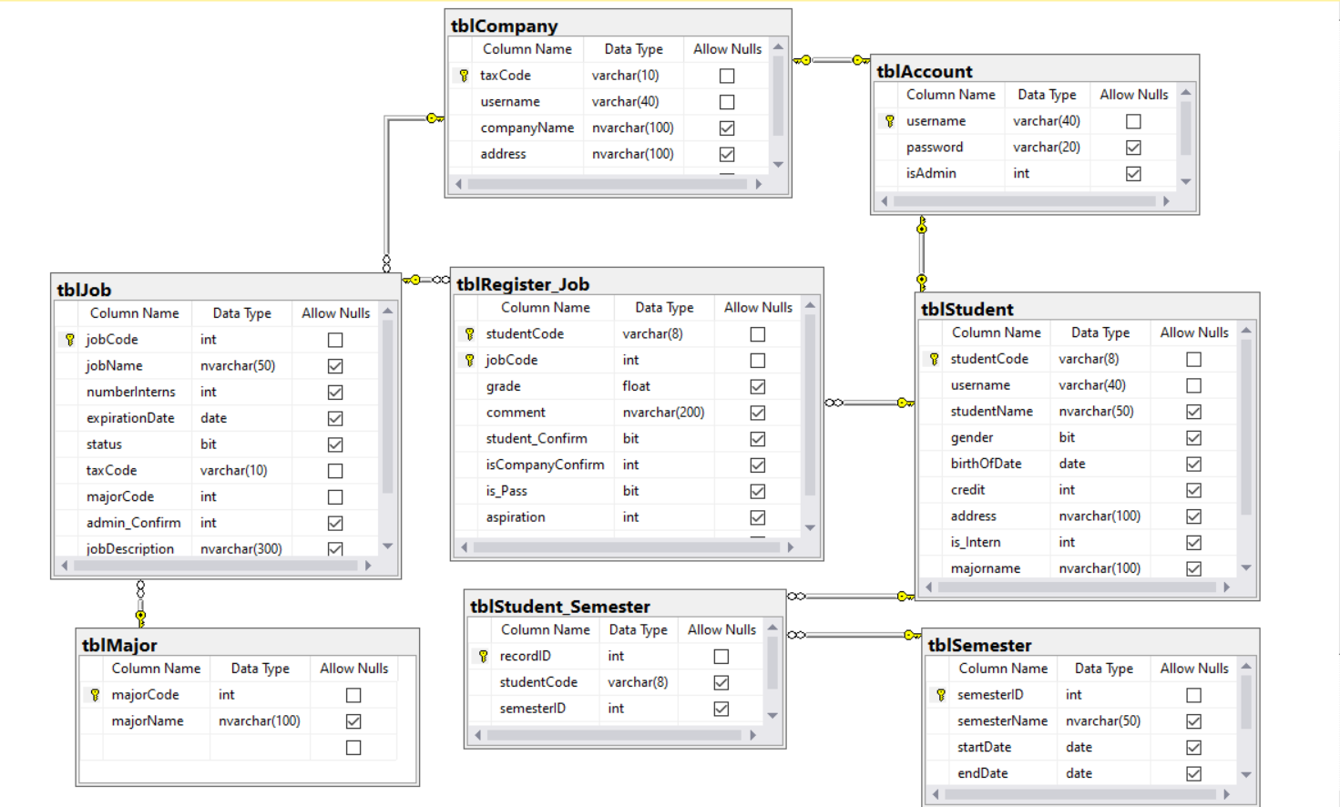

# System Architecture

The system will operate in a Windows Form application which is a UI technology for ".NET". MS SQL Server 2016 version is used to store the data of the system. The system uses Entity Framework Core to interact with data from relational databases using an object model that maps directly to the business objects in our application.

The application will be designed with a three-layers architecture that includes the user interface layer, the business layer, and the data layer. The user interface layer contains pages like windows forms where data is presented to the user and used to take input from the user. The business layer implements business logic and calculations and validates the input conditions before calling a method from the data layer. The data layer established a connection with the database and performs methods to take the data from the database following the user's requirements.

# Implementation

## Deployment Considerations

The deployment can be done through a windows forms application with the connection with the database by Entity framework core 5. The application applies the rule of 3-layers architecture with the business layer is created from the existing database schema.

The system was used by 3 roles that are student, university, and company. For students and companies, if they want to access the system then they must be created an account by the university. The student just uses this account in the default time which is a semester. The company can use this account to recruit students from the university. The university's task is to control the authenticity of the posts that the company has made to the system.

## Screenshots and explanations

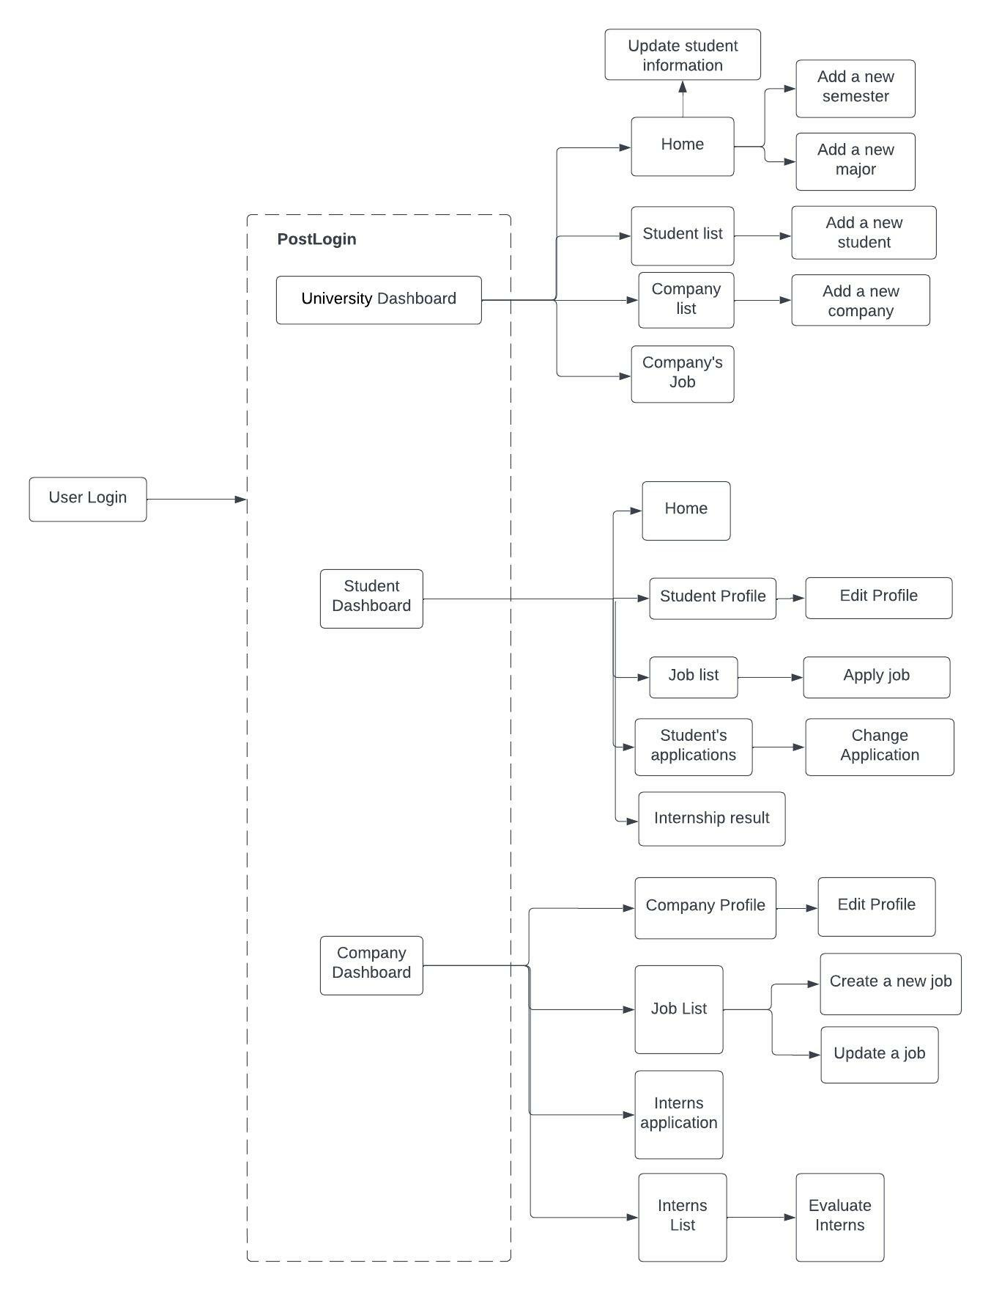

1. Login Form

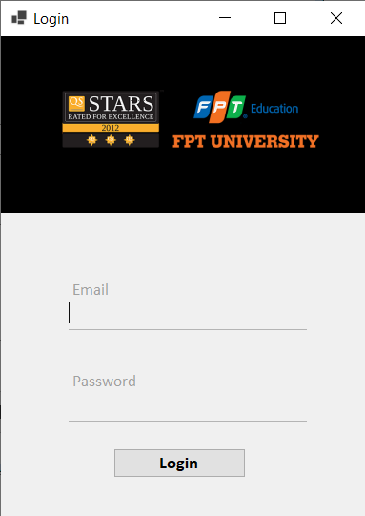

1. University Role

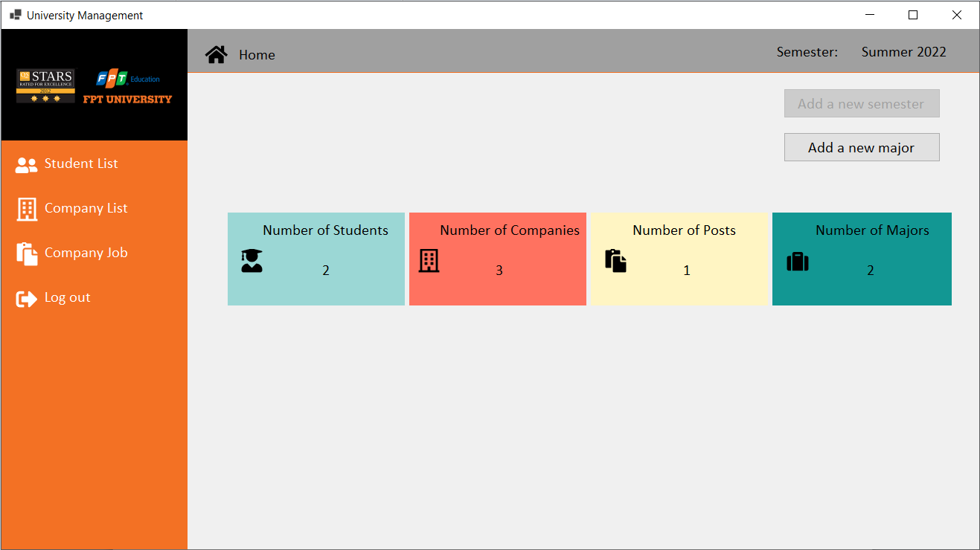

University’s Home form:

* The information about number of students, number of companies, number of posts, and number of majors.
* Allow the university add a new semester if today is a finished day of the current semester.
* Allow the university add a new major.

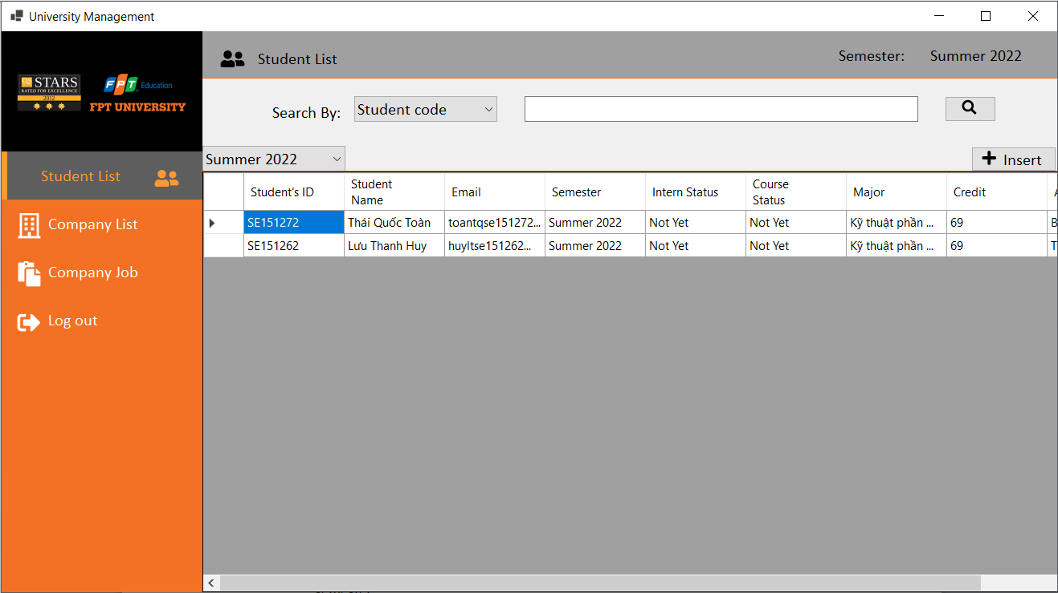

University’s Student list form:

* Allow the university to create a new student in the current semester.
* Allow the university to update a student’s information when they click double into the any rows.

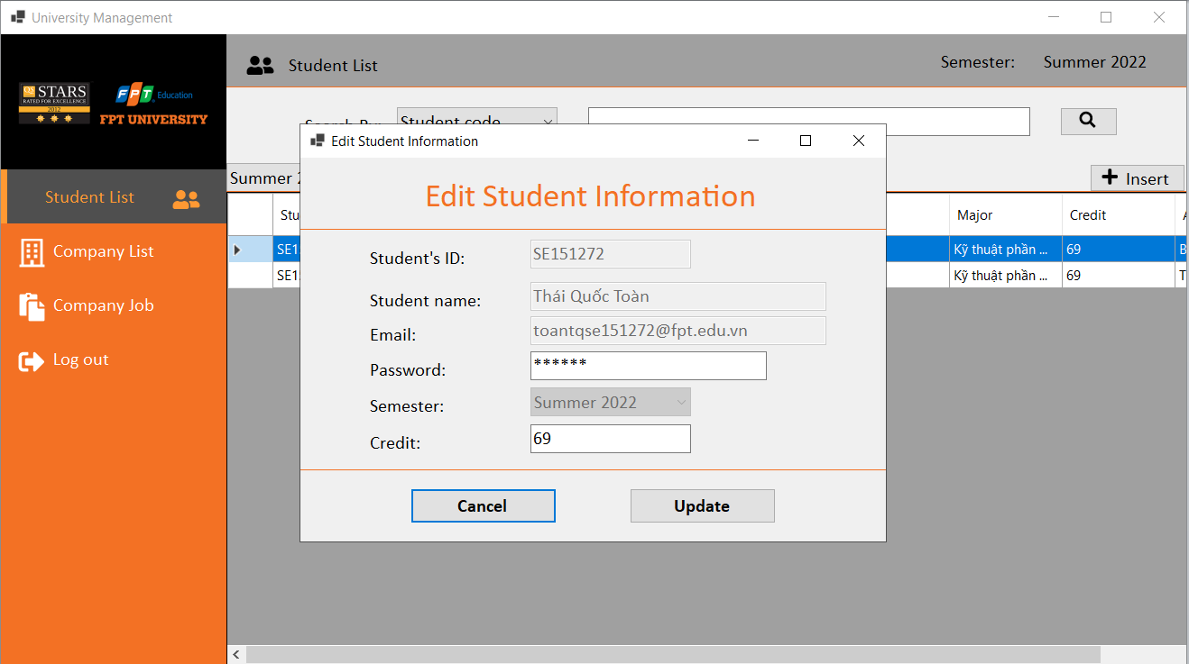

* Allow the university to search students following the filter which they want to choose in the Combobox.

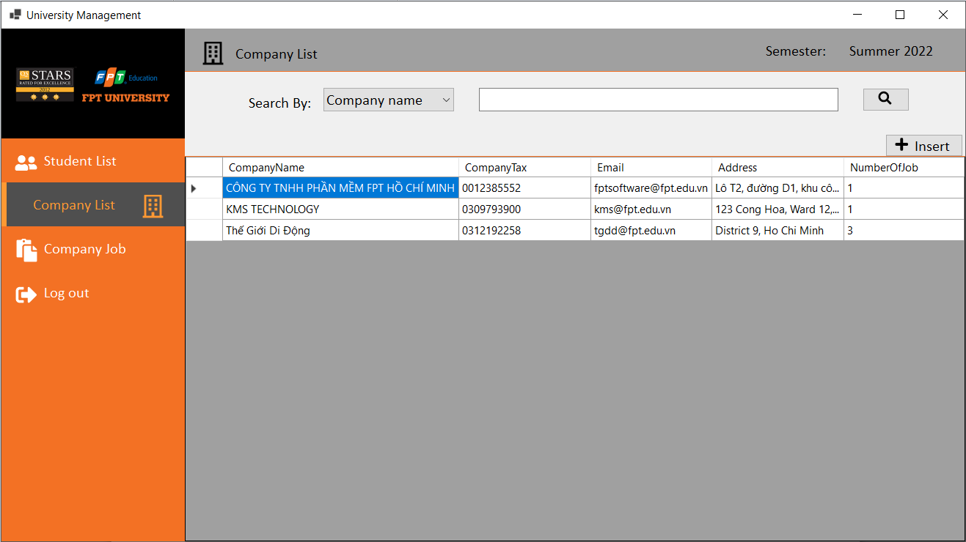

University’s Company List form:

* Allow the university to create a new company.
* Allow the university to search companies following the filter which they want to choose in the Combobox.

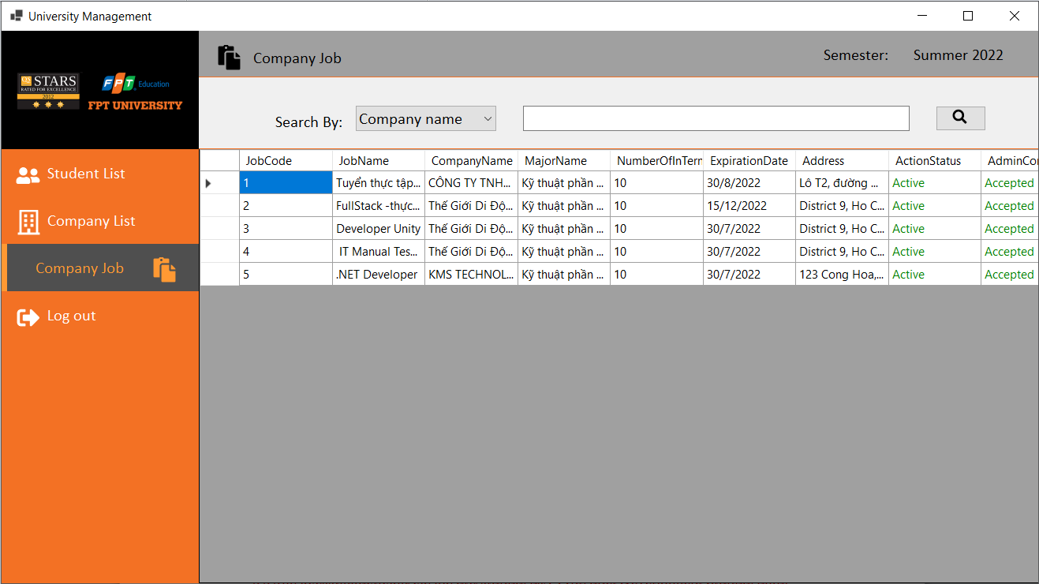

University’s Company Job form:

* Allow the university to view the jobs of companies.
* Allow confirm these posts when the university click double into any rows.

1. Company Role

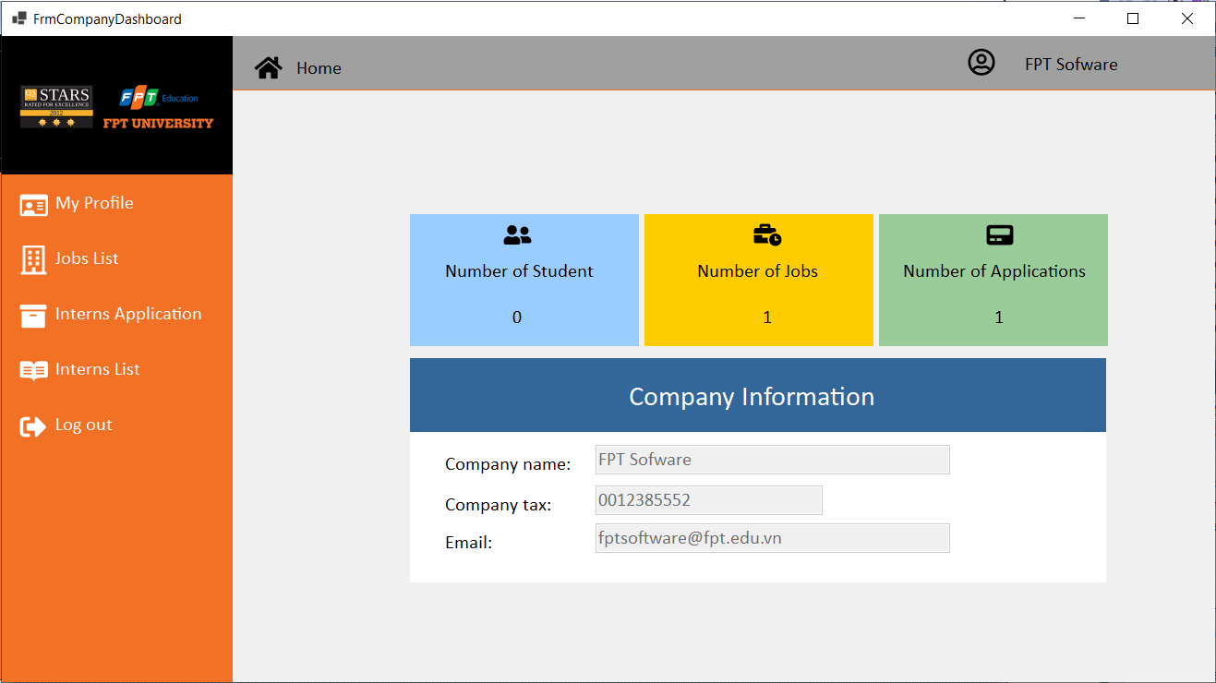

Company’s Home form:

* The company can view all of information about the number of insterns who are the student, number of jobs, number of applications, and their information

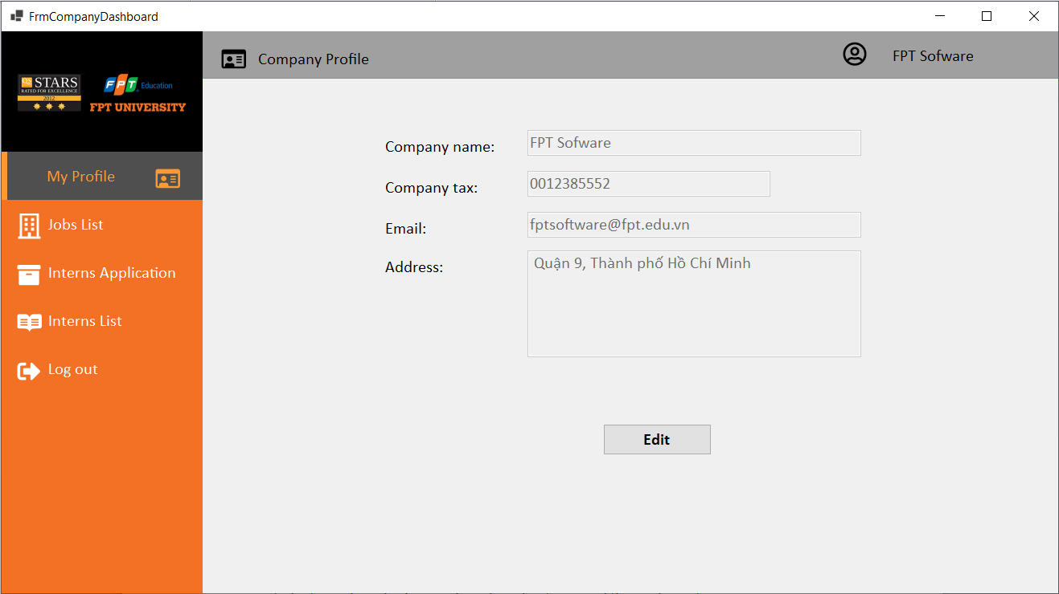

Company’s Profile form:

* Allow the company to update their information.

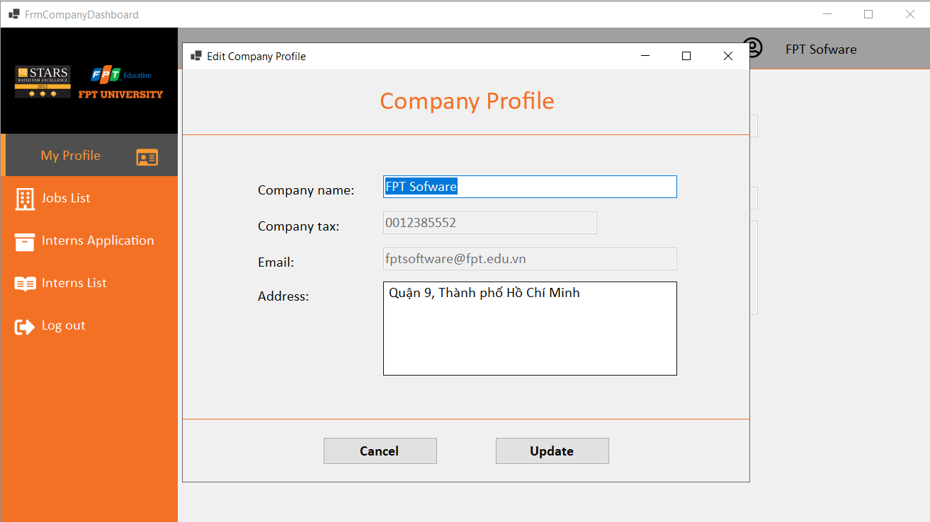

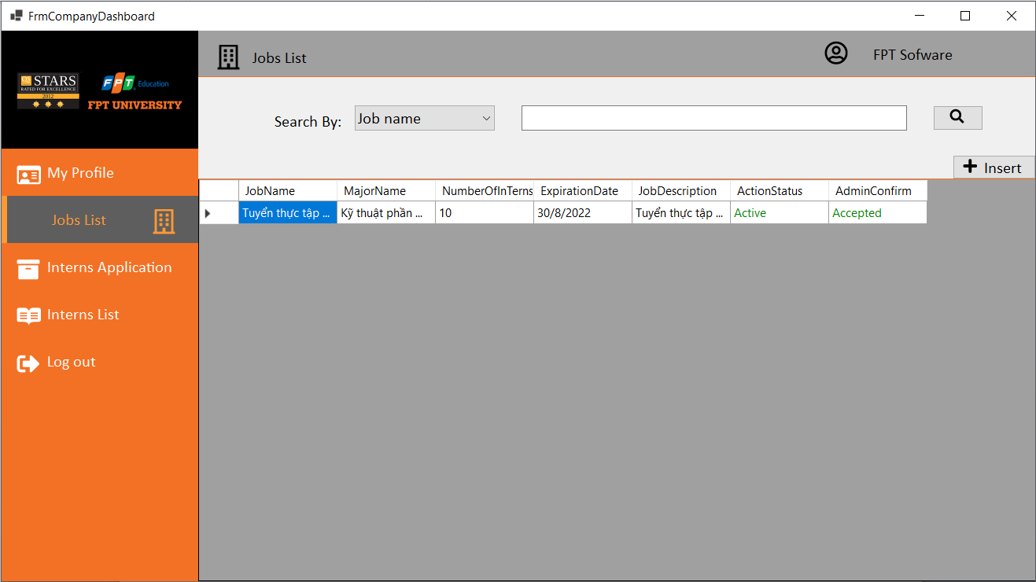

Company’s Jobs List form:

* Allow the company to create a new job and search jobs following the filter.
* Allow the company update the specific job when they clicked double into the one of rows.

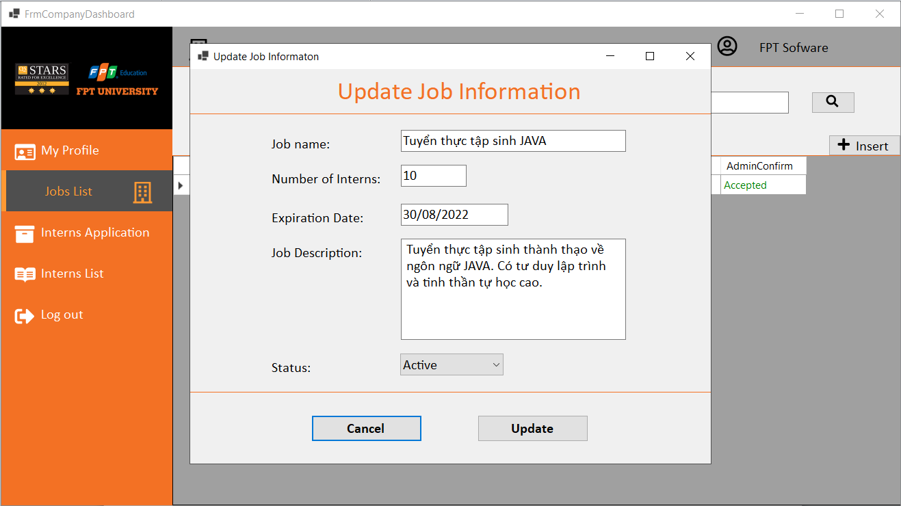

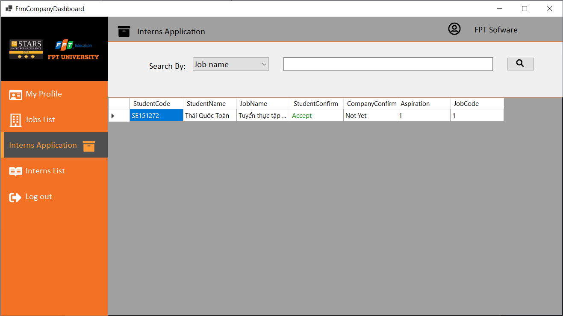

Company’s Interns Application form:

* Allow the company search student applications by filter
* Allow the company confirm student’s application when they double click into row of any students.

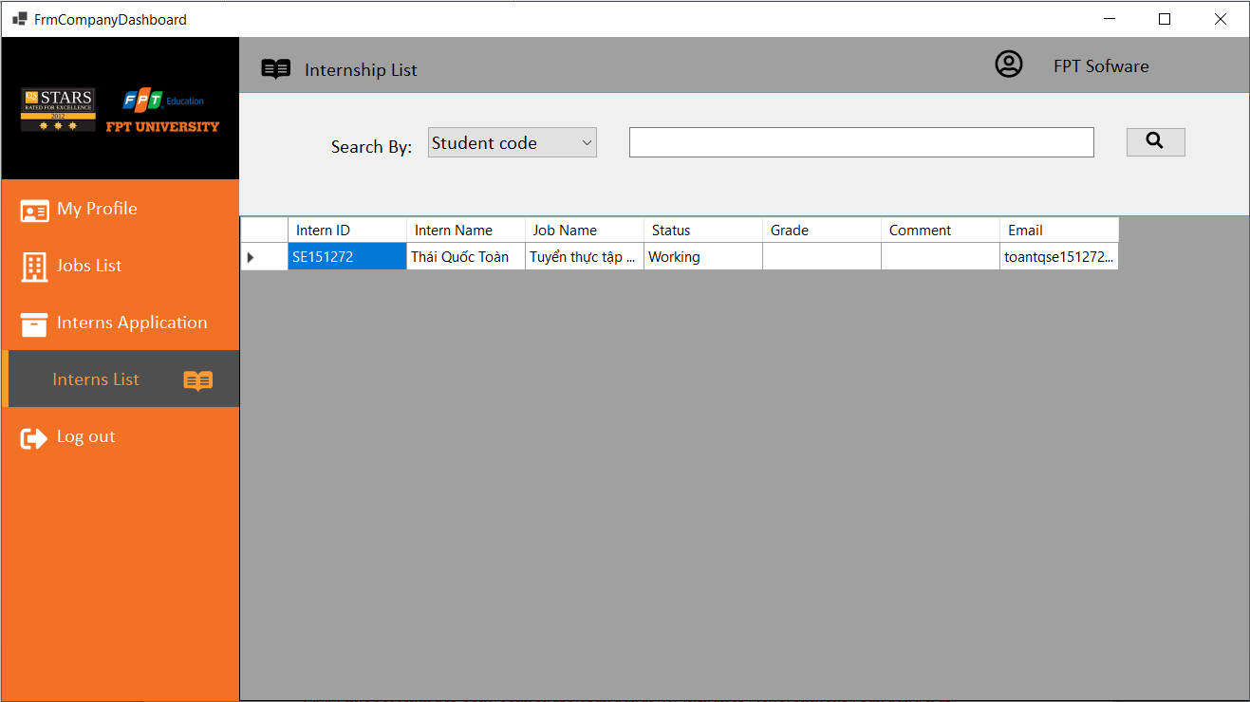

Company’s interns List form:

* Allow the company to search student and view list interns of the company.
* Allow the company to evaluate for student about grade and comment.

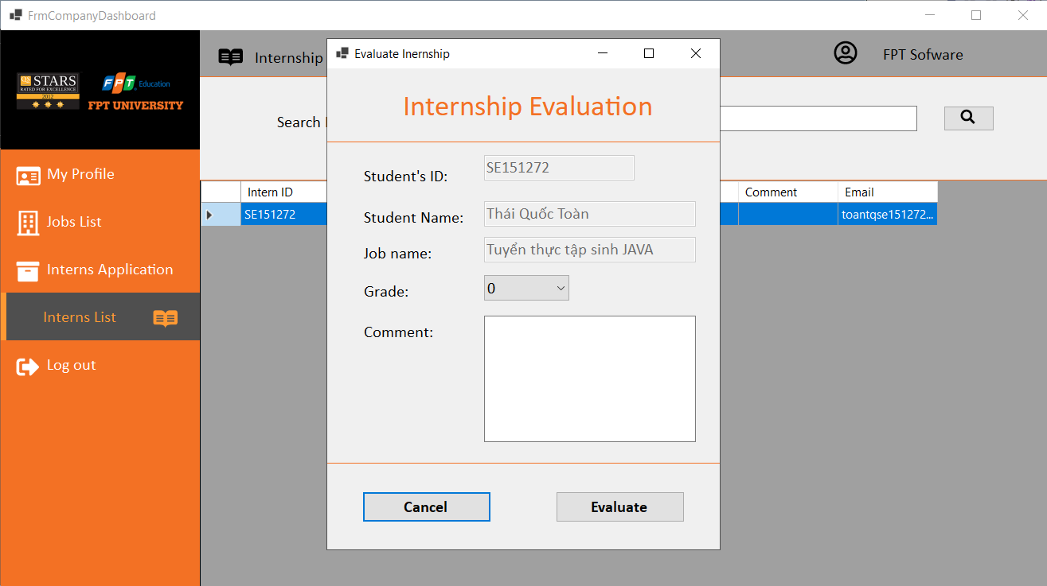

1. Student Role

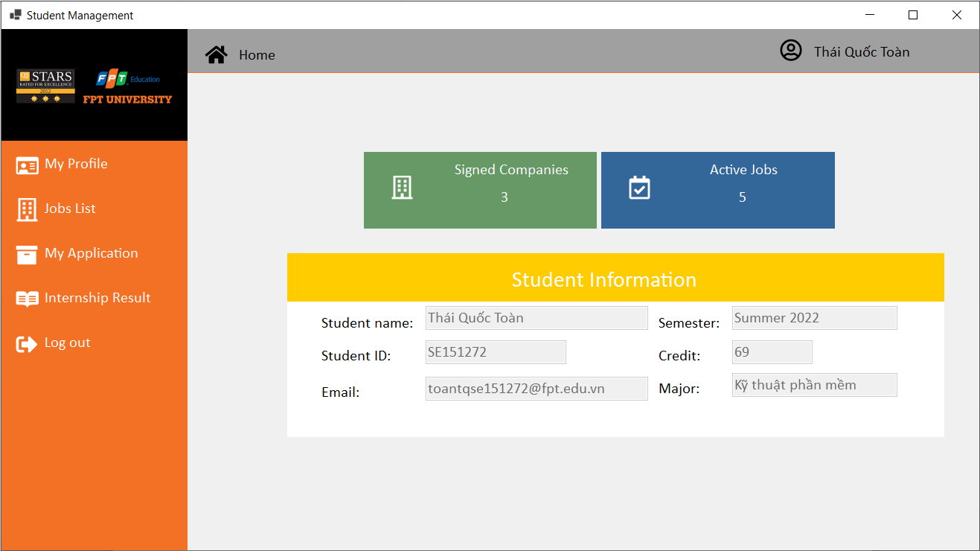

Student’s Home:

* Allow the student view about number of companies that were created by the university and numbre of active jobs in the system, and their information

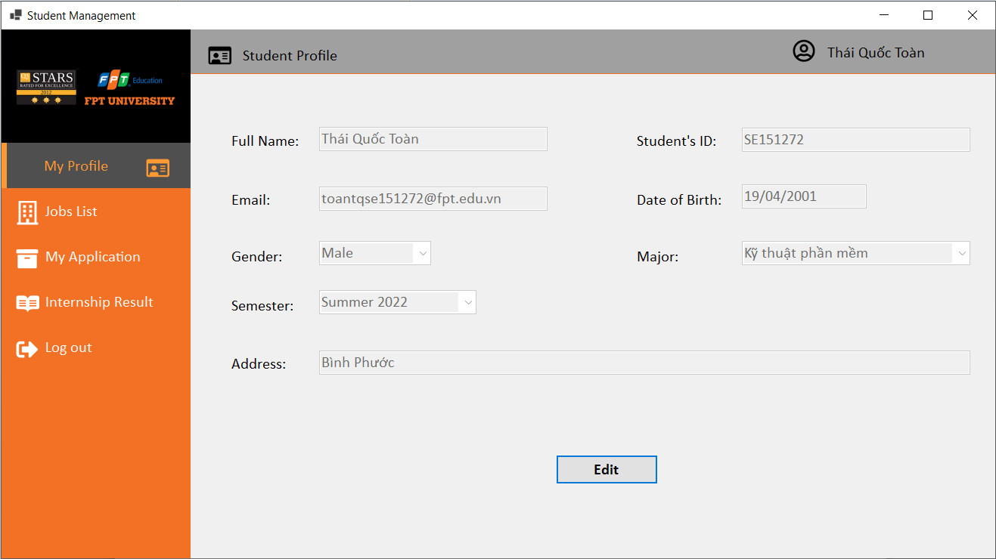

Student’s Profile:

* Allow student to view about their information.
* Allow student to update their profile.

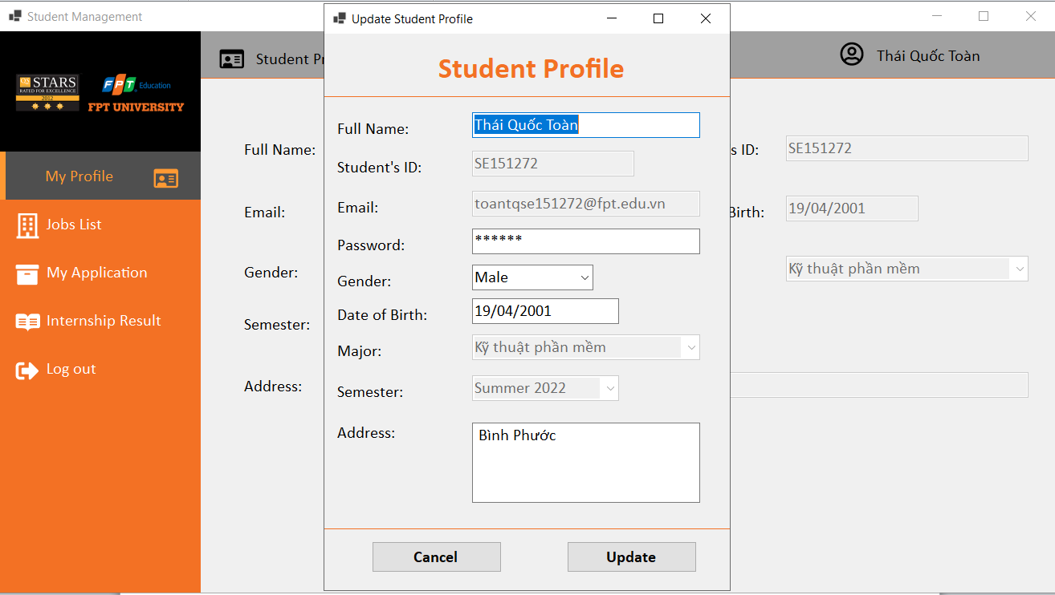

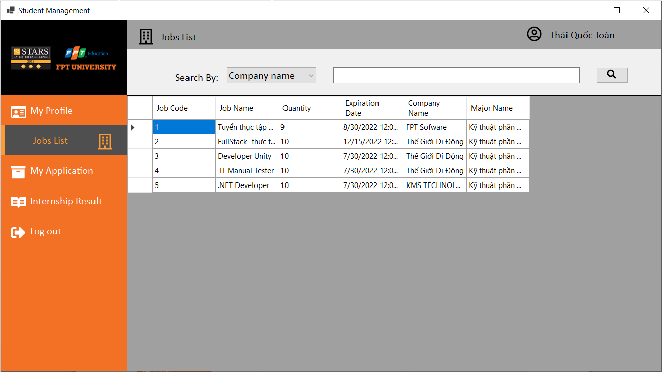

Student’s Jobs List form:

* Allow student to view and search jobs of companies following by filter.
* Allow student to apply the job when they click double into the row.

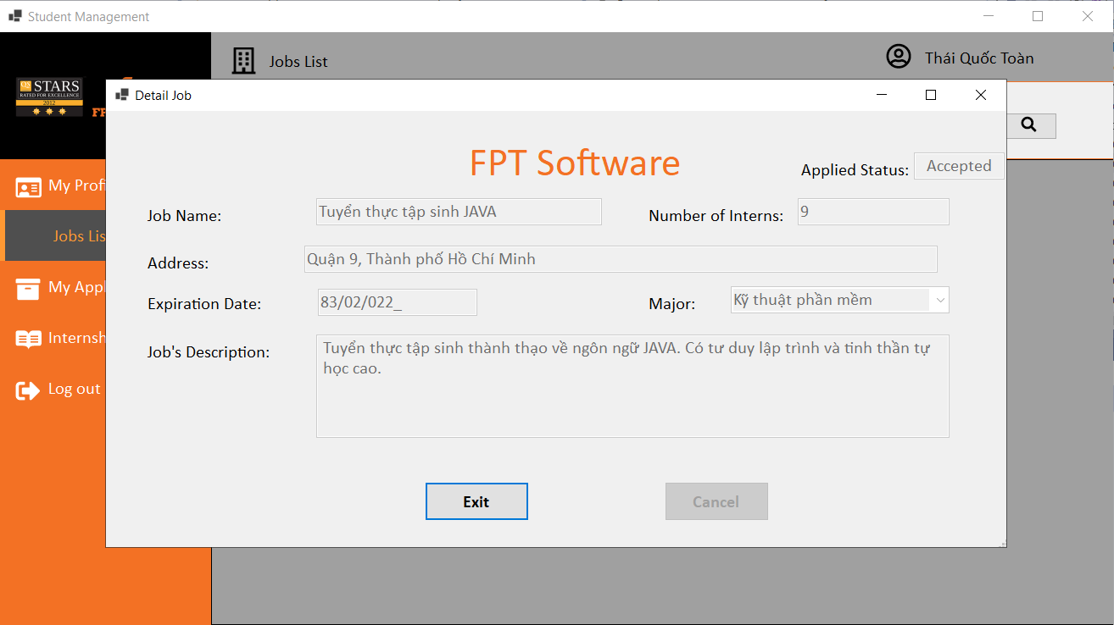

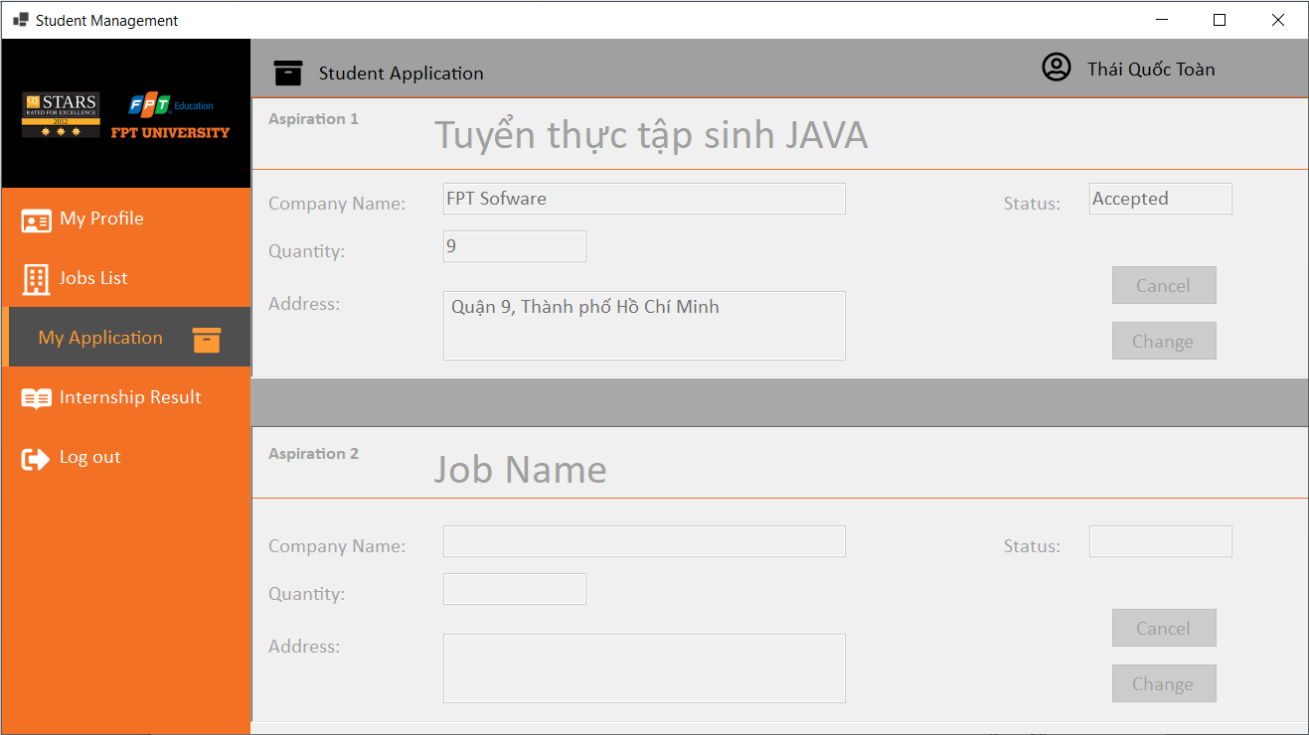

Student’s application form:

* Allow students to view their application.
* Allow students to change the job.

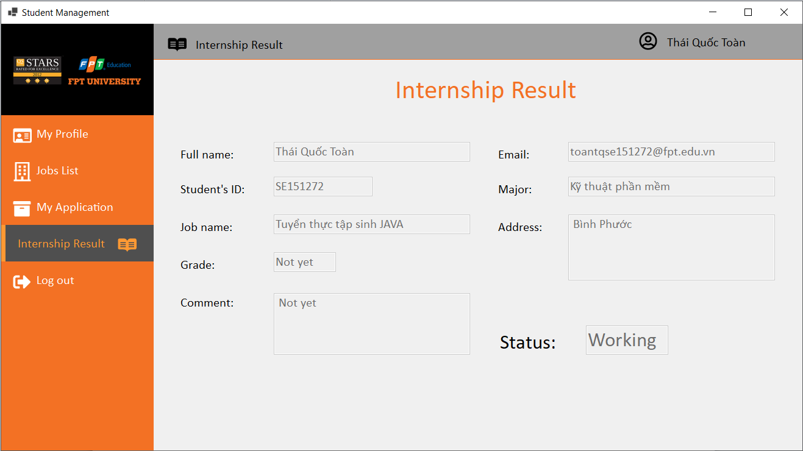

Student’s Internship Result form:

* Allow students to view their grade and comment when their company that evaluated before.