01 - SOLVE ME FIRST
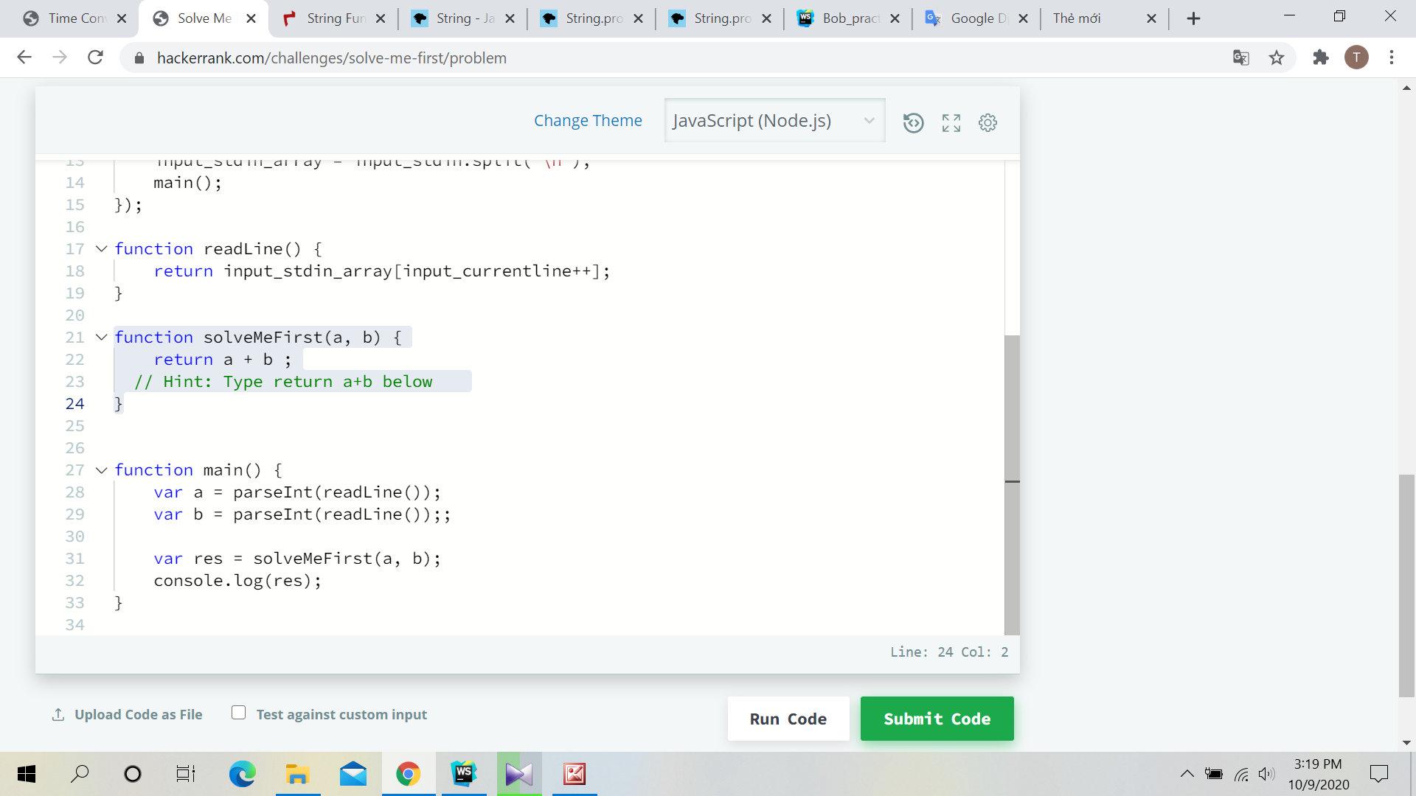
======================================

02 – SIMPLE ARRAY SUM
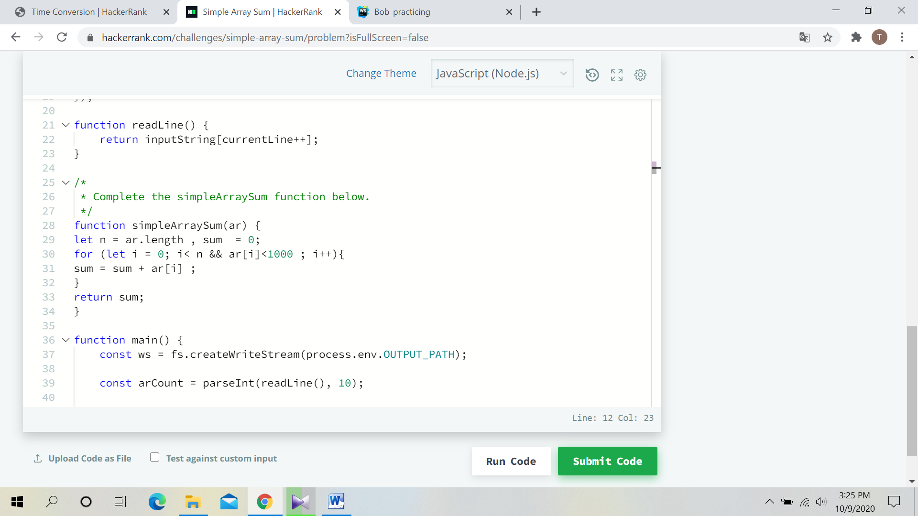
=======================================

03 - Compare the Triplets

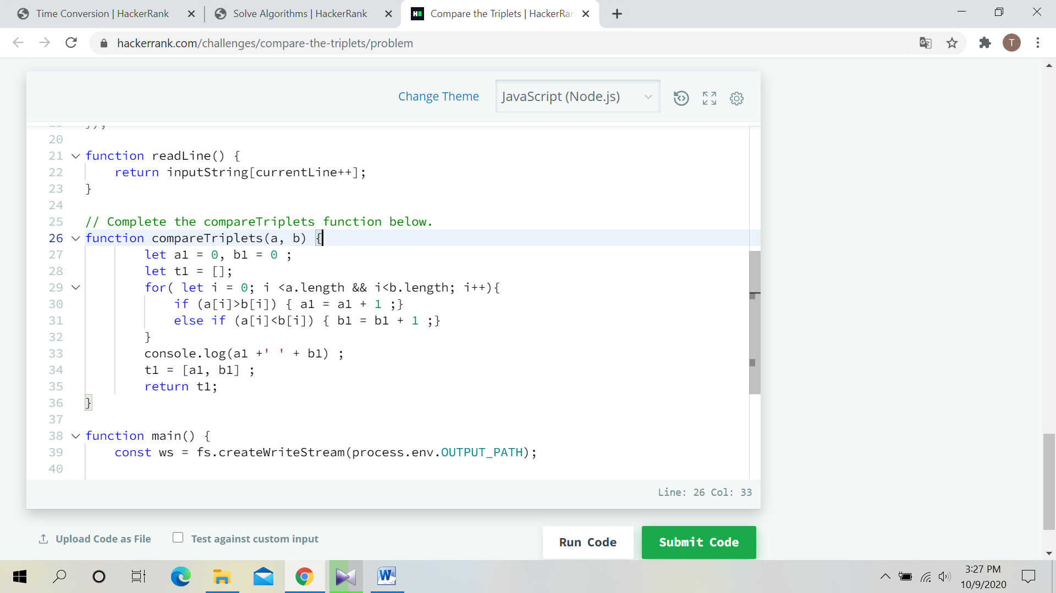

=================================

04- A Very Big Sum

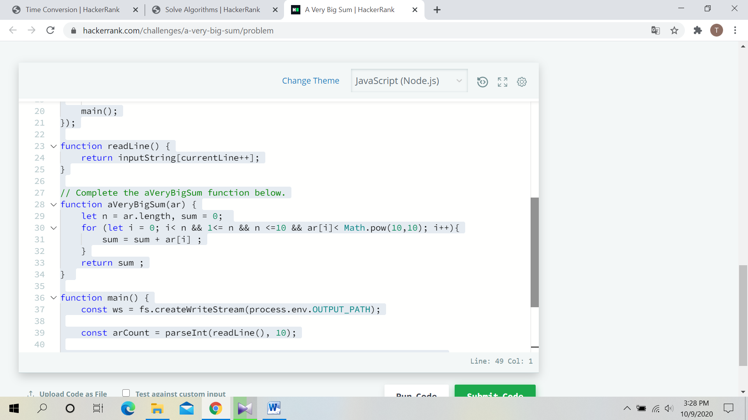

============================

05 - Diagonal Difference

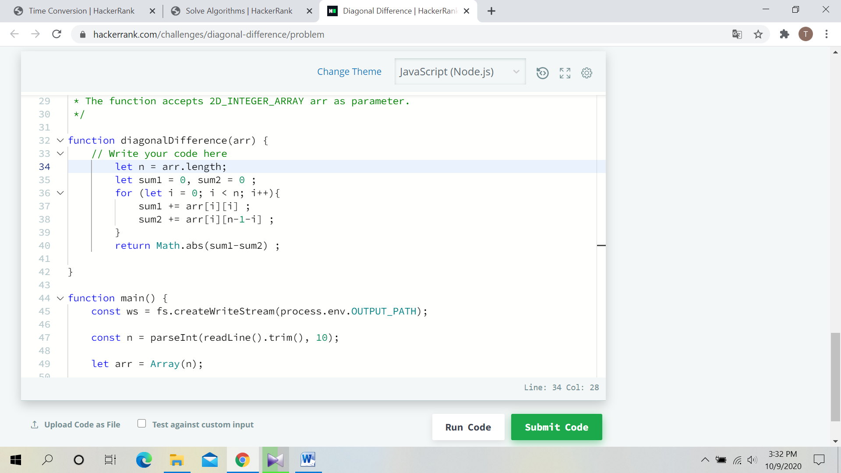

==========================

06 – PLUS MINUS

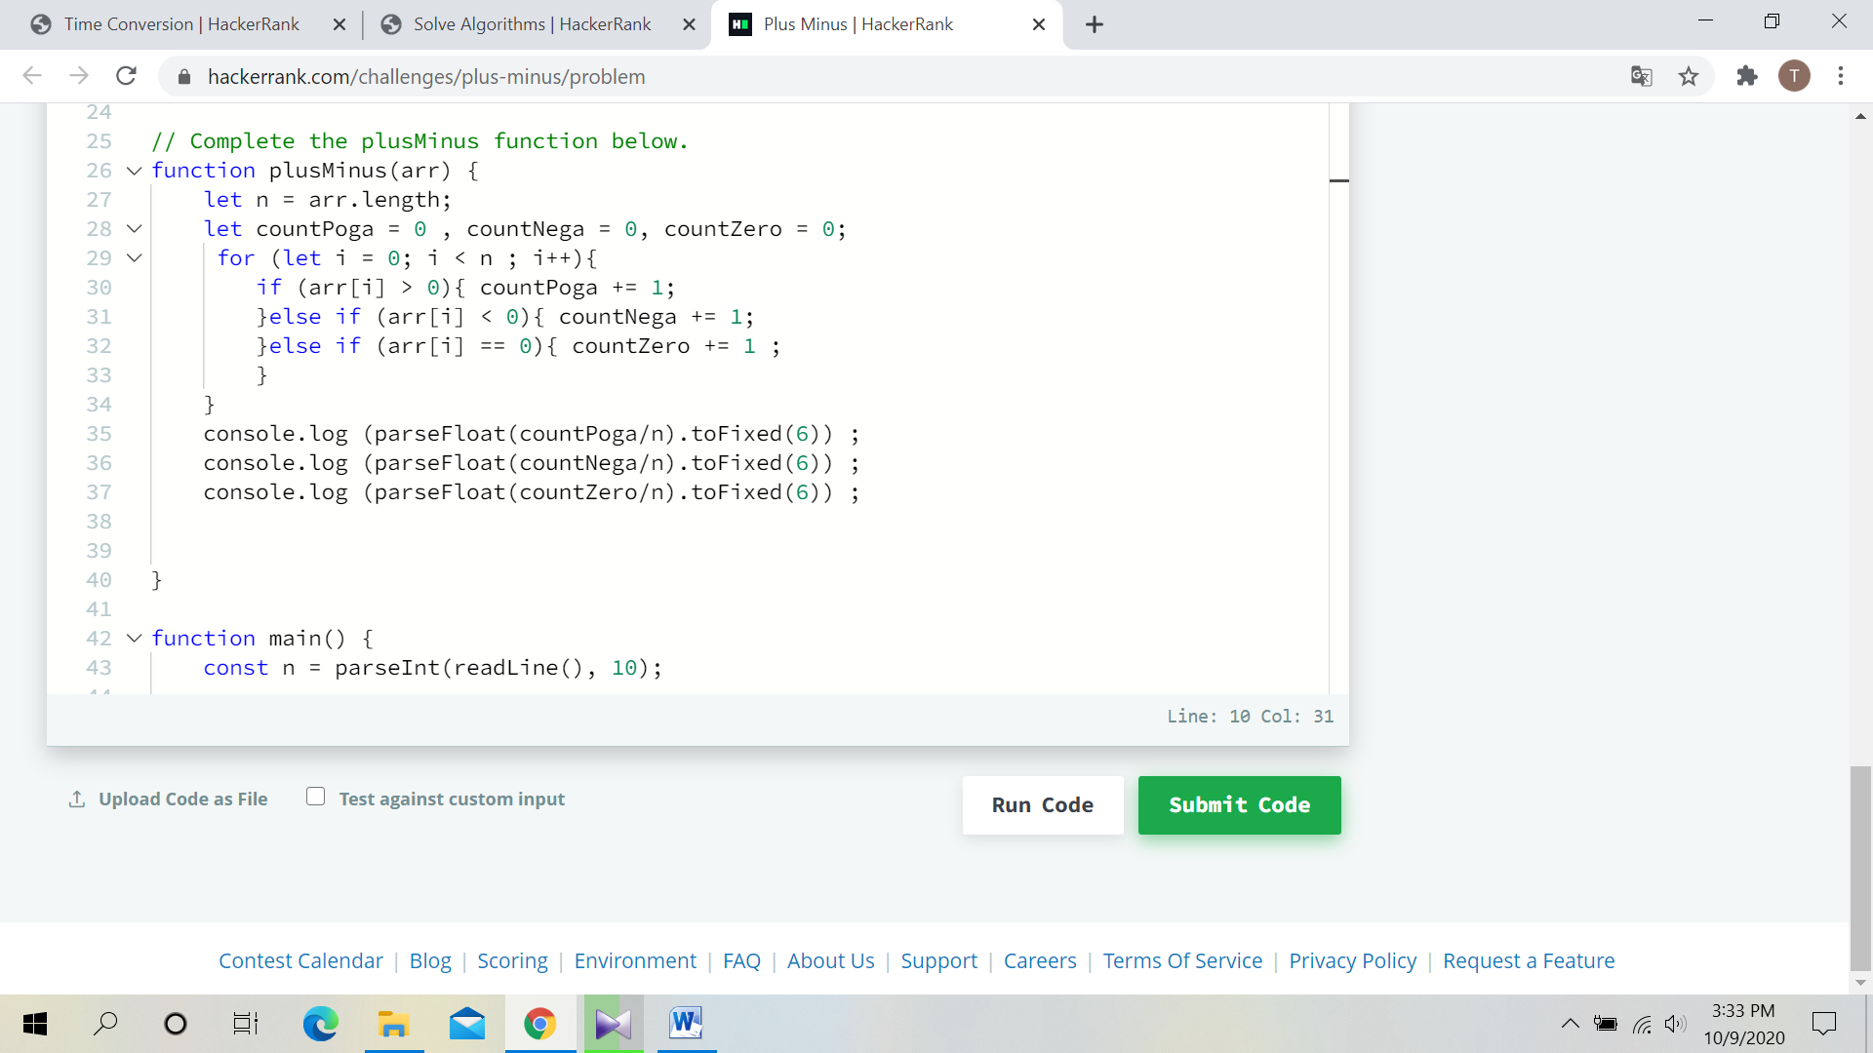

=============================

07 – PLUS MINUS

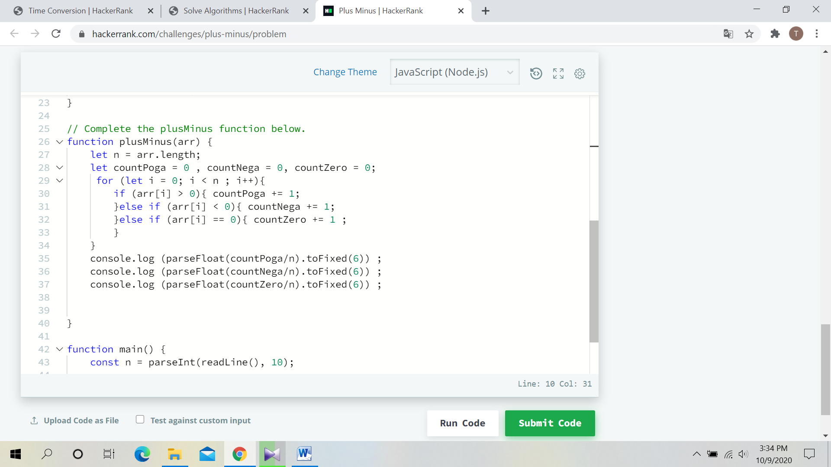

=========================

08 – STAIR CASE

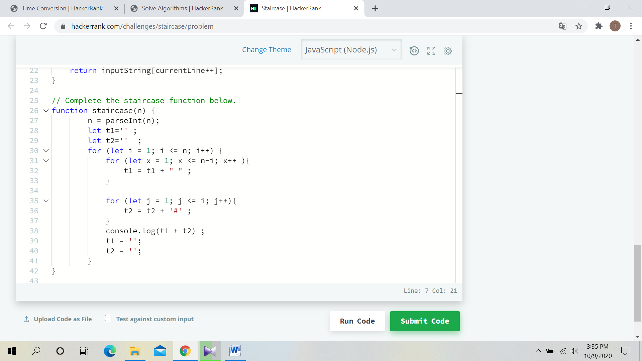

==========================

09 – MINI MAX SUM

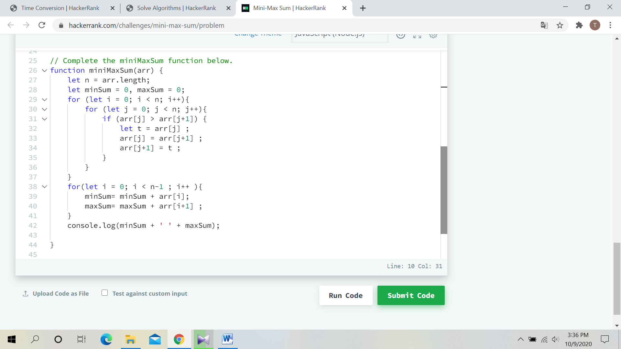

=====================

10- BIRTHDAY CAKE CANDLES

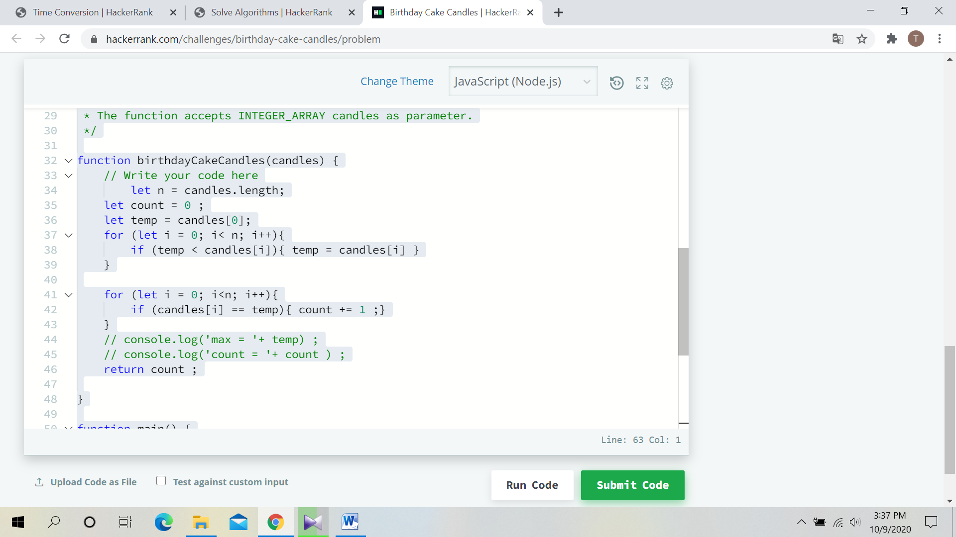

=====================

11- TIMES CONVERSION

