



GROUP EIGHT

Members

1. Trương Thị Thanh Xuân – CE140149
2. Trương Nhật Nam – CE140370
3. Nguyễn Quốc An – CE140024

Table of Contents

I. PROBLEM DENIFITION 3

II. USER REQUIREMENTS 4

*1.* *Input:* 4

*2.* *Output:* 4

*3.* *List of function:* 4

III. SYSTEM REQUIREMENTShttps://use.fontawesome.com/releases/v5.3.1/css/all.css 5

1. *Hardware requirement*: 5

*2.* *Software requirement:* 5

IV. WHAT JSP 6

V. WHAT SERVERLET 7

VI. DETAIL 8

1. Date of project plan 8

2. Project’s Vision/Objective 8

3. Project Initiation/Requirement Document 8

4. Plan 8

VII. ROLES 9

*1.* *Table roles* 9

*2.* *Gantt* 10

VIII. SCHEDULE 11

IX. DESIGN PATTERN 12

*1.* *Data base Diagram* 12

*2.* *Class Diagram* 14

X. PROGRAM INTEFACE 15

# PROBLEM DENIFITION

Watches are an indispensable piece of jewelry for every person. People wearing beautiful watches show their class elegance and elegance. Catching this trend, the group 8 decided to create a website specializing in the sale of men's and women's watches. My group chose the topic of selling watches because:

* The clock has many diverse models
* Many brands are easy to choose,
* When it comes to making it easy for people to like and look to the website to see.
* The website that sells watches has functions that make it easy to find and order products.

*Disadvantage:*

* The group is not very knowledgeable about watches in the world.
* Update prices will not be accurate.
* Not much functional design for the site.
* There are not too many watches so there will be some watches that people find without.

# USER REQUIREMENTS

# *Input:*

* A website that sells watches should have a product listing, product images, product brand names, product prices, login and a shopping cart and payment function to purchase products.
* In addition, it is necessary to have the login function, add new products and update , search function products.

# *Output:*

* Information will be saved on the database when the product is completed.

# *List of function:*

* The user accesses the site
* View and search for product available on the site
* Select product and add to cart
* Login to pay for products
* Pay

# SYSTEM REQUIREMENTS

1. *Hardware requirement*:

|  |  |
| --- | --- |
| **Minimal configurations** | **Recommended configurations** |
| Intel® Core™ i5-8250U Processor (6M Cache, up to 3.40 GHz) | Intel® Core ™ i7-7700HQ Quad Core (6MB Cache, up to 3.8 GHz) | CPU |
| 4GB DDR4 | 8GB, 2400MHz, DDR4 | RAM |
| 1TB | 1TB 5400 rpm Hybrid Hard Drive and 8GB Cache | HDD |

1. *Software requirement:*

* Operating System: Window 7 or highter.
* Toolkit: Software JRE 1.7 or highter.
* Plaform: Microsoft Windows (x86, x64)
* Database: SQL

# WHAT JSP

* It stands for **Java Server Pages**.
* It is a server side technology.
* It is used for creating web application.
* It is used to create dynamic web content.
* In this JSP tags are used to insert JAVA code into HTML pages.
* It is an advanced version of Servlet Technology.
* It is a Web based technology helps us to create dynamic and platform independent web pages.
* In this, Java code can be inserted in HTML/ XML pages or both.
* JSP is first converted into servlet by JSP container before processing the client’s request.

# WHAT SERVERLET

* A **servlet** is a Java programming language class that is used to extend the capabilities of servers that host applications accessed by means of a request-response programming model. Although servlets can respond to any type of request, they are commonly used to extend the applications hosted by web servers. For such applications, Java Servlet technology defines HTTP-specific servlet classes.
* The javax.servlet and javax.servlet.http packages provide interfaces and classes for writing servlets. All servlets must implement the Servlet interface, which defines life-cycle methods. When implementing a generic service, you can use or extend the GenericServlet class provided with the Java Servlet API. The  HttpServlet  class provides methods, such as doGet and doPost, for handling HTTP-specific services.
* This chapter focuses on writing servlets that generate responses to HTTP requests.

# DETAIL

# Date of project plan

* Start: 02/06/2020
* Finish: 25/07/2020

# Project’s Vision/Objective

* Create a website that sells watches so people can view and buy products online.
* Products and prices will be updated regularly so people can visit the website to search and reference products new.

# Project Initiation/Requirement Document

* There are features like login, update, add, delete, add to cart and check out products.
* Detailed information about each product.
* There are comments and reviews from customers.
* Pay for the product that has been purchased and delivered to the user

# Plan

* Check activity: Test code, test program after done.
* Demo activity: Demo every day and at least 1 time a day.
* Review activity: review 4 times in class.
* Backup and recovery: 2 times a week.

# ROLES

1. *Table roles*

|  |  |  |  |  |
| --- | --- | --- | --- | --- |
| Task No | Task Description | Expected Completion Date | Expected Time Needed(hrs) | Members in charge |
| 1 | Lên ý tưởng thiết kế web | 2/06/2020 | 1 | Xuân, Nam , An |
| 2 | Thảo luận nhóm chốt ý tưởng | 4/06/2020 | 1 | Xuân, Nam ,An |
| 3 | Phân công công việc cho các thành viên | 5/06/2020 | 1 | Xuân |
| 4 | Các thành viên trong nhóm nhận công việc | 6/06/2020 | 1 | Xuân, Nam , An |
| 5 | Thiết kế web | 8/06/2020 | 148 | Xuân, Nam , An |
| 6 | Thiết kế database | 19/06/2020 | 3 | Xuân, Nam ,An |
| 7 | Làm classdiagram | 20/06/2020 | 4 | Xuân |
| 8 | Viết document | 21/06/2020 | 4 | Xuân, Nam ,An |
| 9 | Code chức năng insert product | 22/06/2020 | 3 | Nam |
| 10 | Code chức năng insert user | 22/06/2020 |  | An |
| 11 | Code chức năng insert bill | 22/06/2020 | 3 | Xuân |
| 12 | Code chức năng update product | 25/06/2020 | 3 | Nam |
| 13 | Code chức năng update user | 25/06/2020 | 3 | An |
| 14 | Code chức năng update bill | 25/06/2020 | 3 | Xuân |
| 15 | Code chức năng delete product | 30/06/2020 | 3 | Nam |
| 16 | Code chức năng delete user | 30/06/2020 | 3 | An |
| 17 | Code chức năng delete bill | 30/06/2020 | 3 | Xuân |
| 18 | Code chức năng seclected product | 5/07/2020 | 3 | Nam |
| 19 | Code chức năng seclected user | 5/07/2020 | 3 | An |
| 20 | Code chức năng selected bill | 5/07/2020 | 3 | Xuân |
| 21 | Code chức năng port product | 10/07/2020 | 3 | Nam |
| 20 | Code chức năng port user | 10/07/2020 | 3 | An |
| 21 | Code chức năng port bill | 10/07/2020 | 3 | Xuân |
| 22 | Thảo luận nhóm để gộp code | 14/07/2020 | 4 | Xuân, Nam ,An |
| 23 | Testing and fixcode | 16/07/2020 | 5 | Xuân, Nam ,An |
| 24 | Hoàn thành code | 20/07/2020 | 1 | Xuân, Nam, An |
| 25 | Hoàn thành trang web | 22/07/2020 | 2 |  |
| 26 | Deadline | 25/07/2020 | 1 |  |

1. *Gantt*

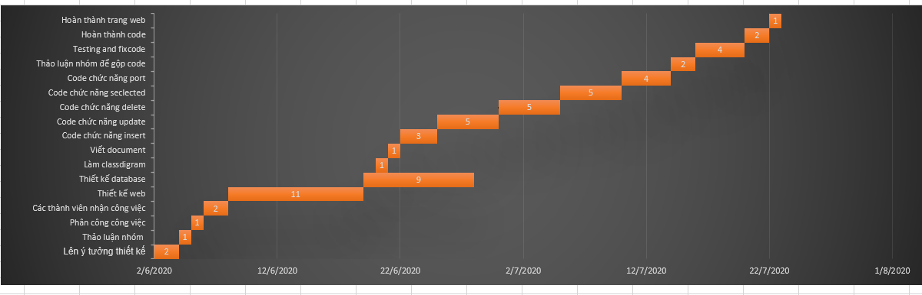

# SCHEDULE

|  |  |  |
| --- | --- | --- |
| 1. Lịch họp dự kiến | | |
| Nội dung | Hình thức | Thời gian |
| Thảo luận về chức năng insert, update product, user, bill | Online | 20h |
| Thảo luận về delete và select product, user, bill, báo cáo tiến độ | Offline | 14h |
| Thảo luận về chức năng post select product, user, bill, báo cáo tiến độ | Offline | 14h |
| Thảo luận về thiết kế giao diện, chỉnh sửa lỗi | Offline | 14h |
| Chỉnh sửa document và làm powerpoint | Offline | 14h |

# DESIGN PATTERN

1. *Data base Diagram*

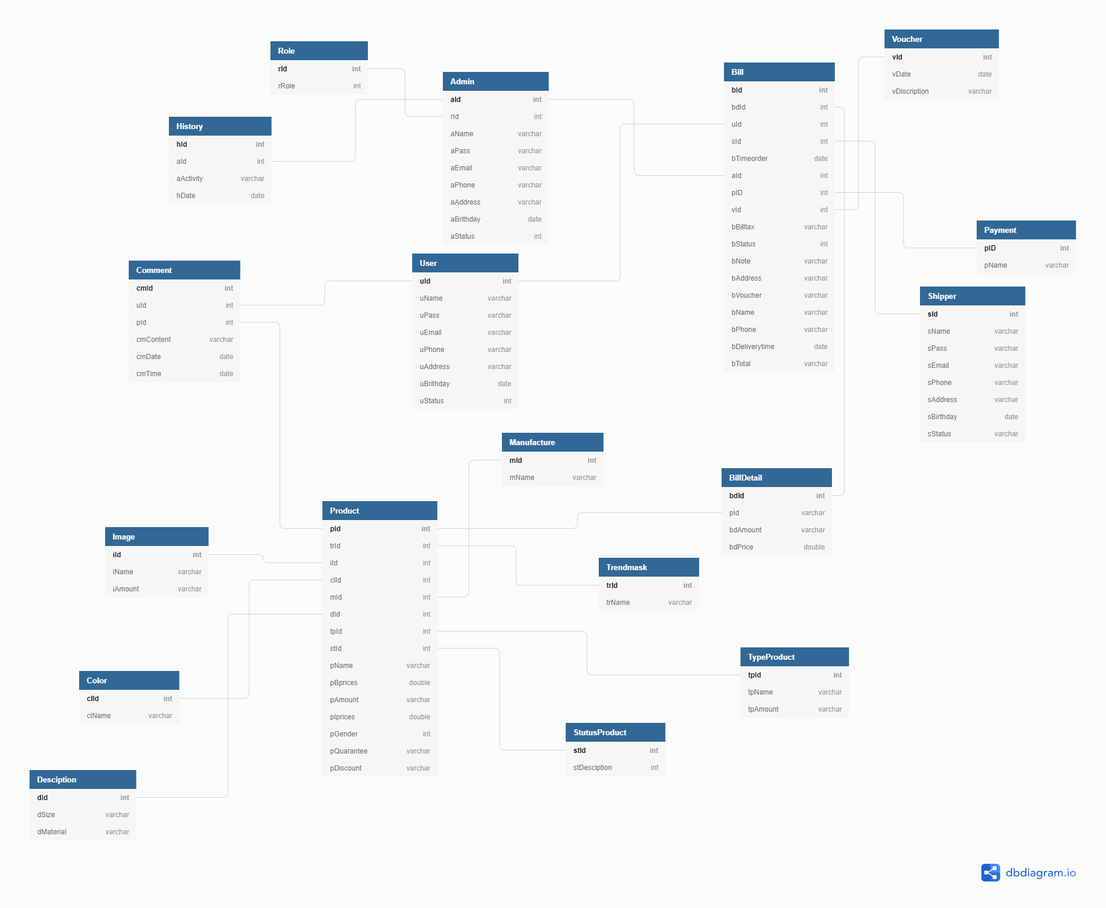

1. *Class Diagram*

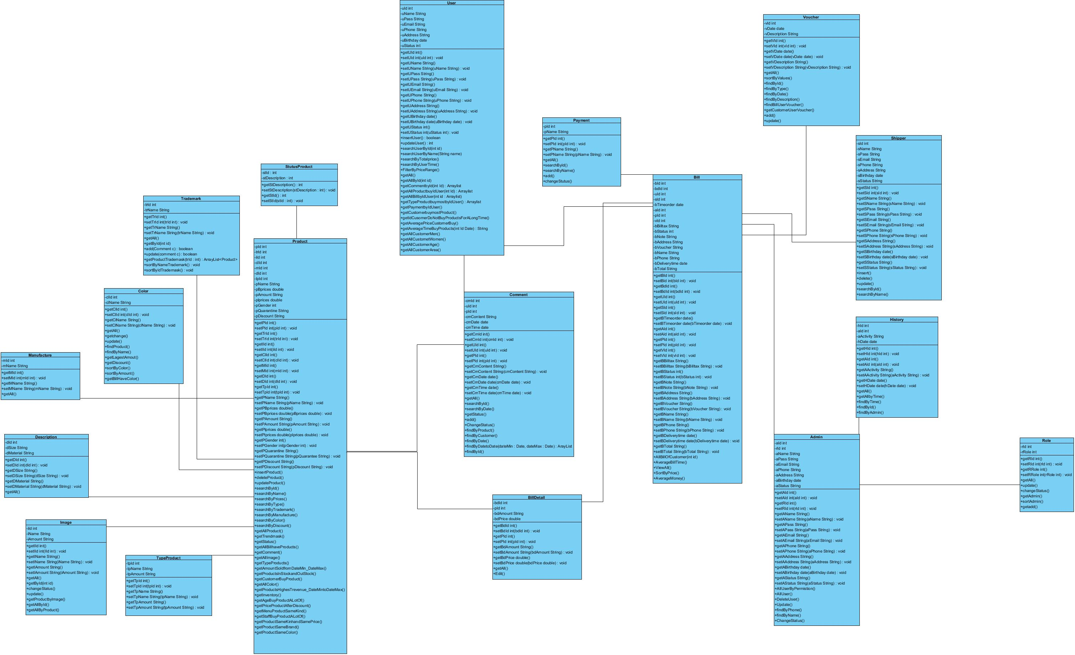

# PROGRAM INTEFACE