**A GUIDE ON USAGE OF THE SCRIPT FOR TESTING ECUCPARTITON**

# 1. Overview

- When executing the ConfManager tool, it is necessary to prompt a specific CLI command. For example:

ConfManager.exe **-m** "Updater" **-p** /path/to/pver/root **-ws** /path/to/cust/ws **-cf** path/to/configuration/file **-o** /path/to/output/folder

- For testing, multiple test cases are designed and each of them is organized into a folder.

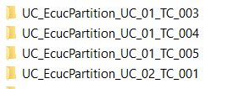

- Therefore, it is ***time-consuming*** for testers to begin testing each folder, as ***they must change the CLI command every time they switch to a new folder***.

🡺 A small script has been designed to help the tester spend less time for these activities.

# 2. How to use the test script

- First unzip the test archive, then put these files together inside it:

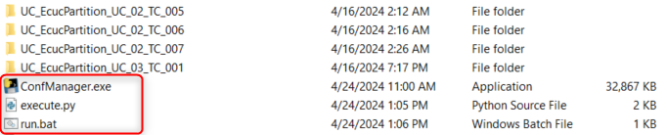

- Click on the **run.bat**, input the test folder and it will automate the testing process, which include the execution of ConfManger tool and automatically call Beyond Compare for the result check.

