PROFESSIONAL TRAINING REPORT – I

Entitled

SENTIQ – AI-POWERED FEEDBACK ANALYZER

Submitted in partial fulfillment of the requirements for the award of Bachelor of Engineering degree in Computer Science and Engineering with specialization

By

Thanigaivel B (Reg.No–44110847)



DEPARTMENT OF COMPUTER SCIENCE AND ENGINEERING SCHOOL OF COMPUTING

SATHYABAMA

INSTITUTE OF SCIENCE AND TECHNOLOGY (DEEMED TO BE UNIVERSITY)
CATEGORY-1 UNIVERSITY BY UGC
Accredited “A++” by NAAC I Approved by AICTE
JEPPIAAR NAGAR, RAJIVGANDHI SALAI CHENNAI-600119
NOV-2026


DEPARTMENT OF COMPUTER SCIENCE AND ENGINEERING

BONAFIDE CERTIFICATE

This is to certify that this Professional Training I Report is the bonafide work of Thanigaivel B (44110847) who carried out the Project Phase-1 entitled “SENTIQ – AI-POWERED FEEDBACK ANALYZER” under my supervision from June 2026 to August 2026.

Internal Guide
Mr. Mohammed Haseeb Rakshan P

Head of the Department
Dr.L.LAKSHMANAN,M.E.,Ph.D.,

Submitted for Professional Training I Viva Voce Examination held on

Internal Examiner External Examiner

DECLARATION
I, Thanigaivel B (Reg. No- 44110847), hereby declare that the Professional Training-1 Report entitled “SENTIQ – AI-POWERED FEEDBACK ANALYZER” done by me under the guidance of Mr. Mohammed Haseeb Rakshan P is submitted in partial fulfillment of the requirements for the award of Bachelor of Engineering degree in Computer Science and Engineering.

DATE:

PLACE: Chennai SIGNATURE OF THE CANDIDATE

ACKNOWLEDGEMENT

I am pleased to acknowledge my sincere thanks to BOARD OF MANAGEMENT of Sathyabama Institute of Science and Technology for their kind Department encouragement in doing this project and for completing it successfully. I am grateful to them.
I convey my thanks to Dr. L. Lakshmanan, M.E., Ph.D., Dean and Head, School of Computing, Department of Computer Science and Engineering for providing me with necessary support and details at the right time during the progressive reviews.
I would like to express my sincere and deep sense of gratitude to my Project Guide Mr. Mohammed Haseeb Rakshan P for his valuable guidance, suggestions, and constant encouragement paved the way for the successful completion of my project work.
I wish to express my thanks to all Teaching and Non-teaching staff members of the Department of Computer Science and Engineering who were helpful in many ways for the completion of the project.

TRAINING CERTIFICATE
ABSTRACT

SentiQ is a browser-based, AI-powered feedback analyzer that converts raw, unstructured user feedback into clear and actionable insights within seconds. Organisations receive large volumes of reviews, survey answers and comments, but reading them manually is slow, inconsistent and difficult to scale, so recurring problems often remain hidden. SentiQ accepts feedback that is pasted as text, uploaded as a CSV or Excel file, typed in manually, or fetched from the comments of a YouTube video through the YouTube Data API. A custom lexicon-based natural language processing engine classifies every response as positive, neutral or negative while handling negation, intensifiers, contrast words, punctuation emphasis and emojis. The same engine detects twelve topic categories, seven emotions, frequent keywords and recurring issues, and builds a satisfaction score, a sentiment trend and an automatically written summary. The results are shown in an interactive dashboard with sentiment, topic, emotion and trend charts, a searchable table of responses, and CSV and Markdown exports. The complete analysis runs inside the browser, so sensitive feedback never leaves the user’s device and no server or database is required. On the built-in customer sample of 36 responses, SentiQ reported a satisfaction score of 57 out of 100 and identified bugs and reliability as the first issue to fix. The modular design allows new lexicons, topics and data sources to be added with minimal change.

TABLE OF CONTENTS

Chapter No. | Title |  |  | Page No.
 | ABSTRACT |  |  | vi
 | LIST OF FIGURES |  |  | viii
 | LIST OF TABLES |  |  | ix
1 | INTRODUCTION |  |  | 1
 | 1.1 | Background |  | 1
 | 1.2 | Problem Statement |  | 1
 | 1.3 | Objectives |  | 2
 | 1.4 | Scope and Organisation of the Report |  | 2
2 | LITERATURE SURVEY |  |  | 3
 | 2.1 | Inferences from Literature Survey |  | 3
 | 2.2 | Open Problems in Existing System |  | 4
3 | REQUIREMENTS ANALYSIS |  |  | 6
 | 3.1 | Feasibility Studies/ Risk Analysis of the Project |  | 6
 | 3.2 | Software Requirements Specification Document |  | 7
4 | DESCRIPTION OF PROPOSED SYSTEM |  |  | 10
 | 4.1 | Selected Methodology or Process Model |  | 10
 | 4.2 | Architecture/ Overall Design of Proposed System |  | 10
 | 4.3 | Description of Software Implementation and Testing plan of the Proposed Model/System |  | 12
 | 4.4 | Project Management Plan |  | 18
 | 4.5 | Financial report on estimated costing |  | 18
 | 4.6 | Transition/Software to Operations Plan |  | 19
 | REFERENCES |  |  | 19

LIST OF FIGURES

FIGURE NO. | FIGURE NAME | PAGE NO.
4.1 | System Architecture | 11
4.2 | Project Workflow | 11
4.3 | Analyzer Input Interface | 12
4.4 | NLP Processing Flow | 13
4.5 | SentiQ Results Dashboard | 16

LIST OF TABLES

TABLE NO. | TABLE NAME | PAGE NO.
2.1 | Open Problems in Existing Systems and the SentiQ Response | 4
3.1 | Risk Assessment | 7
3.2 | Software and Hardware Requirements | 7
3.3 | Functional Requirements | 8
3.4 | Non-Functional Requirements | 9
4.1 | Topic Categories and Example Keywords | 14
4.2 | Test Cases and Results | 16
4.3 | Results on the Built-in Sample Data Sets | 17
4.4 | Project Phases and Deliverables | 18
4.5 | Estimated Cost & Implementation Overheads | 19

CHAPTER 1

INTRODUCTION
1.1 BACKGROUND
Every product, course and workplace generates feedback. Customers leave reviews in app stores, students fill in course surveys, employees answer engagement questionnaires, and viewers write comments below videos. Taken together this feedback describes what people actually experience, and it is one of the most direct sources of information for improving a service. The difficulty is that most of it is written as free text. A team that receives a few thousand comments cannot read each of them carefully, and different readers often judge the same comment differently.
Natural Language Processing (NLP) addresses this problem by allowing a computer to read text and extract structure from it. Sentiment analysis, also called opinion mining, is the branch of NLP that identifies whether a piece of text expresses a positive, negative or neutral opinion [9], [5]. Over the last two decades it has grown from simple word counting into a wide field that includes aspect-level opinions, emotion recognition and topic discovery [6], [7].
SentiQ is a web application that brings these ideas together in a form that non-technical users can operate. A user supplies feedback, presses one button, and receives a dashboard that shows overall sentiment, the topics people talk about, the emotions they express, the issues that keep recurring and the way sentiment changes over time. The whole analysis runs in the browser using HTML, CSS and JavaScript, so no installation, account or server is needed.
1.2 PROBLEM STATEMENT
Manual analysis of feedback is slow, subjective and hard to repeat. Spreadsheet counts show how many comments exist but not what they mean. Many commercial analytics services solve this with cloud processing, which requires feedback to be uploaded to a third-party server; this is unattractive when the data comes from students, employees or customers and may be sensitive. Machine-learning approaches also need labelled training data and computing resources that small teams rarely have. There is therefore a need for a simple, private and transparent tool that turns raw feedback into a prioritised list of what to fix and what to keep.
1.3 OBJECTIVES
The objectives of the project are: (i) to accept feedback from four sources, namely pasted text, CSV or Excel files, manual entry and YouTube comments; (ii) to classify each response as positive, neutral or negative with an explainable score; (iii) to group responses into topics and detect emotions, keywords and recurring issues; (iv) to calculate a satisfaction score and show the trend of sentiment over time; (v) to present the results as an interactive dashboard with charts, a searchable table and an automatically written summary; and (vi) to keep all processing inside the browser so that feedback remains private.
1.4 SCOPE AND ORGANISATION OF THE REPORT
SentiQ analyses English-language text using a rule-based lexicon method. It is intended for small and medium collections of feedback, from a handful of comments to a few thousand, and it is suitable for customer, student and employee feedback because it ships with topic vocabularies for all three. It does not train a model, and it does not store data on any server.
The rest of this report is organised as follows. Chapter 2 reviews the literature and the open problems in existing systems. Chapter 3 presents the feasibility study, risk assessment and the software requirements specification. Chapter 4 describes the proposed system, including the methodology, architecture, module-wise implementation, testing plan with results, project management plan, costing and the transition plan. The references are listed at the end.

CHAPTER 2

LITERATURE SURVEY
Research on sentiment analysis began with attempts to decide whether a movie review was favourable or unfavourable. Pang, Lee and Vaithyanathan applied Naive Bayes, maximum entropy and support vector machine classifiers to movie reviews and showed that machine-learning methods outperformed hand-built keyword baselines, while also observing that sentiment classification is harder than ordinary topic classification [10]. The later survey by Pang and Lee [9] and the books by Liu [5], [6] consolidated the field and describe document-level, sentence-level and aspect-level analysis, which remain the standard levels of study today.
2.1 INFERENCES FROM LITERATURE SURVEY
Opinions about features. Hu and Liu mined customer reviews to find the product features that people comment on, decided whether each opinion sentence was positive or negative using an opinion-word lexicon, and produced a feature-based summary [3]. SentiQ follows the same practical idea: it does not stop at an overall score but links sentiment to topics such as pricing, support or performance so that users can see which part of the service is praised or criticised.
Context matters. Wilson, Wiebe and Hoffmann showed that the polarity of a word listed in a lexicon (its prior polarity) can differ from its polarity in context, for example when the word is negated [13]. Taboada and co-authors developed a lexicon-based method in which each word has a strength, and in which negation and intensification change the final value; they found the approach robust across domains [12]. These findings motivate the negation window, intensifier multipliers and phrase rules used in SentiQ.
Rule-based models for informal text. Hutto and Gilbert introduced VADER, a rule-based model that combines a sentiment lexicon with simple rules for punctuation, capitalisation, degree modifiers, the contrast word “but” and negation, and that needs no training data [4]. The scoring in SentiQ is in the same family: it uses weighted lexicons, boosts for exclamation marks and capitalised words, a re-weighting after contrast words, and a normalisation that maps the raw score into the range −1 to +1.
Emotions and topics. Plutchik described a small set of basic emotions, such as joy, trust, fear, surprise, sadness and anger [11], and Mohammad and Turney built a large word–emotion association lexicon for such categories through crowdsourcing [8]. SentiQ uses compact emotion word lists in this spirit. For topics, probabilistic topic models such as Latent Dirichlet Allocation discover themes automatically from large corpora [1]; SentiQ instead uses curated keyword lists for twelve everyday themes, which works on very small data sets where a topic model has too little text to learn from.
Machine learning and deep learning. Pre-trained transformer models such as BERT have raised accuracy on many language-understanding tasks [2], and deep learning has become a leading approach in sentiment analysis [14]. These methods, however, need substantial computing resources and usually run on a server. Reviews of the field [7] note that lexicon-based and machine-learning approaches complement each other: lexicons are transparent, fast and need no labelled data, while learned models are more accurate when large training sets exist.
2.2 OPEN PROBLEMS IN EXISTING SYSTEM
From the literature and from the tools commonly used for feedback analysis, the open problems summarised in Table 2.1 were identified. SentiQ is designed to address the ones that can be solved within a lightweight, client-side application.
Table 2.1: Open Problems in Existing Systems and the SentiQ Response
Open problem | Observation | Response in SentiQ
Manual reading | Slow, subjective and not repeatable | Automatic scoring with the same rules for every response
Data privacy | Cloud tools need feedback uploaded to a server | All processing runs in the browser
Need for training data | Machine-learning models need labelled examples | Transparent lexicon rules, no training needed
Only an overall score | Hides which topic causes the problem | Topic-wise sentiment and recurring issues
Scattered sources | Reviews, files and videos analysed separately | Four input methods feed one pipeline
Hard to interpret | Raw numbers without explanation | Charts and an auto-written summary

Lexicon-based methods also have known limitations, such as difficulty with sarcasm and with words whose meaning depends on the domain [12], [13]. SentiQ acknowledges these limits and reports them in the testing results of Chapter 4.

CHAPTER 3

REQUIREMENTS ANALYSIS
3.1 FEASIBILITY STUDIES/ RISK ANALYSIS OF THE PROJECT
3.1.1 Feasibility
The feasibility study evaluates whether the proposed system can be developed and used successfully from technical, economic and operational points of view.
3.1.1.1 Technical Feasibility
SentiQ is technically feasible because it relies only on technologies that every modern browser already supports: HTML, CSS and JavaScript. The sentiment engine is a plain JavaScript module that needs no external service. Charts are drawn with the open-source Chart.js library and Excel files are read with the SheetJS library. The only external service is the optional YouTube Data API v3, which is used when comments are fetched from a video.
3.1.1.2 Economic Feasibility
The project is economically feasible because it uses free and open-source tools and does not need a database or application server. The finished application is a set of static files that can be opened locally or hosted on any static web host. The YouTube Data API is free within its daily quota. The detailed costing is given in Section 4.5.
3.1.1.3 Operational Feasibility
The interface is designed so that a user with no technical background can complete an analysis in a few steps: choose an input method, supply the feedback, press Analyze, and read the dashboard. Built-in sample sets for customers, students and employees let a new user see a result immediately. The application also provides a dark and a light theme and works on screens of different sizes.
3.1.2 Risk Assessment
Although the project is feasible, certain risks must be managed. They are listed in Table 3.1 together with the measures taken.
Table 3.1: Risk Assessment
Risk | Level | Mitigation
Sarcasm or domain words are scored wrongly | Medium | Show every response with its score so users can verify; lexicons are plain lists that are easy to extend
Topic keywords overlap (for example “team”) | Medium | Allow a response to belong to several topics; keep keyword lists reviewable
YouTube API key exposed to visitors | Medium | Restrict the key by HTTP referrer and to the YouTube Data API v3 only
YouTube API quota exhausted | Low | Show a clear message; other three input methods are unaffected
CDN libraries fail to load | Low | Show a notice; analysis still works, only charts or Excel reading are affected
Very large files slow the browser | Low | Table shows the first 300 matching rows; analysis is linear in text size

3.2 SOFTWARE REQUIREMENTS SPECIFICATION DOCUMENT
3.2.1 Software Requirements
SentiQ runs on Windows, Linux or macOS and on mobile operating systems that provide a modern web browser. Development used a code editor, Claude Code for AI-assisted development, and a local static web server for testing. Table 3.2 lists the software used.
Table 3.2: Software and Hardware Requirements
Item | Specification
Operating system | Windows, Linux or macOS (any OS with a modern browser)
Browser | Current Chrome, Edge, Firefox or Safari with JavaScript enabled
Languages | HTML5, CSS3, JavaScript (ES2020)
Libraries | Chart.js 4.4.1 for charts; SheetJS 0.18.5 for Excel files
External API | YouTube Data API v3 (optional, needs an API key in config.js)
Editor and tools | Code editor, Claude Code (AI-assisted development), local static web server
Processor and memory | Any dual-core processor with 4 GB RAM is sufficient
Network | Needed only to load libraries and for the YouTube tab

3.2.2 Functional Requirements
The functional requirements describe what the system must do. They are summarised in Table 3.3.
Table 3.3: Functional Requirements
ID | Requirement
FR1 | Accept feedback pasted as text, one response per line
FR2 | Accept CSV, TSV, TXT and Excel files and let the user choose the text, date and source columns
FR3 | Accept responses typed in manually, one at a time
FR4 | Fetch public comments of a YouTube video from its link
FR5 | Classify each response as positive, neutral or negative with a score from −1 to +1
FR6 | Detect topics, emotions and keywords in every response
FR7 | Find recurring issues and recurring praise
FR8 | Calculate the satisfaction score and the sentiment trend
FR9 | Generate a plain-language summary with the main takeaways
FR10 | Show charts and a searchable, filterable table of responses
FR11 | Export results as CSV, download a Markdown report, and print the dashboard

3.2.3 Non-Functional Requirements
The non-functional requirements describe the qualities expected from the system and are given in Table 3.4.
Table 3.4: Non-Functional Requirements
Quality | Requirement
Privacy | Feedback text must be processed in the browser and never sent to a server
Performance | A few hundred responses should be analysed without noticeable delay
Usability | A new user should complete an analysis within a minute using a sample data set
Portability | Works on desktop and mobile browsers without installation
Maintainability | Lexicons, topics and emotions are plain data tables that can be extended without changing the logic
Accessibility | Light and dark themes, readable contrast, labelled controls

CHAPTER 4

DESCRIPTION OF PROPOSED SYSTEM
4.1 SELECTED METHODOLOGY OR PROCESS MODEL
SentiQ was developed with an iterative, Agile-style methodology. The product was divided into small parts, namely the NLP engine, the input handling, the dashboard and the visual design, and each part was built, tested on the sample data and refined in short cycles. This suited the project because the quality of the sentiment engine could only be judged by running it on real sentences and adjusting the lexicons, rules and thresholds.
For the analysis itself, SentiQ uses a lexicon-and-rules method. Each word carries a weight, and modifiers such as negation, intensifiers and contrast words adjust the score of the words around them. This method was selected after comparing it with machine-learning approaches. A learned model would give better accuracy only when a large labelled data set and a server are available, whereas the lexicon method is transparent, fast, needs no training data and can run entirely in the browser, which is the central requirement of the project [4], [12].
4.2 ARCHITECTURE /OVERALL DESIGN OF PROPOSED SYSTEM
SentiQ is a client-side application made of five layers, shown in Fig 4.1. The input layer collects feedback from the four sources. The pre-processing layer reads files, maps the text, date and source columns and cleans the text. The NLP engine, implemented in nlp.js, scores sentiment and detects topics, emotions and keywords. The insight layer calculates the satisfaction score, the trend and the summary, and the presentation layer, implemented in app.js, draws the charts, the table and the exports.
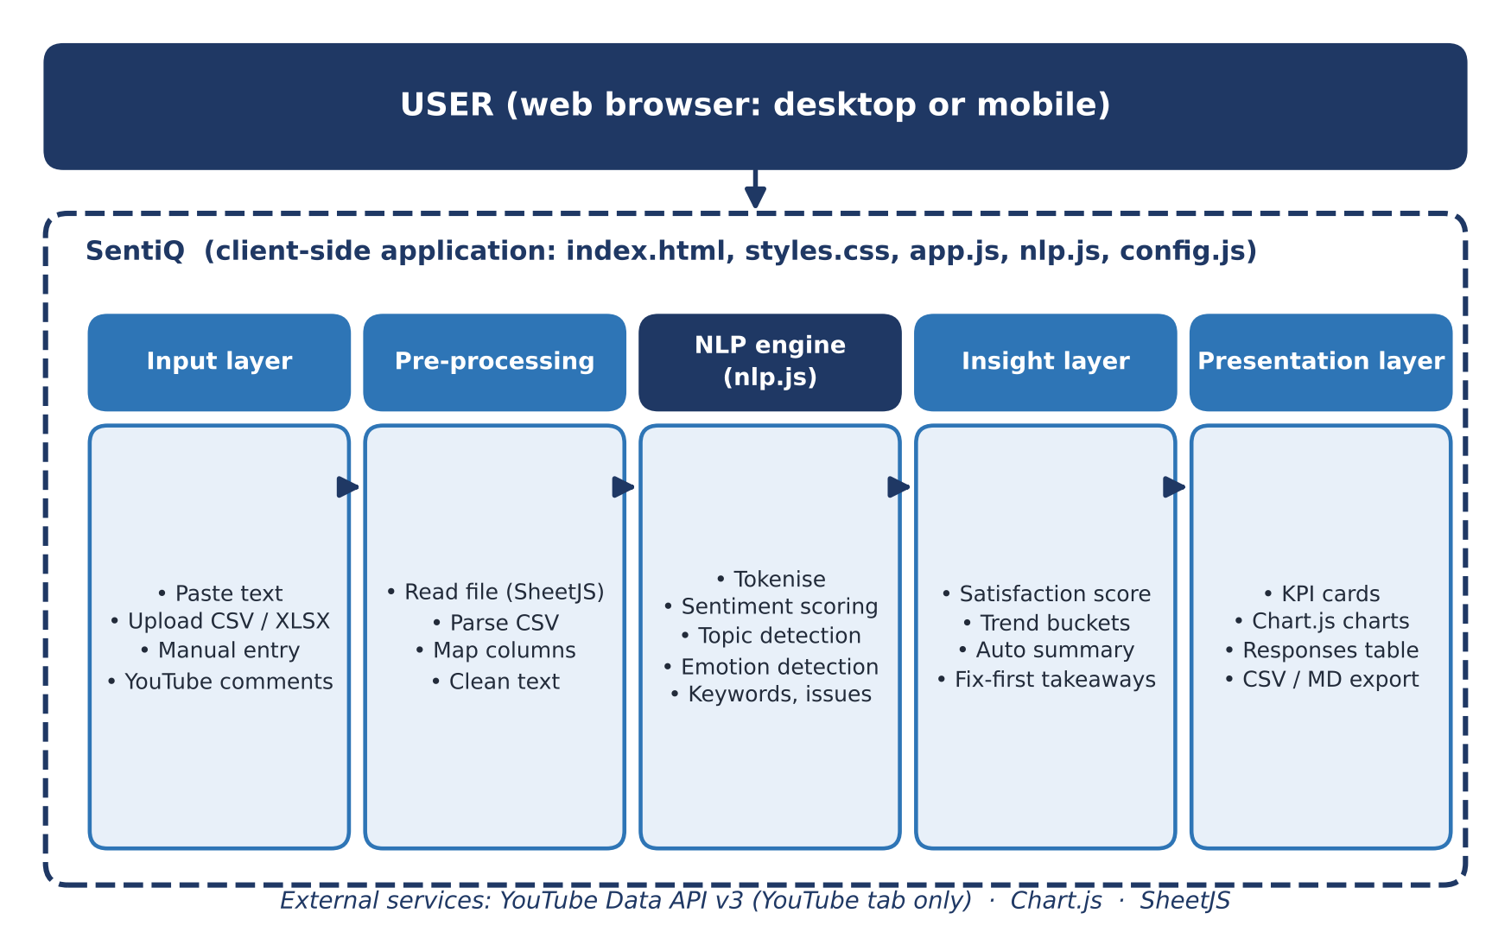

Fig 4.1: System Architecture
The workflow that a user follows is shown in Fig 4.2. After the input is loaded the user presses the Analyze button. The application checks that there is data to analyse, otherwise it shows a short warning. While the engine runs, a progress panel lists the steps: tokenising and cleaning text, running sentiment analysis, detecting topics, finding recurring issues and identifying trends. When the analysis finishes, the dashboard is rendered and the user can export the results or start again.
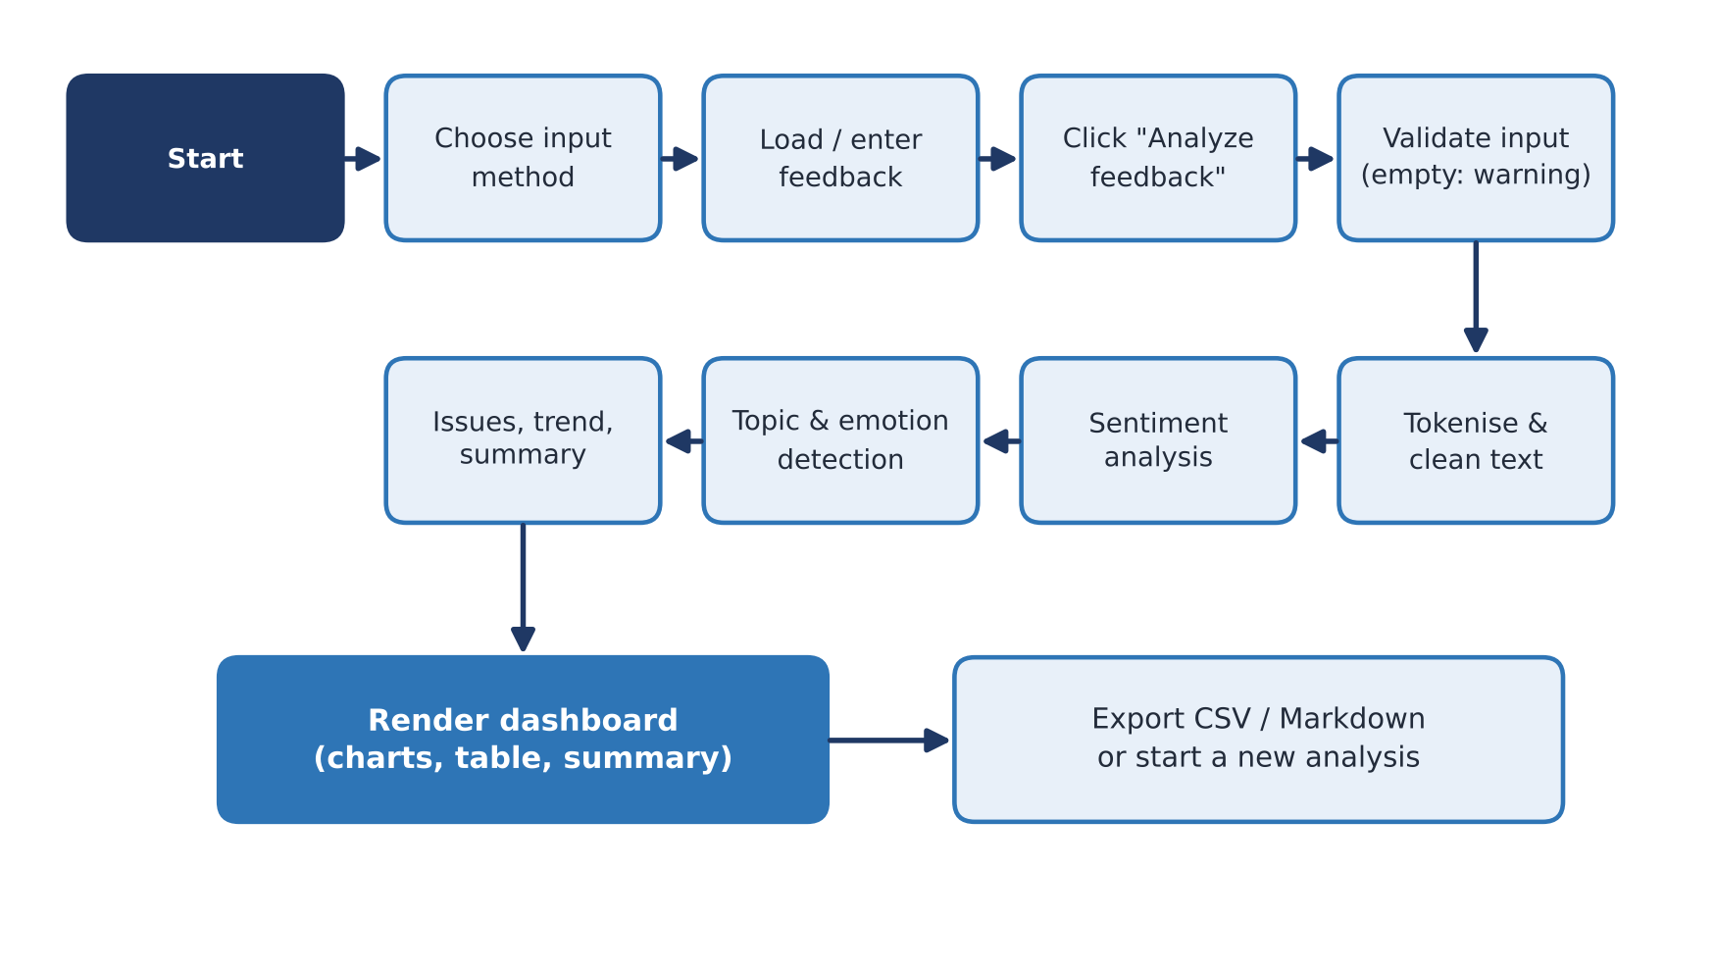

Fig 4.2: Project Workflow
4.3 DESCRIPTION OF SOFTWARE FOR IMPLEMENTATION AND TESTING PLAN OF THE PROPOSED MODEL /SYSTEM
The software consists of seven modules that work together to produce the final dashboard.
4.3.1 Input Module
The Analyzer section provides four tabs. In the Paste tab every line of the text area is treated as one response, and three sample sets for customers, students and employees can be loaded with one click; the sample responses carry dates and sources, so the trend chart can be shown immediately. In the Upload tab the user drops a CSV, TSV, TXT or Excel file; Excel sheets are read with SheetJS and CSV text is parsed by a small built-in parser, after which the user selects which column holds the feedback text and, optionally, the date and the source. In the Manual tab responses are added one at a time and are listed with a quick sentiment icon. In the YouTube tab the user pastes a video link; the application extracts the video identifier, shows a preview of the video and fetches up to the chosen number of top-level comments, in the chosen order, through the commentThreads endpoint of the YouTube Data API. Clear messages are shown when comments are disabled, the video is not found, the quota is used up or the API key is missing or invalid.
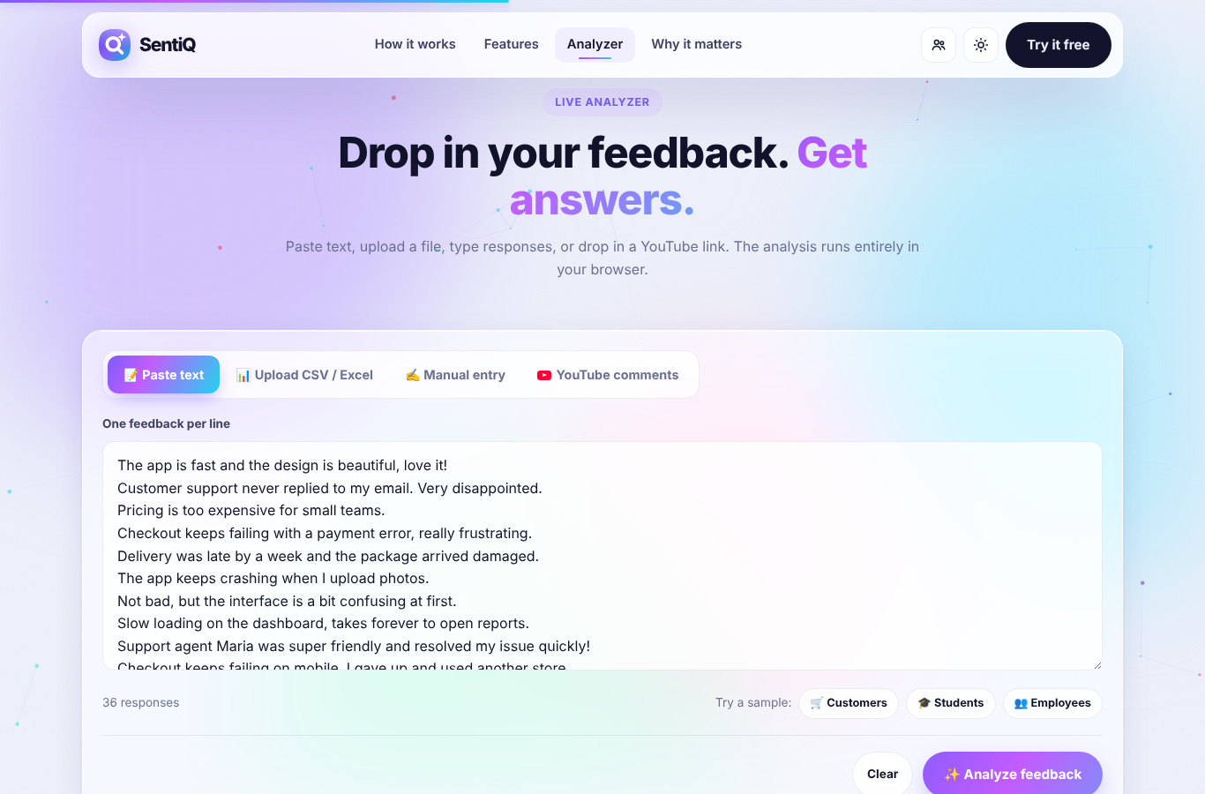

Fig 4.3: Analyzer Input Interface
4.3.2 Sentiment Engine
The sentiment engine in nlp.js works in the sequence shown in Fig 4.4. The text is first lower-cased and tokenised into words, emojis and numbers. Multi-word phrases such as “waste of time”, “not bad” or “highly recommend” are matched first, because their meaning is not the sum of their words. Every remaining word is then looked up in a positive lexicon (for example “excellent” has weight 4), a negative lexicon (for example “terrible” has weight −4) and an emoji lexicon. For each matched word the three preceding words are examined: an intensifier such as “very” or “extremely” multiplies the weight, whereas a negator such as “not” or “never” reverses it and slightly softens it. When a contrast word such as “but” or “however” is found, the score collected so far is reduced and the words that follow are given more weight, because the clause after “but” usually carries the writer’s real opinion. Exclamation marks and words written in capital letters add a small amplification.
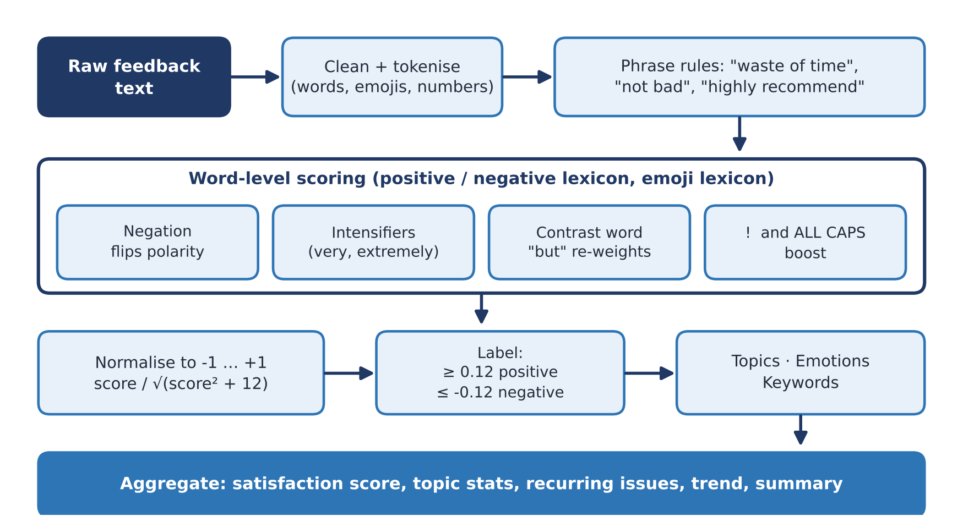

Fig 4.4: NLP Processing Flow
The raw score is normalised to the range −1 to +1 using score ÷ √(score² + 12), so that very long or very emotional responses do not dominate. A response is labelled positive when the normalised score is at least 0.12, negative when it is at most −0.12, and neutral otherwise. The satisfaction score of the whole data set is the average score rescaled to 0–100 as (average + 1) ÷ 2 × 100.
4.3.3 Topic and Emotion Detection
Topics are detected by matching the words of a response against curated keyword lists. Twelve categories are supported, which cover customer, student and employee feedback (Table 4.1). A response can belong to more than one topic, and a response that matches none is placed in a General group. Emotions are detected in the same way from word lists for seven emotions: joy, trust, surprise, anger, sadness, frustration and fear, following the idea of basic emotions [11], [8].
Table 4.1: Topic Categories and Example Keywords
Topic | Example keywords
Pricing | price, cost, expensive, subscription, refund, discount
Customer Support | support, service, agent, reply, response, helpful
Performance | slow, fast, lag, loading, crash, responsive
Usability & UI | design, interface, layout, navigation, intuitive
Bugs & Reliability | bug, error, glitch, failing, broken, unreliable
Features | feature, option, functionality, integration
Delivery & Shipping | delivery, package, courier, tracking, arrived
Product Quality | quality, material, durable, sturdy, taste
Teaching & Content | teacher, lecture, course, content, explanation
Workload & Schedule | workload, deadline, overtime, busy, pace
Management & Culture | manager, leadership, culture, communication, toxic
Facilities | campus, classroom, library, wifi, canteen

4.3.4 Recurring Issues, Keywords and Summary
To find recurring issues, SentiQ collects two-word and three-word phrases from negative responses and keeps those that occur at least twice, removing a shorter phrase when a longer one occurs equally often. These phrases are combined with the topics that have the most negative responses, together with the most frequent negative words in each topic, and the six most frequent items are shown. The same procedure on positive responses gives recurring praise. Keywords are the most frequent meaningful words after common stop words are removed, and each keyword is coloured by the average sentiment of the responses in which it appears.
The summary generator writes a short paragraph from the numbers: the number of responses, an overall mood from “strongly positive” to “strongly negative” based on the difference between the positive and negative percentages, the most discussed topic, the happiest and the most problematic topics, the trend, and the dominant emotion. It also produces takeaways such as “Fix first”, “Keep doing” and a warning when negative feedback is high.
4.3.5 Trend Module
When at least half of the responses have valid dates, the trend is calculated per day, or per month when the data spans more than about two and a half months. Otherwise the responses are divided into up to twelve consecutive groups in the order received, so a trend can still be drawn for undated data. The average score of each group is plotted as a line.
4.3.6 Dashboard and Reporting Module
The dashboard (Fig 4.5) shows five key cards (total responses, percentage positive, neutral and negative, and the satisfaction score), the generated summary and takeaways, a doughnut chart of the sentiment split, a stacked bar chart of sentiment by topic, a trend line, an emotion chart, a keyword cloud, lists of recurring issues and praise, and a table of all responses that can be searched and filtered by sentiment or topic. The user can export a CSV file of the results, download a Markdown report or print the dashboard. A light and a dark theme are available, and short animations such as a loading screen, count-up numbers and a celebration effect after the analysis make the interface more engaging.
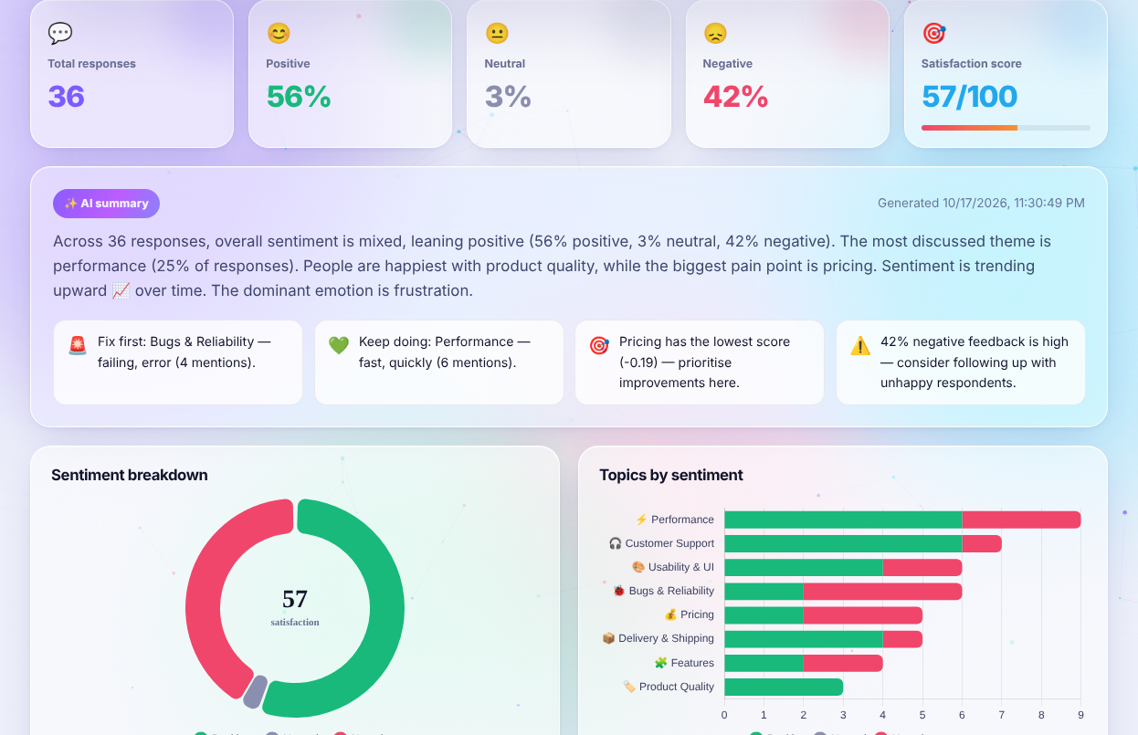

Fig 4.5: SentiQ Results Dashboard
4.3.7 Testing Plan and Results
The testing plan has three parts: unit testing of the sentiment function with sentences that exercise each rule, functional testing of each input method and export through the interface, and result testing on the three built-in sample sets. The sentiment function was run directly on the test sentences in Table 4.2. The scores in the table are the actual outputs of the engine.
Table 4.2: Test Cases and Results
Input sentence | Rule tested | Score | Result
The app is fast and the design is beautiful, love it! | Positive words | +0.93 | Positive
The service is not good. | Negation | −0.42 | Negative
It is not bad at all. | Phrase rule “not bad” | +0.40 | Positive
Customer support never replied to my email. Very disappointed. | Negative + intensifier | −0.92 | Negative
The checkout is slow but the support team is really helpful. | Contrast: clause after “but” | +0.73 | Positive
The support team is helpful but the checkout is extremely slow. | Contrast, reversed order | −0.72 | Negative
I love this 😍 | Emoji | +0.88 | Positive
This is a waste of time and money | Phrase rule | −0.88 | Negative
GREAT PRODUCT!!! | Capitals and exclamation | +0.78 | Positive
The package was delivered yesterday. | No opinion words | 0.00 | Neutral
(empty text) | Empty input | 0.00 | Neutral

All eleven cases produced the expected label. Functional testing confirmed that each of the four input methods loads data into the same pipeline, that the YouTube tab reports a clear message when the API key is missing, and that the CSV and Markdown exports download correctly. The three sample data sets were then analysed; the results are shown in Table 4.3.
Table 4.3: Results on the Built-in Sample Data Sets
Data set | Responses | Positive / Neutral / Negative | Satisfaction | Most discussed topic
Customers | 36 | 20 / 1 / 15 | 57 | Performance (9 responses)
Students | 24 | 12 / 3 / 9 | 54 | Teaching & Content (15 responses)
Employees | 20 | 10 / 4 / 6 | 60 | Management & Culture (14 responses)

For the customer set the engine reported that sentiment was mixed but leaning positive (56% positive and 42% negative), that the first issue to fix was bugs and reliability (failing, error; four mentions), that the best-rated topic was customer support, and that sentiment rose from −0.56 in May to +0.77 in September. The student set highlighted facilities (crowded, terrible) and unclear teaching content as the main complaints, and the employee set highlighted management and culture. These findings match the content of the sample responses, which shows that the engine produces sensible and useful summaries.
Testing also revealed limitations that are typical of keyword methods. A comment about the “support team” was also assigned to the Management & Culture topic because the word “team” appears in both topic lists, and “arrived on time” was also linked to Workload & Schedule because of the word “time”. Such overlaps do not change the sentiment result, and since the keyword lists are plain data they can be refined easily.
4.4 PROJECT MANAGEMENT PLAN
The project followed an iterative plan in which each phase produced a testable result. The phases, activities and deliverables are summarised in Table 4.4. Progress was reviewed after every phase, and the results of testing were used to refine the lexicons and rules before the next phase began. Risks identified in Section 3.1.2 were checked at each review.
Table 4.4: Project Phases and Deliverables
No. | Phase | Activities | Deliverable
1 | Requirement analysis | Study of feedback analysis tools, literature survey, selection of lexicon method | Requirements and scope
2 | Design | Architecture, data flow, dashboard layout, input methods | Design diagrams
3 | NLP engine | Lexicons, negation, intensifiers, topics, emotions, summary | nlp.js
4 | Application | Input tabs, parsing, YouTube integration, charts, table, export | app.js, index.html
5 | Visual design | Styling, themes, animations, responsive layout | styles.css
6 | Testing | Unit tests, sample data sets, input and export checks | Test results
7 | Documentation | Report and presentation | Report, slides

4.5 FINANCIAL REPORT ON ESTIMATED COSTING
SentiQ can be built and run with free and open-source tools, so the development cost is limited to the effort of the project team. Table 4.5 lists the tools and their cost. Hosting the finished application needs only a static web host, many of which offer a free plan.
Table 4.5: Estimated Cost & Implementation Overheads
Serial no | Software Name | Cost
1 | Code editor (for example Visual Studio Code) | Free
2 | Claude Code (AI-assisted development) | Subscription or usage based
3 | Chart.js 4.4.1 | Free (MIT License)
4 | SheetJS 0.18.5 (community edition) | Free (Open Source)
5 | Web browser (Chrome, Edge, Firefox) | Free
6 | YouTube Data API v3 | Free within the daily quota
7 | Static web hosting (optional) | Free plans available

4.6 TRANSITION / SOFTWARE TO OPERATIONS PLAN
SentiQ is delivered as five static files: index.html, styles.css, app.js, nlp.js and config.js. Moving the system from development to operation therefore consists of copying these files to a static web host or to a shared folder and opening index.html in a browser. When the YouTube tab is needed, an API key is created in the Google Cloud Console, the YouTube Data API v3 is enabled for it, and the key is placed in config.js. Because the key is visible to every visitor, it must be restricted to the website’s domain through HTTP referrer restrictions and to the YouTube Data API v3 only.
After deployment, maintenance consists mainly of extending the data tables: new sentiment words, topic keywords or emotion words can be added to nlp.js without changing the program logic. Future releases can add other languages, aspect-level sentiment or a learned model that works with the lexicon [2], [14].

REFERENCES
- Blei, D.M., Ng, A.Y., Jordan, M.I.: Latent Dirichlet allocation. Journal of Machine Learning Research 3, 993–1022 (2003)
- Devlin, J., Chang, M.-W., Lee, K., Toutanova, K.: BERT: Pre-training of deep bidirectional transformers for language understanding. In: Proceedings of NAACL-HLT 2019, pp. 4171–4186 (2019)
- Hu, M., Liu, B.: Mining and summarizing customer reviews. In: Proceedings of the 10th ACM SIGKDD International Conference on Knowledge Discovery and Data Mining, pp. 168–177 (2004)
- Hutto, C.J., Gilbert, E.: VADER: A parsimonious rule-based model for sentiment analysis of social media text. In: Proceedings of the International AAAI Conference on Web and Social Media 8(1), 216–225 (2014)
- Liu, B.: Sentiment Analysis and Opinion Mining. Morgan & Claypool Publishers (2012)
- Liu, B.: Sentiment Analysis: Mining Opinions, Sentiments, and Emotions. Cambridge University Press (2015)
- Medhat, W., Hassan, A., Korashy, H.: Sentiment analysis algorithms and applications: A survey. Ain Shams Engineering Journal 5(4), 1093–1113 (2014)
- Mohammad, S.M., Turney, P.D.: Crowdsourcing a word–emotion association lexicon. Computational Intelligence 29(3), 436–465 (2013)
- Pang, B., Lee, L.: Opinion mining and sentiment analysis. Foundations and Trends in Information Retrieval 2(1–2), 1–135 (2008)
- Pang, B., Lee, L., Vaithyanathan, S.: Thumbs up? Sentiment classification using machine learning techniques. In: Proceedings of the Conference on Empirical Methods in Natural Language Processing (EMNLP), pp. 79–86 (2002)
- Plutchik, R.: The nature of emotions. American Scientist 89(4), 344–350 (2001)
- Taboada, M., Brooke, J., Tofiloski, M., Voll, K., Stede, M.: Lexicon-based methods for sentiment analysis. Computational Linguistics 37(2), 267–307 (2011)
- Wilson, T., Wiebe, J., Hoffmann, P.: Recognizing contextual polarity in phrase-level sentiment analysis. In: Proceedings of HLT/EMNLP 2005, pp. 347–354 (2005)
- Zhang, L., Wang, S., Liu, B.: Deep learning for sentiment analysis: A survey. WIREs Data Mining and Knowledge Discovery 8(4), e1253 (2018)

