Intelligent rule-based phishing websites classification Based on URL Features

- There are number of users who purchase products online and make payment through e- banking.
- There are e- banking websites who ask user to provide sensitive data such as username, password or credit card details etc. often for malicious reasons.
- This type of e-banking websites is known as phishing website.
- In order to detect and predict e-banking phishing website, we proposed an intelligent, flexible and effective system that is based on using classification Data mining algorithm.
- We implemented classification algorithm and techniques to extract the phishing data sets criteria to classify their legitimacy.
- The e-banking phishing website can be detected based on some important characteristics like URL and Domain Identity, and security and encryption criteria in the final phishing detection rate.
- Once user makes transaction through online when he makes payment through e-banking website our system will use data mining algorithm to detect whether the e-banking website is phishing website or not.
- This application can be used by many E-commerce enterprises in order to make the whole transaction process secure.
- Data mining algorithm used in this system provides better performance as compared to other traditional classifications algorithms.
- With the help of this system user can also purchase products online without any hesitation.

Features
- This system uses effective classification data mining algorithm to detect the e-banking phishing websites.
- The e-banking phishing website can be detected based on some important characteristics like URL and Domain Identity, and security and encryption criteria in the final phishing detection rate.
- This application can be used by many E-commerce enterprises in order to make the whole transaction process secure.
- Data mining algorithm used in this system provides better performance as compared to other traditional classifications algorithms.
- By using this system user can make purchase products online securely.

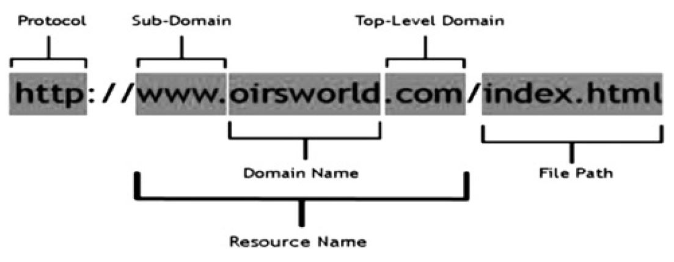

Modules:
The system comprises of 2 major modules with their sub-modules as follows:
- Admin:
- Login: Admin can login his personal account.
- Add Blacklisted Sites: Admin can add some blacklisted sites in database.
- View Feedback: Admin can see feedback written by user.
- Logout: Admin logout from his account.
- User:
  - Register: User can register his personal detail.
  - Login: User Login his personal account.
  - Check Website: User check some websites.
  - Write Feedback: User can write his view in form of feedback.
  - Change Password: User can change his password.
Software Requirements:
- Windows 7 or higher.
- SQL 2008
- Visual studio 2010
Hardware Components:
- Processor – i3
- Hard Disk – 5 GB
- Memory – 1GB RAM
- Internet Connection

Advantages:
- Unused or not secure website automatically scan.
- This system is use for safety from outside virus and bugs.
- Many E-commerce Websites can use this system in order to have good customer relationship.
- User can make online payment securely.
- Data mining algorithm used in this system provides better performance as compared to other traditional classifications algorithms.
- With the help of this system user can also purchase products online without any hesitation.
Disadvantages:
- Admin has to add a website in block listed group, not automatically generate.
- Required an active internet connection.
Reference:
- http://ieeexplore.ieee.org/xpl/articleDetails.jsp?arnumber=5444840&queryText=Associative+Classification+techniques+for+predicting+ebanking+phishing+websites&newsearch=true&searchField=Search_All
- Intelligent rule-based phishing websites classification.pdf

