Welcome!
This small Java app is a Fleet Management System.
It lets you manage a collection of vehicles (cars, trucks, buses, motorcycles, scooters).
The system is very simple:
- All data is stored in memory (no database needed).
- You can manage vehicles through a REST API (using GET, POST, DELETE, etc.).
REST API Overview
- GET /api/vehicles → Get all vehicles
- GET /api/vehicles/{id} → Get vehicle by ID
- POST /api/vehicles → Add a new vehicle
- PUT /api/vehicles/{id} → Update a vehicle
- DELETE /api/vehicles/{id} → Delete a vehicle
- GET /api/vehicles/filter?... → Filter by criteria (fuel, owner, wheels, security measure)
How to Run:
1. Clone the repository:
git clone https://github.com/DanFrei/Fleet-Management
https://github.wdf.sap.corp/uas/Fleet-Management
2. Open in IntelliJ IDEA/VScode.
3. Run FleetApplication.java (Spring Boot main class).
4. The app runs locally at:
http://localhost:8087/api/vehicles
Question 1:
1. Create a new Bus and a new Motorcycle
2. Delete all the Vehicles

Question 2: Retrieve by ID
- Create another new vehicle via POST /vehicles.
- From the response, retrieve the vehicle ID.
- Use GET /vehicles/{id} to fetch that vehicle specifically.
Question 3: Implement new functionality: “Describe”
Objective:
Provide two new APIs that return a description of vehicles:
- GET /describe – returns descriptions for all vehicles
- GET /describe/{id} – returns the description of a specific vehicle by ID
Output Format:
For a FourWheeler:
Vehicle [ID: {id}, Make: {make}, Model: {model}, Year: {year}, Spare Wheels: {spareWheels}]
For a TwoWheeler:
Vehicle [ID: {id}, Make: {make}, Model: {model}, Year: {year}, Pillion Rider: {pillionRider}]
Example /describe Response:
Suppose the system has the following vehicles:
- Truck: FourWheeler, ID 1, Make “Volvo”, Model “FH16”, Year 2022, Spare Wheels 2
- Car: FourWheeler, ID 2, Make “Toyota”, Model “Corolla”, Year 2020, Spare Wheels 1
- Scooter: TwoWheeler, ID 3, Make “Vespa”, Model “Primavera”, Year 2021, Pillion Rider 1
The response should look like:
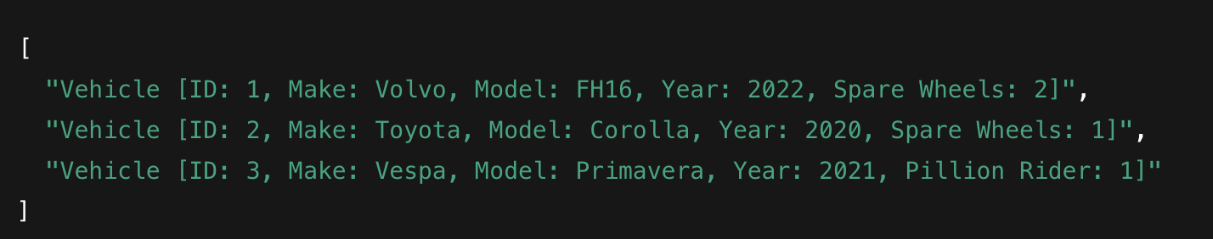

Example /describe/{id} Response:
Request: /describe/2
Response:
Question 4: Expose the Fleet Management System as an MCP Server
Objective:
Make your Fleet Management System accessible to AI assistants by implementing an MCP (Model Context Protocol) server.
MCP is an open standard that lets AI assistants (like Claude) connect to external tools and data sources. Your task is to wrap the Fleet Management API with an MCP server so that an AI assistant can manage vehicles through natural language.
Requirements:
Implement an MCP server that exposes the following tools:
Tool name | Description | Inputs
list_vehicles | Return all vehicles | (none)
get_vehicle | Get a vehicle by ID | id: number
add_vehicle | Add a new vehicle | type, make, model, year, + type-specific fields
delete_vehicle | Delete a vehicle by ID | id: number
describe_vehicle | Return the description string for a vehicle | id: number
The MCP server should call your existing REST API (localhost:8087) - do not duplicate the business logic.
Deliverables:
1. The MCP server source code
2. A mcp.json (or equivalent config) so it can be registered with an MCP-compatible client
3. A short README explaining how to connect it to Claude Desktop or Claude Code
Stretch goal:
Add a filter_vehicles tool that maps to GET /api/vehicles/filter.

