Report
I do not like the results I got from this homework, but I tried many variations with how/what attributes I selected, and I do not know how to improve. The reasoning is as follow:
I tried selecting few attributes (the dataframe child_df) and many attributes (the dataframe child_df_2) to do the clustering to see which would produce more logical results. Furthermore, I decided to do 3 clusters because intuitively it represents developed, developing, and under-developed countries. I filled the Na values using interpolation because I think the mean or median isn’t a good representation for a dataset with countries which the variance of the value of each attribute could be great (upon reflection I realize that I should have checked the variance of each column to make this claim more credible).
The results are as follows:
Clustering with 6 attributes
The attributes I chose: 'GDP','Gross primary education enrollment (%)', 'Infant mortality', 'Maternal mortality ratio','Out of pocket health expenditure','Physicians per thousand'
==================================================
CLUSTER 0
==================================================
['Afghanistan', 'Angola', 'Belize', 'Benin', 'Botswana', 'Brunei', 'Burkina Faso'…]

==================================================
CLUSTER 1
==================================================
['Albania', 'Algeria', 'Andorra', 'Antigua and Barbuda', 'Argentina', 'Armenia', 'Australia', 'Austria', …]

==================================================
CLUSTER 2
==================================================
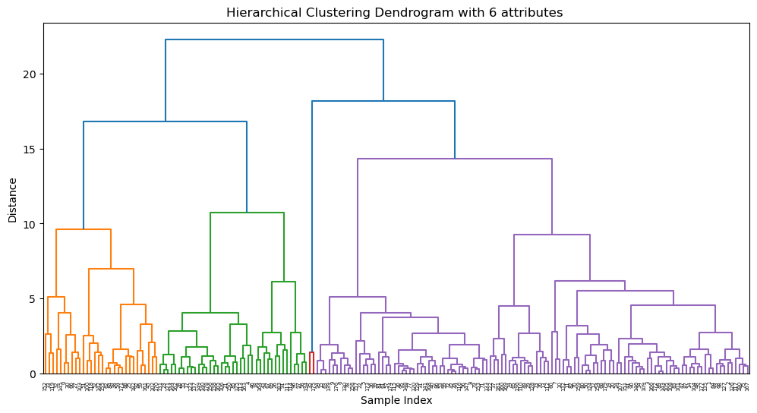
['China', 'United States']

Clustering with 10 attributes
The attributes I chose: 'GDP','Gross primary education enrollment (%)', 'Infant mortality', 'Maternal mortality ratio','Out of pocket health expenditure','Physicians per thousand','Birth Rate','Life expectancy','Unemployment rate','Fertility Rate'
==================================================
CLUSTER 0
==================================================
['Albania', 'Algeria', 'Argentina', 'Armenia', 'Australia', 'Austria', …]

==================================================
CLUSTER 1
==================================================
['Afghanistan', 'Angola', 'Benin', 'Botswana', 'Burkina Faso', 'Burundi', 'Ivory Coast', 'Cameroon', 'Central African Republic', 'Chad', 'Comoros', 'Republic of the Congo', 'Democratic Republic of the Congo', 'Djibouti', 'Equatorial Guinea', …]

==================================================
CLUSTER 2
==================================================
['China', 'United States']
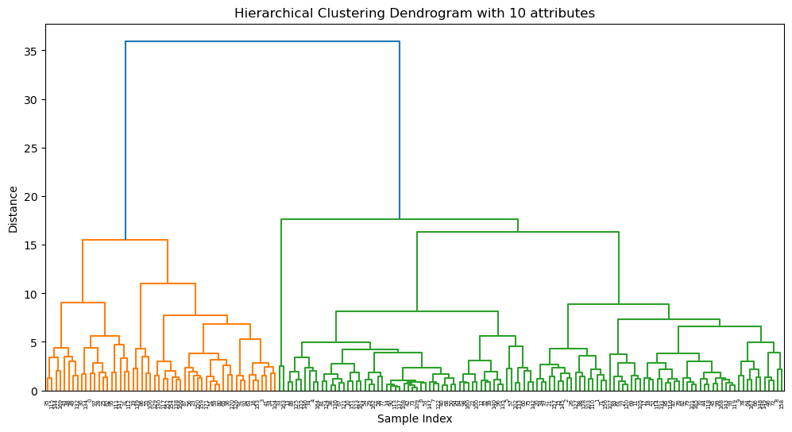
From these two, I realized that there was no significant difference. Furthermore, China and USA were outliers. Since I included GDP into these two, I thought it could be the cause. Therefore, I decided to try more variations: one with 26 attributes and another attempt at choosing attributes I think are related to Children welfare. The results are the following:
Clustering with 26 attributes
Name: 26attri
==================================================
CLUSTER 0
==================================================
['Afghanistan', 'Albania', 'Algeria', 'Argentina', 'Armenia', 'Australia', 'Azerbaijan', 'The Bahamas', 'Bangladesh', 'Barbados', …]

==================================================
CLUSTER 1
==================================================
['Angola', 'Benin', 'Burkina Faso', 'Ivory Coast', 'Cameroon', …]

==================================================
CLUSTER 2
==================================================
['China', 'India', 'United States']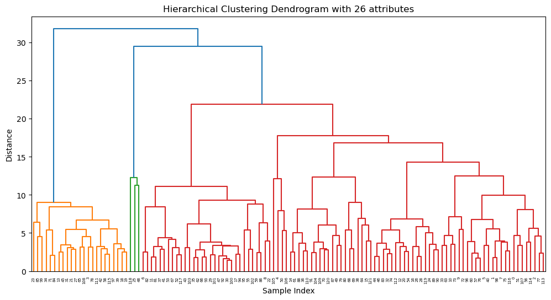
Another attempt at clustering with attributes I think are related to Children welfare.
The attributes I chose: ‘Infant mortality','Out of pocket health expenditure','Life expectancy', 'Co2-Emissions','Minimum wage','Unemployment rate',
'Urban_population'

==================================================
CLUSTER 0
==================================================
['Algeria', 'Argentina', 'Australia', 'Azerbaijan', 'The Bahamas', 'Bangladesh', 'Barbados', 'Belarus', 'Belgium', 'Belize', 'Bhutan', 'Bolivia', 'Bosnia and Herzegovina', 'Brazil', 'Bulgaria', 'Cape Verde', 'Canada', 'Chile', 'Colombia', 'Costa Rica', 'Croatia', 'Czech Republic', …]

==================================================
CLUSTER 1
==================================================
['China', 'India', 'United States']

==================================================
CLUSTER 2
==================================================
['Afghanistan', 'Albania', 'Angola', 'Armenia', 'Benin', 'Botswana', 'Burkina Faso', 'Ivory Coast', 'Cameroon', …]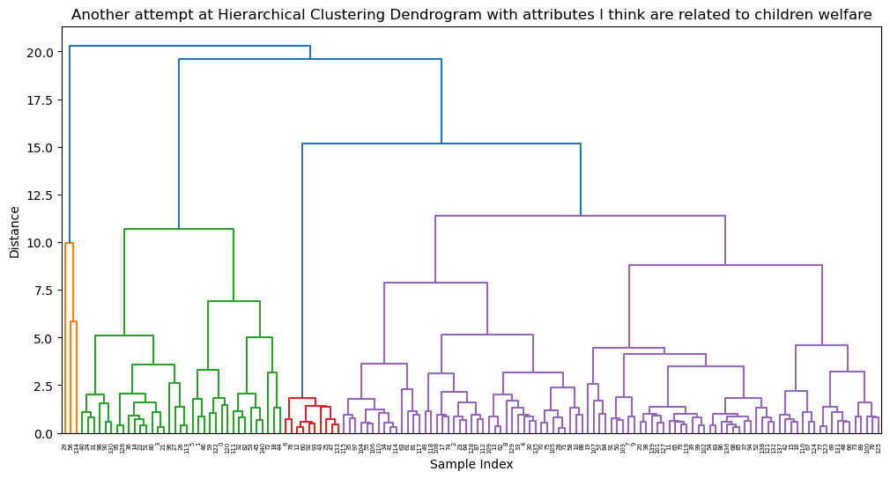
From the results, it can be seen that there are still outliers, and I do not believe these clusters are a good representation of children welfare metrics (I would have expected that developed countries are grouped together, developing countries are together, and under-developed countries are grouped together).

