

Assessment Cover Page
Student Full Name | Thaninnada Samart
Student Number | 2026781
Module Title | Statistical Techniques for Data Analysis
Assessment Title | CA 1 – Capstone Project Proposal
Lecturer/Supervisor | Taufique Ahmed
Assessment Due Date | 01-Nov-2026
Date of Submission | 01-Nov-2026

Use of AI Tools
I acknowledge the use of Codex (with Python support) to assist with my project on depression risk among older adults. I used it to review and improve specific sections of Python code, check data analysis and explain coding techniques, while retaining responsibility for the project content, analysis and final decisions.
Declaration
By submitting this assessment, I confirm that I have read the CCT policy on academic misconduct and understand the implications of submitting work that is not my own or does not appropriately reference material taken from a third party or other source.
I declare it to be my own work and that all material from third parties has been appropriately referenced.
I further confirm that this work has not previously been submitted for assessment by myself or someone else in CCT College Dublin or any other higher education institution.

Capstone Project Proposal

Statistical Analysis of Factors Associated with Depression Among Older Adults

Thaninnada Samart

Statistical Techniques for Data Analysis

Lecturer: Taufique Ahmed

CCT College Dublin

1st November 2026

https://github.com/thaninnada/Statistical_Techniques_Sep2026

Contents
Introduction and Research Aim 2
Dataset Description and Data Preparation 2
Dataset Description 2
Source File Inspection 3
Data Preparation 3
Exploratory Data Analysis (EDA) 4
Descriptive statistics 4
Data Distribution and Visualization 4
Distribution Analysis 5
Binomial Distribution : Depression Screening 5
Poisson Distribution 6
Variable and Inclusion Criteria 6
Poisson Distribution Assumptions 6
Large Sample Behaviour 8
Statistical Inference 8
Normal Distribution 8
Comparison and Critical Discussion 9
Conclusion 10
References 11
Use of Artificial Intelligence 12
AI Declaration using the AI Fluency Framework 12
Appendix I : Missing_Values_Report 14
Appendix II: Data_Dictionary 17
Appendix III 22

Table and Figure Contents
Table 1: Age Distribution of NHANES Participants 2
Table 2: Dataset Overview and SEQN Validation 3
Table 3: Missing Data Summary by Dataset 3
Table 4: Sample Size and Selection Criteria: 4
Table 5: Descriptive Statistics of Selected Variables 4
Table 6: Binomial Probability Results 6
Table 7: Poisson Summary Statistics 7
Table 8: Observed vs Expected Poisson Frequencies 7
Table 9: Poisson Goodness-of-Fit Test 8
Table 10: Distribution Comparison and Limitations 9

Figure 1: Age Distribution: Overall vs Older Adults 2
Figure 2: Age Distribution of Older Adults 5
Figure 3: Distribution of the Family Income to Poverty Ratio (INDFMPIR) for the elderly 5
Figure 4: PHQ-9 Total Score Distribution 5
Figure 5: Binomial Distribution of Positive PHQ-9 Screenings 6
Figure 6: Observed vs Expected Medical Condition Counts 7
Figure 7: INDFMPIR Histogram with Normal Curve 8
Figure 8: Normal Q-Q Plot of INDFMPIR 9

Introduction and Research Aim
The global population is aging rapidly with estimates from the World Health Organization (WHO) stating that the number of individuals aged 60 and over reached approximately 1.1 billion worldwide in 2023 in excess of 2.1 billion. The mental health conditions of older adults particularly depression (WHO, 2025) frequently go unrecognized and untreated. Healthcare organizations are facing significant challenges when identifying depression risk factors. Creating a need for evidence-based approaches to optimize screening and strategic planning (NIA, 2025).
This project uses cross-sectional data to examine the factors associated with depression in the older adult population. Identifying patterns among higher-risk subgroups. The findings will built an empirical foundation that will provide support for effective screening and prioritise resource allocation.
This analysis is designed for risk stratifications it does not aim to predict future onset or provide clinical diagnostics.

Dataset Description and Data Preparation

Dataset Description
The Project uses publicly available data from the National Health and Nutrition Examination Survey (NHANES). The dataset contains 11,933 participants, totalling 3,504 which are aged 60 years and above, forming the studies target population (Table 1).
Table 1: Age Distribution of NHANES Participants
Figure 1 shows the transition from the overall NHANES population to the older-adult cohort. Factors such as age in NHANES is top-coded at 80 years. The 80+ category comprises all participants aged 80 and older whose recorded age is truncated at 80.
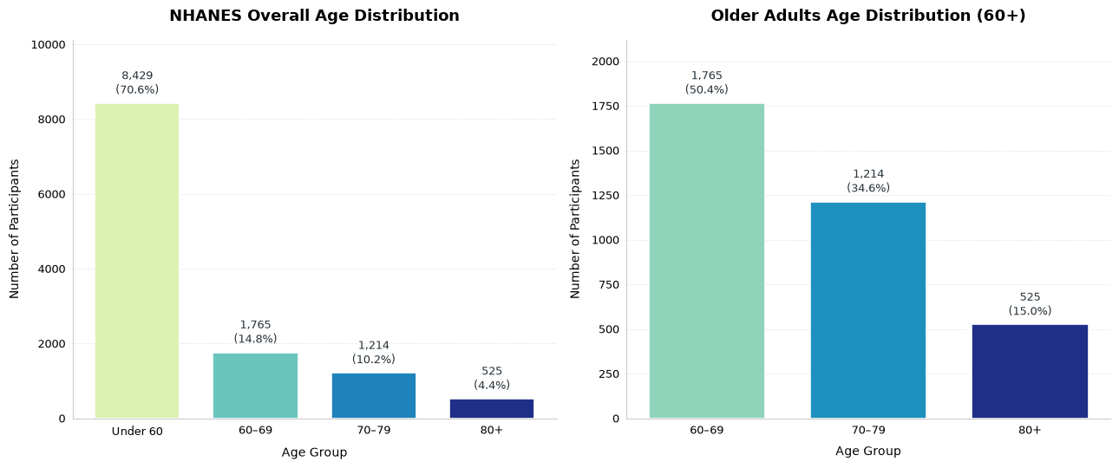
Figure 1: Age Distribution: Overall vs Older Adults

Source File Inspection
All dataset component files were inspected before merging. Table 2 summarises their dimensions and SEQN identifier checks.
Table 2: Dataset Overview and SEQN Validation
The Primary subject identifier was the SEQN variable. The source files presented zero admissions or duplicated identifiers this confirmed data integrity and compatibility for record linkage.

Data Preparation
Data integrity checks covered structure, data types, dimensions, duplicates, missing values, and, the completeness and uniqueness of identifiers (SEQN) has been also checked across sub-datasets to guarantee accurate merging.
A one-to-one left join has been applied to all datasets based on the shared variable (SEQN). This ensures all demographic information from the baseline dataset (DEMO_L) is retained, and relevant data pertaining to socioeconomic status, lifestyle, and health indicators are added (Table 3).
Table 3: Missing Data Summary by Dataset
MCQ_L had the highest percentage of missing data (63.22%), and SLQ_L had the least missing data (0.45%). This percentage is a reflection of the proportion of missing data cells, and does not represent the proportion of individuals with missing data. For the percentage of missing data, only data cells were included in the calculation (i.e. the SEQN column was not included).

Exploratory Data Analysis (EDA)

Descriptive statistics
This section summarises age (RIDAGEYR), family income to poverty ratio (INDFMPIR) and total depression score (PHQ9_Total) among older adults (aged ≥ 60) in NHANES 2021–2023. The sample size varied across measures: 2,902 participants provided valid income data and 2,394 (68.32%) completed all nine PHQ-9 items, forming the analytic sample for depression metrics (Table 4).
Table 4: Sample Size and Selection Criteria:
The sample mean age was 69.94 years (SD = 6.53, median = 69). The mean INDFMPIR was 2.97 (SD = 1.61, median = 2.87). The mean PHQ-9 score was 3.36 (SD = 4.30), which sits above the median of 2.00, consistent with a right-skewed distribution (skewness = 1.994) (Table 5).
Table 5: Descriptive Statistics of Selected Variables
These unweighted results are sample-level, not nationally representative, because NHANES uses a complex survey design; they are not population estimates or prevalence rates.

Data Distribution and Visualization
Age was right skewed (skewness = 0.173). Note: Ages ≥ 80 years were top-coded at 80 years to protect respondent confidentiality; thus, NHANES data do not accurately characterize the distribution of ages ≥ 80 years.
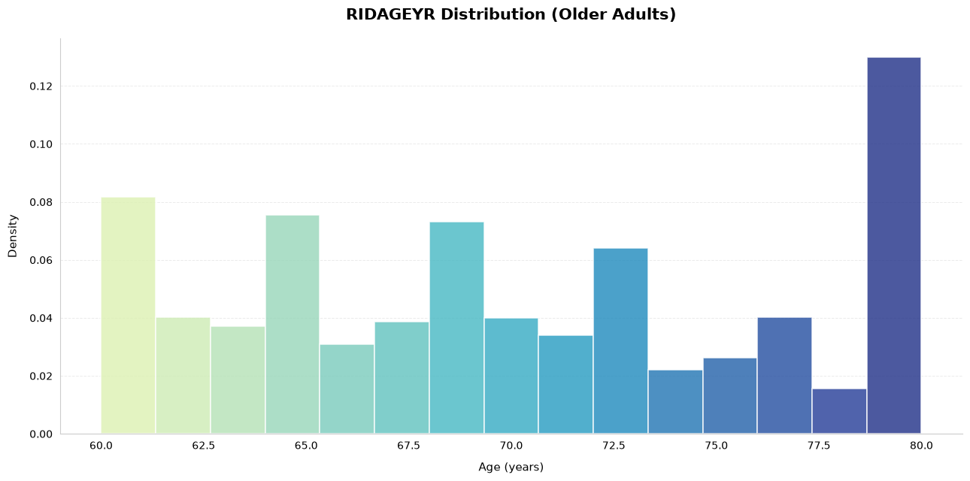
Figure 2: Age Distribution of Older Adults
INDFMPIR is nearly symmetric (skewness = -0.037). The spike in the histogram at 5.0 is due to NHANES collapsing values ≥ 5.00 to 5.00 for privacy reasons, so 5.0 should be interpreted as 5.0 or greater. This means that the upper end of the distribution should not be interpreted literally.
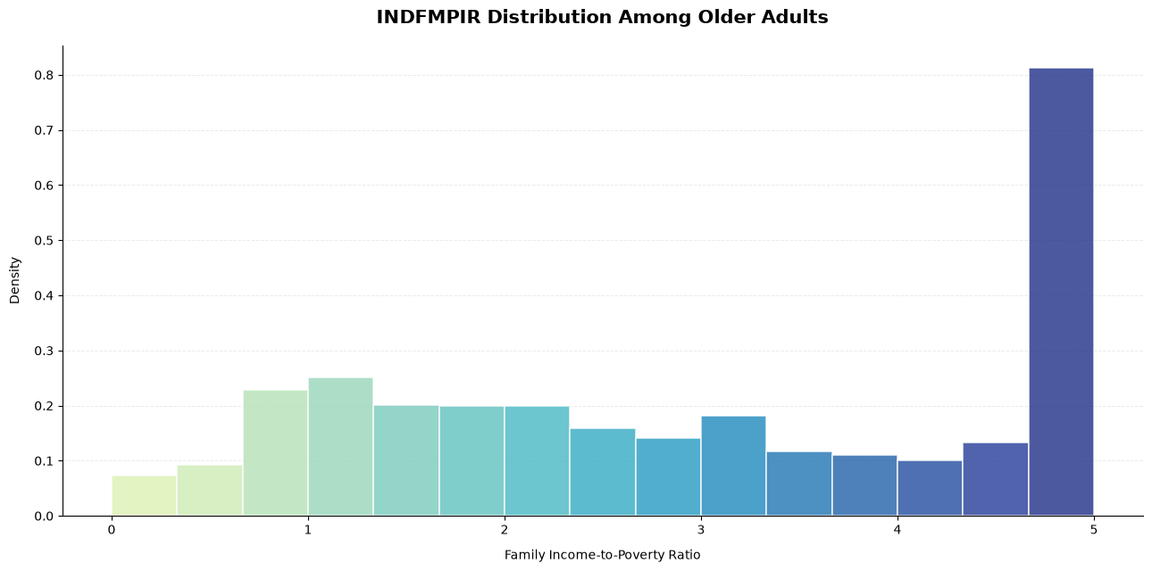
Figure 3: Distribution of the Family Income to Poverty Ratio (INDFMPIR) for the elderly
The distribution of PHQ-9 scores was right-skewed (skewness = 1.994). Most participants having low scores and only a few with higher scores. This means that the majority of participants had low levels of depressive symptoms.
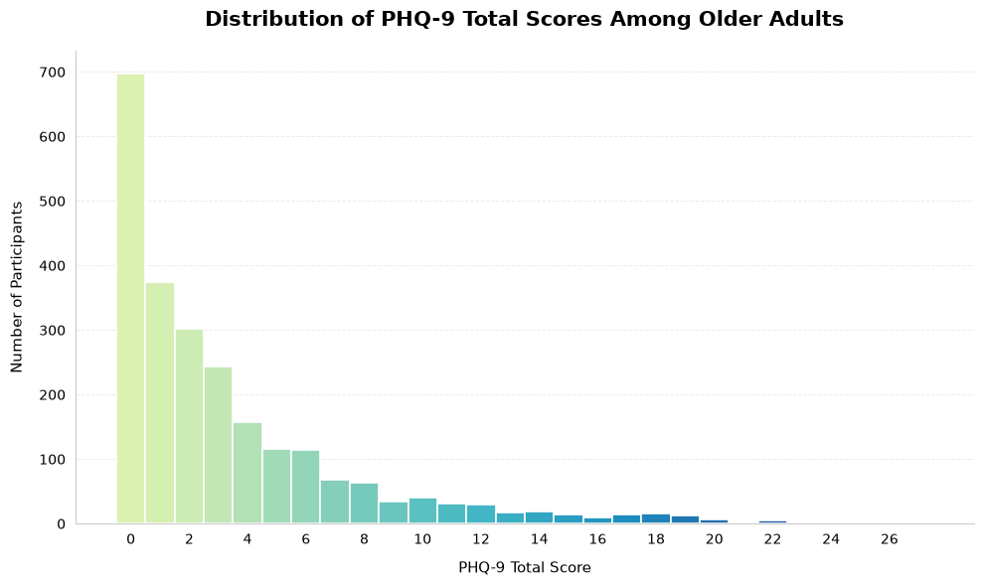
Figure 4: PHQ-9 Total Score Distribution

Distribution Analysis

Binomial Distribution : Depression Screening
Among participants with complete PHQ-9 data (n = 2,394), 223 screened positive for depression (PHQ-9 ≥ 10; 9.31%). The probability (p) of screening positive for depression was modelled using a binomial distribution, X ~ Binomial (100, 0.0931). The mean was 9.31, the variance was 8.45, and the standard deviation was 2.91.
Using this model, for a sample of 100 participants, the probability of observing ≤ 5 positive depression screenings was 8.71%, between 5 and 15 positive depression screenings was 93.91%, ≥ 15 positive depression screenings was 4.40%, and no positive depression screenings was 0.01%.
The binomial model was used with the following assumptions: fixed sample size, independent binary, and a constant probability. A positive screen was defined as a PHQ-9 score ≥ 10.
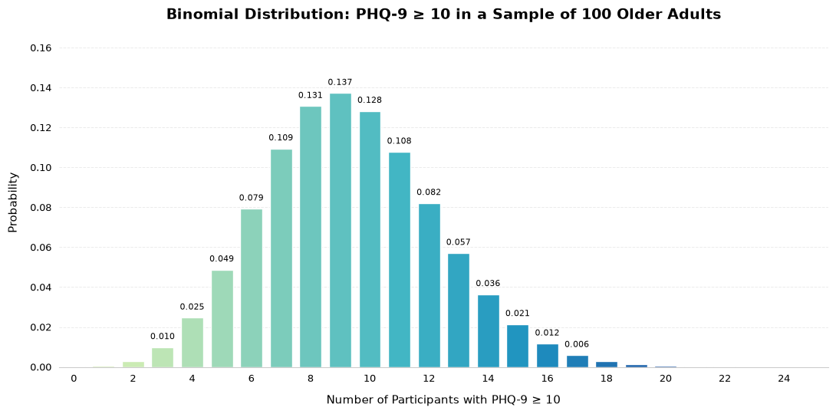
Figure 5: Binomial Distribution of Positive PHQ-9 Screenings
Figure 5 displays the binomial distribution of PHQ-9 ≥ 10 in our sample (p = 9.31%). The distribution peaks at 9, with most of the density between 6 and 13.
Table 6: Binomial Probability Results
In 100 hypothetical older adults, positive-screen probabilities are 0.01% (none), 8.71% (≤ 5), 93.91% (5 - 15 inclusive) and 4.40% (≥ 15). Due to overlapping thresholds at 5 and 15 (with 'none' nested within ≤ 5), these statistics must be interpreted independently; summing them induces double counting.

Poisson Distribution

Variable and Inclusion Criteria
This study analyses self-reported medical conditions in older adults by assessing the presence of seven conditions: arthritis, congestive heart failure, coronary heart disease, angina, heart attack, stroke and COPD/ emphysema/ chronic bronchitis. Participants with valid "Yes" (1) or "No" (2) across all seven conditions yielded analytic sample of 3,409 older adults.

$$X=\text{Number} \text{of} \text{selected} \text{medical} \text{conditions}, X∼Poisson\left(λ\right)$$

Poisson Distribution Assumptions
The Poisson model assumes count data, independent events, a constant average rate, and equal mean and variance. Restricting count data to values between 0 to 7 is not compatible with the standard Poisson model. Beyond these limits, the standard Poisson model becomes more and more inaccurate.

Estimation of Lambda (λ)
$$\hat{λ}=\overline{x}=\frac{\sum_{i=1}^{n}{x_{i}}}{n}$$
The parameter Lambda (λ) was estimated using the sample mean ($\overline{X}$):
$$\hat{λ}=\overline{X}= 0.993$$
Table 7: Poisson Summary Statistics
Observed vs Expected Frequencies
Observed and Poisson-expected frequencies were compared across five categories and counts of ≥ 4 were grouped together in order to maintain adequate expected cell frequencies for statistical analysis (Table 8).
Table 8: Observed vs Expected Poisson Frequencies
The largest discrepancy occurs in the “4+” category, with 142 observed instances versus 63.33 expected.

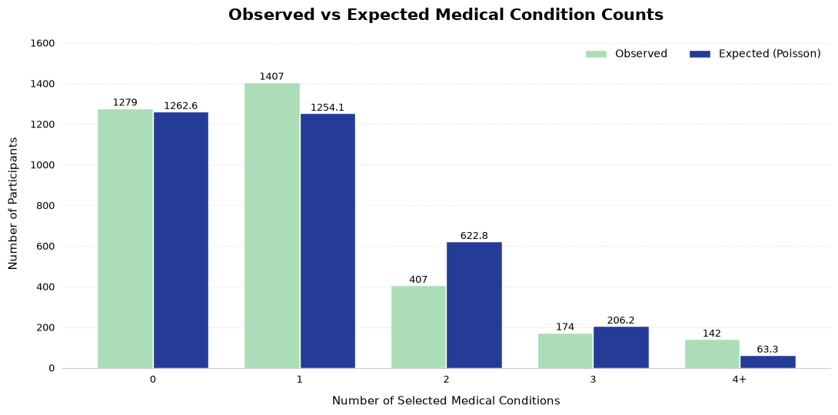
Figure 6: Observed vs Expected Medical Condition Counts
Over-dispersion and the count in the 4+ group likely reflects chronic disease comorbidity. Restricted data in the 0 to 7 range does not allow for a good fit to a standard Poisson distribution.

Large Sample Behaviour
Expected frequencies scale proportionally with sample size via
$$E_{k}=nP\left(X=k\right)$$
While large samples stabilize relative frequencies and improve mean estimates, they do not mitigate systemic violations of core Poisson assumptions.

Statistical Inference
A Pearson chi-square goodness of fit test assessed the fitted Poisson model.
- $Η_{0}$: The observed distribution follows a Poisson distribution with $\hat{λ}=0.993.$
- $Η_{1}$: The observed distribution differs from the fitted Poisson distribution.
- Significance level: $α = 0.05$
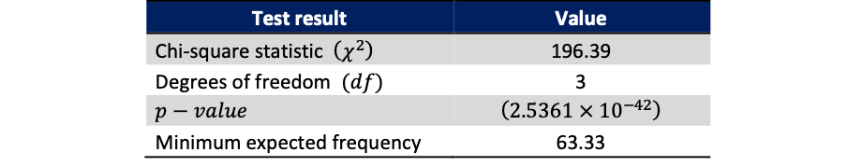
Table 9: Poisson Goodness-of-Fit Test
Since p-value <0.05, we can reject Η0. Η0: the empirical medical-condition count distribution differs significantly from the fitted Poisson distribution.
Normal Distribution
INDFMPIR was chosen because of near-zero skewness relative to the other continuous variables. However, the data are constrained between 0 and 5, with 5 representing a top-coded threshold (≥5). Consequently, near-zero skewness does not indicate the data are normally distributed.

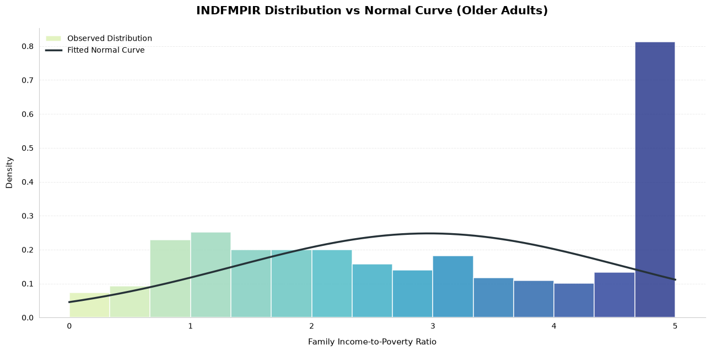
Figure 7: INDFMPIR Histogram with Normal Curve
Normality was assessed using histograms, a Q-Q plot and empirical coverage against the 68.27% (±1 SD) and 95.45% (±2 SD) benchmarks.
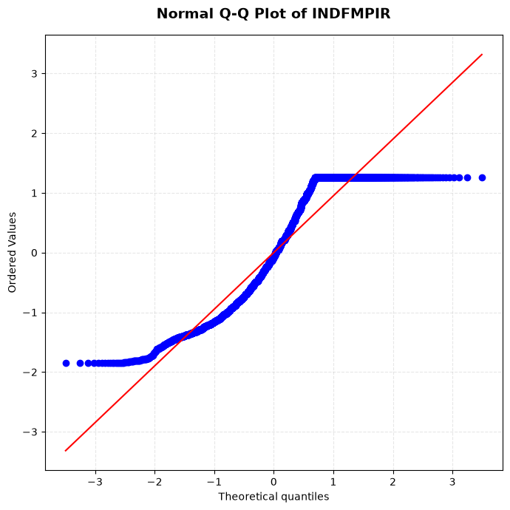
Figure 8: Normal Q-Q Plot of INDFMPIR
Although the skewness of INDFMPIR is near-zero (-0.037), INDFMPIR clearly violates normality. The coverage of observations in +/-1 SD is 50.1% (reference 68.3%), and 100% is in +/-2 SD (reference 95.45%). The Q-Q plot exhibits clear deviation at the tails, with 709 observations truncated at the 5.00 (top) coded level. INDFMPIR cannot be modelled by a generic/unrestricted Normal Distribution.

Comparison and Critical Discussion
Table 10: Distribution Comparison and Limitations
- Suitability Violations: Poisson models rely on mean and variance being equal and normal models rely on the data being unbounded. Violations in either case will result in gross model misfit.
Approximation Deficits:
- Binomial: The model relies on a normal approximation to the Poisson. However, as the expected count ((np) = 9.31) is less than 10, the approximation fails and the model misfits.
- Poisson: For low mean levels (λ = 0.993), the model assumes a discrete, right-skewed structure, and therefore, normal approximation is not allowed..
- INDFMPIR: Because it is continuous, Q-Q plots and high top-coding suggest a Normal model is inappropriate.
- Statistical Conclusion: The Binomial model illustrates probability of depression screening. The other models were unable to approximate the given conditions.

Conclusion
- Empirical Profiles: The mean age is 69.94, and based on INDFMPIR, 63.8% of the sample exhibited no depression. The PHQ-9 score was heavily right-skewed, indicating the presence of minimal symptoms of depression.
- Binomial Framework: X ~ Binomial (100, 0.0931) suggests that 9 positive screenings are expected on average, with a 93.91% probability that the true number of positive depression screenings falls between 5 and 15.
- Model Inadequacy (p < 0.05): Systematic Overdispersion in the medical count is attributed to clinical comorbidities (variance = 1.242 > mean = 0.993). INDFMPIR, however, has a 709-observation cluster at the 5.00 top-coded threshold, resulting in extreme distortion.

References
Aung, T.N.N., Moolphate, S., Koyanagi, Y., Angkurawaranon, C., Supakankunti, S., Yuasa, M. and Aung, M.N. (2022). ‘Depression and associated factors among community-dwelling Thai older adults in Northern Thailand: the relationship between history of fall and geriatric depression’. International Journal of Environmental Research and Public Health, 19(17), 10574. Available at: https://doi.org/10.3390/ijerph191710574.
Kengganpanich, M., Pengpid, S. and Peltzer, K. (2023). ‘Predictors of and healthcare utilisation of depressive symptoms among middle-aged and older adults in Thailand: a national cross-sectional community-based study in 2015’. BMJ Open, 13(10), e071980. Available at: https://doi.org/10.1136/bmjopen-2023-071980.
Khorram, B., Nilforooshan, R., Barnaghi, P. and Kouchaki, S. (2026). ‘Prediction of clinically significant depressive symptoms at 2-year follow-up in older adults: machine learning study using the English Longitudinal Study of Ageing’. JMIR Formative Research, 10, e84744. Available at: https://doi.org/10.2196/84744.
Kroenke, K., Spitzer, R.L. and Williams, J.B.W. (2001). ‘The PHQ-9: validity of a brief depression severity measure’. Journal of General Internal Medicine, 16(9), pp. 606–613. Available at: https://doi.org/10.1046/j.1525-1497.2001.016009606.x.
National Center for Health Statistics (NCHS) (2024). NHANES August 2021–August 2023. Centers for Disease Control and Prevention. Available at: https://wwwn.cdc.gov/nchs/continuousnhanes/default.aspx?Cycle=2021-2023 (Accessed: 10 October 2026).
Naviganuntana, Y., Kerdcharoen, N. and Rawdaree, P. (2022). ‘Factors associated with depressive symptoms in elderly individuals living in urban communities’. Psychology Research and Behavior Management, 15, pp. 855–864. Available at: https://doi.org/10.2147/PRBM.S348782.
Pengpid, S., Peltzer, K. and Anantanasuwong, D. (2023). ‘Prevalence and determinants of incident and persistent depressive symptoms among middle-aged and older adults in Thailand: prospective cohort study’. BJPsych Open, 9(3), e99. Available at: https://doi.org/10.1192/bjo.2023.72.
Pengpid, S., Peltzer, K., Hajek, A., Anantanasuwong, D. and Kaewchankha, W. (2024). ‘Determinants of depressive symptoms among persons 80 years and older: longitudinal national evidence from the health, aging and retirement study in Thailand, 2015–2022’. BMC Geriatrics, 24, 880. Available at: https://doi.org/10.1186/s12877-024-05479-z.
World Health Organization (2026). Mental health of older adults. Available at: https://www.who.int/en/news-room/fact-sheets/detail/mental-health-of-older-adults (Accessed: 5 October 2026).

Use of Artificial Intelligence
This assessment applies the AI Fluency Framework — four interconnected competencies for effective, efficient, ethical and safe AI use. Your engagement with AI will be reviewed across all four dimensions:
Delegation  Setting goals and deciding whether, when and how to engage with AI. | Description  Effectively describing goals to prompt useful AI behaviours and outputs.
Discernment  Accurately assessing the usefulness of AI outputs and behaviours. | Diligence  Taking responsibility for what we do with AI and how we do it.
AI tools may be used in this assessment. Your use of AI will be assessed across the four ‘D’ competencies of the AI Fluency Framework.
Please see below. Note that for Software Development Fundamentals you are required to include an Appendix to show how you used AI. A sample has been provided.

AI Declaration using the AI Fluency Framework
For use in assessment briefs and student submissions. Lecturers complete the Lecturer Expectations column per assessment; students complete the Student Response column.
AI competence | Reflective prompts (to students) | Lecturer expectations | Student response
Delegation  Deciding whether & when to use AI | Identify the specific tasks in this assessment where you chose to use AI and explain your reasoning. Where did AI add value? Where did you decide not to use it and why? | You may use AI to support your learning and development of the application. Clearly identify where you used AI and where you completed the work independently. | I used Codex (with Python support) to evaluate, review and optimize specific sections of my Python code used for the statistical distribution analysis. I also utilized it to verify data consistency during preprocessing, while entirely retaining ownership and making all final analytical decisions independently.
Description  How you prompted the AI | Include the exact prompts you used in your appendix (recorded on the AI Tools declaration). Reflect on how you communicated your goals to the AI — did you need to iterate or refine your prompts to get useful output? | You must provide the exact prompts and relevant AI outputs used during the development of your application. | I structured precise structural prompts in Codex to inspect model distributions, interpret LaTeX errors and troubleshoot coding techniques for the Binomial and Poisson frameworks. The exact prompt iterations and their corresponding outputs are thoroughly cataloged in the AI-use appendix.
Discernment  Evaluating what the AI produced | In your reflection, critically evaluate the AI output: what did you accept, modify, or reject — and why? Assess accuracy, relevance and quality. You are responsible for verifying all AI-generated content before submitting. | You are responsible for checking, testing and understanding any AI-generated code or suggestions before using them in your work. | I critically evaluated all code improvements and statistical suggestions generated by Codex. I independently re-tested every script to guarantee output accuracy, cross-referenced theoretical distribution definitions and rejected any standard approximations that violated NHANES survey boundaries.
Diligence  Responsibility for your AI use | Declare all AI tools used and cite them here. Briefly outline how you considered data protection, copyright and ethical responsibilities when choosing what to input into any AI system. Unauthorised use is subject to CCT disciplinary procedures. | Declare all AI tools used. Do not enter personal, confidential or sensitive information into AI tools. Any external sources used should be appropriately referenced. | I did not enter personal, confidential, or sensitive information. I considered privacy, copyright and ethical responsibilities when using the tool. I take responsibility for the accuracy and academic integrity of my submitted work.
Adapted from the AI Fluency Framework (Dakan, Feller, Anthropic, 2025)

Appendix I : Missing_Values_Report
Variable | Dtype | Missing_Count | Missing_Percent | Non_Missing_Count
BMDBMIC | float64 | 3504 | 100.0 | 0
BMIHEAD | float64 | 3504 | 100.0 | 0
BMIRECUM | float64 | 3504 | 100.0 | 0
BMXHEAD | float64 | 3504 | 100.0 | 0
BMXRECUM | float64 | 3504 | 100.0 | 0
DMDHRAGZ | float64 | 3504 | 100.0 | 0
DMDHREDZ | float64 | 3504 | 100.0 | 0
DMDHRGND | float64 | 3504 | 100.0 | 0
DMDHRMAZ | float64 | 3504 | 100.0 | 0
DMDHSEDZ | float64 | 3504 | 100.0 | 0
MCQ149 | float64 | 3504 | 100.0 | 0
MCQ500 | float64 | 3504 | 100.0 | 0
RIDAGEMN | float64 | 3504 | 100.0 | 0
RIDEXAGM | float64 | 3504 | 100.0 | 0
RIDEXPRG | float64 | 3504 | 100.0 | 0
SMD630 | float64 | 3504 | 100.0 | 0
SMQ621 | float64 | 3504 | 100.0 | 0
MCQ230D | float64 | 3503 | 99.97 | 1
MCQ510B | float64 | 3502 | 99.94 | 2
MCQ510E | float64 | 3497 | 99.8 | 7
MCQ230C | float64 | 3483 | 99.4 | 21
MCQ510C | float64 | 3483 | 99.4 | 21
MCQ510D | float64 | 3467 | 98.94 | 37
MCQ510F | float64 | 3461 | 98.77 | 43
BMIARML | float64 | 3431 | 97.92 | 73
BMIARMC | float64 | 3429 | 97.86 | 75
BMIHT | float64 | 3414 | 97.43 | 90
SMD641 | float64 | 3411 | 97.35 | 93
MCQ510A | float64 | 3371 | 96.2 | 133
MCQ230B | float64 | 3370 | 96.18 | 134
BMIWAIST | float64 | 3359 | 95.86 | 145
BMIWT | float64 | 3356 | 95.78 | 148
BMIHIP | float64 | 3327 | 94.95 | 177
BMILEG | float64 | 3320 | 94.75 | 184
MCQ170L | float64 | 3272 | 93.38 | 232
MCQ040 | float64 | 3150 | 89.9 | 354
MCQ050 | float64 | 3150 | 89.9 | 354
SMD100MN | float64 | 3072 | 87.67 | 432
SMD650 | float64 | 3072 | 87.67 | 432
MCQ035 | float64 | 2961 | 84.5 | 543
DMDYRUSR | float64 | 2880 | 82.19 | 624
MCQ170M | float64 | 2828 | 80.71 | 676
ALQ170 | float64 | 2781 | 79.37 | 723
ALQ280 | float64 | 2779 | 79.31 | 725
ALQ270 | float64 | 2778 | 79.28 | 726
MCQ230A | float64 | 2543 | 72.57 | 961
PAD820 | float64 | 2387 | 68.12 | 1117
IND310 | float64 | 2276 | 64.95 | 1228
ALQ130 | float64 | 1872 | 53.42 | 1632
ALQ142 | float64 | 1866 | 53.25 | 1638
SMQ040 | float64 | 1828 | 52.17 | 1676
DPQ100 | float64 | 1779 | 50.77 | 1725
MCQ195 | float64 | 1694 | 48.34 | 1810
ALQ151 | float64 | 1349 | 38.5 | 2155
ALQ121 | float64 | 1340 | 38.24 | 2164
PHQ9_SCORE | float64 | 1110 | 31.68 | 2394
PHQ9_SCREEN_POSITIVE_GE10 | float64 | 1110 | 31.68 | 2394
ALQ111 | float64 | 1089 | 31.08 | 2415
DPQ010 | float64 | 1082 | 30.88 | 2422
DPQ080 | float64 | 1081 | 30.85 | 2423
DPQ090 | float64 | 1079 | 30.79 | 2425
DPQ060 | float64 | 1078 | 30.76 | 2426
DPQ040 | float64 | 1076 | 30.71 | 2428
DPQ070 | float64 | 1075 | 30.68 | 2429
DPQ050 | float64 | 1074 | 30.65 | 2430
DPQ020 | float64 | 1073 | 30.62 | 2431
DPQ030 | float64 | 1072 | 30.59 | 2432
PAD800 | float64 | 945 | 26.97 | 2559
BMXLEG | float64 | 940 | 26.83 | 2564
BMXHIP | float64 | 930 | 26.54 | 2574
BMXWAIST | float64 | 897 | 25.6 | 2607
INDFMMPI | float64 | 850 | 24.26 | 2654
BMXARMC | float64 | 827 | 23.6 | 2677
BMXARML | float64 | 825 | 23.54 | 2679
BMXBMI | float64 | 782 | 22.32 | 2722
BMXWT | float64 | 772 | 22.03 | 2732
BMXHT | float64 | 763 | 21.78 | 2741
BMDSTATS | float64 | 732 | 20.89 | 2772
RIDEXMON | float64 | 732 | 20.89 | 2772
INDFMPIR | float64 | 602 | 17.18 | 2902
INDFMMPC | float64 | 389 | 11.1 | 3115
INQ300 | float64 | 385 | 10.99 | 3119
SLD012 | float64 | 63 | 1.8 | 3441
SLD013 | float64 | 61 | 1.74 | 3443
DMDMARTZ | float64 | 4 | 0.11 | 3500
DMDBORN4 | float64 | 3 | 0.09 | 3501
DMDEDUC2 | float64 | 3 | 0.09 | 3501
DMQMILIZ | float64 | 3 | 0.09 | 3501
PAD680 | float64 | 3 | 0.09 | 3501
PAD810Q | float64 | 3 | 0.09 | 3501
SMQ020 | float64 | 3 | 0.09 | 3501
PAD790Q | float64 | 2 | 0.06 | 3502
MCQ160C | float64 | 1 | 0.03 | 3503
MCQ160F | float64 | 1 | 0.03 | 3503
MCQ160L | float64 | 1 | 0.03 | 3503
MCQ160M | float64 | 1 | 0.03 | 3503
MCQ160P | float64 | 1 | 0.03 | 3503
MCQ220 | float64 | 1 | 0.03 | 3503
MCQ550 | float64 | 1 | 0.03 | 3503
MCQ560 | float64 | 1 | 0.03 | 3503
OSQ230 | float64 | 1 | 0.03 | 3503
AGQ030 | float64 | 0 | 0.0 | 3504
DMDHHSIZ | float64 | 0 | 0.0 | 3504
MCQ010 | float64 | 0 | 0.0 | 3504
MCQ053 | float64 | 0 | 0.0 | 3504
MCQ160A | float64 | 0 | 0.0 | 3504
MCQ160B | float64 | 0 | 0.0 | 3504
MCQ160D | float64 | 0 | 0.0 | 3504
MCQ160E | float64 | 0 | 0.0 | 3504
PAD790U | object | 0 | 0.0 | 3504
PAD810U | object | 0 | 0.0 | 3504
PHQ9_COMPLETE | int8 | 0 | 0.0 | 3504
RIAGENDR | float64 | 0 | 0.0 | 3504
RIDAGEYR | float64 | 0 | 0.0 | 3504
RIDRETH1 | float64 | 0 | 0.0 | 3504
RIDRETH3 | float64 | 0 | 0.0 | 3504
RIDSTATR | float64 | 0 | 0.0 | 3504
SDDSRVYR | float64 | 0 | 0.0 | 3504
SDMVPSU | float64 | 0 | 0.0 | 3504
SDMVSTRA | float64 | 0 | 0.0 | 3504
SEQN | Int64 | 0 | 0.0 | 3504
SLQ300 | object | 0 | 0.0 | 3504
SLQ310 | object | 0 | 0.0 | 3504
SLQ320 | object | 0 | 0.0 | 3504
SLQ330 | object | 0 | 0.0 | 3504
SMAQUEX2 | float64 | 0 | 0.0 | 3504
WTINT2YR | float64 | 0 | 0.0 | 3504
WTMEC2YR | float64 | 0 | 0.0 | 3504

Appendix II: Data_Dictionary
Variable | Description | Source_File | Data_Type | Notes
SEQN | NHANES participant sequence number; unique key used to merge files. | DEMO_L.csv | Int64
SDDSRVYR | Source variable from DEMO_L.csv; consult the NHANES codebook for exact definition and value labels. | DEMO_L.csv | float64
RIDSTATR | Source variable from DEMO_L.csv; consult the NHANES codebook for exact definition and value labels. | DEMO_L.csv | float64
RIAGENDR | Gender/sex category as coded in NHANES demographic data. | DEMO_L.csv | float64
RIDAGEYR | Age in years at screening. | DEMO_L.csv | float64
RIDAGEMN | Source variable from DEMO_L.csv; consult the NHANES codebook for exact definition and value labels. | DEMO_L.csv | float64
RIDRETH1 | Race/ethnicity category (NHANES coding). | DEMO_L.csv | float64
RIDRETH3 | Expanded race/ethnicity category (NHANES coding). | DEMO_L.csv | float64
RIDEXMON | Source variable from DEMO_L.csv; consult the NHANES codebook for exact definition and value labels. | DEMO_L.csv | float64
RIDEXAGM | Source variable from DEMO_L.csv; consult the NHANES codebook for exact definition and value labels. | DEMO_L.csv | float64
DMQMILIZ | Source variable from DEMO_L.csv; consult the NHANES codebook for exact definition and value labels. | DEMO_L.csv | float64
DMDBORN4 | Source variable from DEMO_L.csv; consult the NHANES codebook for exact definition and value labels. | DEMO_L.csv | float64
DMDYRUSR | Source variable from DEMO_L.csv; consult the NHANES codebook for exact definition and value labels. | DEMO_L.csv | float64
DMDEDUC2 | Education level for adults aged 20+ (NHANES coding). | DEMO_L.csv | float64
DMDMARTZ | Marital status category (NHANES coding). | DEMO_L.csv | float64
RIDEXPRG | Source variable from DEMO_L.csv; consult the NHANES codebook for exact definition and value labels. | DEMO_L.csv | float64
DMDHHSIZ | Source variable from DEMO_L.csv; consult the NHANES codebook for exact definition and value labels. | DEMO_L.csv | float64
DMDHRGND | Source variable from DEMO_L.csv; consult the NHANES codebook for exact definition and value labels. | DEMO_L.csv | float64
DMDHRAGZ | Source variable from DEMO_L.csv; consult the NHANES codebook for exact definition and value labels. | DEMO_L.csv | float64
DMDHREDZ | Source variable from DEMO_L.csv; consult the NHANES codebook for exact definition and value labels. | DEMO_L.csv | float64
DMDHRMAZ | Source variable from DEMO_L.csv; consult the NHANES codebook for exact definition and value labels. | DEMO_L.csv | float64
DMDHSEDZ | Source variable from DEMO_L.csv; consult the NHANES codebook for exact definition and value labels. | DEMO_L.csv | float64
WTINT2YR | Two-year interview sample weight; consult NHANES guidance for appropriate use. | DEMO_L.csv | float64
WTMEC2YR | Two-year MEC examination sample weight; consult NHANES guidance for appropriate use. | DEMO_L.csv | float64
SDMVSTRA | Source variable from DEMO_L.csv; consult the NHANES codebook for exact definition and value labels. | DEMO_L.csv | float64
SDMVPSU | Source variable from DEMO_L.csv; consult the NHANES codebook for exact definition and value labels. | DEMO_L.csv | float64
INDFMPIR | Ratio of family income to the poverty threshold. | DEMO_L.csv | float64
DPQ010 | Little interest or pleasure in doing things (PHQ-9 item; NHANES coding). | DPQ_L.csv | float64 | 7=Refused and 9=Don't know converted to missing for DPQ010–DPQ090; values outside 0–3 set missing.
DPQ020 | Feeling down, depressed, or hopeless (PHQ-9 item; NHANES coding). | DPQ_L.csv | float64 | 7=Refused and 9=Don't know converted to missing for DPQ010–DPQ090; values outside 0–3 set missing.
DPQ030 | Trouble falling/staying asleep or sleeping too much (PHQ-9 item; NHANES coding). | DPQ_L.csv | float64 | 7=Refused and 9=Don't know converted to missing for DPQ010–DPQ090; values outside 0–3 set missing.
DPQ040 | Feeling tired or having little energy (PHQ-9 item; NHANES coding). | DPQ_L.csv | float64 | 7=Refused and 9=Don't know converted to missing for DPQ010–DPQ090; values outside 0–3 set missing.
DPQ050 | Poor appetite or overeating (PHQ-9 item; NHANES coding). | DPQ_L.csv | float64 | 7=Refused and 9=Don't know converted to missing for DPQ010–DPQ090; values outside 0–3 set missing.
DPQ060 | Feeling bad about yourself or that you are a failure (PHQ-9 item; NHANES coding). | DPQ_L.csv | float64 | 7=Refused and 9=Don't know converted to missing for DPQ010–DPQ090; values outside 0–3 set missing.
DPQ070 | Trouble concentrating (PHQ-9 item; NHANES coding). | DPQ_L.csv | float64 | 7=Refused and 9=Don't know converted to missing for DPQ010–DPQ090; values outside 0–3 set missing.
DPQ080 | Moving/speaking slowly or being unusually fidgety/restless (PHQ-9 item; NHANES coding). | DPQ_L.csv | float64 | 7=Refused and 9=Don't know converted to missing for DPQ010–DPQ090; values outside 0–3 set missing.
DPQ090 | Thoughts of being better off dead or self-harm (PHQ-9 item; NHANES coding). | DPQ_L.csv | float64 | 7=Refused and 9=Don't know converted to missing for DPQ010–DPQ090; values outside 0–3 set missing.
DPQ100 | Difficulty caused by problems reported in the depression questionnaire (NHANES coding). | DPQ_L.csv | float64
BMDSTATS | Source variable from BMX_L.csv; consult the NHANES codebook for exact definition and value labels. | BMX_L.csv | float64
BMXWT | Weight (kg). | BMX_L.csv | float64
BMIWT | Source variable from BMX_L.csv; consult the NHANES codebook for exact definition and value labels. | BMX_L.csv | float64
BMXRECUM | Source variable from BMX_L.csv; consult the NHANES codebook for exact definition and value labels. | BMX_L.csv | float64
BMIRECUM | Source variable from BMX_L.csv; consult the NHANES codebook for exact definition and value labels. | BMX_L.csv | float64
BMXHEAD | Source variable from BMX_L.csv; consult the NHANES codebook for exact definition and value labels. | BMX_L.csv | float64
BMIHEAD | Source variable from BMX_L.csv; consult the NHANES codebook for exact definition and value labels. | BMX_L.csv | float64
BMXHT | Standing height (cm). | BMX_L.csv | float64
BMIHT | Source variable from BMX_L.csv; consult the NHANES codebook for exact definition and value labels. | BMX_L.csv | float64
BMXBMI | Body mass index (kg/m²). | BMX_L.csv | float64
BMDBMIC | Source variable from BMX_L.csv; consult the NHANES codebook for exact definition and value labels. | BMX_L.csv | float64
BMXLEG | Source variable from BMX_L.csv; consult the NHANES codebook for exact definition and value labels. | BMX_L.csv | float64
BMILEG | Source variable from BMX_L.csv; consult the NHANES codebook for exact definition and value labels. | BMX_L.csv | float64
BMXARML | Source variable from BMX_L.csv; consult the NHANES codebook for exact definition and value labels. | BMX_L.csv | float64
BMIARML | Source variable from BMX_L.csv; consult the NHANES codebook for exact definition and value labels. | BMX_L.csv | float64
BMXARMC | Source variable from BMX_L.csv; consult the NHANES codebook for exact definition and value labels. | BMX_L.csv | float64
BMIARMC | Source variable from BMX_L.csv; consult the NHANES codebook for exact definition and value labels. | BMX_L.csv | float64
BMXWAIST | Waist circumference (cm). | BMX_L.csv | float64
BMIWAIST | Source variable from BMX_L.csv; consult the NHANES codebook for exact definition and value labels. | BMX_L.csv | float64
BMXHIP | Source variable from BMX_L.csv; consult the NHANES codebook for exact definition and value labels. | BMX_L.csv | float64
BMIHIP | Source variable from BMX_L.csv; consult the NHANES codebook for exact definition and value labels. | BMX_L.csv | float64
ALQ111 | Source variable from ALQ_L.csv; consult the NHANES codebook for exact definition and value labels. | ALQ_L.csv | float64
ALQ121 | Source variable from ALQ_L.csv; consult the NHANES codebook for exact definition and value labels. | ALQ_L.csv | float64
ALQ130 | Source variable from ALQ_L.csv; consult the NHANES codebook for exact definition and value labels. | ALQ_L.csv | float64
ALQ142 | Source variable from ALQ_L.csv; consult the NHANES codebook for exact definition and value labels. | ALQ_L.csv | float64
ALQ270 | Source variable from ALQ_L.csv; consult the NHANES codebook for exact definition and value labels. | ALQ_L.csv | float64
ALQ280 | Source variable from ALQ_L.csv; consult the NHANES codebook for exact definition and value labels. | ALQ_L.csv | float64
ALQ151 | Source variable from ALQ_L.csv; consult the NHANES codebook for exact definition and value labels. | ALQ_L.csv | float64
ALQ170 | Source variable from ALQ_L.csv; consult the NHANES codebook for exact definition and value labels. | ALQ_L.csv | float64
INDFMMPI | Source variable from INQ_L.csv; consult the NHANES codebook for exact definition and value labels. | INQ_L.csv | float64
INDFMMPC | Source variable from INQ_L.csv; consult the NHANES codebook for exact definition and value labels. | INQ_L.csv | float64
INQ300 | Source variable from INQ_L.csv; consult the NHANES codebook for exact definition and value labels. | INQ_L.csv | float64
IND310 | Source variable from INQ_L.csv; consult the NHANES codebook for exact definition and value labels. | INQ_L.csv | float64
MCQ010 | Source variable from MCQ_L.csv; consult the NHANES codebook for exact definition and value labels. | MCQ_L.csv | float64
MCQ035 | Source variable from MCQ_L.csv; consult the NHANES codebook for exact definition and value labels. | MCQ_L.csv | float64
MCQ040 | Source variable from MCQ_L.csv; consult the NHANES codebook for exact definition and value labels. | MCQ_L.csv | float64
MCQ050 | Source variable from MCQ_L.csv; consult the NHANES codebook for exact definition and value labels. | MCQ_L.csv | float64
AGQ030 | Source variable from MCQ_L.csv; consult the NHANES codebook for exact definition and value labels. | MCQ_L.csv | float64
MCQ053 | Source variable from MCQ_L.csv; consult the NHANES codebook for exact definition and value labels. | MCQ_L.csv | float64
MCQ149 | Source variable from MCQ_L.csv; consult the NHANES codebook for exact definition and value labels. | MCQ_L.csv | float64
MCQ160A | Source variable from MCQ_L.csv; consult the NHANES codebook for exact definition and value labels. | MCQ_L.csv | float64
MCQ195 | Source variable from MCQ_L.csv; consult the NHANES codebook for exact definition and value labels. | MCQ_L.csv | float64
MCQ160B | Source variable from MCQ_L.csv; consult the NHANES codebook for exact definition and value labels. | MCQ_L.csv | float64
MCQ160C | Source variable from MCQ_L.csv; consult the NHANES codebook for exact definition and value labels. | MCQ_L.csv | float64
MCQ160D | Source variable from MCQ_L.csv; consult the NHANES codebook for exact definition and value labels. | MCQ_L.csv | float64
MCQ160E | Source variable from MCQ_L.csv; consult the NHANES codebook for exact definition and value labels. | MCQ_L.csv | float64
MCQ160F | Source variable from MCQ_L.csv; consult the NHANES codebook for exact definition and value labels. | MCQ_L.csv | float64
MCQ160M | Source variable from MCQ_L.csv; consult the NHANES codebook for exact definition and value labels. | MCQ_L.csv | float64
MCQ170M | Source variable from MCQ_L.csv; consult the NHANES codebook for exact definition and value labels. | MCQ_L.csv | float64
MCQ160P | Source variable from MCQ_L.csv; consult the NHANES codebook for exact definition and value labels. | MCQ_L.csv | float64
MCQ160L | Source variable from MCQ_L.csv; consult the NHANES codebook for exact definition and value labels. | MCQ_L.csv | float64
MCQ170L | Source variable from MCQ_L.csv; consult the NHANES codebook for exact definition and value labels. | MCQ_L.csv | float64
MCQ500 | Source variable from MCQ_L.csv; consult the NHANES codebook for exact definition and value labels. | MCQ_L.csv | float64
MCQ510A | Source variable from MCQ_L.csv; consult the NHANES codebook for exact definition and value labels. | MCQ_L.csv | float64
MCQ510B | Source variable from MCQ_L.csv; consult the NHANES codebook for exact definition and value labels. | MCQ_L.csv | float64
MCQ510C | Source variable from MCQ_L.csv; consult the NHANES codebook for exact definition and value labels. | MCQ_L.csv | float64
MCQ510D | Source variable from MCQ_L.csv; consult the NHANES codebook for exact definition and value labels. | MCQ_L.csv | float64
MCQ510E | Source variable from MCQ_L.csv; consult the NHANES codebook for exact definition and value labels. | MCQ_L.csv | float64
MCQ510F | Source variable from MCQ_L.csv; consult the NHANES codebook for exact definition and value labels. | MCQ_L.csv | float64
MCQ550 | Source variable from MCQ_L.csv; consult the NHANES codebook for exact definition and value labels. | MCQ_L.csv | float64
MCQ560 | Source variable from MCQ_L.csv; consult the NHANES codebook for exact definition and value labels. | MCQ_L.csv | float64
MCQ220 | Source variable from MCQ_L.csv; consult the NHANES codebook for exact definition and value labels. | MCQ_L.csv | float64
MCQ230A | Source variable from MCQ_L.csv; consult the NHANES codebook for exact definition and value labels. | MCQ_L.csv | float64
MCQ230B | Source variable from MCQ_L.csv; consult the NHANES codebook for exact definition and value labels. | MCQ_L.csv | float64
MCQ230C | Source variable from MCQ_L.csv; consult the NHANES codebook for exact definition and value labels. | MCQ_L.csv | float64
MCQ230D | Source variable from MCQ_L.csv; consult the NHANES codebook for exact definition and value labels. | MCQ_L.csv | float64
OSQ230 | Source variable from MCQ_L.csv; consult the NHANES codebook for exact definition and value labels. | MCQ_L.csv | float64
PAD790Q | Source variable from PAQ_L.csv; consult the NHANES codebook for exact definition and value labels. | PAQ_L.csv | float64
PAD790U | Source variable from PAQ_L.csv; consult the NHANES codebook for exact definition and value labels. | PAQ_L.csv | object
PAD800 | Source variable from PAQ_L.csv; consult the NHANES codebook for exact definition and value labels. | PAQ_L.csv | float64
PAD810Q | Source variable from PAQ_L.csv; consult the NHANES codebook for exact definition and value labels. | PAQ_L.csv | float64
PAD810U | Source variable from PAQ_L.csv; consult the NHANES codebook for exact definition and value labels. | PAQ_L.csv | object
PAD820 | Source variable from PAQ_L.csv; consult the NHANES codebook for exact definition and value labels. | PAQ_L.csv | float64
PAD680 | Source variable from PAQ_L.csv; consult the NHANES codebook for exact definition and value labels. | PAQ_L.csv | float64
SLQ300 | Source variable from SLQ_L.csv; consult the NHANES codebook for exact definition and value labels. | SLQ_L.csv | object
SLQ310 | Source variable from SLQ_L.csv; consult the NHANES codebook for exact definition and value labels. | SLQ_L.csv | object
SLD012 | Source variable from SLQ_L.csv; consult the NHANES codebook for exact definition and value labels. | SLQ_L.csv | float64
SLQ320 | Source variable from SLQ_L.csv; consult the NHANES codebook for exact definition and value labels. | SLQ_L.csv | object
SLQ330 | Source variable from SLQ_L.csv; consult the NHANES codebook for exact definition and value labels. | SLQ_L.csv | object
SLD013 | Source variable from SLQ_L.csv; consult the NHANES codebook for exact definition and value labels. | SLQ_L.csv | float64
PHQ9_SCORE | Sum of DPQ010–DPQ090 (0–27), calculated only when all nine items are valid. | Derived | float64
PHQ9_COMPLETE | 1 if all nine PHQ-9 symptom items are valid; otherwise 0. | Derived | int8
PHQ9_SCREEN_POSITIVE_GE10 | 1 if complete PHQ-9 score is >=10, 0 if <10; screening indicator, not diagnosis. | Derived | float64

Appendix III
- I used prompts in Codex to fix a specific section, review the analysis, or explain the code for my project on depression risk among older adults. This is prompt I use in this project “//X10 think You’re a senior developer joining the project, obsessive about clean and consistent code which generates beautiful project. Before suggest new code, fix a specific section, review the analysis, or explain the code?” and the image below show the actual results with prompt.
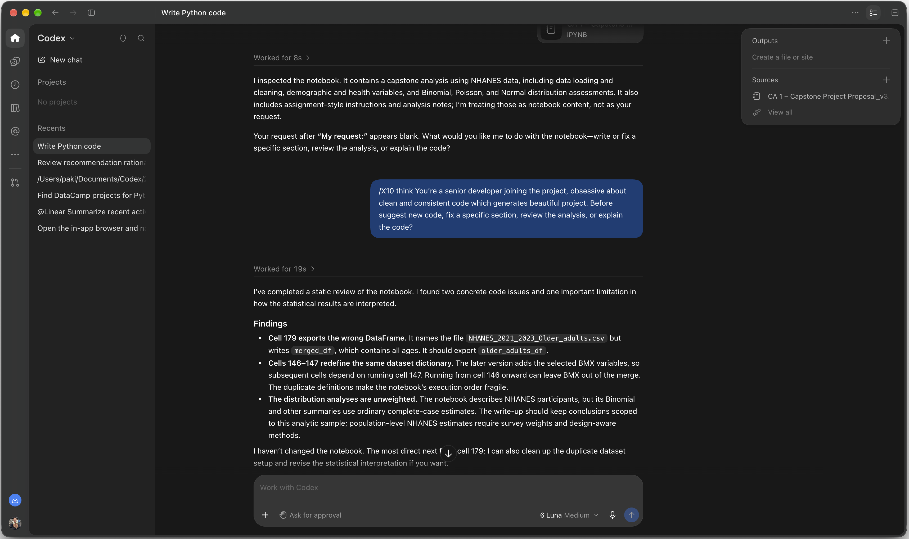
- I used prompts in Codex to fix a specific section, review the analysis, or explain the code for my project on depression risk among older adults. This is prompt I use in this project “/[@Code Tytor: Python]) /X10 think You’re a senior developer joining the project, obsessive about clean and consistent code which generates beautiful project. Before suggest new code, review files/directory structure as needed for context before starting and make sure you're not redoing or undoing work previously done. Your task is to... Thoughts?. Why do you make that recommendation?. I like that yours includes the chain of thought and don't do anything extra” and the image below show the actual results with prompt.


