
CS1931 – Universal Human Values Field Assignment

COMMUNITY CARE
& SUPPORT

THANISHA S
RVUN25SCS054
SRUJANA SHREYA RAJU
RVUN25SCS022
SHREHA KUMARI
RVUN25SCS117
SAHANA SUBBULAKSMI P
RVUN25SCS026
SPANDANA U V
RVUN25SCS077

School of Computer Science and Engineering
RV University, Bangalore
2025-2026
TABLE OF CONTENTS

1.0 | INTRODUCTION | 1
 | 1.1 Approach with the Organization | 1
2.0 | ABOUT THE FIELD ASSINGNMENT | 2
 | 2.1 Activities and Experience | 3
 | 2.2 Observation and Learning | 8
3.0 | REFLECTIONS | 8
 | 3.1 Team Reflections | 8
 | 3.2 Individual Reflections | 10
4.0 | Conclusions | 15
 | 5.1 Strenths | 15
 | 5.2 Limitations | 15
5.0 | PROOFS | 17

- INTRODUCTION

As part of the Universal Human Values (UHV) field assignment, our group chose to visit Charlies Animal Rescue Center (CARE), a reputed organization in Bangalore that focuses on rescuing, treating, and rehabilitating injured, abandoned, and specially-abled animals. The aim of the visit was to experience human values such as compassion, empathy, and responsibility through direct service and observation.

  - APPROACH WITH THE ORGANIZATION

Before our visit, we reached out to the CARE team through email and phone to seek permission. We explained the purpose of our college field assignment and our interest in volunteering for a few hours to understand the daily functioning of the shelter. The management responded warmly, appreciating our initiative and willingness to learn.
Since they have a very structured and busy schedule, they allowed us a five-hour slot and thoughtfully planned a set of activities to ensure our time there was meaningful and well-utilized. This early communication with the organization helped us realize the importance of respectful approach, clarity, and coordination. It taught us that volunteering begins even before reaching the site — with courtesy, professionalism, and understanding of others’ commitments.

2.0 ABOUT THE FIELD ASSIGNMENT

The Universal Human Values (UHV) Field Assignment is a practical component of the UHV course that encourages students to connect classroom learning about ethics, empathy, and social responsibility with real-world experiences. The main objective is to help students observe, reflect, and practice human values such as care, compassion, cooperation, and respect for life.
Through this assignment, students are expected to engage with organizations or communities working for social or environmental welfare, understand their functioning, and contribute in meaningful ways. Such experiences aim to strengthen the sense of social awareness and personal responsibility among students.
For our assignment, we chose to visit Charlies Animal Rescue Center (CARE), a shelter dedicated to rescuing and rehabilitating animals that are injured, abandoned, or specially-abled. The visit provided an opportunity to witness the spirit of service and compassion in action and to understand how human values can extend beyond people to include all living beings.

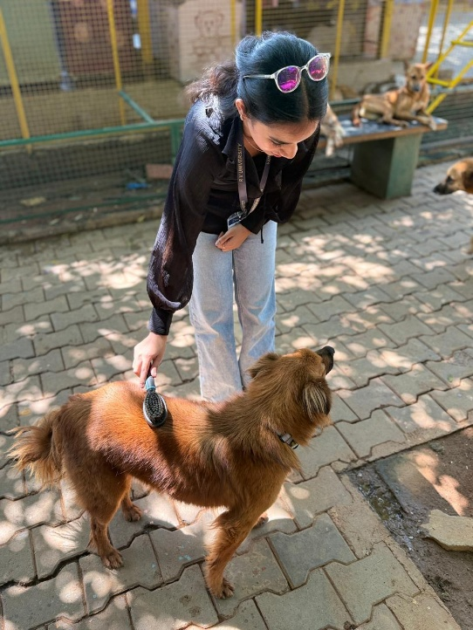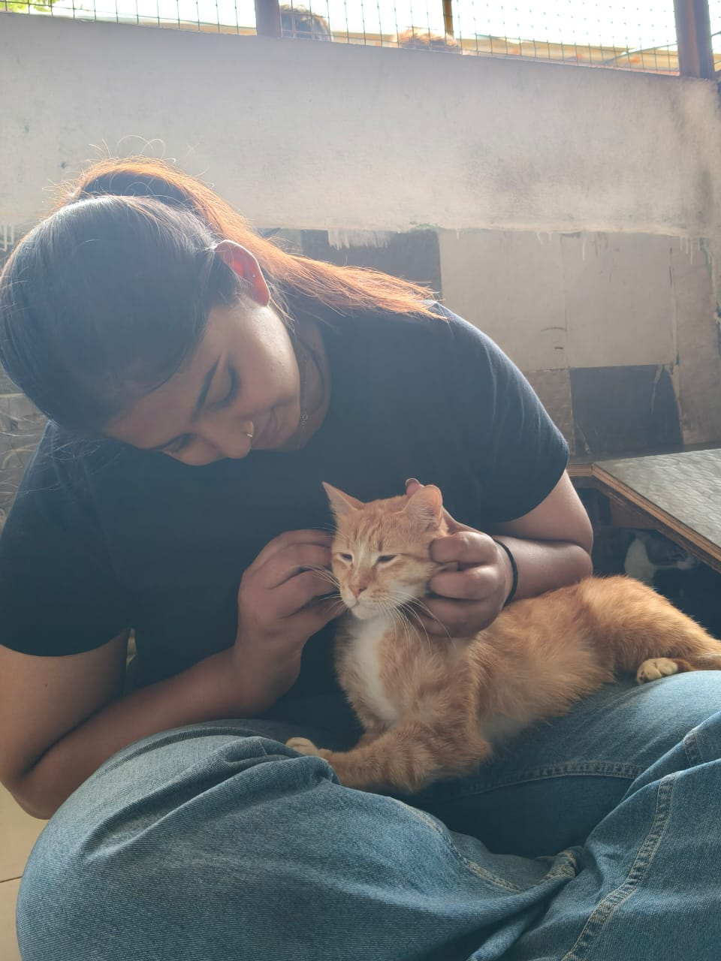

2.1 ACTIVITIES AND EXPERIENCE

1. Petting and Spending Time with Specially-Abled Animals
We began our session by visiting the shelter area that housed dogs and cats with disabilities. Some were blind, some deaf, and others had lost limbs in accidents. Many of these animals were initially hesitant, but as we slowly approached and began petting them, their behavior softened. It was incredible to see how a few minutes of gentle affection could make them feel safe and loved.
Through this interaction, I learned that love doesn’t need language — it’s communicated through presence, touch, and patience. Watching the animals respond to our care reminded me that empathy isn’t just about feeling sorry; it’s about being there for another living being despite differences or limitations.
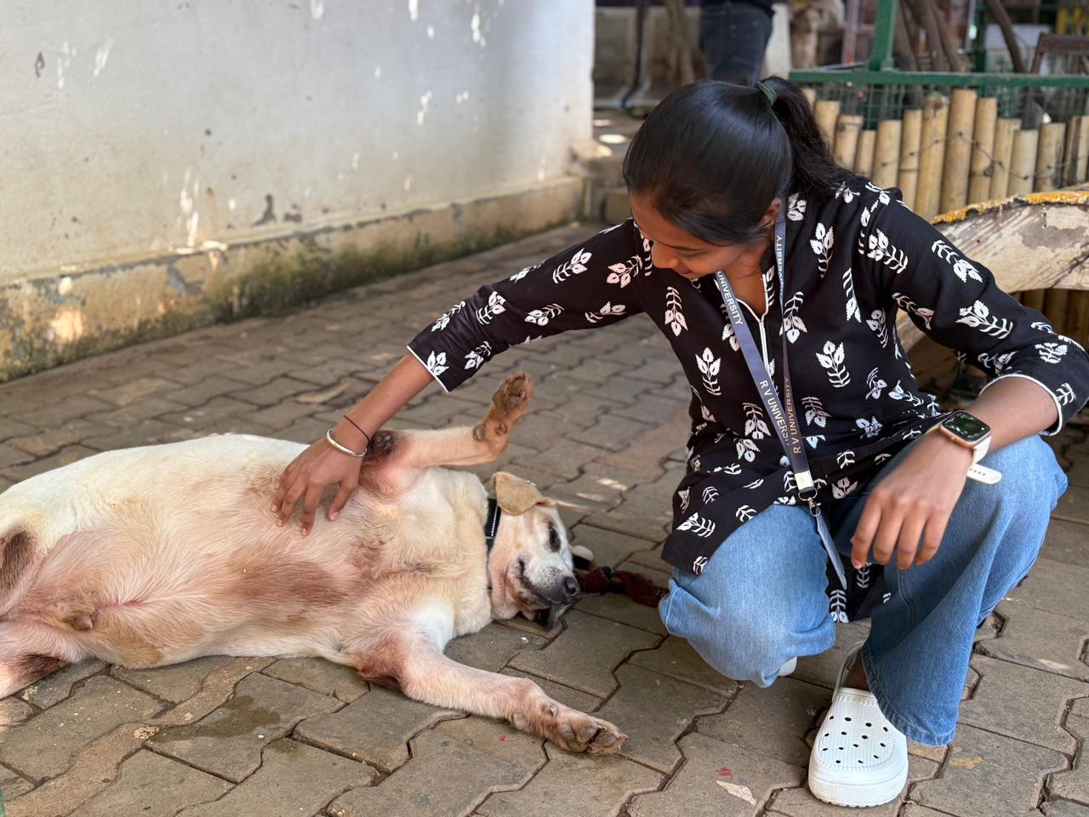
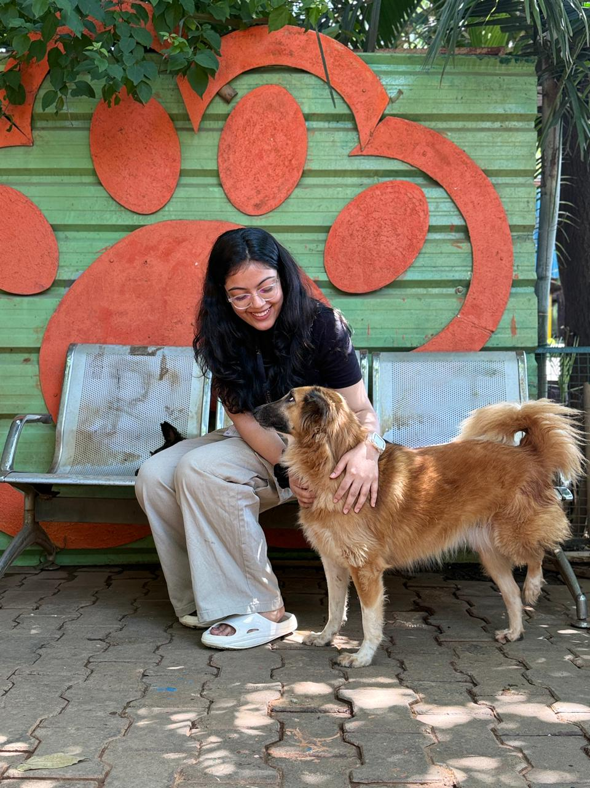

2. Grooming and Hygiene Care
Next, we assisted the staff in grooming sessions. We brushed the dogs’ fur, gently cleaned them, and massaged them using the tools provided. The activity may have seemed simple, but it required focus, calmness, and gentleness — traits that reflect self-discipline and compassion.
One dog initially resisted brushing, but with a few calm strokes and a soft voice, it relaxed completely. That moment made me realise how patience and trust can turn fear into comfort. I also developed a newfound respect for the caretakers who perform these tasks daily with tireless dedication and affection.

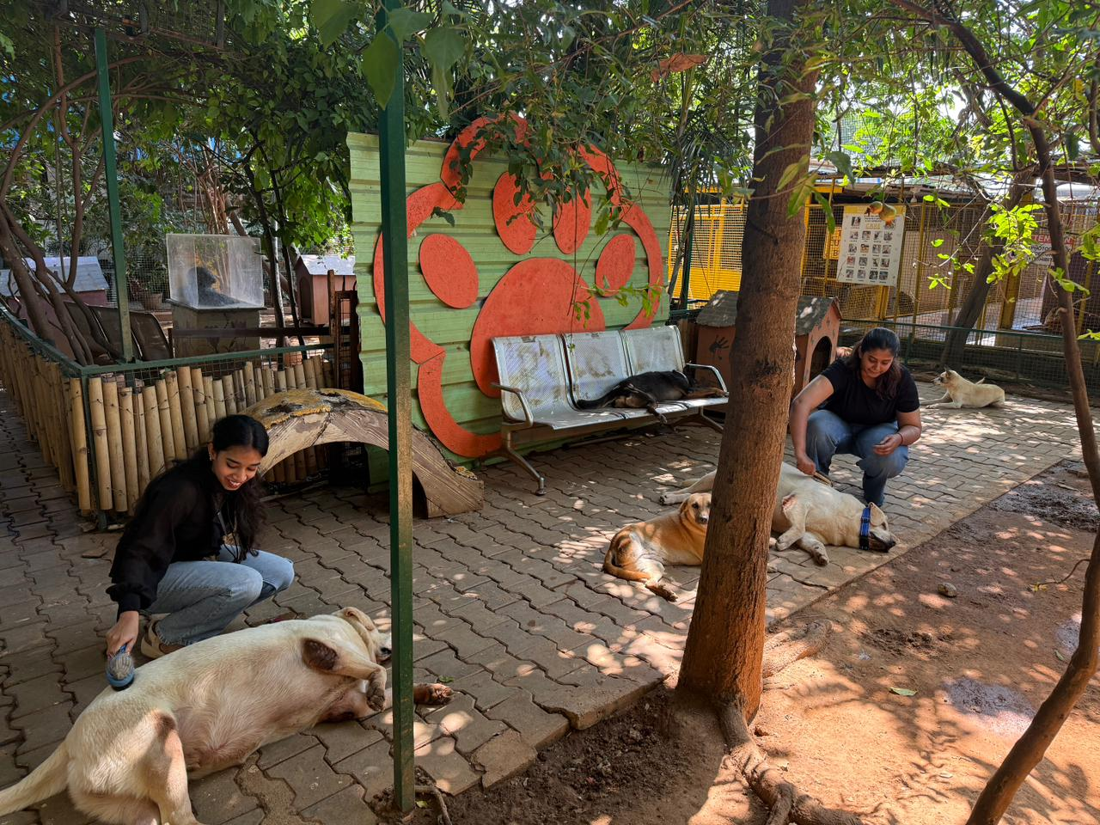

3. Naming the Newborn Puppies
One of the most delightful parts of the visit was meeting a litter of newborn puppies who had just begun teething. We were asked to help name them. Watching those tiny puppies move around clumsily, trying to explore the world, filled us with pure joy.
We discussed and chose names that matched each pup’s personality — some curious, some sleepy, some endlessly playful. Though it was a small task, it felt significant because naming them gave each puppy a sense of individuality and belonging. It was a reminder that every life, no matter how small or voiceless, has meaning and deserves recognition.

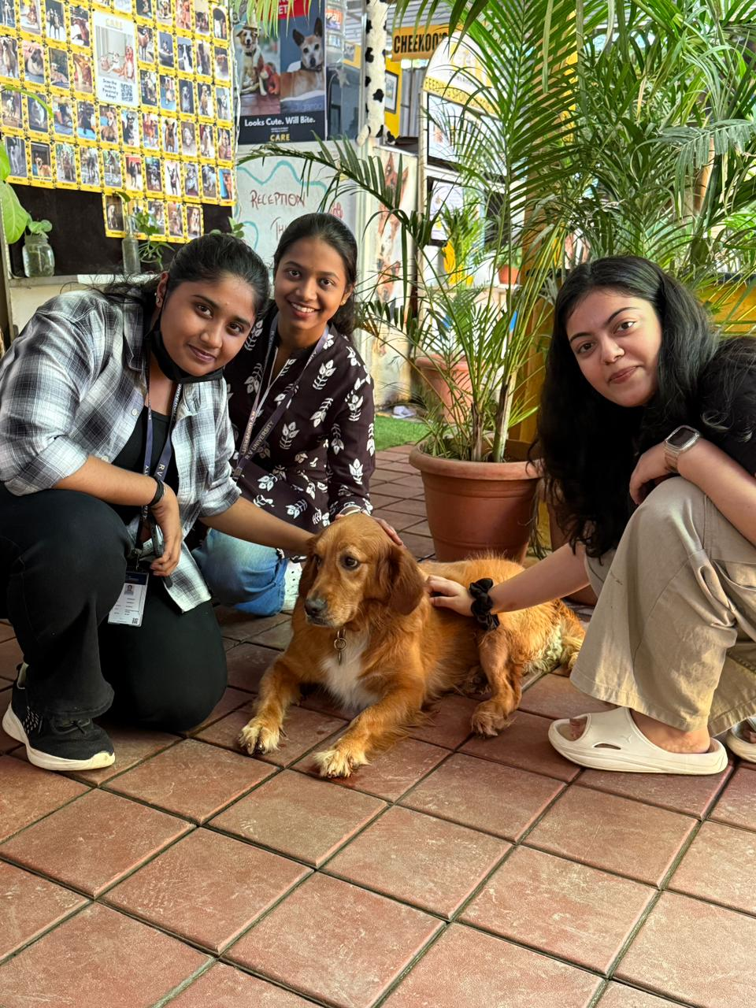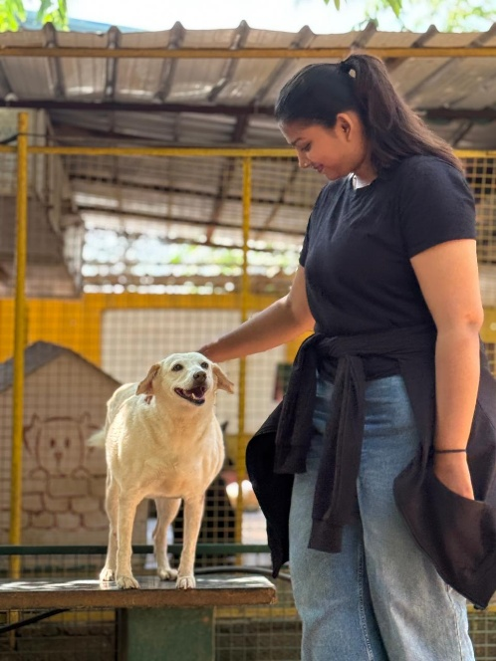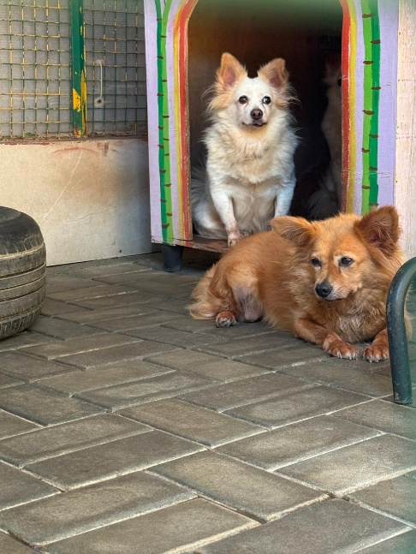
4. Creating Content for Social Media and Adoption Awareness
In the next segment, the CARE team asked us to help with content creation for their social media platforms. We captured photographs and short videos of the animals, wrote captions about their stories, and drafted small posts to encourage adoption and responsible pet ownership.
This activity helped me understand the role of communication in spreading compassion. Awareness is a powerful tool — every post can inspire someone to adopt or donate, directly changing an animal’s life. It also showed that volunteering isn’t limited to physical help; creative and digital efforts are equally valuable in promoting social good.
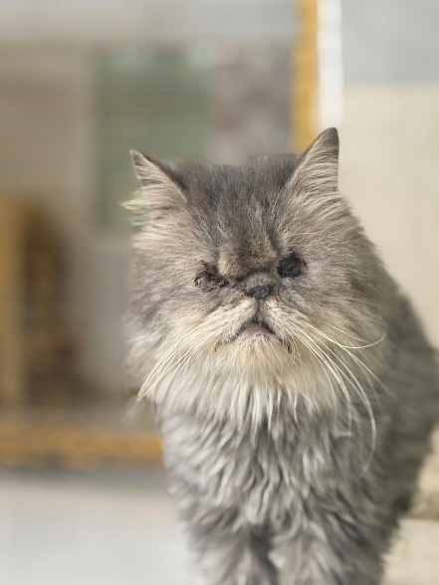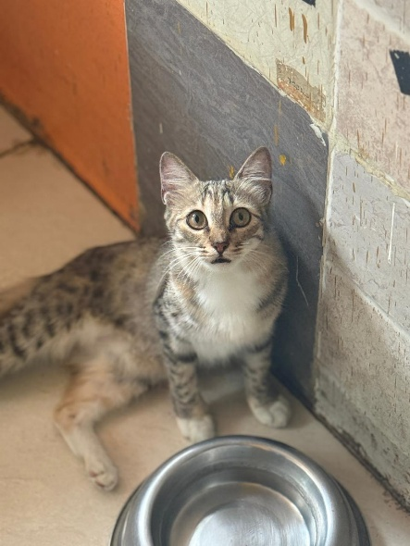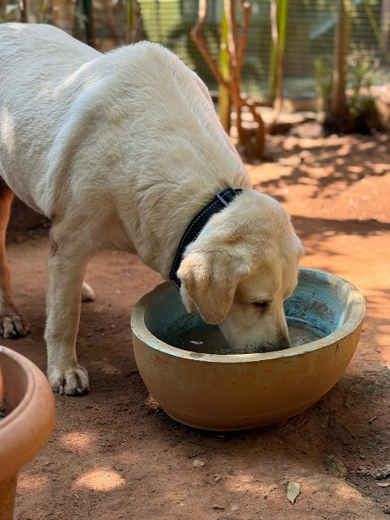
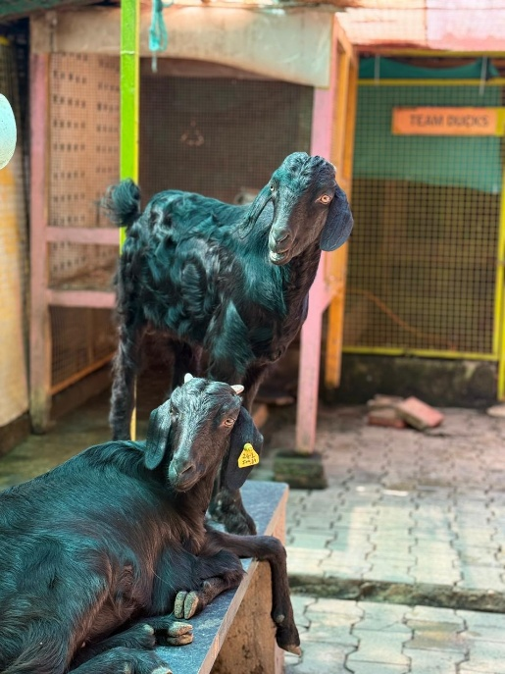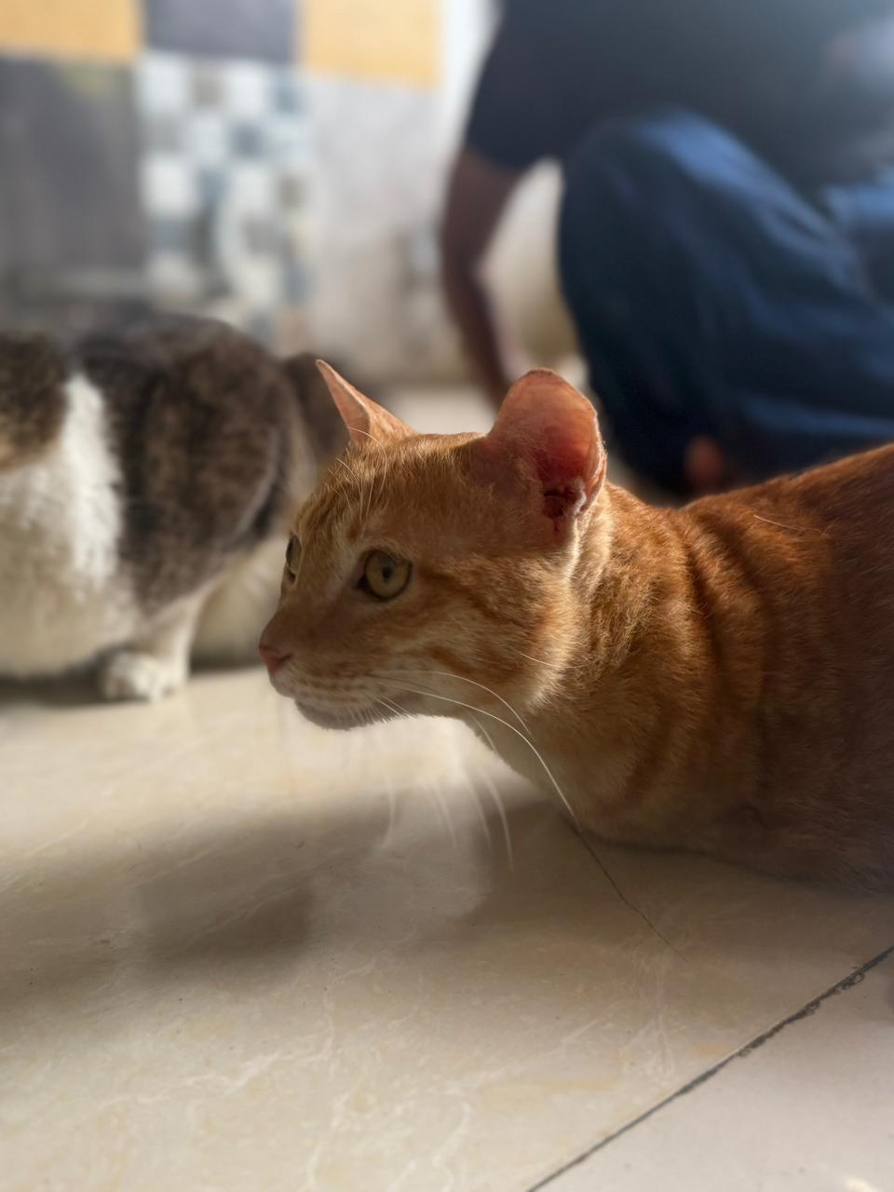

5. Assisting Clients During Adoption Drives
The final and most meaningful part of the visit involved assisting the staff during ongoing adoption drives. We greeted visitors, guided them around the shelter, and shared details about each animal’s temperament, history, and medical condition.
One couple was particularly moved by the story of a three-legged dog rescued from an accident site. They spent time interacting with him and eventually decided to adopt. Witnessing that moment was truly heartwarming. It showed that empathy still thrives — people are willing to open their homes and hearts to animals who have been through pain.
Through this experience, I realized that service goes beyond physical effort — it’s about connection, understanding, and helping others make compassionate choices. The smiles on the adopters’ faces and the hopeful look in the dog’s eyes said more than words ever could.
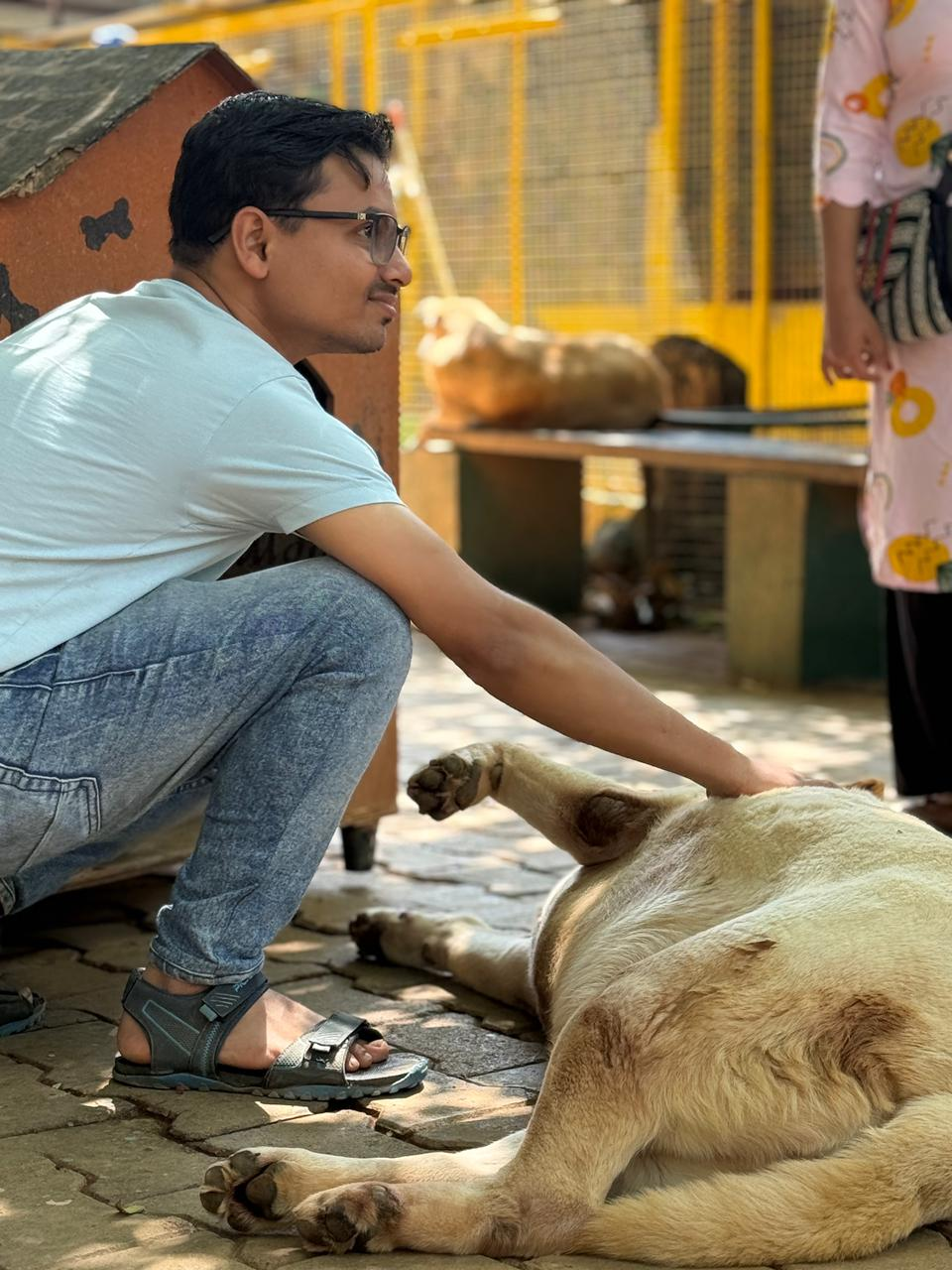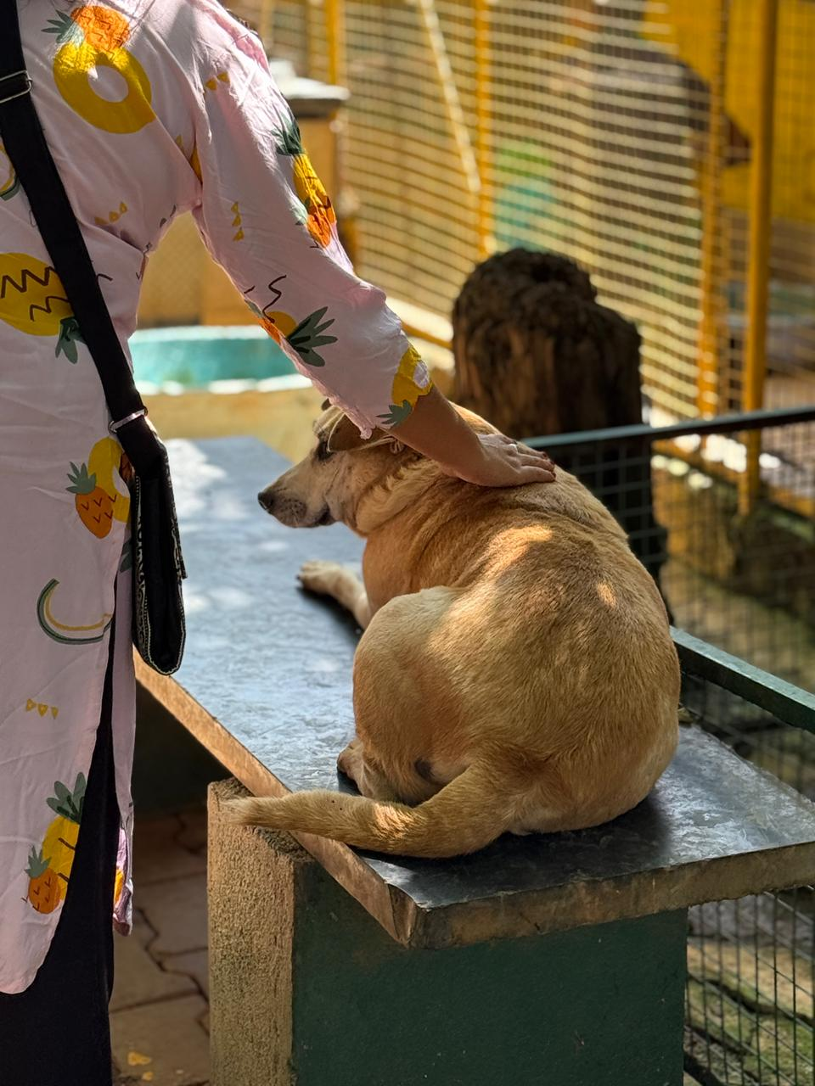

2.2 OBSERVATION AND LEARNING
Through this field experience, we realized that human values extend far beyond human relationships. Caring for animals teaches unconditional love, patience, and respect for life in all forms. The staff at CARE demonstrated selfless service and dedication, inspiring us to contribute more meaningfully to society.

3.0 REFLECTIONS

3.1 TEAM REFLECTION

When we first arrived at Charlies Animal Rescue Center, none of us were particularly comfortable. The strong smell of animals and disinfectants hit us immediately, and most of us felt uneasy and nervous. Some of us were even scared to step closer to the enclosures. It was our first time in such an environment, and the atmosphere — filled with barking dogs and constant activity — was quite overwhelming.
However, we were fortunate to be guided by Mr. Anil, one of the senior caretakers at the center. He noticed our hesitation right away. At first, he was quite strict with us — even raising his voice a little — but in hindsight, it was exactly what we needed. His firmness wasn’t out of anger but from a place of responsibility. He wanted us to understand that working in an animal shelter required seriousness, patience, and compassion, not fear.
As the day progressed, Mr. Anil patiently introduced us to the animals, explained how to handle them safely, and encouraged us to overcome our nervousness. Slowly, we began to adjust and take part in the activities wholeheartedly. His confidence in us helped us move from hesitation to genuine involvement.
Despite the center’s busy environment, where every staff member had a specific role and schedule, Mr. Anil made time to guide us through all five sessions that had been curated for our visit — from petting the specially-abled animals to helping during adoption drives. His understanding of our academic deadlines and his willingness to support us made a huge difference.
By the end of the visit, our fear and discomfort had completely turned into appreciation and empathy. We realised that our initial reaction was naturl, but what mattered was how we pushed past it and grew through the experience. As a team, we left with a sense of pride and gratitude — not only for the work we did but also for the lessons we learned about courage, teamwork, and compassion.
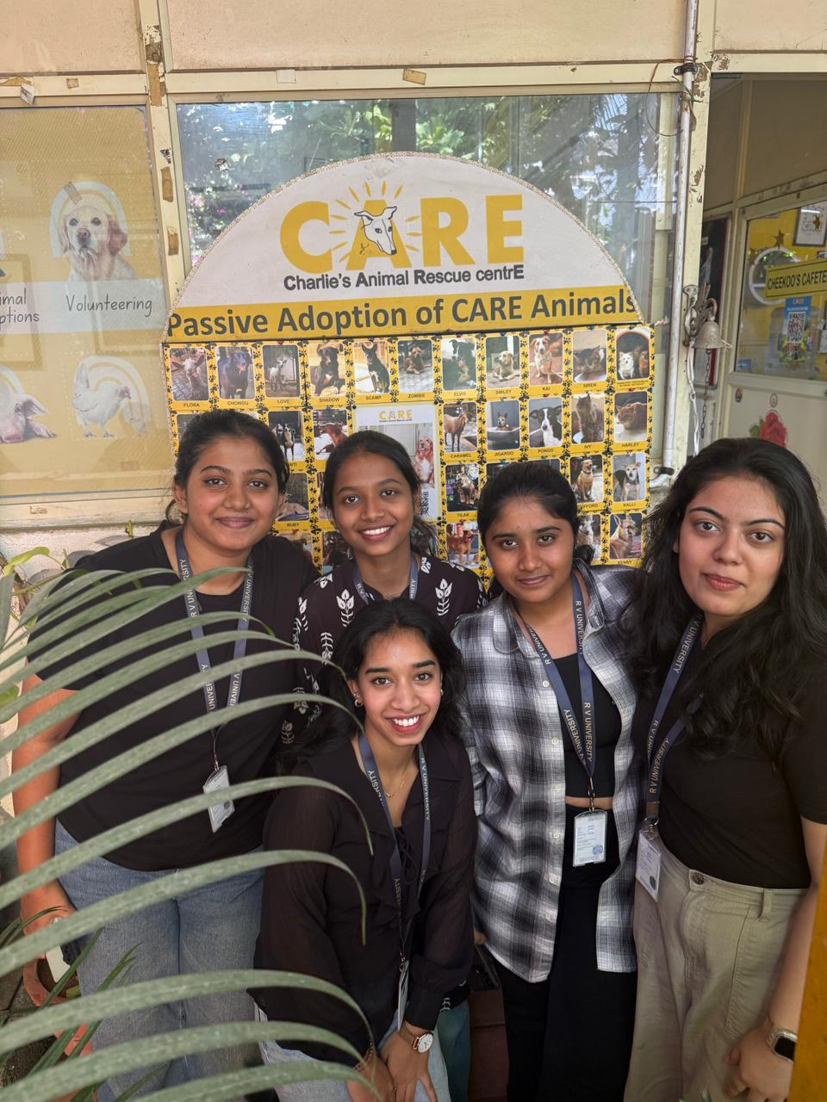
3.1 INDIVIDUAL REFLECTION

THANISHA S
RVUN25SCS054
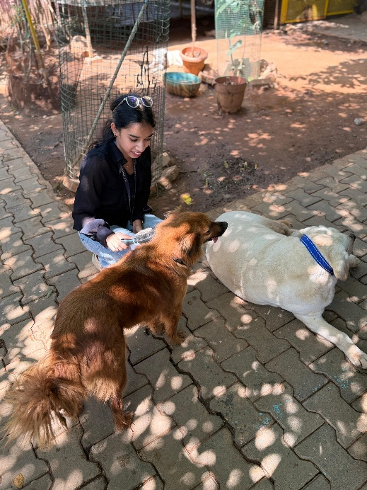
The UHV field visit was honestly one of the most memorable experiences for me. I was the one who took charge of organizing everything right from scratch — planning the schedule, coordinating with everyone, arranging the transport, and making sure the day went smoothly. It was definitely a lot of work, but I actually enjoyed the process.
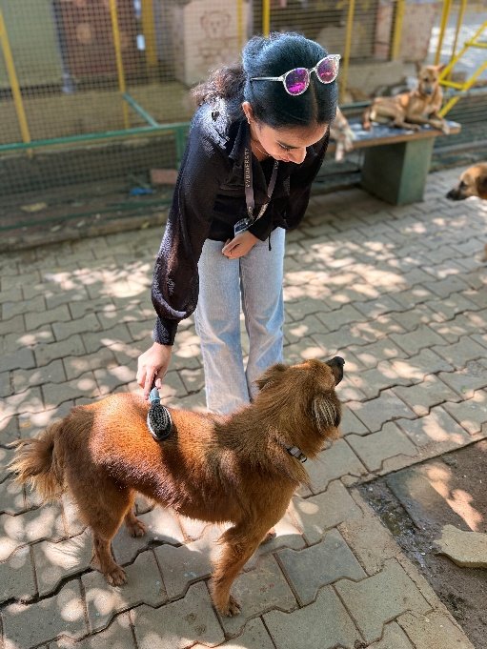
Leading the team taught me so many things — patience, time management, and how to handle people with different ideas and moods. There were moments where things got a bit hectic, but once everything started falling in place, it felt really nice. Watching everyone participate, learn, and have a good time gave me a sense of pride and relief.
More than just an event, this visit helped me understand what Universal Human Values are in real life. It’s about being responsible, understanding others, and working together with empathy. By the end of it, I felt grateful — not only because everything went well, but also because I learned a lot about leadership, teamwork, and myself.

SRUJANA SHREYA RAJU
RVUN25SCS022

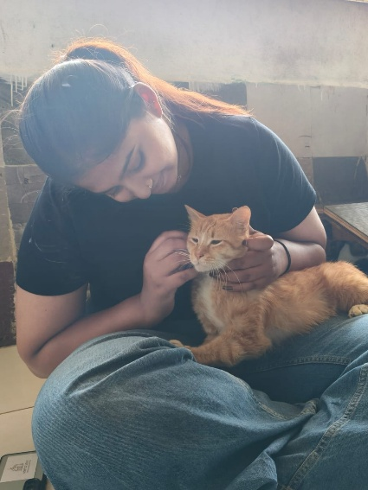
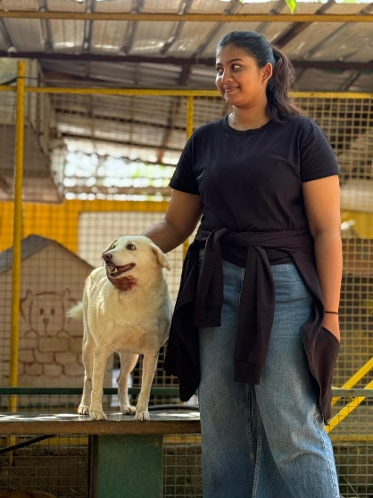
As a part of my Universal Human Values course, I had the opportunity to visit a mixed animal shelter along with my friends. At first, I was quite nervous and scared because this was my first time doing something like this. I didn’t know what to expect or how I would react to being around so many animals who had been rescued or abandoned. Once we reached the shelter, we were given different tasks such as feeding, grooming, playing with the animals, and even helping to click pictures for the adoption unit. Slowly, my fear started fading away as I interacted with the animals. I could see the trust and affection in their eyes, even after all the pain and neglect they might have faced before. It was a very emotional and heartwarming experience for me. There was this one dog at the shelter that I felt an instant connection with. It was almost like it chose me out of everyone there! It followed me everywhere and kept looking at me with those big, innocent eyes. For a moment, I seriously thought of bringing it home. But then I realized that if I did, I’d probably be the one ending up on the streets instead of the dog — my parents would have definitely kicked me out! Still, that small bond made me realize how easily animals can sense kindness and how much love they have to give, even after all they’ve been through.
After spending some time there, I felt genuinely happy and free. The whole experience made me realize how grateful I should be for everything I have in my life. It made me think deeply about how we, as humans, sometimes forget to appreciate what we have and how small acts of care can make a big difference to others — even to animals who can’t speak for themselves.
This experience brought a real change in me. It made me more empathetic, patient, and aware of the world around me. I learned that compassion is not just a value to be spoken about but something that must be lived through our actions. I now feel inspired to contribute more animal welfare in the future, even in small ways, because these innocent lives truly deserve love and care.
SHREHA KUMARI
RVUN25SCS117
As part of our UHV (Universal Human Values) project, we visited the CARE Animal Health Care Shelter. The experience was truly heartwarming and eye-opening. We met many animals — dogs, cats, birds, goats, sheep, hens, rats, turtles, and more. We fed them, brushed them, and spent quality time with them. It was beautiful to see how happy they were just to receive love, care, and attention. Some animals showed feelings of jealousy when we pampered others, which made us realize how emotionally aware they are. The cats and puppies were especially active and playful — we played with them using bouncing balls and enjoyed every moment. Sitting with them in the sun, cuddling, hugging, and simply being around them brought immense joy to us all.The shelter staff are doing an incredible job caring for these beautiful and specially-abled animals. We saw a puppy who had been brought in after a knee injury from an accident, and it was heartbreaking to know that even high-breed dogs, once considered precious, were abandoned because of their disabilities. This visit opened our eyes to the harsh reality of human neglect and cruelty.We are deeply grateful to our UHV faculty for giving us this opportunity. It not only allowed us to serve and connect with these animals but also taught us the true meaning of compassion, empathy, and responsibility towards all living beings.
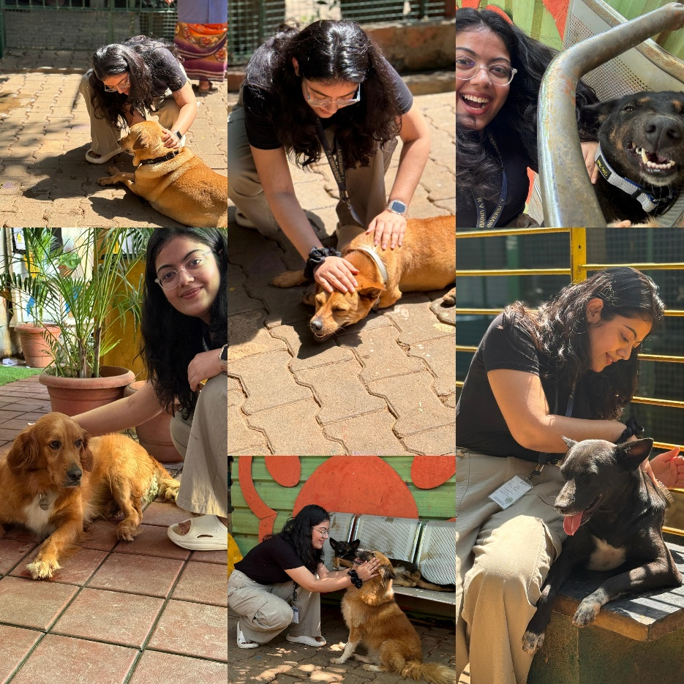
SAHANA SUBBULAKSMI P
RVUN25SCS026


Visiting Charlie’s Animal Rescue Centre was such an emotional and unforgettable experience for me. Seeing how the animals were cared for with such love and compassion made me feel grateful for the people who dedicate their time to rescuing and rehabilitating them. Interacting with the animals reminded me of the importance of kindness, empathy, and responsibility towards all living beings. The moment I walked inside the CARE there were two dogs who sat in front of the gate welcoming by wagging their tail, I could see the innocence and happiness in their eyes. I saw some specially disabled dogs, many dogs lost their legs still they had so much of spirit in them and even there were some birds like parrots, turkey, hen, pig, goat, rabbits, guinea pigs and some cats which was blind. The volunteers there were really kind and caring they treated every animal like family and made sure they were safe, fed, and happy. I also saw many rescued dogs and cute puppies waiting to be adopted, they were bit naughty and very loving and needy they needed constant attention and petting them. When we stopped petting them, they made very cute actions like patting us in their leg to pet them again, they started licking, jumping they were hyperactive and enthusiastic. Even though some of them were hurt or disabled, they still showed so much trust and joy. Cats were kind and calm they allowed us to touch them and play with them they didn’t cause any harm to us like scratching or attacking. There were many regular volunteers who were been volunteering regularly from long time they come there to take care of animals spend time with them they feel relaxed being there and it’s kind of therapy for them to come there and spend time. I left the centre feeling warm inside, thankful for the experience, and more aware of how much love these rescued animals deserve.

SPANDANA U V
RVUN25SCS077

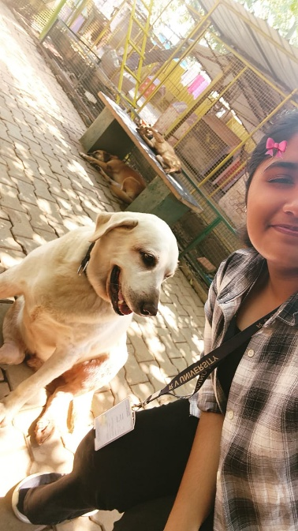
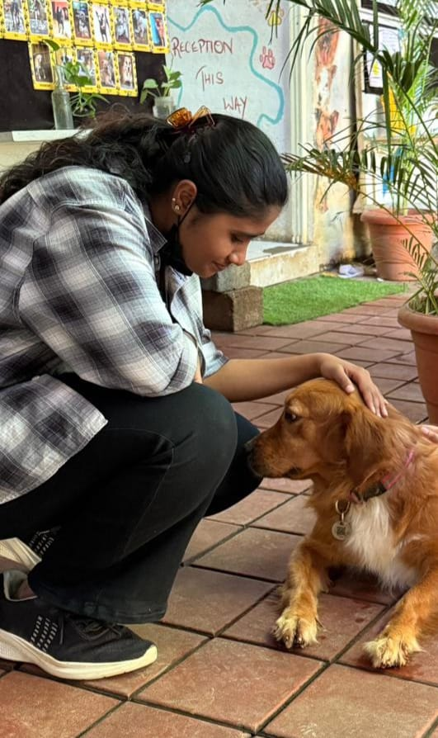
It's difficult to articulate the depth of my affection for animals, a bond that feels less like a preference and more like an integral part of who I am. Among all creatures, dogs hold a particularly cherished place in my heart; their loyalty, boundless energy, and unreserved affection are a constant source of happiness. There is a purity in their existence that is truly inspiring. Spending time with them was the highlight of the day. The simple act of playing fetch with a spirited young Labrador or offering a gentle scratch behind the ears to an older, more reserved companion brought an intense, immediate joy. These weren't just animals; they were individuals, each responding to attention with an immediate and heartfelt warmth. There was a moment with a small terrier mix, who had been shy initially, when she finally relaxed enough to lean her whole weight against my leg, looking up with complete trust it was profoundly touching. Running, tumbling, and sharing moments of quiet connection made the time fly by far too quickly. Equally enjoyable was the opportunity to capture these cute, fleeting moments on camera. Photographing their playful antics, their innocent expressions, and the deep emotional connection they instantly form with human interaction, provided a perfect way to immortalize the day. Every picture is a testament to the beautiful spirit of these animals. Leaving Charlie's Animal Centre was difficult, but I departed with a renewed sense of purpose and an even deeper understanding of why I love them so profoundly. It was a beautiful, officially overwhelming day that confirmed, yet again, that my passion for animals, especially dogs, is unwavering and eternal.

- CONCLUSION

5.1 ADVANTAGES / KEY LEARNINGS
The visit to Charlies Animal Rescue Center (CARE) was a memorable and value-driven experience for our entire team. It gave us a real understanding of compassion, patience, and responsibility — values that cannot be fully understood through classroom learning alone.
Each of the five sessions we participated in offered something unique. Petting and grooming the specially-abled animals helped us see the impact of kindness and patience. Naming the newborn puppies made us appreciate the innocence of life and the joy of small gestures. Creating social media content taught us how creativity can contribute to social causes, while assisting in adoption drives helped us build confidence, communication skills, and emotional awareness.
We also developed teamwork, adaptability, and respect for structured environments. Working under the guidance of Mr. Anil and witnessing the dedication of the staff inspired us to take our responsibilities seriously and to approach service with sincerity. The experience strengthened our understanding of Universal Human Values such as empathy, coexistence, and selfless contribution — not just toward humans, but toward all living beings.

5.2 LIMITATIONS / CHALLENGES FACED
While the visit was insightful, it also came with certain challenges. The strong odor of the shelter and the constant barking initially made us uncomfortable and anxious. Most of us had never worked so closely with animals before, which made the start quite difficult.
Time was another limitation. Since the shelter had a busy routine, our participation was limited to a five-hour slot, and we couldn’t witness all areas of work such as rescue or medical treatment. Additionally, as new volunteers, we required supervision for most activities, which slightly restricted our independence.
However, these challenges became learning opportunities. They taught us how to adjust to new environments, respect rules, and stay patient even when things felt uncomfortable. By the end of the day, what started as hesitation turned into confidence and compassion.
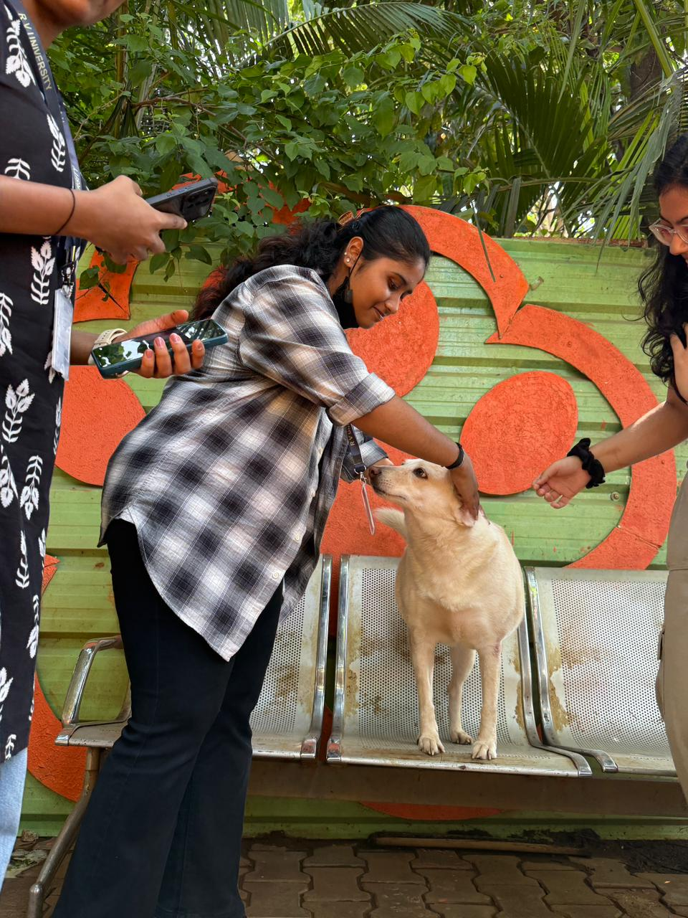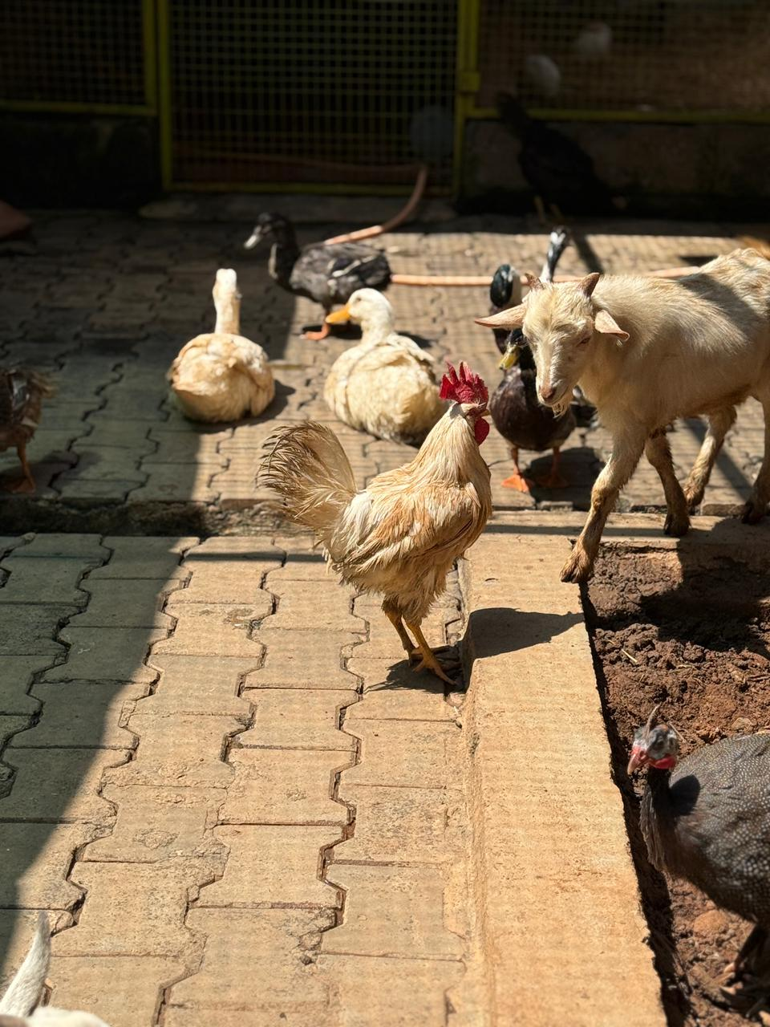
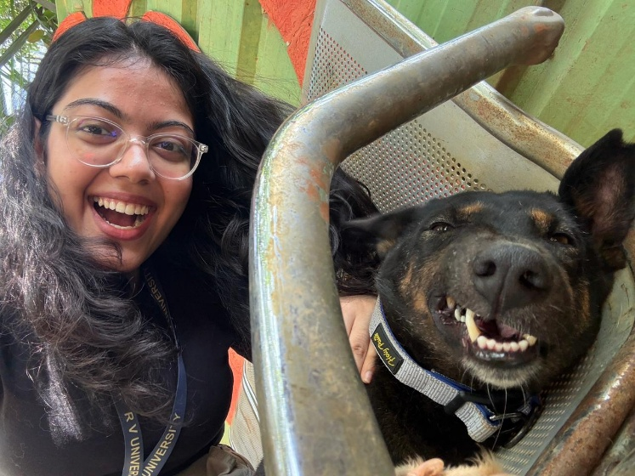
5.0 | PROOFS
