MYSQL STORED PROCEDURES
Examples and Practice Exercises for MySQL Workbench

1. Setup: Employees Table
CREATE DATABASE IF NOT EXISTS employeedb1;
USE employeedb1;
CREATE TABLE IF NOT EXISTS employees (
emp_id INT PRIMARY KEY,
emp_name VARCHAR(50),
dept_id INT,
salary DECIMAL(10,2)
);
INSERT INTO employees VALUES
(101,'Rahul',1,50000),
(102,'Priya',2,65000),
(103,'Anil',1,55000),
(104,'Sneha',3,70000),
(105,'Kiran',2,48000);
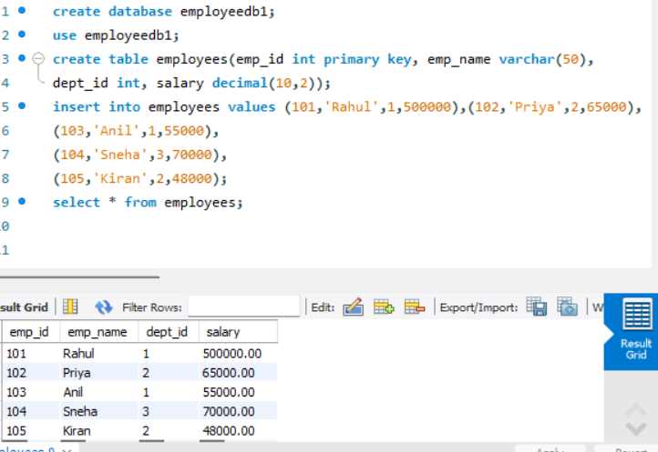

2. Verify Data
Question: Display all employee records.
SELECT * FROM employees;
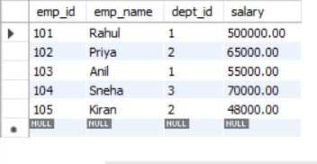

Procedure 1 – Display All Employees
Question: Create a procedure that displays all employees.
DROP PROCEDURE IF EXISTS GetEmployees;
DELIMITER $$
CREATE PROCEDURE GetEmployees()
BEGIN
SELECT * FROM employees;
END $$
DELIMITER ;
CALL GetEmployees();
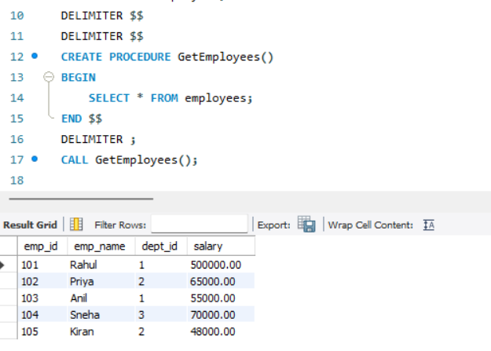

Procedure 2 – IN Parameter
Question: Create a procedure that accepts an employee ID and displays that employee's details.
DROP PROCEDURE IF EXISTS GetEmployeeById;
DELIMITER $$
CREATE PROCEDURE GetEmployeeById(IN eid INT)
BEGIN
SELECT * FROM employees
WHERE emp_id = eid;
END $$
DELIMITER ;
CALL GetEmployeeById(102);
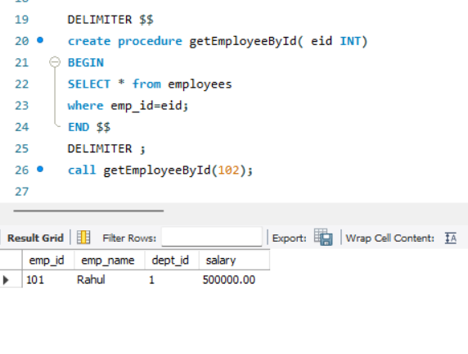

Procedure 3 – Update Salary
Question: Create a procedure that accepts employee ID and amount, then increases the employee's salary.
DROP PROCEDURE IF EXISTS IncreaseSalary;
DELIMITER $$
CREATE PROCEDURE IncreaseSalary(
IN eid INT,
IN amount DECIMAL(10,2)
)
BEGIN
UPDATE employees
SET salary = salary + amount
WHERE emp_id = eid;
END $$
DELIMITER ;
CALL IncreaseSalary(101,5000);
SELECT * FROM employees WHERE emp_id=101;
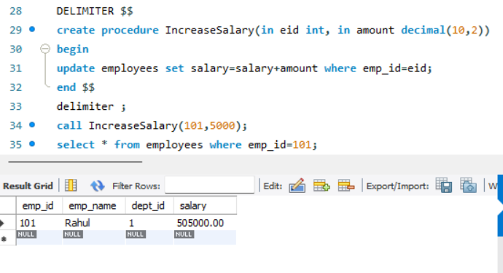

Procedure 4 – Aggregate Function
Question: Create a procedure to calculate the average salary of all employees.
DROP PROCEDURE IF EXISTS AvgSalary;
DELIMITER $$
CREATE PROCEDURE AvgSalary()
BEGIN
SELECT AVG(salary) AS AverageSalary
FROM employees;
END $$
DELIMITER ;
CALL AvgSalary();
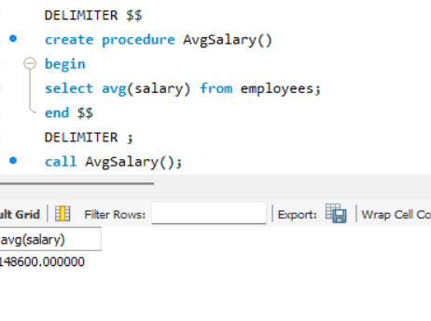

Procedure 5 – JOIN
Question: Create a procedure to display employee name, department name and salary. Run the department setup first.
CREATE TABLE IF NOT EXISTS departments (
dept_id INT PRIMARY KEY,
dept_name VARCHAR(50)
);
INSERT IGNORE INTO departments VALUES
(1,'CSE'),(2,'ECE'),(3,'EEE');
DROP PROCEDURE IF EXISTS EmployeeDepartment;
DELIMITER $$
CREATE PROCEDURE EmployeeDepartment()
BEGIN
SELECT e.emp_name, d.dept_name, e.salary
FROM employees e
JOIN departments d ON e.dept_id=d.dept_id;
END $$
DELIMITER ;
CALL EmployeeDepartment();
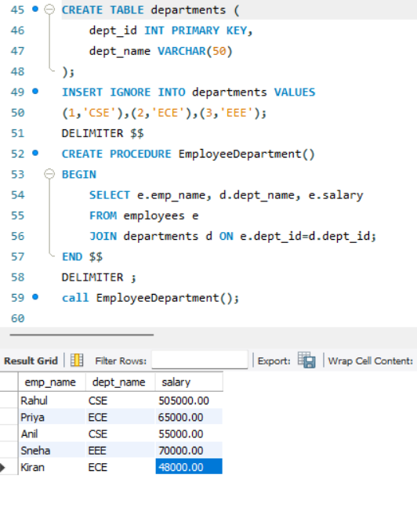

Procedure 6 – GROUP BY and AVG
Question: Create a procedure to display department-wise employee count and average salary.
DROP PROCEDURE IF EXISTS DepartmentAverageSalary;
DELIMITER $$
CREATE PROCEDURE DepartmentAverageSalary()
BEGIN
SELECT d.dept_name,
COUNT(e.emp_id) AS EmployeeCount,
AVG(e.salary) AS AverageSalary
FROM employees e
JOIN departments d ON e.dept_id=d.dept_id
GROUP BY d.dept_id, d.dept_name;
END $$
DELIMITER ;
CALL DepartmentAverageSalary();
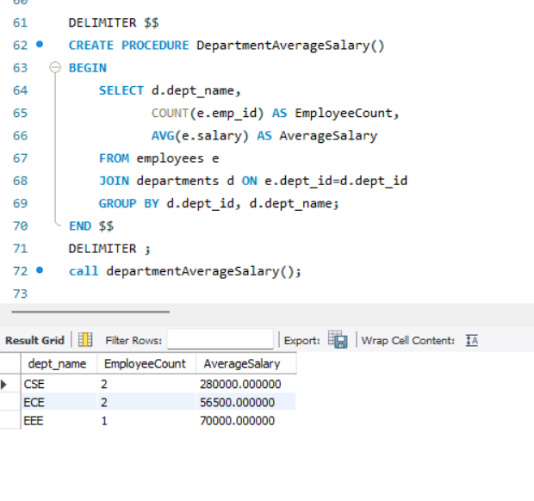

Procedure 7 – IF...ELSE
Question: Display High Salary if salary is at least 60000; otherwise display Low Salary.
DROP PROCEDURE IF EXISTS SalaryStatus;
DELIMITER $$
CREATE PROCEDURE SalaryStatus(IN eid INT)
BEGIN
DECLARE sal DECIMAL(10,2);
SELECT salary INTO sal
FROM employees
WHERE emp_id=eid;
IF sal >= 60000 THEN
SELECT 'High Salary' AS Status;
ELSE
SELECT 'Low Salary' AS Status;
END IF;
END $$
DELIMITER ;
CALL SalaryStatus(102);
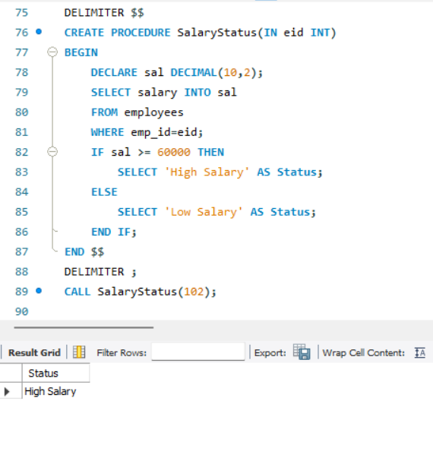

Procedure 8 – OUT Parameter
Question: Return the total number of employees using an OUT parameter.
DROP PROCEDURE IF EXISTS EmployeeCount;
DELIMITER $$
CREATE PROCEDURE EmployeeCount(OUT total INT)
BEGIN
SELECT COUNT(*) INTO total
FROM employees;
END $$
DELIMITER ;
CALL EmployeeCount(@total);
SELECT @total AS TotalEmployees;
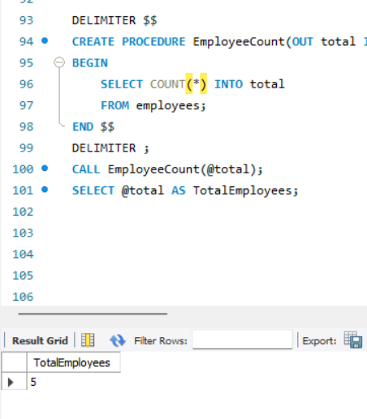

Procedure 9 – INOUT Parameter
Question: Receive a bonus through an INOUT parameter and add 5000 to it.
DROP PROCEDURE IF EXISTS AddBonus;
DELIMITER $$
CREATE PROCEDURE AddBonus(INOUT bonus DECIMAL(10,2))
BEGIN
SET bonus = bonus + 5000;
END $$
DELIMITER ;
SET @bonus=10000;
CALL AddBonus(@bonus);
SELECT @bonus AS UpdatedBonus;
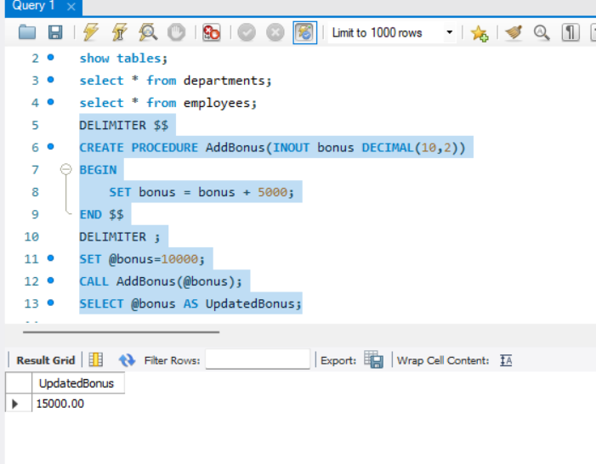

Procedure 10 – Transaction
Question: Transfer an amount from one employee salary record to another using START TRANSACTION and COMMIT.
DROP PROCEDURE IF EXISTS TransferSalaryAmount;
DELIMITER $$
CREATE PROCEDURE TransferSalaryAmount(
IN fromEmp INT,
IN toEmp INT,
IN amount DECIMAL(10,2)
)
BEGIN
START TRANSACTION;
UPDATE employees
SET salary=salary-amount
WHERE emp_id=fromEmp;
UPDATE employees
SET salary=salary+amount
WHERE emp_id=toEmp;
COMMIT;
END $$
DELIMITER ;
CALL TransferSalaryAmount(101,102,2000);
SELECT * FROM employees WHERE emp_id IN (101,102);
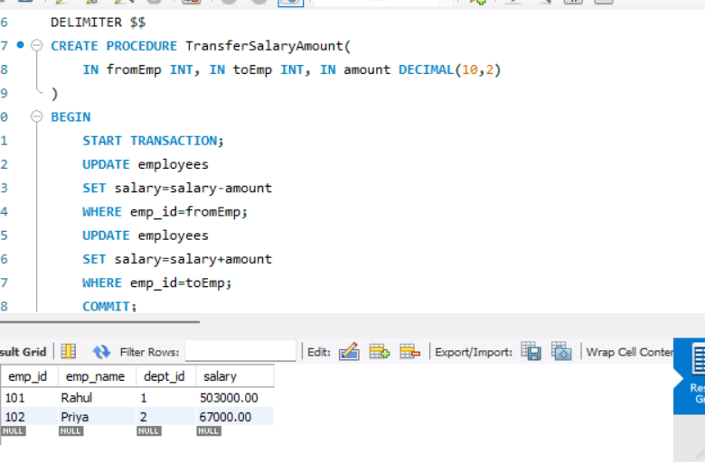

4. Useful Procedure Commands
SHOW PROCEDURE STATUS
WHERE Db='employeedb1';
SHOW CREATE PROCEDURE GetEmployees;
DROP PROCEDURE IF EXISTS GetEmployees;
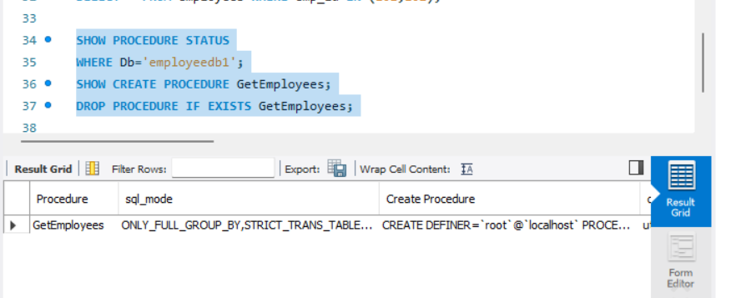

5. Why DELIMITER is Used
DELIMITER temporarily changes the statement terminator in MySQL Workbench. It prevents the semicolons inside BEGIN...END from being interpreted as the end of the entire CREATE PROCEDURE statement.
DELIMITER $$
CREATE PROCEDURE Example()
BEGIN
SELECT * FROM employees;
END $$
DELIMITER ;
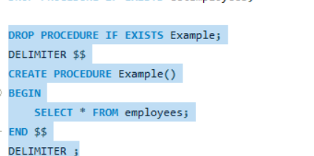

6. Student Practice Tasks
1. Create a procedure to display employees whose salary is greater than a given amount.
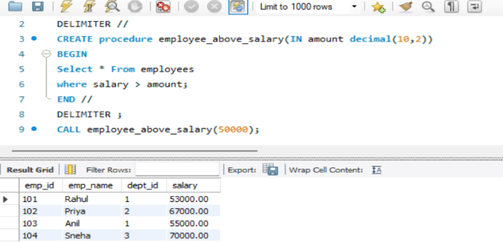
2. Create a procedure to update an employee's department using IN parameters.
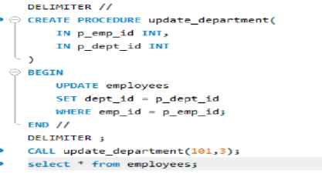
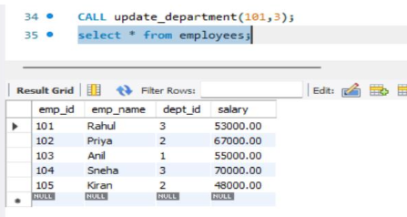
3. Create a procedure to return the maximum salary using an OUT parameter.
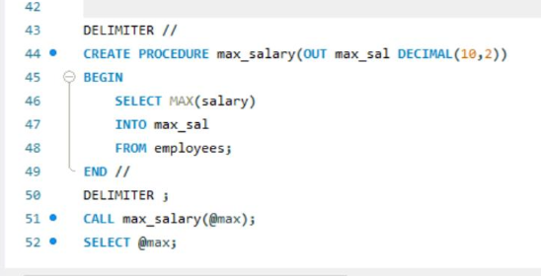
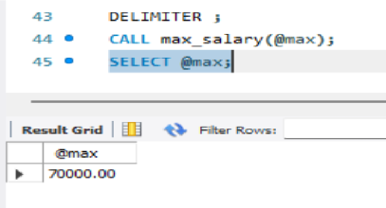
4. Create a procedure to return the employee count of a specified department.
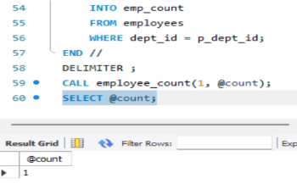
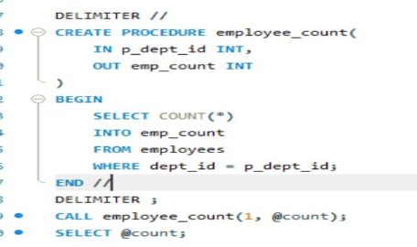

5. Create a procedure using JOIN to display employee and department details.
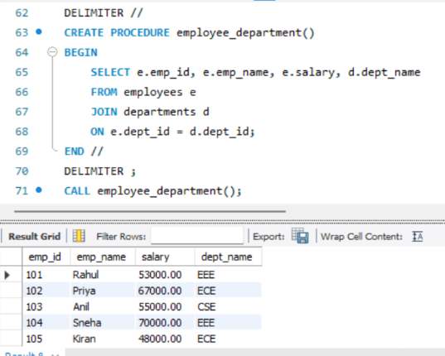
6. Create a procedure to display departments whose average salary is greater than 55000.
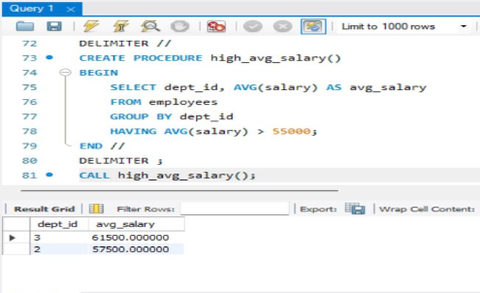
7. Create a procedure using IF...ELSE to classify salary as High, Medium or Low.
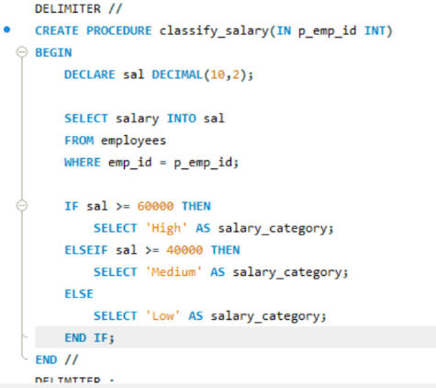
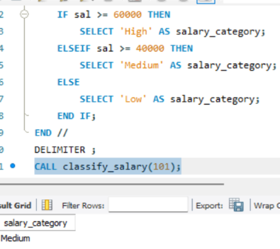
8. Create a procedure that accepts a department ID and returns its average salary.
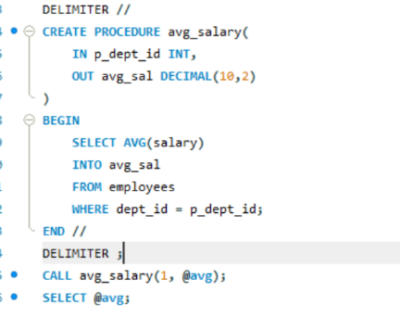
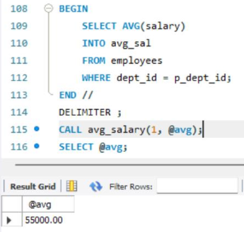
9. Create a procedure using INOUT to apply a bonus to an input salary.
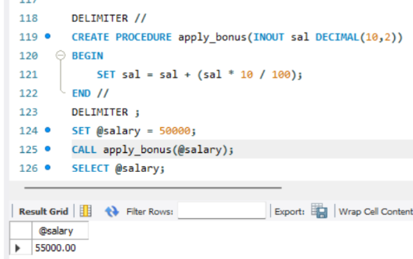
10. Create a procedure that performs two related updates inside a transaction.
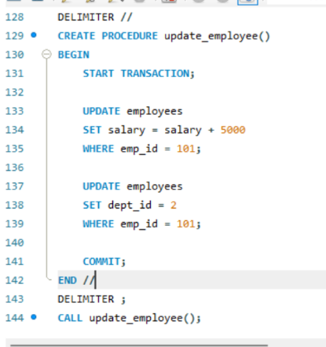
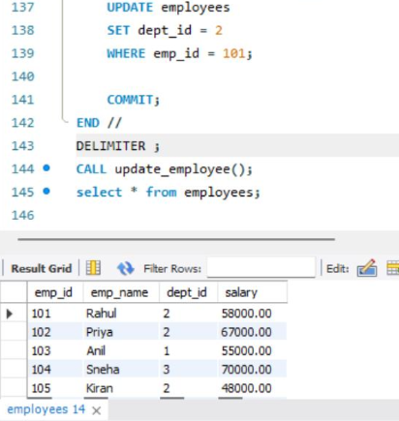

7. Common Errors
Procedure already exists: Use DROP PROCEDURE IF EXISTS before recreating it.
Syntax error near BEGIN: Check DELIMITER $$ and DELIMITER ;.
Table does not exist: Run USE employeedb1; and SHOW TABLES;.
Unknown column: Check names using DESCRIBE employees;

