MYSQL VIEWS
Practical Examples and Student Exercises using MySQL Workbench

1.What is a View?
A View is a virtual table created from one or more existing tables.
- It does not store data itself.
- It stores only the SQL query.
- Whenever you query the view, MySQL retrieves the latest data from the underlying tables.

2. Setup: Employees and Departments Tables
Run this setup first. If these tables already exist with data, you may skip the setup.
CREATE DATABASE IF NOT EXISTS employeedb1;
USE employeedb1;
CREATE TABLE IF NOT EXISTS departments (
dept_id INT PRIMARY KEY,
dept_name VARCHAR(50)
);
CREATE TABLE IF NOT EXISTS employees (
emp_id INT PRIMARY KEY,
emp_name VARCHAR(50),
dept_id INT,
salary DECIMAL(10,2)
);
INSERT IGNORE INTO departments VALUES
(1,'CSE'),
(2,'ECE'),
(3,'EEE');
INSERT IGNORE INTO employees VALUES
(101,'Rahul',1,50000),
(102,'Priya',2,65000),
(103,'Anil',1,55000),
(104,'Sneha',3,70000),
(105,'Kiran',2,48000);
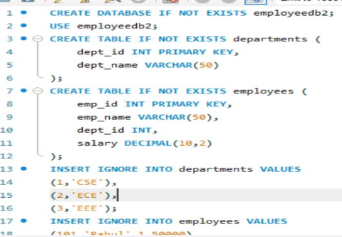
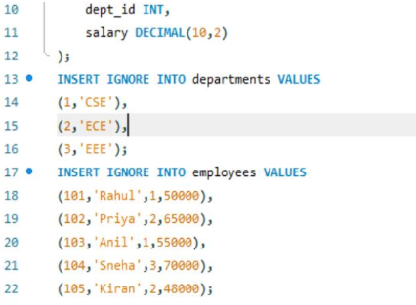

3. Verify the Tables
SHOW TABLES;
SELECT * FROM departments;
SELECT * FROM employees;
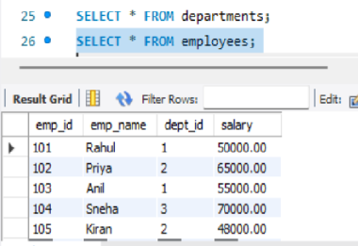
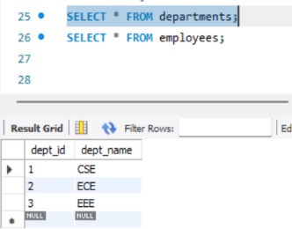

View 1 – Display All Employees
Question: Create a View named EmployeeView to display all columns from employees.
DROP VIEW IF EXISTS EmployeeView;
CREATE VIEW EmployeeView AS
SELECT *
FROM employees;
SELECT * FROM EmployeeView;
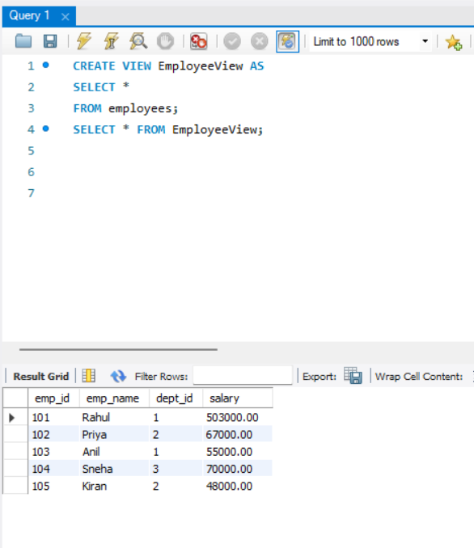

View 2 – Selected Columns
Question: Create a View showing employee ID, employee name and salary only.
DROP VIEW IF EXISTS EmployeeBasicView;
CREATE VIEW EmployeeBasicView AS
SELECT emp_id, emp_name, salary
FROM employees;
SELECT * FROM EmployeeBasicView;
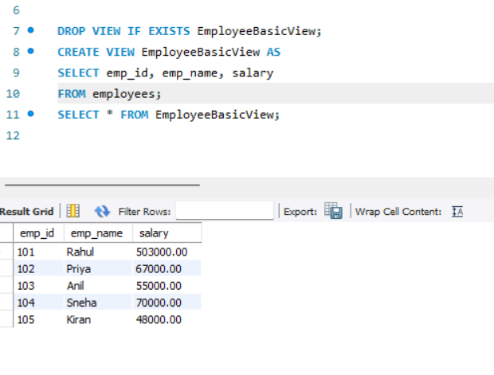

View 3 – High Salary Employees
Question: Create a View that displays employees earning more than 55000.
DROP VIEW IF EXISTS HighSalaryEmployees;
CREATE VIEW HighSalaryEmployees AS
SELECT emp_id, emp_name, salary
FROM employees
WHERE salary > 55000;
SELECT * FROM HighSalaryEmployees;
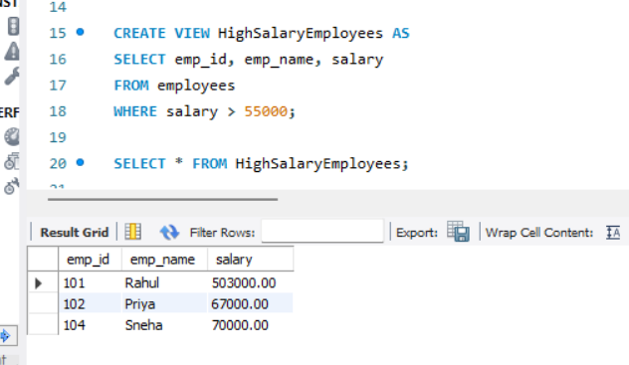

View 4 – Employee and Department using JOIN
Question: Create a View that displays employee name, department name and salary.
DROP VIEW IF EXISTS EmployeeDepartmentView;
CREATE VIEW EmployeeDepartmentView AS
SELECT
e.emp_id,
e.emp_name,
d.dept_name,
e.salary
FROM employees e
JOIN departments d
ON e.dept_id = d.dept_id;
SELECT * FROM EmployeeDepartmentView;
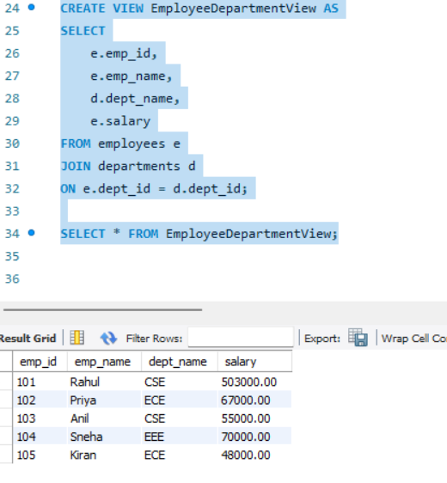

View 5 – Employees from a Particular Department
Question: Create a View that displays only CSE employees.
DROP VIEW IF EXISTS CSEEmployees;
CREATE VIEW CSEEmployees AS
SELECT
e.emp_id,
e.emp_name,
d.dept_name,
e.salary
FROM employees e
JOIN departments d
ON e.dept_id = d.dept_id
WHERE d.dept_name = 'CSE';
SELECT * FROM CSEEmployees;
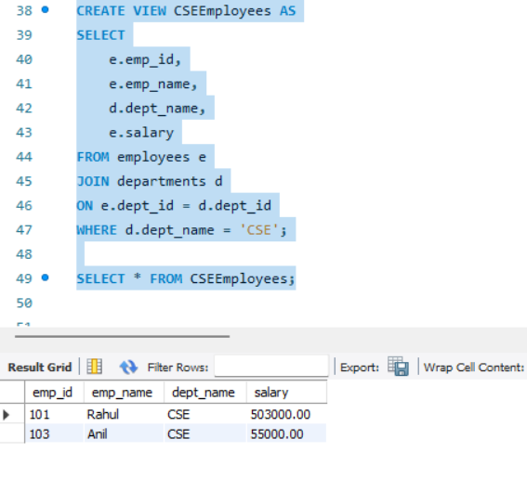

View 6 – Department-wise Average Salary
Question: Create a View using GROUP BY and AVG() to display department-wise average salary.
DROP VIEW IF EXISTS DepartmentSalaryView;
CREATE VIEW DepartmentSalaryView AS
SELECT
d.dept_name,
COUNT(e.emp_id) AS EmployeeCount,
AVG(e.salary) AS AverageSalary
FROM employees e
JOIN departments d
ON e.dept_id = d.dept_id
GROUP BY d.dept_id, d.dept_name;
SELECT * FROM DepartmentSalaryView;
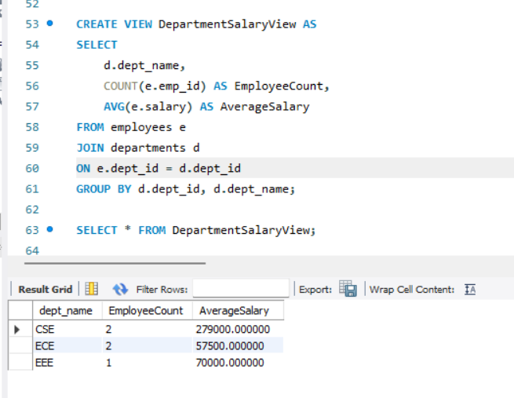

View 7 – Departments with Average Salary Above 55000
Question: Create a View that displays departments whose average salary is greater than 55000.
DROP VIEW IF EXISTS HighAverageDepartments;
CREATE VIEW HighAverageDepartments AS
SELECT
d.dept_name,
AVG(e.salary) AS AverageSalary
FROM employees e
JOIN departments d
ON e.dept_id = d.dept_id
GROUP BY d.dept_id, d.dept_name
HAVING AVG(e.salary) > 55000;
SELECT * FROM HighAverageDepartments;
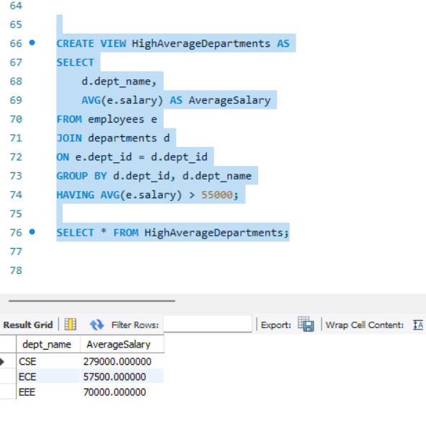

View 8 – Salary Range View
Question: Create a View that displays employees with salary between 50000 and 70000.
DROP VIEW IF EXISTS SalaryRangeView;
CREATE VIEW SalaryRangeView AS
SELECT emp_id, emp_name, salary
FROM employees
WHERE salary BETWEEN 50000 AND 70000;
SELECT * FROM SalaryRangeView;
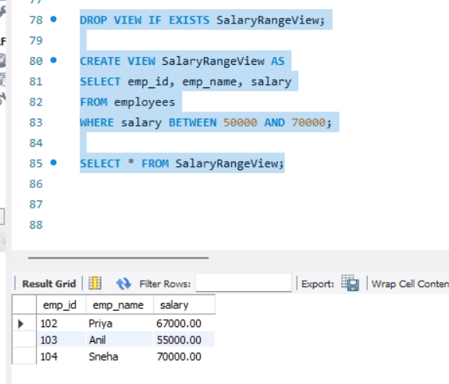

View 9 – View with Calculated Column
Question: Create a View that displays employee name, monthly salary and annual salary.
DROP VIEW IF EXISTS AnnualSalaryView;
CREATE VIEW AnnualSalaryView AS
SELECT
emp_id,
emp_name,
salary AS MonthlySalary,
salary * 12 AS AnnualSalary
FROM employees;
SELECT * FROM AnnualSalaryView;
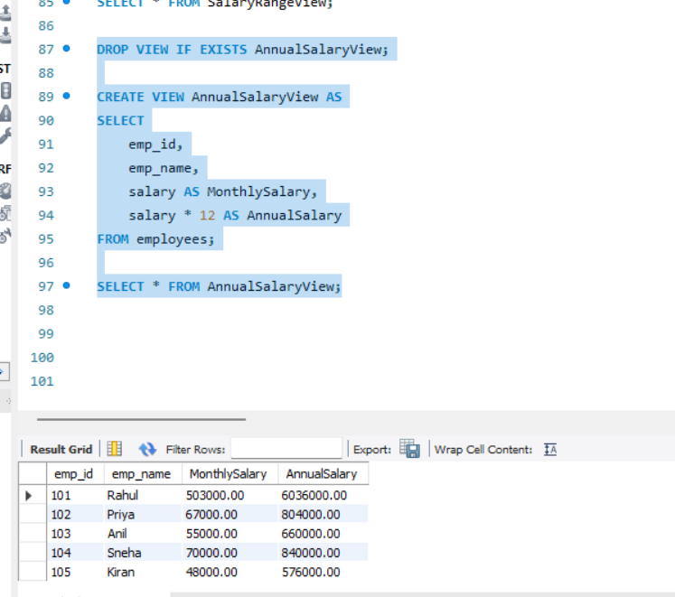

View 10 – Update Data Through a Simple View
Question: Create a simple single-table View and update an employee's salary through the View.
DROP VIEW IF EXISTS EmployeeSalaryView;
CREATE VIEW EmployeeSalaryView AS
SELECT emp_id, emp_name, salary
FROM employees;
UPDATE EmployeeSalaryView
SET salary = 60000
WHERE emp_id = 101;
SELECT * FROM EmployeeSalaryView;
SELECT * FROM employees WHERE emp_id = 101;
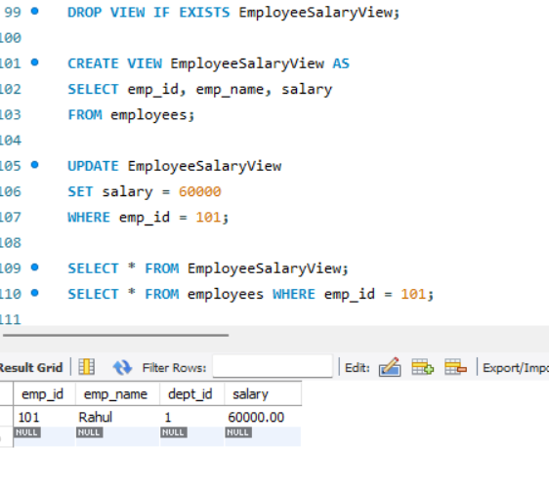

View 11 – CREATE OR REPLACE VIEW
Question: Modify an existing View so that it displays employee name and salary only.
CREATE OR REPLACE VIEW EmployeeBasicView AS
SELECT emp_name, salary
FROM employees;
SELECT * FROM EmployeeBasicView;
CREATE OR REPLACE VIEW EmployeeBasicView AS
SELECT emp_name, salary
FROM employees;
SELECT * FROM EmployeeBasicView;

View 12 – View Definition
Question: Display the SQL statement used to create a View.
SHOW CREATE VIEW EmployeeDepartmentView;
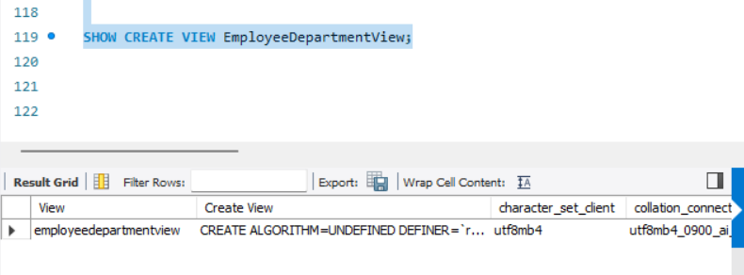

View 13 – List All Views
Question: Display all Views available in the current database.
SHOW FULL TABLES
WHERE Table_type = 'VIEW';
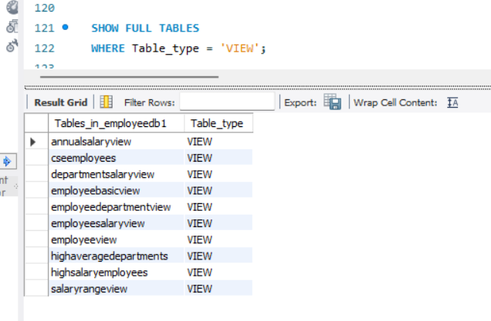

View 14 – Drop a View
Question: Remove an existing View from the database.
DROP VIEW IF EXISTS SalaryRangeView;
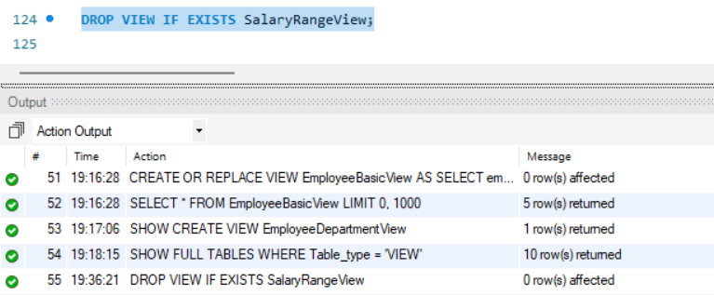

4. Important Concept: Simple View vs Complex View
A simple View is generally based on one table and does not use grouping or aggregate functions. Some simple Views can be updated. A View containing JOINs, GROUP BY, aggregate functions such as AVG(), DISTINCT, or other non-updatable constructs may not be directly updatable.

5. View vs Table
Feature | Table | View
Stores data | Yes | Normally no; stores query definition
Created with CREATE TABLE | Yes | No
Created with CREATE VIEW | No | Yes
Can use JOINs | Not applicable | Yes
Reflects current underlying data | Own stored data | Yes
Can always be updated | Yes | No; depends on the View

6. Student Practice Tasks
1. Create a View showing only emp_id, emp_name and salary.
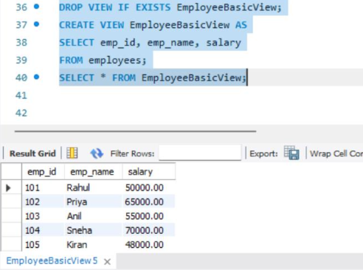
2. Create a View for employees earning more than 60000.
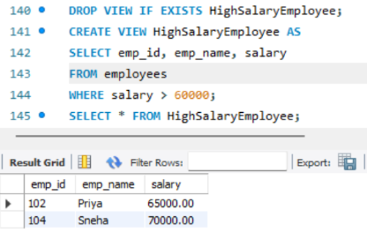
3. Create a View showing employee name, department name and salary using JOIN.
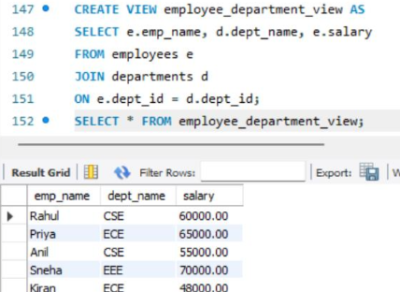
4. Create a View showing only ECE employees.
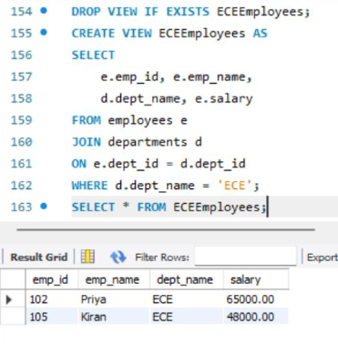
5. Create a View showing department-wise employee count.
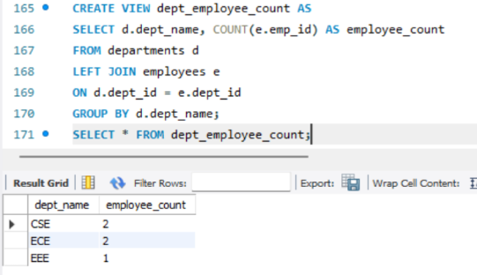
6. Create a View showing department-wise maximum salary.
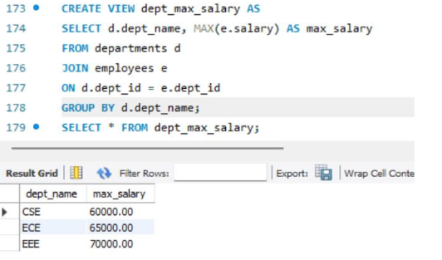
7. Create a View showing departments whose average salary is greater than 50000.
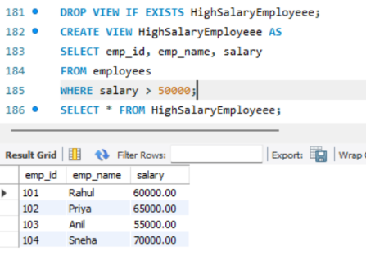
8. Create a View with employee name, salary and annual salary.
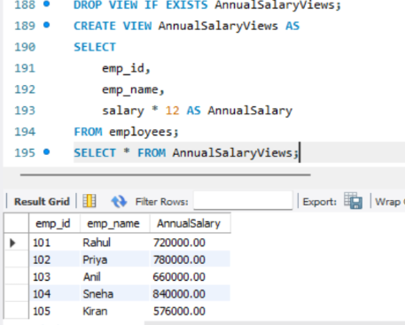
9. Update an employee's salary through a simple View and verify the base table.
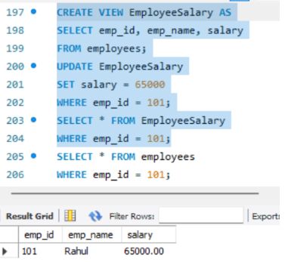
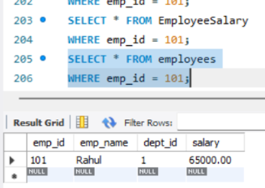
10. Use SHOW CREATE VIEW to display the definition of a View.
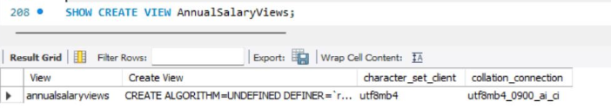
11. List all Views in the database.
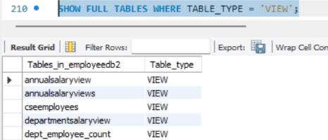
12. Drop a View and verify that it no longer appears in the list.
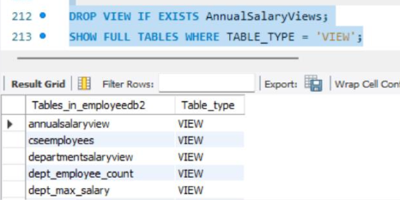

7. Viva / Discussion Questions
1. What is a View? A View is a virtual table created from a SQL query. It displays selected data from one or more tables.
2. Why do we use Views? Views are used to simplify complex queries, improve security, and show only required data.
3. Does a View normally store a separate copy of the data? No. A View normally stores only the SQL query, not a separate copy of the data.
4. What is the difference between a View and a table? A table stores actual data, while a View displays data from one or more tables.
5. Can a View be created using multiple tables? Yes. A View can use multiple tables with JOINs.
6. Can every View be updated? No. Simple Views can usually be updated, but Views using GROUP BY, aggregate functions, etc. may not be directly updatable.
7. Why are Views useful for security? Views can hide sensitive columns and allow users to access only the data they need.
8. What is the difference between CREATE VIEW and CREATE OR REPLACE VIEW?
CREATE VIEW creates a new View. CREATE OR REPLACE VIEW creates a new View or replaces an existing View.
9. How do you display the definition of a View in MySQL?
SHOW CREATE VIEW view_name; It shows the SQL query used to create the View.
10. How do you remove a View?
DROP VIEW view_name; It permanently removes the View, but does not delete the base table data.

